
zero-riscy: User Manual
January 2018
Revision 0.2
Pasquale Davide Schiavone (pschiavo@iis.ee.ethz.ch)

Micrel Lab and Multitherman Lab
University of Bologna, Italy
Integrated Systems Lab
ETH Zürich, Switzerland

Copyright 2017 ETH Zurich and University of Bologna.
Copyright and related rights are licensed under the Solderpad Hardware License, Version 0.51 (the “License”); you may not use this file except in compliance with the License. You may obtain a copy of the License at http://solderpad.org/licenses/SHL-0.51. Unless required by applicable law or agreed to in writing, software, hardware and materials distributed under this License is distributed on an “AS IS” BASIS, WITHOUT WARRANTIES OR CONDITIONS OF ANY KIND, either express or implied. See the License for the specific language governing permissions and limitations under the License.
Document Revisions
Rev. | Date | Author | Description
0.1 | 06.06.17 | P.D. Schiavone | First Draft
0.2 | 15.01.18 | P.D. Schiavone | Fixed CSR reset values
Table of Contents
1 Introduction 6
1.1 Supported Instruction Set 6
1.2 ASIC Synthesis 6
1.3 FPGA Synthesis 6
1.4 Outline 7
2 Instruction Fetch 8
2.1 Protocol 8
3 Load-Store-Unit (LSU) 9
3.1 Misaligned Accesses 9
3.2 Protocol 9
4 Register File 11
4.1 Latch-based Register File 11
5 Control and Status Registers 12
5.1 Machine Status (MSTATUS) 12
5.2 Machine Trap-Vector Base Address (MTVEC) 13
5.3 Machine Exception PC (MEPC) 13
5.4 Machine Cause (MCAUSE) 14
5.5 MHARTID 14
6 Performance Counters 15
6.1 Performance Counter Mode Register (PCMR) 15
6.2 Performance Counter Event Register (PCER) 15
6.3 Performance Counter Counter Register (PCCR0-31) 16
7 Exceptions and Interrupts 19
7.1 Interrupts 19
7.2 Exceptions 19
7.3 Handling 19
8 Debug Unit 20
8.1 Address Map 20
8.2 Debug Registers 20
8.2.1 Debug Control (DBG_CTRL) 21
8.2.2 Debug Hit (DBG_HIT) 21
8.2.3 Debug Interrupt Enable (DBG_IE) 22
8.2.4 Debug Cause (DBG_CAUSE) 23
8.2.5 Debug Hardware Breakpoint x Control (DBG_BPCTRLx) 23
8.2.6 Debug Next Program Counter (DBG_NPC) 24
8.2.7 Debug Previous Program Counter (DBG_PPC) 24
8.3 Control and Status Registers 25
8.4 Interface 25

Introduction
ZERO-RISCY is a 2-stage in-order 32b RISC-V processor core. ZERO-RISCY has been designed to be small and efficient. Via two parameters, the core is configurable to support four ISA configurations.
Figure 1 shows a block diagram of the core.

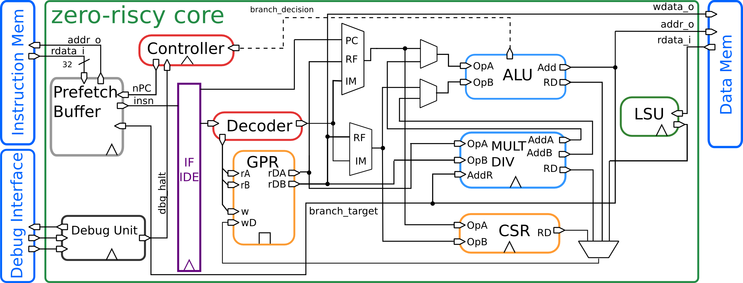
Figure 1: Block Diagram

Supported Instruction Set
ZERO-RISCY supports the following instructions:
- Full support for RV32I Base Integer Instruction Set
- Full support for RV32E Base Integer Instruction Set
- Full support for RV32C Standard Extension for Compressed Instructions
- Full support for RV32M Integer Multiplication and Division Instruction Set Extension
The RV32M and RV32E can be enable and disable using two parameters.

ASIC Synthesis
ASIC synthesis is supported for ZERO-RISCY. The whole design is completely synchronous and uses positive-edge triggered flip-flops, except for the register file, which can be implemented either with latches or with flip-flops. See Chapter 4 for more details about the register file. The core occupies an area of about 18.9 kGE when the latch based register file and the RV32IMC ISA is used or 11.6 kGE when the RV32EC is used .

FPGA Synthesis
FPGA synthesis is supported for ZERO-RISCY when the flip-flop based register file is used. Since latches are not well supported on FPGAs, it is crucial to select the flip-flop based register file.

Outline
This document summarizes all the functionality of the ZERO-RISCY core in more detail. First, the instruction and data interfaces are explained in Chapter 2 and 3. Chapter 4 explains the register file. Control and status registers are explained in Chapter 5 and Chapter 6 gives an overview of all performance counters. Chapter 7 deals with exceptions and interrupts, and finally Chapter 8 summarizes the accessible debug registers.

Instruction Fetch
The instruction fetcher of the core is able to supply one instruction to the ID stage per cycle if the instruction cache or the instruction memory is able to serve one instruction per cycle. The instruction address must be half-word-aligned due to the support of compressed instructions. It is not possible to jump to instruction addresses that have the LSB bit set.

For optimal performance and timing closure reasons, a prefetcher is used which fetches instruction from the instruction memory, or instruction cache.

Table 1 describes the signals that are used to fetch instructions. This interface is a simplified version that is used by the LSU that is described in Chapter 3. The difference is that no writes are possible and thus it needs less signals.

Signal | Direction | Description
instr_req_o | output | Request ready, must stay high until instr_gnt_i is high for one cycle
instr_addr_o[31:0] | output | Address
instr_rdata_i[31:0] | input | Data read from memory
instr_rvalid_i | input | instr_rdata_is holds valid data when instr_rvalid_i is high. This signal will be high for exactly one cycle per request.
instr_gnt_i | input | The other side accepted the request. instr_addr_o may change in the next cycle
Table 1: Instruction Fetch Signals

Protocol
The protocol used to communicate with the instruction cache or the instruction memory is the same as the protocol used by the LSU. See the description of the LSU in Chapter 3.2 for details about the protocol.

Load-Store-Unit (LSU)
The LSU of the core takes care of accessing the data memory. Load and stores on words (32 bit), half words (16 bit) and bytes (8 bit) are supported.
Table 2 describes the signals that are used by the LSU.

Signal | Direction | Description
data_req_o | output | Request ready, must stay high until data_gnt_i is high for one cycle
data_addr_o[31:0] | output | Address
data_we_o | output | Write Enable, high for writes, low for reads. Sent together with data_req_o
data_be_o[3:0] | output | Byte Enable. Is set for the bytes to write/read, sent together with data_req_o
data_wdata_o[31:0] | output | Data to be written to memory, sent together with data_req_o
data_rdata_i[31:0] | input | Data read from memory
data_rvalid_i | input | data_rdata_is holds valid data when data_rvalid_i is high. This signal will be high for exactly one cycle per request.
data_gnt_i | input | The other side accepted the request. data_addr_o may change in the next cycle
Table 2: LSU Signals

Misaligned Accesses
The LSU is able to perform misaligned accesses, meaning accesses that are not aligned on natural word boundaries. However, it needs to perform two separate word-aligned accesses internally. This means that at least two cycles are needed for misaligned loads and stores.

Protocol
The protocol that is used by the LSU to communicate with a memory works as follows:
The LSU provides a valid address in data_addr_o and sets data_req_o high. The memory then answers with a data_gnt_i set high as soon as it is ready to serve the request. This may happen in the same cycle as the request was sent or any number of cycles later. After a grant was received, the address may be changed in the next cycle by the LSU. In addition, the data_wdata_o, data_we_o and data_be_o signals may be changed as it is assumed that the memory has already processed and stored that information. After receiving a grant, the memory answers with a data_rvalid_i set high if data_rdata_i is valid. This may happen one or more cycles after the grant has been received. Note that data_rvalid_i must also be set when a write was performed, although the data_rdata_i has no meaning in this case.

Figure 2, Figure 3 and Figure 4 show example-timing diagrams of the protocol.

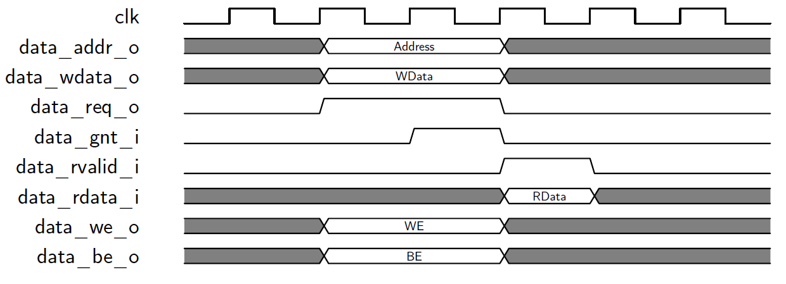
Figure 2: Basic Memory Transaction

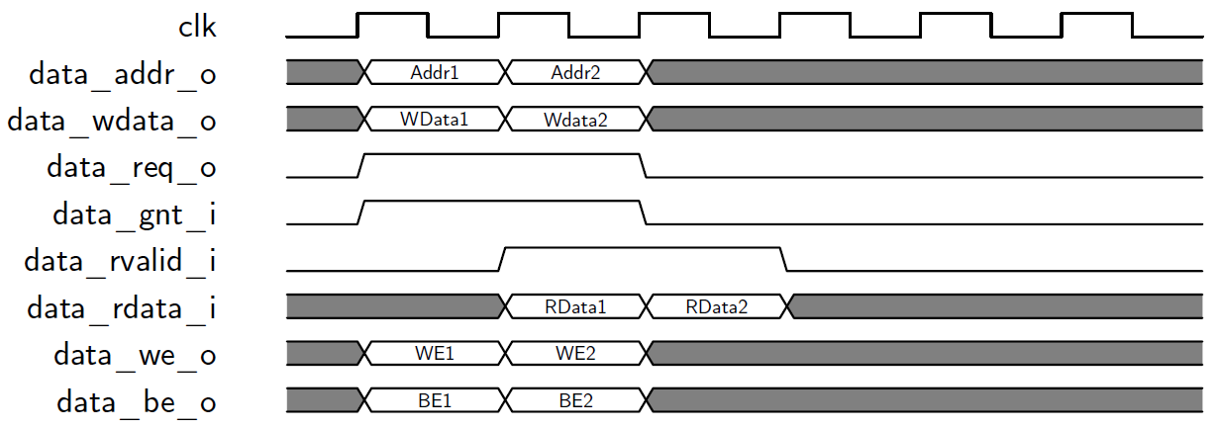
Figure 3: Back-to-back Memory Transaction

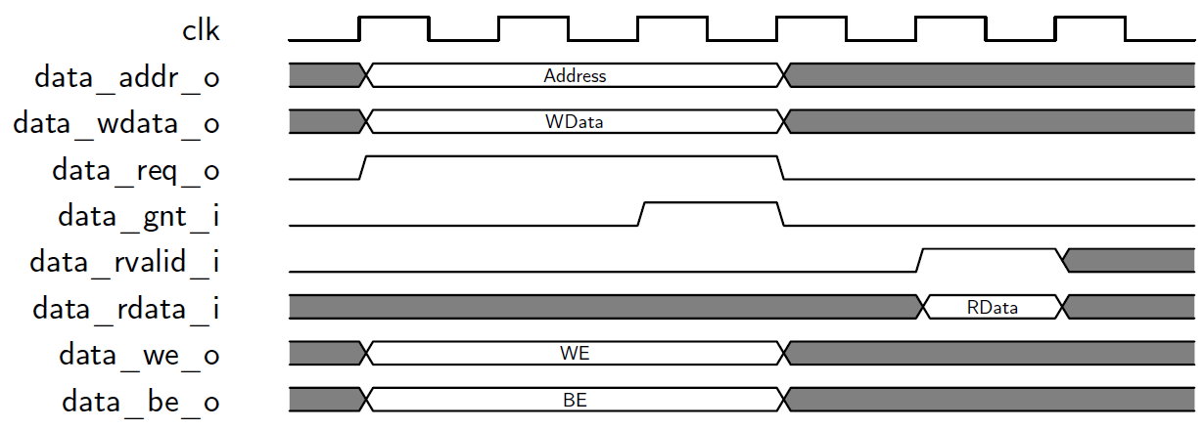
Figure 4: Slow Response Memory Transaction

Register File
ZERO-RISCY has 31 or 15 32-bit wide registers depending if the RV32E extension is enabled. Register x0 is statically bound to 0 and can only be read, it does not contain any sequential logic.

There are two flavors of register file available:
- Latch-based
- Flip-flop based

While the latch-based register file is recommended for ASICs, the flip-flop based register file is recommended for FPGA synthesis, although both are compatible with either synthesis target. Note the flip-flop based register file is significantly larger than the latch-based register-file for an ASIC implementation.

Latch-based Register File
The latch based register file contains manually instantiated clock gating cells to keep the clock inactive when the latches are not written.

It is assumed that there is a clock gating cell for the target technology that is wrapped in a module called cluster_clock_gating and has the following ports:
- clk_i: Clock Input
- en_i: Clock Enable Input
- test_en_i: Test Enable Input (activates the clock even though en_i is not set)
- clk_o: Gated Clock Output

Control and Status Registers
ZERO-RISCY does not implement all control and status registers specified in the RISC-V privileged specifications, but is limited to the registers that were needed for the PULP system. The reason for this is that we wanted to keep the footprint of the core as low as possible and avoid any overhead that we do not explicitly need.

CSR Address |  |  |  | Hex | Name | Acc. | Description
11:10 | 9:8 | 7:6 | 5:0
00 | 11 | 00 | 000000 | 0x300 | MSTATUS | R/W | Machine Status
00 | 11 | 00 | 000101 | 0x305 | MTVEC | R | Machine Trap-Vector Base Address
00 | 11 | 01 | 000001 | 0x341 | MEPC | R/W | Machine Exception Program Counter
00 | 11 | 01 | 000010 | 0x342 | MCAUSE | R/W | Machine Trap Cause
01 | 11 | 00 | 0xxxxx | 0x780-0x79F | PCCRs | R/W | Performance Counter Counter Registers
01 | 11 | 10 | 100000 | 0x7A0 | PCER | R/W | Performance Counter Enable
01 | 11 | 10 | 100001 | 0x7A1 | PCMR | R/W | Performance Counter Mode
11 | 11 | 00 | 010100 | 0xF14 | MHARTID | R | Hardware Thread ID
Table 3: Control and Status Register Map

Machine Status (MSTATUS)
CSR Address: 0x300
Reset Value: 0x0000_1800
31 |  |  |  |  |  |  |  |  |  |  |  |  |  |  |  |  |  |  |  |  |  |  |  |  |  |  |  |  |  |  |  |  |  |  |  | 12 |  | 11 |  |  |  |  |  |  | 7 |  |  |  |  |  |  |  | 3
 |  |  |  |  |  |  |  |  |  |  |  |  |  |  |  |  |  |  |  |  |  |  |  |  |  |  |  |  |  |  |  |  |  |  |  |  | MPP |  |  |  |  |  |  |  |  | MPIE |  |  |  |  |  |  |  | MIE

Detailed:
Bit # | R/W | Description
12:11 | R | MPP: Statically 2’b11 and cannot be altered (read-only).
7 | R/W | Previous Interrupt Enable: When an exception is encountered, MPIE will be set to IE. When the mret instruction is executed, the value of MPIE will be stored to IE.
3 | R/W | Interrupt Enable: If you want to enable interrupt handling in your exception handler, set the Interrupt Enable to 1’b1 inside your handler code.

Machine Trap-Vector Base Address (MTVEC)
CSR Address: 0x305
31 |  |  |  |  |  |  |  |  |  |  |  |  |  |  |  |  |  |  |  |  |  |  |  |  |  |  |  |  |  |  |  |  |  |  |  |  |  |  |  |  |  |  |  |  |  | 7 |  |  |  |  |  |  |  | 0

When an exception is encountered, the core jumps to the corresponding handler using the content of the MTVEC as base address. It is a read-only register which contains the boot address.
Table 3: MTVEC

Machine Exception PC (MEPC)
CSR Address: 0x341
Reset Value: 0x0000_0000
31 |  |  |  |  |  |  |  |  |  |  |  |  |  |  |  |  |  |  |  |  |  |  |  |  |  |  |  |  |  | 0
MEPC

When an exception is encountered, the current program counter is saved in MEPC, and the core jumps to the exception address. When an mret instruction is executed, the value from MEPC replaces the current program counter.

Machine Cause (MCAUSE)
CSR Address: 0x342
Reset Value: 0x0000_0000
31 |  |  |  |  |  |  |  |  |  |  |  |  |  |  |  |  |  |  |  |  |  |  |  |  |  |  |  |  |  |  |  |  |  |  |  |  |  |  |  |  |  |  |  |  |  |  |  |  |  |  |  |  |  | 4 |  |  |  |  | 0
Interrupt |  |  |  |  |  |  |  |  |  |  |  |  |  |  |  |  |  |  |  |  |  |  |  |  |  |  |  |  |  |  |  |  |  |  |  |  |  |  |  |  |  |  |  |  |  |  |  |  |  |  |  |  |  |  | Exception Code

Detailed:
Bit # | R/W | Description
31 | R | Interrupt: This bit is set when the exception was triggered by an interrupt.
4:0 | R | Exception Code
Table4: MCAUSE

MHARTID
CSR Address: 0xF14
Reset Value: Defined
31 |  |  |  |  |  |  |  |  |  |  |  |  |  |  |  |  |  |  |  |  |  |  |  |  |  |  |  |  |  |  |  |  |  |  |  |  |  |  |  | 10 |  |  |  |  |  | 5 | 4 |  | 3 |  |  |  | 0
 |  |  |  |  |  |  |  |  |  |  |  |  |  |  |  |  |  |  |  |  |  |  |  |  |  |  |  |  |  |  |  |  |  |  |  |  |  |  |  |  | Cluster ID |  |  |  |  |  |  |  |  | Core ID

Detailed:
Bit # | R/W | Description
10:5 | R | Cluster ID: ID of the cluster
3:0 | R | Core ID: ID of the core within the cluster
Table 5: MHARTID

Performance Counters
Performance Counters in ZERO-RISCY are placed inside the Control and Status Registers and can be accessed with csrr and csrw instructions. See Table 9.1 for the address map of the performance counter registers

Performance Counter Mode Register (PCMR)
CSR Address: 0x7A1
Reset Value: 0x0000_0003
31 |  |  |  |  |  |  |  |  |  |  |  |  |  |  |  |  |  |  |  |  |  |  |  |  |  |  |  |  |  |  |  |  |  |  |  |  |  |  |  |  |  |  |  |  |  |  |  |  |  |  |  |  |  |  |  |  |  | 1 |  | 0
 |  |  |  |  |  |  |  |  |  |  |  |  |  |  |  |  |  |  |  |  |  |  |  |  |  |  |  |  |  |  |  |  |  |  |  |  |  |  |  |  |  |  |  |  |  |  |  |  |  |  |  |  |  |  |  |  |  |  | Saturation |  | Global Enable

Detailed:
Bit # | R/W | Description
1 | R/W | Global Enable: Activate/deactivate all performance counters. If this bit is 0, all performance counters are disabled. After reset, this bit is set.
0 | R/W | Saturation: If this bit is set, saturating arithmetic is used in the performance counter counters. After reset, this bit is set.
Table 6: PCMR

Performance Counter Event Register (PCER)
CSR Address: 0x7A0
Reset Value: 0x0000_0000
31 |  |  |  |  |  |  |  |  |  |  |  |  |  | 16 | 15 | 14 | 13 | 12 | 11 | 10 | 9 | 8 | 7 | 6 | 5 | 4 | 3 | 2 | 1 | 0
 |  |  |  |  |  |  |  |  |  |  |  |  |  | TCDM_CONT | ST_EXT_CYC | LD_EXT_CYC | ST_EXT | LD_EXT | DELAY_SLOT | BRANCH | JUMP | ST | LD | WBRANCH_CYC | WBRANCH | IMISS | - | - | INSTR | CYCLES

Detailed:
Bit # | R/W | Description
16 | R/W | TCDM_CONT
15 | R/W | ST_EXT_CYC
14 | R/W | LD_EXT_CYC
13 | R/W | ST_EXT
12 | R/W | LD_EXT
11 | R/W | DELAY_SLOT
10 | R/W | BRANCH
9 | R/W | JUMP
8 | R/W | ST
7 | R/W | LD
6 | R/W | WBRANCH_CYC
5 | R/W | WBRANCH
4 | R/W | IMISS
3 | R/W | RESERVED
2 | R/W | RESERVED
1 | R/W | INSTR
0 | R/W | CYCLES
Table 7: PCER
Each bit in the PCER register controls one performance counter. If the bit is 1, the counter is enabled and starts counting events. If it is 0, the counter is disabled and its value won’t change.

In the ASIC there is only one counter register, thus all counter events are masked by PCER and ORed together, i.e. if one of the enabled event happens, the counter will be increased. If multiple non-masked events happen at the same time, the counter will only be increased by one.
In order to be able to count separate events on the ASIC, the program can be executed in a loop with different events configured.

In the FPGA or RTL simulation version, each event has its own counter and can be accessed separately.

Performance Counter Counter Register (PCCR0-31)
CSR Address: 0x780 - 0x79F
Reset Value: 0x0000_0000
31 |  |  |  |  |  |  |  |  |  |  |  |  |  |  |  |  |  |  |  |  |  |  |  |  |  |  |  |  |  | 0
Unsigned Integer Counter Value
Table 4: PCCR0-31
PCCR registers support both saturating and wrap-around arithmetic. This is controlled by the saturation bit in PCMR.

Register | Name | Description
PCCR0 | CYCLES | Counts the number of cycles the core was active (not sleeping)
PCCR1 | INSTR | Counts the number of instructions executed
PCCR2 | - | Reserved
PCCR3 | - | Reserved
PCCR4 | IMISS | Cycles waiting for instruction fetches, i.e. number of instructions wasted due to non-ideal caching
PCCR5 | LD | Number of data memory loads executed.  Misaligned accesses are counted twice
PCCR6 | ST | Number of data memory stores executed.  Misaligned accesses are counted twice
PCCR7 | JUMP | Number of unconditional jumps (j, jal, jr, jalr)
PCCR8 | BRANCH | Number of branches.  Counts taken and not taken branches
PCCR9 | BTAKEN | Number of taken branches.
PCCR10 | RVC | Number of compressed instructions executed
PCCR11 | LD_EXT | Number of memory loads to EXT executed. Misaligned accesses are counted twice. Every non-TCDM access is considered external (PULP only)
PCCR12 | ST_EXT | Number of memory stores to EXT executed. Misaligned accesses are counted twice. Every non-TCDM access is considered external (PULP only)
PCCR13 | LD_EXT_CYC | Cycles used for memory loads to EXT. Every non-TCDM access is considered external (PULP only)
PCCR14 | ST_EXT_CYC | Cycles used for memory stores to EXT. Every non-TCDM access is considered external (PULP only)
PCCR15 | TCDM_CONT | Cycles wasted due to TCDM/log-interconnect contention (PULP only)
PCCR31 | ALL | Special Register, a write to this register will set all counters to the supplied value
Table 8: PCCR Definitions
In the FPGA, RTL simulation and Virtual-Platform there are individual counters for each event type, i.e. PCCR0-30 each represent a separate register. To save area in the ASIC, there is only one counter and one counter register. Accessing PCCR0-30 will access the same counter register in the ASIC. Reading/writing from/to PCCR31 in the ASIC will access the same register as PCCR0-30.

Figure 5 shows how events are first masked with the PCER register and then ORed together to increase the one performance counter PCCR.

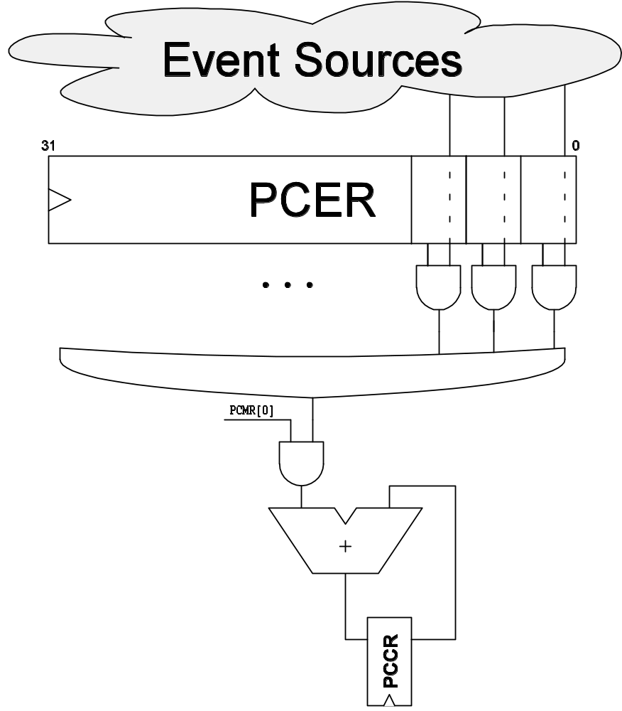
Figure 5: Events and PCCR, PCMR and PCER on the ASIC.

Exceptions and Interrupts
ZERO-RISCY supports interrupts, exceptions on illegal instructions.

Address | Description
0x00-0x7C | Interrupts 0 – 31
0x80 | Reset
0x84 | Illegal Instruction
0x88 | ECALL Instruction Executed
Table 5: Interrupt/Exception Offset Vector Table

The base address of the interrupt vector table is given by the boot address. The most significant 3 bytes of the boot address given to the core are used for the first instruction fetch of the core and as the basis of the interrupt vector table. The core starts fetching at the address made by concatenating the most significant 3 bytes of the boot address and the reset value (0x80) as the least significant byte. The boot address can be changed after the first instruction was fetched to change the interrupt vector table address. It is assumed that the boot address is supplied via a register to avoid long paths to the instruction fetch unit.

Interrupts
Interrupts can only be enabled/disabled on a global basis and not individually. It is assumed that there is an event/interrupt controller outside of the core that performs masking and buffering of the interrupt lines. The global interrupt enable is done via the CSR register MSTATUS.
Multiple interrupts requests are assumed to be handled by event/interrupt controller. When an interrupt is taken, the core gives an acknowledge signal to the event/interrupt controller as well as the interrupt id taken.

Exceptions
The illegal instruction exception and ecall instruction exceptions cannot be disabled and are always active.

Handling
ZERO-RISCY does support nested interrupt/exception handling. Exceptions inside interrupt/exception handlers cause another exception, thus exceptions during the critical part of your exception
handlers, i.e. before having saved the MEPC and MESTATUS registers, will cause those register to be overwritten. Interrupts during interrupt/exception handlers are disabled by default, but can be explicitly enabled if desired.
Upon executing an mret instruction, the core jumps to the program counter saved in the CSR register MEPC and restores the MPIE value of the register MSTATUS to IE. When entering an interrupt/exception handler, the core sets MEPC to the current program counter and saves the current value of MIE in MPIE of the MSTATUS register.

Debug Unit

Address Map

Address | Name | Description
0x0000-0x007F | Debug Registers | Always accessible, even when the core is running
0x400-0x47F | GPR (x0-x31) | General Purpose Registers  Only accessible if the core is halted
0x500-0x5FF | FPR (f0-f31) | Reserved. Not used in the ZERO-RISCY core.  First LSP from 0x500-0x57F, then MSP from 0x580-0x5FF
0x2000-0x20FF | Debug Registers | Only accessible if the core is halted
0x4000-0x7FFF | CSR | Control and Status Registers  Only accessible if the core is halted
Table 9: Debug Unit Address Map
Addresses are intended for a bus system with 32-bit wide words.
FPR get more address space than GPR because they can be 64-bit wide even in a 32-bit system.
Addresses have to be aligned to word-boundaries.

Debug Registers

Address | Name | Description
0x00 | DBG_CTRL | Debug Control
0x04 | DBG_HIT | Debug Hit
0x08 | DBG_IE | Debug Interrupt Enable
0x0C | DBG_CAUSE | Debug Cause (Why we entered debug state)
0x40 | DBG_BPCTRL0 | HW BP0 Control
0x44 | DBG_BPDATA0 | HW BP0 Data
0x48 | DBG_BPCTRL1 | HW BP1 Control
0x4C | DBG_BPDATA1 | HW BP1 Data
0x50 | DBG_BPCTRL2 | HW BP2 Control
0x54 | DBG_BPDATA2 | HW BP2 Data
0x58 | DBG_BPCTRL3 | HW BP3 Control
0x5C | DBG_BPDATA3 | HW BP3 Data
0x60 | DBG_BPCTRL4 | HW BP4 Control
0x64 | DBG_BPDATA4 | HW BP4 Data
0x68 | DBG_BPCTRL5 | HW BP5 Control
0x6C | DBG_BPDATA5 | HW BP5 Data
0x70 | DBG_BPCTRL6 | HW BP6 Control
0x74 | DBG_BPDATA6 | HW BP6 Data
0x78 | DBG_BPCTRL7 | HW BP7 Control
0x7C | DBG_BPDATA7 | HW BP7 Data
0x2000 | DBG_NPC | Next PC
0x2004 | DBG_PPC | Previous PC
Table 10: Debug Unit Registers

Debug Control (DBG_CTRL)
Compact:
31 | 30 | 29 | 28 | 27 | 26 | 25 | 24 | 23 | 22 | 21 | 20 | 19 | 18 | 17 | 16
reserved |  |  |  |  |  |  |  |  |  |  |  |  |  |  | HALT
 |  |  |  |  |  |  |  |  |  |  |  |  |  |  | R/W
15 | 14 | 13 | 12 | 11 | 10 | 9 | 8 | 7 | 6 | 5 | 4 | 3 | 2 | 1 | 0
reserved |  |  |  |  |  |  |  |  |  |  |  |  |  |  | SSTE
 |  |  |  |  |  |  |  |  |  |  |  |  |  |  | R/W

Detailed:
Bit # | R/W | Description
16 | W1 | HALT: When 1 written, core enters debug mode, when 0 written, core exits debug mode.  When read, 1 means core is in debug modekkj
0 | R/W | SSTE: Single-step enable
Table 11: DBG_CTRL register

Debug Hit (DBG_HIT)
Compact:
31 | 30 | 29 | 28 | 27 | 26 | 25 | 24 | 23 | 22 | 21 | 20 | 19 | 18 | 17 | 16
reserved |  |  |  |  |  |  |  |  |  |  |  |  |  |  | SLEEP
 |  |  |  |  |  |  |  |  |  |  |  |  |  |  | R
15 | 14 | 13 | 12 | 11 | 10 | 9 | 8 | 7 | 6 | 5 | 4 | 3 | 2 | 1 | 0
reserved |  |  |  |  |  |  |  |  |  |  |  |  |  |  | SSTH
 |  |  |  |  |  |  |  |  |  |  |  |  |  |  | R/W

Detailed:
Bit # | R/W | Description
16 | R | SLEEP: Set when the core is in a sleeping state and waits for an event
0 | R/W | SSTH: Single-step hit, sticky bit that must be cleared by external debugger
Table 12: DBG_HIT register

Debug Interrupt Enable (DBG_IE)
Compact:
31 | 30 | 29 | 28 | 27 | 26 | 25 | 24 | 23 | 22 | 21 | 20 | 19 | 18 | 17 | 16
TO BE DEFINED
15 | 14 | 13 | 12 | 11 | 10 | 9 | 8 | 7 | 6 | 5 | 4 | 3 | 2 | 1 | 0
reserved |  |  |  | ECALL | reserved |  |  | SAF | SAM | LAF | LAM | BP | ILL | IAF | IAM
 |  |  |  | R/W |  |  |  | R/W | R/W | R/W | R/W | R/W | R/W | R/W | R/W

Detailed:
Bit # | R/W | Description
11 | R/W | ECALL: Environment call from M-Mode
7 | R/W | SAF: Store Access Fault (together with LAF)
6 | R/W | SAM: Store Address Misaligned (never traps)
5 | R/W | LAF: Load Access Fault (together with SAF)
4 | R/W | LAM: Load Address Misaligned (never traps)
3 | R/W | BP: EBREAK instruction causes trap
2 | R/W | ILL: Illegal Instruction
1 | R/W | IAF: Instruction Access Fault (not implemented)
0 | R/W | IAM: Instruction Address Misaligned (never traps)
Table 13: DBG_IE register
When ‘1’ exceptions cause traps, otherwise normal exceptions.

Debug Cause (DBG_CAUSE)
Compact:
31 | 30 | 29 | 28 | 27 | 26 | 25 | 24 | 23 | 22 | 21 | 20 | 19 | 18 | 17 | 16
IRQ | reserved
R
15 | 14 | 13 | 12 | 11 | 10 | 9 | 8 | 7 | 6 | 5 | 4 | 3 | 2 | 1 | 0
reserved |  |  |  |  |  |  |  |  |  |  | CAUSE
 |  |  |  |  |  |  |  |  |  |  | R

Detailed:
Bit # | R/W | Description
31 | R | IRQ: Interrupt caused us to enter debug mode
4:0 | R | CAUSE: Exception/interrupt number
Table 14: DBG_CAUSE register

Debug Hardware Breakpoint x Control (DBG_BPCTRLx)
Compact:
31 | 30 | 29 | 28 | 27 | 26 | 25 | 24 | 23 | 22 | 21 | 20 | 19 | 18 | 17 | 16
reserved
15 | 14 | 13 | 12 | 11 | 10 | 9 | 8 | 7 | 6 | 5 | 4 | 3 | 2 | 1 | 0
reserved |  |  |  |  |  |  |  |  |  |  |  |  |  |  | IMPL
 |  |  |  |  |  |  |  |  |  |  |  |  |  |  | R0

Detailed:
Bit # | R/W | Description
0 | R | IMPL: ZERO-RISCY does not implement hardware breakpoints. Always read as 0.
Table 15: DBG_BPCTRLx register

Debug Next Program Counter (DBG_NPC)
Compact:
31 | 30 | 29 | 28 | 27 | 26 | 25 | 24 | 23 | 22 | 21 | 20 | 19 | 18 | 17 | 16
NPC[31:16]
R/W
15 | 14 | 13 | 12 | 11 | 10 | 9 | 8 | 7 | 6 | 5 | 4 | 3 | 2 | 1 | 0
NPC[15:0]
R/W

Detailed:
Bit # | R/W | Description
31:0 | R/W | NPC: Next PC to be executed
Table 16: DBG_NPC register
When written core jumps to PC.

Debug Previous Program Counter (DBG_PPC)
Compact:
31 | 30 | 29 | 28 | 27 | 26 | 25 | 24 | 23 | 22 | 21 | 20 | 19 | 18 | 17 | 16
PPC[31:16]
R
15 | 14 | 13 | 12 | 11 | 10 | 9 | 8 | 7 | 6 | 5 | 4 | 3 | 2 | 1 | 0
PPC[15:0]
R

Detailed:
Bit # | R/W | Description
31:0 | W | PPC: Previous PC, already executed
Table 17: DBG_PPC register

Values of PPC and NPC when entering debug mode:
Reason | PPC | NPC | Cause | GDB Sigval
ebreak | ebreak instruction | next instruction | BP | TRAP
ecall | ecall instruction | IVT entry | ECALL | TRAP
illegal instruction | illegal instruction | IVT entry | ILL | ILL
invalid mem access | load/store instruction | IVT entry | LAF/SAF | SEGV
interrupt | last instruction | IVT entry | ? | INT
halt | last instruction | next instruction | ? | TRAP
single-step | last instruction | next instruction | ? | TRAP
Table 18: NPC/PPC when entering Debug Mode

Control and Status Registers
Address | Name | Description
0x4000 | CSR 0 = 0x000 | CSR
... | ... | ...
0x7FFC | CSR 4095 = 0xFFF | CSR
Table 19: Debug CSR Mapping
Can only be accessed when core is in debug mode.

Interface

Signal | Direction | Description
debug_req_i | input | Request
debug_gnt_o | output | Grant
debug_rvalid_o | output | Read data valid
debug_addr_i[14:0] | input | Address for write/read
debug_we_i | input | Write Enable
debug_wdata_i[31:0] | input | Write data
debug_rdata_o[31:0] | output | Read data
debug_halted_o | output | Is high when core is in debug mode
debug_halt_i | input | Set high when core should enter debug mode
debug_resume_i | input | Set high when core should exit debug mode
Table 20: Debug Interface
debug_halted_o, debug_halt_i and debug_resume_i are intended for cross-triggering between multiple cores. They are not required for single-core debug, thus debug_halt_i and debug-resume_i can be tied to 0.
debug_halt_i and debug_resume_i should be high for only one single cycle to avoid deadlock issues.

