Supplementary Material for

Measurement of borehole seismometer orientation using tangential P-wave receiver function based on harmonic decomposition

Hobin Lim¹, YoungHee Kim^{1*}, Teh-Ru Alex Song², Xuzhang Shen³

¹School of Earth and Environmental Sciences, Seoul National University, Seoul, 08826, Republic of Korea
²Seismological Laboratory, Department of Earth Sciences, University College London, Kathleen-Lonsdale Building, Gower Street, London, WC1E 6BT, UK
³Lanzhou Institute of Seismology, China Earthquake Administration, 450 Donggang West Road, Lanzhou, Gansu Province, 730000, China

* Corresponding author
Email: younghkim@snu.ac.kr
Phone: +82-2-880-6735

1. Introduction
The orientation of the stations in South Korea is presented in Table 1. Previous results on the orientation for some stations in South Korea (Ekström & Busby, 2008; Shin et al., 2009; Lee & Rhie, 2015; Lee & Sheen, 2015) are also listed in Table 1. We provide the orientation for each station by minimizing a constant term in a harmonic expansion of tangential receiver functions (T-RFs) in back azimuth near and at 0 s. Here we perform this correction for a specific period of time (denoted as validation period), which is defined by a start and an end of the period when the polarity and/or the amplitude of the T-RFs near 0 s shifted significantly, or manually set by the sensor replacement/maintenance record if available (Table S1). Table S2 lists the orientation values obtained from different methods. This Supplementary Material includes Tables S1 and S2 and Figs S1-S14 that are supplementary to the main text.

2. Effect of stacking with 5° bin in back azimuth
Here we show the effect of stacking in the harmonic terms of RFs and the means of RFs in both radial and tangential components using the synthetics. In this synthetic test, we use earthquake distribution from Korean seismic network and ocean bottom seismic network (Figs 2 and S2, respectively). Note that the event distribution from the Korean network ensures nearly complete back-azimuth coverage, whereas that from the ocean bottom seismic network does not. The 5° bin-stack of the RFs prior to the regression reduces the row of data matrix (d_{R} and d_{T}) from over 1,000 to 72, and thus this stacking procedure minimizes computational cost. Also, the stacking in back azimuth normalizes the uneven back-azimuthal distribution of the earthquakes. The harmonic terms of the RFs from the stacking do not greatly differ from the one without for both network data (Figs S14a and b). However, we observe some noticeable difference in amplitudes of the mean of T-RFs for both network data (Figs 14a and b).

3. Uncertainty of orientation
Following three types of uncertainty in determining the orientation can be discussed in this study: (1) the uncertainty in orientation based on the bootstrapping in back azimuth (Fig. S14a), (2) the difference in estimates for using the minimization of a constant term in a harmonic expansion of T-RFs or the mean of the T-RFs (Fig. S14b), and (3) the difference with previously reported estimates based on different methods (Figs S14c, d and e). As Fig. S4 shows, the difference in estimates based on the minimization of a constant term in harmonics and the mean of T-RFs is quite small except for three stations in South Korea with a deviation larger than 1°. This deviation is mostly due to insufficient back-azimuthal coverage.

In regards to the uncertainty from type (3), it is difficult to statistically compare these two values because different types of data (e.g., regional body-wave phase versus teleseismic body-wave phase) and different data processing (e.g., passband) are involved in determining the orientation. In addition, the histogram for the type (3) uncertainty follows close to the 10°-uncertainty, similar to the estimate reported by Schulte-Pelkum et al. (2001) and Wang et al. (2016). Both studies report that the uncertainty of ~10° can be achieved when the anisotropic and/or dipping structure is present beneath the receiver (Figs S14c, d and e). Whereas, our method determines the orientation of the horizontal component, less influenced by the anisotropy or dipping structure.

References
Ekström, G., & Busby, R. W. (2008). Measurements of seismometer orientation at USArray transportable array and backbone stations. Seismological Research Letters, 79(4), 554-561. doi:10.1785/gssrl.79.4.554
Schulte-Pelkum, V., Masters, G. & Shearer, P.M., 2001. Upper mantle anisotropy from long-period P polarization, J. Geophys. Res., 106, 21917−21934, doi: 10.1029/2001JB000346
Lee, H., & Sheen, D. (2015). A study on determination of orientation of borehole seismometer. Journal of the Geological Society of Korea, 51(1), 93. doi:10.14770/jgsk.2015.51.1.93
Lee, S.-J., & Rhie, J. (2015). Determining the Orientations of Broadband Stations in South Korea using Ambient Noise Cross-correlation. Geophysics and Geophysical Exploration, 18(2), 85-90. doi:10.7582/GGE.2015.18.2.085
Shin, J. S., Sheen, D.-H., & Shin, I. C. (2009). Orientation correction for borehole seismic stations in South Korea. Journal of the Geological Society of Korea, 45(1), 47-54.
Wang, X., Chen, Q.F., Li, J. & Wei, S., 2016. Seismic sensor misorientation measurement using P-wave particle motion: an application to the NECsaids array, Seismological Research Letters, 87, 901−911.

Table S1. Replacement date of velocity sensor of KG network in South Korea.
Station | Date
 | First | Second | Third
YKB | 2006-04-21‡
JJB | 2007-01-16‡
HSB | 2007-04-13 | 2007-12-28
SNU† | 2007-10-23 | 2008-02-18
HWSB | 2007-11-22‡ | 2014-07-11
YSB | 2009-02-06‡ | 2016-07-20‡
MGB | 2010-03-19‡ | 2010-10-21 | 2013-01-14
HDB | 2010-03-23‡ | 2012-11-14‡
GSU | 2016-04-20‡
JSB | 2016-08-09‡
Based on the report provided by KIGAM on October 10, 2016 (http://quake.kigam.re.kr/bbs/view.php?id=notice&no=24)
†: The sensor is deployed at surface; The others are deployed underground.
‡: Date beyond the data acquisition period for our analysis

Table S2. Comparison of the orientations based on different methods.
Station ID | Orientation  (°; minimization of H_{T1} based on harmonic decomposition & stacking with a 5-degree bin; Table 1) | Orientation  (°; minimization of a mean of T-RFs; Table 1) | Orientation  (°; minimization of H_{T1} based on harmonic decomposition & no stack in back azimuth)
BAR | 5.5 | 5.5 | 4.6
BGD | 359.5 | 359.6 | 1.1
BOSB | 31.5 | 31.3 | 33.6
BUS2 | 9.3 | 9.4 | 8.5
CHC2 | 3.8 | 3.9 | 4.3
CHJ2 | 10.5 | 10.6 | 10.5
CHNB | 19.4 | 19.3 | 18.0
DACB | 268.4 | 268.5 | 268.1
DAG2 | 3.5 | 3.5 | 3.1
DGY2 | 9.6 | 9.5 | 8.7
EMSB | 338.2 | 338.2 | 338.6
EURB | 104.4 | 105.1 | 102.5
GAHB | 128.5 | 128.6 | 128.7
GKP1 | 5.4 | 5.4 | 6.2
GOCB | 234.5 | 234.3 | 234.4
GSU | 146.2 | 146.5 | 144.5
GWYB | 120.5 | 120 | 124.9
HALB | 355.4 | 355.1 | 355.1
HAMB | 121.0 | 120.8 | 121.5
HAWB | 246.7 | 247.1 | 244.4
HKU | 8.2 | 8.3 | 8.6
HSB | 144.7 | 144.5 | 149.4
HSB | 228.5 | 228.6 | 226.2
HWCB | 3.3 | 3.4 | 3.3
HWSB | 60.9 | 60.7 | 57.8
HWSB | - | - | 198.3
IMWB | 196.7 | 197.1 | 195.6
INCN⁰⁰ | 335.3 | 327.7 | 203.8
INCN⁰⁰ | 4.6 | 4 | 190.5
INCN¹⁰ | 359.2 | 359.2 | 1.6
INCN¹⁰ | 0.1 | 359.7 | 359.4
JEO2 | 2.7 | 3 | 2.8
JJB | 237.1 | 236.5 | 236.5
JJB | 233.8 | 233.3 | 233.9
JJU | 1.9 | 1.8 | 4.0
JRB | 194.7 | 194.7 | 194.8
JSB | 245.0 | 245.2 | 245.6
KOHB | 256.3 | 251.7 | 187.9
KOHB | - | - | -
KSA | 4.4 | 4.2 | 4.3
MGB | 134.7 | 134.8 | 132.7
MGB | 10.8 | 10.8 | 10.4
MGB | 359.2 | - | 356.6
NAWB | 148.6 | 148.8 | 147.9
NPR | 2.9 | 3.2 | 334.8
OKCB | 251.1 | 250.9 | 250.5
OKEB | 35.2 | 34.8 | 35.1
SEHB | 264.5 | 264.2 | 266.2
SEHB | 77.2 | 77.2 | 78.0
SEO | 358.1 | 358.1 | 359.8
SEO2 | 0.9 | 1.2 | 359.3
SES2 | 7.3 | 7.2 | 4.5
SHHB | 326.3 | 326.2 | 326.0
SMKB | - | - | -
SMKB | - | - | -
SND | 0.9 | 0.9 | 0.8
SNU | 3.8 | 3.8 | 4.7
SNU | - | - | -
SNU | 3.5 | 3.9 | 4.5
TJN | 1.6 | 1.5 | 0.6
ULJ2 | 358.0 | 358.1 | 358.2
ULL | 9.7 | 9.4 | 11.6
ULLB | 10.4 | 10.2 | 11.3
YKB | 194.9 | 194.9 | 194.1
YNCB | 309.0 | 309.1 | 309.1
YNCB | 21.0 | 20.8 | 22.1
YSB | 13.6 | 13.8 | 13.8

The orientation angle ranges from 0° to 360° with clockwise direction, and our values indicate the angles that we need to correct from the misaligned north.

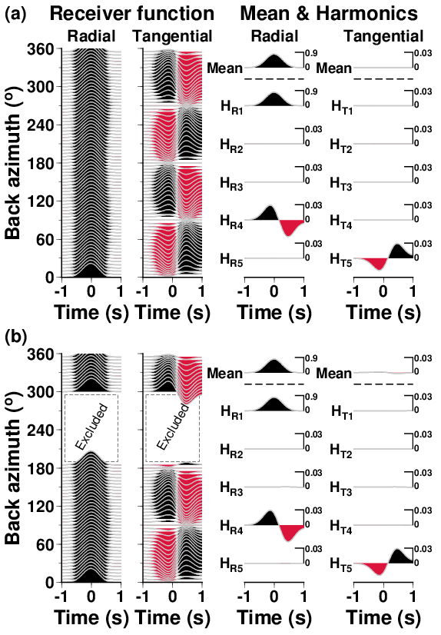
Figure S1. Synthetic test results showing means and five harmonic terms of both R- and T-RFs in the case of full (a) and poor (b) back-azimuthal coverage of earthquakes. We use the model with the 3 km-thick topmost anisotropic layer (Fig. 3d) to compute the R- and T-RFs (left panel), and their means and harmonic terms (right panel). The RF is sampled with an interval of 5° in back azimuth.
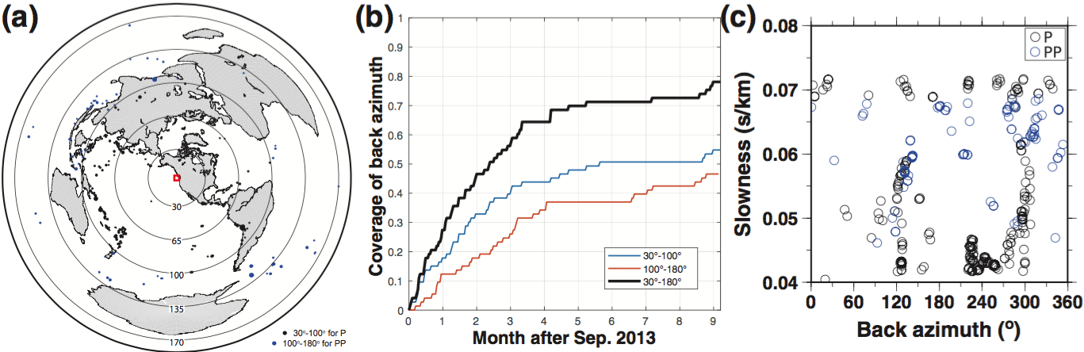
Figure S2. Distribution of teleseismic earthquakes in spatial and temporal scales, recorded from the OBS J61C (Cascadia Initiative; Toomey et al., 2014). (a) The numbers of earthquakes for P and PP phases are 276 and 95, respectively, in 2013−2014. The location of the station is indicated by a red rectangle. (b) Cumulative coverage in back-azimuth ray coverage for 9 months, discretized in 72 bins, after September 2013. (c) Distribution of the back azimuth and slowness of the earthquake in (b).

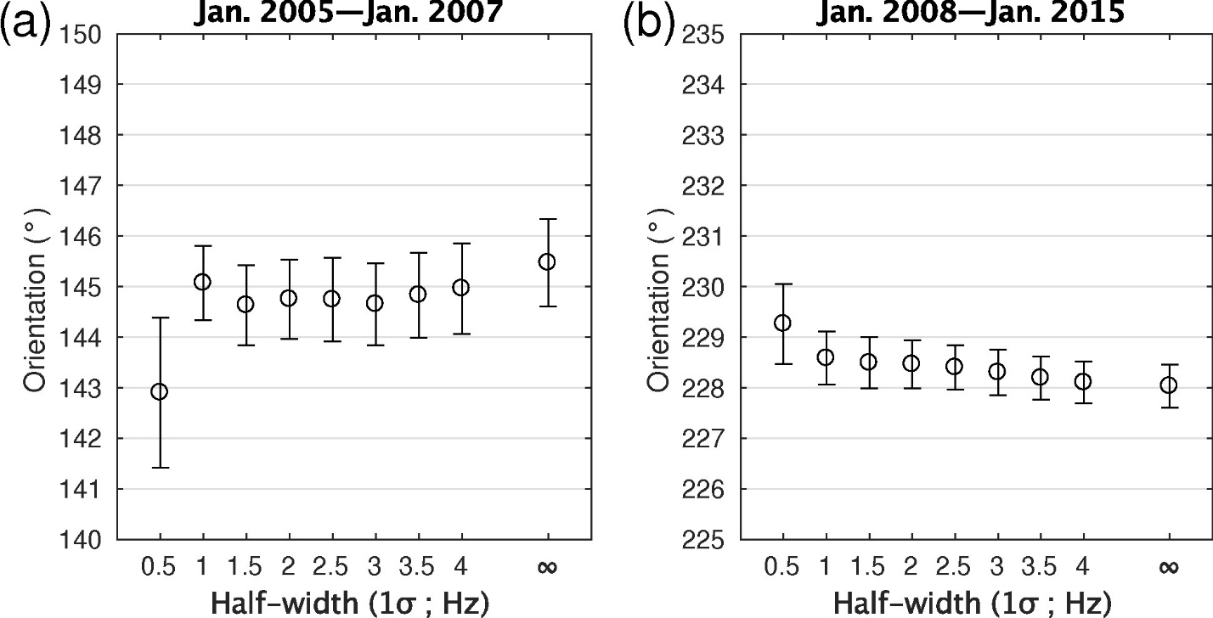
Figure S3. Orientation estimations using various half-widths in Gaussian lowpass filter for the station HSB. (a) Period of January 2005‒January 2007 and (b) period of January 2008‒January 2015. The infinity symbol means no filter.

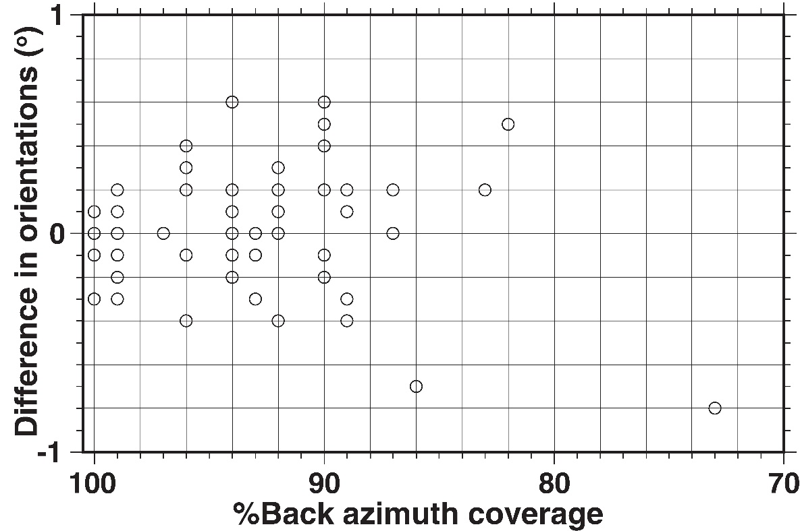
Figure S4. Difference between the orientation estimates from two methods, which are (1) the minimization of H_{T1} and (2) the minimization of the mean of T-RF near 0 s (Table S2). The stations SEHB, INCN⁰⁰ and KOHB are excluded in this figure because of large differences (2.3°, 7.6°, and 4.6°, respectively) in this figure.

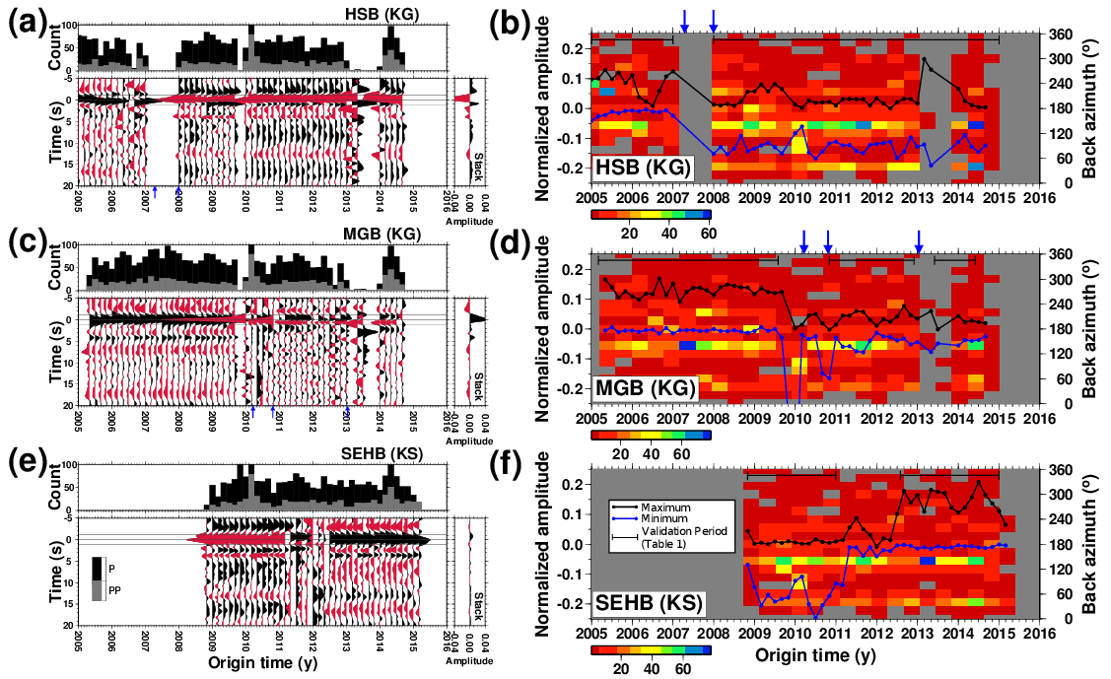
Figure S5. Stacked T-RFs and temporal change of their maximum and minimum amplitudes for stations HSB, MGB and SEHB. (a, c, and e) Stacked T-RFs (lower panel) and a histogram showing the number of earthquakes in each bin with a two-month window (upper panel) for stations HSB, MGB and SEHB. Blue arrows indicate reported replacement date of sensors (Table S1). (b, d, and f) Temporal change of the maximum and minimum amplitudes (black and blue lines, respectively) of the T-RFs within -1.2 to 1.2 s for stations HSB, MGB and SEHB. Colored background indicates the number of earthquakes in time and back azimuth. The fluctuation of either maximum or minimum amplitude can be partially explained by heterogeneous space-time occurrence of earthquakes. Gray background color means no data.

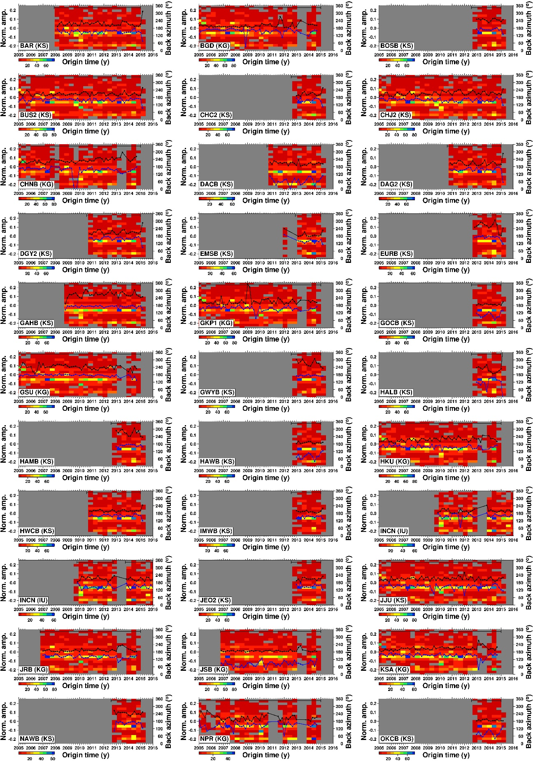
Figure. S6. (Continued)
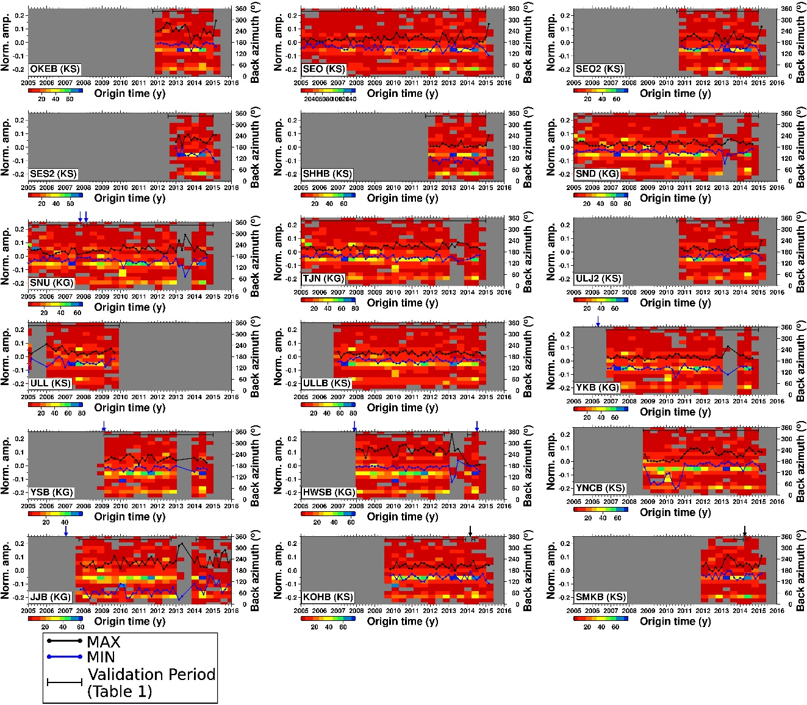
Figure S6. Temporal change of the maximum and minimum amplitudes (black and blue lines, respectively) of the T-RF within -1.2 to 1.2 s for 51 stations (including the station INCN ‘00’ and ‘10’). See Figs S5b, S5d and S5f for stations HSB, MGB and SEHB. Colored background indicates the number of earthquakes in time and back azimuth. A blue arrow indicates reported replacement date of a sensor (Table S1). The fluctuation of either maximum or minimum amplitude can be partially explained by heterogeneous space-time occurrence of earthquakes. Gray background color means no data.

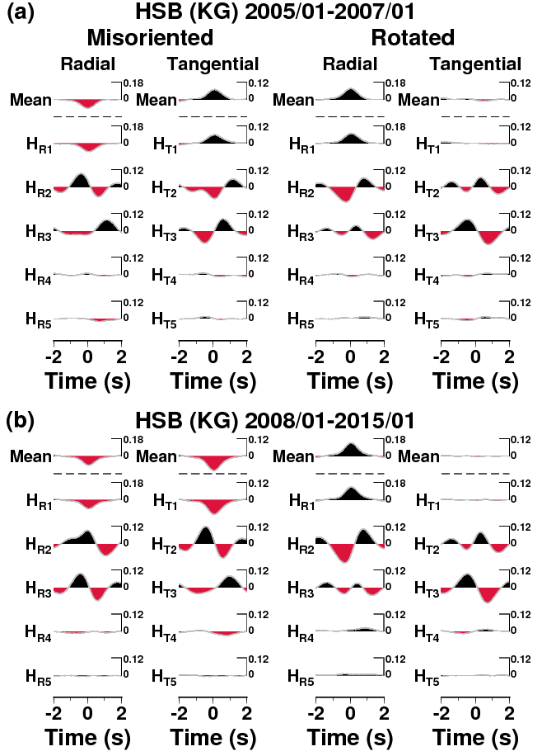
Figure S7. Harmonic terms of R- and T-RFs, and their means for the station HSB during the two different validation periods. In each panel, first two columns show the results prior to the correction, and the third and fourth columns after the correction.
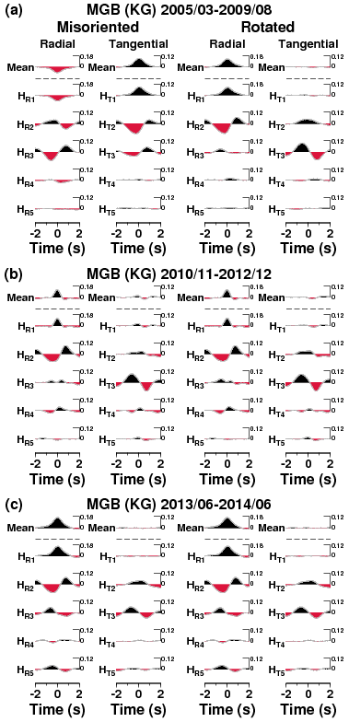
Figure S8. Harmonic terms of R- and T-RFs, and their means for the station MGB during the three different validation periods. In each panel, first two columns show the results prior to the correction, and the third and fourth columns after the correction.
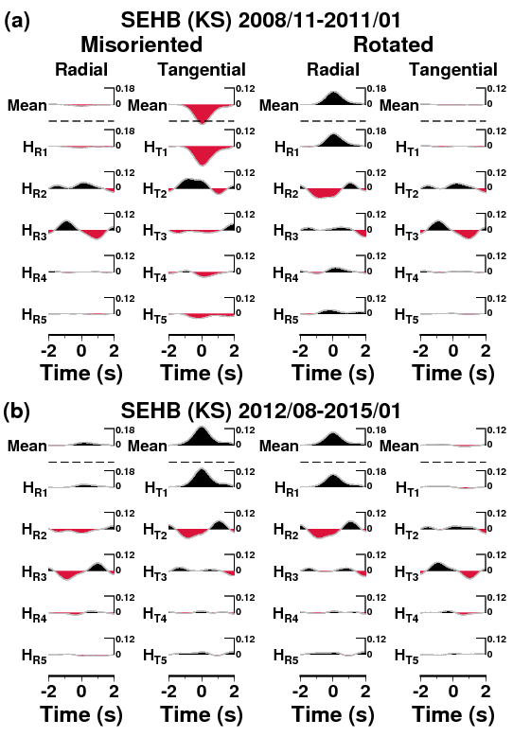
Figure S9. Harmonic terms of R- and T-RFs, and their means for the station SEHB during the two different validation periods. In each panel, first two columns show the results prior to the correction, and the third and fourth columns after the correction.

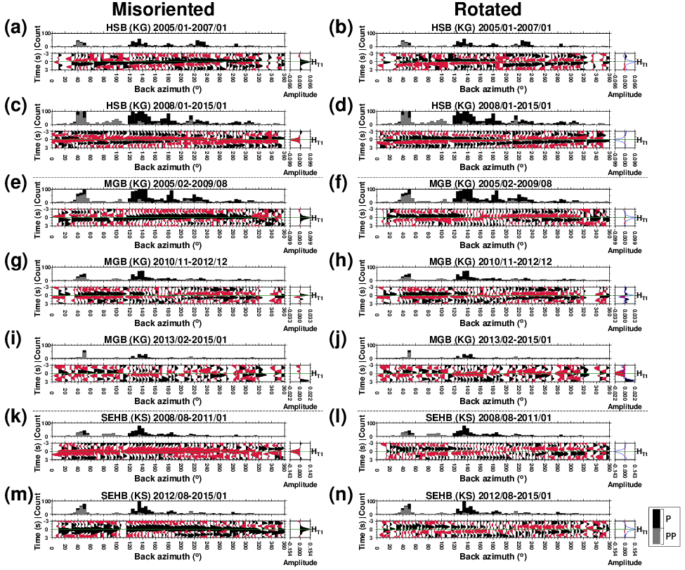
Figure S10. Stacked T-RFs plotted according to back azimuths for stations HSB, MGB and SEHB for each different validation period, prior to (a, c, e, g, i, k and m) and after the orientation correction (b, d, f, h, j, l and n). A solid green horizontal line marks a time of 0 s. The histogram in upper panel shows the number of earthquakes in each bin with a 5° window. The right panel shows a constant harmonic term of the T-RF (blue traces indicating not corrected waveforms).

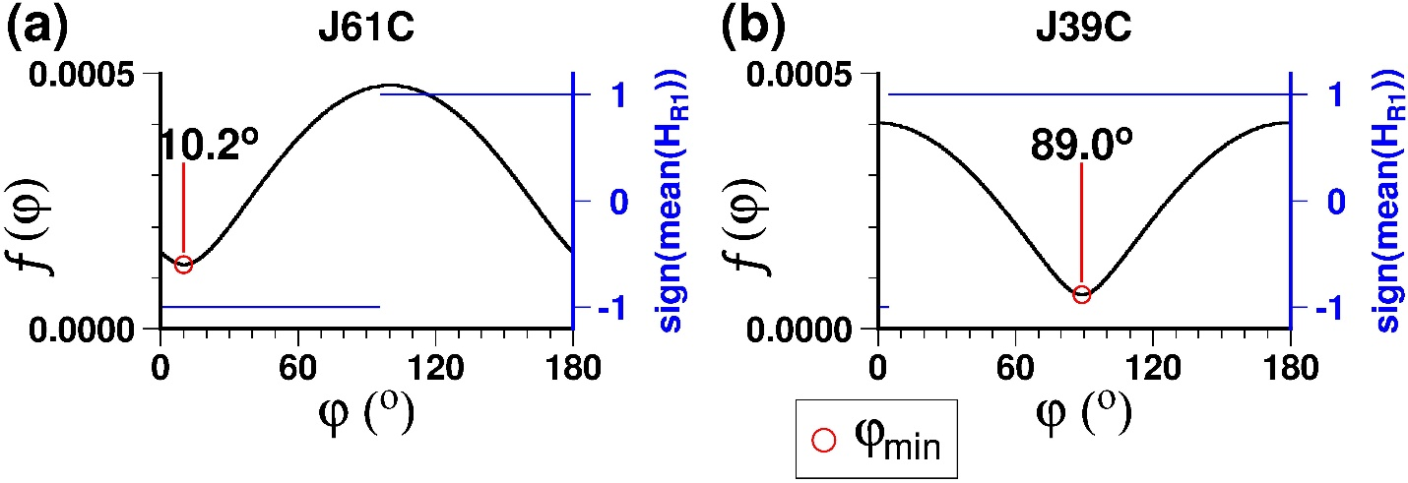
Figure S11. The function f (φ) for OBSs (a) J61C and (b) J39C plotted against φ. Note that the range of the function f (φ) is quite limited because of small amplitudes of the T-RFs at and near 0 s for the OBS data. Regardless of such small range in f (φ), the φ_{min} can be determined as shown in the figure.

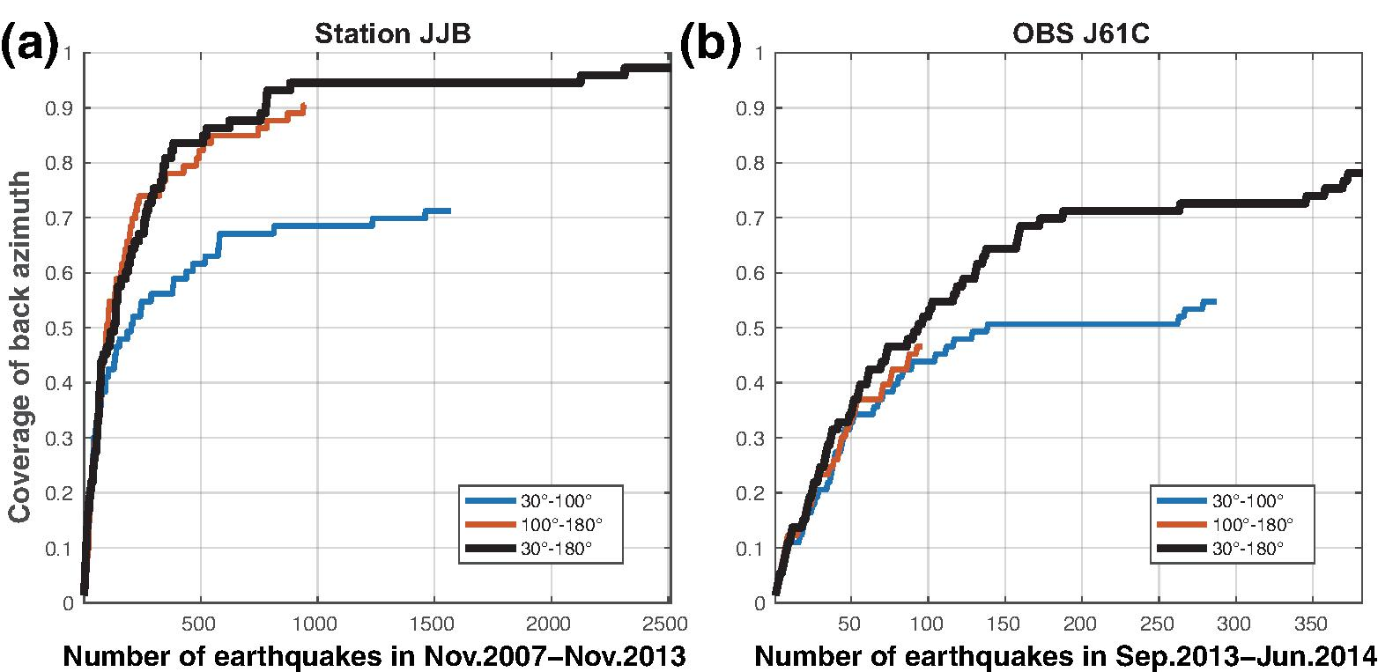
Figure S12. Back-azimuthal coverage plotted against the cumulative numbers of earthquakes for (a) the station JJB and (b) OBS J61C.

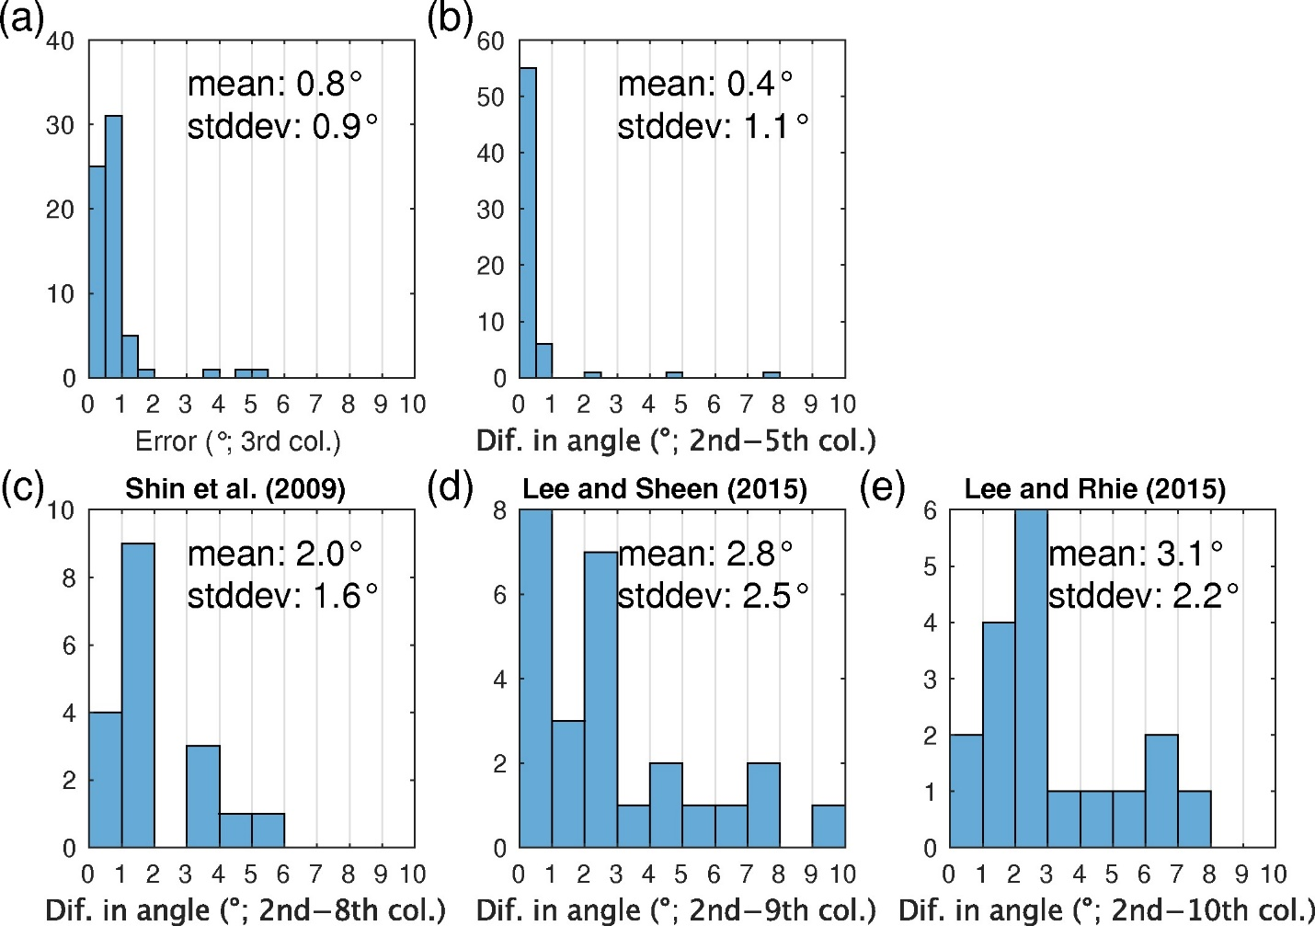
Figure S13. Histogram showing our uncertainties and differences in the orientation estimates shown in Table 1. (a) The error based on the bootstrapping method (the third column in Table 1). (b) Difference between the orientations determined by the minimization of H_{T1} (the second column) and the mean of T-RFs (the fifth column) (see also Fig. S4). Difference between ours (the second column) and previous estimates, (c) Shin et al. (2009) (the eighth column), (d) Lee & Sheen (2015) (the ninth column), (e) Lee & Rhie (2015) (the tenth column), respectively. The differences shown in (b), (c), (d), and (e) are root-mean-square values, and we exclude a few values which exceed 10°. Dif.‒difference; col. ‒column; stddev‒standard deviation.

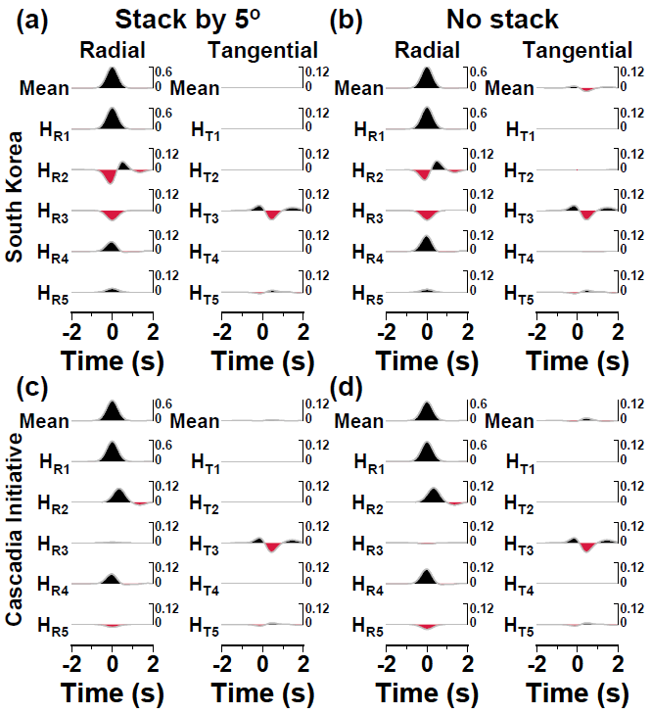
Figure S14. Synthetic test results showing means and harmonic terms of both R- and T-RFs in the cases of (a and b) for Korean seismic network and (c and d) the Cascadia Initiative when the RFs are stacked by 5°of bin in back azimuth (a and c) and not stacked (b and d).

