
Journal of Geophysical Research: Solid Earth
Supporting Information for
2017 Mw 5.5 Pohang earthquake, South Korea, and poroelastic stress change associated with fluid injection
Hobin Lim¹, Kai Deng², YoungHee Kim^{1*}, Jin-Han Ree³, Teh-Ru Alex Song⁴, Kwang-Hee Kim⁵

¹School of Earth and Environmental Sciences, Seoul National University, Seoul 08826, Republic of Korea
²College of Geophysics, Chengdu University of Technology, Sichuan 610059, China
³Department of Earth and Environmental Sciences, Korea University, Seoul 02841, Republic of Korea
⁴Department of Earth Sciences, University College London, Kathleen-Lonsdale Building, Gower Street, London WC1E 6BT, United Kingdom
⁵Department of Geological Science, Pusan National University, Busan 46241, Republic of Korea
*E-mail: younghkim@snu.ac.kr
Contents of this file

Figures S1 to S11
Table S1

Introduction
This supporting file includes 11 figures and 1 table. Figure S1 shows relation between the permeability and the hydraulic diffusivity (D). Figure S2 shows seismic station distribution in a map view with the station ID names. Figure S3 illustrates temporal changes in stresses and pore pressure when hydraulic diffusivities for the bedrock and fault damage zone are equal (D_{bed} = D_{dmz} = 1 × 10⁻² m²/s). Figure S4 is an another version of Figure 5 with different color scheme. Figure S5 shows temporal changes in stresses and pore pressure by injection at a single well or two wells (PX-1 and PX-2). Figure S6 shows hydraulic diffusivities for the bedrock and fault damage zone, reconciling the timing and location of the Mw 3.2 earthquake. Figure S7 shows the spatial distribution of stress changes and pore pressure change by the injection at the PX-1 and PX-2 when the impermeable fault core is included in the model. Figure S8 shows the spatial distribution of stress changes and pore pressure change by the injection at the PX-1 and PX-2 at different snapshots for the earthquake occurred on 15 April 2017. Figure S9 shows a timetable showing used seismic data. Table S1 shows hypocenteral locations determined in this study.
Appendix A includes two figures (Figures S10 and S11). Figure S10 shows one-dimensional velocity model used to locate the hypocenters. Figure S11 shows measured arrival times as a function of the epicentral distance for the Pohang earthquake.

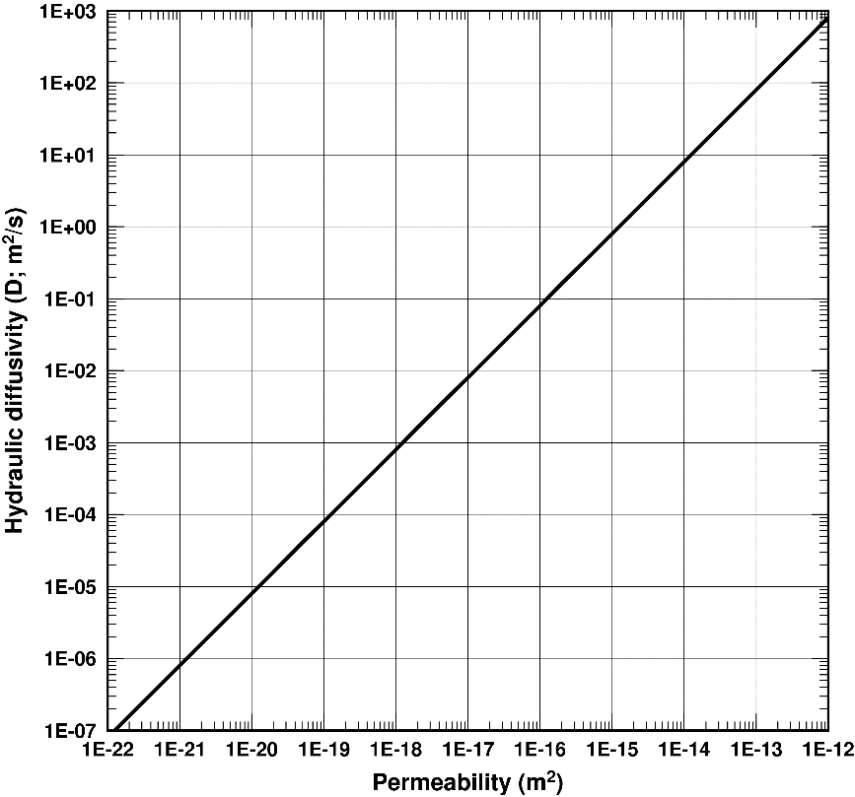
Figure S1. Relation between the permeability and the hydraulic diffusivity (D) based on Equation (3) and poroelastic parameters (Table 1).

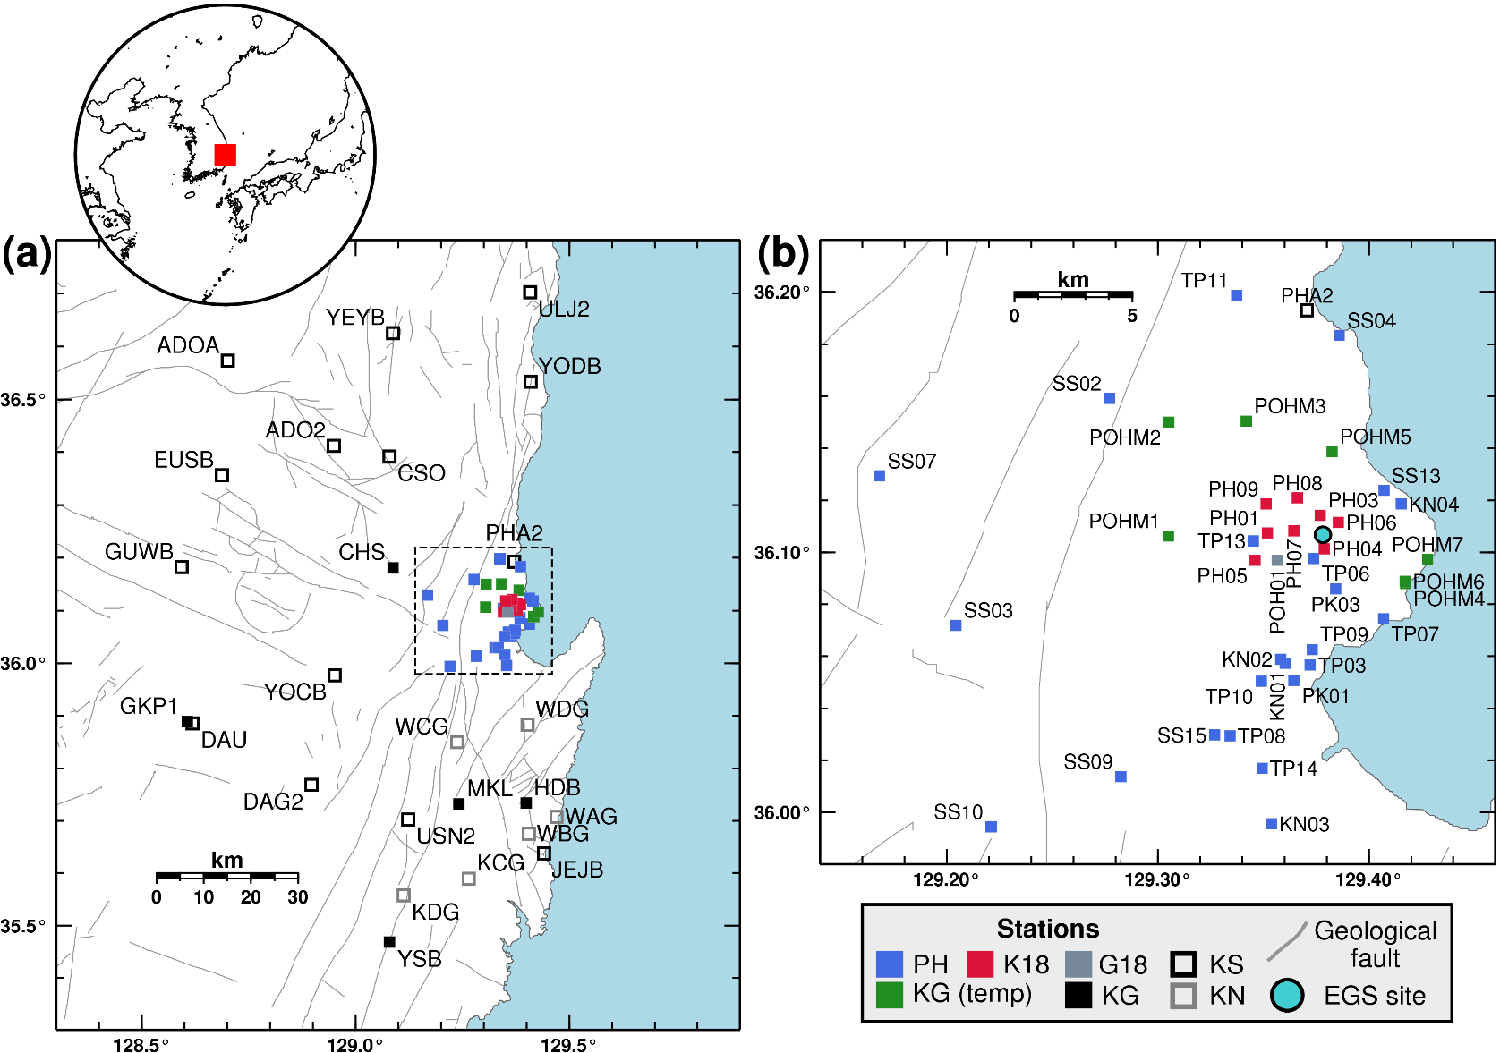
Figure S2. Map of the study region. (a) Map including all of the seismic stations used in the analysis with an inset showing East Asia. Networks KS, KG, and KN are deployed permanently, and PH, K18, G18, and KG (temp) are deployed temporarily for aftershock monitoring. The area enclosed in a dashed box is shown in (b), and gray lines represent faults. (b) Map showing the temporary stations and one permanent station PHA2. G18—Grigoli et al. (2018). K18—Kim et al. (2018). KG—Korea Institute of Geoscience and Mineral Resources. KS—Korea Meteorological Administration. KN—Korea Hydro & Nuclear Power Co., Ltd. PH—Seoul National University and Pukyong National University. EGS—Enhanced geothermal system.

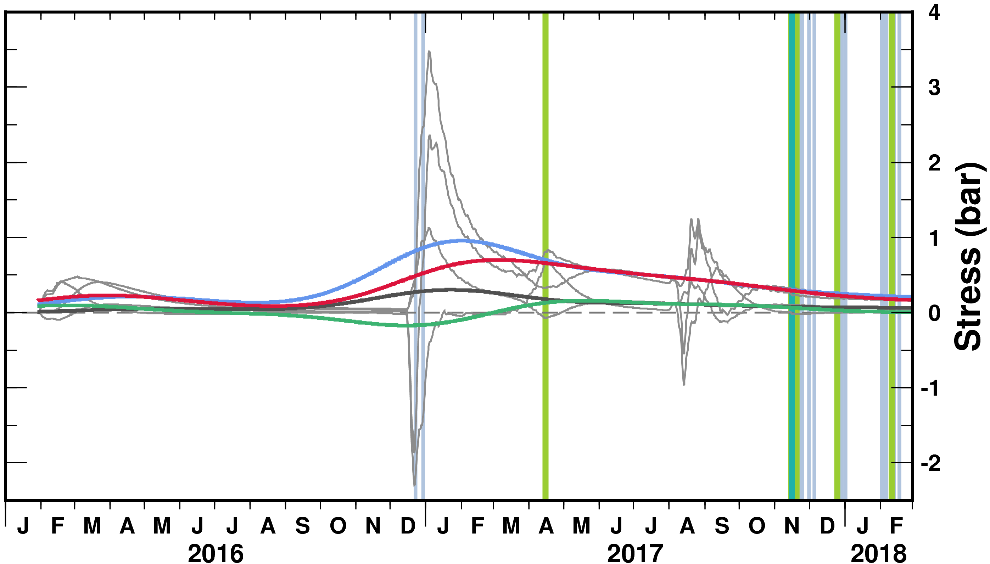
Figure S3. Similar to Figure 5. D_{bed} = D_{dmz} = 1 × 10⁻² m²/s.
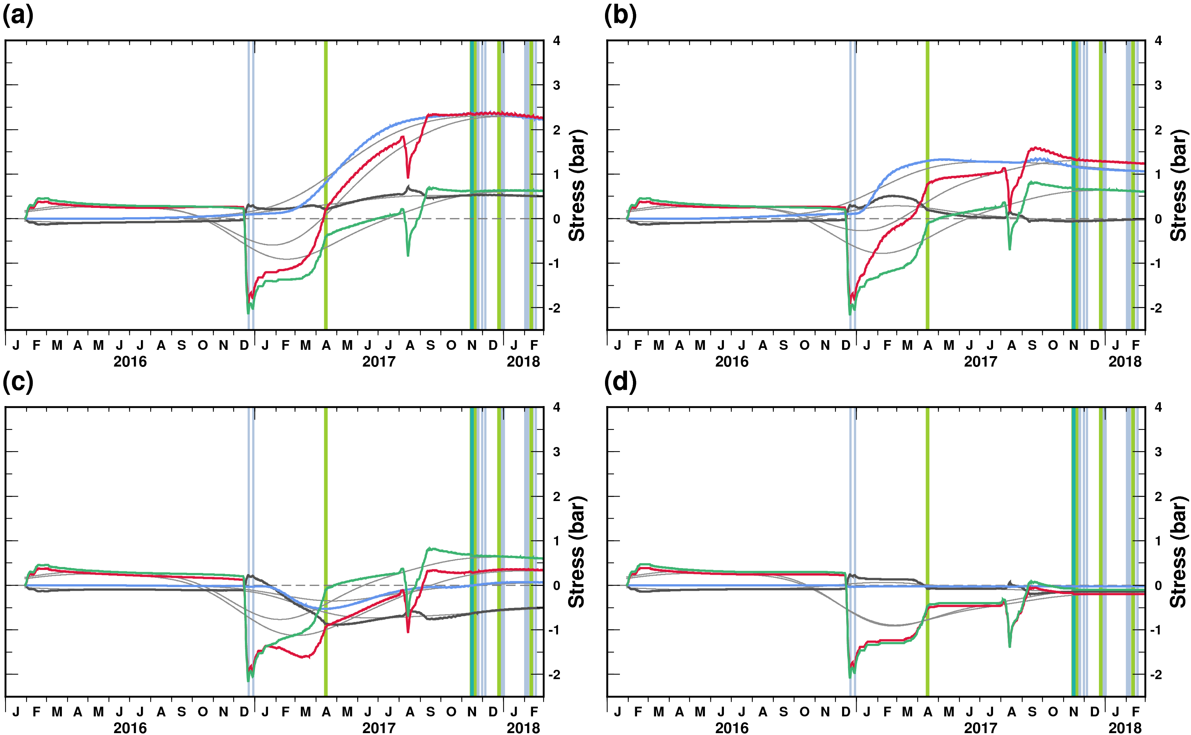
Figure S4. Same as Figure 5 but with different color scheme. Unfiltered stresses and pore pressure are shown in colors and filtered ones in grey.
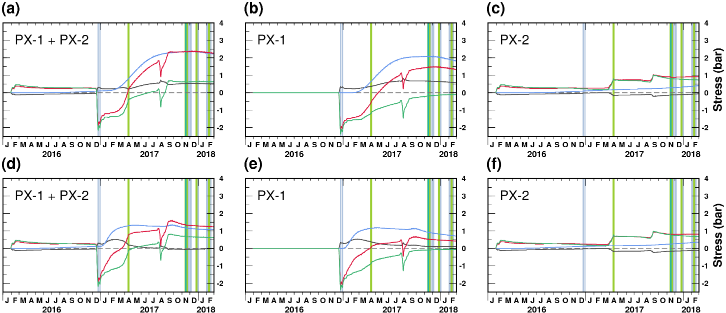
Figure S5. Changes in stresses and pore pressure by injection at the wells. Gaussian filter is not applied. (a–c) Results from the homogeneous model (D_{bed} = D_{dmz} = 5 × 10⁻⁴ m²/s). The stress changes and pore pressure change in (a) are same with those shown in Figure 5a (grey lines) and Figure S4a (colored lines). The stress changes and pore pressure change due to the injection at PX-1 and PX-2 are shown in (b) and (c), respectively. (d–f) Results from the model including a permeable fault damage zone. D_{bed} = 5 × 10⁻⁴ m²/s and D_{dmz} = 1 × 10⁻² m²/s. The stress changes and pore pressure change in (d) are same with those shown in Figure 5b (grey lines) and Figure S4b (colored lines). The stress changes and pore pressure change due to the injection at PX-1 and PX-2 are shown in (e) and (f), respectively. See also a caption of Figure 5.
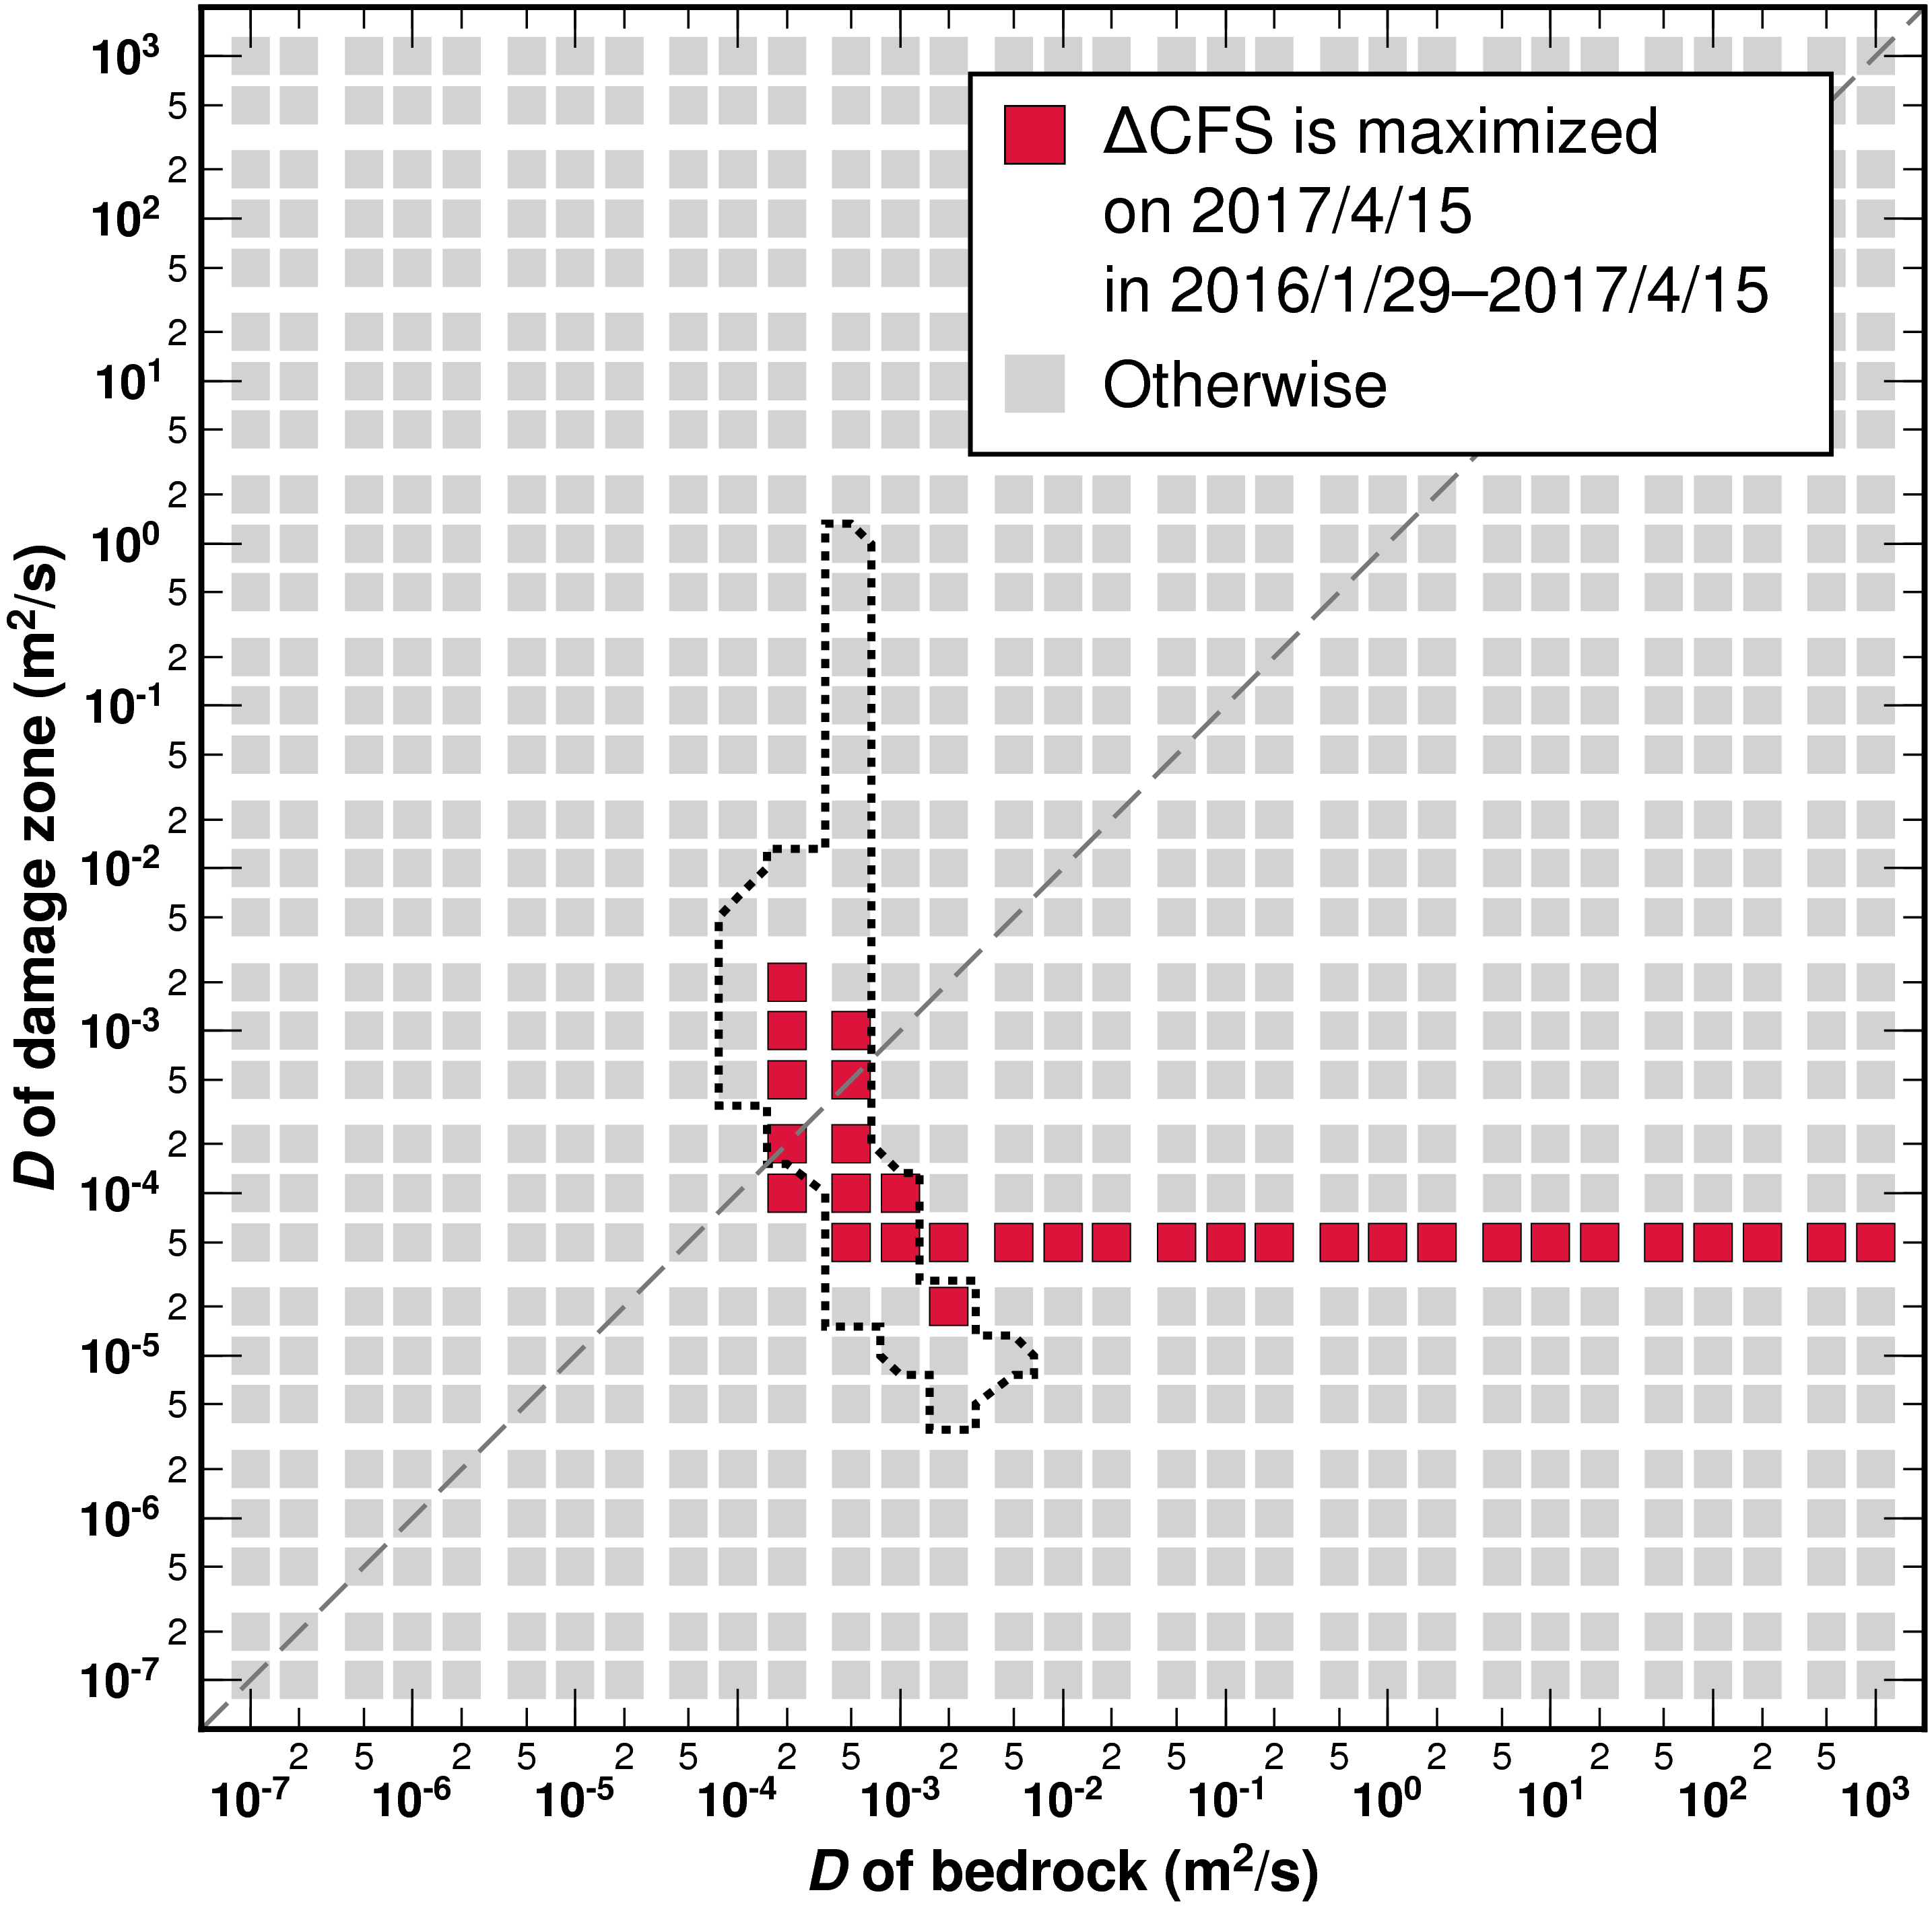
Figure S6. The ranges of hydraulic diffusivities for the fault damage zone and bedrock, D_{dmz} and D_{bed} respectively, that satisfy the criteria for the Coulomb stress change (ΔCFS) amplitude at the time of the Mw 3.2 earthquake on 15 April 2017. See a caption of Figure 7 for detailed information. Dotted line indicates the red square zone in Figure 7.
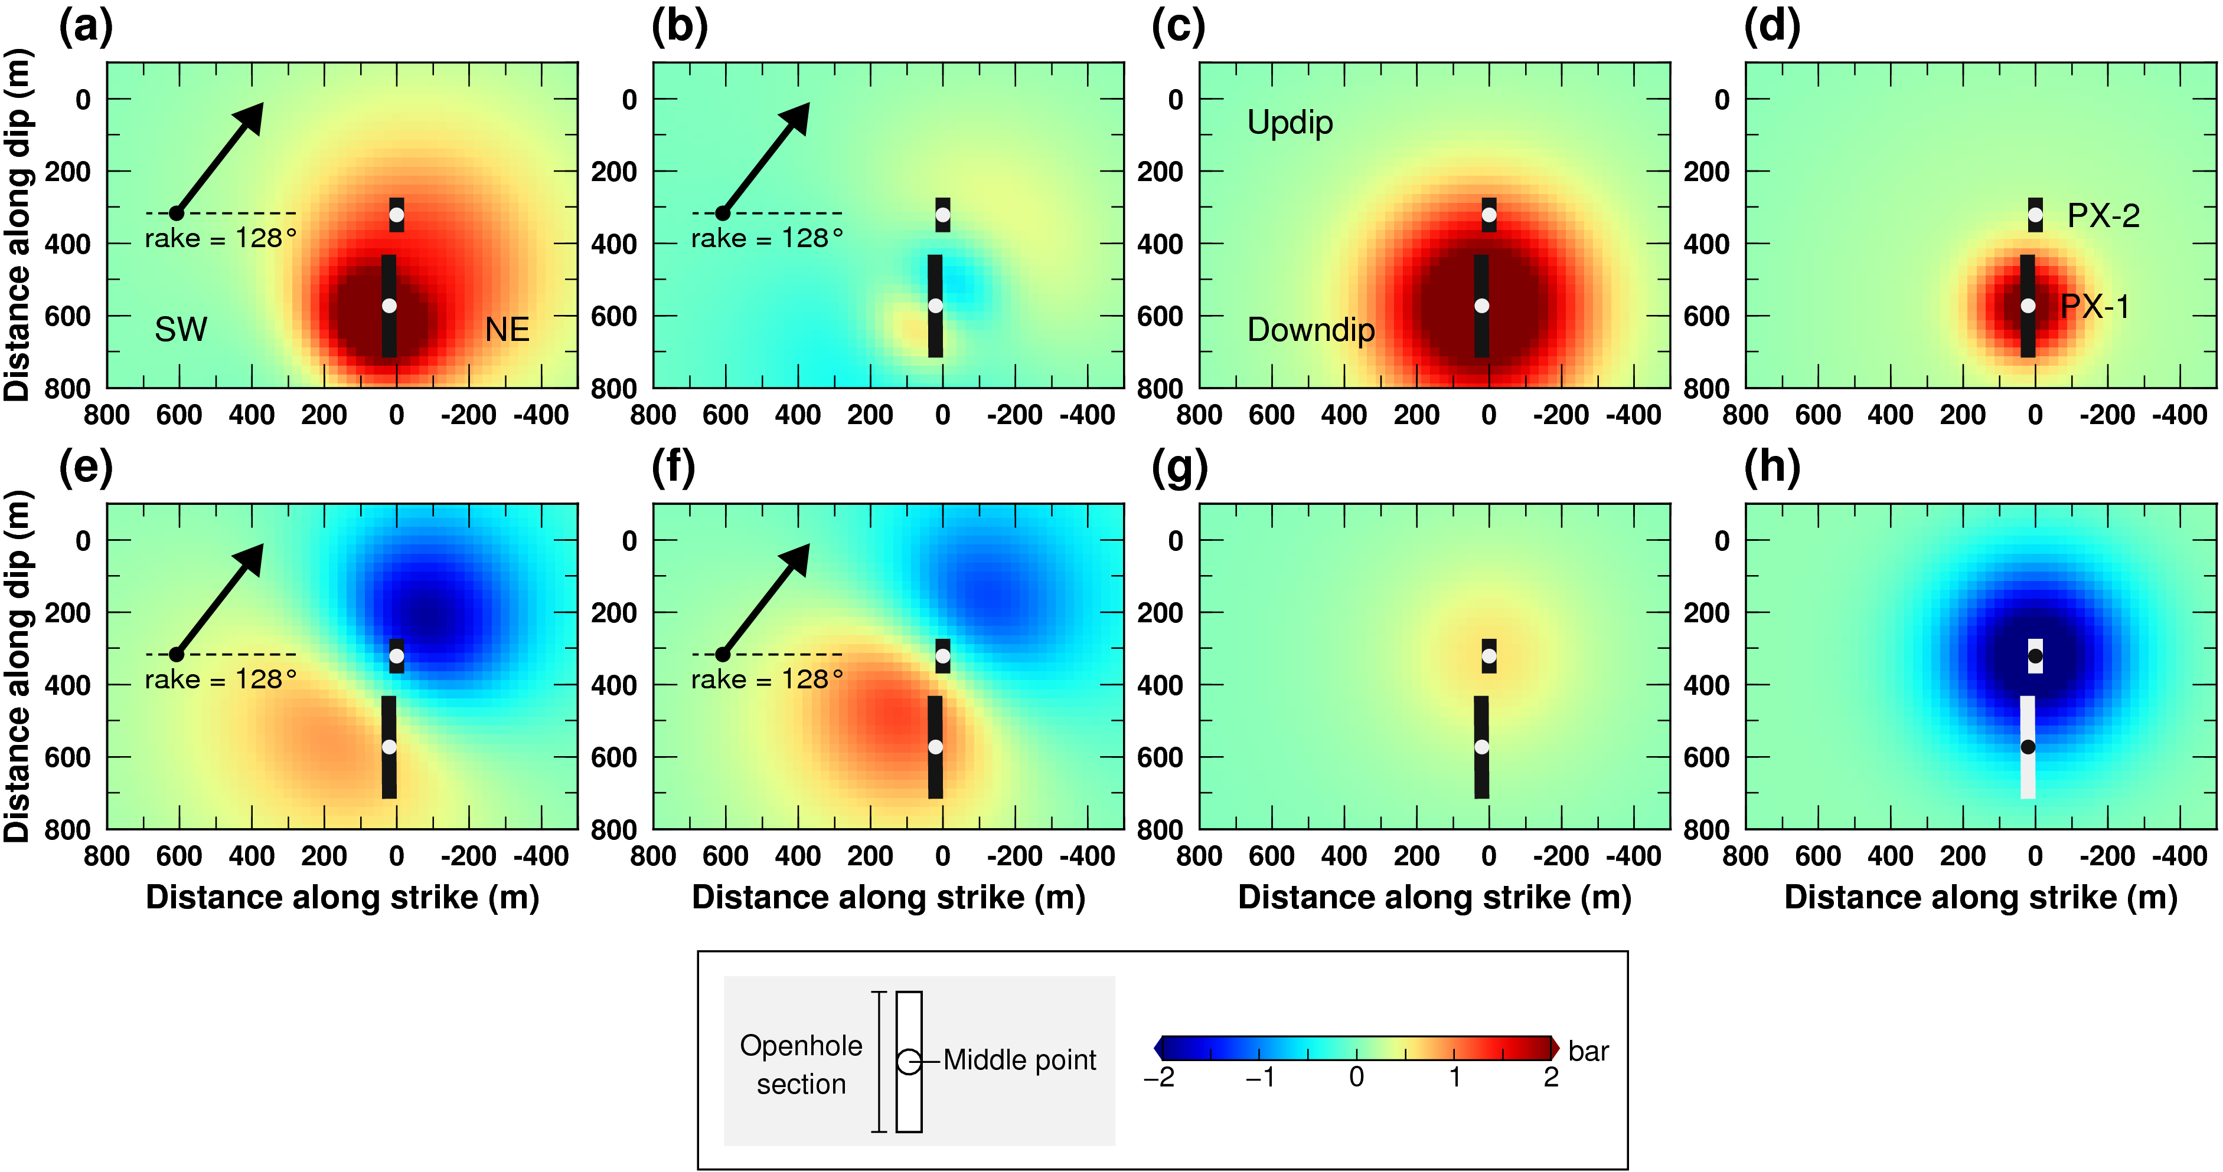
Figure S7. Stress changes and pore pressure change sampled along the fault plane on 15 November 2017, computed with the impermeable core model (Figure 9b). (a) ΔCFS by the PX-1. (b) Δτ by the PX-1. (c) Δp by the PX-1. (d) Δσ_{n} by the PX-1. (e) ΔCFS by the PX-2. (f) Δτ by the PX-2. (g) Δp by the PX-2. (h) Δσ_{n} by the PX-2.
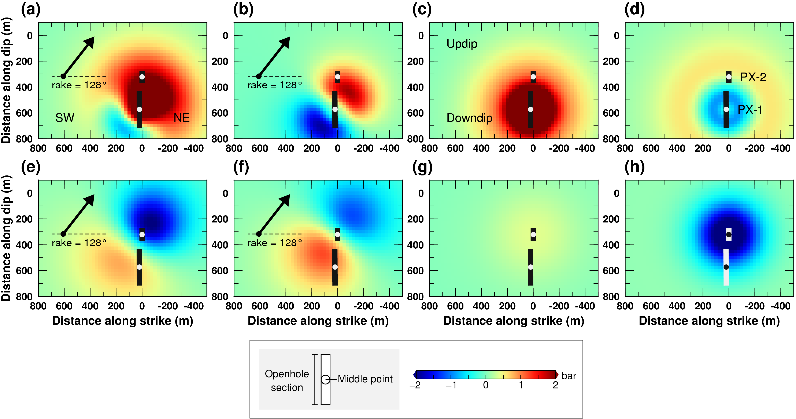
Figure S8. Stress changes and pore pressure change sampled along the fault plane on 15 April 2017, computed (Figure 11b). (a) ΔCFS by the PX-1. (b) Δτ by the PX-1. (c) Δp by the PX-1. (d) Δσ_{n} by the PX-1. (e) ΔCFS by the PX-2. (f) Δτ by the PX-2. (g) Δp by the PX-2. (h) Δσ_{n} by the PX-2.

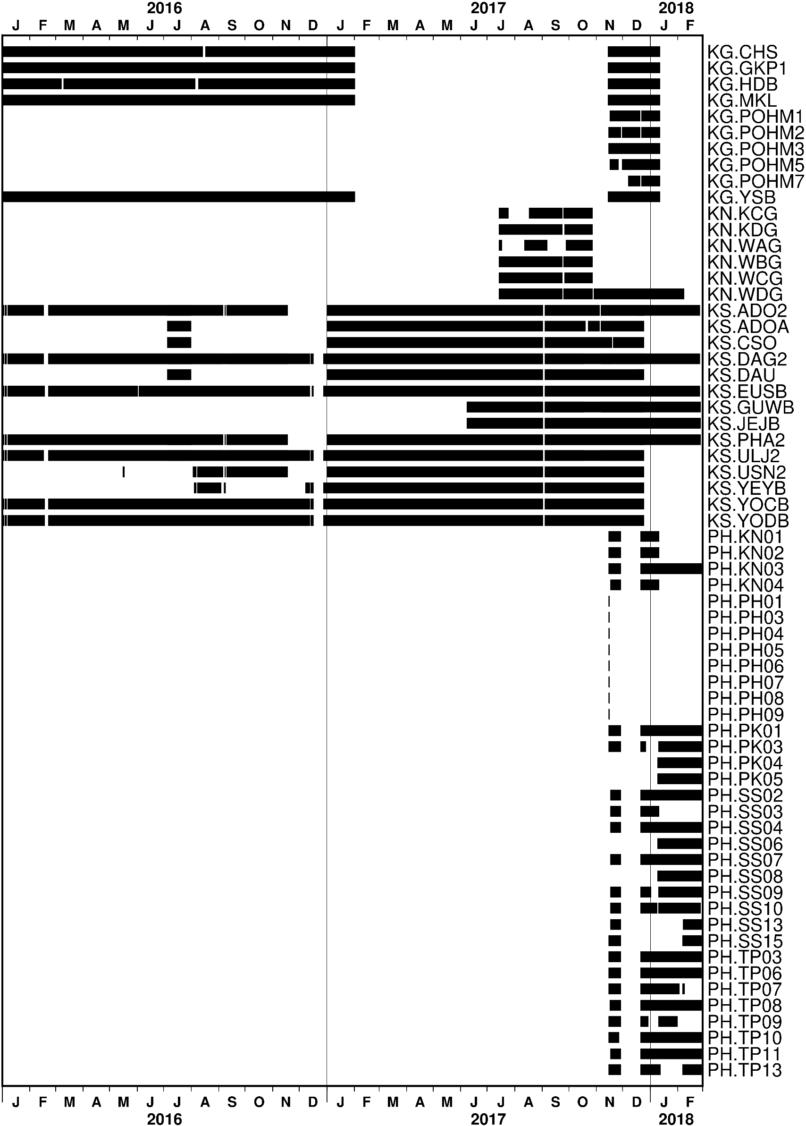
Figure S9. Timetable showing used seismic data in this study. The text on the right hand side shows the names of network and station in format of “network.station”. See Figures 1 and S2 for the station locations in a map view.
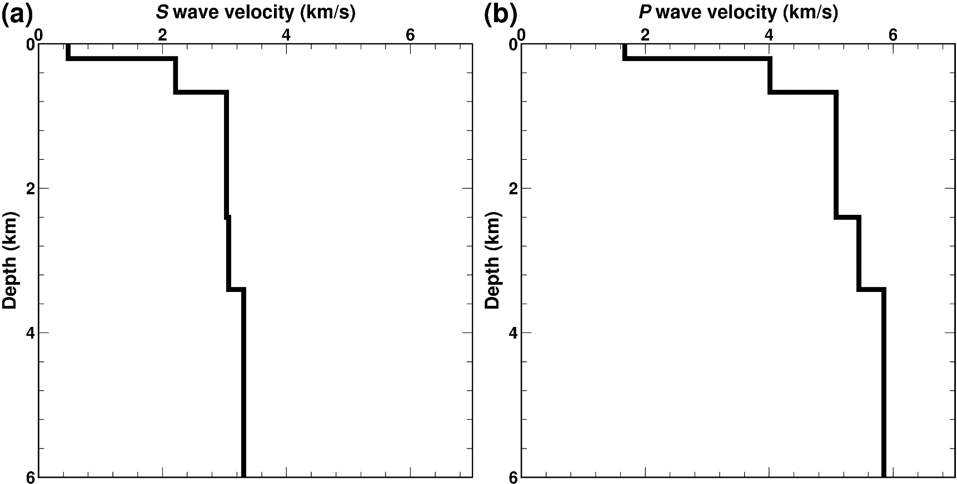

Figure S10. The one-dimensional velocity model used to locate hypocenters. (a) S wave velocity model. (b) P wave velocity model. The model is taken from Table 5-1 of Korean Government Commission (2019).
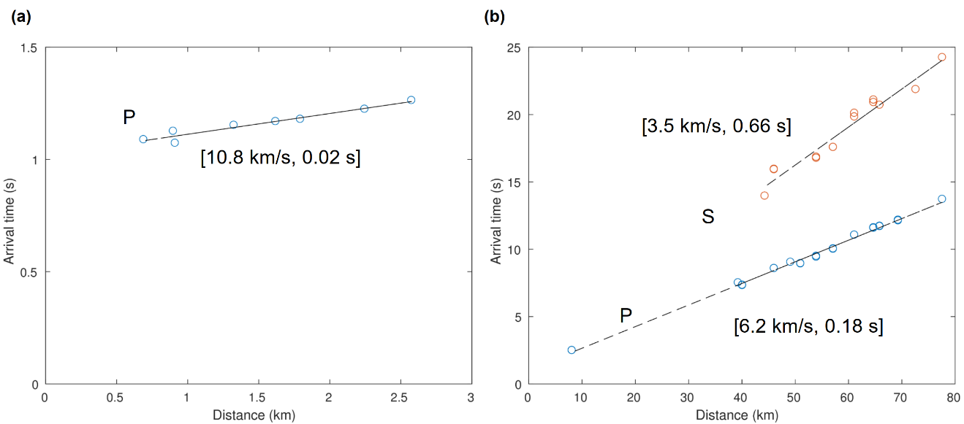
Figure S11. Measured arrival times as a function of the epicentral distance for the Pohang earthquake. (a) P waves measured at the stations close to the epicenter (K18 and G18; see Figures 1 or S2 for station network location). (b) P and S waves measured at distant stations. Slope of the fitted line and standard deviation of difference between the measured arrival time and the fitted line are shown inside the bracket.

Table S1. Hypocenter and uncertainty determined in this study. See a separate file for a content. ev_id—event id. sd—standard deviation (1σ). K18—Kim et al. (2018). W19—Woo et al. (2019).
References
Grigoli, F., Cesca, S., Rinaldi, A. P., Manconi, A., López-Comino, J. A., Clinton, J. F., et al. (2018). The November 2017 M w 5.5 Pohang earthquake: A possible case of induced seismicity in South Korea. Science, 360(6392), 1003–1006. https://doi.org/10.1126/science.aat2010
Kim, K.-H., Ree, J.-H., Kim, Y., Kim, S., Kang, S. Y., & Seo, W. (2018). Assessing whether the 2017 M w 5.4 Pohang earthquake in South Korea was an induced event. Science, 360(6392), 1007–1009. https://doi.org/10.1126/science.aat6081
Korean Government Commission (2019). Final Report of the Korean Government Commission on Relations between the 2017 Pohang Earthquake and EGS Project. The Geological Society of Korea. http://doi.org/10.22719/KETEP-2019043001 (mixed in Korean and English)
Woo, J. ‐U., Kim, M., Sheen, D. ‐H., Kang, T. ‐S., Rhie, J., Grigoli, F., et al. (2019). An In‐Depth Seismological Analysis Revealing a Causal Link Between the 2017 MW 5.5 Pohang Earthquake and EGS Project. Journal of Geophysical Research: Solid Earth, 2019JB018368. https://doi.org/10.1029/2019JB018368

