Name __Jeff Crawford________ Mark _____________________/50

## Brief introduction __/3

My features include the invisible walls and HUD also known as a score board.

## Use case diagram with scenario __14

### Use Case Diagram

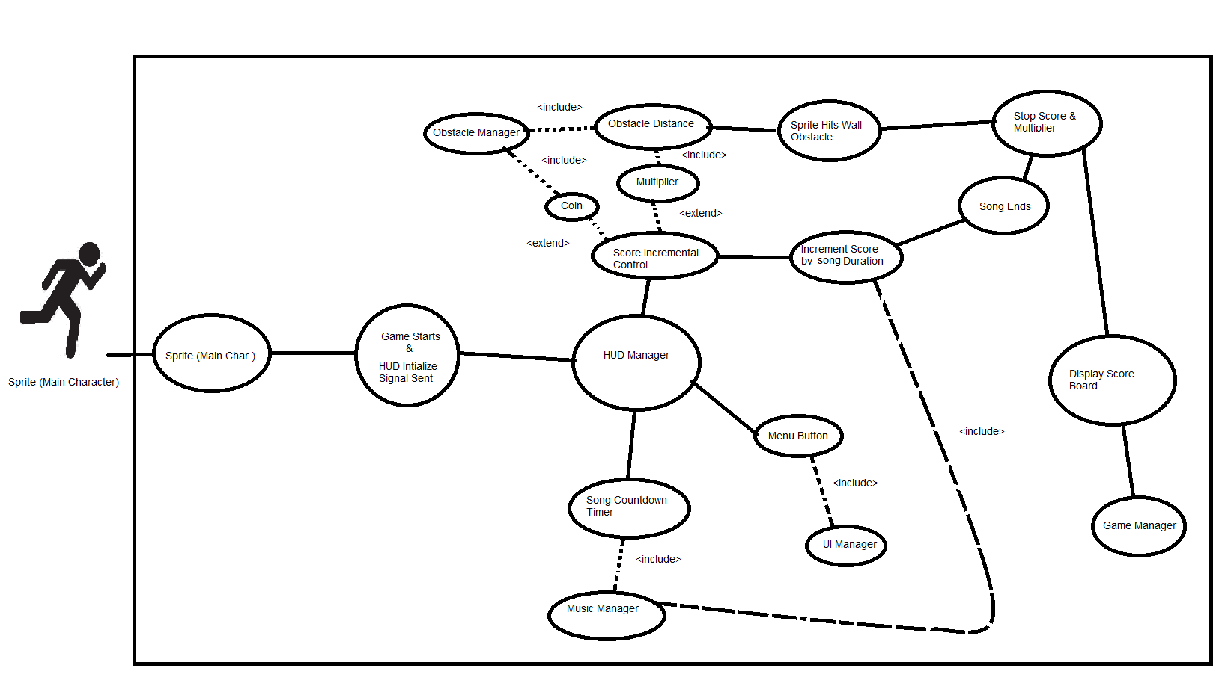

### Scenarios

**Name:** Sprite interaction with HUD

**Summary:** Sprite will continuously run which will tell the HUD from the Game Manager score to stay active by continuously increasing. When the sprite hits an obstacle the game ends and a score ranking is then displayed. The player is then given the option to end the game or restart.

**Actors:** Player & Sprite

**Preconditions:** The Game must be launched.

**Basic sequence:**

**Step 1:** Play button Pressed

**Step 2:** Score Initialized to Zeroes.

**Step 3:** Multiplier Initialized to Zero.

**Step 4:** Song Clock Timer Initialized

**Step 5:** Menu Button Initialized & displayed

**Step 6:** Display Score & Song Duration

**Step 7:** Score increases by song duration

**Step 8:** Multiplier increases dependent on Obstacle Distance to Sprite

**Step 9:** Sprite touches Obstacle or Song Ends

**Step 10:** Score & Multiplier Stop

**Step 11:** Record Score & compare to top scores

**Step 12:** Display Score Rank & pass control to Game Process

**Exceptions:** Sprite Touches Coin

**Step 1:** Increment Score by a predetermined value

**Post conditions:** Game Manager Takes Over

**Priority:** Nice to Have

**ID:** 3

*The priorities are 1 = must have, 2 = essential, 3 = nice to have.

## Data Flow diagram(s) from Level 0 to process description for your feature _______14

### Data Flow Diagrams

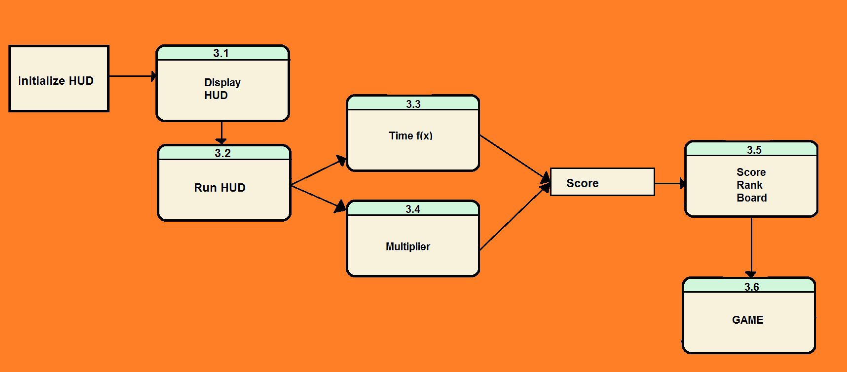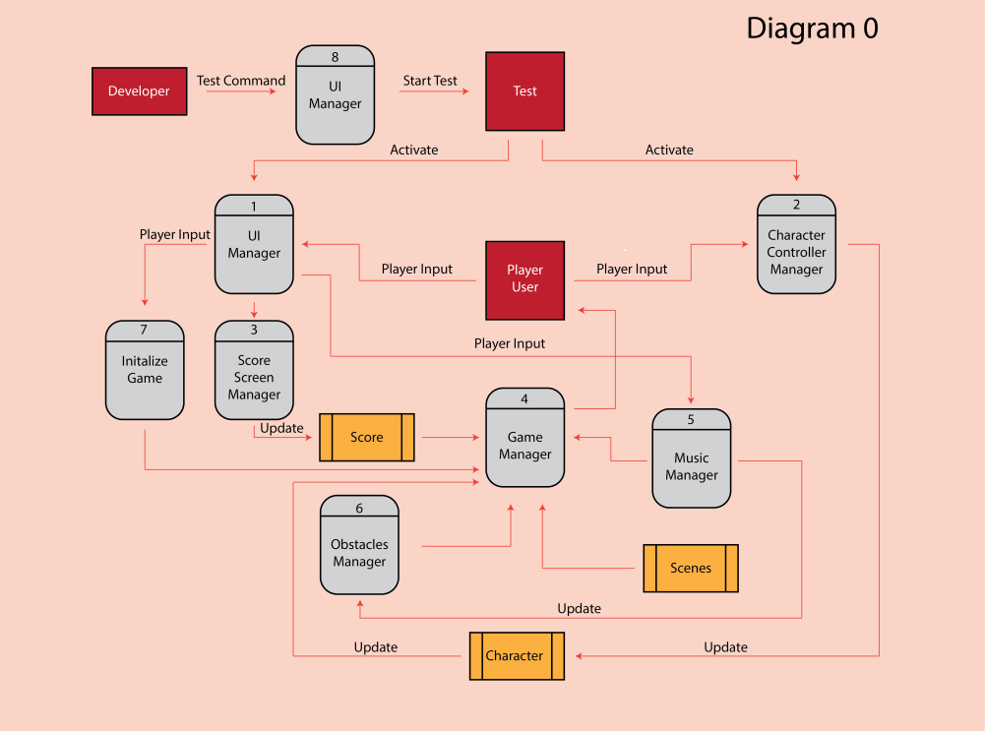

### Process Descriptions

**Display HUD**: Generation, placement coordinates of the HUD where it needs to be at the top of screen.

**Run Hud**: Starts the timer and reads input from UI Manager for what the game is doing.

**Time f(x)**: In Charge of the start, stop and reset functionality of the time which outputs the seconds into the score.

**Multiplier**: Keeps track of the scope multiplier that is sent to the score box continuously.

**Score Rank Board**: Will display the top scores for the game.

**Game**: After scoreboard produced at the end of the game it will return back to the Game process.

## Acceptance Tests ________9

**Invisible Walls**: After setting up the walls with physics parameters move the sprite (Character) Left, Right and Down to see if it will go beyond the boundaries set forth.

**HUD (Heads up Display)**: Will be reading input from Game Manager, Clock f(x) for score & display score along with high score for direct comparison.

* As the Clock F(x) starts will look to see the score displayed increases as time elapse.
* Game Manager will tell HUD where the sprite is in regard to passing obstacles and whether or not the sprit has hit an obstacle.
  + If obstacle is touched score stops & clock stops.
  + If passed obstacle score gains a predetermined point bonus which is displayed temporarily below score board, after which will fade into the background.
* Multiplier displayed next to score. When increase should reflect a direct correlation with the score itself and change the color font of score to reflect current multiplier bonus.

## Timeline _________/10

### Work items

|  |  |  |
| --- | --- | --- |
| Task | Duration (PWks) | Predecessor Task(s) |
| 1. Requirements Collection | 10 | - |
| 2. Invisible Wall Generation | 3 | 1 |
| 3. HUD Overlay | 5 | 1 |
| 4. Score Manipulation | 10 | 3 |
| 5. Score Management | 10 | 3 |
| 6. Programming | 20 | 2,3,4,5 |
| 7. Testing | 5 | 6 |
| 8. Installation | 5 | 7 |

### Pert diagram

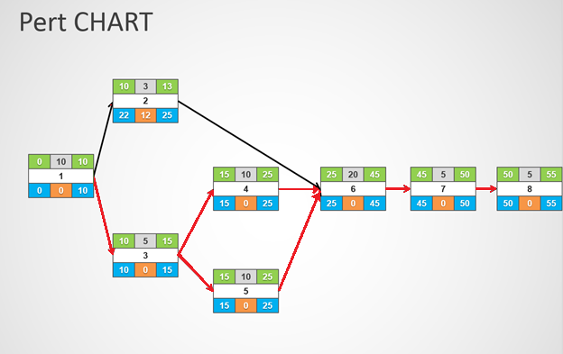

### Gantt timeline

|  |  |  |  |  |  |  |  |  |  |  |  |  |  |  |  |  |  |  |  |  |  |  |  |  |
| --- | --- | --- | --- | --- | --- | --- | --- | --- | --- | --- | --- | --- | --- | --- | --- | --- | --- | --- | --- | --- | --- | --- | --- | --- |
| 1 |  |  |  |  |  |  |  |  |  |  |  |  |  |  |  |  |  |  |  |  |  |  |  |  |
| 2 |  |  |  |  |  |  |  |  |  |  |  |  |  |  |  |  |  |  |  |  |  |  |  |  |
| 3 |  |  |  |  |  |  |  |  |  |  |  |  |  |  |  |  |  |  |  |  |  |  |  |  |
| 4 |  |  |  |  |  |  |  |  |  |  |  |  |  |  |  |  |  |  |  |  |  |  |  |  |
| 5 |  |  |  |  |  |  |  |  |  |  |  |  |  |  |  |  |  |  |  |  |  |  |  |  |
| 6 |  |  |  |  |  |  |  |  |  |  |  |  |  |  |  |  |  |  |  |  |  |  |  |  |
| 7 |  |  |  |  |  |  |  |  |  |  |  |  |  |  |  |  |  |  |  |  |  |  |  |  |
| 8 |  |  |  |  |  |  |  |  |  |  |  |  |  |  |  |  |  |  |  |  |  |  |  |  |
|  | 5 | 10 | 15 | 20 | 25 | 30 | 35 | 40 | 45 | 50 | 55 | 60 | 65 | 70 | 75 | 80 | 85 | 90 | 95 | 100 | 105 | 110 | 115 | 120 |