**Assignment 2- Proposal ePortfolio Site**

**Matthew Lowe**

**Part I**

**Purpose Statement**- Create a professional quality ePortfolio for Joe Jaguar to “highlight his skills and accomplishments.” This will allow his peers and potential employers to learn more about Joe’s projects, and possibly provide a starting point for interviews. For example, “I saw in your ePortfolio you’ve done A B C, that’s very similar to what we do here at Company, Inc.”

**Objectives**

1. A professional representation of Joe and his accomplishments
2. A streamlined layout to make it easy to find an arbitrary piece of information
3. A minimalistic graphic style as to not distract or turn off readers
4. Prioritize accessibility; a light mode and dark mode, large font option, and captioned photos might be suitable
5. Stay with the times: mobile accessibility and avoiding outdated web elements, such as Adobe Flash, are critical
6. Leave room for the site to grow as Joe continues his studies and pursues careers

**Competitor Sites**- 3 Good student ePortfolio sites

Competitor 1: PortfolioGen.com

According to their website, PortfolioGen has over 136,000 users across 110 countries. It also claims to have intuitive features, such as embedding photos and a messaging system to talk to other people on the website. However, pricing for one person is not clear, and an employer not on PortfolioGen might have difficulty contacting someone on PortfolioGen due to the paywall.

Competitor 2: Weebly.com

Weebly.com is service to create free websites for almost any purpose, provided you’re willing to have the phrase “weebly” in the URL. The widespread use would make it very easy to build your own layout from scratch, instead of being forced to choose from a handful of templates. According to their page on making online portfolios, features such as “remove Weelby branding” and “search engine indexing” are available with monthly subscriptions. Weebly is also not dedicated to eportfolios, which means it might carry a negative reputation with some people. On the digital bookshelf, your portfolio might be next to a conspiracy website and a front for buying drugs.

Competitor 3: Foliospaces.org

Their website proudly displays “Free ePortfolios since 2008” as the first heading. It looks like a very simplistic service, based on the minimalist front page. This might be ideal for some users, who struggle when faced with a mountain of different styles and layouts. However, this may be a turn off for other users who become frustrated from a lack of options. Artists may especially feel this, wanting to design their ePortfolio to be a work itself.

**Advantage** - Lowe and Co. Design (LCD) will put the website’s user in the driver seat. The only limits or “templates” are their imagination. To compete with large user bases like that of PortfolioGen, LCD can provide seamless integration with LinkedIn, YouTube, Flickr, or any other website the user hosts their work on. Pricing will be determined by the hours involved in first creating the website, and a dynamic hosting fee determined by the website’s traffic. Users with poor traffic, such as a fall in demand for their prospective field, should not be punished with flat hosting fees. Finally, LCD strives for accessibility to all website visitors. Mobile users, visually impaired, or those with slow connections will still be able to browse.

**Target Audience** - Joe wants the ePortfolio to showcase his work to future employers and his peers. Based on Joe’s involvement in robotics and the Industrial Advisory Committee, it’s reasonable to assume that Joe will apply at a STEM focused company and have friends in similar majors. Joe also noted a love for music and college spirit. This could mean potential visitors looking into Joe’s music or contacting him about an upcoming college event.

**Demographics** - Using the assumptions above, we’ve come up with three likely groups that will visit Joe’s ePortfolio. They are presented in order of importance and likely traffic flow.

1. Employers, likely from STEM based companies or university departments. Depending on the nature of the job, a number of these employers might be Indianapolis or Indiana based. They’ll understand technical languages and projects, and will likely be looking for this to gauge Joe’s skills in that field.
2. Peers from school, likely in STEM majors. This largely reflects the previous groups, but most viewers from this group will be around 18 to 25 years old. Many of them will also be from Indianapolis or Indiana.
3. People interested in Joe’s talent in music, hiking, or college spirit. None of these topics were part of the Joe’s main goal behind the ePortfolio, but he did mention he was very passionate about them. He might want to include a few of these points for personalization.

**Part II**—Diagram of the Site-Use Word or any diagram program and paste it into your proposal. Should include all information in Objectives.

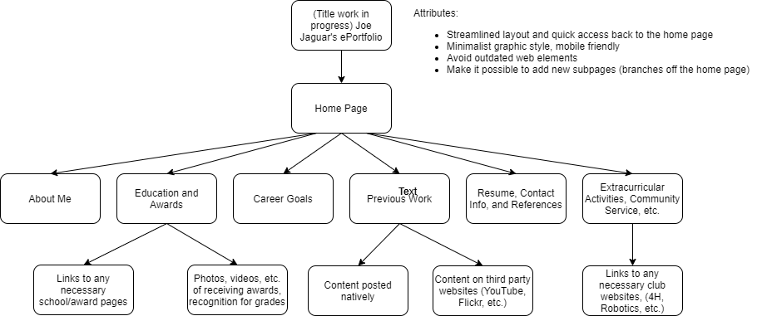

**Part III—Wire Frames—**2 different layouts of Home pagepasted it into your proposal.

Should have logo, site name in header, and actual navigation links in nav area. Wire frame should have Headings, Images and text. Body text can be lorem ipsum- https://www.lipsum.com/.

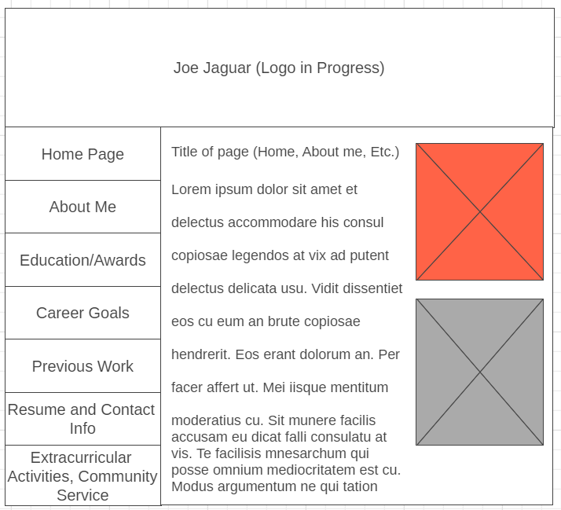

The crimson box is a stand in for a good picture of Joe Jaguar in a professional setting, such as high school graduation or wedding.

The gray box is a stand in for Joe Jaguar in an academic/extracurricular setting, such as at a robotics event. It could also be used for one of his previous works, such as a project photo.

Each small box on the left is a link to a different page, as described in the part II diagram.

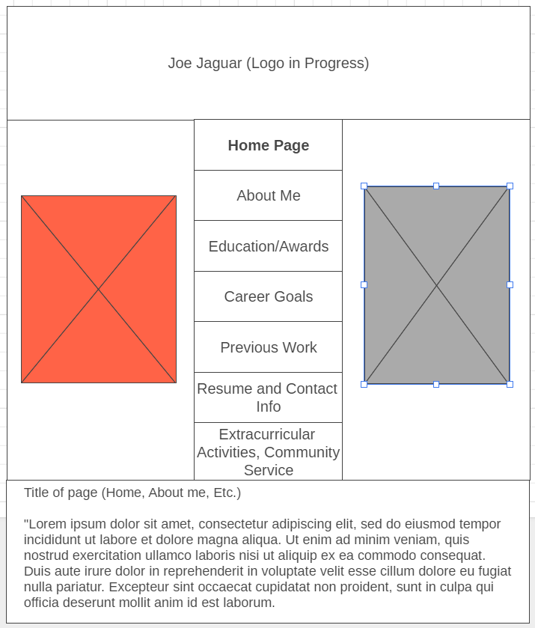

The crimson and gray boxes share the same purpose.

Whichever page is active, in this case, the home page, will be highlighted in the navigation bar in some way. Here, it is bolded, but another method might be used.

Diagram in Part II created with app.diagrams.net. The wireframes in Part III were created with wireframe.cc. The Lorem ipsum passage is from lipsum.com.