Details on how the class participation will be graded.

|  |  |
| --- | --- |
| 30% of total grade | **Participation in in-class discussions of papers**  Bring a digital copy of the paper on a tablet/laptop (preferred) or a print-out |

* This is a participation grade and participation in all discussions is required. And everyone should present a similar number of times per quarter.
* Each of the 8 modules are worth 5 points (40 total points). You earn 5 points if you participate in the small-group discussions on Zoom and annotate the Google Presentation with your group. If you miss the class, you earn 0 points*.
* A second portion of your participation grade comes from presenting your figures to the class. Based on the class size & number of students, everyone should present 3 times. You will get 3 points each time, for a maximum of 9 points.
  + Make sure that you do not monopolize the presentations. If you have presented, you should make sure that your discussion partners present the next weeks.
  + I will post the names of students who I logged as presentations in the class slack (#4-paper-discussion channel). Please let me know if I missed you.

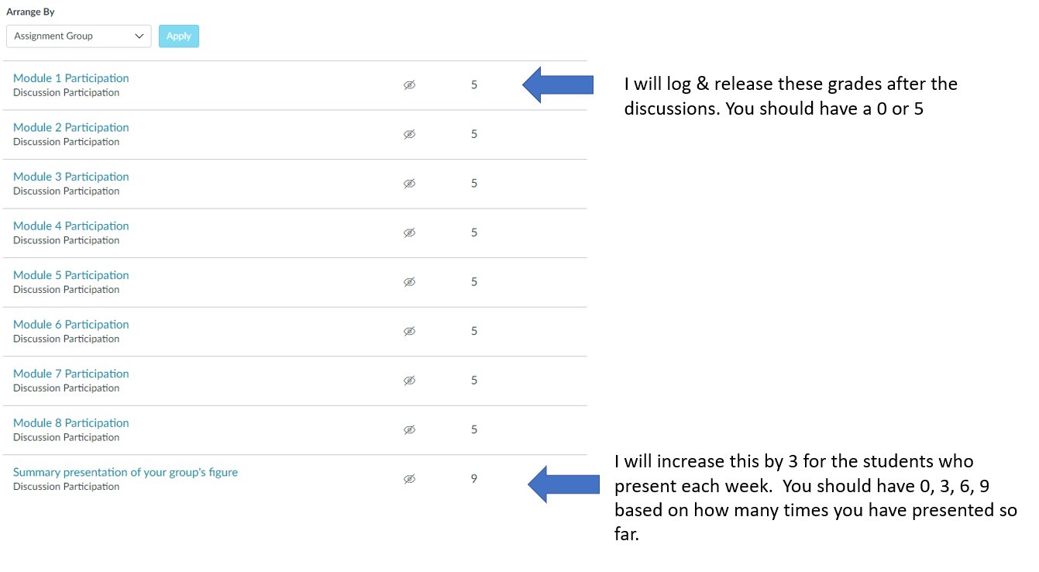

**Make-up assignment**

* You are allowed to make-up **one** paper discussion if you do not attend in-person. If you miss 2 or more discussions, then you will lose points for those discussions
* As a make-up assignment, you can write a summary of 2 Figures from the paper. Within 1 week of the missed discussion, ask in the **#4-paper-discussions-channel** which figures are the focus of a make-up assignment. (Do not email or direct message Prof. Lowe-Power. Posting in the channel allows her to answer the question once for all students).