# Rotation Project:

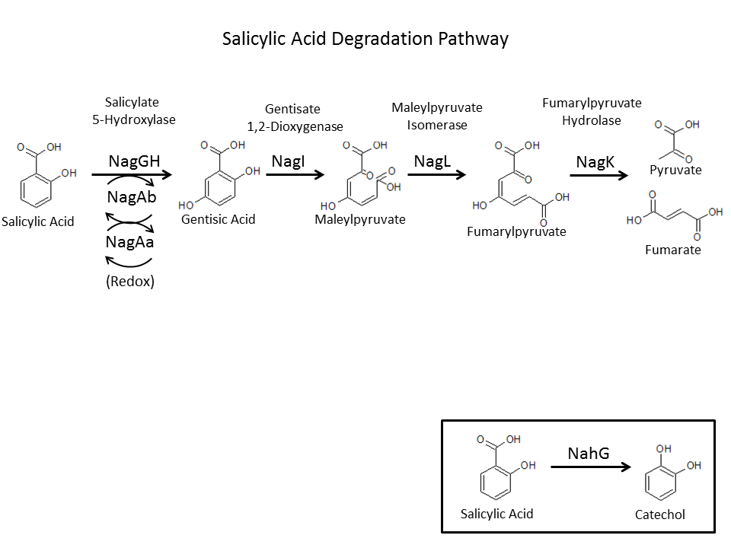

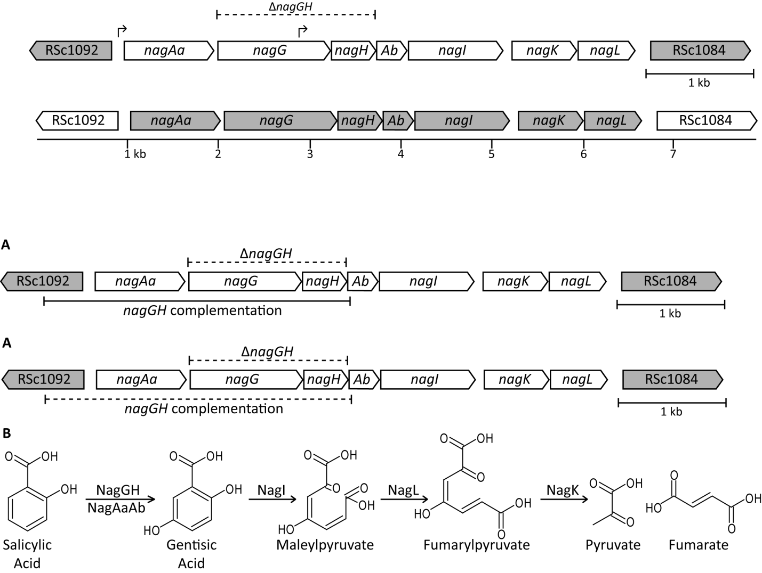

Aim 1: Does the Nag pathway contribute to *R. solanacearum* virulence on tomato?

Aim 2: Does *R. solanacearum* suppress plant defenses by degrading the plant signaling molecules salicylic acid and gentisic acid?

Strains to be used

|  |  |  |  |
| --- | --- | --- | --- |
| Name | Genotype | Description | Antibiotic Resistance |
| WT | GMI1000 |  | none |
| Δ*nagGH*  “Δ*GH*” | Δ*nagGH* | *nagGH* genes were cleanly deleted by two-step selection/*sacB* counter selection method | None |
| +*nagGH*  “+GH” | Δ*nagGH* + pRCG-*nagAaGH* | *nagGH* deletion was complemented with native promoter using chromosomal insertion vector pRCG-GWY (Monteiro et al. 2012) | Gm |
| Δ*nagOperon*  *“*Δ*nagOp”* | Δ*nagOperon*::Ω | *nag* operon was exchanged with Ω cassette | Spec (on Ω) |
| +*nagOperon*  “+Op” | Δ*nagOperon*::Ω  + pMiniTn7-nagOperon | *nagOperon* with native promoter was complemented using miniTn7 (Choi et al. 2005). | Spec; Gm |

# Aim 1: Does the Nag pathway contribute to *R. solanacearum* virulence on tomato?

Brief Methods:

1. Directly inoculate 21 day old tomato plants with 500 CFU of each strain   
   (N=10 per strain).
2. Rate symptoms daily (up to 14 days post-inoculation) according to disease index:

0: no symptoms

1: 0-25% leaflets wilted

2: up to 50% leaflets wilted

3: up to 75% leaflets wilted

4: up to 100% leaflets wilted

1. Graph the end result.

# Aim 2: Does *R. solanacearum* Nag pathway suppress plant defenses?

Relevant reading:

* Milling et al. 2011. PLoS One
* Milling et al. draft
* Lison et al. 2014
* Lopez-Gresa 1999.

Sub Aims:

1. Confirm results from Lison et al: Use detached leaf assay to verify that
   1. Gentisic acid (GA) treatment induces expression of tomato P23 (aka Osm)
   2. GA and salicylic acid (SA) treatment induces expression of PR1.
2. Test whether this holds true on whole plants
   1. Apply GA or SA to soil/roots of whole plants
   2. Harvest stem tissue to measure gene expression
3. Measure RNA levels of P23 and PR1 in tomato plants infected with WT and Δ*nagOp*. (^Probably won’t get to this during rotation)

Brief Methods

1. Treat plant tissue/whole plants
2. Harvest plant tissue for RNA extraction
3. Extract RNA using Zymo RNA extraction kit (with on-column DNase treatment).
   1. Also do an extra prep without DNase treatment→ positive control for step 4
4. Confirm absence of DNA contamination in RNA
5. Synthesize cDNA using Superscript III
6. perform qRT-PCR
   1. Controls for normalization: genes encoding actin, GapDH, & DnaJ-like protein
   2. Experimental primers: Osm and PR1