# Allen Lab Fall 2015 rotation project proposal (background)

Tiffany Lowe discovered that the RSp1579 transcriptional regulation contributes to virulence of *Ralstonia solanacearum*:

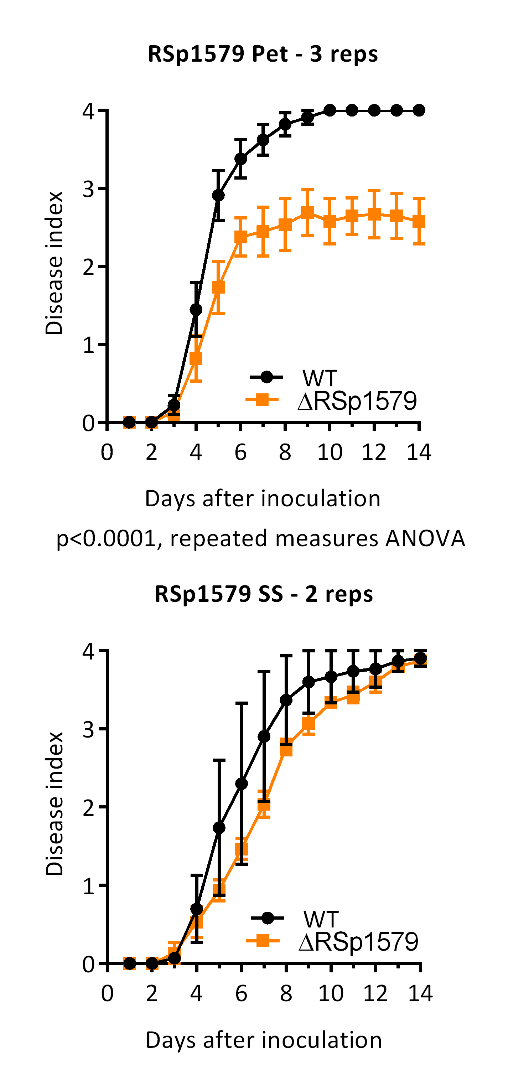

**Figure 1:** Virulence of *R. solanacearum* GMI1000 and ΔRSp1579::Sm mutant on tomato (cv Bonny Best). (left) Tomato plants were inoculated by naturalistic soil soak (SS) inoculation: ~5x108 CFU/g soil were poured into the pots of unwounded 17 day old tomato plants. (right) Tomato plants were directly inoculated by placing 50 CFU (in 2 ul droplet) onto the stump of a cut petiole. Symptoms are rated on 0-4 scale with 0 corresponding to unwilted and 1-4 corresponding to <25%, <50%, <75%, <100% leaves wilted. Each rep consisted of 15 plants per strain (N=30 for SS and N=45 for Pet).

## How did Tiffany become interested in RSp1579?

by accident

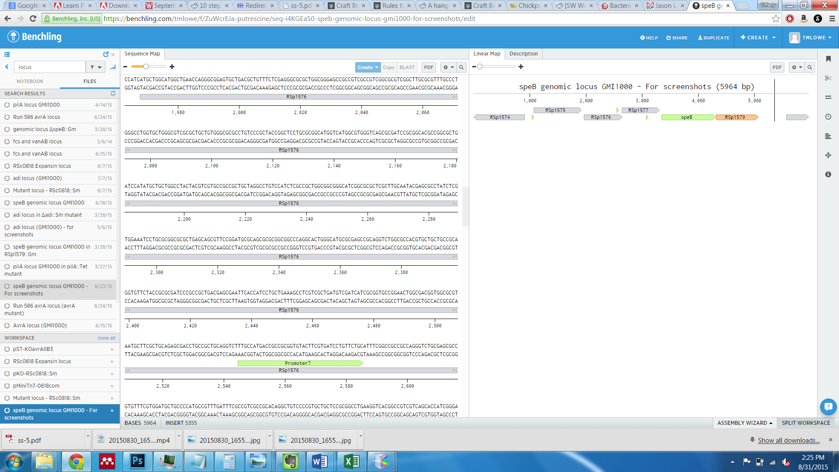

**Figure 2:** Genomic locus of RSp1579. Rsp1575-1577 encode subunits of an ABC transporter with predicted amino acid substrate. *speB* encodes a putative arginase or agmatinase that may be involved in putrescine biosynthesis (*Tiffany was interested in this gene due to xylem sap metabolomics data*). Rsp1579 encodes a transcriptional regulator with a helix-turn-helix domain. ~500 bp downstream is a gene encoding a short “hypothetical” protein.

Tiffany wanted to make a *Ralstonia* strain that did not make putrescine, so she make a *speB* mutant where a gentamicin cassette replaced the *speB* gene:

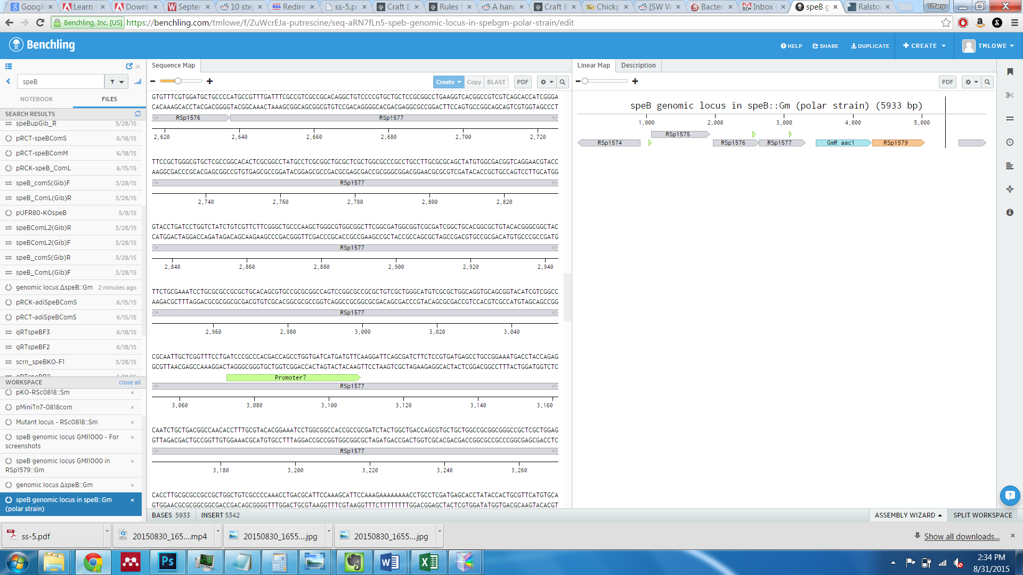

**Figure 3:** Genotype of Δ*speB*::Gm.

The Δ*speB*::Gm strain was very exciting. It was severely reduced in virulence, and hyper-twitched AKA it constitutively displayed a twitching phenotype (wildtype only twitches at low cell density).

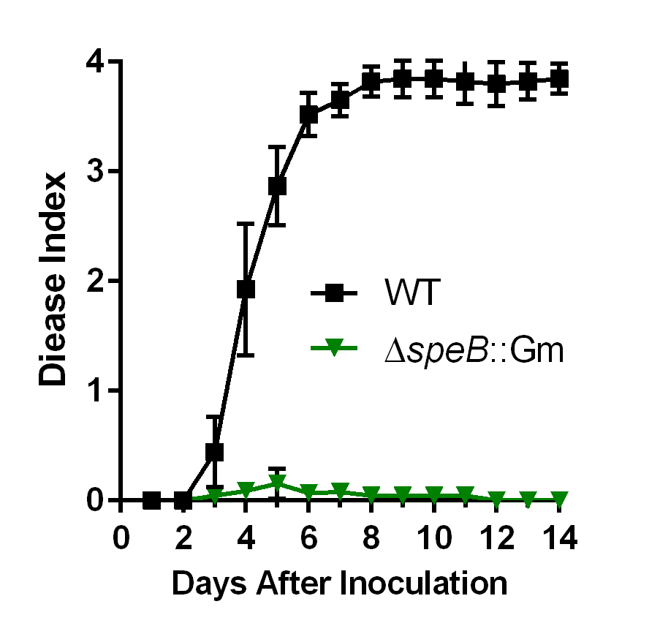 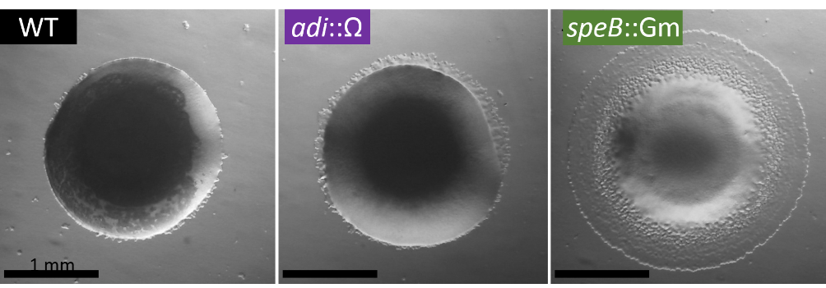

**Figure 4:** Phenotypes of Δ*speB*::Gm. (left) Δ*speB*::Gm was drastically reduced in virulence following direct petiole inoculations (50 cfu inoculum). (right) Colony morphology of wild type (WT), Δ*adi*::Sm, and Δ*speB*::Gm. All strains appeared to produce EPS (extracellular polysaccharide) at high cell density—mucoid centers of the colonies. WT has minor “colony fringe,” but the Δ*speB*::Gm has significant colony fringe. Increased colony fringe was shown to be produced by twitching motility because Δ*pilA*::tetAR mutation in the Δ*speB*::Gm strain background ablated the colony fringe (*pilA* encodes the major pilin of the type IV pilus used in twitching motility).

However… it soon became apparent that the Δ*speB*::Gm strain was *too* exciting, and I became worried that the marked deletion was having unintended effects on expression of the the RSp1579 transcriptional regulator. So I made a Δ*speB* mutant where the *speB* gene was cleanly deleted (using a vector with positive Kanamycin selection and negative sucrose sensitivity selection [*sacB* gene]). I also made a marked ΔRSp1579::Gm strain to determine whether the Δ*speB*::Gm phenotypes were due to less/no expression of the RSp1579 gene.

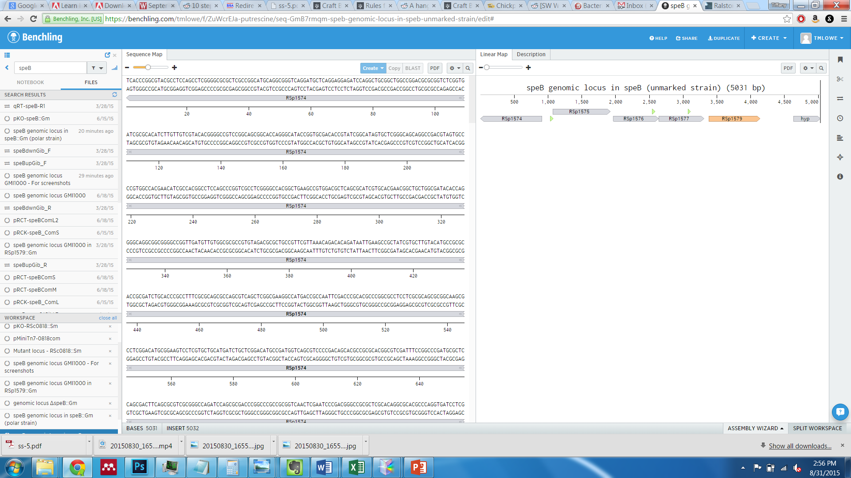

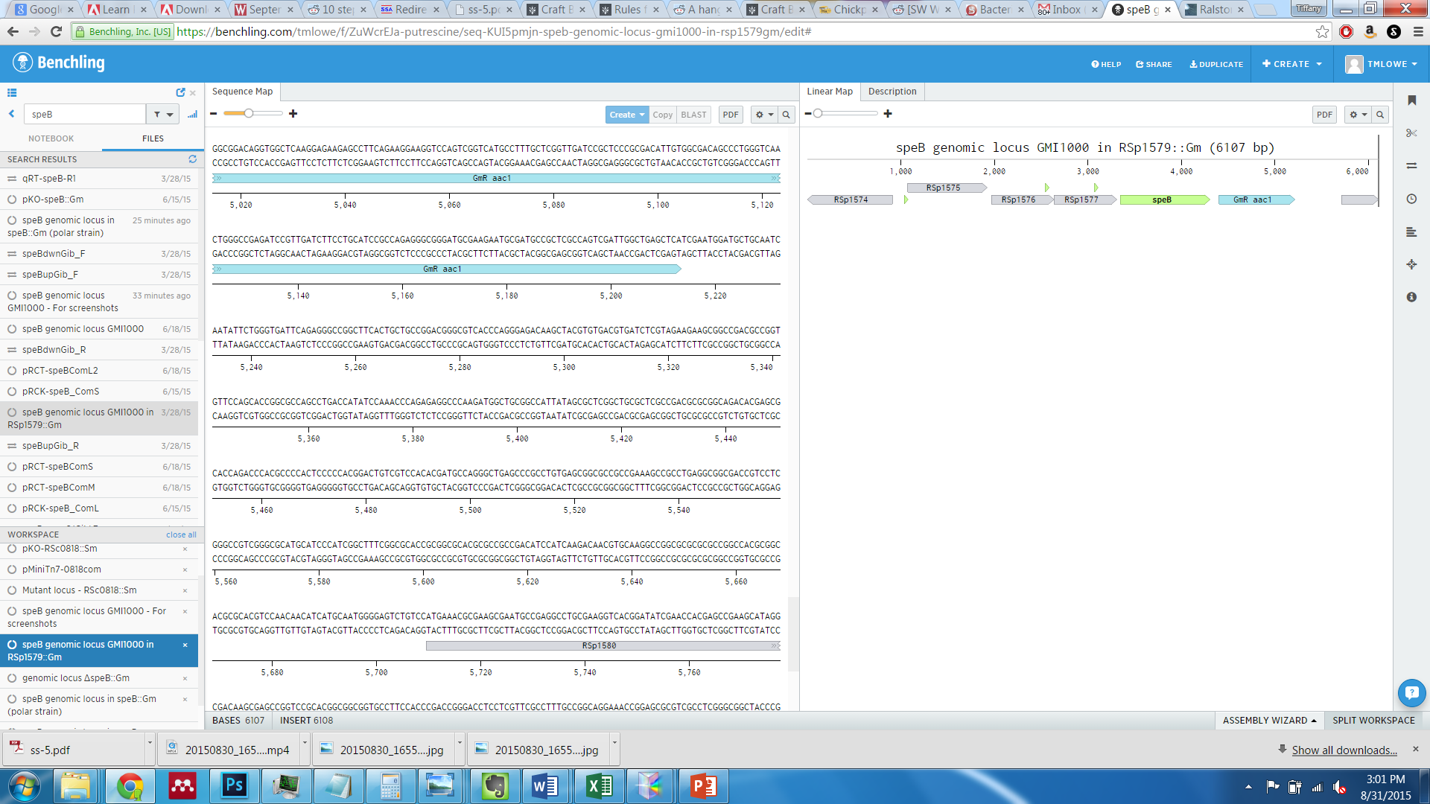

**Figure 5:** Genotype of (top) Δ*speB* and (bottom) ΔRSp1579::Gm

The Δ*speB* strain does not have a virulence defect, and it does not hypertwitch. To my surprise, the ΔRSp1579::Gm strain had a virulence defect, but it does not obviously hypertwitch (careful assay has not been performed). qRT-PCR indicated that RSp1579 was expressed ~10-fold higher in the Δ*speB*::Gm strain (Fig 6). We were surprised to see that *pilA* expression was not affected in the Δ*speB*::Gm strain. This result indicates that the hypertwitching phenotype is not due to transcriptional regulation of *pilA*.

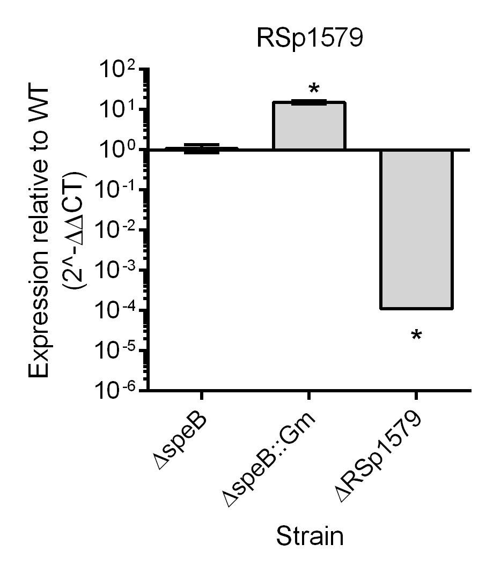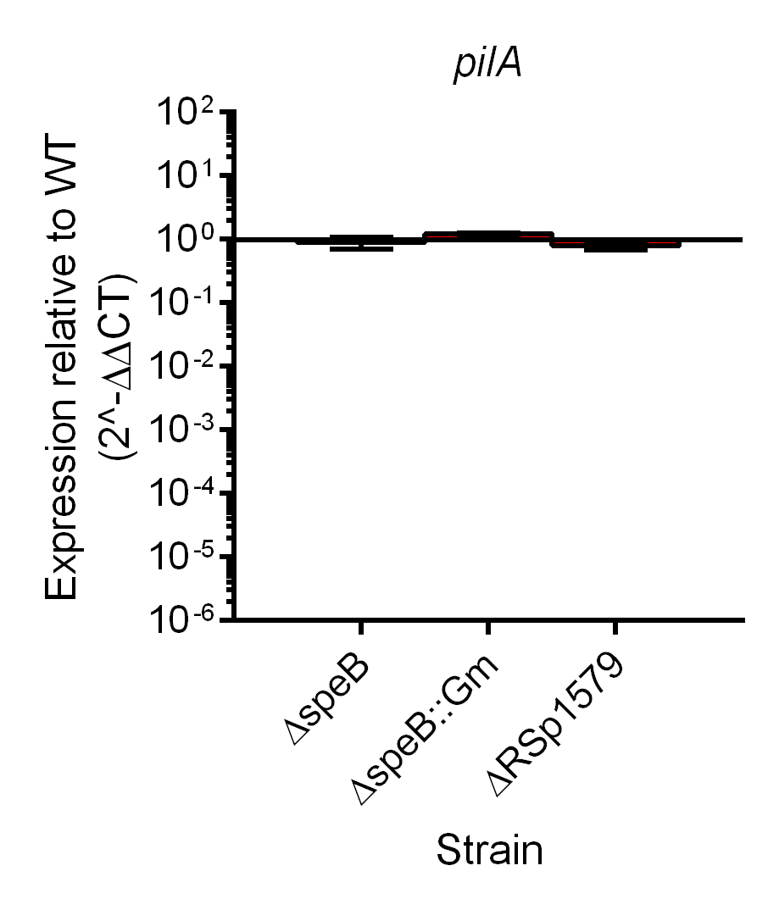

**Figure 6:** Expression of (left) RSp1579 and (right) *pilA* in mutant strains.

## Aims for the rotation project

1. Determine whether the ΔRSp1579::Gm strain have a colonization defect following petiole inoculation.
2. Determine whether ΔRSp1579::Gm strain has altered twitching behavior
3. Determine whether ΔRSp1579::Gm strain produces normal biofilms (Tuan Tran will help)
4. Determine whether ΔRSp1579::Gm strain is hypersensitive to ROS (Alicia will help with the H2O2 overlay experiment in her lab meeting).
5. Control: Is there overexpression of RSp1580 gene encoding a hypothetical protein in strains ΔspeB::Gm and ΔRSp1579::Gm