(This is not a great description. But it is a summer project that I developed for a student who I had been mentoring on a different project previously)

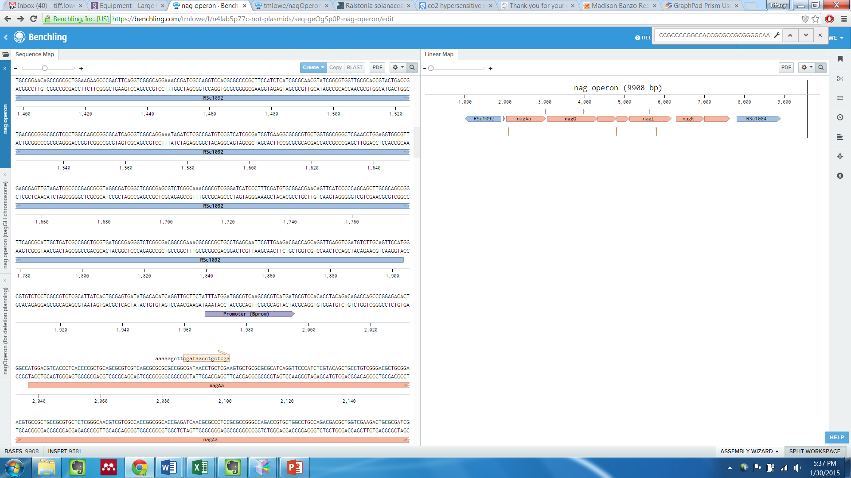

RSc1092 = LysR type regulator; putative positive regulator of the *nag* operon; 5.6-fold induced by SA

RSc1084 = Transmembrane porin; 60-fold induced by SA in microarray

Adding the *nag* genes alone to K60 did not confer the ability to degrade SA. The genes around the *nag* genes (encoding the enzymes in the SA degradation pathway) may be important for SA degradation. RSc1092 may be required for transcription of the *nag* operon, and RSc1084 may be a porin that allows SA to enter the cytoplasm, where the Nag enzymes are.

I made 3 vectors

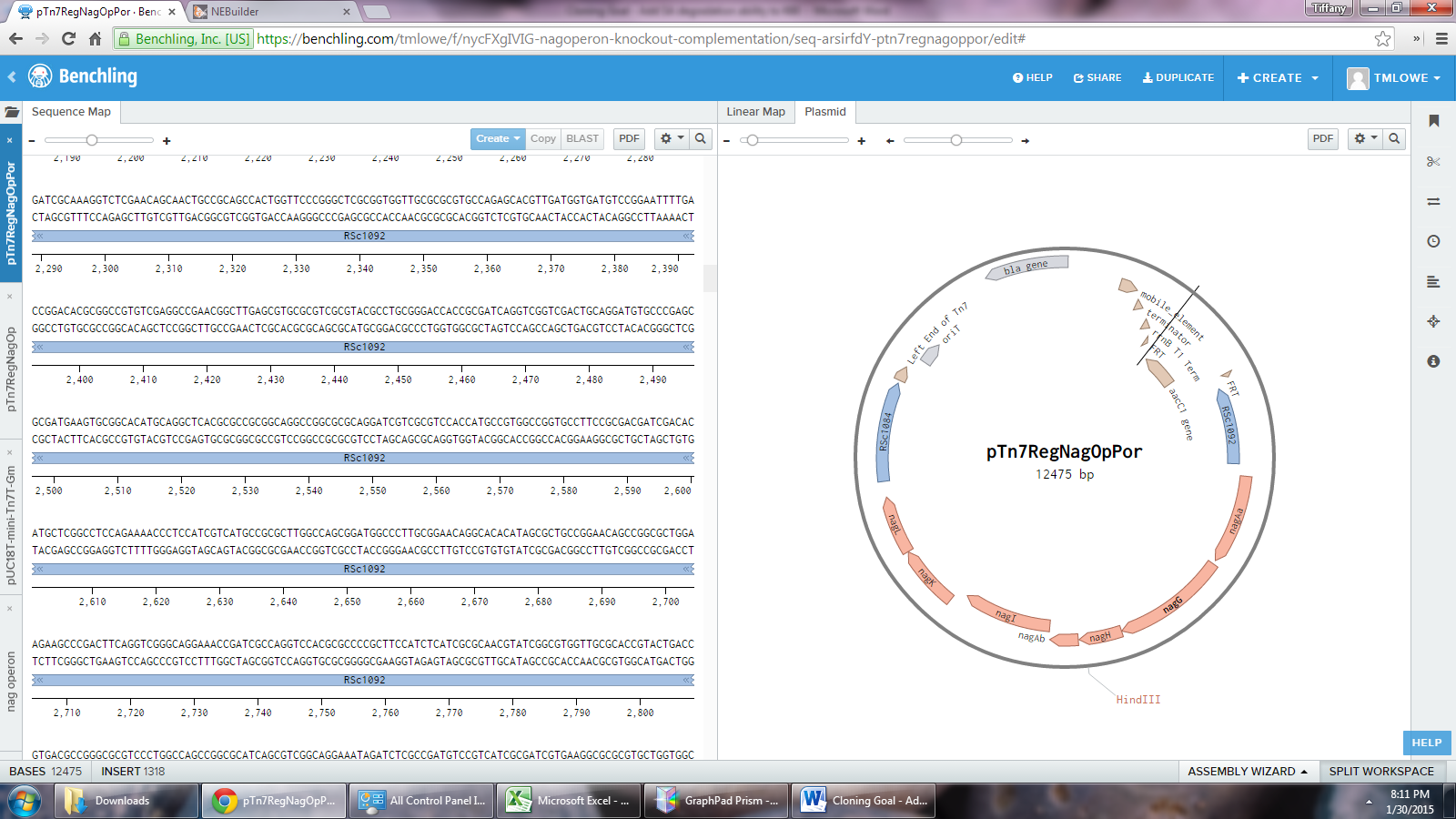K60+RNP

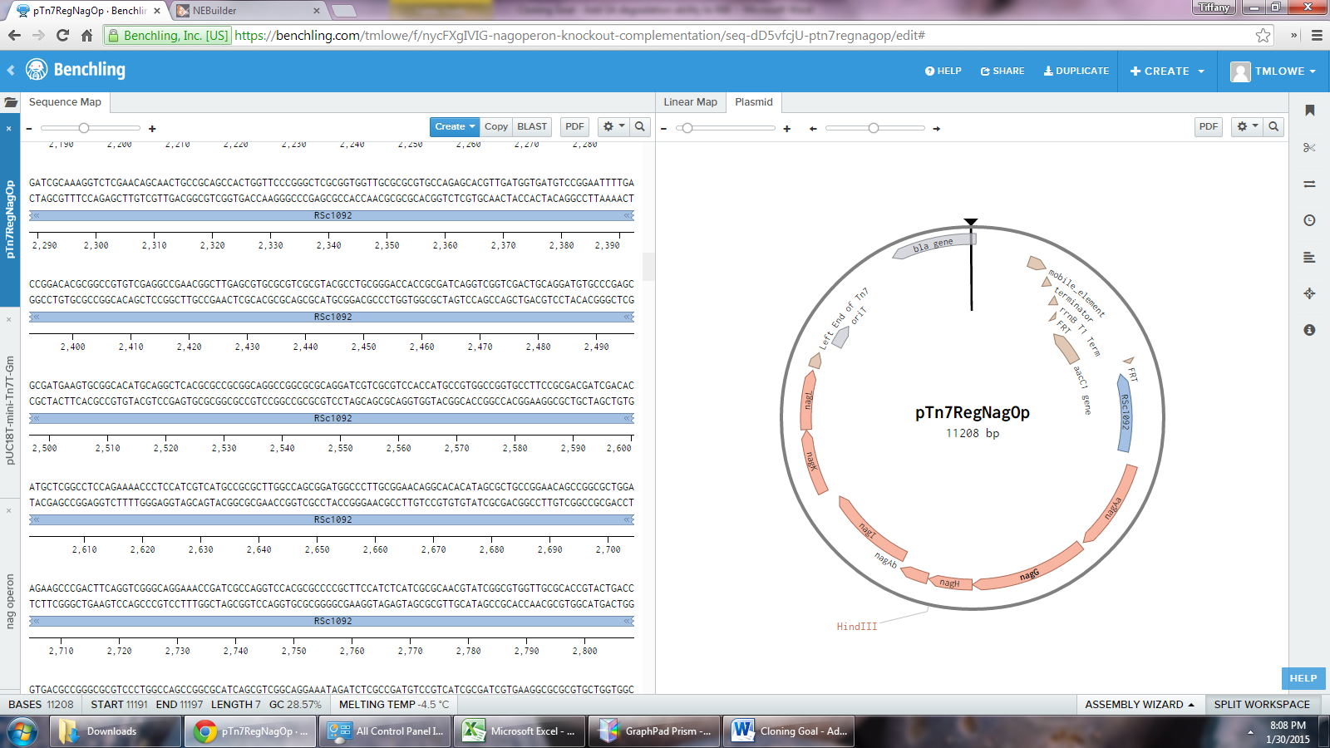K60+RN

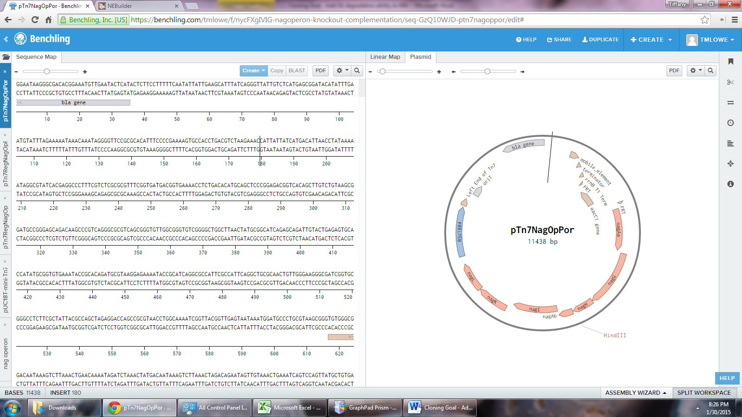K60+NP

And I added each of them into K60. I then did a quick & dirty test of transformants to see if they grew on SA. I believe that some of them did, but I won’t give away which genes. Your job is to devise an experiment that will test whether addition of any of these constructs allows K60 to grow on Salicylic acid. Try to think of all the controls you will need to interpret results.