Background

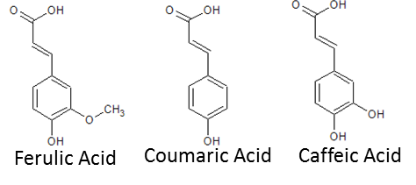*R. solanacearum* is a broad host-range plant vascular pathogen. Plants defend themselves from pathogens by producing antimicrobial phenylpropanoid compounds (phenyl groups attached to a 3-carbon chain). For my project, I’m looking at a class of phenylpropanoids called hydroxycinnamic acids (HCAs). In plants, the major HCAs are ferulic acid, coumaric acid, and caffeic acid. HCAs inhibit growth by disrupting bacterial membranes, which abolishes electrochemical potentials required for ATP generation by oxidative phosphorylation.

*In planta* transcriptome profiles of *R. solanacearum* indicate that this pathogenexpresses a pathway encoding degradation of hydroxycinnamic acids (HCAs):

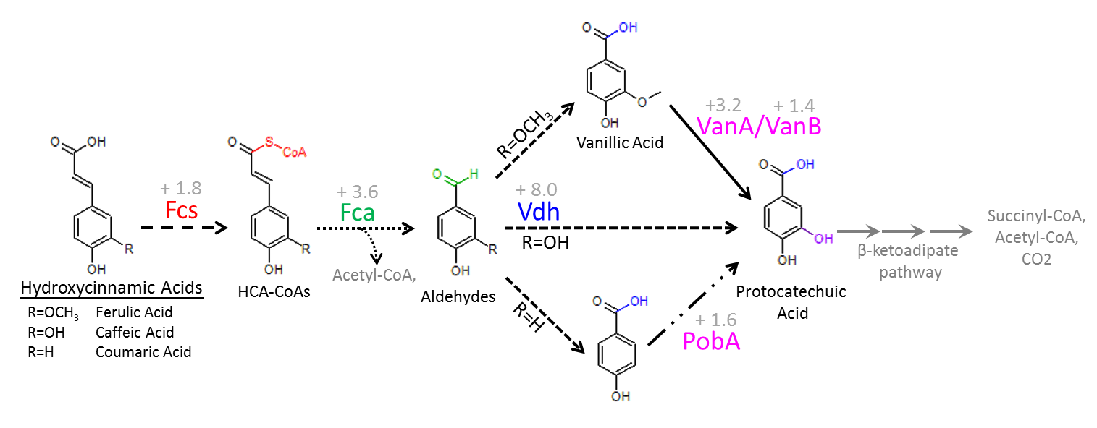

Fig 1. The HCA detoxification pathway. Enzymes responsible for catalyzing each step are listed by the arrows. Arrows with the same “dashing” are reactions performed by the same enzyme. Names of the molecules are below the molecule. The labels for the first 3 molecules only apply when R=OCH3. Colored font on each product indicates the changes performed by the enzyme(s) of the corresponding color. The relative expression of each gene in *R. solanacearum* GMI1000 *in planta* vs in culture.

My Data

I have determined that HCA detoxification contributes to *R. solanacearum* virulence (Fig2). Genetic disruption of the HCA pathway results in slightly delayed disease progression.

Fig 2. Disease progress curve. We use a naturalistic soil-soak inoculation (ie we directly pour bacterial suspensions into the soil & let them invade the plant & cause disease). I infected 14 tomatoes with wildtype GMI1000 and 14 tomatoes with a mutant I created that lacks the *fcs* gene (Fcs protein catalyzes the first step in the HCA degradation pathway). Each day after inoculation, I rated the severity of wilt symptoms on each plant: healthy=**0**; 1-25% leaves wilted =**1**; 26-50% wilted=**2**; 51-75% wilted=**3**; 76-100% wilted=**4**. The disease values for each plant population were averaged and plotted against time.

Additionally, I have confirmed that HCAs inhibit *R. solanacearum* growth *in vitro*. In fact, I was surprised to find that *R. solanacearum* is particularly susceptible to inhibition by HCAs and other metabolites in the HCA detox pathway (Table 1).

Table 1: Minimum inhibitory concentrations (MIC) for metabolites in the HCA detoxification pathway

|  |  |  |
| --- | --- | --- |
| Compound | *R. solanacearum*  GMI1000 | Other bacteria  (from literature) |
| Ferulic Acid | 3 mM | 1-8 mM |
| Vanillin | 0.375 mM | 5-33 mM |
| Vanillic Acid | 1.5 mM | 10 mM |

This was determined using a minimum inhibitory concentration (MIC) assay. In general, the minimum inhibitory concentration (MIC) is the lowest concentration of an antimicrobial compound that will inhibit the visible growth of a microorganism after overnight incubation. (However *Ralstonia* grows slowly, so we check for growth after 2 days). To set this up, we prepare media with a range of concentrations of the antimicrobial compound. We add the same amount of bacteria to each culture, and let them incubate for 2 days. Then we determine what the minimum inhibitory concentration is. In the case of the diagram below, 12 mM, 6 mM, and 3 mM all inhibit growth while 1.5 mM allowed growth. This means 3 mM is the MIC.

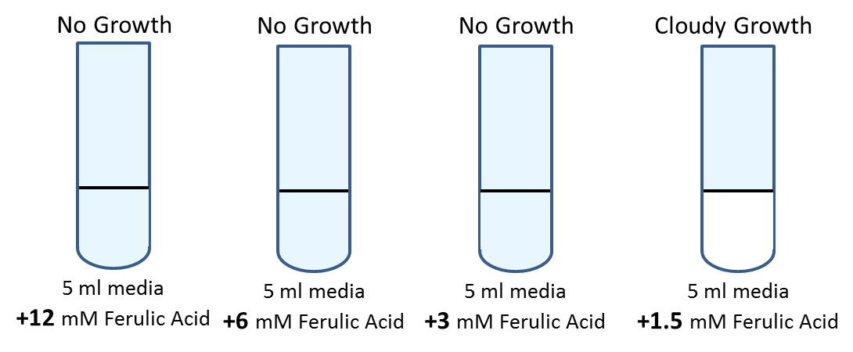

Undergraduate Project

Question 1: Is there variation in ferulic acid susceptibility in the *R. solanacearum* species complex?

The *R. solanacearum* species complex is a diverse grouping with four major phylotypes (I-IV). I’ve been working predominantly with GMI1000, a phylotype I strain. I would like you to compare the ferulic acid MIC for GMI1000 to strains from the other phylotypes

|  |  |
| --- | --- |
| Strain | Phylotype |
| GMI1000 | I |
| K60 | II |
| CMR15 | III |
| PSI07 | IV |

Question 2: Is *R. solanacearum* more susceptible to ferulic acid than other plant symbiotic bacteria?

|  |  |  |
| --- | --- | --- |
| Bacteria | Plant Host | Symbiotic outcome |
| *Pseudomonas syringae* pv. *tomato* DC3000 | Tomato | Bacterial speck disease |
| *Dickeya dadantii* 3937 | (broad host range) | Soft rot disease |
| *Xanthomonas euvesicatoria* | Tomato | Bacterial spot disease |
| *Clavibacter michiganensis* subsp. *michiganensis* | Tomato | Bacterial wilt & canker |
| *Agrobacterium tumefaciens* | Many dicots | Crown gall disease |
| *Sinorhizobium meliloti* | Legumes | Nitrogen fixation |

Research Outline

* Media preparation & Sterile Technique
  + CPG – liquid and solid
  + Boucher’s Minimal Media (BMM)
* Stock Solutions
  + 1 M Glucose in H2O
  + 1 M and 0.1 M ferulic acid in DMSO
  + 1% TZC
* How to culture bacteria
  + Making freezer stocks
* MICs for ferulic acid
  + Start with *R. solanacearum* GMI1000.
  + Other *R. solanacearum*
  + Other plant pathogenic bacteria