MID-2011 iMAC → macOS MONTEREY
A Step-by-Step OpenCore Legacy Patcher Field Guide
Based on a real upgrade session • screenshots redacted for privacy • updated with final successful outcome
Case machine: 21.5-inch Mid-2011 iMac (iMac12,1), 2.5 GHz Intel Core i5, 24 GB DDR3, 1 TB SSD, starting from macOS High Sierra. Target: macOS Monterey using OpenCore Legacy Patcher (OCLP).
CAUTION — This is a case-study guide, not a universal copy-and-paste recipe. Disk identifiers such as disk0s2 and disk0s3 were correct for this specific iMac. On another Mac, verify your own disk layout before any erase or resize command.
CHECKPOINT — The most important lesson from this upgrade: do not rush. At every CHECKPOINT, verify the screen/output before continuing. If your result differs, stop and diagnose rather than assuming the next step is safe.

What ultimately worked
- Monterey installed and ran very well on the SSD/24 GB configuration.
- OpenCore Legacy Patcher 2.4.1 and OpenCore 1.0.4 were verified.
- Post-install root patches completed successfully.
- Ethernet provided a stable recovery path when Wi-Fi was unreliable.
- Wi-Fi was restored and works reliably when the saved network is selected manually after startup; on this case machine it does not consistently auto-join.
- The Magic Mouse problem was finally solved by deleting TWO stale Bluetooth entries (one named entry and one hardware-address entry), then rediscovering/pairing the mouse fresh.
- The temporary ~32 GB Monterey installer partition was removed and the APFS container was expanded back to the full 1 TB.
FINAL SUCCESSFUL CONFIGURATION — Monterey boots normally through OpenCore; the Magic Mouse reconnects and works smoothly; Wi-Fi is detected at startup and connects immediately when the saved network is manually selected; Ethernet remains a reliable fallback; the temporary installer partition is gone; and the APFS container has been restored to essentially the full 1 TB. Day-to-day performance was reported as substantially better than the previous High Sierra setup.

Contents / Road Map
Chapter 1 — Decide whether Monterey is a sensible target
Chapter 2 — Install OpenCore Legacy Patcher
Chapter 3 — Download Monterey and prepare installer media
Chapter 4 — Advanced workaround: internal installer partition
Chapter 5 — Build/install OpenCore and boot the Monterey installer
Chapter 6 — Install Monterey without erasing the existing system
Chapter 7 — Run post-install root patches
Chapter 8 — Recover networking safely
Chapter 9 — Bluetooth/Magic Mouse troubleshooting — and the real fix
Chapter 10 — OCLP update and deep diagnostics (only if needed)
Chapter 11 — Remove the temporary installer partition and reclaim space
Chapter 12 — Final validation and everyday-use recommendations
Chapter 13 — Publish and share the guide responsibly
Appendix A — Command reference
Appendix B — Symptom → likely meaning → next move
Appendix C — Privacy/redaction notes

Chapter 1 — Decide Whether Monterey Is a Sensible Target
This iMac began on High Sierra, Apple’s last officially supported macOS for the Mid-2011 model. The machine already had an SSD and 24 GB of RAM, which substantially improved the odds that Monterey would remain responsive.

Case hardware
Model | 21.5-inch Mid 2011 (iMac12,1)
Processor | 2.5 GHz Intel Core i5
Memory | 24 GB DDR3
Storage | 1 TB SSD
Starting OS | macOS High Sierra
Target OS | macOS Monterey
Known weak points | Legacy graphics + old Wi-Fi/Bluetooth hardware
TIP — If your Mac has a spinning hard drive and very little RAM, fix those bottlenecks first. OCLP can make newer macOS versions boot, but it cannot turn slow storage or insufficient memory into fast hardware.
CHECKPOINT — Before starting, have a fallback input method available if possible: a wired USB mouse/keyboard. This became critical when Bluetooth pairing failed temporarily.

Chapter 2 — Install OpenCore Legacy Patcher
STEP 1 — Download OCLP
Use the official OpenCore Legacy Patcher installer package. High Sierra may block the package because it was not downloaded from the App Store; use Security & Privacy → Open Anyway if required.
STEP 2 — Install the application
Install OCLP to the Mac’s internal drive. This step installs the patcher application; it does not yet replace macOS.
STEP 3 — Choose Monterey
In OCLP, select Create macOS Installer → Download macOS Installer → Monterey.
TIP — Do not choose Ventura/Sonoma/Sequoia merely because they are newer. On this hardware, Monterey was selected as the more conservative stopping point.
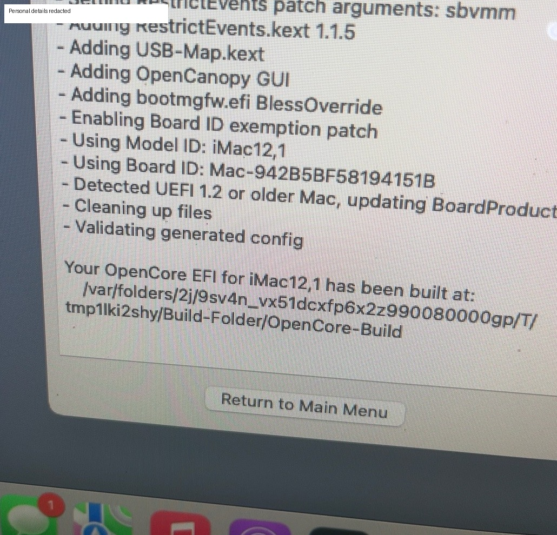
Example: OCLP successfully building an OpenCore configuration for iMac12,1. Personal details are redacted.

Chapter 3 — Download Monterey and Prepare Installer Media
The Monterey installer downloaded and extracted correctly, but OCLP repeatedly reported “No disks found” when a 32 GB SD card was placed in the iMac’s built-in SD reader.
STEP 1 — Confirm the storage device in Terminal
Use diskutil list to identify the removable device. In this case the 32 GB SD card appeared as disk2.
diskutil list
STEP 2 — If needed, format as GUID + HFS+
The card initially used an FDisk/MBR partition map. It was reformatted correctly with:
diskutil eraseDisk JHFS+ MONTEREY GPT /dev/disk2
CAUTION — ERASE COMMAND: /dev/disk2 was the SD card on this specific machine. Never copy that identifier blindly.
Even after correct formatting, OCLP still did not show the card. The built-in SD reader exposed it as an internal physical disk, so the workflow moved to an internal-partition workaround.
CHECKPOINT — Preferred alternative for most people: use a normal 32 GB+ USB flash drive or an SD card in an external USB card reader. The internal-partition workaround in the next chapter is advanced and carries more risk.

Chapter 4 — Advanced Workaround: Create an Internal Installer Partition
Because no suitable USB reader/flash drive was available, approximately 32 GB was carved from the end of the 1 TB APFS container and used as temporary installer media.
STEP 1 — Inspect APFS and the physical disk
Do not resize anything until you know the physical store and existing partitions.
diskutil apfs list
diskutil list disk0
STEP 2 — Shrink the APFS container and create a temporary HFS+ partition
On this specific Mac the APFS physical store was disk0s2 and the chosen target size was 992 GB:
sudo diskutil apfs resizeContainer disk0s2 992g JHFS+ MONTEREYINSTALL 0b
CHECKPOINT — STOP if fsck_apfs reports errors. In the successful case, the storage-system check exited with code 0 and a new disk0s3 partition was created.
STEP 3 — Verify the Monterey app
The installer app existed at:
ls -ld "/Applications/Install macOS Monterey.app"
STEP 4 — Turn the temporary partition into bootable installer media
Apple’s createinstallmedia tool was used directly:
sudo /Applications/Install\ macOS\ Monterey.app/Contents/Resources/createinstallmedia --volume /Volumes/MONTEREYINSTALL
CAUTION — When createinstallmedia asks to erase MONTEREYINSTALL, confirm only after verifying that the volume name is correct.

Chapter 5 — Build/Install OpenCore and Boot the Monterey Installer
STEP 1 — Build OpenCore
Use OCLP → Build and Install OpenCore.
STEP 2 — Install OpenCore to the internal EFI
For this Mac the EFI partition was disk0s1. Installing OpenCore there allowed the machine to boot the unsupported OS through OpenCore.
STEP 3 — Restart and hold Option
At Apple’s boot picker, choose EFI Boot. Then at the OpenCore picker, choose Install macOS Monterey.
TIP — If EFI Boot simply returns you to High Sierra, restart and choose EFI Boot again, then explicitly select the Monterey installer from the OpenCore picker.
CAUTION — Do not erase the existing system disk just because you are in the installer. The goal here was an in-place upgrade.

Chapter 6 — Install Monterey Without Erasing the Existing System
The installer first presented a Recovery-style screen. From there, Install macOS Monterey was launched and the existing main system volume, named “Untitled” in this case, was selected.
STEP 1 — Choose the existing main system volume
Select the current macOS volume; do not select the temporary installer partition.
STEP 2 — Let the installer restart itself
Time estimates can increase after a reboot. The upgrade restarted several times and continued normally.
TIP — A changing estimate (for example, 17 minutes becoming 29 minutes) is not by itself a failure. Let the installer continue unless an actual error appears.
STEP 3 — Reach the Monterey desktop
Input and networking may be incomplete at first because legacy root patches have not yet been applied.

Chapter 7 — Run Post-Install Root Patches
On this 2011 iMac, the first Monterey boot had severe input/wireless limitations. OCLP’s post-install root patches were essential.
STEP 1 — Launch OCLP
If the GUI cannot be navigated, Terminal can invoke the installed patcher directly.
sudo /Applications/OpenCore-Patcher.app/Contents/MacOS/OpenCore-Patcher --patch_sys_vol
STEP 2 — Allow patching to finish
Do not interrupt while it rebuilds Boot/System kernel collections.
STEP 3 — Reboot when explicitly instructed
The successful run ended with “Patching complete” and “Please reboot the machine for patches to take effect.”
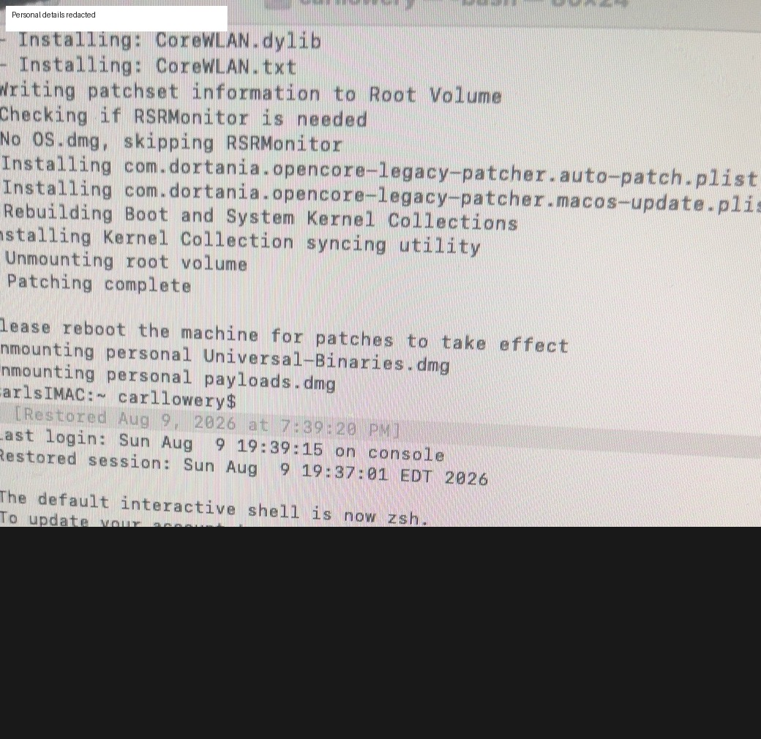
Successful post-install root patch. Shell/session identifiers have been redacted.
CHECKPOINT — CHECKPOINT: Do not assume Bluetooth/Wi-Fi will be perfect immediately. First confirm that the root patch itself completed, then troubleshoot remaining hardware one subsystem at a time.

Chapter 8 — Recover Networking Safely
The Atheros Wi-Fi hardware was visible to Monterey, but association was unreliable. Terminal confirmed the card and nearby network were visible, which meant the driver path was at least partially working.
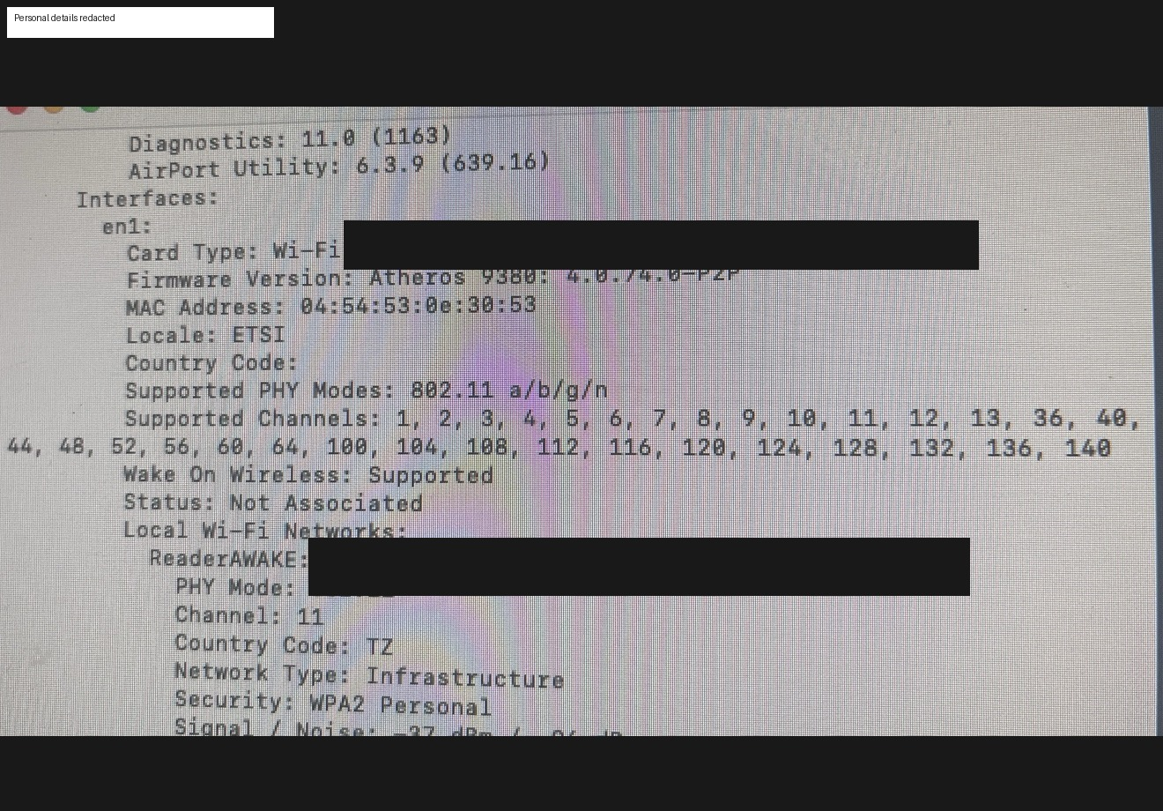
Wi-Fi hardware detected by system_profiler. MAC address and network name are redacted.
STEP 1 — Identify the Wi-Fi interface
The interface on this machine was en1.
networksetup -listallhardwareports
STEP 2 — Turn Wi-Fi on
networksetup -setairportpower en1 on
STEP 3 — Join a network carefully
When the Wi-Fi password contains shell-special characters such as !, single quotes can prevent shell expansion.
networksetup -setairportnetwork en1 "YOUR-WIFI-NAME" 'YOUR!PASSWORD'
CAUTION — Do not publish screenshots containing Wi-Fi passwords. One early screenshot accidentally showed a credential; the version used in this guide has been excluded/redacted.
When Wi-Fi became unreliable again, Ethernet was used as the recovery path. This was one of the most useful decisions in the entire upgrade.
STEP 4 — Verify wired internet
ping -c 4 8.8.8.8
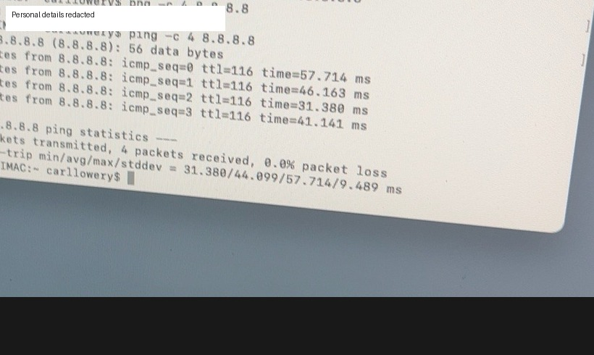
Successful Ethernet connectivity check: 4 packets received, 0% loss. Personal details are redacted.
TIP — Keep Ethernet connected while updating OCLP or rerunning patches. A stable network removes one major source of uncertainty.

Chapter 9 — Bluetooth/Magic Mouse: Troubleshooting and the Real Fix
This was the longest troubleshooting section. The mouse was visible, but the pointer did not move and Bluetooth sometimes showed “Connection rejected.” Deep diagnostics showed that the Bluetooth compatibility layer was loaded, but the daemon repeatedly failed to scan.

What diagnostics showed
- BlueToolFixup 2.6.9 was loaded.
- Apple Bluetooth transport components were loaded.
- The controller was on and discoverable.
- The mouse was visible with a good signal.
- bluetoothd repeatedly logged “Failed to start scan with error 105.”
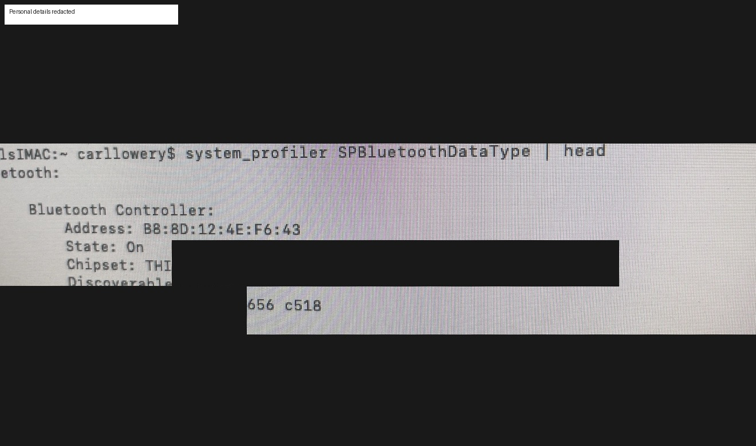
Diagnostic proof that BlueToolFixup was loaded. Device addresses and personal identifiers are redacted.
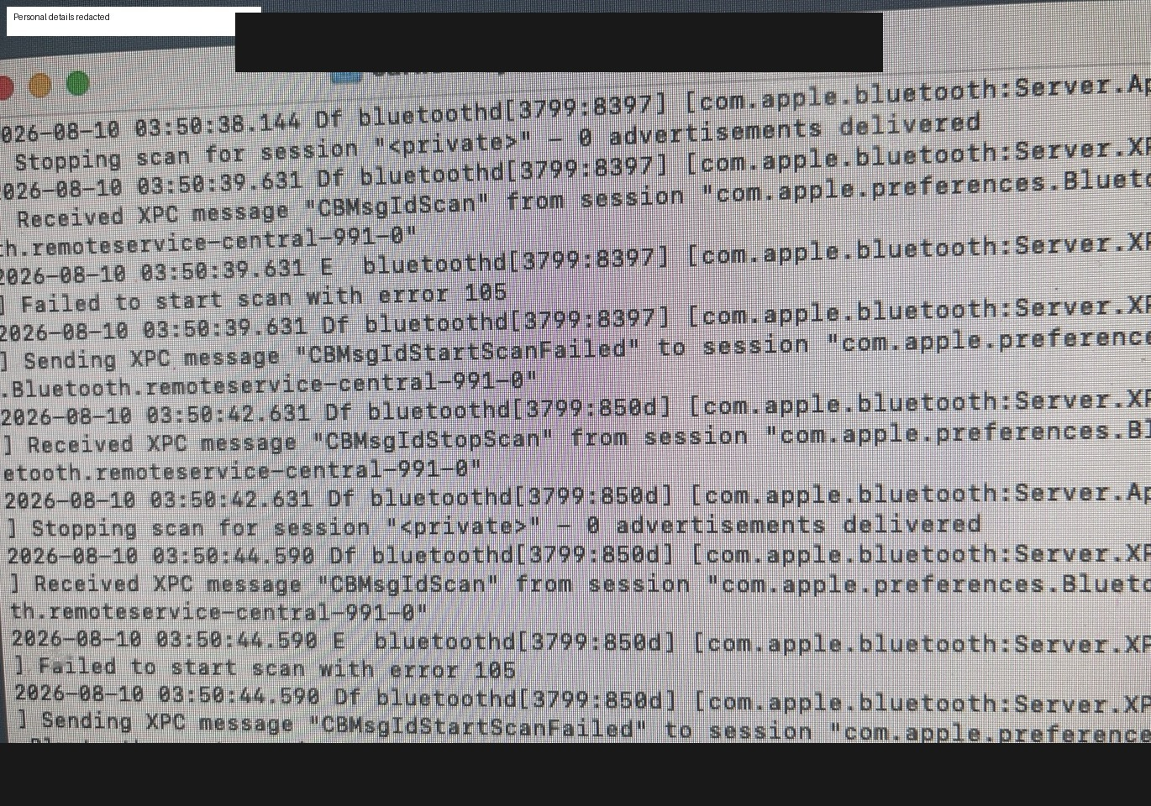
bluetoothd scan failure (error 105). Personal details are redacted.

The actual fix
CHECKPOINT — Once a wired mouse gave reliable pointer control, Bluetooth Settings revealed TWO records for the same Magic Mouse: one under the friendly name “System Administrator’s Mouse” and one under a raw hardware-address entry.
STEP 1 — Delete both stale mouse records
Remove/Forget the friendly-name entry AND the hardware-address entry.
STEP 2 — Turn the Magic Mouse off
Wait about 10 seconds.
STEP 3 — Turn the Magic Mouse on and rediscover it
Let Monterey find it as a fresh device.
STEP 4 — Connect once
The mouse paired immediately and worked normally.
TIP — This duplicate-record fix resolved a problem that looked much deeper than it really was. Before replacing hardware, always check for duplicate/stale Bluetooth records—especially if the device is detected but pairing is rejected.
A cheap wired USB mouse was therefore valuable twice: first as a fallback input device, and second because it made the final Bluetooth cleanup possible.

Chapter 10 — Update OCLP and Deep Diagnostics (Only If Needed)
During troubleshooting, the OCLP package was reinstalled/updated from Terminal because GUI authorization dialogs were hard to use without a reliable pointer.
sudo installer -pkg ~/Downloads/OpenCore-Patcher.pkg -target /
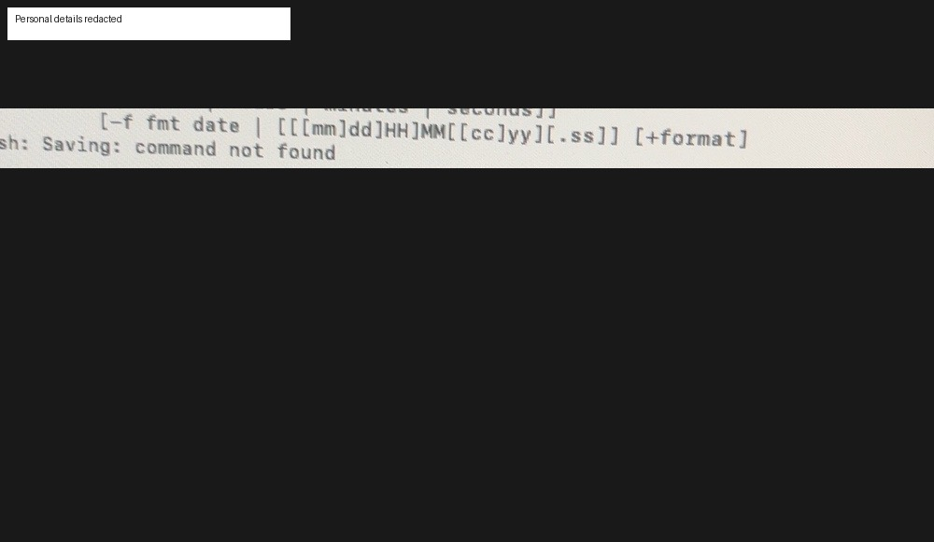
The OCLP package upgrade completed successfully. Personal identifiers are redacted.

Verify versions
nvram 4D1FDA02-38C7-4A6A-9CC6-4BCCA8B30102:OCLP-Version
nvram 4D1FDA02-38C7-4A6A-9CC6-4BCCA8B30102:opencore-version
The successful case reported OCLP 2.4.1 and OpenCore REL-104 (1.0.4).

Optional Bluetooth diagnostics
kmutil showloaded | grep -i BlueTool
log show --last 10m --process bluetoothd --style compact | tail -80
CAUTION — These commands are diagnostic, not routine installation steps. If the system is working, do not keep changing kexts or Bluetooth settings simply because advanced diagnostics exist.

Chapter 11 — Remove the Temporary Installer Partition and Reclaim Space
After Monterey was stable, the ~32 GB internal installer partition was no longer needed. The cleanup was done deliberately in two stages: erase the installer partition to free space, verify, then grow APFS into that space.
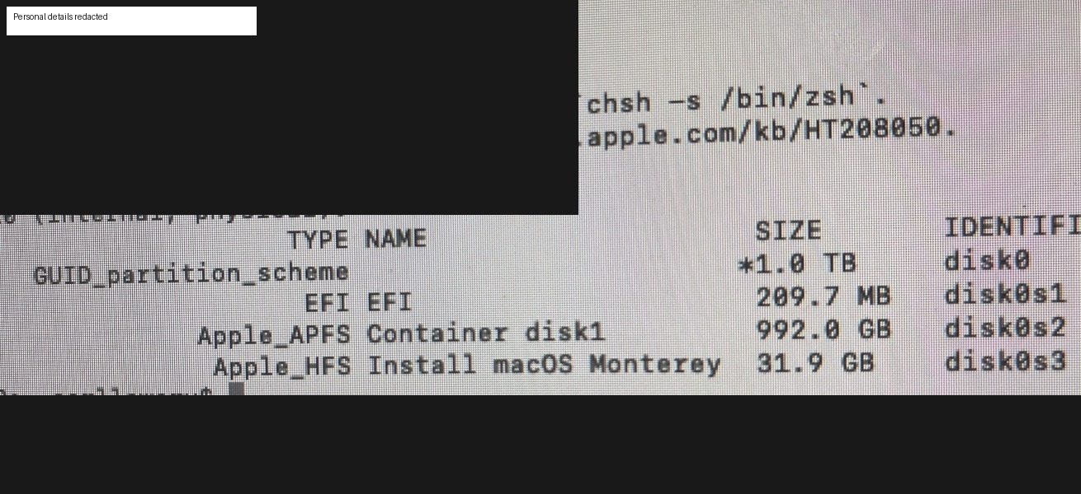
Before cleanup: EFI + 992 GB APFS + 31.9 GB Monterey installer. Personal details are redacted.
STEP 1 — Turn only the installer partition into free space
On this machine the temporary installer was disk0s3:
sudo diskutil eraseVolume free none disk0s3
STEP 2 — Verify before resizing
diskutil list disk0
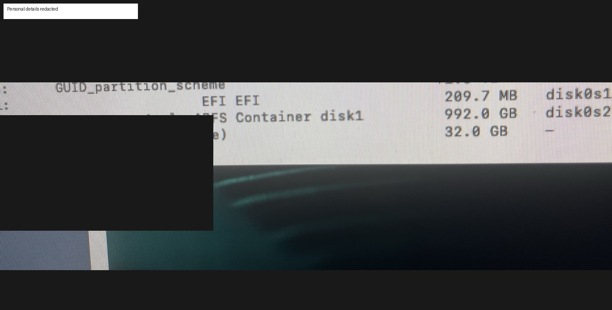
Checkpoint after erase: the installer partition is gone and ~32 GB appears as free space.
CHECKPOINT — STOP if the expected free-space entry is not immediately adjacent to the APFS container. Do not improvise partition commands.
STEP 3 — Expand APFS to all adjacent free space
On this machine the APFS physical store was disk0s2:
sudo diskutil apfs resizeContainer disk0s2 0
STEP 4 — Wait for fsck/APFS checks to finish
The operation may verify multiple APFS volumes and snapshots. Do not interrupt it.
STEP 5 — Verify the final layout
diskutil list disk0
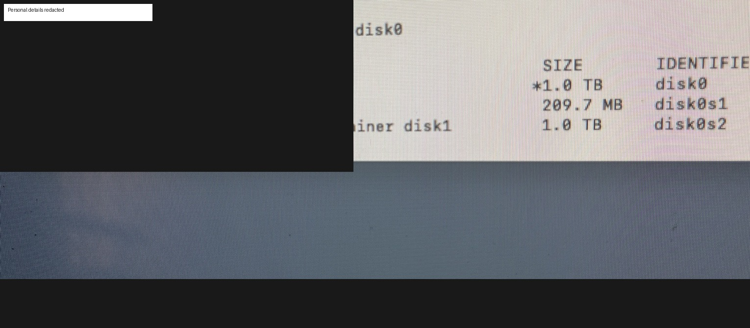
Final layout: EFI preserved and the APFS container restored to essentially the full 1 TB.
CHECKPOINT — The successful operation ended with “Finished APFS operation.” The temporary disk0s3 and the separate 32 GB free-space entry were gone.

Chapter 12 — Final Validation and Everyday-Use Recommendations
Once input and networking were stable, Monterey performed excellently on this iMac. That result matters more than whether a newer OS could technically be forced to boot.

Final validation checklist
- Restart normally and confirm Monterey boots through OpenCore without manual intervention.
- Confirm Wi-Fi is detected after restart. On this case machine the saved network is recognized but does not consistently auto-join; selecting it manually connects immediately. Keep Ethernet as a troubleshooting fallback.
- Confirm the Magic Mouse reconnects automatically. In the final configuration it did so normally after the duplicate Bluetooth records were removed and the mouse was paired fresh.
- Keep a wired USB mouse available as a recovery device.
- Open Finder, browser, System Preferences, Office-type apps, PDFs and media; judge actual responsiveness.
- Avoid moving to Ventura/Sonoma/Sequoia merely for novelty if Monterey is already stable and responsive.
- Keep background/login utilities lean so the 2011 CPU/GPU are not wasting resources on unnecessary services.
TIP — Stopping at a stable, useful OS is often better than maximizing the version number. On this hardware, Monterey became a practical stopping point.

Chapter 13 — Publish and Share the Guide Responsibly
This guide grew out of a real troubleshooting session rather than a clean laboratory install. That is its value: it records not only the successful path, but also the moments where a reader should stop, verify, and avoid compounding an error.
STEP 1 — Make two public formats
Publish a read-only PDF for easy viewing and a DOCX source for people who want to adapt or translate the guide. Keep the redacted screenshots in both versions and never publish the unredacted troubleshooting transcript.
CHECKPOINT — Before every public release, re-check screenshots and Terminal commands for usernames, Wi-Fi names, hardware addresses, passwords, serial numbers, or other identifiers.
STEP 2 — Give the guide a stable home
A small public GitHub repository is a strong home for the guide because it provides version history, a clear README, downloadable releases, and a place to record corrections. A cloud-drive PDF can be kept as a simple mirror for readers who do not use GitHub.
STEP 3 — Share it where owners of unsupported Macs already gather
Good current channels include the r/OpenCoreLegacyPatcher community on Reddit and relevant MacRumors OpenCore/unsupported-Mac threads. Share a short case summary first, then link to the full guide rather than pasting twenty pages into a forum post.
TIP — Do not present this guide as official Dortania documentation. Label it clearly as an independent case-study field guide and link readers to the official OCLP documentation for current support status and releases.
STEP 4 — Use a concise post format
Suggested title: “Field guide: Mid-2011 iMac (iMac12,1) High Sierra → Monterey with OCLP — internal installer workaround, Wi-Fi recovery, Magic Mouse duplicate-entry fix, and disk cleanup.”
Suggested opening: “I documented a complete real-world upgrade of a Mid-2011 21.5-inch iMac to Monterey using OpenCore Legacy Patcher. The guide is organized around STOP/CHECKPOINT steps and includes redacted screenshots, the internal-partition installer workaround, Wi-Fi recovery, the duplicate Bluetooth-device fix that restored the Magic Mouse, and final APFS cleanup.”
STEP 5 — Invite corrections without turning the guide into a support promise
Ask readers to report model identifier, macOS version, OCLP version, the exact step where their result differs, and the relevant Terminal output with private data removed. That produces useful corrections while keeping the guide focused on reproducible evidence.
STEP 6 — Version the guide
Use simple release numbers such as v1.0, v1.1, and v2.0. Record the date, OCLP version, and what changed. Older-Mac patching evolves, so a visible version/date prevents an old field guide from being mistaken for current official instructions.
CAUTION — Do not use GitHub Issues or an OCLP bug tracker simply to promote the guide. Those channels are for project-specific reports and support workflows. Community forums are the better place for a case-study tutorial unless maintainers explicitly request a contribution.

Appendix A — Command Reference
Inspect disks: diskutil list
Inspect disk0: diskutil list disk0
Inspect APFS: diskutil apfs list
Format SD card as GUID/HFS+: diskutil eraseDisk JHFS+ MONTEREY GPT /dev/disk2
Create internal installer partition: sudo diskutil apfs resizeContainer disk0s2 992g JHFS+ MONTEREYINSTALL 0b
Create Monterey install media: sudo /Applications/Install\ macOS\ Monterey.app/Contents/Resources/createinstallmedia --volume /Volumes/MONTEREYINSTALL
Run OCLP root patches: sudo /Applications/OpenCore-Patcher.app/Contents/MacOS/OpenCore-Patcher --patch_sys_vol
List network hardware: networksetup -listallhardwareports
Turn Wi-Fi on: networksetup -setairportpower en1 on
Join Wi-Fi: networksetup -setairportnetwork en1 "YOUR-WIFI-NAME" 'YOUR!PASSWORD'
Test internet: ping -c 4 8.8.8.8
Install/update OCLP pkg: sudo installer -pkg ~/Downloads/OpenCore-Patcher.pkg -target /
Check OCLP version: nvram 4D1FDA02-38C7-4A6A-9CC6-4BCCA8B30102:OCLP-Version
Check OpenCore version: nvram 4D1FDA02-38C7-4A6A-9CC6-4BCCA8B30102:opencore-version
Check BlueToolFixup: kmutil showloaded | grep -i BlueTool
Read Bluetooth log: log show --last 10m --process bluetoothd --style compact | tail -80
Erase temp installer to free space: sudo diskutil eraseVolume free none disk0s3
Grow APFS into adjacent free space: sudo diskutil apfs resizeContainer disk0s2 0
CAUTION — Again: disk identifiers in this appendix are from the case machine. Verify before using any destructive disk command.

Appendix B — Symptom → Meaning → Next Move
Symptom | What it suggested here | Next move
OCLP: “No disks found” | Built-in SD reader was not being offered as external installer media | Use USB media, USB SD reader, or advanced internal partition workaround
Monterey boots but mouse/Wi-Fi are broken | Root patches not yet complete | Run OCLP post-install root patches and reboot
Wi-Fi card visible but not associated | Hardware/patch loaded; association problem remains | Use Ethernet as stable fallback; join Wi-Fi after system is patched
Mouse visible but “Connection rejected” | Discovery works, pairing state is bad | Check for duplicate/stale device records before replacing hardware
bluetoothd “Failed to start scan with error 105” | Bluetooth stack/controller path is struggling | Stop random resets; get reliable wired pointer and inspect device list cleanly
Magic Mouse listed twice | Duplicate pairing records | Delete both entries, power-cycle mouse, rediscover and connect fresh
32 GB installer still on internal SSD | Temporary installer partition not yet reclaimed | Erase only temp partition to free space, verify, then resize APFS

Appendix C — Privacy and Redaction Notes
The original troubleshooting session contained screenshots with user account names, Bluetooth/Wi-Fi hardware addresses, network names and—in one early command history—an actual Wi-Fi credential. This public/shareable guide uses selected screenshots that have been cropped or blotted to remove sensitive information.
CAUTION — Before sharing your own troubleshooting screenshots, check Terminal history and command lines carefully. Passwords can appear in plain text if they were supplied as command arguments.
A separate full-chat working transcript was preserved during the session. This field guide is the organized, shareable companion designed to help another person understand the sequence, checkpoints, mistakes and recovery decisions.
PUBLIC-RELEASE NOTE — The shareable edition should contain only redacted/cropped screenshots. Keep the full raw troubleshooting transcript private because it contains more identifying context than the field guide needs.

