CCICOMP Asynchronous Activity - Internetworking

Lorenz Bernard B. Marqueses S13

**Tasks:**

1. Open a browser, perform an online speed test on your current Internet Connection. Take a screenshot and attach to this document. Identify the ff:
   1. Upload and download speed
   2. Your IP address
   3. Internet Service Provider

1. Identify the following network devices and explain their function in 1-2 sentences.

a.

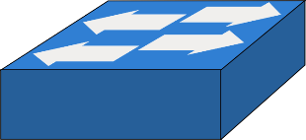

b.

c.

d.

1. Examine the network connection of your computer. Identify the ff:
   1. MAC address
   2. IPv6 address
   3. IPv4 address
   4. Subnet Mask
   5. Default Gateway

How did you get this information from your machine? Describe the step-by-step process.

**1.**

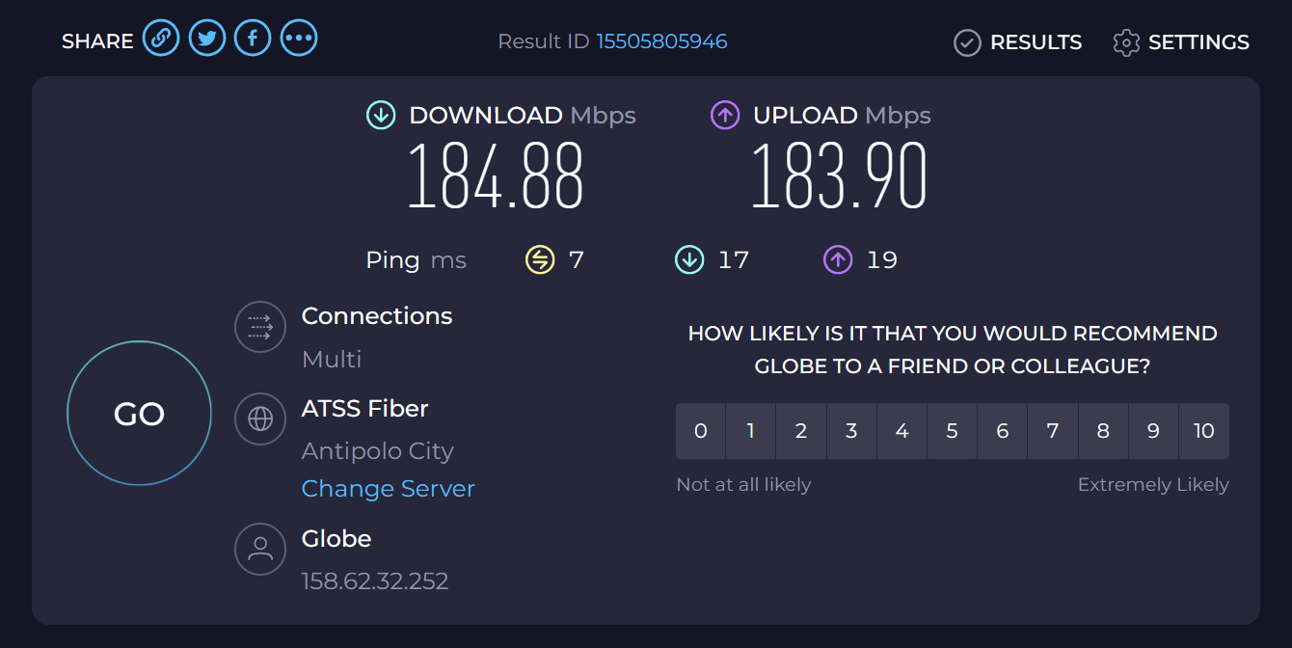

**Download speed:** 184.88 Mbps

**Upload speed:** 183.90 Mbps

**IP address:** 158.62.32.252

**Internet service provider:** Globe

**2.**

1. **Switch**. Switches allow for the formation of connections between devices using **cables** to form a network. They serve as the intermediary between end devices, i.e., servers and clients connected to the network.
2. **Wireless Access Points.** Like switches, WAPs allow for the formation of connections between end devices. However, they do so wirelessly, i.e., WAPs allow *wireless devices* to connect together and form a network.
3. **Router.** Routers connect networks, calculating the best possible *route* to move data around.
4. **Firewall.** Firewalls serve as a *shield* that filters out unwanted data from a network, preventing access.

**3.**

1. 74:97:79:59:c0:49
2. fe80::2aef:e86a:55b0:eb2f%17
3. 192.168.254.129
4. 255.255.255.0
5. 192.168.254.254

This information can be found by opening **Command Prompt** and entering the command ipconfig /all. The /all flag is required to see the physical address (MAC), as it displays information in more detail than simply running ipconfig. An alternative way is to view **Network & internet > Advanced network settings > Hardware and connection properties** in the Windows 11 Settings application.