*Business Calculus Week 10*

Functions of Several Variables

The function $f\left(x,y\right)=x^{2}+y^{2}$ is so called *a function of two variables*. These two variables are $x$ and $y$. For each ordered pair $(x,y)$, the function $f$ returns a real number $f(x,y)$.

Let say $\left(x,y\right)=(2,3)$. It means $x=2$ and $y=3$. We then have

$$f\left(2,3\right)={\left(2\right)}^{2}+{\left(3\right)}^{2}=4+9=13.$$

The domain of a function $f(x,y)$ is the set of all ordered pairs $(x,y)$ at which $f(x,y)$ is well defined.

Also, the range of $f(x,y)$ is the set of all values $f(x,y)$ given by ordered pairs $(x,y)$ inside the domain of $f(x,y)$.

Example. The domain of $f\left(x,y\right)=x^{2}+y^{2}$ is

$$\left\{\left(x,y\right) | all possible ordered pairs \left(x,y\right)\right\}$$

Q. Let $f\left(x,y\right)=\frac{\sqrt{x}}{y}$.   
(1) Find the domain of $f(x,y)$.  
(2) Find $f(4,3)$.

>

>

>

>

Q. Find the domain of the function $f\left(x,y\right)=\frac{1}{x-y}$.

>

>

>

The graph of a two-variable function is displayed on the three dimensional coordinate system. The graph of $f(x,y)$ is the surface $z=f(x,y)$ on $(x,y,z)$ coordinate space. For example,

$$f\left(x,y\right)=x^{2}+y^{2} .$$

In the below figure, the red line (pointing left) is the x-axis, the green line (pointing right) is the y-axis, and the blue line (pointing up) is the z-axis. The plane on the floor is the xy-plane in this (x,y,z) coordinate space.

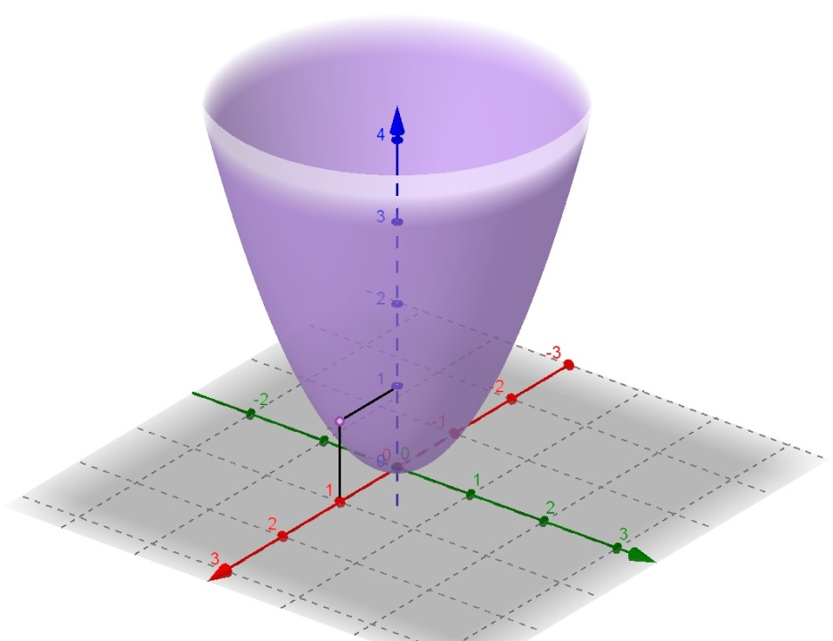

The purple-shaded surface is the graph of $f(x,y)$, denoted by $z=x^{2}+y^{2}$. For example, I pick the ordered pair $(1,0)$ on the xy-plane, and then draw a vertical line above $(1,0)$ until it hits the surface at a point.

We know that $f\left(1,0\right)=1$. So the z-coordinate of that point is $1$. That point is $(1,0,1)$.

Differentiation on a two variable function is by taking partial derivatives. Given a function $f(x,y)$, it has two partial derivatives, one coming from $x$ and other coming from $y$, which are

$$\frac{∂f}{∂x} and \frac{∂f}{∂y} .$$

Partial derivatives. At a point $(x,y)$ in the domain of $f(x,y)$.

$$\frac{∂f}{∂x}=\lim_{h→0}{\frac{f\left(x+h,y\right)-f\left(x,y\right)}{h}}⁡$$

$$\frac{∂f}{∂y}=\lim_{h→0}{\frac{f\left(x,y+h\right)-f\left(x,y\right)}{h}}$$

We are finding partial derivatives by differentiation formulas.

1. When finding $\frac{∂f}{∂x}$, we treat $y$ as a constant and differentiate everything with respect to $x$. All differentiation formulas apply.
2. When finding $\frac{∂f}{∂y}$, we treat $x$ as a constant and differentiate everything with respect to $y$. All differentiation formulas apply.

There are two ways to write down partial derivatives.

$$f_{x}\left(x,y\right)=\frac{∂f}{∂x}(x,y)$$

$$f_{y}\left(x,y\right)=\frac{∂f}{∂y}(x,y)$$

Q. Let $f\left(x,y\right)=x^{4}y^{3}$. Find $\frac{∂f}{∂x}$ and $\frac{∂f}{∂y}$.

>

>

>

Q. Let $f\left(x,y\right)=4x^{3}-3x^{2}y^{2}-2y^{2}$.

(1) Find $f_{x}$ and $f_{y}$.   
(2) Find $f_{x}(-1,1)$ and $f_{y}(-1,1)$.

>

>

>

>

>

>

>

>

>

Q. Let $f\left(x,y\right)=y \left(\ln{x}\right)+xe^{y}$. Find $\frac{∂f}{∂x}$ and $\frac{∂f}{∂y}$.

>

>

>

>

>

>

>

>

>