*Business Calculus - Week 11*

Functions of Several Variables (2)

We start with mentioning more on the graph of a function $f(x,y)$. Then we go to see some application problems, and discuss more on partial differentiation.

The three dimensional coordinate system is the space that consists of three coordinate axes. They are x-axis, y-axis and z-axis. In this space, denoted by $R^{3}$, we can talk about both left-and-right, front-and-back, and up-and-down, just like this space that we are living in.

A point inside the three dimensional coordinates is represented by its x-coordinate, y-coordinate and z-coordinate. For example, a point is

$$\left( 3 , 2 , 1 \right).$$

Here 3 is the x-coordinate, 2 is the y-coordinate and 1 is the z-coordinate of this point (3,2,1).

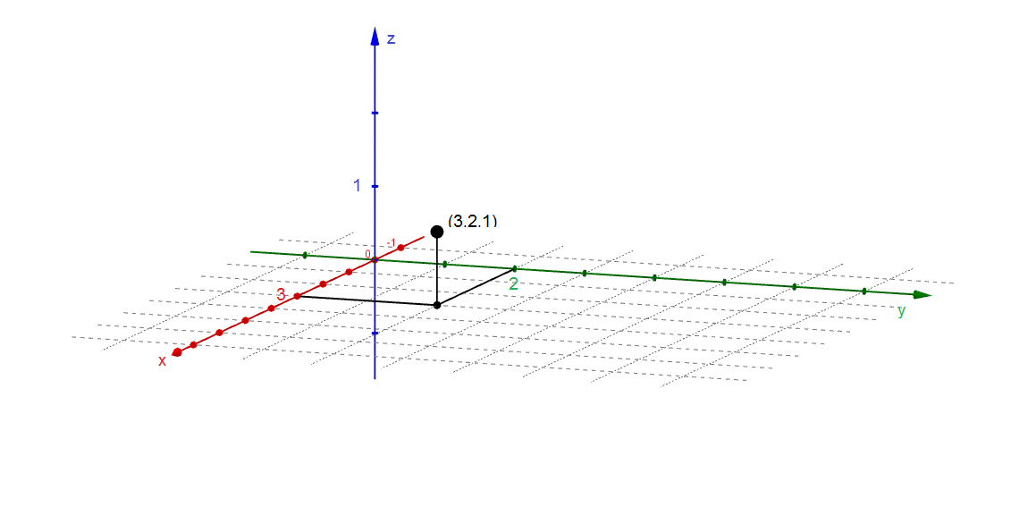

The graph of a function $f(x,y)$ consists of points $(x,y,z)$ in the three dimensional coordinate system of which

1. the ordered pair $(x,y)$ lies on the domain of $f(x,y)$,
2. and $z=f(x,y)$

In set language, the graph of $f(x,y)$ is

$$\left\{\left(x,y,z\right) \right| \left(x,y\right) is in the domain of f\left(x,y\right) , z=f(x,y)\} .$$

Example. Let $f\left(x,y\right)=x^{2}+y^{2}$.

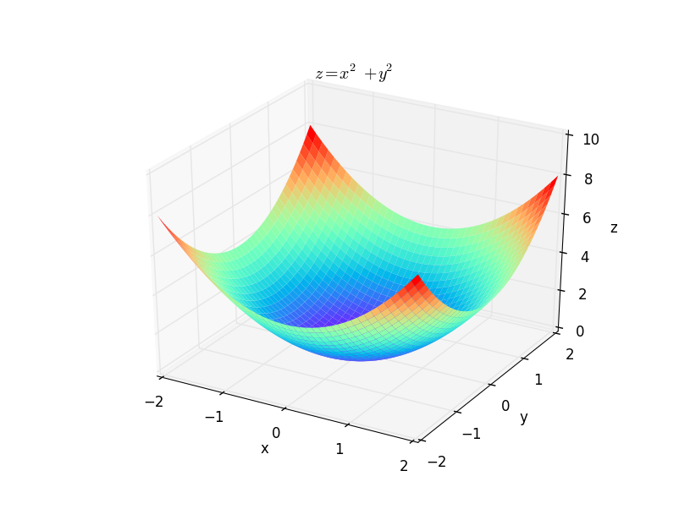

There are some points on the graph of $f(x,y)$ that draw extra attention. They are (1) relative maximum point(s), (2) relative minimum point(s), and (3) saddle point(s).

Relative maximum point. [textbook, p.469]  
A point $(a,b,c)$ on the surface $z=f(x,y)$ is a relative maximum point if

$$f\left(a,b\right)≥f\left(x,y\right)$$

for all (x,y) close to (a,b).

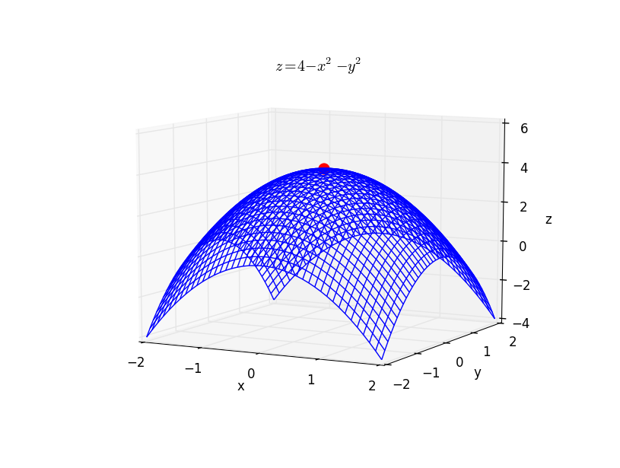

Relative minimum point. [textbook, p.469]  
A point $(a,b,c)$ on the surface $z=f(x,y)$ is a relative minimum point if

$$f\left(a,b\right)≤f(x,y)$$

for all (x,y) close to (a,b).

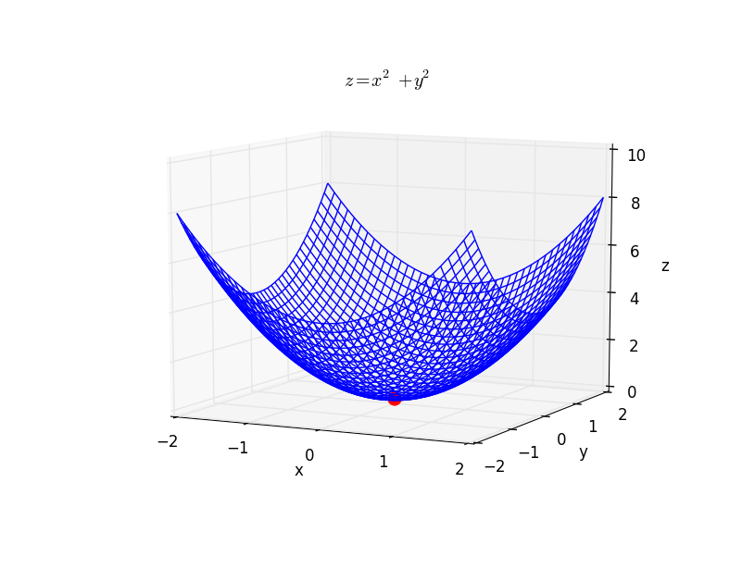

Saddle point. [textbook, p.469]  
A saddle point $(a,b,c)$ on the surface $z=f(x,y)$ is the highest point along one curve on the surface, but is the lowest point along another curve on the surface,

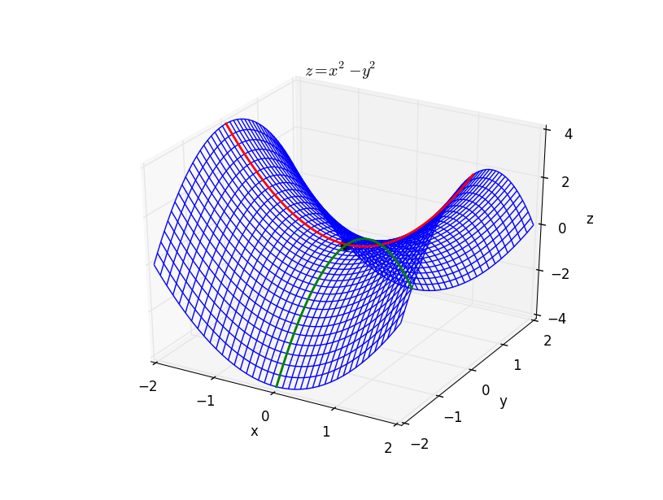

A relative extreme point is either a relative maximum point or a relative minimum point. A saddle point is **not** a relative extreme point.

***

We continue our discussion on partial derivatives. We can interpret partial derivatives as rates of change. [textbook, p.478]

Given a function of two variables $f(x,y)$, $f_{x}\left(x,y\right)$ is the instantaneous rate of change of $f$ with respect to $x$ when $y$ is held constant. Similarly, $f_{y}(x,y)$ is is the instantaneous rate of change of $f$ with respect to 𝑦 when $x$ is held constant.

For example, when $C(x,y)$ is the cost function for $x$ units of product A and $y$ units of product B. Then, $C_{x}(x,y)$ is the marginal cost function for   
product A, keeping production level of product B the same. On the other hand, $C_{y}(x,y)$ is the marginal cost function for product B, keeping production level of product A the same.

Q. A company sells donuts and bagels. It costs $0.5 to make a donut and $1 to make a bagel. The fixed cost is $50 per day. Find the cost function (per day), and use it to find the cost of producing 100 donuts and 30 bagels.

>

>

>

>

>

>

Q. An electronics company’s profit $P(x,y)$ from making $x$ DVD players and $y$ CD players per day is given by

1. Find the marginal profit function for DVD players.

2. Evaluate your answer to part (a) at x=200 and y=300.   
Interpret your answer.

>

>

>

>

>

>

>

>

For a function $f(x,y)$, $f_{x}(x,y)$ and $f_{y}(x,y)$ are so-called the first order partial derivatives. At the same time, we have higher-order partial derivatives. Very often we look at the first and second order partials of a function $f(x,y)$ only.

The second order partials of a function $f(x,y)$ are

$$f_{xx}=\frac{∂^{2}}{∂x^{2}}f=\frac{∂}{∂x}\left(\frac{∂f}{∂x}\right)$$

$$f_{yy}=\frac{∂^{2}}{∂y^{2}}f=\frac{∂}{∂y}\left(\frac{∂f}{∂y}\right)$$

$$f_{xy}=\frac{∂^{2}}{∂y ∂x}f=\frac{∂}{∂y}\left(\frac{∂f}{∂x}\right)$$

$$f_{yx}=\frac{∂^{2}}{∂x ∂y}f=\frac{∂}{∂x}\left(\frac{∂f}{∂y}\right)$$

Q. Let $f\left(x,y\right)=4x^{2}-3x^{3}y^{2}+5y^{5}$.   
Find the second-order partials $f_{xx}$, $f_{xy}$, $f_{yx}$ and $f_{yy}$.

>

>

>

>

>

>

>

>

>

>

We have a useful formula.

$$f_{xy}=f_{yx}$$

Q. Let $f\left(x,y\right)={\left(xy+1\right)}^{3}$.   
Find the second-order partials $f_{xx}$, $f_{xy}$, $f_{yx}$ and $f_{yy}$.

>

>

>

>

>

>

>

>

>

>

Finally we mention that partial differentiation is applicable on functions of two or more variables. For example now,

$$f\left(x,y,z\right)=xyz .$$

It has three (first order) partial derivatives,

$$\frac{∂f}{∂x} , \frac{∂f}{∂y} and \frac{∂f}{∂z} .$$

The second-order partials of $f(x,y,z)$ are $f_{xx}$, $f_{yy}$, $f_{zz}$, $f_{xy}$, $f_{yx}$, $f_{yz}$, $f_{zy}$, $f_{xz}$, $f_{zx}$. There are nine of them with $f_{xy}=f_{yx}$, $f_{yz}=f_{zy}$ and $f_{xz}=f_{zx}$.

We use the same skill to find these partials: differentiate with respect to one variable every time, while treating other variables as constant.

Q. $f\left(x,y\right)=\frac{xy}{x+y}$. Find $f_{x}$ and $f_{y}$.

>

>

>

>

>

>

>

>

>

>

Q. $f\left(x,y\right)={\left(x^{2}+xy+1\right)}^{4}$. Find $f_{x}$ and $f_{y}$.

>

>

>

>

>

>

>

>

>

>

Optimizing Functions of Several Variables

Given a function $f(x,y)$, we first define a critical point of $f(x,y)$.

A point $(a,b)$ in the domain of $f(x,y)$ is a critical point of $f(x,y)$ if

$$\frac{∂f}{∂x}\left(a,b\right)=0 and \frac{∂f}{∂y}\left(a,b\right)=0.$$

We still call the xy-coordinate $(a,b)$ of a relative maximum/minimum point $(a,b,c)$ by a relative maximum/minimum point. In particular, all relative maximum, points, relative minimum points and saddle points of $f(x,y)$ are CPs of $f(x,y)$.

The second derivative test is used for classifying a CP. When $f(x,y)$ is a function of two variables, this second derivative test is called the D-test.

D-test. Suppose $(a,b)$ is a critical point of a function $f(x,y)$. Let

$$D=f_{xx}\left(a,b\right)⋅f_{yy}\left(a,b\right)-{\left[f_{xy}\left(a,b\right)\right]}^{2} .$$

Then, is a

1. relative maximum point if and .

2. relative minimum point if and .

3. saddle point if $D<0$.

Finding a relative maximum/minimum point, or a saddle point of $f(x,y)$ means that we

1. find CPs of $f(x,y)$ by setting $f_{x}=0$ and $f_{y}=0$,
2. find the second-order partials of $f\left(x,y\right)$ and the $D$-value at CPs.
3. and look at $f_{xx}$ at CPs if necessary.

Q. Find the relative extreme values of the function $f(x,y)$.

$$f\left(x,y\right)=2x^{2}+3y^{2}+2xy+4x-8y$$

>

>

>

>

>

>

>

>

>

>

>

>

>

>

>

>

>

>

>

>

>

Q. Find the relative extreme values of the function $f(x,y)$.

$$f\left(x,y\right)=x^{3}-y^{2}-3x+6y$$

>

>

>

>

>

>

>

>

>

>

>

>

>

>

>

>

>

>

>

>

>

Q. Find the relative extreme values of the function $f(x,y)$.

$$f\left(x,y\right)=-x^{2}-y^{3}-6x+3y+4$$

>

>

>

>

>

>

>

>

>

>

>

>

>

>

>

>

>

>

>

>

>

Q. [Company’s Profit, textbook P.496]

A company manufactures two products. The price function for product A is

$$p=12-\frac{1}{2}x , for 0≤x≤24.$$

The price function for product B is

$$q=20-y , for 0≤y≤20.$$

Both $p$ and $q$ are in thousands of dollars. $x$ are $y$ are the amounts of products $A$ and $B$ produced, respectively. The cost function is

$$C\left(x,y\right)=9x+16y-xy+7$$

in thousands of dollars. Find the quantities and the prices of the two products that maximize profit. Also find the maximum profit.

>

>

>

>

>

>

>

>

>

>

>

>

>

>

>

>

>

>

>

>

>

>

>

>

>

>

>

>

>

>

>

>

>

>

>

>

Q. [Drug Dosage, textbook P.497]

In a laboratory test, the combined antibiotic effect of $x$ milligrams of medicine A and $y$ milligrams of medicine B is given by the function

$$f\left(x,y\right)=xy-x^{2}-y^{2}+11x-4y+120 .$$

Here $0≤x≤55$ and $0≤y≤60$. Find the amounts of the two medicines that maximize the antibiotic effect.

>

>

>

>

>

>

>

>

>

>

>

>

>

>

>

>

>

Lagrange Multipliers and Constrained Optimization

In the previous lecture, we are optimizing a function $f(x,y)$. For example, we find the relative extreme values of a function

$$f\left(x,y\right)=x^{3}-y^{2}-3x+6y .$$

Some optimization problems are with certain constraints. For example, we are maximizing

$$f(x,y)=2x+2xy+y subject to 2x+y=100.$$

The function $f(x,y)$ can get as large as possible in value, so it doesn’t make sense to maximize $f(x,y)$ per se. However, when we further require that $2x+y=100$, $f(x,y)$ attains a maximum value at some point $(x,y)$ at which $2x+y$ is 100.

In general, a constrained optimization problem is of the form:

maximize(or minimize) $f(x,y)$, subject to $g\left(x,y\right)=0$.

The condition “ $g\left(x,y\right)=0$” is the constraint on the optimization problem. The method of Lagrange multipliers is a method to solve constrained optimization problems.

Lagrange multiplier. [textbook, p.513]  
Maximize (or minimize) $f\left(x,y\right)$ subject to .

1. Write .

2. Set the partial derivatives of $F\left(x,y\right)$ to be zero.

$$F_{x}=0, F_{y}=0 and F_{z}=0.$$

Solve for critical points.

3. The solution to the oirginal problem (if exists) will occur at one of these   
 critical points.

Q. Use Lagrange multipliers to find the maximum and minimum values of

$$f\left(x,y\right)=2xy$$

subject to the constraint $x^{2}+y^{2}=18$.

>

>

>

>

>

>

>

>

>

>

>

>

>

>

>

>

>

>

>

>

Q. Use Lagrange multipliers to find the maximum value of

$$f\left(x,y\right)=2x+2xy+y$$

subject to the constraint $2x+y=100$. (The maximum value exists.)

>

>

>

>

>

>

>

>

>

>

>

>

>

>

>

>

>

>

>

>

Q. Use Lagrange multipliers to find the minimum value of

$$f\left(x,y\right)=5x^{2}+6y^{2}-xy$$

subject to the constraint $x+2y=24$. (The minimum value exists.)

>

>

>

>

>

>

>

>

>

>

>

>

>

>

>

>

>

>

>

>

Q. Use Lagrange multipliers to find the maximum value of

$$f\left(x,y\right)=e^{\left(x+2\right)\left(y-3\right)}$$

subject to the constraint $x+3y=1$. (The maximum value exists.)

>

>

>

>

>

>

>

>

>

>

>

>

>

>

>

>

>

>

>

>

Q. A cardboard box with a square base and without a lid, is to a have a volume of 32,000 $cm^{3}$. Find the dimensions that minimize the amount of cardboard used.

>

>

>

>

>

>

>

>

>

>

>

>

>

>

>

>

>

>

>

>

>

>

>

>

>

>

>

>

>

>

>

>

>

>

>

>

>

>

>

>

>

>

>