*Business Calculus – Week 1*

Real Numbers and Inequalities

Real numbers are $0, 1, 2006, 2.2124, π, \sqrt{2},$ and so on. They are points on the number line.

0

Q. Mark the numbers $5$ and $-2.1$ on the number line.

Inequalities express the order of real numbers. For example

|  |  |
| --- | --- |
| $$a<b$$ | $a$ is smaller than $b$. |
| $$a<b<c$$ | $a$ is smaller than $b$, and $b$ is smaller than $c$. |
| $$a≥b$$ | $a$ is greater than or equal to $b$. |
| $$-10<-3$$ |  |
|  | $2$ is between $-1$ and $5$. |

Sets and intervals are commonly seen in this course.

|  |  |
| --- | --- |
|  | The set of all $x$ such that $x$ is greater than . |
|  | The set of all $x$ such that $x$ is between $-2$ and . |
|  | The set of all $x$ such that $x$ is between $-1$ and $2$, including endpoints. |

Those sets on the left hand side are called intervals.

|  |  |  |
| --- | --- | --- |
|  |  | The closed interval from $a$ to $b$. |
| $$(3,5)$$ |  | The open interval from $3$ to $5$. |
| $$(-1,10]$$ |  | The left-open interval from $-1$ to $10$. |
| $$\left[-2,5\right)$$ |  | The right-open interval from $-2$ to $5$. |

Describe intervals: http://www.mathquickeasy.com/types_of_intervals.html

In addition to finite intervals, we have infinite intervals.

|  |  |  |
| --- | --- | --- |
|  |  | The closed interval from $a$ to plus infinity. |
| $$(3 ∞)$$ |  |  |
| $$(-∞,1]$$ |  |  |
| $$(-∞, 10)$$ |  |  |

**You may hear that $\left[a, ∞\right)$ is called the closed ray from $a$ to plus infinity.

On the Cartesian plane, a point is specified uniquely by an ordered pair $(x,y)$. $x$ is the x-coordinate, and $y$ is the y-coordinate of that point.

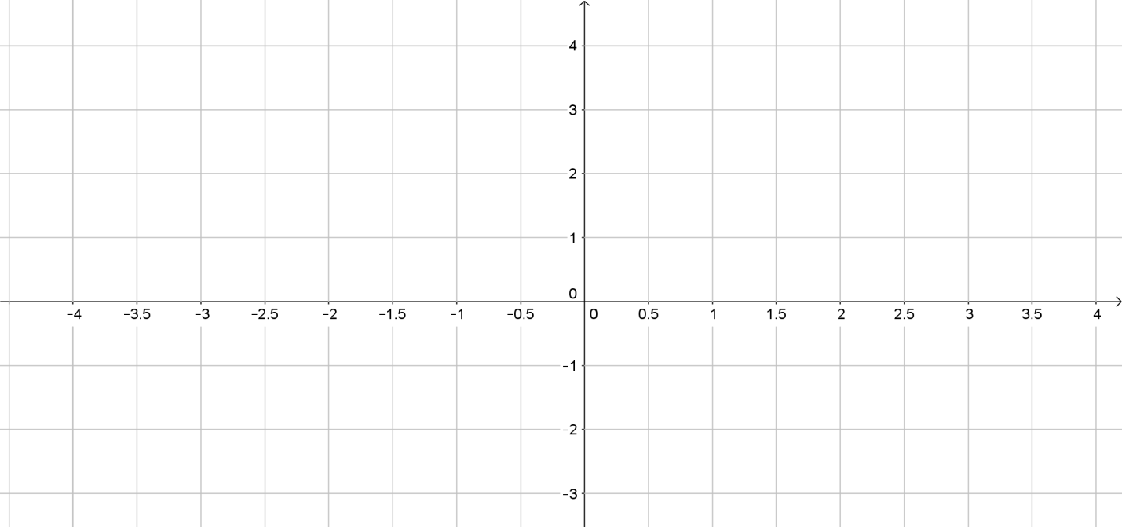

Q.Mark and label the point (1,2), (-2,3), (-3,-3) and (3,-1).

Two points $\left(x_{1},y_{1}\right)$ and $(x_{2},y_{2})$ determine a line on the Cartesian plane. The slope of the line through $\left(x_{1},y_{1}\right)$ and $\left(x_{2},y_{2}\right)$ is

$$m= \frac{Δy}{Δx}=\frac{y_{2}-y_{1}}{x_{2}-x_{1}}.$$

The terms $Δx$ and $Δy$ are called the change in $x$ and the change in $y$. If we put $Δx=1$ to the slope formula, we get $m=Δy$. In other words, slope is the amount that the line rises when $x$ is increased by $1$.

Q. Find the slope of the line through pairs of points below. Graph the lines.

1. (2,1) and (3,4)
2. (-1,10) and (5,7)

>

>

>

>

>

>

>

>

Very often we have to find the equation of a line. There are two forms of a line equation.

1. Slope-intercept form of a line.

If $m$ is the slope of a line and $b$ is the y-intercept of the line, then the line equation is given by $y=mx+b$

1. Point-slope form of a line.

If $m$ is the slope of a line and $(x_{1},y_{1})$ is a point on the line, then the line equation is given by $y-y_{1}=m(x-x_{1})$.

A general linear equation of a line is in the form of $ax+by=c$ for some constants $a,b,c$. Whenever you see this equation, immediately you know it represents a line on the Cartesian plane.

We also have the following facts about line equations.

1. A horizontal line is given by the equation $y=a$.

A vertical line is given by the equation $x=b$.

The slope of a horizontal line is $0$, and that of a vertical line is undefined.

1. Two lines $l_{1}$ and $l_{2}$ are   
   (a) parallel to each other if they have the same slope, i.e. $m_{1}=m_{2}$.

(b) perpendicular to each other if $m_{1}=-\frac{1}{m_{2}}$.

Q. Write down the linear equation of the line passing through (5,3)   
and (7,-1) in the slope-intercept form. >

>

>

>

>

>

>

Q. Given the linear equation $2x-3y=12$, find the slope $m$ and the y-intercept $b$. Draw the graph.

>

>

>

>

>

>

Exponents

For any positive integer $n$, $x^{n}=x⋅x⋅x⋯x$ for $n$ many $x$ on the right hand side. In the term $x^{n}$, $x$ is called the base, and $n$ is called the exponent or power.

|  |  |
| --- | --- |
| Formula | Example |
| $$x^{m}⋅x^{n}=x^{m+n}$$ |  |
| $$\frac{x^{m}}{x^{n}}=x^{m-n}$$ |  |
| $${\left(x^{m}\right)}^{n}=x^{m⋅n}$$ |  |
| $${\left(xy\right)}^{n}=x^{n}⋅y^{n}$$ |  |
| $${\left(\frac{x}{y}\right)}^{n}=\frac{x^{n}}{y^{n}}$$ |  |

When $x≠0$, we have the below formulas for zero and negative exponents.

|  |  |
| --- | --- |
| Formula | Example |
| $$x^{0}=1$$ |  |
| $$x^{-1}=\frac{1}{x}$$ |  |
| $$x^{-n}=\frac{1}{x^{n}}$$ |  |

Formulas for roots and fractional exponents are stated below.

|  |  |
| --- | --- |
| Formula | Example |
| $$x^{1/2 }=\sqrt{x}$$ |  |
| $$x^{1/3}=\sqrt[3 ]{x}$$ |  |
| $$x^{1/n}=\sqrt[n ]{x}$$ |  |
| $$x^{m/n }={\left(\sqrt[n]{x}\right)}^{m}=\sqrt[n]{x^{m}}$$ |  |

Q. Evaluate each expression.

${\left( \frac{3}{4} \right)}^{-1}$

${\left(-27\right)}^{2/3}$

${16}^{3/4}$

>

>

>

>

>

>

Q. Write each expression in power form $ax^{b}$ for numbers $a$ and $b$.

a. $\frac{18}{{\left(3\sqrt[3]{x}\right)}^{2}}$

b. $\frac{10\sqrt{x}}{2\sqrt[3]{x}}$

>

>

>

>

>

>

>

>

Q. Simplify the expression. $\frac{{\left(5xy^{4}\right)}^{2}}{25x^{3}y^{3}}$.

>

>

>

>

>

>

Linear and Quadratic Functions

A function $f$ is assigning each number $x$ to another number $f(x)$. For example, the function $f\left(x\right)=x^{2}$ assigns $1$ to $f\left(1\right)=1^{2}=1$, $2$  
 to $f\left(2\right)=2^{2}=4$ and so on.

Domain of $f$ = the set of all values $x$ at which $f(x)$ is well defined.

Range of $f$ = the set of all values $f(x)$.

Q. Let $f\left(x\right)=x^{2}+1$, $-1≤x≤5$. Find the domain and range of $f(x)$.

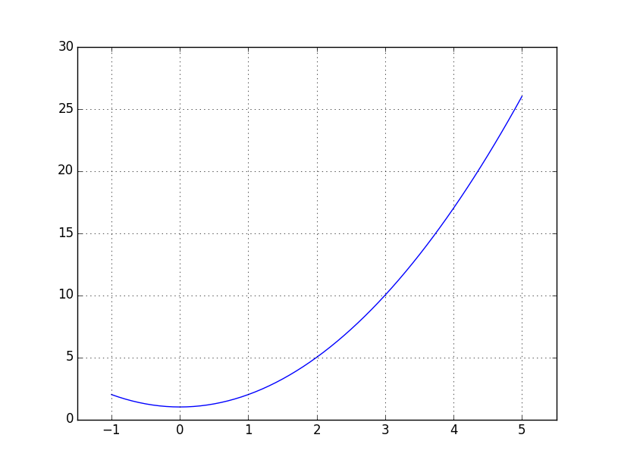

>

>

Q. Find the domain and range of the following functions.

a) $f\left(x\right)=x^{2}+4$.

b) $f\left(x\right)=\sqrt{x-2}$

>

>

>

A linear function is a function in the form $f(x)=mx+c$ for some constants $m$ and $c$. The graph of $f(x)$ is a line, of slope $m$ and y-intercept $c$.

A quadratic function is a function in the form $f\left(x\right)=ax^{2}+bx+c$ for some constants $a, b, c$, where $a≠0$. Its graph is called a parabola.

Example. The graph of $f\left(x\right)=x^{2}+1$ and $f\left(x\right)=-x^{2}+1$.

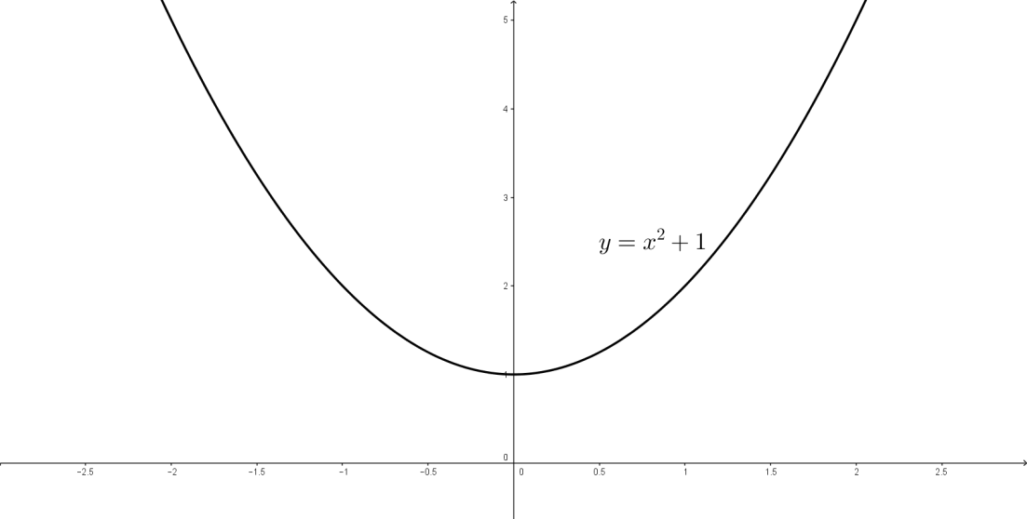

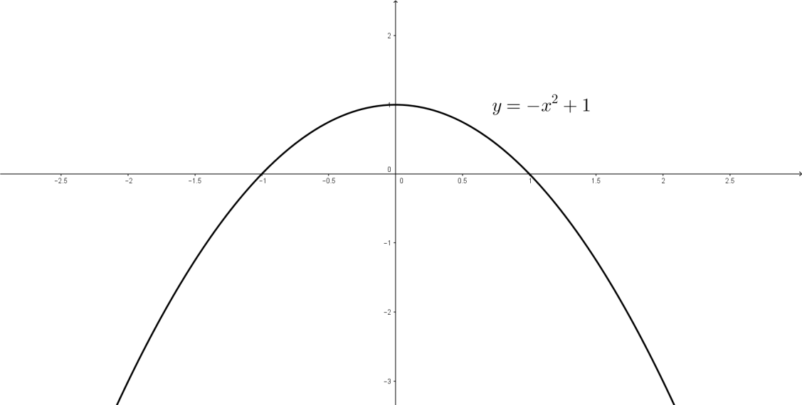

Q. Identify the constants $a,b,c$ in the function $f\left(x\right)=3x^{2}+2x+5$.

>

>

>

Suppose we have a quadratic function $f\left(x\right)=ax^{2}+bx+c$, $a≠0$.

|  |  |  |
| --- | --- | --- |
| *If* | *then* | Example |
| $$a>0$$ | $f(x)$ opens upward. | $$f\left(x\right)=x^{2}+1$$ |
| $$a<0$$ | $f(x)$ opens downward. | $$f\left(x\right)=-x^{2}+1$$ |

The vertex of the parabola $f\left(x\right)=ax^{2}+bx+c$, has x-coordinate $x=-\frac{b}{2a}$.  
Therefore, its vertex is the point $x=-\frac{b}{2a} , y=f\left(-\frac{b}{2a}\right)$.

Q. Find the x-coordinate of the vertex of $f\left(x\right)=3x^{2}+2x+5$.

>

>

>

>

Solving a quadratic equation $ax^{2}+bx+c=0$ is exactly finding the x-intercept(s) of the quadratic function $f\left(x\right)=ax^{2}+bx+c$.

There are two ways of solving a quadratic equation. By (1) factorization, or by (2) quadratic formula, which is stated as follows.

The solution to $ax^{2}+bx+c=0$ is

$$x=\frac{-b±\sqrt{b^{2}-4ac}}{2a}$$

whenever $b^{2}-4ac≥0$

Q. Solve the following quadratic equations.

a. $x^{2}-3x+2=0$

b. $x^{2}-2x-8=0$

>

>

>

>

>

>

Q. Find the domain of the function $f\left(x\right)=\frac{1}{x^{2}-4x+3}$.

>

>

>

>

>

>

Example. (P.40) A company that installs automobile CD players finds that, if the company installs $x$ CD players per day, then its costs will be $C\left(x\right)=130x+5000$ 
 and its revenue will be $R\left(x\right)=-2x^{2}+500x$  
(both in dollars). Find the profit function $P(x)$ of the company.

>

>

>

Functions: Polynomial, Rational and Exponential

Polynomials are functions in the forms

$f\left(x\right)=a_{n}x^{n}+a_{n-1}x^{n-1}+⋯+a_{0}$.

For example, $f(x)=3x^{3}+4x^{2}+5x+7$ is a polynomial of degree 3.

A rational function is a quotient of two polynomials. For example,

$$f\left(x\right)=\frac{2x+1}{x-1}.$$

The domain of a rational function is the set of numbers $x$ at which the bottom polynomial is non-zero. Using the above rational function,

$Domain of f\left(x\right)=\left\{x \right| x≠1\}=(-∞,1)∪(1,∞)$.

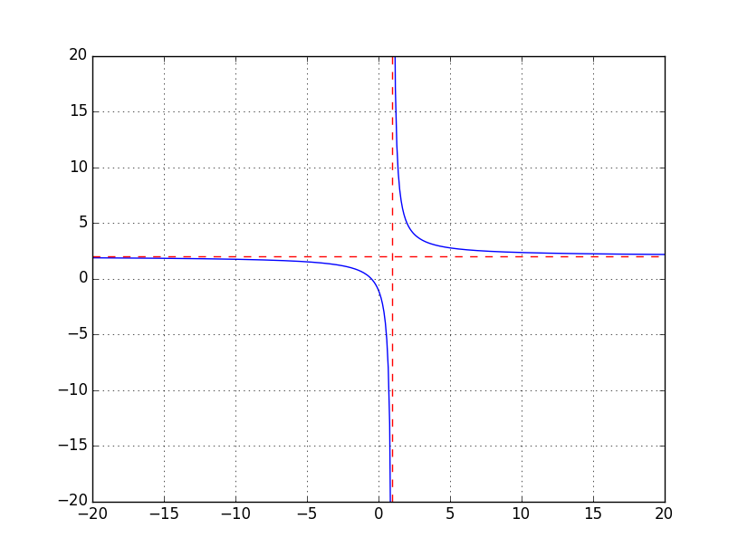

An exponential function is a function in the form $f\left(x\right)=a^{x}$ for some   
non-zero number $a$. For example, $f\left(x\right)=3^{x}$ or $f\left(x\right)={0.5}^{x}$.

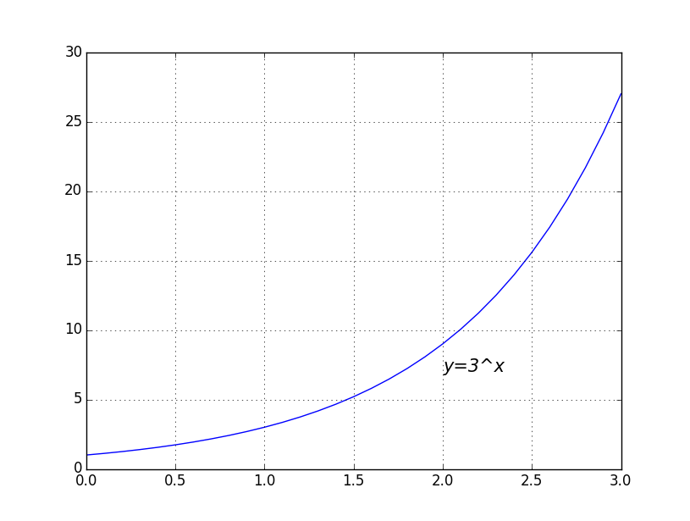

The absolute value function is

$$f\left(x\right)=\left|x\right|=\left\{\begin{aligned}x when x≥0 \\ -x when x<0\end{aligned}\right.$$

Q. Draw the graph of the absolute value function.

>

>

>

A piecewise linear function is a function defined by different formulas on different intervals. The function $f\left(x\right)=|x|$ above is a good example of piecewise linear functions.

Q. Express $f\left(x\right)=\left|x+1\right|$ in the form of a piecewise linear function.

>

>

A composite function is a function defined by the composition of two functions. Suppose we have two functions $f\left(x\right)=x+1$ and $g\left(x\right)=2x$.

The composition of $f$ with $g$, (or the function $f∘g$) is defined by $$\left(f∘ g\right)\left(x\right)=f\left(g\left(x\right)\right).$$ 
For example, $f\left(g\left(1\right)\right)=f\left(2\right)=2+1=3$. We are finding (1) g(1) first, and then (2) use x=g(1)=2 as an input and put it to the formula f(x)=x+1. In general, $$\left(f∘g\right)\left(x\right)=f\left(g\left(x\right)\right)=f\left(2x\right)=2x+1 .$$

Note $\left(g∘f\right)\left(x\right)=g\left(f\left(x\right)\right)=g\left(x+1\right)=2\left(x+1\right)=2x+2≠\left(f∘g\right)\left(x\right) .$ $f∘g$ 
 and $g∘f$ are basically two different functions.

Q, Let $f\left(x\right)=x^{2}+1$. Find $f(x+1)$.

>

>

>

>

The difference quotient of a function $f(x)$ is the quantity

$$\frac{f\left(x+h\right)-f(x)}{h} .$$

The top is the change in $f$ when $x$ increases to $x+h$. The bottom captures the change in $x$, which is $h$ by default.

Q. Let $f\left(x\right)=x^{2}$. Find its difference quotient and simplify your answer.

>

>

>

>