*Business Calculus – Week 2*

Limits and Continuity

The notation $x→3$ means $x$ approaches 3. It describes the process that the variable $x$ is getting closer and closer to $3$. For example,

$$x=2.9, x=2.99, x=2.999, x=2.9999, x=2.9999,$$

and so on. Let $f\left(x\right)$ be a function of $x$. In this section, we are interested in finding this limit as $x$ approaches 3 of $f(x)$,

$$\lim_{x→3 }{f(x)} .$$

It means the value that the function $f(x)$ goes to when $x$ approaches 3. Take $f\left(x\right)=2x+5$ as an example. A very simple method to get this limit is to draw a table.

|  |  |
| --- | --- |
| $$x$$ | $$f\left(x\right)=2x+5$$ |
| 2.9 | 10.8 |
| 2.99 | 10.98 |
| 2.999 | 10.998 |
| … | … |

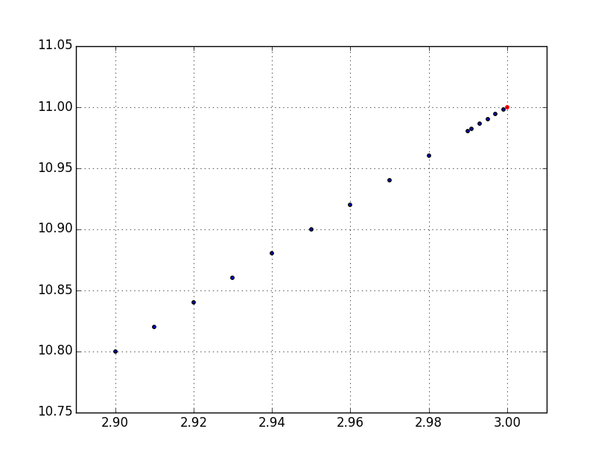

The blue dots represent $f\left(2.9\right)=10.80, f\left(2.99\right)=10.98, f\left(2.999\right)$ and other values of $f\left(x\right)$ at the corresponding $x$. We can see that the blue dots are approaching the red dot. The red dot is the point $(3,11)$. So we say $$\lim_{x→3}{(2x+5)}=11 .$$

The function $f\left(x\right)=2x+5$ approaches 11 when $x$ approaches $3$. In a more rigorous context, the concept of *limit* is defined as follows.

The statement

$$\lim_{x→c}{f\left(x\right)=L}$$ means that the value $f(x)$ can be arbitrarily close to a number $L$ when $x$ is sufficiently close to $c$.

Yet, basically, we are concerning where the $f(x)$ goes to, when $x$ approaches some number $c$, and then call that resulting number, the limit as $x$ approaches $c$ of $f(x)$, written as $\lim_{x→c}{f(x)}$.

**1. One-sided limit**

Back to the notation $x→3$, there are two different ways for $x$ to get close to the number $3$. $x$ can approach 3 from the right or from the left.

3

3.1

2.9

The notation $x→3^{+}$ means that $x$ approaches 3 from the right (red arrow). For example, $x=3.1$, $x=3.01$, $x=3.001$, $x=3.0001$ and so on. These $x$’s are (i) getting close to $3$ and (2) all **larger** than $3$. So we say these $x$’s are approaching $3$ from the right.

On the other hand, $x→3^{-}$ means that $x$ approaches 3 from the left (blue arrow). For example, $x=2.9$, $x=2.99$, $x=2.999$, $x=2.9999$ and so on. These $x$’s are (i) getting close to $3$ and (2) all **smaller** than $3$. So we say these $x$’s are approaching $3$ from the left.

The limit as $x$ approaches $c$ from the right of $f(x)$, $(x>c)$

$$\lim_{x→c^{+}}{f(x)}$$

is the number where $f(x)$ goes to, when $x$ approaches $c$ from the right.

The limit as $x$ approaches $c$ from the left of $f(x)$, $(x<c)$

$$\lim_{x→c^{-}}{f(x)}$$

is the number where $f(x)$ goes to, when $x$ approaches $c$ from the left.

$\lim_{x→c^{+}}{f(x)}$ is called the right-hand limit, and $\lim_{x→c^{-}}{f(x)}$ is called the left-hand limit. They are one-sided limits. We call $\lim_{x→c}{f(x)}$ the two-sided limits.

Q. Let $f\left(x\right)$ be a piecewise linear function on the interval $[-1,1]$.

$$f\left(x\right)=\left\{\begin{aligned}x when 0≤x≤1 \\ \\ 2x+1 when -1≤x<0\end{aligned}\right.$$

Find $\lim_{x→0^{+}}{f(x)}$ and $\lim_{x→0^{-}}{f(x)}$ from its graph.

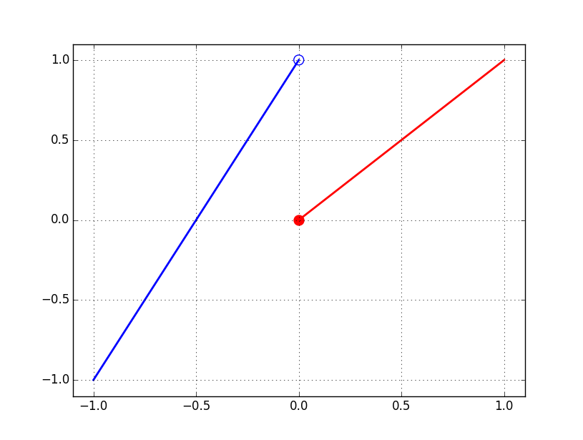

$$\lim_{x→0^{+}}{f(x)}=\text{_________}\text{__________ }\text{and }\lim_{x→0^{-}}{f(x)}=\text{_________}\text{__________ }$$

$\lim_{x→0^{+}}{f(x)}≠\lim_{x→0^{-}}{f(x)}$. We say that $\lim_{x→0}{f(x)}$ does not exist (DNE) whenever these two one-sided limits don’t agree each other. We have the following facts.

If both $\lim_{x→c^{+}}{f(x)}$ and $\lim_{x→c^{-}}{f(x)}$ exist, and

$$\lim_{x→c^{+}}{f(x)}=\lim_{x→c^{-}}{f(x)}=L$$

For some number $L$, then

$$\lim_{x→c}{f(x)} \text{exists and }\lim_{x→c}{f(x)}=L .$$

If (i) any of the one-sided limit $\lim_{x→c^{+}}{f(x)}$ or $\lim_{x→c^{-}}{f(x)}$ doesn’t exist,   
or (ii) both of them exist but not equal each other, then

$$\lim_{x→c}{f(x)}\text{does not exist }.$$

**2. Finding limits by substitution**

In the previous example, $\lim_{x→3}\left(2x+5\right)=11$. This number 11, is exactly

$$f\left(3\right)=2\left(3\right)+5=11.$$

So we are putting $x=3$ into $f\left(x\right)=2x+5$ to get this limit $\lim_{x→3}\left(2x+5\right)$. In many situations, finding a limit as $x$ approaches $c$ is as easy as putting $x$ to be the number $c$.

(A) When $f(x)$ is a polynomial, and $c$ is a real number, we have

$$lim_{x→c }f\left(x\right)=f\left(c\right) .$$

For example, $f\left(x\right)=3x^{2}+5x+6$. Then,

$$lim_{x→1}\left(3x^{2}+5x+6\right)=3{\left(1\right)}^{2}+5\left(1\right)+6=3+5+6=14 .$$

Note that for any constant $a$, the constant function $f\left(x\right)=a$ suits the above criterion. So we have $\lim_{x→c}{a}=a$, whatever the number $c$ is.

(B) When $f\left(x\right)=\frac{p(x)}{q(x)}$ is a rational function, and $c$ is a real number such that the bottom polynomial $q(x)$ is non-zero at $x=c$. That is, $q\left(c\right)≠0$. Then, $lim_{x→c }f\left(x\right)=f(c).$

For example, $f\left(x\right)=\frac{3x+6}{5x+8}$. Then, $5\left(0\right)+8=8≠0$, and we have

$$\lim_{x→0}{\frac{3x+6}{5x+8}}=\frac{3\left(0\right)+6}{5\left(0\right)+8}=\frac{6}{8}=\frac{3}{4} .$$

(C) When $f\left(x\right)=\sqrt{x}$ is the square root function, and $c$ is a non-negative number ($c≥0$), then, $lim_{x→c }\sqrt{x}=\sqrt{c}.$

This method also works for functions like $f\left(x\right)=\sqrt{x+a}$, but then we require $c+a≥0$ instead. Equivalently, $c≥-a$. For example, $a=1$,

$$\lim_{x→-0.5}{\sqrt{x+1}}=\sqrt{(-0.5)+1}=\sqrt{0.5}=0.7071068⋯.$$

**3. Rules of Limits**

We have seen these two rules,

$$\lim_{x→c}{a}=a \text{and} \lim_{x→c}{x^{n}}=c^{n} .$$

There are four rules of limit concerning addition, subtraction, multiplication and division between functions.

When both $\lim_{x→c}{f(x)}$ and $\lim_{x→c}{g(x)}$ exist,

$$\lim_{x→c}\left[f\left(x\right)+g\left(x\right)\right]=\lim_{x→c}{f(x)}+\lim_{x→c}{g(x)} ,$$

$$\lim_{x→c}\left[f\left(x\right)-g\left(x\right)\right]=\lim_{x→c}{f(x)}-\lim_{x→c}{g(x)} ,$$

$$\lim_{x→c}\left[f\left(x\right)⋅g\left(x\right)\right]=[\lim_{x→c}{f(x)]⋅[\lim_{x→c}{g\left(x\right)}] .}$$

When both $\lim_{x→c}{f(x)}$ and $\lim_{x→c}{g(x)}$ exist, and $\lim_{x→c}{g\left(x\right)}≠0$,

$$\lim_{x→c}{\frac{f\left(x\right)}{g(x)}}=\frac{\lim_{x→c}{f(x)}}{\lim_{x→c}{g(x)}} .$$

Q. Find the following limits.

(a) $lim_{x→3}\frac{8x+4}{7x-2}$

(b) $\lim_{x→0}[{\sqrt{x+1} +(5x^{2}+4x+8)} ]$

(c) $\lim_{x→1}{[ \left(\sqrt{x}\right)⋅\left(x^{3}+x^{2}+x+1\right) ]}$

>

>

>

>

>

>

>

>

**4. Finding limits by factorization.**

Some limits cannot be found by a direct substitution. However, we can still find these limits by simplifying the expression. For example, let

$$f\left(x\right)=\frac{x^{2}-4}{x-2} .$$

We are finding $\lim_{x→2}{f(x)}$. By direct substitution,

$$\lim_{x→2}{\frac{x^{2}-4}{x-2}}=\frac{{\left(2\right)}^{2}-4}{2-2}=\frac{0}{0} ,$$

which is not any number. So, direct substitution doesn’t work. Note

$$x^{2}-4=x^{2}-2^{2}=(x-2)(x+2)$$

by the identity $\left(a+b\right)\left(a-b\right)=a^{2}-b^{2}$. Back to the limit,

$$\lim_{x→2}{\frac{x^{2}-4}{x-2}}=\lim_{x→2}{\frac{(x-2)(x+2)}{x-2}}=\lim_{x→2}\left(x+2\right)=2+2=4 .$$

This limit turns out to be 4.

Q. Find the $\lim_{x→4}{\frac{x^{2}-4x }{x-4} }$.

>

>

>

>

>

>

>

>

>

Q. Find the following limit.

$$\lim_{x→25}{\frac{x-25}{\sqrt{x}-5}}$$

>

>

>

>

>

>

**5. Limits involving infinity**

0

Infinity $∞$ is the concept that it is larger than any number on the number line. But the infinity itself is not a number. Similarly, $-∞$ is smaller than any number on the number line. In some context, $∞$ is represented by $+∞$ to emphasize the positive sign.

The notation $x→∞$ means $x$ approaches infinity. That is, $x$ is getting larger than any real numbers (red arrow). For example,

$$x=10, x=100, x=1,000, x=10,000, x=100,000, ⋯$$

and so on. In a similar fashion, the notation $x→-∞$ means that $x$ is getting smaller than any real number (blue arrow). For example,

$$x=-10, x=-100, x=-1,000, x=-10,000, ⋯$$

and so on.

The limit as $x$ approaches $∞$ of $f(x)$,

$$\lim_{x→∞}{f(x)}$$

is the number where $f(x)$ goes to, when $x$ is arbitrarily large.

The limit as $x$ approaches $-∞$ of $f(x)$,

$$\lim_{x→-∞}{f(x)}$$

is the number where $f(x)$ goes to, when $x$ is arbitrarily small.

Q. Find the limit, $\lim_{x→∞}{\frac{1}{x^{2}}}$.

>

>

>

>

>

>

Q. Find the limit, $\lim_{x→∞}{\frac{3x+1}{5x+8}}$.

>

>

>

>

>

>

Q. Find the limit, $\lim_{x→∞}{\frac{x+1}{x^{2}+4}}$.

>

>

>

>

>

Infinity also appears when we are finding the value of a limit.

$$\lim_{x→c^{+}}{f\left(x\right)=∞}$$

means the value of $f(x)$ is getting larger than any real number when $x$ approaches $c$ from the right.

$$\lim_{x→c^{-}}{f\left(x\right)=∞}$$

means the value of $f(x)$ is getting larger than any real number when $x$ approaches $c$ from the left.

$$\lim_{x→c}{f\left(x\right)=∞}$$

when both $\lim_{x→c^{+}}{f\left(x\right)=∞}$ and $\lim_{x→c^{-}}{f\left(x\right)=∞}$.

For example, let $\left(x\right)=\frac{1}{x-1}$. We are finding $\lim_{x→1^{+}}{\frac{1}{x-1}} .$

Tracing from the right hand side of the graph of $f\left(x\right)=\frac{1}{x-1}$ below,

$$\lim_{x→1^{+}}{\frac{1}{x-1}}=∞ .$$

Since $∞$ or $-∞$ is not a number, we say that this limit

$$\lim_{x→1^{+}}{\frac{1}{x-1}} does not exist.$$

If you know that your limit to be found is an $∞$ or a $-∞$ in any quiz or exam, please specify your answer. Don’t just say that the limit doesn’t exist. Instead, write down $∞$ or $-∞$ in your answer.

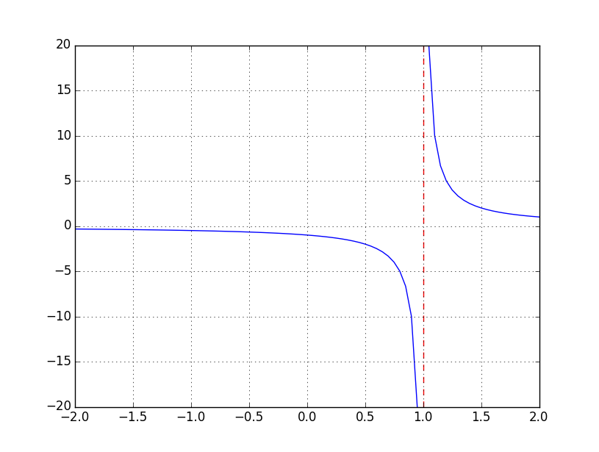

Q. Find the limit .

>

>

>

>

>

>

>

>

>

6. Continuity

A function $f(x)$ is continuous at a number $c$ if   
(1) $c$ is in the domain of $f(x)$,   
(2) $\lim_{x→c}{f(x)}$ exists,   
and (3) $\lim_{x→c}{f(x)}=f(c)$.

$f(x)$ is discontinuous at $c$ if $f(x)$ is not continuous at $c$.

We say a function $f(x)$ is continuous, if $f(x)$ is continuous at every number $c$ on the real line. All polynomials are continuous at every number $c$. Rational functions $\frac{p\left(x\right)}{q\left(x\right)}$ are continuous at a number $c$ if $q\left(c\right)≠0$.

For example, $f\left(x\right)=3x^{2}+5x+8$ is continuous on the real line. On the other hand, the function $f\left(x\right)=\frac{1}{x-1}$ is continuous at any number $c≠1$.

Q. Given the graph of the piecewise function

$$f\left(x\right)=\left\{\begin{aligned}x^{2}+1 when x<0 \\ \\ 2x-2 when x≥0\end{aligned}\right. ,$$

find the following limits or state that they does not exist.

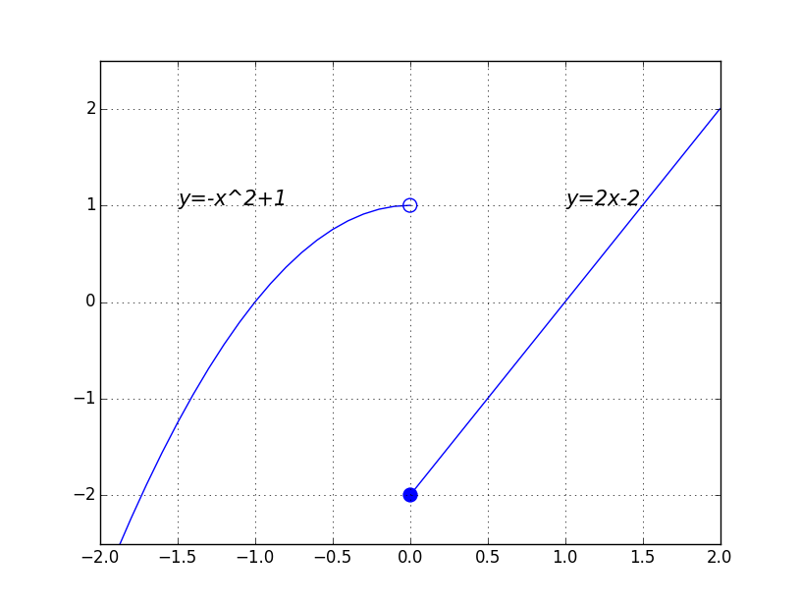

(a) $\lim_{x→0^{+}}{f(x)}$, (b) $\lim_{x→0^{-}}{f(x)}$, (c) $\lim_{x→0}{f(x)}$

>

>

>

>

>

>

Q. Let $f(x)$ be a piecewise function defined as follows.

$$f\left(x\right)=\left\{\begin{aligned}\begin{aligned}x^{2} when x≤0 \\ \\ 2-x when 0<x≤1 \\ \end{aligned} \\ x when x>1\end{aligned}\right.$$

State where $f(x)$ is discontinuous. Sketch the graph of $f(x)$.

>

>

>

>

>

>

>

>

>

>

Rates of Change, Slopes, and Derivatives

Suppose $f(x)$ is a function depending on a variable $x$. The **rate of change** of the function $f(x)$ describes how $f(x)$ changes with respect to the change in $x$.

The average rate of change of $f\left(x\right)$ between numbers $a$ and $a+h$ is

$$\frac{f\left(a+h\right)-f(a)}{h} .$$

The instantaneous rate of change of $f(x)$ at the number $a$ is

$$\lim_{h→0}{\frac{f\left(a+h\right)-f(a)}{h} . }$$

If $f(x)$ measures certain distance travelled by an object, or position of an object, then average rate of change usually means average speed or average velocity over a period of time. Instantaneous rate of change measures the speed or velocity of this object at a particular moment.

Q. A ball is thrown straight up from a height of 192 feet with an initial velocity of 64 feet/second. Its height at time $t$ (in seconds), $0≤t≤6$, is given by

$$h\left(t\right)=-16t^{2}+64t+192$$

in feet. Find the average rate of change (=average velocity) of $h(t)$ between $t=0$ and $t=1$.

>

>

>

>

>

The above quantities can be traced back to the graph of $f(x)$.

$$\frac{f\left(a+h\right)-f\left(a\right)}{h}$$

is the slope of the line passing through $\left(a, f\left(a\right)\right)$ and $\left(a+h, f\left(a+h\right)\right)$.

$$\lim_{h→0}{\frac{f\left(a+h\right)-f(a)}{h} . }$$

is the slope of the the **tangent line** to $f(x)$ at $x=a$.

For example, we let $f\left(x\right)=2x^{2}+3$. Let $a=1$. $f\left(1\right)=5$.

When $h=0.5$. we have $a+h=1.5$. The average rate of change is

$$\frac{f\left(a+h\right)-f\left(a\right)}{h}=\frac{f\left(1.5\right)-f\left(1\right)}{0.5}=\frac{7.5-5}{0.5}=5 .$$

The slope of the line passing through $\left(1, 5\right)$ and $(1.5, 7.5)$ is $m=5$.

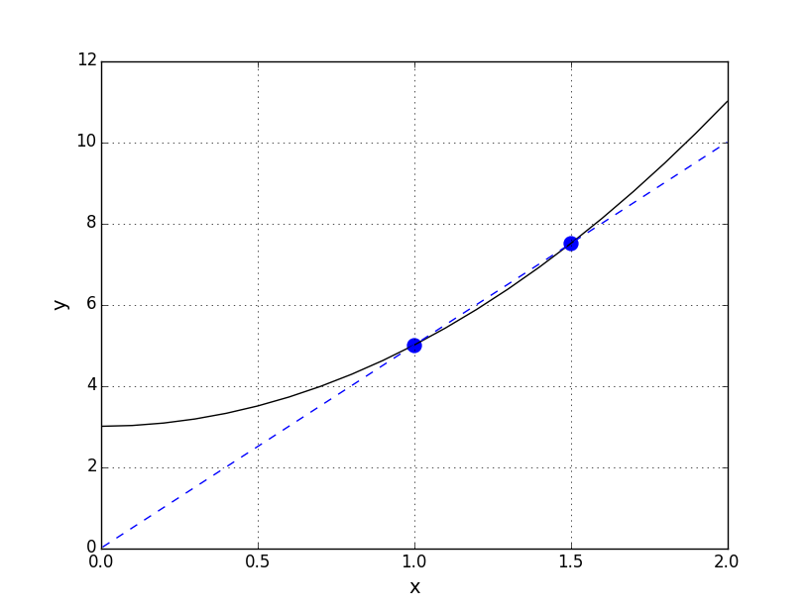

We call this blue line the secant line to $f(x)$ through the points $(1, 5)$ and $(1.5, 7.5)$. It cuts the curve $y=2x^{2}+3$ at two different points.

Q. Find $\lim_{h→0}{\frac{f\left(1+h\right)-f(1)}{h}}$ when $f\left(x\right)=2x^{2}+3$.

>

>

>

>

>

>

The slope of the tangent line to $f(x)$ at $x=1$ is then $m=_________$.

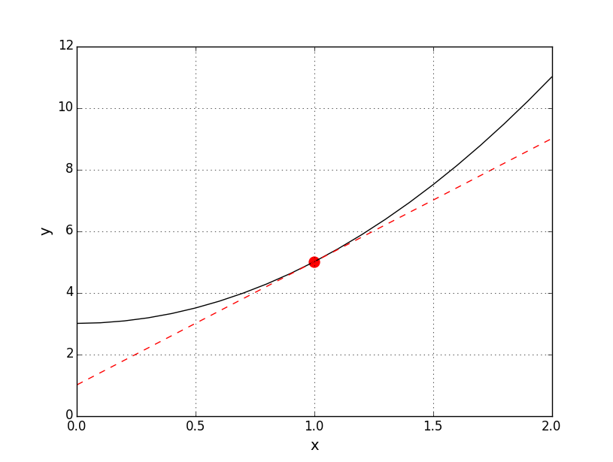

We call this red line the **tangent** line to $f(x)$ at $x=1$, since it cuts the curve $y=2x^{2}+3$ at exactly one point. This point is $(1, f\left(1\right))$.

Given a function $f(x)$, the **derivative of $f(x)$**  is a new function which returns the instantaneous rate of change of $f(x)$, or the slope of the tangent line to $f(x)$ at any number $x$. Here comes the definition of the derivative.

The derivative of $f(x)$ at a number $x$, written as $f'(x)$ is defined by

$$f^{'}\left(x\right)=\lim_{h→0}{\frac{f\left(x+h\right)-f(x)}{h}} .$$

It gives the instantaneous rate of change of $f(x)$ at $x$, and also the slope of the tangent line to $f(x)$ at $x$.

Let $a$ be a particular number. What does the derivative of $f$ at $x=a$, $f'(a)$, tell us that if we increase $x$-value by $h$ units, correspondingly the value of $f(x)$ will change by $h⋅f'(a)$ units.

The derivative of $f\left(x\right)$, $f^{'}\left(x\right)$, is very often seen as $\frac{df}{dx}$. If we are putting $x=a$, and hence finding $f'(a)$, then we write $f'(a)$ as $\frac{df}{dx}(a)$. If $y$ is a function of $x$, then $y^{'}$ or $y^{'}\left(x\right)$ denotes the derivative (function) of $y$, so as $\frac{dy}{dx}$.

Q. Using the previous example, $f\left(x\right)=2x^{2}+3$.

(a) Find $f'(1)$ and the line equation of the tangent line to $f(x)$ at $x=1$.

(b) Find $f'(x)$ by the definition of the derivative.

>

>

>

>

>

>

>

In your text-book, on P.93, there is an example about the annual sales of Macintosh. We are rephrasing that example by a different context, the annual global sales of iPhones between 2007 and 2015.

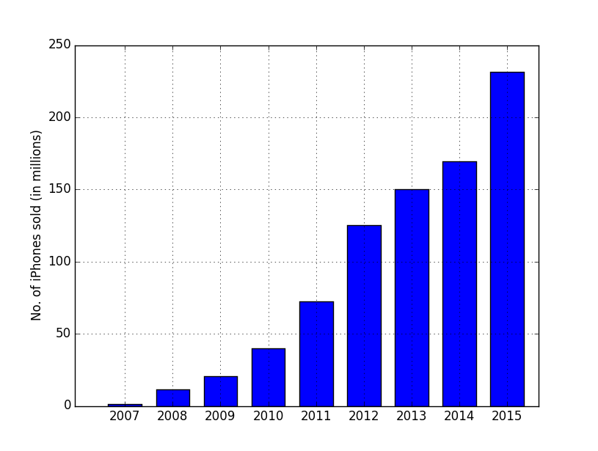

Let $x$ be the number of years after Year 2007. $x=0$ means the year 2007, $x=1$ means the year 2008, and so on. $x=8$ means the year 2015. The annual sales are approximated by the following function.

$f\left(x\right)=2.335x^{2}+10.269x-2.727 .$ 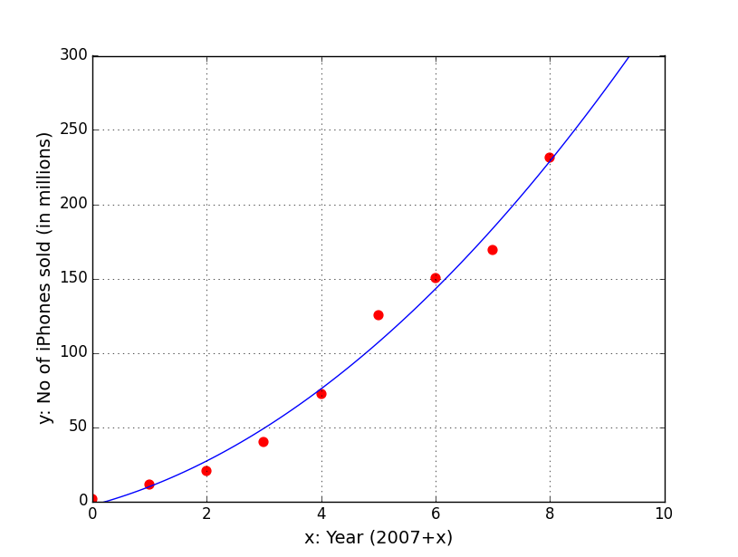

$f(x)$ is a realistic approximation of the annual sales of iPhones between year 2007 and year 2015.

Q. Find the derivative of $f(x)$. Find $f^{'}\left(8\right)$ and interpret your answer.

>

>

>

>

>

>

Therefore, $f^{'}\left(x\right)=4.67x+10.269 .$

$$f^{'}\left(8\right)=4.67\left(8\right)+10.269=47.629$$

*Interpretation. $x=8$* represents the year 2015.

In 2015, the global sales of iPhones is increasing at the rate of 47.629 million units per year.

The above interpretation consists of several parts.

|  |  |  |
| --- | --- | --- |
| In 2015 | means | at $x=8$ |
| the global sales of iPhones | means | $$f(x)$$ |
| increasing | means | $$f^{'}\left(8\right)>0$$ |
| at the rate of 47.629 | means | $$f^{'}\left(8\right)=47.629$$ |
| million units per year | means | the unit of $f'(8)$ |

*If $f^{'}\left(8\right)<0$, we use “decreasing” or “falling” instead of “increasing”.  
 “ $f^{'}\left(8\right)=-10.0$” means falling at the rate of 10.0 (million units per year).

Some functions are not differentiable at a certain $x$-value, $x=a$. Graphically, it means that the graph of the function $f\left(x\right)$ has a corner point at $x=a$. Here comes an example.

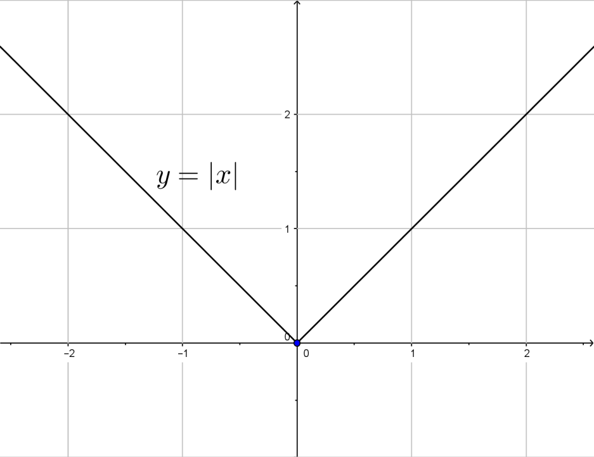

The absolute value function $f(x)=|x|$ has a corner point at $x=0$. It is not differentiable at $x=0$. The underlying reason is that the two-sided limit

$$\lim_{h→0}{\frac{f\left(0+h\right)-f(0)}{h}}=\lim_{h→0}{\frac{\left|h\right|}{h}}$$

doesn't exist. Since we have to define $f^{'}\left(0\right)=\lim_{h→0}{\frac{f\left(0+h\right)-f(0)}{h}}$, in this case, $f'(0)$ doesn’t exist. We say that $|x|$ is not differentiable at $x=0$.

Differentiation Formulas

Very often we use formulas to differentiate a function, instead of using the definition of derivatives, if the function itself is nice.

1. Constant rule. If $c$ is a constant,

$$\frac{d}{dx}c=0 .$$

For example, .

2. Power rule. If the function is $x^{n}$ for any constant exponent $n$,

$$\frac{d}{dx}x^{n}=nx^{n-1}$$

In particular , and .

3. Constant-multiple rule. If $c$ is a constant, and $f\left(x\right)$ is a function,

$$\frac{d}{dx}\left(c⋅f\left(x\right)\right)=c⋅f^{'}\left(x\right).$$

For example. $\frac{d}{dx}\left(2016x\right)=2016⋅\frac{d}{dx}\left(x\right)=2016$.

4.Sum-Difference rule. For two functions $f(x)$ and $g(x)$.

$$\frac{d}{dx}\left(f\left(x\right)+g\left(x\right)\right)=f^{'}\left(x\right)+g^{'}\left(x\right) ,$$

$$\frac{d}{dx}\left(f\left(x\right)-g\left(x\right)\right)=f^{'}\left(x\right)-g^{'}\left(x\right) .$$

Sume-Difference rule can be applide even though we have three or more functions in a sum (or in a difference). For example,

$$\frac{d}{dx}\left(10+x+x^{2}\right)=\frac{d}{dx}\left(10\right)+\frac{d}{dx}\left(x\right)+\frac{d}{dx}\left(x^{2}\right)=0+1+2x=1+2x .$$

Q. Differentiate the following functions.

(a) $f\left(x\right)=x^{3/2 }$

>

>

(b) $f\left(x\right)=x\sqrt{x}$

>

>

(c) $f\left(x\right)=x^{5/2 }-2x+5$

>

>

>

(d) $f\left(x\right)=\frac{7x^{2}+5x+3}{\sqrt{x}}$

>

>

>

Q Find $f'(x)$. Find the tangent line to $f(x)$ at $x=1$.

$$f\left(x\right)=\frac{1}{x^{3/2 }}$$

>

>

>

>

We mention an application here, marginal analysis. Suppose a company has certain revenue function, cost function and profit function.

$$R\left(x\right)=\text{Total revenue gained by selling }x\text{ units}$$

$$C\left(x\right)=\text{Total cost of producing }x\text{ units}$$

$$P\left(x\right)=\text{Total profit gained} \left(\text{or loss incurred}\right)\text{ by selling }x \text{units.}$$

We have $P\left(x\right)=R\left(x\right)-C(x)$.

The marginal cost function, is the derivative of the cost function.

$$MC\left(x\right)=C'(x)$$

The marginal revenue function, is the derivative of the revenue function.

$$MR\left(x\right)=R'(x)$$

The marginal profit function, is the derivative of the profit function.

$$MP\left(x\right)=P'(x)$$

Q. Suppose a company is producing a mini optical mouse. Let $x$ be the number of units of mouses produced. Let the cost function (in dollars) be

$$C\left(x\right)=8x+60 ,$$

and the revenue function (in dollars) be

$$R\left(x\right)=25x-0.2x^{2} .$$

(a) Find the profit function $P(x)$, and the marginal profit function $MP(x)$.

(b) Find $MP(5)$. Interpret your answer.

>

>

>

>

(b) $MP\left(5\right)=P^{'}\left(5\right)=-0.4\left(5\right)+17=15$.

*Interpretation.*

When 5 units of mouses have been produced, the profit is increasing at a rate of $15 per unit of mouses produced.

You may also say:

When 5 units of mouses have been produced, the profit increases by $15 per unit of mouses produced.

When 5 units of mouses have been produced, the company gained $15 for an additional mouse being produced and sold.

The above interpretation captures everything we mentioned before about an interpretation.

|  |  |  |
| --- | --- | --- |
| When 5 units of mouses have been produced, | means | at $x=5$ |
| the profit | means | $$P(x)$$ |
| increasing | means | $$MP\left(5\right)=P'(5)>0$$ |
| at the rate of 15 | means | $$MP\left(5\right)=P^{'}\left(5\right)=15$$ |
| dollars by unit of mouses | means | the unit of $MP(5)$ |