*Business Calculus – Week 3*

Product and Quotient Rules

Last week we learnt four differentiation formulas. This week, we start with two more. The product rule and the quotient rule.

The product rule is used when we have to differentiate a product of two functions, and the quotient rule is used when we have to differentiate a quotient of two functions.

5. Product rule. For two functions $f(x)$ and $g(x)$,

$$\frac{d}{dx}\left(f\left(x\right)⋅g\left(x\right)\right)=f^{'}\left(x\right)⋅g\left(x\right)+f\left(x\right)⋅g^{'}\left(x\right).$$

For example, let $f\left(x\right)=x^{2}+1$ and $g\left(x\right)=x+10$.

$$\frac{d}{dx}\left[\left(x^{2}+1\right)\left(x+10\right)\right]=\left[\frac{d}{dx}\left(x^{2}+1\right)\right]⋅\left(x+10\right)+\left(x^{2}+1\right)⋅\left[\frac{d}{dx}\left(x+10\right)\right]$$

$$=\left[\frac{d}{dx}\left(x^{2}\right)+\frac{d}{dx}\left(1\right)\right]⋅\left(x+10\right)+\left(x^{2}+1\right)⋅\left[\frac{d}{dx}\left(x\right)+\frac{d}{dx}\left(10\right)\right]$$

$$=\left[2x+0\right]⋅\left(x+10\right)+\left(x^{2}+1\right)⋅\left[1+0\right]$$

$$=(2x)\left(x+10\right)+(x^{2}+1)$$

Be cautious that .

6. Quotient rule. . For two functions $f(x)$ and $g(x)$,

$$\frac{d}{dx}\left(\frac{f\left(x\right)}{g\left(x\right)}\right)=\frac{g\left(x\right)⋅f^{'}\left(x\right)-f\left(x\right)⋅g'(x)}{g{\left(x\right)}^{2}} .$$

Q. Differentiate the following functions

(a) ${f\left(x\right)=x}^{4}(x^{3}+1)$

>

>

>

(b) $f\left(x\right)=6\sqrt{x}⋅\left(x^{2}+10\right)$

>

>

>

(c) $g\left(t\right)=\left(t+10\right)\left(t^{2}+5t+7\right)$

>

>

>

(d) $f\left(x\right)=\frac{x}{x+1}$

>

>

>

>

(e) $f\left(x\right)=\frac{1}{x^{2}}$

>

>

>

(f) $f\left(x\right)=\frac{x^{2}+5x+2}{x+1}$

>

>

>

>

>

>

(g) $f\left(x\right)=\left(x^{2}+10\right)\left(\frac{x+1}{x-1}\right)$

>

>

>

>

>

>

(h) $f\left(x\right)=\frac{(x+1)(x+2)}{x+3}$

>

>

>

>

>

>

Derivative and Approximation

We open up this section with a remark. The derivatives of a function $f(x)$ represents how fast $f(x)$ changes with respect to $x$. That is, $f'(a)$ is the instantaneous rate of change of $f\left(x\right)$ at number $x=a$. In principle,

$$change in f\left(x\right)=\left(rate of change\right)⋅\left(change in x\right) .$$

When $x$ increases from $a$ to $a+Δx$, the value of $f(x)$ changes by about $f^{'}\left(a\right)⋅Δx$ units. Similarly, when $x$ decreases from $a$ to $a-Δx$, the value of $f(x)$ changes by about $-f^{'}\left(a\right)⋅Δx$ units.

Let $f(x)$ be a function differentiable at $x=a$. Then,

$f\left(x\right)≈f\left(a\right)+f^{'}\left(a\right)⋅\left(x-a\right).$

In other words, $f\left(x\right)-f\left(a\right)$ is about $f^{'}\left(a\right)⋅(x-a)$.

If we let $x=a+Δx$, then the above equation is

$$f\left(a+Δx\right)≈f\left(a\right)+f^{'}\left(a\right)⋅Δx .$$

For example, $f\left(x\right)=2x^{2}+3$. We have known that $f\left(1\right)=5$ and $f^{'}\left(1\right)=4$. So we have

$$f\left(x\right)≈f\left(1\right)+f^{'}\left(1\right)⋅\left(x-1\right)=5+4⋅\left(x-1\right).$$

The following table examine how accurate this approximation of $f(x)$ is.

|  |  |  |  |
| --- | --- | --- | --- |
| $$x=1+Δx$$ | $$Δx$$ | $$f\left(x\right)$$ | $$5+4⋅(x-1)$$ |
| $$x=1$$ | $$Δx=0$$ | $$f\left(1\right)=5$$ | $$5$$ |
| $$x=1.01$$ | $$Δx=0.01$$ | $$f\left(1.01\right)=5.0402$$ | $$5.04$$ |
| $$x=1.05$$ | $$Δx=0.05$$ | $$f\left(1.05\right)=5.205$$ | $$5.2$$ |
| $$x=1.1$$ | $$Δx=0.1$$ | $$f\left(1.1\right)=5.42$$ | $$5.4$$ |
| $$x=1.5$$ | $$Δx=0.5$$ | $$f\left(1.5\right)=7.5$$ | $$7$$ |
| $$x=2$$ | $$Δx=1$$ | $$f\left(2\right)=11$$ | $$9$$ |

This approximation is about the exact value when $Δx$ is small.

The linear approximation of $f(x)$ at $x=a$ is the function

$$L\left(x\right)=f\left(a\right)+f^{'}\left(a\right)⋅\left(x-a\right).$$

Note that $y=f\left(a\right)+f^{'}\left(a\right)⋅(x-a)$ is the tangent line to $f(x)$ at $x=a$. Using the previous example, $f\left(x\right)=2x^{2}+3$. The tangent line to $f\left(x\right)$ at $1$ is close to the graph of $2x^{2}+3$ when $x$ is around $1$.

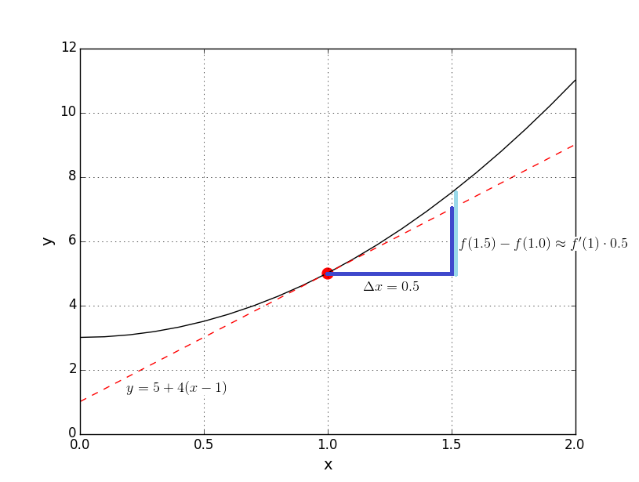

The light blue line represents the quantity $f\left(1.5\right)-f(1.0)$ and the dark blue line represents the quanitity $f^{'}\left(1\right)⋅0.5$. This difference between them is getting smaller, as $x$ goes from $1.5$ to $1.0$.

From the graph above, the tangent line at $x=1$ is sloping up, and the function $f\left(x\right)=2x^{2}+3$ is increasing at $x=1$. Here, “increasing” means that $f(x)$ goes up as $x$ goes up.

When $f^{'} \left(a\right)>0$, the function $f(x)$ is increasing at $x=a$. Moreover, $f(x)$ increases by $f'(a)$ units, for every additional unit of $x$.

When $f^{'}\left(a\right)<0$, the function $f(x)$ is decreasing at $x=a$. Moreover, $f(x)$ decreases by $f'(a)$ units, for every additional unit of $x$.

Last week we talked about the cost function $C(x)$ of producing $x$ units of a product, as well as the revenue function and the profit function. Here we have new concepts about average cost, average revenue and average profit.

The average cost function gives the average cost per unit.

$$AC\left(x\right)=\frac{C\left(x\right)}{x}$$

The marginal average cost function is the derivative of $AC(x)$.

$$MAC\left(x\right)=AC^{'}\left(x\right)=\frac{d}{dx}\left[\frac{C\left(x\right)}{x}\right]$$

The marginal average revenue function is the derivative of $\frac{R\left(x\right)}{x}$.

$$MAR\left(x\right)=\frac{d}{dx}\left[\frac{R\left(x\right)}{x}\right]$$

The marginal average profit function is the derivative of $\frac{P\left(x\right)}{x}$.

$$MAP\left(x\right)=\frac{d}{dx}\left[\frac{P\left(x\right)}{x}\right]$$

Q. [Week 2, P.23] Suppose a company is producing a mini optical mouse. Let $x$ be the number of units of mouses produced. Let the cost function (in dollars) be

$$C\left(x\right)=8x+60 ,$$

and the revenue function (in dollars) be $R\left(x\right)=25x-0.2x^{2} .$

(c) Find the average cost function, $AC(x)$,

(d) and the marginal average cost function, $MAC(x)$.

>

>

>

>

>

Q. A company can produce computer flash memory devices at a cost of $7 each, while fixed costs are $100 per day. So the cost function is

$$C\left(x\right)=7x+100 .$$

(a) Find the average cost function, $AC(x)$.

(b) Find the marginal average cost function, $MAC(x)$.

(c) Evaluate $MAC(x)$ at $x=30$. Interpret your answer.

>

>

>

>

>

>

Higher-order Derivatives

We can also differentiate the derivative function of a function $f(x)$.

The second derivative of the function $f(x)$ is the derivative of $f'(x)$.

$$f^{''}\left(x\right)=\frac{d}{dx}f'(x)$$

The third derivative of the function $f\left(x\right)$ is the derivative of $f''(x)$.

$$f^{'''}\left(x\right)=\frac{d}{dx}f''(x)$$

In this manner, we define higher-order derivatives of $f(x)$,

The n-th derivative of $f(x)$ is the derivative of the (n-1)-th derivative of $f(x)$.

$$f^{\left(n\right)}\left(x\right)=\frac{d}{dx}\left[f^{\left(n-1\right)}\left(x\right)\right]$$

Starting from the fourth derivative, we denote the n-th derivative function by $f^{\left(n\right)}\left(x\right)$ instead of adding prime until we get to $f^{'''⋯^{'}}(x)$.

$f''(x)$ is often written as $\frac{d^{2}}{dx^{2}}f(x)$, and $f'''(x)$ is often written as $\frac{d^{3}}{dx^{3}}f(x)$. Similarly, $f^{\left(n\right)}\left(x\right)$ is written as $\frac{d^{n}}{dx^{n}}f(x)$.

Q. Find $f''(x)$ and $f'''(x)$ for the following function.

$$f\left(x\right)=x^{4}-2x^{3}-3x^{2}+5x-7$$

>

>

>

>

>

>

Q. Find $f'(x)$, $f''(x)$ and $f'''(x)$ for the following function.

$$f\left(x\right)=x\sqrt{x}$$

>

>

>

>

>

>

As an application of the second derivative, we talk about velocity and acceleration. Suppose a car is moving from its starting point along a straight line. At time $t$ (in hour), let $s(t)$ be the distance travelled by the car in miles.

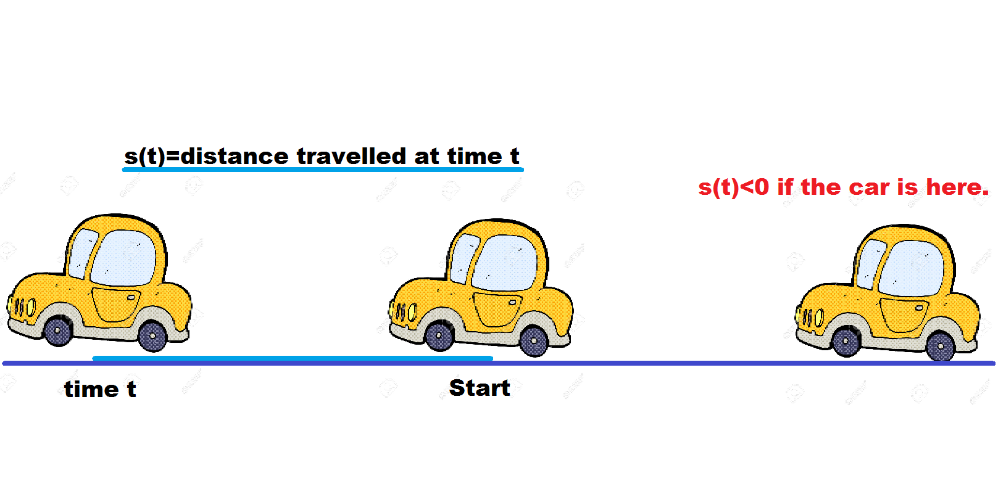

If the car is behind its starting point, we say that this distance travelled is negative at certain time $t$.

The distance function $s(t)$ measures the distance travelled (in miles) by the car at time t (in hours).

The velocity function $v(t)$ measures the velocity (i.e. signed speed) of the car at time t (in miles per hour). It is the derivative of $s(t)$.

$$v\left(t\right)=s^{'}\left(t\right)$$

The acceleration function $a(t)$ measures the instantenous rate of change of the velocity of the car at time t (in $miles/hour^{2}$) . It is the derivative of $v(t)$.

$$a^{'}\left(t\right)=v^{'}\left(t\right)=s''(t)$$

When the acceleration $a(t)$ is positive, the car is speeding up. That is, it is going faster and faster. For example, at time $t$ it is going at $50 mph$. Then at time $t+1$ it may go at $60 mph$. When $a(t)$ is negative, the car is slowing down. It is going slower and slower.

Q. A truck is driving along a straight road. After $t$ hours its distance (in miles) from the starting time at time $t$ (in hours) is given by

$$s\left(t\right)=18t^{2}-3t^{3}, for 0≤t≤6.$$

(a) Find the velocity of the truck after 2 hours.

(b) Find the acceleration of the truck after 4 hours.

>

>

>

>

>

>

Recall that

1. When $f^{'} \left(a\right)>0$, the function $f(x)$ is increasing at $x=a$.
2. When $f^{'}\left(a\right)<0$, the function $f(x)$ is decreasing at $x=a$.

Similarly, we get information about the behaviour of $f(x)$ near $x=a$, by looking at the signs of $f'(a)$ and $f''(a)$.

Suppose you are driving a car along a straight road with acceleration. $a\left(t\right)=s^{''}\left(t\right)>0$. First the car is at rest $v\left(0\right)=0$, and $s\left(0\right)=0$.

In the first hour, we move by 1 miles. $s\left(1\right)=1$ miles. In the second hour, our car is getting faster, so we move by 4-1=3 miles. Again, our car is much faster in the third hour, and we move by 9-4 = 5 miles in this period of time.

This straight road motion can be described by the following graph, in distance travelled by the car against time.

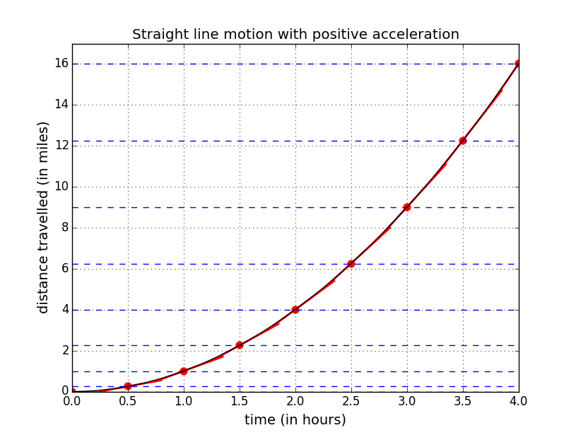

What do we learn from this acceleration example?

1. When ${a\left(t\right)=s}^{''}\left(t\right)>0$, the velocity $v\left(t\right)=s'(t)$ keeps increasing. Note the $s'(t_{0})$ is the slope of the tangent line (red line) at time $t_{0}$. The tangent line gets steeper as time goes. So the slope is increasing.
2. When ${a\left(t\right)=s}^{''}\left(t\right)>0$ and $v\left(t\right)=s^{'}\left(t\right)>0$ (we are not moving backward), the graph of $s(t)$ resembles this shape of an openning up parabola. Your distance travelled within an hour increases as time goes.

|  |  |  |  |
| --- | --- | --- | --- |
| $$f'(a)$$ | $$f''(a)$$ | Rate of change of $f(x)$ | Slope of the tangent line to function $f(x)$ |
| $$f^{'}\left(a\right)>0$$ | $$f^{''}\left(a\right)>0$$ | The quantity $f(x)$ is increasing at an increasing rate. | The tangent line is sloping up. The slope $m$ increases as $x$ increases. |
| $$f^{'}\left(a\right)>0$$ | $$f^{''}\left(a\right)<0$$ | The quantity $f(x)$ is increasing at an decreasing rate. | The tangent line is sloping up. The slope $m$ decreases as $x$ increases. |
| $$f^{'}\left(a\right)<0$$ | $$f^{''}\left(a\right)>0$$ | The quantity $f(x)$ is decreasing at an decreasing rate. That is it is getting closer to level off. | The tangent line is sloping down. The slope $m$ increases as $x$ increases. That is the tangent line is getting flatter. |
| $$f^{'}\left(a\right)<0$$ | $$f^{''}\left(a\right)<0$$ | The quantity $f(x)$ is decreasing at an increasing rate. | The tangent line is sloping down. The slope $m$ decreases as $x$ increases. |

The Chain Rule and the Generalized Power Rule

Here we have two more differentiation rules.

7. Chain rule. For two functions $f(x)$ and $g(x)$,

$$\frac{d}{dx}f\left(g\left(x\right)\right)=f^{'}\left(g\left(x\right)\right)⋅g'(x)$$

Suppose $f\left(x\right)=x^{3}$ and $g\left(x\right)=x+4$. Then,

$$f\left(g\left(x\right)\right)=f\left(x+4\right)={\left(x+4\right)}^{3} .$$

We know $f^{'}\left(x\right)=3x^{2}$ by power rule. Also $g^{'}\left(x\right)=\frac{d}{dx}\left(x+4\right)=1$. Therefore,

$$\frac{d}{dx}f\left(g\left(x\right)\right)=f^{'}\left(g\left(x\right)\right)⋅g^{'}\left(x\right)=f^{'}\left(x+4\right)⋅1=3{\left(x+4\right)}^{2} .$$

When $f\left(x\right)=x^{n}$ for some number $n$, $f\left(g\left(x\right)\right)={\left[g\left(x\right)\right]}^{n}$. In this case, we can use the generalized power rule to find .

8. Generalized power rule.

$$\frac{d}{dx}{\left[g\left(x\right)\right]}^{n}=n{\left[g\left(x\right)\right]}^{n-1}⋅g'(x)$$

In the above example, $f\left(g\left(x\right)\right)={\left(x+4\right)}^{3}$.

$$\frac{d}{dx}{\left(x+4\right)}^{3}=3⋅{\left(x+4\right)}^{2}⋅\left[\frac{d}{dx}\left(x+4\right)\right]$$

We are treating $(x+4$) as a whole in ${\left(x+4\right)}^{3}$ and apply the power rule to the later, pretending that $x+4$ is the variable $y$ in power rule

$$\frac{d}{dy}y^{3}=3y^{2}.$$

So we after $3{\left(x+4\right)}^{3}$. Don’t forget to multiply it by $g'(x)$ at the end.

Q. Suppose $f\left(x\right)=\sqrt{x}$ and $g\left(x\right)=x^{2}+9$. Find $f(g\left(x\right))$ and its derivative by the chain rule.

>

>

>

>

>

>

Q. Use the generalized power rule to find the derivative of

>

>

>

>

>

>

Q. Find .

>

>

>

>

>

>

1. Constant rule.

2. Power rule.

3. Constant-multiple rule.

$$\frac{d}{dx}\left(c⋅f\left(x\right)\right)=c⋅f^{'}\left(x\right)$$

4.Sum-Difference rule.

5. Product rule.

6. Quotient rule.

7. Chain rule.

8. Generalized power rule.

$$\frac{d}{dx}{\left[g\left(x\right)\right]}^{n}=n{\left[g\left(x\right)\right]}^{n-1}⋅g'(x)$$

Practice on differentiation rules.

Q. Find $f'(x)$.

$$f\left(x\right)={\left(\frac{x+2}{x-1}\right)}^{4}$$

>

>

>

>

>

>

>

>

Q. Find $f'(x)$.

$$f\left(x\right)=x^{2}\sqrt{1+x^{2}}$$

>

>

>

>

>

>

>

>

>

Q. [Webwork HW4, Q13] find $f^{'}(x)$.

$$f\left(x\right)={\left(9x^{2}-8\right)}^{3}{\left(7x^{2}+2\right)}^{14}$$

>

>

>

>

>

>

>

>

Q. [Webwork HW4, Q7]

Suppose $F\left(5\right)=2$, $F^{'}\left(5\right)=5$, $H\left(5\right)=2$ and $H^{'}\left(5\right)=4$.

1. Find $G'(5)$ if $G\left(z\right)=F\left(z\right)⋅H(z)$.
2. Find $G^{'}\left(5\right)$ if $G\left(w\right)=F(w)/H(w)$.

>

>

>

>

>

>

>