*Business Calculus – Week 4*

Non-differentiable Functions

We start with revising the meaning of *continuity*.

A function $f(x)$ is continuous at $x=c$ if $\lim_{x→c}{f(x)}$ exists and

$$\lim_{x→c}{f\left(x\right)=f\left(c\right) .}$$

We say $f(x)$ is discontinuous at $x=c$ if it is NOT continuous at $c$. There are several conditions that guarantee $f(x)$ discontinuous at a number $c$.

A function $f(x)$ is discontinuous at a number $c$ when one of the following conditions applies.   
(1) $f(c)$ does not exist.

(2) The two-sided limits $\lim_{x→c}{f(x)}$ doesn’t exist.

(3) $f(c)$ doesn’t equal the limit $\lim_{x→c}{f(x)}$.

The graph of a continuous function is special. You can draw and complete it without lifting your hand from the paper.

Let us go back to differentiation.

A function $f(x)$ is differentiable at a point $x=c$ if $f'(c)$ exists.

Previously we mentioned that the absolute function $f\left(x\right)=|x|$ is not differentiable at $x=0$.   
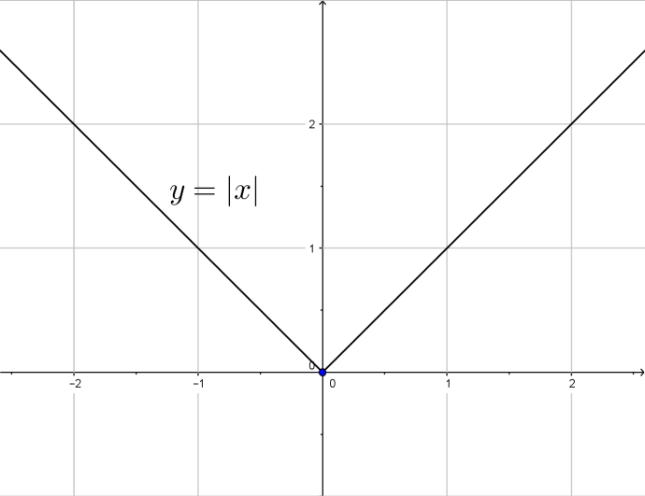

A function $f(x)$ is not differentiable at a number $c$ if one of the following conditions applies.

(1) $f(x)$ has a corner point at $c$. Basically, a corner point is formed when

$$\lim_{h→0^{+}}{\frac{f\left(c+h\right)-f(c)}{h}}≠\lim_{h→0^{-}}{\frac{f\left(c+h\right)-f(c)}{h} .}$$

We can look at different kinds of corner points.

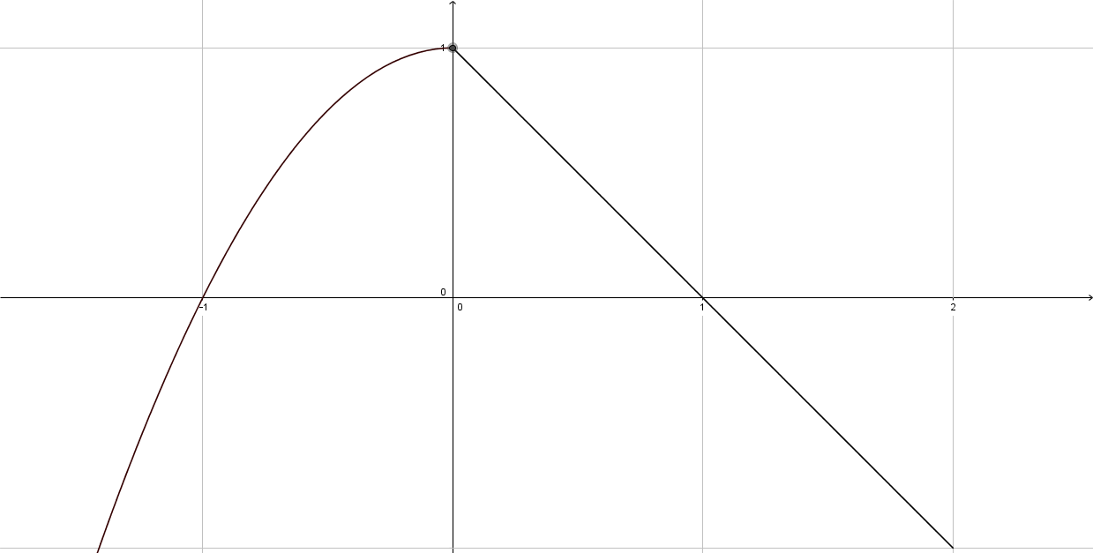

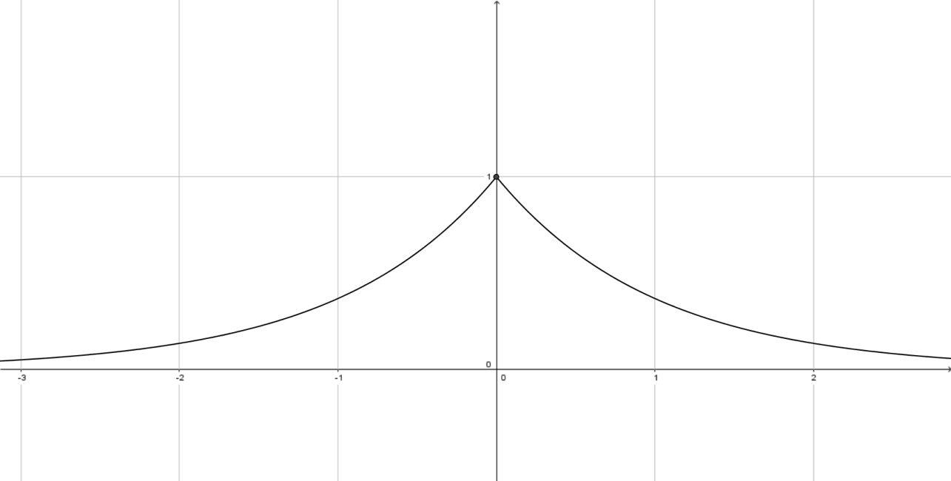

These two functions are having a corner point at $x=0$. Note that they are continuous at $x=0$.

(2) $f(x)$ has a vertical tangent line at $x=c$. It means $f^{'}\left(c\right)=±∞$.

We can see what’s exactly happening from the graph of $f(x)$. For example.

$$f\left(x\right)=\left\{\begin{aligned}\sqrt{x} when x>0 \\ 0 when x=0 \\ \sqrt{-x} when x<0\end{aligned}\right. .$$

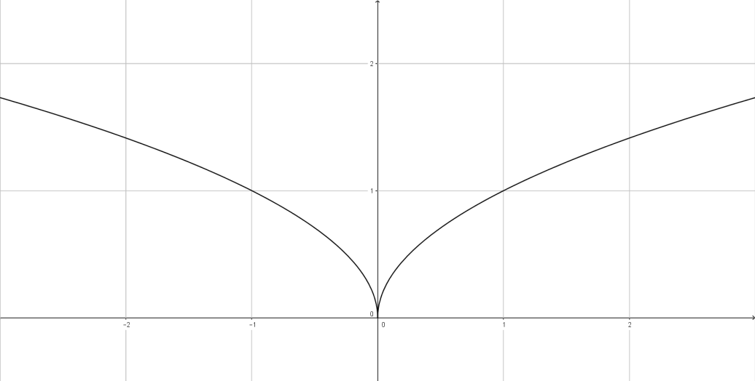

The tangent line to $f(x)$ at 0 is the vertical line $x=0$. We say that $f(x)$ is not differentiable at 0 because $f'(0)$ doesn’t exist.

We also say that $f(x)$ has a vertical tangent line at $x=0$ in this case. The slope of the tangent line is approaching $±∞$ as $x$ approaches $0$ from the left or from the right.

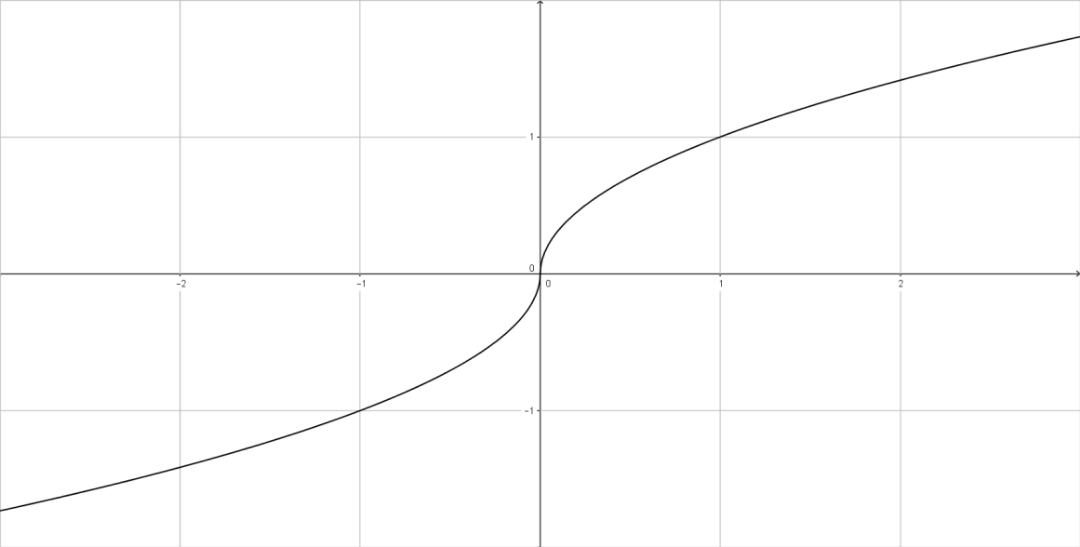

(3) $f(x)$ is discontinuous at $x=c$.

We have the following fact

If $f(x)$ is differentiable at $x=c$, then $f(x)$ is continuous at $x=c$.

Q. Below is the graph of a function $f(x)$.

(a) At what x-value(s) does $f(x)$ appear to be not continuous?

(b) At what x-value(s) does $f(x)$ appear to be not differentiable?

Explain your answer.

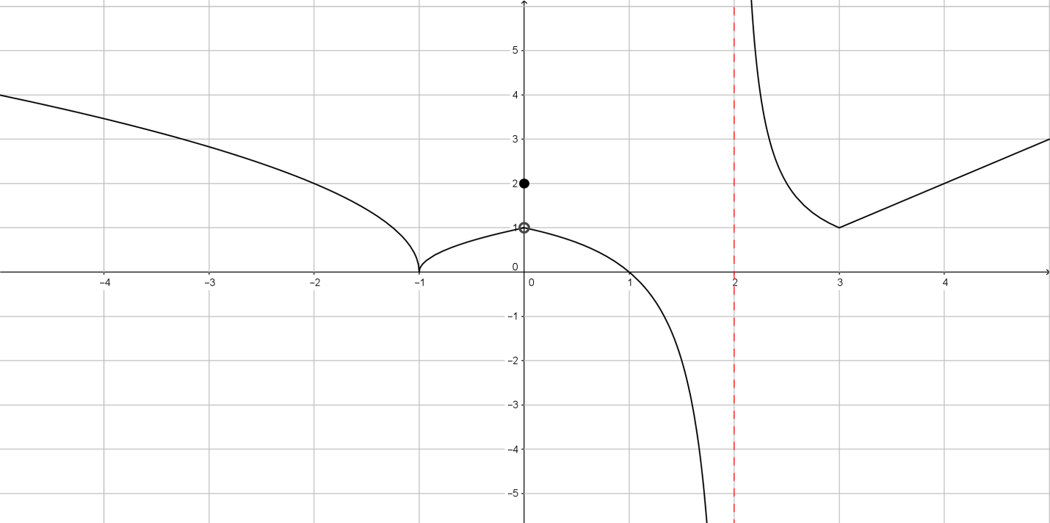

>

>

>

>

>

>

*Business Calculus – Week 4*

Graphing using the First Derivative

The first derivatives tell us whether a function is increasing or decreasing in a region of $x$-values.

Suppose $(a,b)$ is an interval contained in the domain of a function $f(x)$.   
We say $f(x)$ is increasing on $(a,b)$ if the value $f(x)$ keeps rising as $x$ goes from $a$ to $b$. We say $f(x)$ is decreasing on $(a,b)$ if the value $f(x)$ keeps falling as $x$ goes from $a$ to $b$.

Given a function $f(x)$ and an open interval $(a,b)$ inside the domain of .

1. is increasing on if for all in .

2. is decreasing on $\left(a,b\right)$ if $f^{'}\left(x\right)<0$ for all $x$ in $(a,b)$.

In this example, $f(x)$ is increasing on the interval $(0 , 1.57)$ and on the interval $(4.71 , 6.28)$. It is decreasing on the interval $(1.57 , 4.72)$.

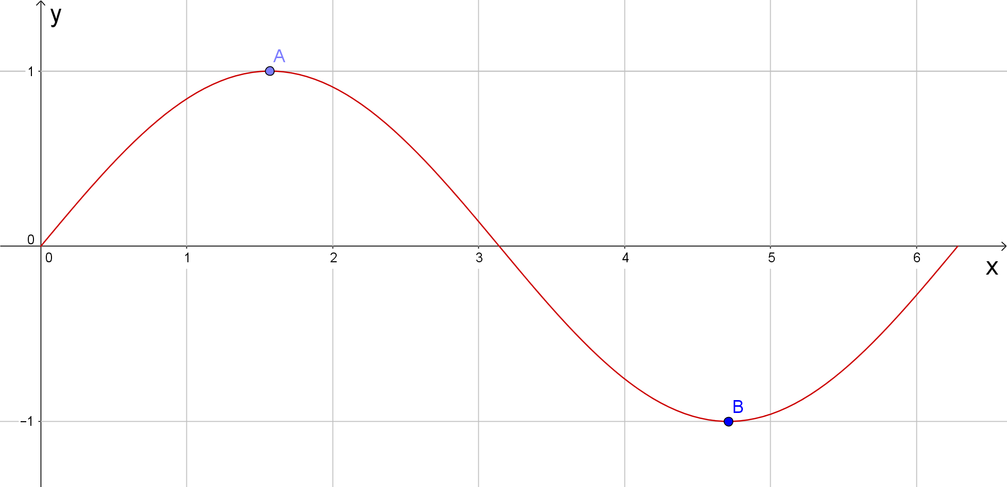

The point $A(1.57 , 1)$ on the graph of $f(x)$ is the highest point. Before $x=1.57$, $f\left(x\right)$ is increasing, and after $x=1.57$, $f(x)$ is decreasing. We call this point $A$ a relative maximum point of $f(x)$.

We have the following more formal definition.

Suppose $f(x)$ is a function, and a number $x=c$ is in its domain.

1. has a relative maximum point at $c$ if $f\left(c\right)≥f(x)$ for any $x$ close to .

2. has a relative minimum point at $c$ if $f\left(c\right)≤f(x)$ for any $x$ close to $c$.

In the textbook (P.164), there are two exact statements about relative maximum and relative minimum. But there we say $f(x)$ has a relative maximum/minimum **value**.

Let’s use the above example to illustrate everything.

1. The point $A(1.57 , 1)$ is called a relative maximum point of .

2. The number $c$ is 1.57 here. $f(x)$ has a relative maximum point at 1.57.

3. We can also say that $f(x)$ has a relative maximum value at 1.57.

4. Sometimes, relative maximum point refers to the x-value 1.57. [Wiki]

5. The relative maximum value of $f(x)$ at $1.57$ refers to the y-value of the relative maximum point. $A(1.57 , 1)$. It is the value $1$ here.

By this logic, $f(x)$ has a relative minimum point at $x=4.71$, The relative minimum value at 4.71 is $y=-1$.

A relative maximum point is like the peak of a mountain. This mountain can be just a small hill within a mountain range, and its peak is still a relative maximum point.

The condition “ $f\left(c\right)≥f(x)$ for any $x$ close to $c$” means that, this point is at least higher than any surrounding points, but not necessarily one of the highest points along the graph of $f(x)$.

Similarly, a relative minimum point is the bottom of a valley. It needs not be the lowest point on the graph of .

6. A relative maximum/minimum point is also named as *a relative extreme point*, or a *relative extremum* (plural: *extrema*), when not specifying whether it is a relative maximum or a relative minimum.

Below is the graph of $f\left(x\right)=x^{3}-3x^{2}+2x$, $0≤x≤2.5$.

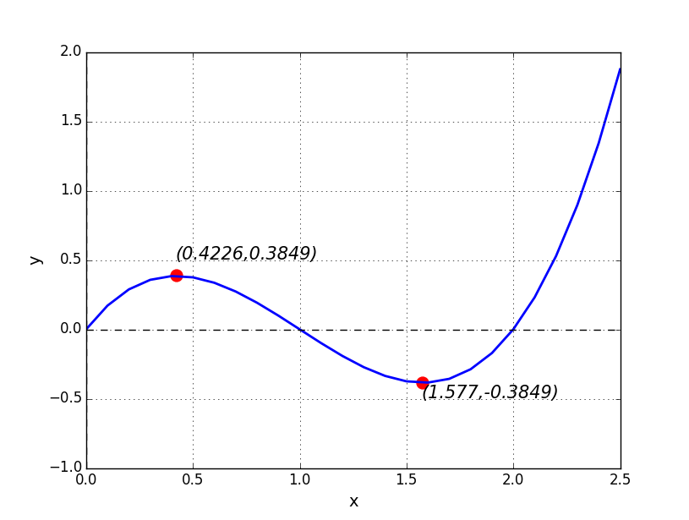

Q. Write down the x-value(s) of the relative maximum and relative minimum points of $f(x)$.

Relative maximum: __________ Relative minimum: : __________

Q. Find the x-value(s) of the relative extrema of $f(x)$ below.

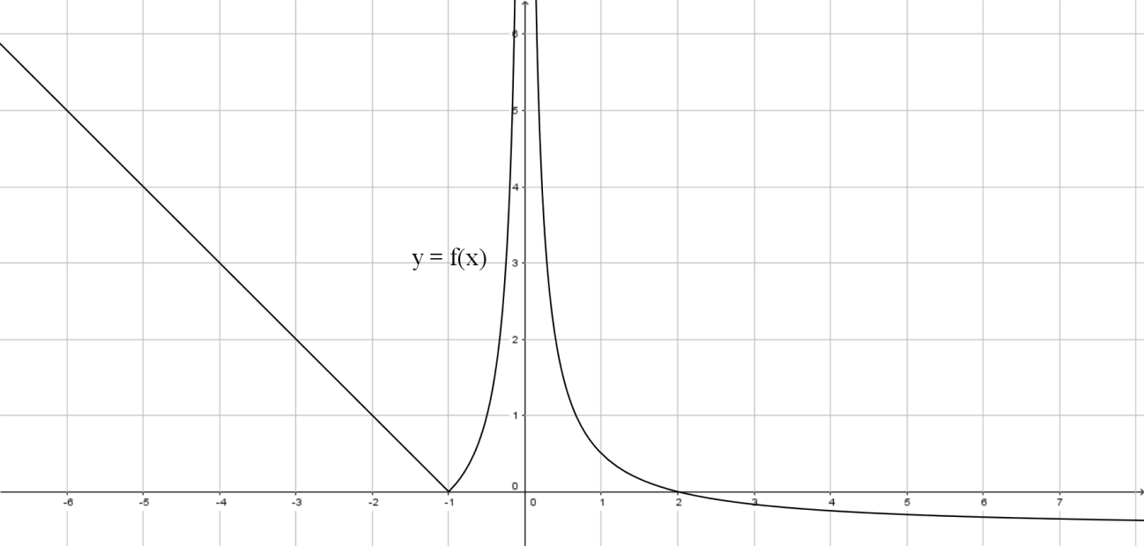

$f(x)$** does/doesn’t have to be differentiable at a relative maximum point or a relative minimum point.

A critical number of $f(x)$ is a number $x$ in the domain of $f(x)$ at which

1. or 2. is undefined. [ $f(x)$ is well-defined.]

In particular, all relative maximum points and relative minimum points are critical numbers. The converse is not true. A critical number doesn’t have to be a relative maximum or relative minimum.

Suppose $c$ is a critical number of $f(x)$. How can we know that $c$ is a relative maximum, a relative minimum, or none of them?

First-Derivative Test. Suppose $f(x)$ has a critical number (CN) .

1. If just before $c$ and $f^{'}\left(x\right)<0$ just after $c$, then $c$ is a relative maximum point of .

2. If just before $c$ and $f^{'}\left(x\right)>0$ just after $c$, then $c$ is a relative minimum point of $f(x)$.

A relative maximum is the peak of a mountain. We have to climb up the mountain to reach the top. $f(x)$ is increasing before the number $c$, meaning that $f^{'}\left(x\right)>0$ before $c$. After we have reached the top, we have to go down. $f(x)$ is decreasing after $c$, and so $f^{'}\left(x\right)<0$ after $c$. 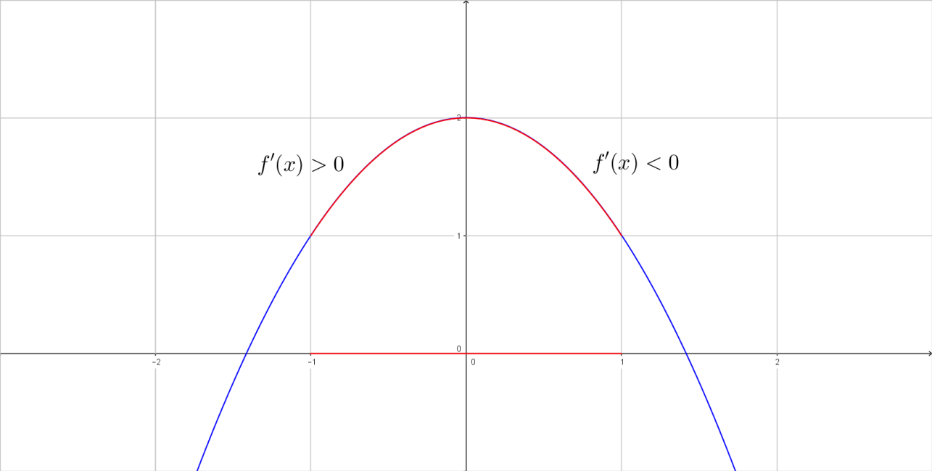

As long as $f'(x)$ changes its sign from positive to negative across a critical number $c$ over an open interval containing $c$, (being the interval (-1,1) in the above graph and $c=0$), we are sure that $c$ is a relative maximum.

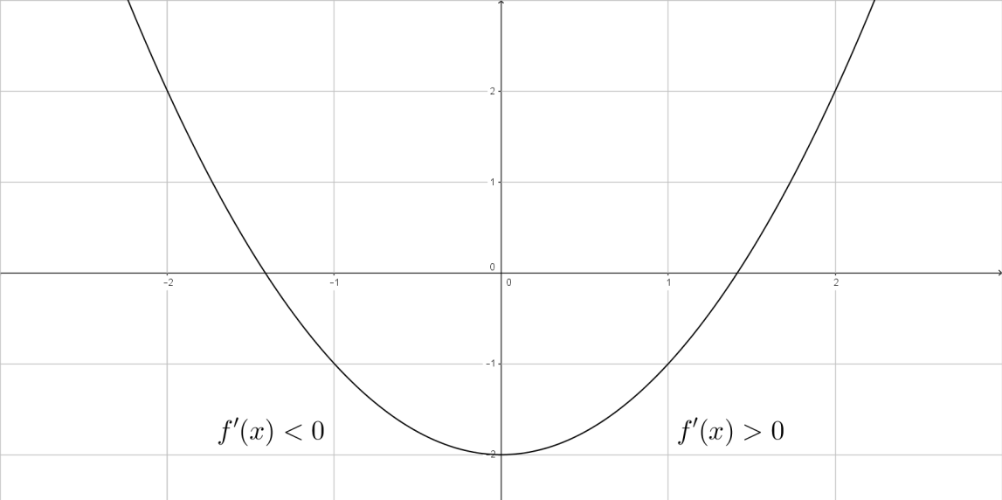

Now, giving a function $f(x)$, we try to (1) find all its critical numbers, and (2) identify relative maximum or relative minimum points from those CNs. This process is done by the method of drawing a **sign diagram**.

Q. Find the critical numbers of the function $f(x)$.

$$f\left(x\right)=x^{3}+6x^{2}-36x-60$$

Use sign diagrams for the derivatives to find all open intervals of increase and decrease.

The solution is as follows.

1. Find the critical numbers of $f(x)$.

$$f^{'}\left(x\right)=3x^{2}+12x-36=3(x+6)(x-2)$$

Solve $f^{'}\left(x\right)=0$.

$∴$ CNs are and .

2. Make a sign diagram for the derivative.

|  |  |  |  |  |  |
| --- | --- | --- | --- | --- | --- |
| $$x$$ | $$(-∞ , -6)$$ | $$-6$$ | $$(-6 , 2)$$ | $$2$$ | $$(2 , ∞)$$ |
| $$f'(x)$$ |  | $$0$$ |  | $$0$$ |  |
| $$f(x)$$ |  |  |  |  |  |

We have to determine the signs of $f^{'}\left(x\right)$ on intervals $\left(-∞ , -6\right)$, $\left(-6 , 2\right)$ and $\left(2 , ∞\right)$ respectively. (Sign means positive + or negative -.) Here we use **test points** to find the correct signs.

Suppose $(a,b)$ is in the domain of a function $f(x)$. If there is no critical number in the open interval $(a,b)$, then $f'(x)$ remains positive or remains negative all over the interval $(a,b)$.

On $(-∞ , -6)$, we can pick $x=-7$.

$$f^{'}\left(-7\right)=3\left(-7+6\right)\left(-7-2\right)=3⋅\left(-1\right)⋅\left(-9\right)=27$$

$f^{'}\left(-7\right)>0$ means that $f(x)$ is increasing on $(-∞ , -6)$.

>

>

>

>

>

>

>

>

>  
>

>

>

>

Therefore, we have the following

|  |
| --- |
| Interval(s) of increase: __________________________ |
| Interval(s) of decrease: __________________________ |
| Critical numbers: __________________________ |
| Relative maximum points (x-values): __________________________ |
| Relative minimum points (x-values): __________________________ |

Q. Find the critical numbers of the function $f(x)$.

$$f\left(x\right)=3x^{4}-8x^{3}+6x^{2}$$

Use sign diagrams for the derivatives to find all open intervals of increase and decrease.

>

>

>

>

>

>

>

>

>

>

>

>

>

>

>

>

>

>

>

>

>

>

>

>

>

>

>

>

>

In this course we are graphing rational functions. We have to first find the critical numbers (relative maximum and relative minimum), and intervals of increase or decrease, which is mentioned above.

Another important part to graph a rational function, is to find out vertical asymptotes and horizontal asymptotes of a rational function.

A function $f(x)$ has a horizontal asymptote (HA) $y=c$ if

$$\lim_{x→∞}{f\left(x\right)=c or \lim_{x→-∞}{f\left(x\right)=c}}.$$

A function can have two different horizontal asymptotes at most. However, a rational function can have ZERO or ONE asymptote.

The word “asymptote” above refers to the line $y=c$ on the xy-plane. It is horizontal in nature. Sometimes this horizontal asymptote can refer to the y-value $c$.

A rational function $\frac{p(x)}{q(x)}$ has a vertical asymptote (VA) $x=c$ if

$$p\left(c\right)≠0 and q\left(c\right)=0 .$$

Again, this vertical asymptote $x=c$ can refer to the vertical line on xy-plane or the x-value $c$. 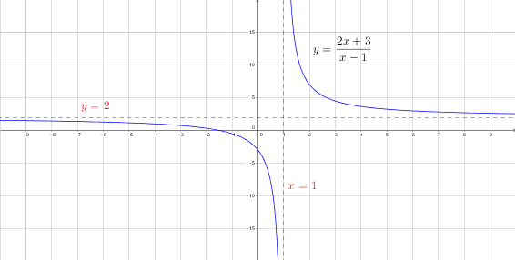

In general, function $f(x)$ has a vertical asymptote $x=c$ if

(1) $\lim_{x→c^{+}}{f\left(x\right)= ±∞}$, and (2) $\lim_{x→c^{-}}{f\left(x\right)=±∞}$.

Since our intention is to work on rational functions, we always stick to the framed box definition of a vertical asymptote.

Q. Find the horizontal asymptote of $\left(x\right)=\frac{4x}{x-2}$.

>

>

>

>

Q. Find the horizontal asymptote of $\left(x\right)=\frac{11x}{x^{2}-25}$.

>

>

>

>

Q. Find all the vertical asymptotes of $f(x)$.

$$f\left(x\right)=\frac{12}{x^{2}-2x-3}$$

>

>

>

>

>

>