*Business Calculus – Week 5*

Graphing using the First and Second Derivatives

A curve on the xy-plane is concave up if it curls upward. It is like an opening up parabola. A curve is concave down if it curls downward, like an opening down parabola. We say that a straight line is flat, having no concavity.

The second derivative of a function $f(x)$ tells us about the concavity of the graph of $f\left(x\right)$.

Suppose $f(x)$ is a function, and an open interval $(a,b)$ is contained in the domain of $f(x)$.

(1) If $f^{''}\left(x\right)>0$ on $(a,b)$, then $f\left(x\right)$ is concave up on $(a,b)$.

(2) If $f^{''}\left(x\right)<0$ on $(a,b)$. Then $f(x)$ is concave down on $(a,b)$.

An inflection point (IP) is a point on the graph of $f(x)$ where concavity changes. At an inflection point $\left(x , y\right)$, $f^{''}\left(x\right)=0$ or undefined.

A possible inflection point is a point on the graph of $f(x)$ of which the x-value solves $f^{''}\left(x\right)=0$.

Example. Let $f\left(x\right)=x^{4}+8x^{3}+18x^{2}+8$. Find the followings.

1. Find all critical numbers of $f(x)$.
2. Find all intervals of increase and intervals of decrease.
3. Find x-values of all relative extrema of $f(x)$.
4. Find the x-values of all possible inflection points of $f(x)$.
5. Find all concave-up intervals and concave-down intervals of $f(x)$.
6. Find the x-values of all inflection points of $f(x)$.

Step 1 to Step 6

1. Find $f'(x)$ and $f''(x)$.
2. Solve $f^{'}\left(x\right)=0$ to find all CNs.   
   Solve $f^{''}\left(x\right)=0$ to find all possible IPs (x-values).
3. Make a sign diagram for the first derivative $f'(x)$.
4. Find intervals of increase and decrease.   
   Locate relative maximum and relative minimum (x-values).
5. Make a sign diagram for the second derivative $f''(x)$.  
   Find concave-up and concave-down intervals.
6. Locate IPs (x-values).

>

>

>

>

>

>

>

>

>

>

>

>

>

>

>

>

>

>

>

>

>

>

>

>

>

>

>

>

>

>

>

>

>

>

>

>

>

>

Now we can (7.) sketch the graph of $f\left(x\right)=x^{4}+8x^{3}+18x^{2}+8$.

On the graph, we have to label all relative extreme points, inflection points and intercepts. Here we have to find the y-values of those relative maximum/minimum points and that of IPs.

[DON’T work on asymptote if it is not mentioned in the question. ]

>

>

>

>

>

>

>

>

>

>

>

>

>

>

>

>

>

>

Here we mention an application of inflection point and concavity,

Suppose a company has its revenue function $R(x)$, where $x$ represents the amount in dollars invested in advertising. (Or we can use its profit function $P\left(x\right)$.) An inflection point where $R(x)$ changes from concave up to concave down, is called a point of diminishing returns.

Basically it means after this point, further investment will bring decreasing returns but not increasing returns. The additional dollar spent on advertising starts to be not as worth as the previous dollar spent on advertising.

Q. By increasing its advertising cost $x$, in thousands of dollars, a company discovers that it can increase the sales $y$, in thousands of dollars, of a product according to the model.

$$y=10-3x+24x^{2}-x^{3}, for 0≤x≤15$$

Find the point of diminishing returns for this product, and explain what this means.

>

>

>

>

>

>

>

>

The last section is about the second-derivative test. The second derivative of a function also gives us information about its critical numbers.

Second-Derivative Test

Let $c$ be a critical number of a function $f(x)$. Suppose $f''(c)$ is well defined.

(1) If $f^{''}\left(c\right)>0$, then $f(x)$ has a relative minimum at $x=c$.

(2) If $f^{''}\left(c\right)<0$, then $f(x)$ has a relative maximum at $x=c$.

Q. Find all critical numbers for the function

$$f\left(x\right)=-x^{3}+27x+2 .$$

Use the second-derivative test to classify each critical number as a relative maximum point, a relative minimum point, or neither of them.

>

>

>

>

>

>

>

>

>

>

>

>

>

Example. It Is a more involving example that can be skipped.

$$f\left(x\right)=\frac{x}{x^{2}-1} .$$

Given the function $f\left(x\right)$, we have to

1. make a sign diagram for the first derivative,
2. make a sign diagram for the second derivative,
3. sketch the graph of $f(x)$, showing relative max/min points, IPs, intercepts, and all asymptotes.

>

>

>

>

>

>

>

>

>

>

>

>

>

>

>

>

>

>

>

>

>

>

>

>

>

>

>

>

>

>

>

>

>

>

>

>

>

>

>

Optimization

Optimizing a function $f(x)$ means finding its maximum or minimum value over the domain of $f(x)$.

The absolute maximum value of $f(x)$ is the largest value of the function on its domain. The absolute minimum value of $f(x)$ is the smallest value of the function on its domain.

An absolute extreme value of $f(x)$ refers to the absolute maximum value or the absolute minimum value of $f(x)$.

It can happen that a function $f(x)$ has no absolute maximum value, or no absolute minimum value, or none of the absolute max and min values.

Let $f(x)$ be a continuous function, and let $[a,b]$ be a closed interval inside the domain of $f(x)$. Then, $f(x)$ must have the absolute maximum value, and the absolute minimum value on $[a,b]$.

Example. Let $f\left(x\right)=x^{3}-6x^{2}+9x+8$. Find the absolute maximum and absolute minimum values of $f(x)$ on the closed interval $[-1,2]$.

Find absolute max/min values of $f\left(x\right)$ on $[a,b]$.

Step 1: Find all critical numbers of $f(x)$ on $[a,b]$.

Step 2: Evaluate $f(x)$ at all CNs, and at the endpoints $x=a$ and $x=b$.

Step 3: Compare all the values of $f(x)$ you get in Step 2.

>

>

>

>

>

>

>

>

>

>

>

Q. Let $f\left(x\right)=6x^{2}-x^{3}$. Find the absolute maximum and absolute minimum values of $f(x)$ on the interval [0,5].

>

>

>

>

>

>

>

>

>

>

The second derivative test states as follows. If $f(x)$ has a critical number $c$ in its domain, then (1) $f^{''}\left(c\right)>0$ means $c$ is a relative minimum point, and (2) $f^{''}\left(c\right)<0$ means $c$ is a relative maximum point.

Second-Derivative Test (Absolute max/min)

Suppose the domain of $f\left(x\right)$ is an interval, a ray or $(-∞ , ∞)$.   
Let $c$ be the ONLY critical number of $f(x)$ in its domain.

(3) If $f^{''}\left(c\right)>0$, then $f(x)$ attains the absolute minimum value at $x=c$  
 and the absolute minimum value is $f(c)$.

(4) If $f^{''}\left(c\right)<0$, then $f(x)$ attains the absolute maximum value at $x=c$  
 and the absolute maximum value is $f(c)$.

Example. [Company’s Profit] Uber (Pittsburgh) finds that its price function is

$$p\left(x\right)=125-3x,$$

where $p(x)$ is the price in dollars at which $x$ Uber cars will be in service per day. It costs Uber 5 dollars to call on a Uber driver each ride, and the fixed cost is 400 dollars per day.

(1) Find the number of Uber cars that Uber should deploy per day, and the price it should charge to maximize profit.

(2) Find the maximum profit.

These two statements come from the text book P.193 & P.195.

The price function $p(x)$ gives the price $p$ at which consumers will buy exactly $x$ units of the products.

A maximum profit, marginal revenue $MR(x)$ equals marginal cost $MC(x)$.

>

>

>

>

>

>

>  
>

>

>

>

>

>

>

>

>

>

>

>

>

>

>

>

Example. [Fencing, textbook P.196]

A farmer has 2000 feet of fence and wants to build a rectangular enclosure along a straight wall. The side along this wall needs no fence. Find the dimension that make the enclosure as large as possible. Also find the maximum area.

>

>

>

>

>

>

>

>

>

>

>

>

>

>

>

>

>

>

>

Example. [Box, textbook P.197]

An open-top box is to be made from a square sheet of paper 12 inches on each side, by cutting a square from each corner and folding up the sides. Find the volume of the largest box that can be made in this way.

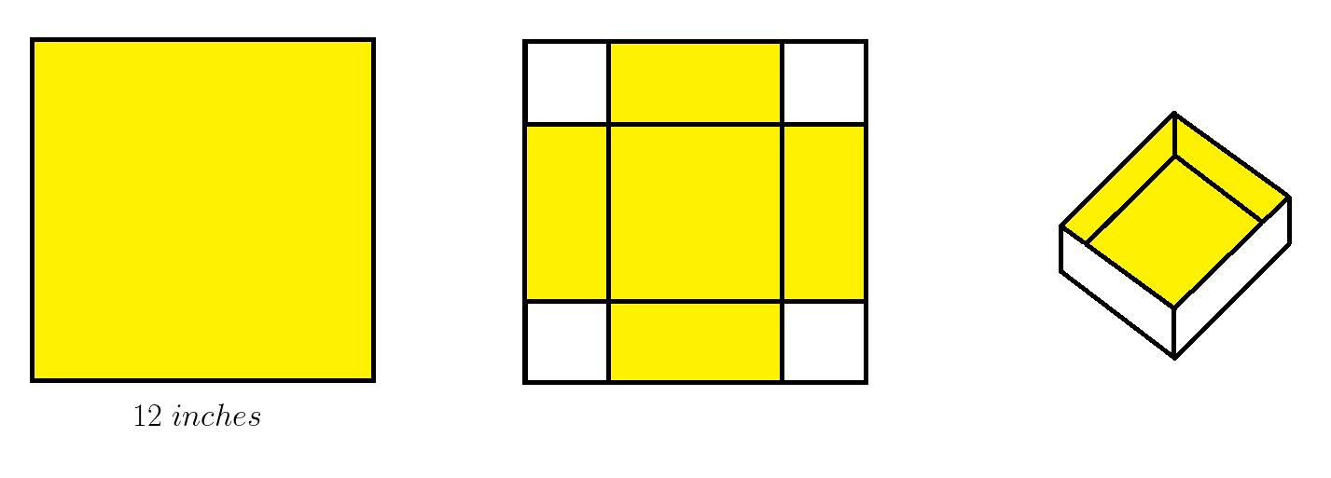

>

>

>

>

>

>

>

>

>

>

>

>

>

Further Applications of Optimization

We are looking at more and deeper optimization problems in this section.

Example. [Company’s Profit, textbook P.203]

A store can sell 20 bicycles per week at a price of $400 each. The manager estimates that for each $10 price reduction, she can sell 2 more bicycles per week. The bicycles cost the store $200 each.

Find (1) the price and quantity of bicycles that maximize profit,   
and (2) the maximum profit.

>

>

>

>

>

>

>

>

>

>

>

>

>

>

>

>

Example. [Farming]

An apple grower finds that if she plants 20 trees per acre, each tree will yield 90 bushels of apples. She also estimates that for each additional tree that she plants per acre, the yield of each tree will decrease by 3 bushels.

How many trees should she plant per acre to maximize her harvest?

>

>

>

>

>

>

>

>

>

>

>

>

>

>

>

>

>

>

Example. [Fencing]

A homeowner wants to build, along his driveway, a garden surrounded by a fence. The garden is to be $800 ft^{2}$. The fence along the driveway costs $\$6$ per foot, while on the other three sides, it costs only $\$2$ per foot.

Find the dimensions that will minimize the cost. Also find the minimum cost.

>

>

>

>

>

>

>

>

>

>

>

>

>

>

>

>

>

>

Example. [Box, Webwork HW6, Q11]

A rectangular storage container with a lid is to have a volume of $14 m^{3}$. The length if its base is twice the width. Material for the base cost $\$7$ per $m^{2}$. Material for the sides and lid costs $\$14$ per $m^{2}$.

Find the dimension of the container which will minimize cost.   
Find the minimum cost.





































































