*Business Calculus - Week 6*

Optimizing Lot Size and Harvest Size

Inventory means the amount of goods held by a company at a particular time. The inventory cost means the cost of holding goods in stock.

For a company, there are two kinds of costs involved in maintaining inventory. First, it is storage cost , eg. warehouse cost and insurance cost for goods not yet sold. Second, recorder cost, including delivery and bookkeeping costs for each order.

Inventory cost = Storage cost + Reorder cost

For example, the Pitt Shop expects to sell 3000 T-shirts in a year. It could order all 3000 T-shirts at once.

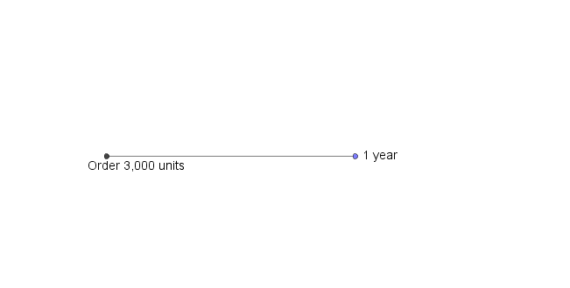

Or it can order 300 T-shirts in many small lots. Say 4 orders of 750 units each. The order size of each lot, is called the lot size.

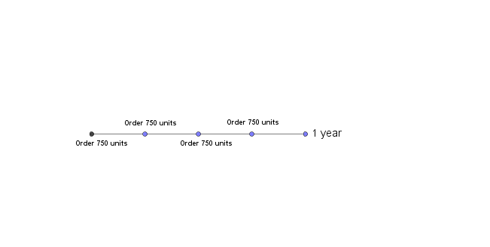

The best lot size is one that minimizes the inventory cost.

We always assume that T-shirts are sold steadily throughout a year. The store reorders whenever stocks run out. So, throughout a year,

$$average inventories =\frac{lot size}{2} .$$

Example. The Pitt Shop expects to sell 3000 T-shirts a year. Each T-shirt costs the store $10, and there is a fixed charge of $20 per order. If it costs $3 to store a T-shirt for a year, how large should each order be, and how often should orders be placed to minimize inventory costs?

>

>

>

>

>

>

>

>

>

>

>

>

>

>

>

>

>

>

>

>

>

>

>

Similar to the retail business, in manufacturing business, a company estimates the annual demand of a product, and then chooses to manufacture all at once, or to manufacture the total in several smaller runs. These runs are called production runs.

The total costs in production consists of storage cost, just like what we did before, and the setup cost for every production run, similar to the reorder cost in previous example.

Inventory cost = Storage cost + Setup cost

Example. A book publisher estimates to sell 200 copies of a book per year. Each copy costs the publisher $6 to print, and the setup cost is $50 for each printing. It costs $2 per year to store a book.

How many books should be printed per run in order to minimize costs?

>

>

>

>

>

>

>

>

>

>

>

>

>

>

>

>

>

>

>

>

>

>

>

>

>

>

>

>

>

>

>

>

>

>

>

>

The third application of optimization in this section, is about finding maximum sustainable yield. In fishing (or hunting) industry, we get fish from the mother nature, but it is important to keep the animal population as large as before hunting every year.

The maximum amount of fish that we can harvest this year, while the animal population can still return to the previous level in the next year, is called the maximum sustainable yield.

Reproduction function. A reproduction function $f(p)$ gives the animal population a year from now if the current population is $p$.

Given reproduction function $f\left(p\right)$ and the current population of size $p$, the amount of growth in the population during this year is

$$\left(Amount of growth\right)=f\left(p\right)-p .$$

Sustainable yield. For a reproduction function $f(p)$, the sustainable yield is

$$Y\left(p\right)=f\left(p\right)-p .$$

$Y(p)$ is the function to be maximized in our concern.

Maximum sustainable yield. For reproduction function $f(p)$, the population $p$ that results in the maximum sustainable yield is the solution to

$$f^{'}\left(p\right)=1 ,$$

provided that $f^{''}\left(p\right)<0$. The maximum sustainable yield is then

$$Y\left(p\right)=f\left(p\right)-p .$$

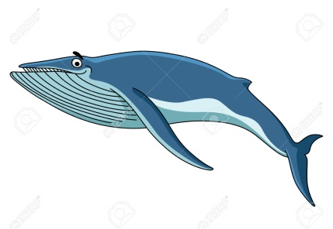

Example. The reproduction function for the Antarctic blue whale is estimated to be

$$f\left(p\right)=-0.0004p^{2}+1.06p$$

where $p$ and $f(p)$ are in thousands. Find the population that gives the maximum sustainable yield, and the size of the yield.

>

>

>

>

>

>

>

>

>

>

>

>

>

>

>

>

>

>

>

>

>

>

>

Implicit Differentiation and Related Rates

Suppose $x$ and $y$ are two variables. Many times $y$ is a function of $x$, and then we say $y=f(x)$. Variables $x$ and $y$ are related explicitly in this case. However, sometimes $x$ and $y$ are related implicitly. For example, we know that $x$ and $y$ are related by

$$x^{2}+y^{2}=16 .$$

$y$ fails to be a function of $x$ in this equation. We call this equation an implicit equation, and $y$ is called an implicit function of $x$. In this section, we find

$$\frac{dy}{dx}$$ from an implicit equation. The process is called implicit differentiation.

Generalized power rule.

$$\frac{d}{dx}\left(y^{n}\right)=n⋅y^{n-1}⋅\frac{dy}{dx}$$

Example. Use implicit differentiation to find $\frac{dy}{dx}$ when $7x^{2}+y^{2}=16$.

>

>

>

>

>

>

>

>

>

>

Q. Find the equation of the tangent line to ${7x}^{2}+y^{2}=16$ at $(1,3)$.

>

>

>

>

Steps of Implicit Differentiation

1. Differentiate every term with respect to $x$.
2. Collect on terms with $\frac{dy}{dx}$ on the LHS. Put other terms to the RHS.
3. Factor out $\frac{dy}{dx}$ on the left. Solve by division.

Q. Find the slope of the tangent to the curve

$$2x^{3}+3xy+y^{2}=12$$

at $(1,2)$.

>

>

>

>

>

>

>

>

>  
>

>

In economics, a demand equation is the relation between the price $p$ of a product, and the quantity $x$ that consumers will demand at that price.

Q. A company’s demand equation is

$$x=\sqrt{2000-p^{2}} ,$$

where $p$ is the price in dollars. Find $\frac{dp}{dx}$ when $p=40$. Interpret your answer.

>

>

>

>

>

>

>

>

>

>

>

>

>

>

>

>

>

Example. [Sales]

The number of printer cartridges that a store will sell per week, $x$ in number, and their price, $p$ in dollars, are related by the equation

$$x^{2}=4500-5p^{2} .$$

If the price is falling at the rate of $1 per week, find how the sales will change when the current price is $20.

>

>

>

>

>

>

>

>

>

>

>

>

>

>

>

>

>

Implicit differentiation is useful when we are finding related rates.

Example. [Snowball]

A large snowball is melting so that its radius is decreasing at the rate of  
2 inches per hour. How fast is the volume decreasing at the moment when the radius is 3 inches?

[Hint: The volume of a sphere of radius $r$ is given by $=\frac{4}{3}πr^{3}$.]

>

>

>

>

>

>

>

>

>

>

>

>

>

>

>

>

>

Example. [Ladder]

A ladder of 25 feet long is leaning against the wall of a house. The base of the ladder is being pulled away from the wall at a rate of 2 feet per second.

How fast is the top of the ladder moving down the wall when its base is   
7 feet from the wall?

>

>

>

>

>

>

>

>

>

>

>

>

>

>

>

>

>

>

Example. [Distance]

Two people on bikes start riding from the same point at the same time. Person A starts riding west at a rate of 3 meters per second, and Person B starts riding south at 4 meters per second.

At what rate is the distance separating these two people changing when it is 2 seconds after they started riding?

>

>

>

>

>

>

>

>

>

>

>

>

>

>

>

>

>

>