*Business Calculus - Week 7*

Exponential & Logarithmic Functions

The exponential function with base $a$ and exponent $x$ is $f\left(x\right)=a^{x} .$

We require $a>0$. When this constant $a=1$, we have $f\left(x\right)=1$ for all $x$.

When $a>1$, for example $a=1$, the graph of $f\left(x\right)=2^{x}$ is plotted below.

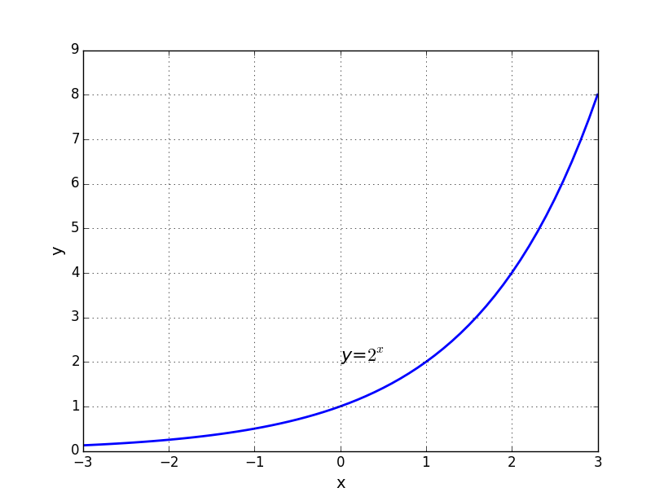

On the other hand, when $a<1$, for example $a=\frac{1}{2}$, the graph is as below.

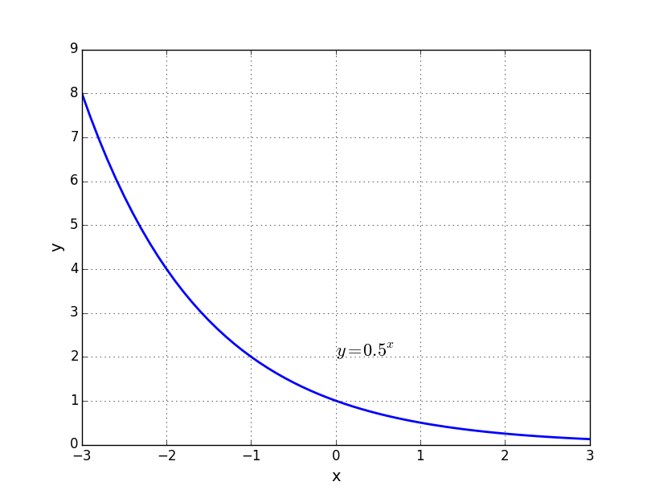

*Compound interest* means that, the interest is counted multiple times within a year. Suppose a bank offers an annual interest rate at $8\%$ compounded quarterly, and suppose your starting investment, *the principal*, is $\$100$.

Starting from January, you put your money in the bank. After a quarter, that means we are on the first day of April, your amount in the bank, principal plus interest, is

$$100×\left(1+\frac{0.08}{4}\right)=\$102 .$$

Keeping this amount in the bank, on the first day of July, the bank gives you another round of interest. At this moment you have

$$102×\left(1+\frac{0.08}{4}\right)=\$104.04$$

in your bank account. In this fashion, you also get your interest on the first day of October and on the first day of 2017. In each quarter, the interest rate is $\frac{0.08}{4}=0.02$.

Compound interest. For $P$ dollars invested at annual interest rate $r$ compounded $m$ times a year for $t$ years,

$$Value after t years=P⋅{\left(1+\frac{r}{m}\right)}^{mt}.$$

The number $e$ is $2.71828⋯$. We have

$$e=\lim_{n→∞}{{\left(1+\frac{1}{n}\right)}^{n}}.$$

The bank can offer an annual interest *compounded continuously* at certain rate. It means that at every moment, you gain the interest.

Continuous compounding. For $P$ dollars invested at annual interest rate $r$ compounded continuously for $t$ years

$$Value after t years=Pe^{rt} .$$

The number $e$ gives us a family of exponential functions. For example,

$$f\left(x\right)=e^{x}, f\left(x\right)=e^{3x}, f\left(x\right)=e^{-5x}, ⋯$$

which will appear in the following sections.

Q. Find the value of $1000 deposited in a bank at $10\%$ interest for 8 years compounded

(a) annually, (b) quarterly, (c) continuously.

>

>

>

>

>

>

>

>

>

In addition to the interest gained after certain years under an investment, we can reverse the order and look at the present value of a future payment at a certain annual interest rate, compounded several times a year.

Present value. For a future payment of $P$ dollars at annual interest rate $r$ compounded $m$ times a year to be paid in $t$ years,

$Present Value=\frac{P}{{\left(1+\frac{r}{m}\right)}^{mt}} .$

For a future payment of $P$ dollars at annual interest rate $r$ compounded continuously to be paid in $t$ years,

$$Present Value=P⋅e^{-rt} .$$

Logarithm is the inverse of exponent. For example, we know

$$10,000={10}^{4} ,$$

so we have $\log_{10}{10,000=4}$. The operator $\log_{10}{ }$ is the logarithm to the base 10. $\log_{10}{x=y}$ if we know that ${10}^{y}=x$.

For the logarithm to the base $a$,

$$\log_{a}{x=y is equivalent to a^{y}=x} .$$

Example. Find $\log_{10}{\frac{1}{10}}$.

>

>

>

The natural logarithm refers to the logarithm to the base $e$. It is denoted by the symbol .

$$\ln{x}=logarithm of x to the base e$$

There are many properties of the natural logarithm.

Properties of $ln$.

|  |  |
| --- | --- |
| $\ln\left(1\right)=0$ | $\ln\left(M⋅N\right)=\ln{M}+ln{N}$ |
| $\ln\left(e\right)=1$ | $\ln\left(\frac{1}{N}\right)=-\ln{N}$ |
| $\ln{e^{x}=x}$ | $\ln\left(\frac{M}{N}\right)=\ln{M}-\ln{N}$ |
| $e^{\ln{x}}=x$ | $\ln{M^{p}}=p⋅\ln{M}$ |

Q. Simplify the following functions.

1. $f\left(x\right)=\ln{(9x)}-\ln{9}$

2. $f\left(x\right)=\ln{x^{5}}-3\ln{x}$

3. $f\left(x\right)=\ln{e^{5x}}$

4. $f\left(x\right)={100}^{\log_{10}{x}}$

>

>

>

>

>

>

Q. A bank account grows at 8% compounded quarterly. How long will it take to double the amount? [Use natural logarithm to find the number of years $t$. Leave $ln$ in your answer and simply the result.]

>

>

>

>

>

>

>

>

>

>

Differentiation of Logarithmic & Exponential functions

In this section, we are differentiating these two functions and .

9. Derivative of

10. Derivative of

11. Derivative of

12. Derivative of $e^{f\left(x\right)}$

$$\frac{d}{dx}e^{f\left(x\right)}=f^{'}\left(x\right)⋅e^{f\left(x\right)}$$

In particular, for any constant $k$, $\frac{d}{dx}e^{kx}=k⋅e^{kx}$ in item (12).

Q. Differentiate the following functions.

(a) $f\left(x\right)=x^{3}\ln{x}$

(b) $f\left(x\right)={\ln\left(x^{4}+1\right)}^{2}$

(c) $f\left(x\right)=2e^{7x}$

(d) $f\left(x\right)=e^{x}ln⁡(x+1)$

(e) $f\left(x\right)={-8e}^{x^{2}}$

(f) $f\left(x\right)={\left(\ln{x}\right)}^{1/2 }$

>

>

>

>

>

>

>

>

>

>

>

>

>

>

>

>

>

>

>

>

>

>

>

We always have

$$a^{y}=e^{\ln{a}⋅y} and \log_{a}{y}=\frac{\ln{y}}{\ln{a}} .$$

Differentiation formula (13)

$$\frac{d}{dx}\log_{a}{x}=\frac{1}{\left(\ln{a}\right)x} and \frac{d}{dx}\log_{a}{f(x)}=\frac{f^{'}\left(x\right)}{\left(\ln{a}\right)f(x)}$$

Differentiation Formula (14)

$$\frac{d}{dx}a^{x}=\left(\ln{a}\right)a^{x} and \frac{d}{dx}a^{f\left(x\right)}=(\ln{a)}a^{f\left(x\right)}f'(x)$$

Q. The United States population (in millions) is predicted to be

$$P\left(t\right)=317e^{0.01t} ,$$

where $t$ is the number of years after 2013. Find the instantaneous rate of change of population in 2023.

>

>

>

>

>

>

>

>

>

>

>

Relative Rates and Elasticity of Demand

The relative rate of change of a function $f(t)$ at a number $t=t_{0}$ is the derivative $f'(t_{0})$ divided by $f\left(t_{0}\right)$.

$$Relative rate of change of f\left(t\right)=\frac{d}{dt}\ln{f\left(t\right)}=\frac{f^{'}\left(t\right)}{f\left(t\right)}$$

Example. We know that GDP stands for gross domestic product.

For example, the GDP of the United States is 17419 billion dollars in 2014. Suppose that it is increasing at a *relative rate* of 3% per year. Then, the instantaneous rate of change of GDP in 2014 is

$$17419×3\%=522.57 billion dollars per year.$$

It is simpler to talk about the relative rate than the actual rate of change in this situation.

In 2014, the GDP of Canada is 1785 billion dollars. Suppose the Canada GDP is increasing at the instantaneous rate of 36 billion dollars per year. Then, the relative rate of change of Canada is

$$\frac{36}{1785}=0.02=2\% .$$

So we may say that in 2014, the US GDP is growing faster than the Canada GDP, by comparing their relative rates of change.

If $f(t)$ is in dollars while $t$ is in years, $f'(t)$ is in dollars per year. On the other hand, the relative rate $\frac{f^{'}\left(t\right)}{f\left(t\right)}$ is in “per year”.

The demand function $x=D(p)$ gives the quantity $x$ of a product that will be demanded by consumers if the price is $p$.

Elasticity of demand ($E$) is the percentage change in demand divided by the percentage change in price.

$$E=\frac{Percent change in demand}{Percent change in price}$$

We have the following.

For a demand function $D(p)$, the elasticity of demand is

$$E\left(p\right)=\frac{-p⋅D'(p)}{D(p)} .$$

Demand is elastic if $E\left(p\right)>1$. Demand is inelastic if $E\left(p\right)<1$.

We say that demand is unit-elastic if $E\left(p\right)=1$.

Elasticity and Revenue.

1. If demand is elastic $(E>1)$, lower the price to increase revenue.
2. If demand is inelastic $(E<1)$, raise the price to increase revenue.

At maximum revenue, the elasticity of demand must equal 1.

Q. The demand function for a newspaper is $D\left(p\right)=80,000\sqrt{75-p}$,   
where $p$ is the price in cents. The publisher currently charges 40 cents. Should it raise or lower the price to increase revenue?

>

>

>

>

>

>