*Business Calculus - Week 9*

Definite Integrals and Areas

Suppose we have a non-negative function $f(x)$. Let $[a,b]$ be an interval within the domain of $f(x)$. We may consider the area under the curve $y=f(x)$ and above the x-axis, bounded between two vertical lines $x=a$ and $x=b$.

Definite integral. The area under the curve $y=f(x)$ from $a$ to $b$ is called the definite integral of the function $f(x)$ from $a$ to $b$. It is written as

$$\int_{a}^{b}{f\left(x\right) dx} .$$

For example, let $f\left(x\right)=x^{2}+1$ and the interval be $[0,2]$. We are finding

$$\int_{0}^{2}{x^{2}+1 dx} .$$

The area under $f\left(x\right)=x^{2}+1$ from $0$ to $2$ can be approximated by rectangles below the curve $y=x^{2}+1$. First we use four rectangles.

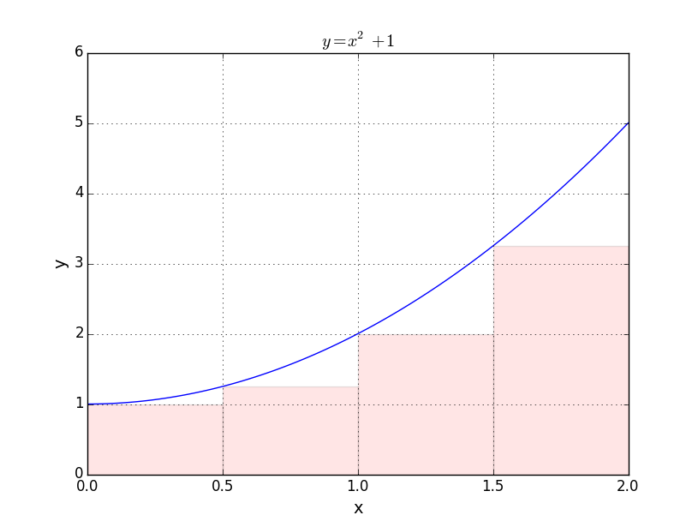

The pink rectangles above are called *left rectangles*, because each has a height equal to the height of the curve at the left-hand edge of the rectangle.

The approximate area by these four rectangles is

$$S_{4}=0.5\left(f\left(0\right)+f\left(0.5\right)+f\left(1\right)+f\left(1.5\right)\right)=0.5\left(1+1.25+2+3.25\right)=3.75$$

in square units. This approximate area doesn’t count the area under the curve $y=x^{2}+1$ outside the red-shaded region. It can be improved by using more left-rectangles. Let say this time we use 8 left-rectangles to estimate the area under $y=x^{2}+1$.

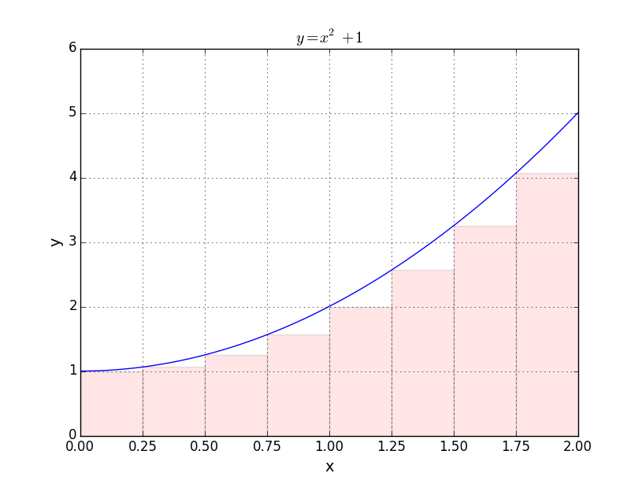

The new approximate area is

$$S_{8}=0.25\left(1+1.0625+1.25+⋯+3.25+4.0625\right)=4.1875 .$$

This figure is closer to the definite integral $\int_{0}^{2}{x^{2}+1 dx}$ than $S_{4}=3.75$, since the unshaded region under the curve $y=x^{2}+1$ is smaller in the upper graph.

So, what is the value of $\int_{0}^{2}{x^{2}+1 dx}$?

Fundamental Theorem of Integral Calculus.

Suppose $f(x)$ is a continuous function on an interval $[a,b]$. If $F(x)$ is one antiderivative of $f(x)$, I.e. $F^{'}\left(x\right)=f(x)$. Then,

$$\int_{a}^{b}{f\left(x\right) dx}=F\left(b\right)-F\left(a\right).$$

Before going on, we introduce a notation here. Suppose $F(x)$ is the above function. We set

$${\left.\left.F\left(x\right)\right|\right.}_{a}^{b}=F\left(b\right)-F\left(a\right) .$$

Example. Find $\int_{0}^{2}{x^{2} dx}$. We know that

$$\int{x^{2} dx}=\frac{1}{3}x^{3}+C .$$

So we ignore the arbitrary constant $C$ and let $F\left(x\right)=\frac{1}{3}x^{3}$.

$${\left.\int_{0}^{2}{x^{2} dx}=\left(\frac{1}{3}x^{3}\right) \right|}_{0}^{2}=\left(\frac{2^{3}}{3}\right)-\left(\frac{0}{3}\right) =\frac{8}{3} .$$

** When you are finding a definite integral, always write down your antiderivative “ $F(x)$” in your answer. Don’t just jump to a numerical figure!

Q. Find $\int_{0}^{2}{x^{2}+1 dx}$.

>

>

>

>

>

>

Properties of definite integrals follow from properties of indefinite integral.

3. Constant-multiple rule for definite integrals. For any constant ,

4. Sum-Difference rule for definite integrals.

$$\int_{a}^{b}{\left[f\left(x\right)+g\left(x\right)\right] dx}=\int_{a}^{b}{f\left(x\right) dx}+\int_{a}^{b}{g\left(x\right) dx}$$

Q. Find the definite integral $\int_{2}^{4}{\left(1+x^{-2}\right) dx}$.

>

>

>

Q. Find the definite integral $\int_{0}^{1}{12e^{3x} dx}$.

>

>

>

Q. Find the definite integral $$\int_{1}^{2}{\frac{{\left(x+1\right)}^{2}}{x}dx} .$$

>

>

>

>

>

Q. Find the definite integral

$$\int_{0}^{7}{\frac{8x^{2}+9}{\sqrt{x}} dx} .$$

>

>

>

>

>

>

Example. [Area under curve]

Find the area under $f\left(x\right)=\frac{1}{x}$ from $x=1$ to $x=13$.

>

>

>

>

>

>

Q. Find the area under $f\left(x\right)=\frac{\sqrt{x}+1}{x}$ from $x=1$ to $x=2$.

>

>

>

>

Example. [Cost of succession of units, textbook P.336]

For a marginal cost function $MC(x)$, the total cost of units $a$ to $b$ is

$$\int_{a}^{b}{MC\left(x\right) dx} .$$

A company’s marginal cost function is

$$MC\left(x\right)=8e^{-0.01x}+4,$$

where $x$ is the number of units. Find the total cost of producing the first hundred units.

>

>

>

>

>

>

>

>

>

>

>

>

>

>

>

In general, we find the total accumulation at a given rate by definite integral.

The total accumulation at rate $f\left(x\right)$ from $a$ to $b$ is

$$\int_{a}^{b}{f\left(x\right) dx} .$$

Example. An average child of age $x$ years grows at the rate of $6x^{-1/2 }$  
 inches per year (for $2≤x≤16)$. Find the total height gain from age 4 to age 9.

>

>

>

>

>

>

>

>

>

>

>

>

>

>

>

>

Average Value and Area between Curves

The first application of definite integrals is to find the average value of a function $f(x)$ on an interval $[a,b]$.

$$Average value of f\left(x\right) on \left[a,b\right]=\frac{1}{b-a}\int_{a}^{b}{f\left(x\right) dx}$$

Example. [Population of the United States, textbook P.346]

The population of the United States is predicted to be $P\left(t\right)=310e^{0.0073t}$  
in million people, where $t$ is the number of years since 2010. Find the average population between the year 2020 and year 2030.

>

>

>

>

>

>

>

Example. [Average temperature]

The temperature at time $t$ hours is $T\left(t\right)=-0.3t^{2}+4t+60,$ for $0≤t≤12$. Find the average temperature between time 0 and time 10.

>

>

>

>

>

The second application is to find the area between curves. Suppose $f(x)$ and $g(x)$ are two functions on the interval $[a.b]$. Assume that at any point $x$ between $a$ and $b$ on the x-axis, we have

$$f\left(x\right)≥g\left(x\right) .$$

In this case, we call $y=f(x)$ the upper curve, and $y=g(x)$ the lower curve.

Area between curves. The area between two curves $y=f(x)$ and $y=g(x)$ on $\left[a,b\right]$, when $f\left(x\right)≥g(x)$ for all $x$ in $[a,b]$, is given by the below formula.

$$Area between f\left(x\right) and g\left(x\right) on \left[a,b\right]=\int_{a}^{b}{\left[f\left(x\right)-g\left(x\right)\right] dx}$$

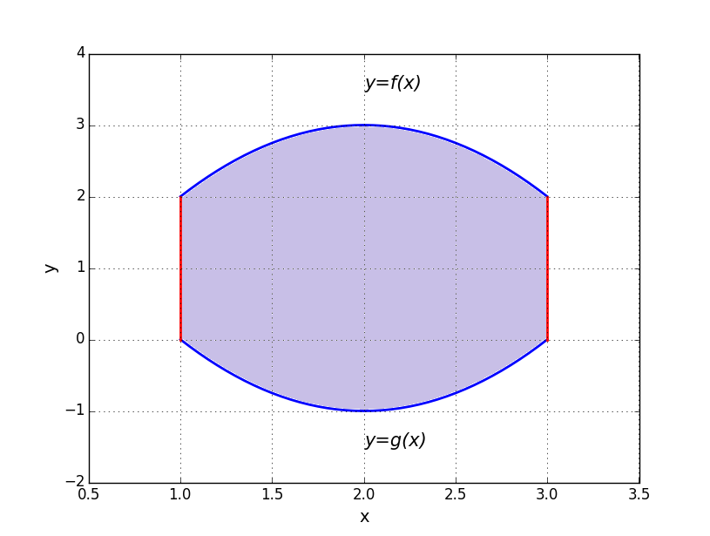

The purple-shaded region is the area between $f(x)$ and $g(x)$ on interval $[1,3]$. Note that $f(x)$ is the upper function, while $g(x)$ is the lower function on the graph above. The area is given by

$$\int_{1}^{3}{\left[f\left(x\right)-g\left(x\right)\right] dx} .$$

Example. [Area between curves]

Find the area between $y=x^{2}+4$ and $y=2x+1$ from $x=0$ to $x=3$.

>

>

>

>

>

>

>

>

Q. Find the area between $y=3x^{2}-3$ and $y=2x+5$ from $x=0$ to $x=3$.

>

>

>

>

>

>

>

>

>

>

>

>

Q. Find the area bounded by the curves $y=7x$ and $y=9x^{2}$.

>

>

>

>

>

>

>

>

>

>

>

>

>

>

>

>

>

>

>

>

>

>

Consumers’ Surplus, Producers’ Surplus & Gini Index

The third application is on the classical economics, Demand & Supply. Weeks before, we mentioned that a demand equation is the relation between the price $p$ of a product, and the quantity demanded $x$ at that price. We also have introduced the demand function $x=D(p)$, which gives us the quantity demanded $x$ by consumers at the price $p$.

Now, we switch the roles of $x$ and $p$ in the demand function. We introduce the demand function (or demand curve) as a function of $x$.

$$p=d\left(x\right)$$

It gives us the price of a product at which $x$ units of products will be sold.

The market price is the price at which all transactions actually occur. Consumers buy good at this market price, and suppliers sell good at this market price.

**Here we assume that all prices are in dollars.

Consumers’ surplus.   
Suppose $d(x)$ is a demand function and the market price is $B$. Let $A$ be the quantity demanded (=demand level) at price $B$, i.e. $B=d(A)$.   
The consumers’ surplus (CS) is the area between the demand curve and the market price.

$$CS=\int_{0}^{A}{\left[d\left(x\right)-B\right] dx}$$

Consumers’ surplus measures the total benefit consumers get under the market price $B$.

The supply function $s(x)$ for a product, gives us the price at which $x$ units of the product are supplied.

$$p=s\left(x\right)$$

Similar to consumers’ surplus, we have the producers’ surplus (PS). It measures the total benefit producers get at the market price.

Producers’ surplus.  
Suppose $d(x)$ is a demand function and the market price is $B$. Let $A$ be the quantity supplied (= supply level = demand level) at price $B$, i.e. $B=s(A)$. The producers’ surplus (PS) is the area between the market price and the supply curve.

$$PS=\int_{0}^{A}{\left[B-s\left(x\right)\right] dx}$$

Given a demand function $p=d(x)$ and a supply function $p=s(x)$, we can find out the market price and market demand. Market demand $A$ is the quantity of a product exactly sold and bought in the marketplace. $A$ 
 is the $x$-value that solves

$$d\left(x\right)=s\left(x\right).$$

Then, the market price $B=d\left(A\right)=s(A)$. The pair $(x=A,p=B)$ is called the market equilibrium.

Q. For the demand function $d\left(x\right)=4000-12x$ and the demand level $x=80$, find the consumers’ surplus.

>

>

>

>

>

>

>

>

>

>

Q. For the supply function $s\left(x\right)=0.03x^{2}$ and the demand level $x=200$, find the producers’ surplus.

>

>

>

>

>

>

>

>

>

Q. Given the demand and supply functions

$$d\left(x\right)=300-0.4x and s\left(x\right)=0.2x,$$

(a) find the market demand and market price,

(b) find the consumers’ surplus at the market demand,

(c) and find the producers’ surplus at the market demand.

>

>

>

>

>

>

>

>

>

>

>

>

>

>

>

>

>

>

The fourth application is on income distribution. The Lorenz curve and Gini index help us measure income inequality in a city or over a country.

The Lorenz curve $L(x)$ gives us the proportion of total income earned by the lowest $x\%$ of population (or of households) in income.

Suppose in 2016, the city A carries out a census and obtains the following data about household incomes.

|  |  |
| --- | --- |
| Proportion of population  (from lowest to highest) | Proportion of income |
| 0.2 | 0.032 |
| 0.4 | 0.1 |
| 0.6 | 0.226 |
| 0.8 | 0.43 |
| 1.0 | 1 |

For example, it means the bottom 20% of population earns 3.2% of the total income. We plot the income population against population proportion to obtain the Lorenz curve.

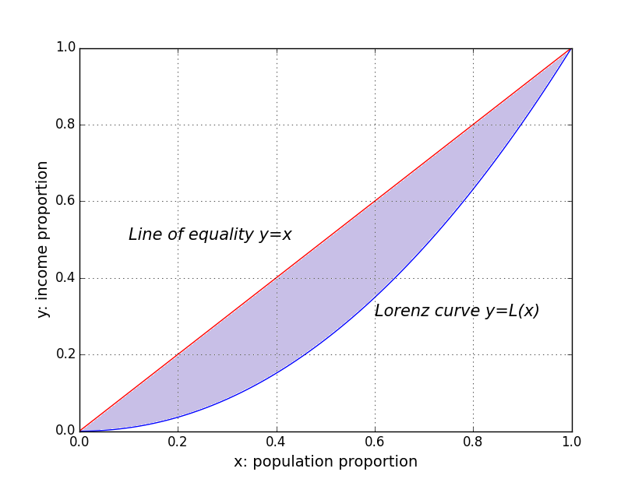

For convenience, we are not using the above data, but use them to approximate $L(x)$ instead. We get

$$L\left(x\right)=x^{2.063} .$$

The line $y=x$ above is called the line of equality. Income equality is achieved if the Lorenz curve is exactly the line of equality $y=x$.

For a Lorenz curve $L\left(x\right)$, Gini index is two times the area between the line of equality and the Lorenz curve.

$$Gini index=2\int_{0}^{1}{\left[x-L\left(x\right)\right] dx}$$

The Gini index is always between 0 and 1.

The area between the line of equality and the Lorenz curve is shaded in purple in the above graph.

Q. Find the Gini index for the given Lorenz curve.

$$L\left(x\right)=x^{2.063}$$

>

>

>

>

>

>

>

>

>

>

Integration by Substitution

In this section, we learn a new integration technique: integration by substitution. Suppose we have a function $g(x)$. A change in $g(x)$ is denoted by $Δg$. When this change is very small, we denote it by

$$dg .$$

$dg$ is called the differential of $g(x)$. Since $g$ is a function of $x$, we have

$$dg=g^{'}\left(x\right)⋅dx .$$

It means that when $x$ is a number $a$ and the change in $x$ ( $Δx or dx)$ is $0.001$, the change in $g(x)$ $(Δg or dg)$ is given by

$$dg=g^{'}\left(a\right)⋅dx=g^{'}\left(a\right)⋅\left(0.001\right) .$$

The right hand side is just a number. Basically, we only use the differentials $dg$ and $dx$ within integration. Elsewhere we represent the changes of $x$ and $g(x)$ by $Δx$ and $Δg$.

Integration by substitution.

Suppose $f\left(u\right)$ and $u(x)$ are two functions. Putting $u=u(x)$, we have

$$\int{f\left(u\left(x\right)\right)⋅u'\left(x\right) dx=\int{f\left(u\right) du}} .$$

Note that $u=u(x)$ gives $du=u^{'}\left(x\right)⋅dx$ as in above discussion. So we are replacing (1) $u(x)$ by $u$, and (2) $u'\left(x\right) dx$ by $du$.

If we are looking at definite integrals, we use the below formula.

$$\int_{a}^{b}{f\left(u\left(x\right)\right)⋅u^{'}\left(x\right) dx}=\int_{u\left(a\right)}^{u\left(b\right)}{f\left(u\right) du}$$

The substitution remains $u=u\left(x\right)$.

In the following, we study 3 particular cases.

(I) Suppose $u(x)$ is a polynomial, and $n$ is a number

$$\int{{\left[u\left(x\right)\right]}^{n}⋅u^{'}\left(x\right) dx}=\int{u^{n} du}=\frac{1}{n+1}{u(x)}^{n+1}+C$$

Q. Find $\int{{\left(x^{2}+1\right)}^{3}2x dx}$.

>

>

>

>

>

>

>

>

>

Q. Find $\int{{\left(x^{2}+10\right)}^{4}x dx}$.

>

>

>

>

>

>

>

>

>

Q. Find $\int{\sqrt{x^{2}+5} \left(2x\right) dx} .$

>

>

>

>

>

>

>

>

>

>

Q. Find $\int{\frac{5x}{{\left(x^{2}+1\right)}^{3}} dx}$.

>

>

>

>

>

>

>

>

>

>

(II) Suppose $u(x)$ is a polynomial.

$$\int{e^{u\left(x\right)}⋅u^{'}\left(x\right) dx}=\int{e^{u} du }=e^{u\left(x\right)}+C$$

Q. Find $\int{e^{x^{3}}⋅x^{2} dx}$

>

>

>

>

>

>

>

>

Q. Find $\int_{0}^{2}{te^{t^{2}} dt}$.

>

>

>

>

>

>

>

>

>

Q. Find $\int{\frac{1}{\sqrt{x} }e^{\sqrt{x}} dx}$.

>

>

>

>

>

>

>

>

>

>

Q. Find $∫x^{3}e^{-x^{4}} dx$.

>

>

>

>

>

>

>

>

>

>

(III) Suppose $u(x)$ is a polynomial.

$$\int{\frac{1}{u\left(x\right)}⋅u^{'}(x) dx}=\int{\frac{1}{u} du }=\ln{|u(x)|}+C$$

Q. Find $\int{\frac{x^{3}}{x^{4}+2} dx}$.

>

>

>

>

>

>

>

>

Q. Find $\int_{4}^{5}{\frac{dx}{x-3}}$.

>

>

>

>

>

>

>

>

>

Q*. Find

$$\int_{1}^{2}{\frac{e^{x}}{1+e^{x}}dx}$$

>

>

>

>

>

>

>

>

>

Q*. Find

$$\int{\frac{\sqrt{\ln\left(x^{3}\right)}}{x}}dx$$

>

>

>

>

>

>

>

>