PAGSIBOL VILLAGE PH2 4B EAST
HOA Portal Documentation
Technical Setup Guide and User Manual
Generated: June 24, 2026
Project folder: C:\Users\lowie\Documents\Codex\2026-06-21\copy-this-into-codex-text-build
Local URL: http://localhost:3000/login
Public URL: https://pagsibol-hoa.tail2abf68.ts.net/login
Document style preset: compact_reference_guide

1. Executive Summary
This document combines technical setup information, system administration configuration, and a user manual for the Pagsibol HOA Portal. It is intended for association officers, the system administrator, and future maintainers.
Area | Summary
Application | Next.js, TypeScript, Tailwind CSS, Prisma, PostgreSQL
Hosting | Local Windows computer with Docker Desktop, Next.js, and Tailscale Funnel
Roles | SYSTEM_ADMIN, ADMIN, HOMEOWNER
Public link | https://pagsibol-hoa.tail2abf68.ts.net/login
Current data state | Operational demo data has been removed; screenshots show clean-state pages.

2. Technical Setup
Project location:
C:\Users\lowie\Documents\Codex\2026-06-21\copy-this-into-codex-text-build
Important startup scripts:
Script | Purpose
start-public-portal.ps1 | Starts Docker, PostgreSQL, Next.js, and Tailscale Funnel.
stop-public-portal.ps1 | Stops public Funnel access.
maintain-public-portal.cmd | Autostart watchdog used by Windows Task Scheduler.
run-next-portal.cmd | Starts the Next.js production server process.

Core maintenance commands:
Command | Purpose
pnpm install | Install project dependencies.
pnpm db:generate | Generate Prisma client.
pnpm db:migrate | Apply development migrations.
pnpm build | Build production website.
pnpm start | Start production website.
pnpm db:studio | Open Prisma Studio.

3. Configuration Reference
System Admin settings are configured in /admin/settings.
Section | Keys
Association profile | ASSOCIATION_NAME, ASSOCIATION_ADDRESS, ASSOCIATION_CONTACT_NUMBER, ASSOCIATION_TIN_NUMBER, ASSOCIATION_LOGO_URL
Database | DATABASE_URL, DATABASE_PROVIDER
Email | EMAIL_FROM, RESEND_API_KEY, SMTP_HOST, SMTP_PORT, SMTP_USER, SMTP_PASSWORD
Facebook | FACEBOOK_GRAPH_API_VERSION, FACEBOOK_PAGE_ID, FACEBOOK_PAGE_ACCESS_TOKEN, FACEBOOK_MESSENGER_ACCESS_TOKEN
GCash and QR payments | GCASH_ACCOUNT_NAME, GCASH_MOBILE_NUMBER, GCASH_QR_IMAGE_URL, PAYMENT_INSTRUCTIONS, PAYMENT_WEBHOOK_SECRET

4. User Manual

4.1 Login
- Open the login URL.
- Enter the issued email address.
- Enter the password.
- Click Sign in securely.
- Use Log out when finished.

Login page
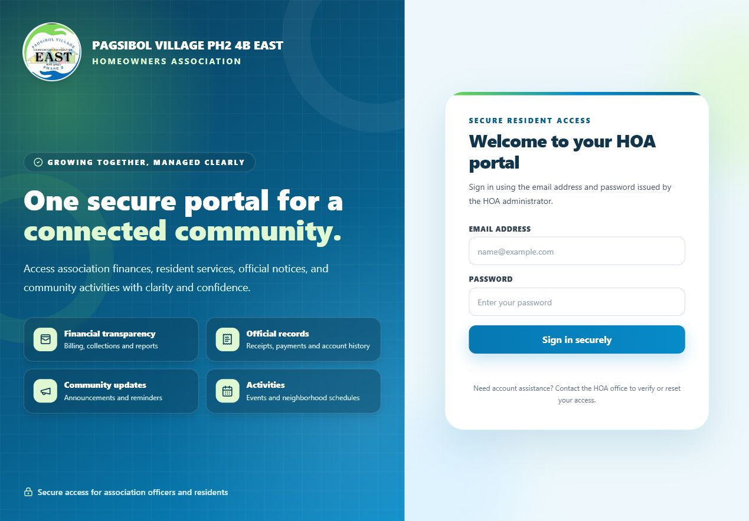
Public login page with HOA branding.

4.2 System Admin
- Configure association profile values used across pages and generated documents.
- Set email, Facebook Page, Messenger placeholder, GCash QR, and webhook settings.
- Secret values are hidden after saving.

System settings
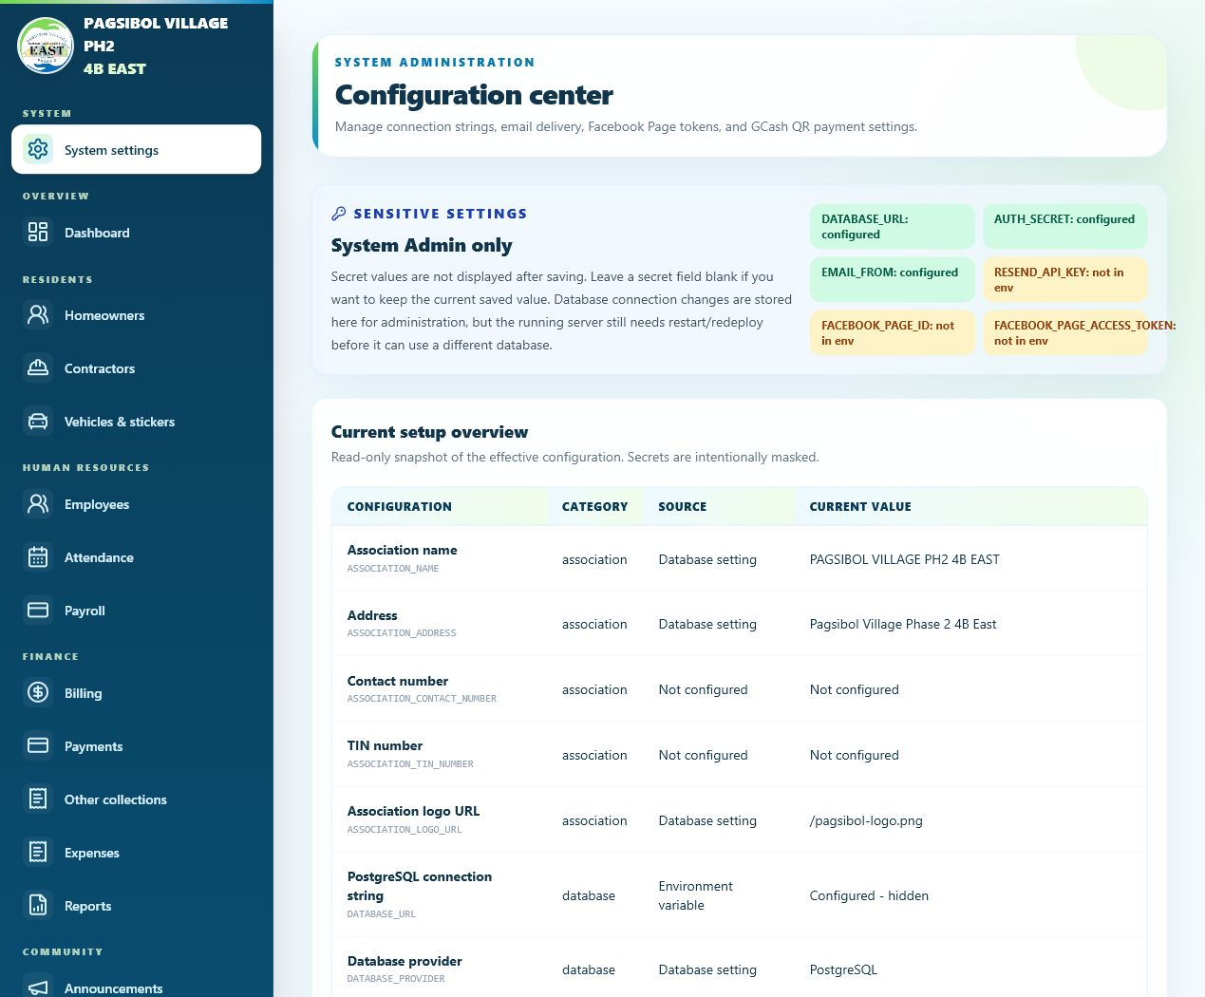
Configuration center for the System Admin.

4.3 Admin Dashboard and Core Modules

Admin dashboard
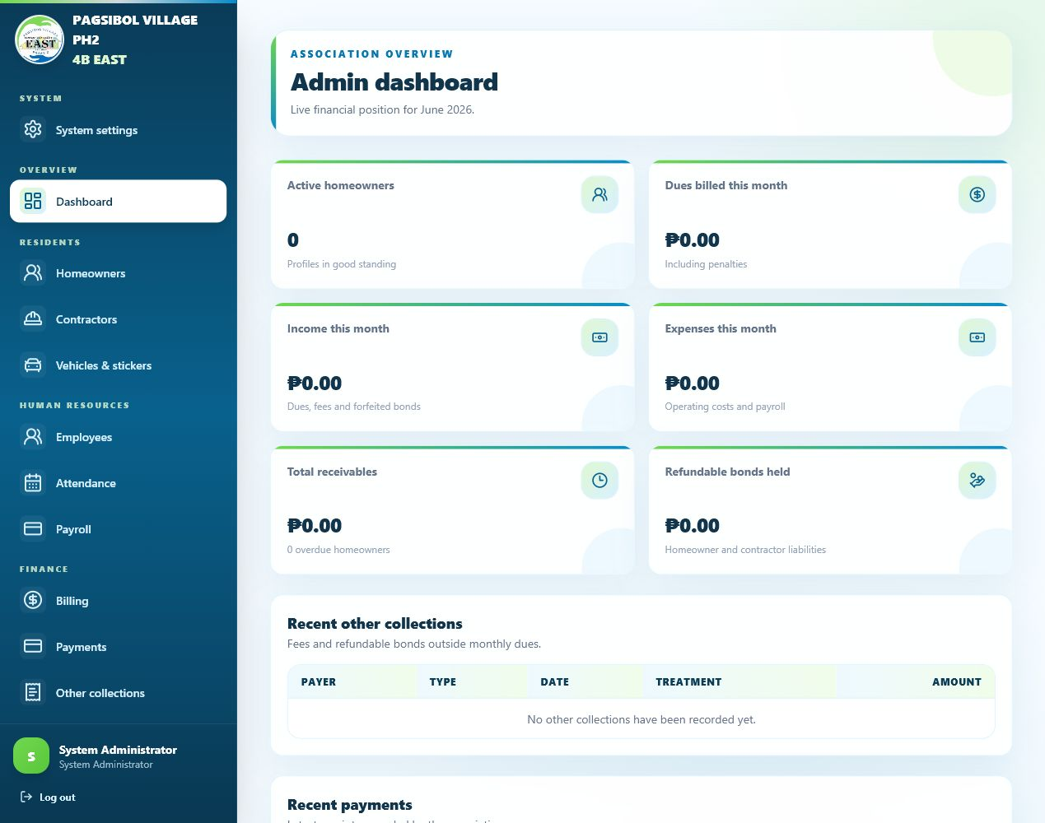
Clean dashboard totals and recent activity sections.
Module | Main Use
Homeowners | Create and maintain resident profiles and login accounts.
Billing | Generate dues, manage bills, and record dues exemptions.
Payments | Record payments and review homeowner QR submissions.
Other collections | Record gate pass, sticker, membership, bonds, and custom income.
Vehicles | Track vehicle plate numbers and sticker validity.
Employees and Attendance | Maintain employee records and daily attendance.
Payroll | Compute salary, manage deduction types, print payslips, and lock paid periods.
Expenses | Track categories, vouchers, and disbursements.
Reports | Generate printable PDF/DOCX and CSV financial reports.
Announcements and Events | Publish community updates and optional Facebook posts.

4.4 Homeowner Records

Homeowners list
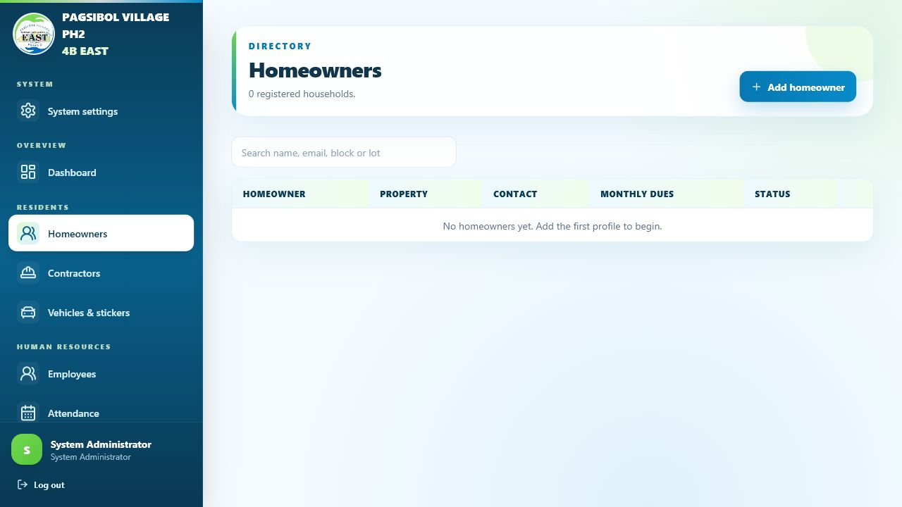
Directory and search page.

New homeowner form
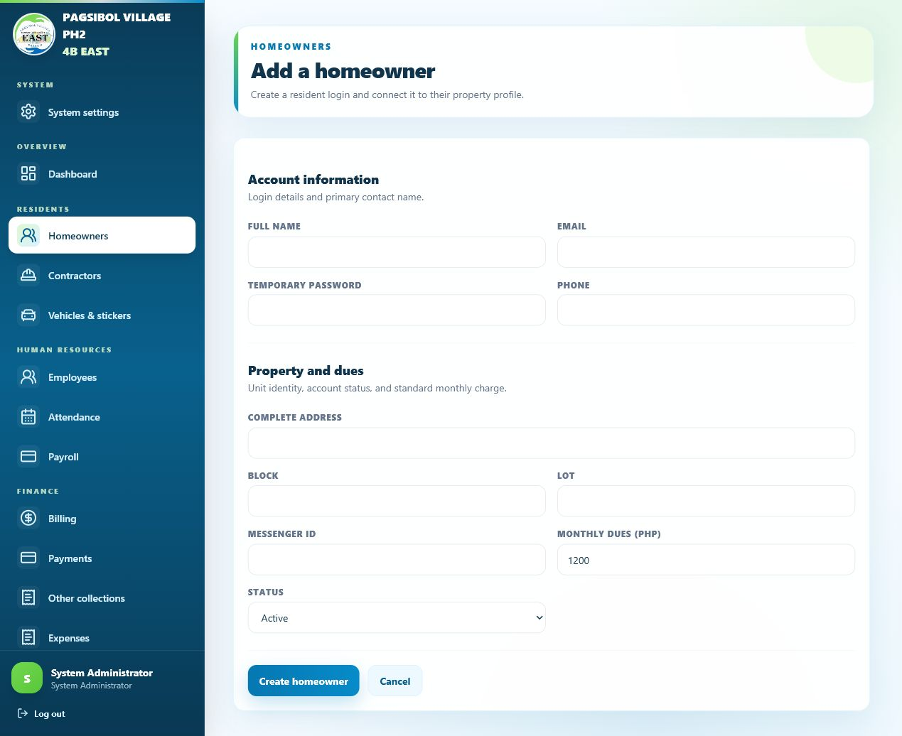
Create resident login and homeowner profile.

4.5 Finance Workflows

Billing management
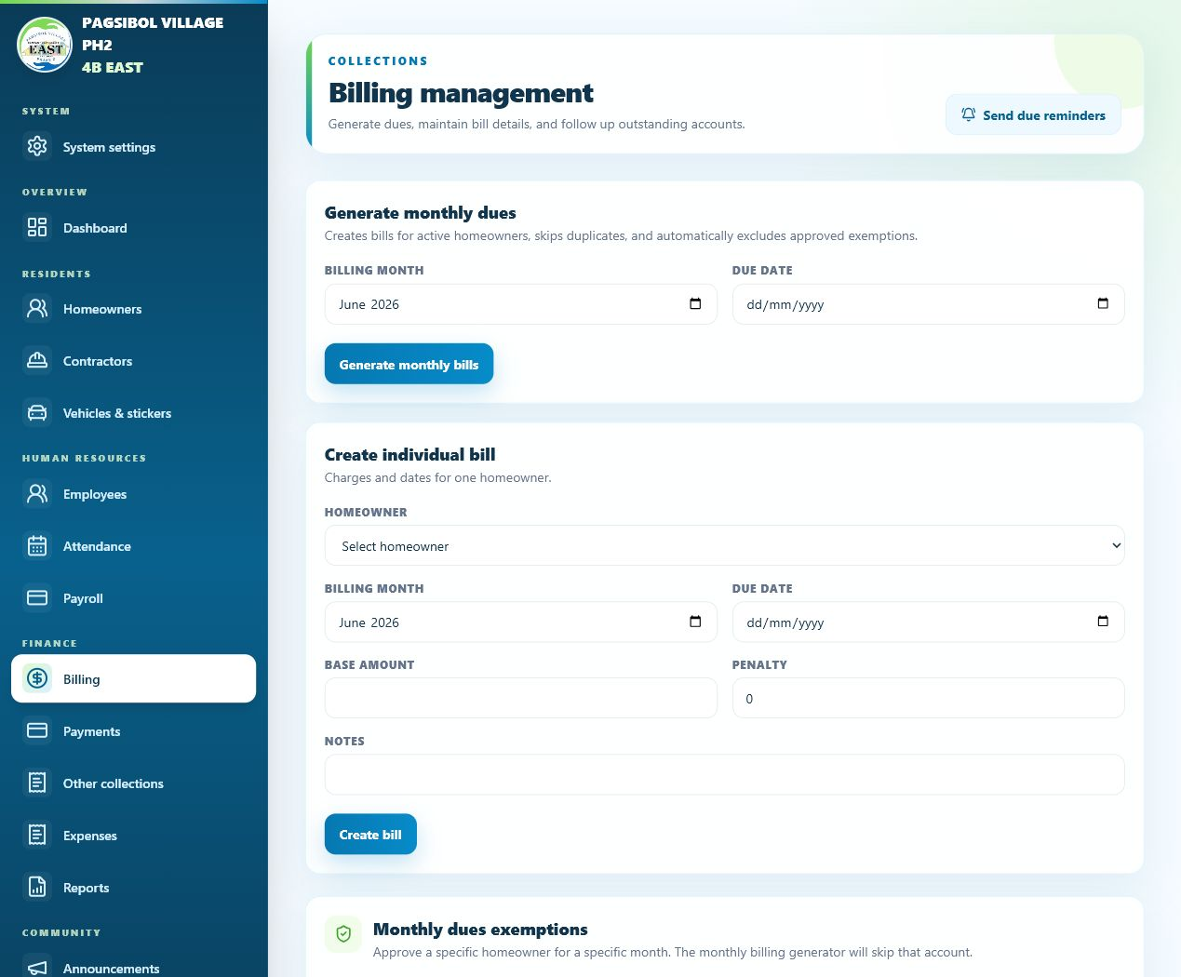
Monthly dues and exemption management.

Payment recording
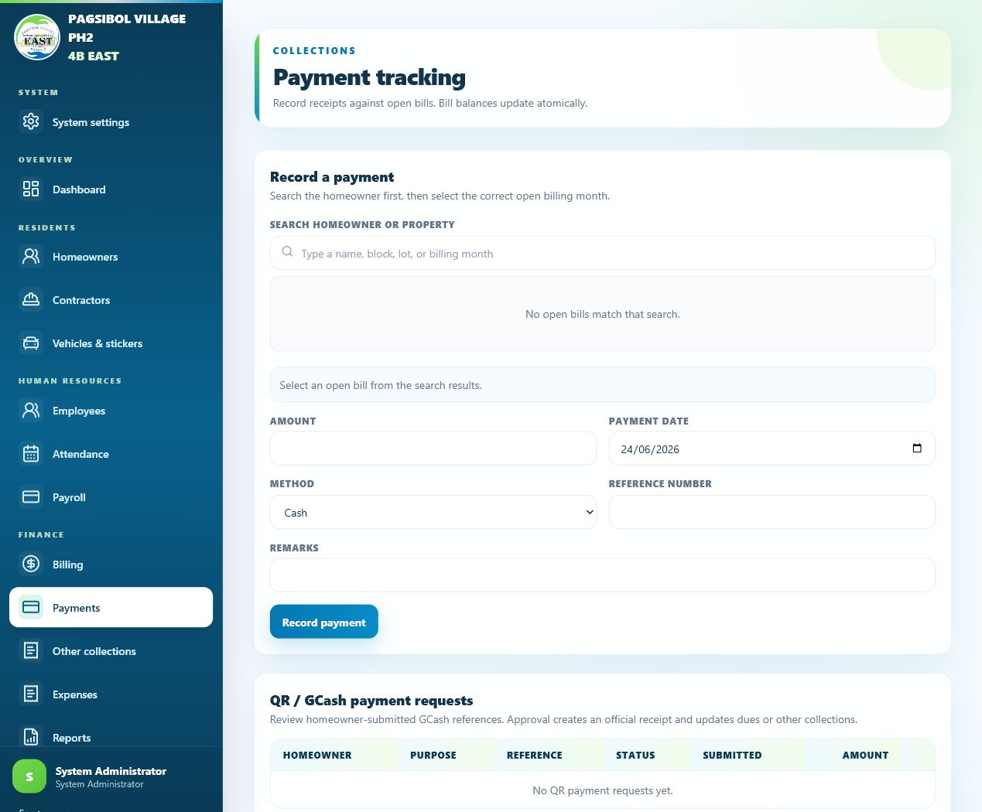
Search homeowners, record payments, and review QR requests.

Expenses
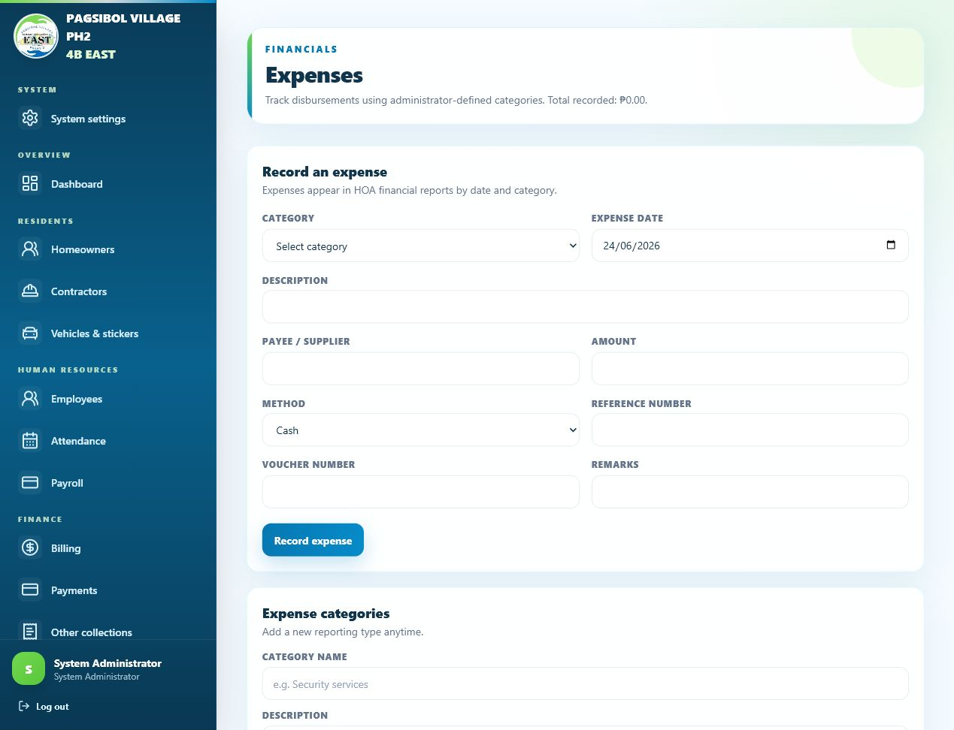
Expense categories and transaction entry.

Financial reports
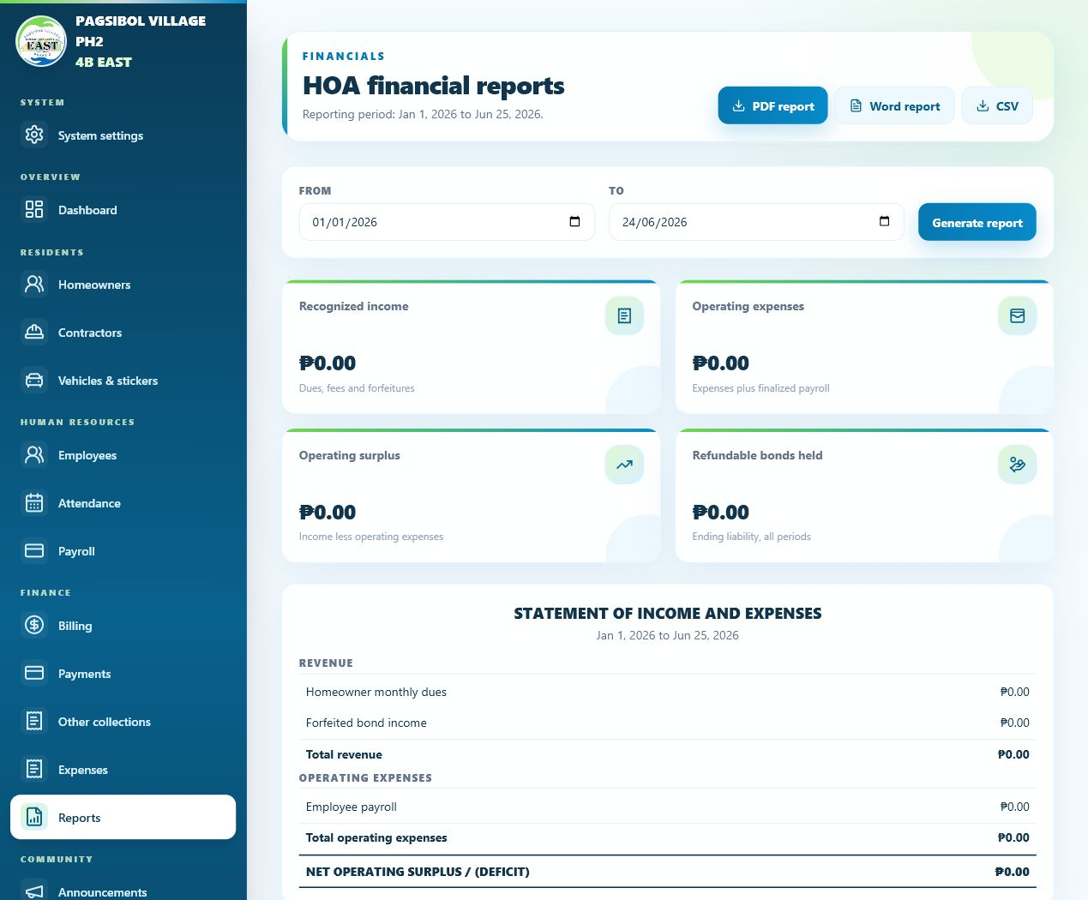
Printable reports and exports.

4.6 HR, Community, and Mobile

Payroll management
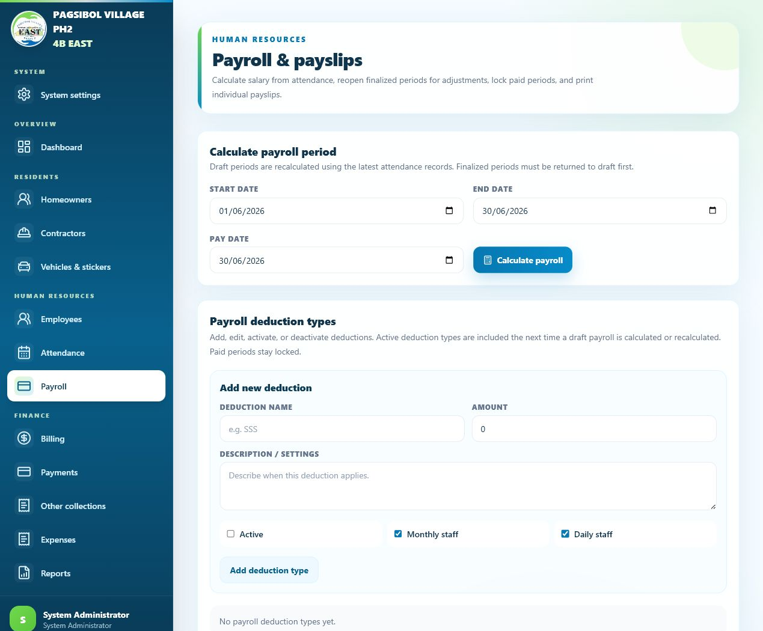
Payroll periods, deduction types, and paid locks.

Announcements
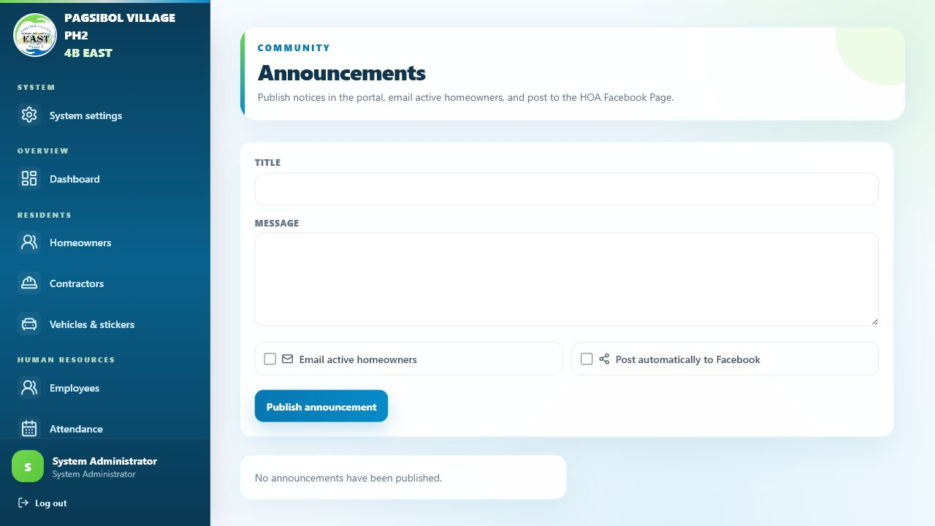
Community announcements with email and Facebook options.

Events
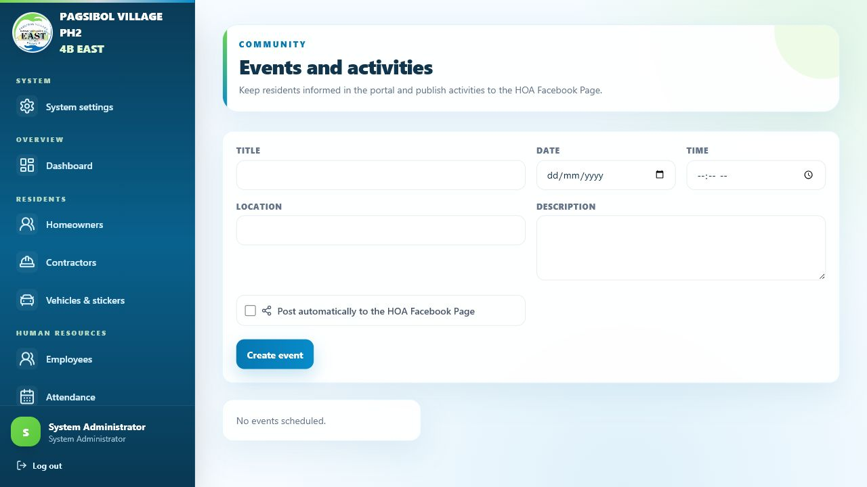
Upcoming activities and Facebook posting option.

Vehicle monitoring
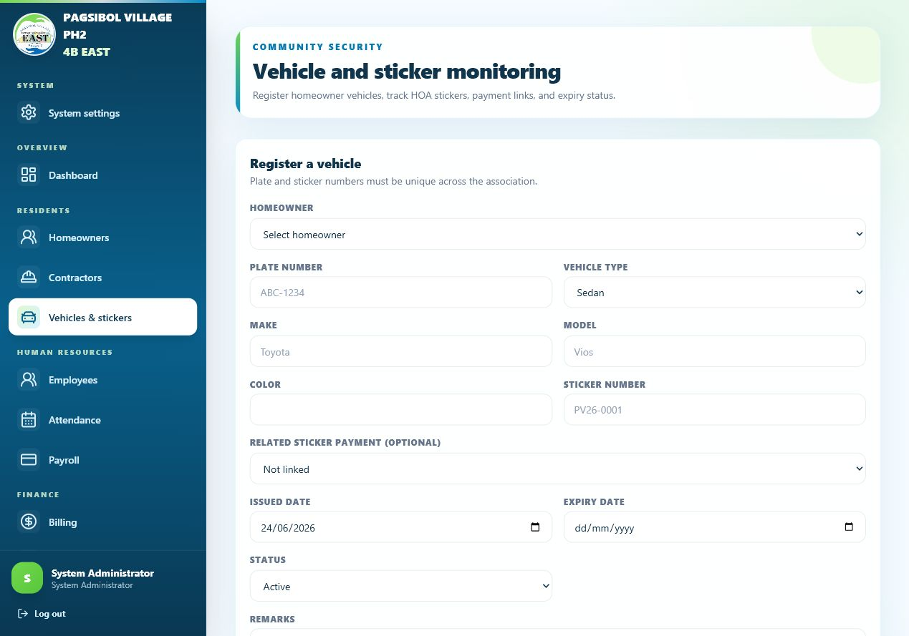
Vehicle and sticker record management.

Mobile navigation
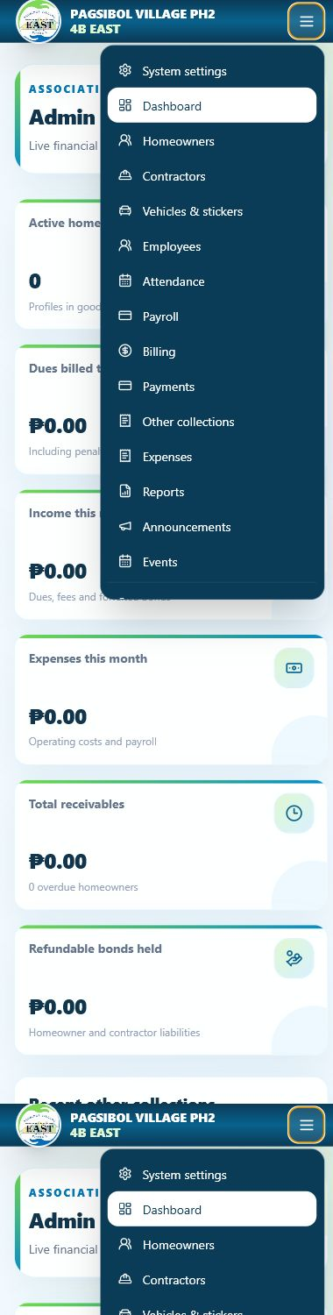
Responsive menu on a phone-sized screen.

5. Operational Notes
- Keep the host computer powered on and plugged in.
- Disable sleep while plugged in so the public link remains reachable.
- Keep Docker Desktop and Tailscale installed, running, and signed in.
- After restarting the computer, sign in to Windows and wait for the autostart watchdog.
- Use the local URL first when troubleshooting, then test the public URL.
- Back up PostgreSQL and the project folder before major changes.

