Hardware and Node-Red
REQUIRED SOFTWARE(S)
- Java
- To run Node-Red, Node.js must be installed. Install Node.js here:
https://nodejs.org/en/
- Once installed, open Command Prompt. Run the following command(s) to ensure Node.js and npm are installed correctly.
- node --version; npm –version
You should receive an output that looks similar to: (Exact version will vary)
V18.15.0
9.5.0

- Node-Red
- Install Node-Red by running the following in Command Prompt.
- npm install -g --unsafe-perm node-red
- To run Node-Red, open Command Prompt. Run the following command(s).
Warnings may appear but cay be safely ignored
- node-red
- Import the flow.
- In Node-Red, click on Import. Select “select a file to import” and locate the flows.json file on your laptop. (Download flows.json file from Telegram)

SETTING UP THE DEVICE
- This is to be done on the components side which are sending data. Laptops receiving data may skip this step.

- Wi-Fi Network
- The devices must be connected to the following networks:
- LOW's S24+
- Monitoring devices (such as server or host) can be on any network.

- Bluetooth Network
- The system does not use Bluetooth.

USING THE DEVICE
- Components
- The device comprises of THREE parts, namely
- Headset
- Right Glove
- Left Glove

- The headset tracks movement. It tracks if a headset is removed or worn. It also has a battery monitor to track battery level. Speech can also be recorded via the microphone.

- The gloves track speed of exercise. An exercise position is to be constantly repeated until a new position is shown on the visualizer. A tier will be calculated based on the speed of the user’s hand movement. The gloves also track Beats Per Minute (BPM). If the BPM < 50 or > 150 consistently for the past 10 seconds, an alert will be triggered. It also has a battery monitor to track battery level.
- A consistently slower hand movement will result in a lower tier, reducing the next position’s difficulty.

- To use the headset and gloves, turn on the switch. It will automatically connect to the Wi-Fi network (see: Setting up device) and start sending values to Node-Red.
Example data format
{"Worn":0,"H Bat":100,"Mic":61,"Tier":0,"R Bat":97.2,"L Bat":0,"BPM":80,"A":0}

- If battery level is low (<15%), charge the device through the micro-USB port.

- Node-Red
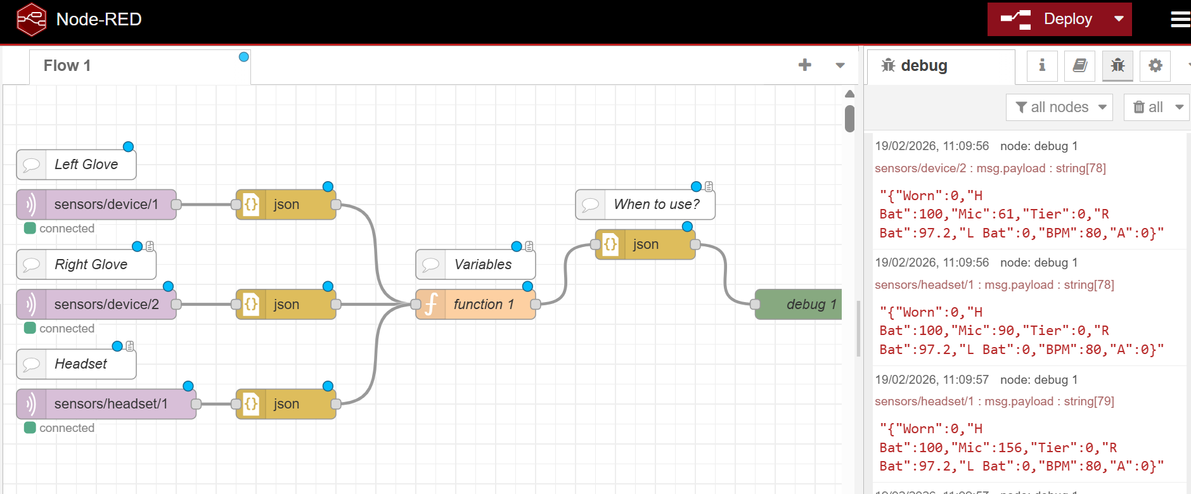
- The common issues and troubleshooting are found below.
Issue | Solution
How do I know if a device is connected? | See the colored dot below the node.  Green: Connected and values will be sending.  Red: Check Wi-Fi connection or component battery level.  IP Address of laptop is not required to send data.
What are the variables being sent or received? | Double-click on the Variables comment above function 1.  Headset  Worn Is the device being taken on or off? 0: Not taken on or off 1: Taken on or off  Bat Battery percentage  Mic Microphone Peak-to-Peak value  Left (L) / Right (R) Gloves  L Bat Battery percentage  R Bat  BPM Average BPM of both Left and Right fingers  A BPM Alerts 0: No alert 1: Alert danger  Example output  Note: This data is received every few ms  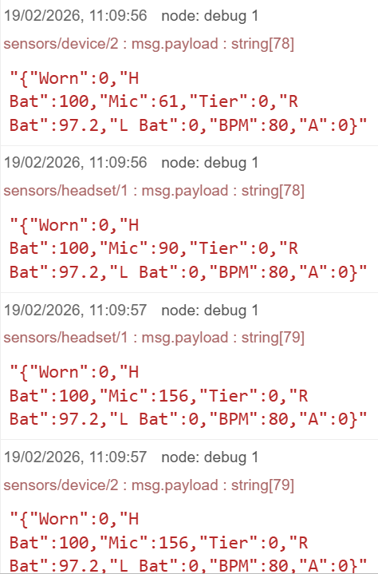
What is the format of data received? | Data is received as json by default. However, connecting a json node changes it to a string (as shown in the figure below)
Some of the values are incorrect. How do I check the variables of individual components? | Connect a debug node to each json node. Click Deploy.  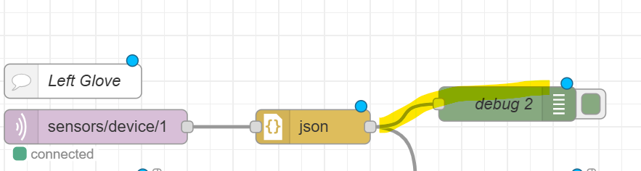
How do I temporarily stop receiving values? | Toggle the button at the end of the debug node. Click Deploy.  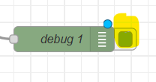

CODE EXPLANATION (Not required to read)
- Gloves (Left / Right)
Code | Explanation
 | The device ID of left glove is 1
 | The device ID of right glove is 2
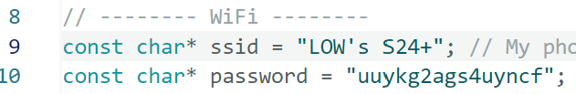 | Components connect to this Wi-Fi network only, unless reconfigured.
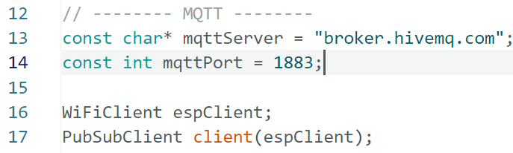 | Sends data to laptop (central location)  Sets up MQTT. Using public broker instead of Mosquitto (Hivemq). Therefore, IP address is not required for this method.  HTTP is not used, as it is significantly slower.
MAX17048 | Calculates the battery percentage.  Since the component is powered by a battery, if it is turned ON, battery is connected.
MPU6050  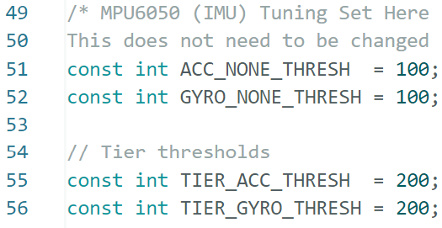 | Calculates tier values.  Runs raw values through a low-pass filter with a factor of 0.9. A low-pass filter (LPF) lets slow changes pass through but suppresses fast fluctuations (noise).  To further reduce fluctuations, only takes the majority of the previous 10 binary values to determine the new tier. This happens well under 1ms and provides a more consistent tier value.  These parameters are changed to achieve different activity intensities.  NONE: Increasing this value requires more vigorous action to qualify for ‘0’  TIER: Increasing this value requires more vigorous action to qualify for ‘1’
Pulse Sensor  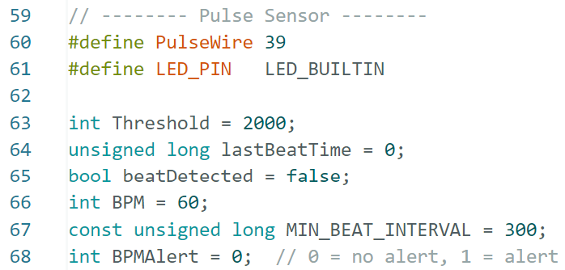  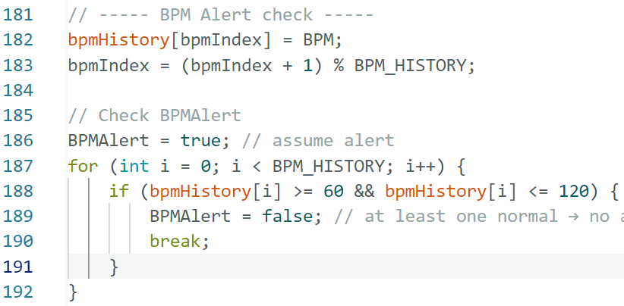 | Measures BPM and outputs alert signal.  To increase accuracy of BPM, if a raw BPM is < 50 or > 150, it is automatically rejected. It takes the previous reading instead.  If BPM is consistently < 60 or > 120 with different readings for the past 10 readings (~10 seconds), then BPMAlert will be ‘1’.
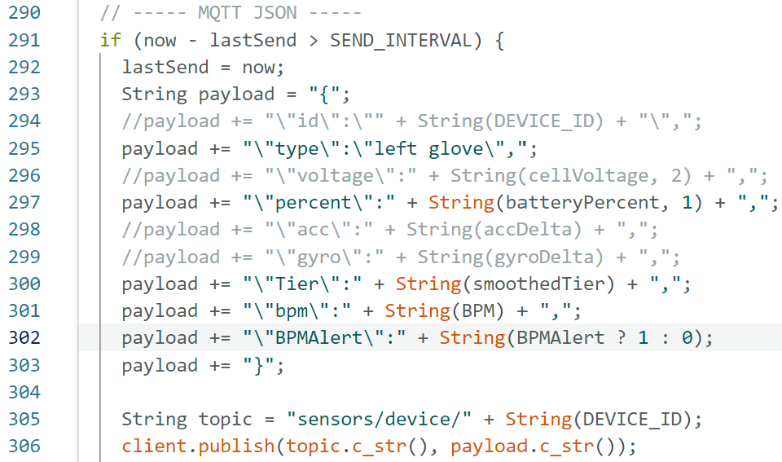 | Data output to Node-Red JSON  Upload once to FireBeetle via USB cable to laptop. Disconnect from laptop, and turn on remotely via battery. It will send to Node-Red.
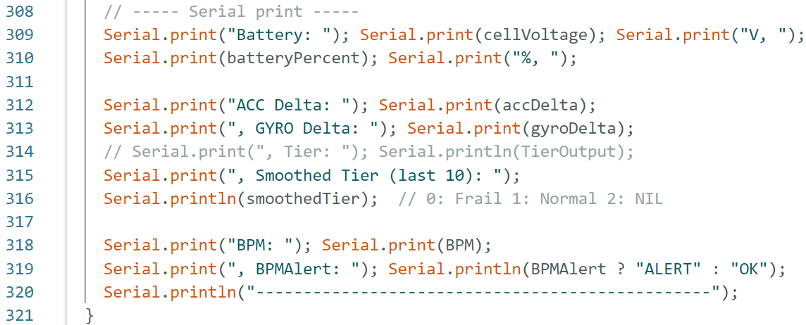 | Data output to Serial Monitor.  Only used via USB cable when FireBeetle is connected to laptop.

- Headset
Code | Explanation
 | The device ID is 1
 | Components connect to this Wi-Fi network only, unless reconfigured.
 | Sends data to laptop (central location)  Sets up MQTT. Using public broker instead of Mosquitto (Hivemq). Therefore, IP address is not required for this method.  HTTP is not used, as it is significantly slower.
MAX17048 | Calculates the battery percentage.  Since the component is powered by a battery, if it is turned ON, battery is connected.
MPU6050  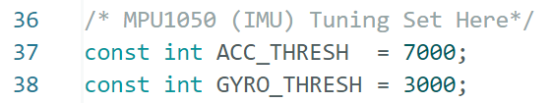 | Calculates movement (If headset is removed)  If these thresholds are removed, assumes headset is removed.  To increase sensitivity, reduce threshold values.
Microphone  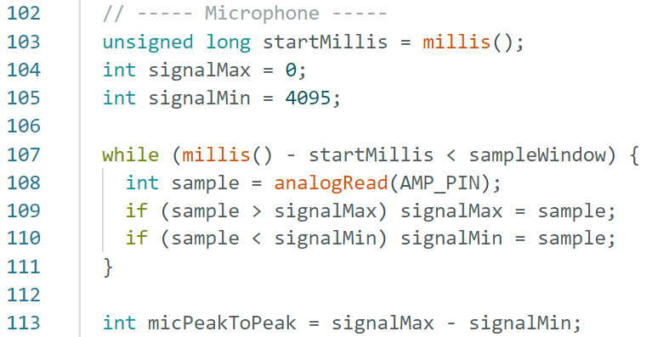 | Calculates Peak-to-Peak values (loudness) of voice.  A very short sampling window (~10 ms), it records the minimum and maximum voltage levels of the microphone signal and computes the peak-to-peak amplitude. This value represents the instantaneous loudness or intensity of sound in that window.
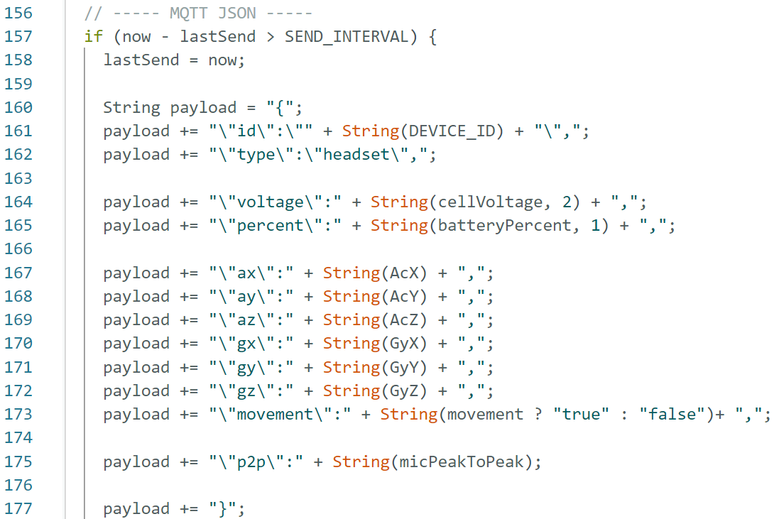 | Data output to Node-Red JSON  Upload once to FireBeetle via USB cable to laptop. Disconnect from laptop, and turn on remotely via battery. It will send to Node-Red.
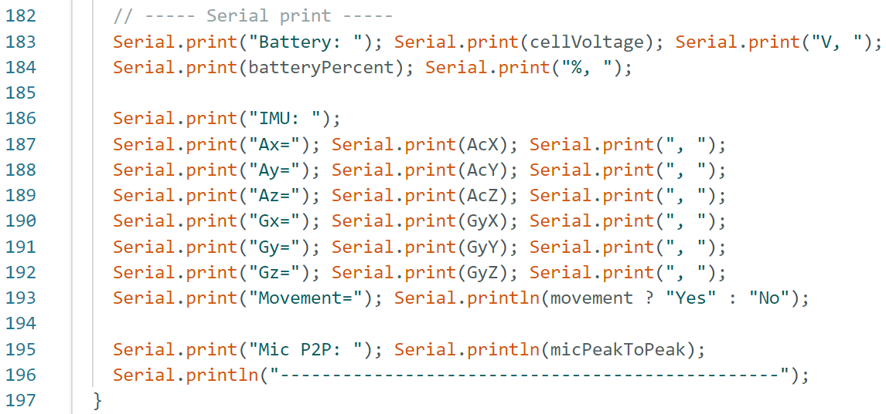 | Data output to Serial Monitor.  Only used via USB cable when FireBeetle is connected to laptop.

PCB AND CONNECTIONS (Not required to read)
- Gloves (Left / Right)
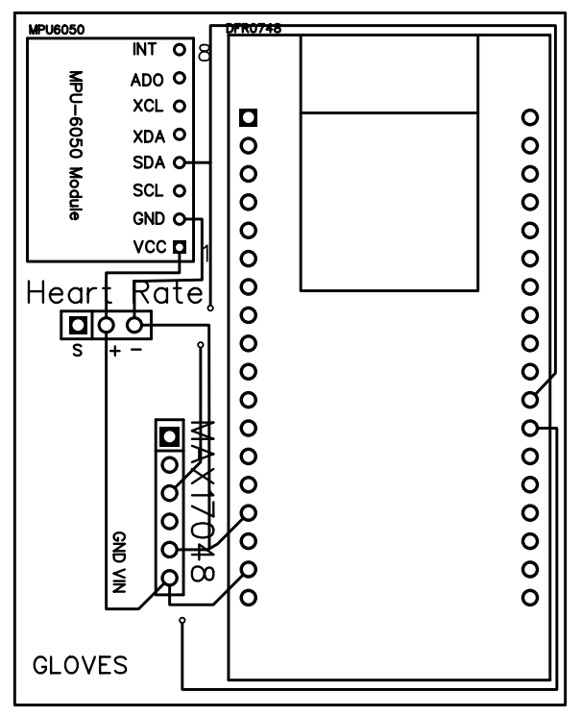
MPU6050 | MAX17048 | BP | ESP32
VCC | VCC | + | 3V3
GND | GND | - | GND
SCL | SCL |  | IO22
SDA | SDA |  | IO21
 |  | S | IO39

- Headset
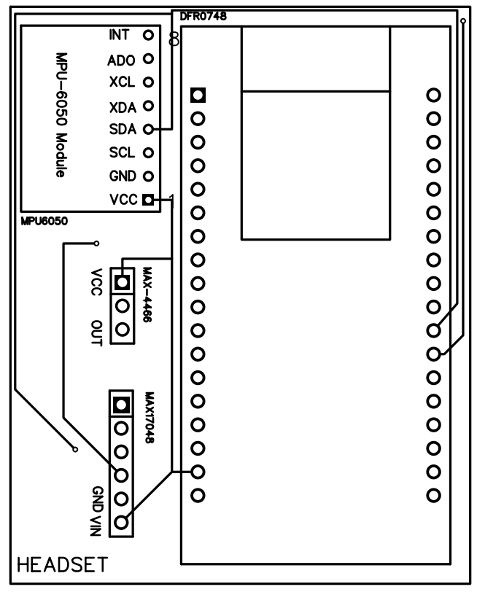
MPU6050 | MAX17048 | MAX4466 | ESP32
VCC | VCC | VCC | 3V3
GND | GND | GND | GND
SCL | SCL |  | IO22
SDA | SDA |  | IO21
 |  | OUT | IO34

