

DIPLOMA IN INFORMATION TECHNOLOGY

APRIL 2026
SKILL-BASED EXAMINATION

PROGRAMMING FUNDAMENTAL
SUBJECT CODE: DIT1124
TIME ALLOWED: 3 HOURS
DATE: 6 APRIL 2026 TIME: 9:30AM-11:30AM

INSTRUCTIONS TO CANDIDATE:
- Answer ALL questions.
- ALL answers must be written on the question paper and submitted.
- Dictionaries, Crying and Tantrum are NOT ALLOWED.

STUDENT’S NAME | : | LOW KAH SHENG
STUDENT’S ID | : | SCSJ2500286

 |  |  |  |  | TOTAL MARKS
SECTION | A | :
 | B | :
 | C | :
 | D | :
 | E | :

SECTION A – MCQ (TOTAL: 10 MARKS)

Questions | Answer
1. | B
2. | C
3. | C
4. | D
5. | A
6. | A
7. | A
8. | C
9. | B
10. | A

SECTION B – True/False and Explanation (TOTAL: 10 MARKS)
No | Answer | Explanation
1. | TRUE | Variables must be declared before use in C++
2. | FALSE | “=” is NOT used to compare two values
3. | FALSE | A “for” loop is repeated if condition is false
4. | TRUE | Arrays can store different data types.
5. | TRUE | Flowcharts help visualize program logic.

SECTION C – Tracing Errors with Explanation (TOTAL: 20 MARKS)
QUESTION 1
1 | #include <iostream>
2 | using namespace std;
3
4 | int main() {
5 | int marks[3];
6 | int total;
7 | float avg;
8
9 | cout << "Enter 3 marks:"<< endl;
10 | for (int i = 1; i < 3; i++) {
11 | cin >> marks[i]:
12 | total = total + marks [i];
13 | }
14
15 | avg = total / 3;
16
17 | cout << endl <<"Final Total: " << total << endl;
18 | cout << Average Mark: " << avg << endl;
19
20 | if (avg = 50)
21 | cout << "Pass";
22 | else
23 | cout << "Fail";
24
25 | return 0;
26 | }
1.1 |  | Based on above code, what is the meaning of “endl”? |  | (1 marks)
Answer:
“endl” is state for endline.
1.2 |  | Based on above code, identify the relevant errors, explain them and rewrite the corrected codes in table as shown below. |  | (10 marks)
 |  | Answer:
Line | Explanation | Corrected Code
5 | Using marks[i] must to be use in the whole coding not we can’t change it | int marks[i];
20 | If just write avg = 50 that’s mean equal to 50 only you can pass, even tough you above 51 also Fail. | if (avg >= 50)

1.3 |  | Based on answers in 1.2, what is the purpose of this code? |  | (4 marks)
Answer:
Calculate the totals mark and average marks with the status Pass or Fail.
1.4 |  | Based on the corrected code, what is the final output if the input marks are: 50, 90, 35? You are required to use Tracing Table to support your answer. |  | (5 marks)
Answer:
Final Total: 175
Average Mark: 58.3333333333
Pass

 |  | (Total: 20 marks)

SECTION D – Tracing Output (TOTAL: 20 MARKS)
QUESTION 1
 | //Code nested for Loop
1 | #include <iostream>
2 | using namespace std;
3
4 | int main() {
5 | int total = 0;
6
7 | for (int i = 0; i <= 5; i++)
8 | {
9 | if (i > 2)
10 | {
11 | total += 2;
12 | }
13 | else
14 | {
15 | total += i;
16 | }
17 | }
18 | cout << "Total: " << total;
19
20 | return 0;
21 | }
2.1 |  | Based on above segment code, create tracing table to show the value of each variable during iteration of the loop. |  | (16 marks)
 |  | Answer:
2.2 |  | Based on your answer in 2.1, provide the final values for “i”. |  | (1 marks)
 |  | Answer:
2.3 |  | Based on your answer in 2.1, provide the final value for “total”. |  | (1 marks)
 |  | Answer:
2.4 |  | Explain what happens to the variable total when the following statements are executed inside a loop:  - “total += 2”  - “total += i” |  | (2 marks)
 |  | Answer:
 |  | (Total: 40 marks)

SECTION E – Case Study (TOTAL: 40 MARKS)
You are assigned to develop a C++ program that allows users to enter an integer number, check the number either positive or negative. If the integer number is positive, determine whether it is odd or even. Then display relevant messages such as “Positive number is an Even Number”, “Positive Number is an Odd Number”, and “The number is a Negative Number!”. The requirements are as follow:
1.1 | Create an IPO Analysis. | (9 marks)
Answer:
INPUT | Number
PROCESS | check the number either positive or negative  if positive, check is it odd/even
OUPUT | Positive Number is an Odd Number

1.2 | Create flowchart that reflects the answer in 1.1. | (10 marks)
 | Answer:
 | 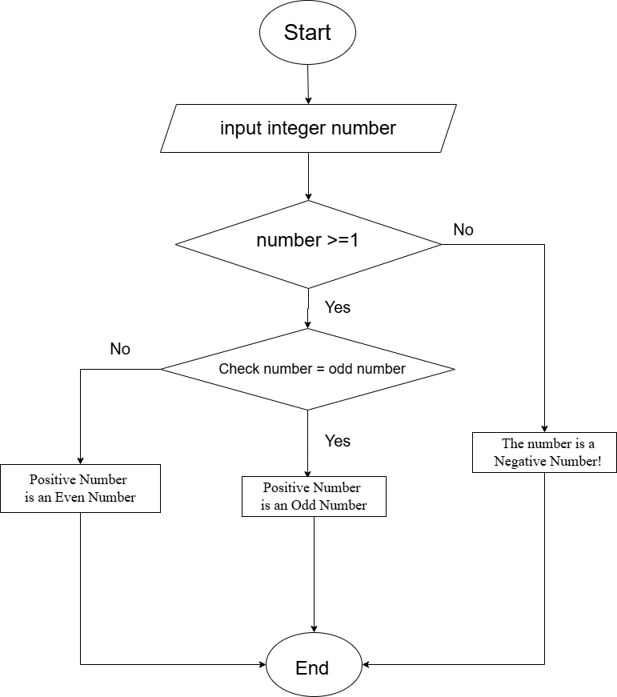

1.3 | Create a C++ program based on the answers in 1.1 and 1.2. Attach the Screenshot of the output. | (21 marks)
 | Answer:
 | (Total: 40 marks)

END OF PRACTICAL ASSESSMENT ANSWER PAPER

