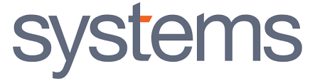



Technical Proposal for
Core Banking Upgrade Project

Jun 30th 2026

Table of Contents
1 Executive Summary 5
2 Introduction 6
2.1 Proprietary Notice 6
2.2 Validity Period 6
2.3 Contact Details 7
3 Company Profile 8
3.1 Company Overview 8
3.2 Company Financial Reports 14
3.3 Company Certifications 15
A Certified Partnerships 15
a Temenos Partnership 15
b IBM Partner Certificate 16
c Microsoft Partnership Network Certificate-Gold Category 17
4 Scope of Work 20
4.1 Core Upgrade: Temenos Transact R19 TAFJ to R26 TAFJ 20
Environment Readiness Assessment 20
Upgrade Analysis 20
Core Technical Upgrade 20
Customization & Interface Retrofit 20
Testing 20
Deployment & Go-Live 21
Post Go-Live Support 21
5 Proposed Solution 22
5.1 Target Solution Principles 22
Target Solution Principles 22
Upgrade Approach 22
6 Upgrade Methodology 24
6.1 General Upgrade Activities 24
Stage 1: Project Initiation 24
Stage 2: Project Planning 26
Stage 3: Upgrade Analysis 26
Stage 4: Technical Upgrade 27
Stage 5: Unit testing in integrated environment before delivery to client 28
Stage 6: Upgrade Training 29
Stage 7: System Integration Testing 30
Stage 8: User Acceptance Testing 30
Stage 9: Mock Upgrade and Dress Rehearsals 30
Stage 10: Pre-GO LIVE 31
Stage 11: GO LIVE 31
Stage 12: Post GO LIVE Support 31
6.2 Planning and Control 32
7 Project Timeline 34
Core Banking Upgrade R19 to R26 34
8 Project Governance 35
8.1 Communication Plan 35
8.2 Quality Management 36
8.3 Change Management 36
8.4 Project Issue Escalation Management 36
8.4.1 Review Board 37
8.4.2 Steering Committee 37
8.5 Governance Model 37
9 Assumptions 38
10 Case Studies 40
10.1 State Bank of Pakistan 40
10.2 National Bank of Fujairah 41
10.3 Ziraat Bankasi 41
10.4 Meezan Bank 42
10.5 Sharjah Islamic Bank 42
10.6 VPBank 43

Executive Summary

Systems Limited is pleased to submit this Technical Proposal for the Core Banking Upgrade Project for Alkuraimi Islamic Bank.
This engagement focuses on the technical upgrade of the bank’s Temenos Transact Core Banking platform from the current release to the latest supported Temenos release, ensuring improved system performance, enhanced security, greater operational efficiency, and long-term product supportability.
The proposed upgrade will modernize Alkuraimi Bank’s core banking environment while preserving existing business processes, custom developments, interfaces, and integrations. SYS will execute a structured, low-risk upgrade using proven Temenos upgrade methodologies, proprietary accelerators, and extensive experience in delivering successful core banking upgrades across the MEA region.
The upgrade initiative will enable Alkuraimi Bank to benefit from:
Modernized Core Banking Platform
Upgrade to the latest Temenos release with improved performance, enhanced architecture, and better maintainability.
Improved Operational Efficiency
Optimized batch processing, faster transaction execution, and improved system responsiveness for business users.
Enhanced Security and Compliance
Adoption of latest Temenos security patches, technical standards, and regulatory readiness.
Future Readiness
A scalable platform capable of supporting future digital transformation initiatives, product innovation, and integration requirements.
Systems Limited is uniquely positioned to deliver this engagement due to:
- 24+ years of strategic partnership with Temenos
- 150+ successful banking transformation engagements globally
- Deep expertise in Temenos upgrades from legacy T24 versions to latest Transact releases
- Strong Islamic banking domain expertise across 40+ Islamic financial institutions
- Proven delivery capability with 1,200+ banking consultants and Temenos specialists
We are confident that our experience, methodology, and delivery capability will ensure a seamless upgrade for Alkuraimi Bank with minimal business disruption and accelerated realization of business value.

- Introduction

Proprietary Notice
Systems Limited (SYS) is honoured to present this proposal for the Core Banking Upgrade Project for Alkuraimi Islamic Bank.
As banking technology continues to evolve, maintaining a modern, secure, and high-performing core banking platform has become essential for operational resilience and competitive advantage. Upgrading to the latest Temenos release enables Alkuraimi Bank to benefit from improved performance, enhanced architecture, stronger security controls, and access to new product capabilities.
SYS proposes a comprehensive upgrade approach covering assessment, planning, technical uplift, customization retrofit, interface validation, testing, deployment, and post-go-live stabilization.
Leveraging our extensive experience in Temenos implementations and upgrades, SYS will ensure that the transition to the target release is controlled, low-risk, and aligned with Alkuraimi Bank’s operational and business objectives.

Validity Period
Validity period of the proposal is 90 days from the day of submission.

Contact Details
Systems welcomes the opportunity to submit this proposal and would be pleased to clarify any aspect of it or provide you with further information. Questions or requests for clarification or additional information should be addressed to:

Commercial Contact Name: | Adeel Haider
Position and title: | VP - BFS Regional Growth Leader
Mail Address: | Office # 404, Building 3, Dubai Hills Business Park
Mobile: | +971 50 555 0138
E-mail: | adeel.haider1@systemsltd.com
Website: | www.systemsltd.com

Company Profile

Company Overview
Systems Limited is a globally recognized technology company with over 49 years of industry experience, specializing in delivering next-generation digital transformation services for the Banking and Financial Services industry. With a team of 8500+ professionals and operations in 47+ countries, we empower financial institutions to modernize their technology landscape, reimagine customer experiences, and accelerate innovation at scale.

Over the past decade, we have transformed more than 150+ banks and financial institutions, equipping them with future-ready platforms and operational agility. From traditional banks to digital-first challengers, our solutions have empowered institutions to meet regulatory requirements, compete digitally, and serve evolving customer demands across geographies.
Our industry-focused approach blends deep banking domain expertise, strong partnerships with platform providers, and a relentless focus on talent, data, and AI. With 30+ million end customers banking on platforms implemented by Systems, we take pride in creating measurable business impact for our clients.

We help banks envision what is possible — and bring it to life. Whether launching greenfield digital banks or reinventing legacy operations, Systems Limited delivers with precision, scalability, and speed.

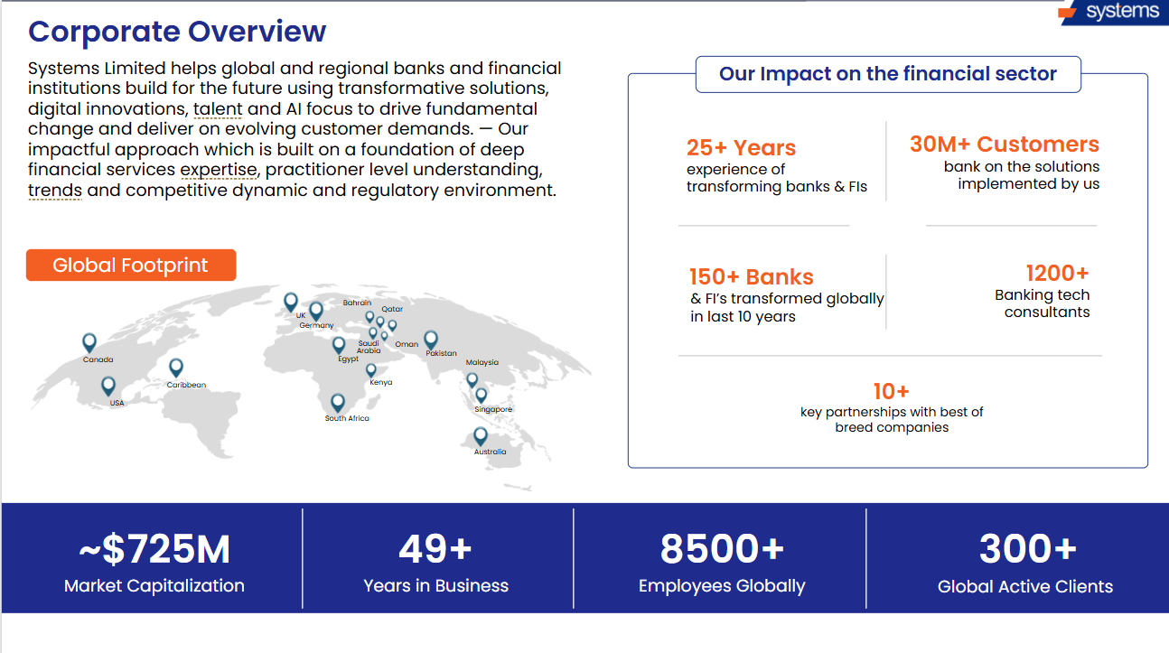
Systems Limited’s credibility in the banking technology space is reinforced by a series of prestigious global recognitions. We are the only Pakistani IT company to be featured five times consecutively on the Forbes Asia Best Under A Billion list and have been recognized as Asia Money’s Most Outstanding Company for three years in a row. Our achievements also include analyst recognitions such as the Everest Group’s BFSI IT Services PEAK Matrix® 2025, highlighting our deep specialization in banking services and our proven track record in core and digital transformations.

Our strong ecosystem of partnerships has earned us accolades such as Temenos Best Sales Partner MEA (2025) and Regional Delivery Partner (2024), along with the Microsoft Partner of the Year 2023 award for both UAE and Pakistan. We have also been recognized by leading industry platforms — winning the Technology Excellence Award for Digital IT Services in Banking (2023) from the Asian Technology Excellence Awards, receiving Highly Commended – Top Tech Team at the Banking Tech Awards by FinTech Futures (2022 & 2023), and securing Best Core and Digital Banking Implementation Awards from IBS Intelligence in both 2022 and 2023. These accolades underscore our commitment to delivering innovation, measurable outcomes, and trusted transformation at scale.

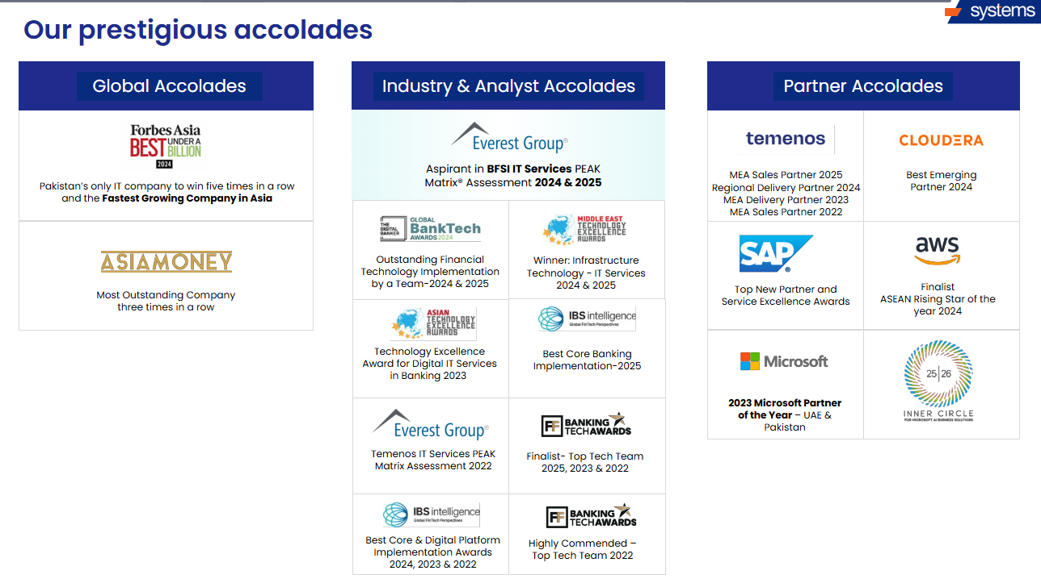

At Systems Limited, we provide comprehensive, end-to-end solutions tailored for banks and financial institutions — ranging from core banking transformation to AI-driven compliance, cloud modernization, digital lending, and payments orchestration. Our holistic offerings are designed to help financial institutions build future-ready platforms that are agile, secure, and customer-centric.

Our Banking Platforms services help institutions transition from legacy environments to modern, cloud-enabled digital ecosystems. We specialize in Core Banking Modernization, offering end-to-end upgrades, performance optimization, and managed services. Our digital transformation portfolio includes CRM, Digital Portals, Mobile Banking, and Loan Origination Systems, all enhanced with intelligent features such as conversational AI, customer onboarding flows, and real-time analytics. These platforms are supported by our proprietary accelerators like the Country Model Bank, allowing rapid deployment with built-in regulatory compliance.

To support long-term scalability and delivery efficiency, Systems Limited offers modern Global Capability Centers (GCCs) through established hubs in Pakistan and Egypt. These GCCs serve as transformation engines, staffed with experts in core banking, cloud, AI, digital channels, data engineering, and compliance. Clients can engage through flexible models — such as Centers of Excellence, ODCs, or SLA-based managed services — allowing them to optimize operational costs, expand talent capacity, and drive continuous innovation.

Our Cloud Services enable banks to modernize their IT infrastructure by adopting secure, scalable, and cost-effective cloud architectures. We support financial institutions throughout their cloud journey — from strategy and migration to deployment and ongoing management. With strong partnerships across leading cloud providers such as Microsoft Azure, AWS, Oracle OCI, and Red Hat, we help banks enhance agility, improve resilience, and accelerate time to market while ensuring compliance with industry standards.
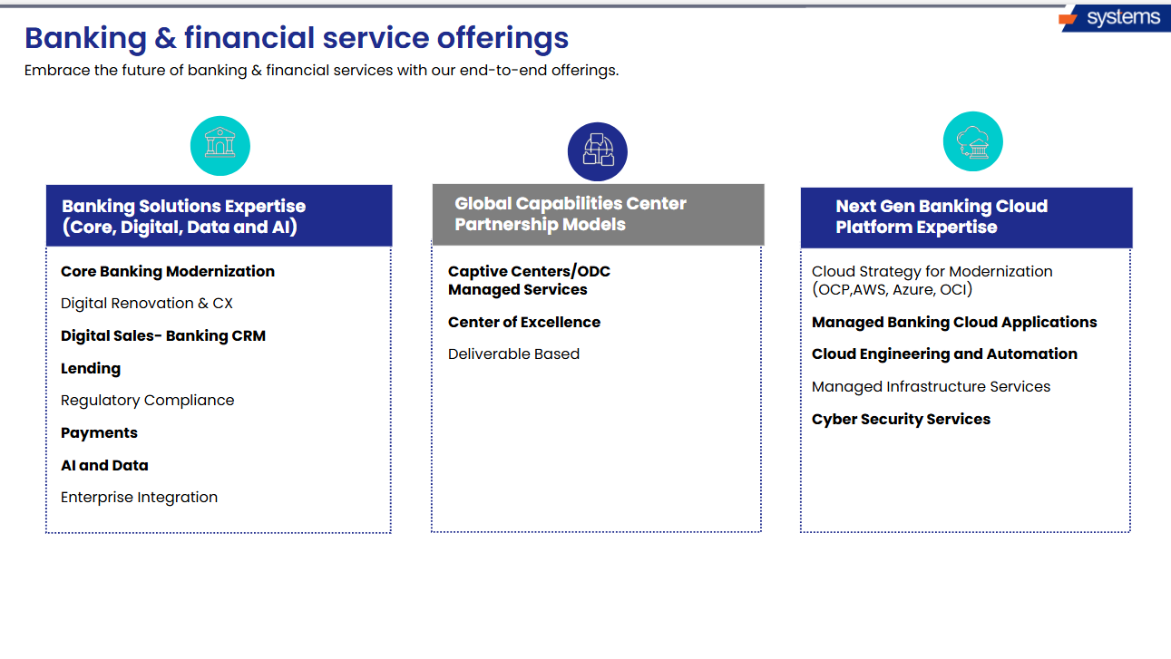
Our client base spans Tier 1 banks, digital-only banks, microfinance institutions, Islamic banks, central banks, and development finance institutions, giving us unparalleled exposure to regional, regulatory, and operational complexities.

With over 150+ BFS clients transformed in the last decade and more than 30 million customers using platforms implemented by Systems, we have played a pivotal role in enabling scalable, secure, and customer-centric financial services. From established banks undergoing core modernization to greenfield institutions launching with cloud-native platforms, our engagements reflect the full spectrum of banking transformation.

At the heart of our global success lies our ability to localize solutions, navigate diverse regulatory environments, and deliver consistently through hybrid delivery models. This strong international client base is both a testament to our credibility and a reflection of the trust financial institutions have placed in Systems Limited to shape their future.
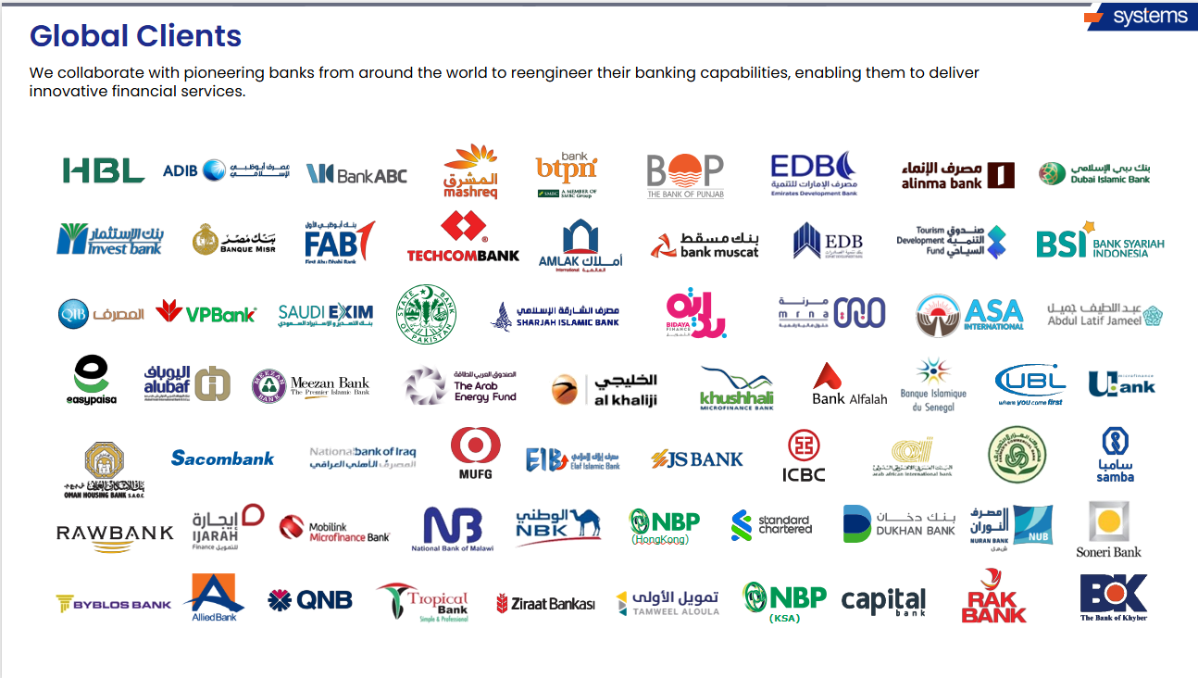

At Systems Limited, we believe that transformation is best achieved through collaboration. Our strong and evolving partner ecosystem enables us to deliver comprehensive, future-ready solutions to our clients across the banking and financial services landscape. By partnering with global technology leaders, we ensure access to cutting-edge tools, platform extensibility, and seamless innovation across cloud, core, data, and security domains.

As a long-standing partner of Temenos, we have executed some of the most complex core and digital banking implementations globally and hold license rights to develop Country Model Banks across GCC, ASEAN, and Africa — accelerating compliance and localization for our clients. Our strategic alliance with Microsoft has also earned us the Partner of the Year 2023 award for both UAE and Pakistan.

We further collaborate with leading technology providers including AWS, Oracle, Red Hat, and fintech partners like Nevis Security and Formpipe, helping banks modernize with scalable, secure, and compliant architectures. These partnerships strengthen our ability to deliver modular, cloud-native, and AI-powered banking platforms — empowering institutions to drive innovation, reduce risk, and scale faster in dynamic markets.

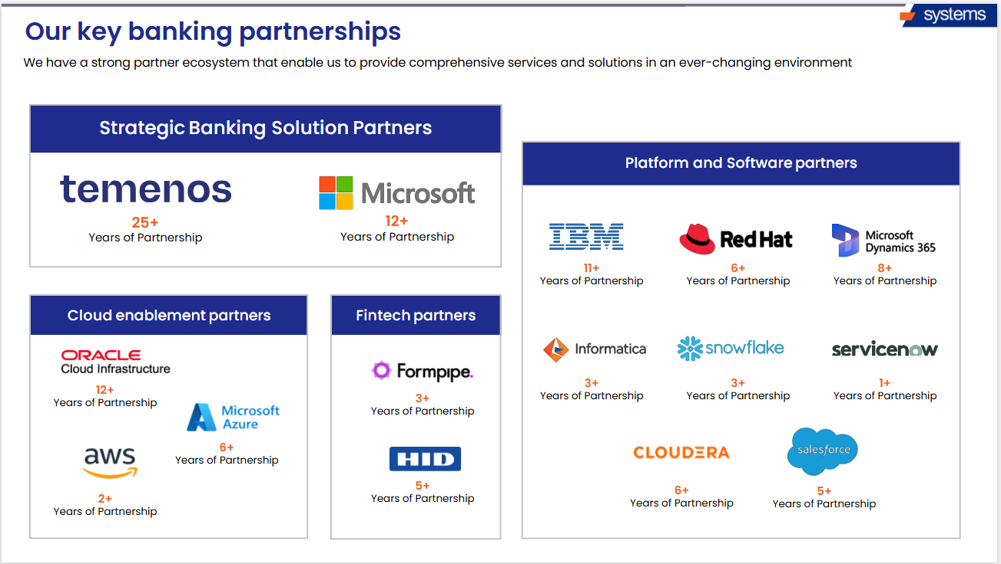

Company Financial Reports
Our company's 2024 revenue was $240M plus with YOY growth of 30% plus and our profitability was 20%. Provided below is a snapshot of Systems Limited Financials.

Abstracts of Financial Statements of last years in Rupees & USD (Consolidated):

 | 2024 (Rupees) | 2024 (USD)
Revenue | 67,473,021,160 | $ 242,229,478.23
Cost of revenue | (51,437,339,563) | $ (184,661,064.67)
Gross Profit | 16,035,681,597 | $ 57,568,413.56
Distribution expenses | (2,482,298,867) | $ (8,911,501.95)
Administrative expenses | (4,820,394,646) | $ (17,305,311.96)
Research & development expenses | (92,264,918) | $ (331,232.88)
(Impairment losses) / Reversal of impairment | (485,686,404) | $ (1,743,623.78)
Other operating expenses | (5,083,691) | $ (18,250.55)
 | (7,885,728,526) | $ (28,309,921.11)
 | 8,149,953,071 | $ 29,258,492.45
Other income | 725,575,753 | $ 2,604,831.28
Gain on disposal of investment | - | -
Finance costs | (465,258,660) | $ (1,670,278.78)
Share of loss of Associate | (118,973,681) | $ (427,117.86)
Impairment loss on investment in associates | - | -
Profit before taxation and levy | 8,291,296,483 | $ 29,765,918.09
Levy | (474,934,619) | $ (1,705,024.66)
 | 7,816,361,864 | $ 28,060,893.43
Taxation | (356,349,091) | $ (1,279,300.27)
Profit for the year | 7,460,012,773 | $ 26,781,593.15

Provided Below Are Links To Key Published Complete Audited Financial Statements for Systems Limited:

- Annual Report 2023
- Annual Report 2024

Company Certifications

Certified Partnerships
Systems Limited is the IT Leader and Largest IT and BPO Led services provider in Pakistan and Partner with all key Principals i.e., Temenos, IBM, Microsoft, and many others. We are providing partnership evidence for reference to the client.

Temenos Partnership
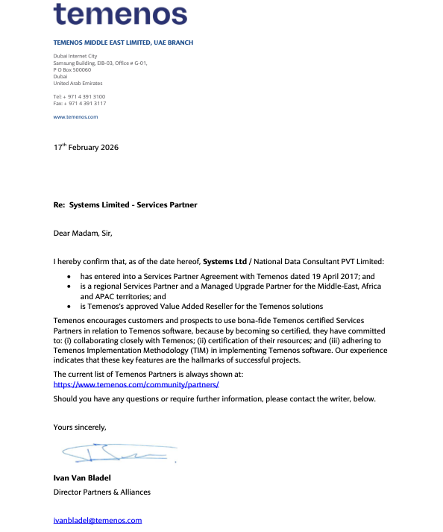

IBM Partner Certificate
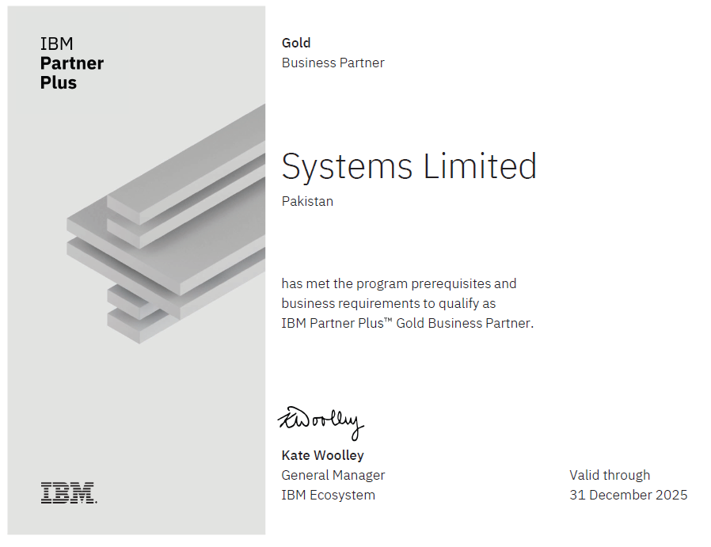

Microsoft Partnership Network Certificate-Gold Category
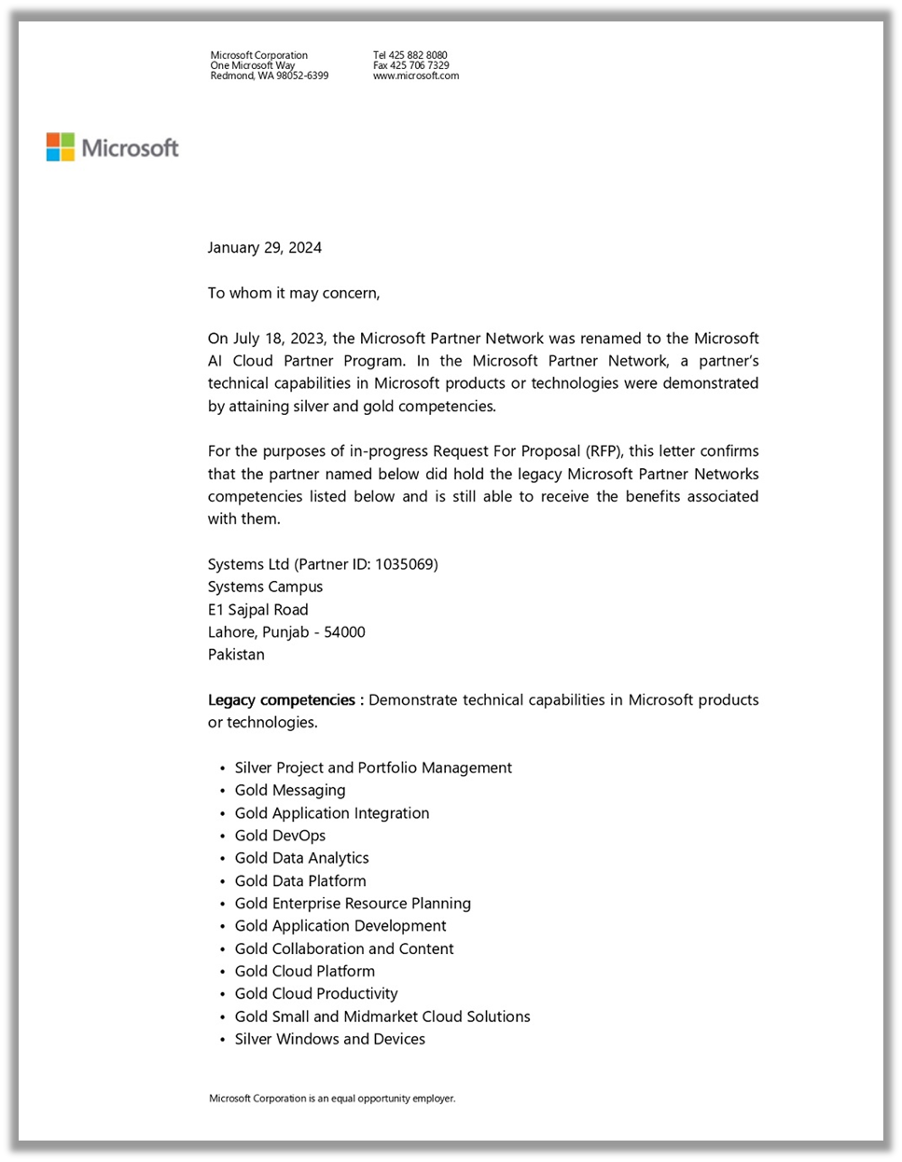
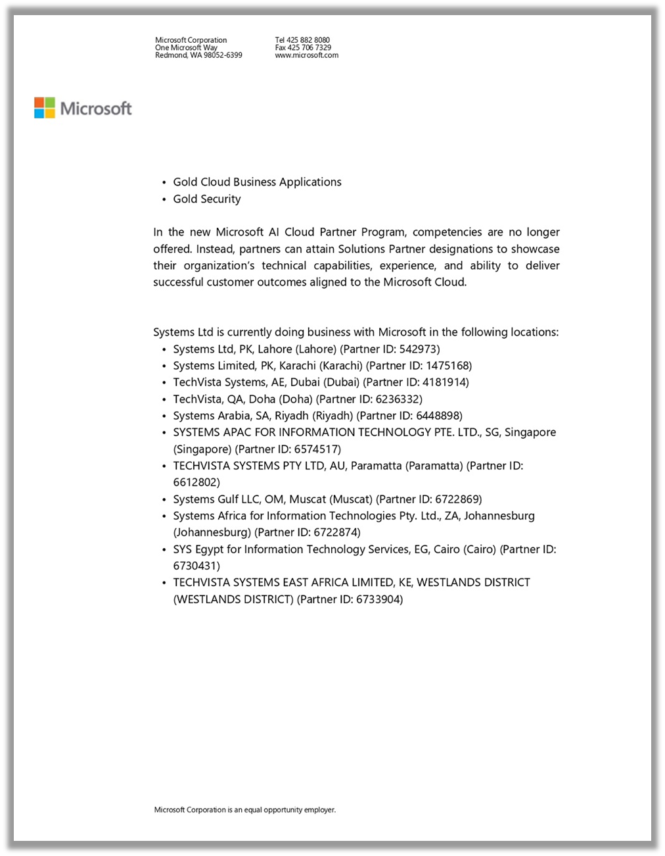
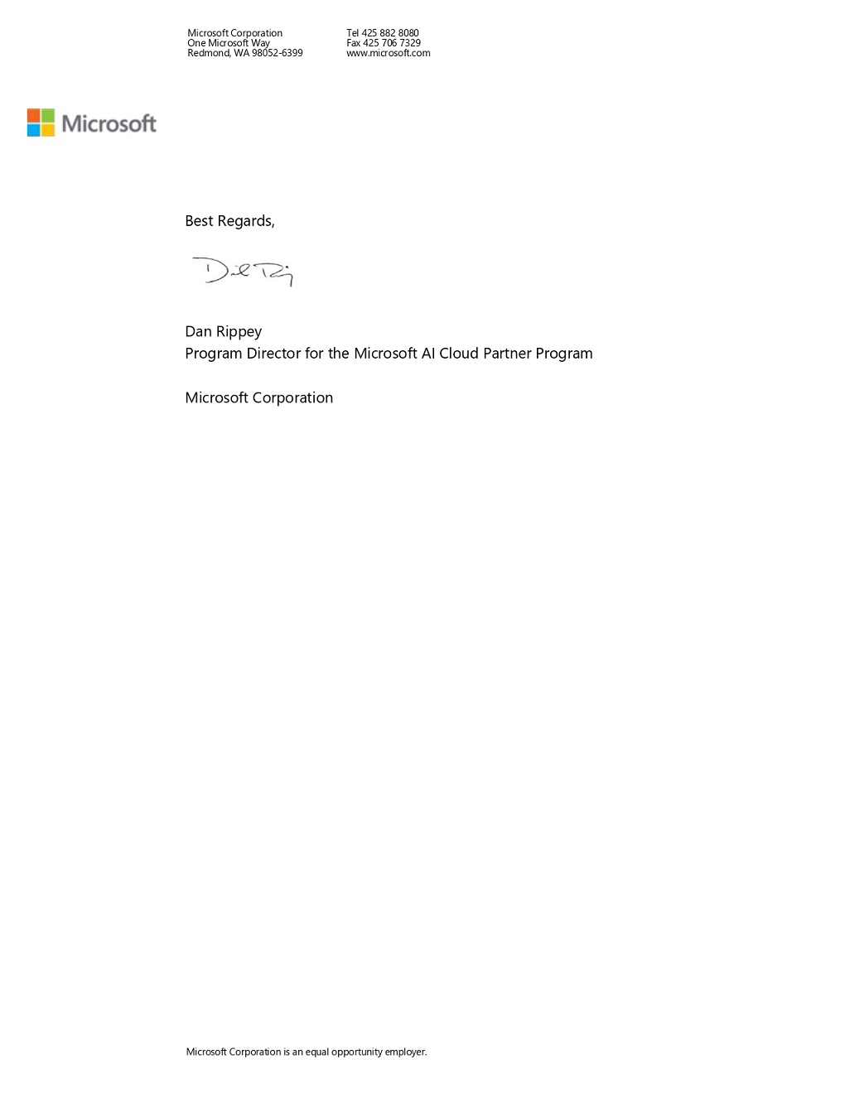

Scope of Work

Core Upgrade: Temenos Transact R19 TAFJ to R26 TAFJ
SYS will execute a like-for-like technical upgrade of Alkuraimi Bank’s Temenos Transact Core Banking platform from the current release to the latest agreed Temenos release.
The scope includes:

Environment Readiness Assessment
- Hardware, operating system, middleware, compiler, and database compatibility assessment
- Review of infrastructure readiness for target release

Upgrade Analysis
- Inventory of existing modules, parameters, local developments, and integrations
- Upgrade impact assessment on customizations and interfaces

Core Technical Upgrade
- Installation and configuration of target Temenos release
- Upgrade of core components including TAFJ, BrowserWeb, and supporting libraries
- Technical uplift of existing environment

Customization & Interface Retrofit
- Analysis and retrofit of local code, routines, reports, enquiries, and APIs
- Interface compatibility validation and remediation

Testing
- Unit Testing
- System Integration Testing (SIT)
- User Acceptance Testing (UAT)
- Regression Testing
- Mock upgrade and dress rehearsal

Deployment & Go-Live
- Cutover planning
- Production deployment
- Rollback planning
- Go-live execution support

Post Go-Live Support
- Hypercare support for stabilization
- Issue resolution and knowledge transfer

Proposed Solution

Target Solution Principles
SYS proposes a structured Temenos upgrade approach based on Temenos Implementation Methodology (TIM) and proven upgrade accelerators.

Target Solution Principles
- Like-for-like technical upgrade to minimize operational risk
- Maximum reuse of Temenos standard capabilities
- Controlled retrofit of custom developments and interfaces
- Comprehensive testing and reconciliation
- Minimal downtime during production cutover

Upgrade Approach

Environment Assessment
SYS will assess the current architecture, infrastructure, software stack, and dependencies to ensure compatibility with the target Temenos release.

Upgrade Execution
SYS will perform the technical upgrade in controlled non-production environments, including:
- Application upgrade
- Compilation
- Deployment
- Initial sanity testing
- COB validation

Customization Retrofit
All local developments including routines, versions, reports, enquiries, and integrations will be reviewed and retrofitted for compatibility.

Testing & Validation
Comprehensive validation will be performed including:
- Functional validation
- Interface testing
- Batch testing
- GL reconciliation
- Performance validation

Cutover & Stabilization
SYS will execute mock runs, finalize the runbook, perform production cutover, and provide post-go-live stabilization support.

- Upgrade Methodology
SYS will follow the Temenos Implementation Methodology tailored towards the Upgrade R19 to R26 Transact. SYS has a highly successful and proven model for project Upgrades using Temenos evolved implementation methodology (Temenos Implementation Methodology or TIM) for Upgrades, which is based on its experience of numerous successful upgrade engagements.

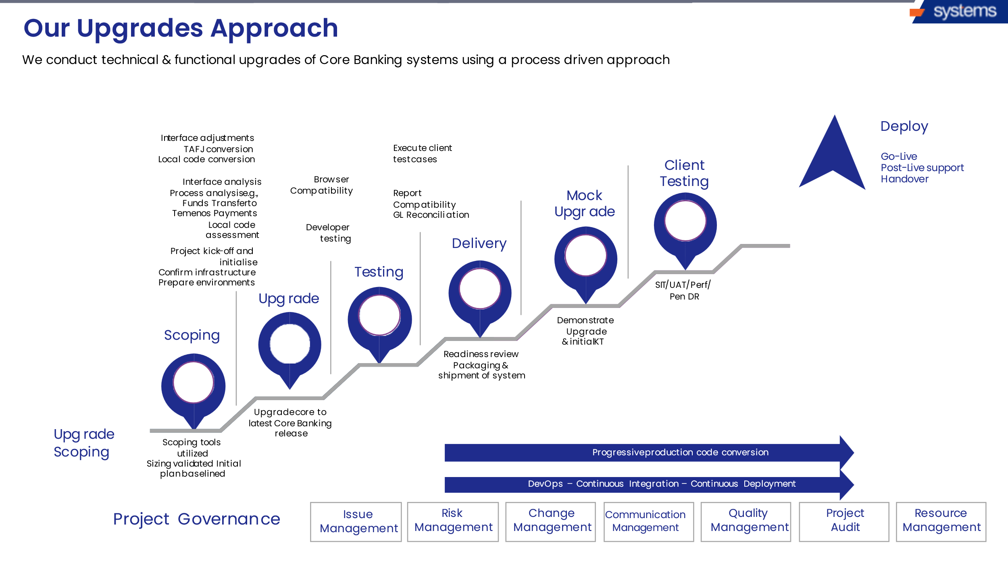

General Upgrade Activities
Following are the standard upgrade activities which are performed.

Stage 1: Project Initiation
The objective of this phase is scoping for an upgrade project, detailing the effort estimates, duration and costs of the proposed upgrade. This phase will enable Systems Limited to build an inventory of the locally developed technical assets in a client’s environment and through this inventory determine the effort that would be required to enable the client’s locally developed technical assets achieve the same functionality post completion of the upgrade. Scoping activities is performed with help of a routine / script developed by the SYSTEMS upgrade team.

During this phase SYSTEMS Upgrade team will coordinate with Temenos for the GPACK and/or supported TAM packages. Delivery of the GPACK and/or supported TAM package will be the responsibility of Temenos and testing / deployment of the packages will be the responsibility of SYSTEMS Upgrade team after technical upgrade (onsite activities).

Review of SOW
The scoping exercise is a process that is designed to precisely identify the effort which would need to be undertaken, the upgrade scoping exercise is used to detail all activities and defining all work efforts in terms of content, realization, and volumes. This results in the actual upgrade being a sized exercise, for which a precise resource involvement can be anticipated and therefore correspondingly planned.

Runbook Template
This guide lists the various approaches to migrating from the T24 R19 TAFJ to the Transact R26 TAFJ environments. The recommendations contained in this guide are by no means definitive and do not cover all possible combinations and scenarios. These recommendations are meant to guide you in the process of choosing the best migration path.

Run Book template standardization for client.
A Run Book will be provided entailing step-by-step guidelines regarding the upgrade of T24 release.
Automation for reconciliation of application vs records count utility to be updated as per target client base release.

The GL, records count and balances between the pre and post upgrade systems are reconciled and balanced with no major or inexplicable differences in the post upgrade GL that has been caused by the upgrade to the latest Transact R26 release.

The utility subroutine to update as per the target base release to get the records count and balances.

Hardware Sizing
Same hardware will be used for R26 however an assessment will be done to ensure the sizing will meet the needs of the bank.

Analysis Utility Setup
SYSTEMS Technical team has designed couple of routines to extract the inventory of the client T24 environment. First routine takes in the list of main menu used by the client on production and output of the routine is list of all the version, routines, deal slips, enquiries, reports, services and etc. attached to that main menus. Second routine will extract all information on the local codes / scripts available in the client environment along with the folder names and list of local code with missing source codes. The information extracted from routine 1 and routine 2 are checked for the shared elements / duplications in excel sheet (using excel functions).

Rest of the inventory is extracted manually by the SYSTEMS Upgrade services team. SYSTEMS Upgrade services team use the ESEARCH function to identify the local codes that require retrofits.

Stage 2: Project Planning
In this phase all the administrative tasks and project planning that need to be executed prior to the initiation of the offsite phase of the client upgrade will be completed with a formal consent of client. A project plan, project charter and/or project scope is put in writing, outlining the work to be performed. During this phase, a team is prioritizing the project, calculating budget and schedule, and determining what resources are needed. The plans created during this phase will help manage time, cost, quality, change, risk and issues. They will also help Systems Limited in managing staff and external suppliers, to ensure that the project is delivered on time and within budget.

Stage 3: Upgrade Analysis
The Upgrade analysis exercise is a process that is designed to precisely identify the effort which would need to be undertaken, to ensure at minimum a like to like upgrade. the upgrade scoping exercise is used to detail all activities and defining all work efforts in term of content, realization and volumes. This results in the actual upgrade being a sized exercise, for which a precise resource involvement can be anticipated and therefore correspondingly planned.

Data Integrity Health Check
The health check exercise is a process (Subroutine) to assess several aspects of your database's health. These include various data integrity checks for file structures.

Identify local jobs and CORE Batches
In this phase, Identify the local jobs that attached with core batches need to replace with target base release batches.

Stage 4: Technical Upgrade
This phase of the upgrade project consists of a series of tasks that must be completed by the upgrade project team to ensure that the infrastructure and the supporting software required to execute the technical milestones of the upgrade project are ready, configured and made available. Without the completion of these tasks the project team will be unable to undertake the subsequent milestones of the upgrade project.

First level of testing that will be executed by the upgrade services project team once the technical upgrade tasks have been completed. The primary focus of this milestone is to:

- Perform high level tests directly on the core applications (e.g., FT, TT, LD, MM etc.) without any versions or local customization to ensure proper functioning and processing within those applications.

- Successfully complete without any crashes or errors the first post upgrade COB cycle with all the locally developed COB jobs in the proper place.

Perform technology upgrades as per analysis identification.

In this phase, performing Technology upgrade like:
- Application Framework upgrade (i.e., TAFC to TAFJ etc.)
- TAFJ Installation

Perform Core Upgrade
The Core upgrade contains the tasks related to the actual technical upgrade of the client environment from the current release (T24 RXX) to the latest T24 release.

The activities within this milestone are by requirement sequential in nature and are usually executed by two resources full time with periodic review from the team lead and the project manager.

This milestone is the most important in the overall upgrade project and the successful completion of the first post upgrade COB process without local jobs is one of the most important tasks. The locally developed COB jobs are removed from the first post upgrade COB to ensure that the COB is completed and baselined without the influence of local jobs. The stability of this COB cycle would determine the schedule of the subsequent tasks in the upgrade project.

Post upgrade verification for successful and complete Upgrade
In this phase, performing verification of error free upgrade process.

GL Reconciliation
GL Reconciliation is part of the technical upgrade phase. The basis of GL reconciliation will be the GL difference in the environment provided for the upgrade. If the task is included, then the GL report after and before upgrade will be reconciled by SYSTEMS & Client Upgrade team. There are certain tools used to extract reports from the current/upgraded environment, so it can be compared, and necessary measures be taken to rectify the differences.

Stage 5: Unit testing in integrated environment before delivery to client
This milestone of the upgrade project relates to the first level of internal unit testing that will be executed by the upgrade services project team once the technical upgrade tasks have been completed. The primary focus of this milestone is to perform high level tests directly on the core applications (e.g., FT, TT, LD, MM etc.) without any versions or local customization. The secondary focus will be to successfully complete without any crashes or errors the first post upgrade COB cycle with all of the locally developed COB jobs in the proper execution sequence.

Once these tasks are completed, the project team will be able to compare the results from these tests against similar tests conducted in the pre-upgrade system. This comparison would enable the project team to identify any potential issues from the post upgrade system that could impact the subsequent detailed testing stage of the project.

Unit Testing of functionality
The client will perform internal unit testing of functionally from T24 application, version and enquires.

Unit Testing of interfaces
Perform internal unit testing of existing configured interfaces.

Unit Testing of Gpacks
Perform internal unit testing of Gpacks provide along with upgrade build.

Stage 6: Upgrade Training
Training Need Analysis for best usage of Training days agreed in the SOW
- Admin Training
- Technical Training of Latest Functions
- Business Trainings
- Executive overview of upgrade value proposition

Pre-UAT Training
The Pre-User Acceptance Testing Training offers training to client on the methods and procedures that the client UAT team would use while they are engaged in the key user acceptance phase of the Transact Upgrade Project. The client UAT team will learn the concepts, background and formal techniques to facilitate user sign off of the acceptance phase. The training focus is on:

- Classification of the UAT Test Cases
- Identifying the project risks and deciding what to test
- How to be an effective tester and what to look for when testing
- Determining which techniques, user acceptance test scenarios and resources to use in the UAT Planning
- Writing User Acceptance Test Cases
- Testing and Traceability
- Performing Usability Testing
- UAT Procedures Guide and how to execute User Acceptance Testing
- UAT Defect Reporting and Defect Tracking

Technical and admin Training advance level
The Technical and admin Training exercise that enables clients' technical users to use the Upgrade system in an efficient manner.

Functional Training covering new features
The functional training exercise is covering new features and this is for end users to train the trainer approach.

Stage 7: System Integration Testing
In this phase, the system is fully tested by the client against the test scripts designed by client for all respective channels and Interfaces areas functional on the replica of production environment, corrections are made as required. Client must be using a defect management tool like Bugzilla to manage the testing process.

Stage 8: User Acceptance Testing
In this phase, the system is fully tested by the client against the test scripts designed by client for all respective areas functional on the production environment, corrections are made as required, and the mock upgrades are performed in next phase with all the final changes. Test Scripts are replicas of production scenarios, interface transactions and COB tests (daily, weekly, monthly, quarterly, yearly and special posting (where applicable)). Pre UAT training will be delivered at the start of the phase. Pre UAT training will cover the UAT testing demonstration and maintaining the UAT templates.

Stage 9: Mock Upgrade and Dress Rehearsals
This phase is executed to calculate the actual time required to perform the upgrade on the production environment. Two initial mocks are collective efforts of SYSTEMS upgrade team and client’s project team and the last two mocks including the final mock are executed by the team responsible for upgrading the production.

Based on the mock runs conducted in this phase, run book may be updated for the GO Live run.

- Optimization of conversion time and run book steps.
- Performance Review.
- Performance Tuning (Index and distributed files).
- Performance Tips and best practices.
- Financial and static Reconciliation.
- COB Optimization and Best Practices.

Stage 10: Pre-GO LIVE
This phase is related to before upgrade the production below items has to finalize before going to stage 11
  - Run Book finalization.
  - Activity check list
  - Fallback Plan

Stage 11: GO LIVE

  - Cutover as per the run book
  - Sanity / Smoke Test
  - Financial and static Reconciliation
  - Go Live announcement.

The purpose of this phase is to upgrade the production. All the functionalities tested during the UAT phase are available to end users on the latest release. Project completion is dependent on successful closure of this phase along with a project closing report.

Stage 12: Post GO LIVE Support
This is an optional phase designed for the clients with low product expertise to deal with the post upgrade issues. Issue log is maintained with current status of upgrade issues. Normally a specific period is agreed for this phase and activities are repeated during the life cycle of this phase.

  - Project Handover Strategy
  - KT and Code Handover to PACS or client team
  - Project Closure Report

Planning and Control
In addition to the seven key TIM stages, the seven Planning and Control processes provide a series of processes and procedures that are executed across the entire implementation lifecycle to ensure that at every stage the key project goals are being successfully achieved:

- Risk Management – A systematic approach to fully understanding, quantifying and mitigating risks associated with the project delivery schedule.

- Change Management – Provides a structure for the planning, monitoring and control of any changes to agreed deliverables during the implementation along with the impact to and alterations of the delivery schedule.

- Communication Management – Ensures that the status of the implementation is communicated via pre-defined structures to all the stakeholders, both internal and external.

- Quality Management – Provides the basis for assuring that there are formal standards, procedures and controls to ensure the quality of the delivery.

- Project Audit – An onsite corporate review using defined matrices that ensures that the implementation is being delivered successfully from a contractual, delivery, methodology and client satisfaction perspective.

- Resource Management – Facilitates the allocation of services consultants for the timely delivery of the relevant implementation components.

- Internal Temenos Project Review - The internal Temenos project review is a short onsite exercise, conducted via a series of face-to-face interviews with the Temenos project leadership team (Project Manager, Client Architect, PMO, senior architects) and customer stakeholders (PM, Executive Sponsor and others as determined by the reviewer). The aim of this exercise is to assess risks to overall project success (for Temenos and customer) and address any key issues with Temenos executive support.

As TIM uses standardized processes which are the result of the acquired wisdom of hundreds of project implementations, a number of gains can accrue to a client:

- A generic plan, structure and framework in which to complete a project, from Sales through to post-Implementation support.

- A centralized library of pro-forma documents and processes to be used in this process ensuring consistency of approach and re-usability.

- A central, application-based portal for all project documentation produced during the project lifecycle.

- A business process review which helps a client to re-align business processes to achieve stated goals in the most efficient way.

- A collection of best practices, hints and tips ensuring hundreds of years of intellectual capital gained from T24 implementations is maintained. It on the basis of this experience that the T24 Model Bank is built, which is used by the client for implementation. T24 Model Bank reduces implementation time, thus giving the client substantial cost benefits.

- Restricted and sanitized access to prior implementation information, completed analyses, migration detail etc., thus ensuring that any consultant with access to the methodology library, can effectively draw on the combined experience of the entire company.

Project Timeline
The project will be executed through phased upgrade milestones covering assessment, retrofit, testing, cutover, and stabilization.

Core Banking Upgrade R19 to R26
- 8 months implementation
- 4 weeks PGLS
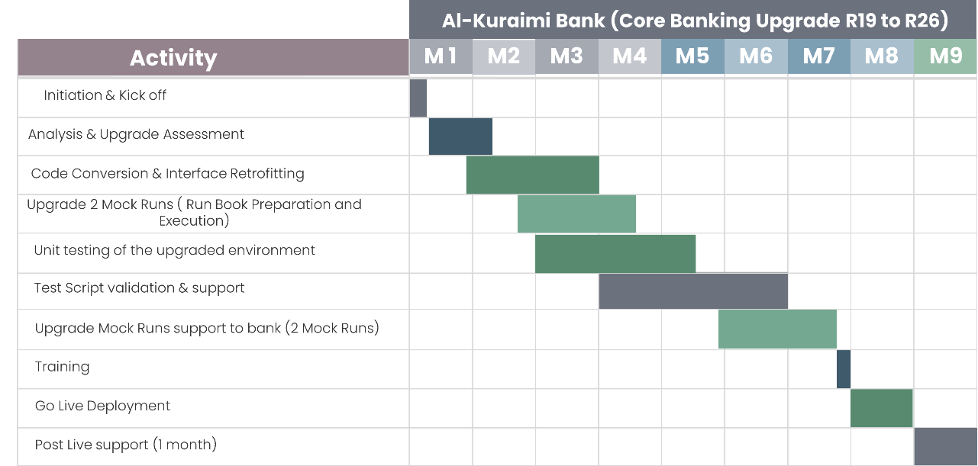

Project Governance

Communication Plan
SYS recognizes that a communication/reporting plan is essential for good project management. Good communication forestalls surprises, prevents duplication of effort, and can help to reveal any omissions or misallocations such that early corrective action can be taken. It ensures that the status of the implementation is communicated via pre-defined structures to all the stakeholders, both internal and external.

As part of its implementation methodology, SYS first plans its Communication Management in a series of activities, such as:

Identify the Target Audience – The first step is to identify the right people that need to be communicated with. At this stage, it is also confirmed with each individual what groups they belong to i.e., part of the steering committee, members of the risk review board, part of the business review team, etc. The Standard List could include Steering Committee members, Project Sponsor(s) internal and the Clients, Clients PM and PMO, etc.

Identify what information needs to be communicated – Once the target audience has been identified, the next step is to decide who should receive what keeping in mind that the target should receive information relevant to their roles and responsibilities and should not be overwhelmed by a surfeit of information. A list of communication requirements could consist of Steering Committee Meeting Agenda, Steering Committee Meeting Minutes, etc.

Identify the delivery tools – Delivery Tools could be Emails, Face to face-to-face meetings, Telephone calls, Conference calls, Newsletters, Using Standard Reporting Templates etc.

Identify how to distribute the communication – The persons who are responsible for collating and distributing the information are identified. The frequency with which this information should be distributed is also decided depending upon the criticality of the information and the target audience addressed.

Communication Plan Signoff – The Communication Plan is agreed to and signed off by the Client.

Quality Management
During project implementation, SYS pays great attention to the quality of its deliverables as part of the Temenos Implementation Methodology (TIM). It provides the basis for assuring that there are formal standards, procedures, and controls to ensure the quality of the delivery. It is one of the key planning and control processes built into TIM.

Change Management
Change Management is an essential part of project control. It provides a structure for the planning, monitoring, and control of any changes to agreed deliverables during the implementation along with the impact to and alterations of the delivery schedule.

During the Initiation stage, the change management process is jointly agreed upon between SYS and the Client. SYS manages the process and provides estimates of the impact of the change on cost and time; as owners of the project, the Client decides if a change should be approved. The Change Management Process manages all scope changes, however small. Given the usual tight timeframes, scope changes are to be kept to an absolute minimum.

Any Change Requests (CRs) arising during the project, will be estimated separately, and signed off with the Client. All CRs will follow a strict change management procedure.

If any changes are required by the Client in any business requirement, project plan or other documentation during the project implementation, then there is a Change Management procedure to guide the Client.

The client will provide SYS with a written proposal (Change Request Document) including:
a description of the change, specifying its estimate of the timescale involved in implementing the change and an impact analysis.

Project Issue Escalation Management
As part of project governance, SYS recommends the following joint roles being staffed by personnel from SYS as well as Client. Any reasonable problems that arise during project implementation and that do not get sorted out at the Project Manager levels can be dealt with at one of the appropriate levels below:

Review Board
The Review Board is staffed by SYS and Senior Managers from Client. The Board sets the strategic vision and objectives for a given program or project. Leads efforts to build consensus through the organization to support the project’s objectives. The Review Board meets quarterly.

Steering Committee
Also known as the Project Board, it comprises a formal team of executives to ensure the project meets enterprise goals. The Steering Committee meets monthly and should comprise at least three members; the Executive (Client project sponsor), the Super User, and the SYS representative (project/Program director). The Project Board represents at a managerial level the Client’s business, the users, and SL's interests in the overall project.

Governance Model
To ensure a seamless implementation process and timely delivery, SYS governance model focuses on creating a structured framework for successful execution.
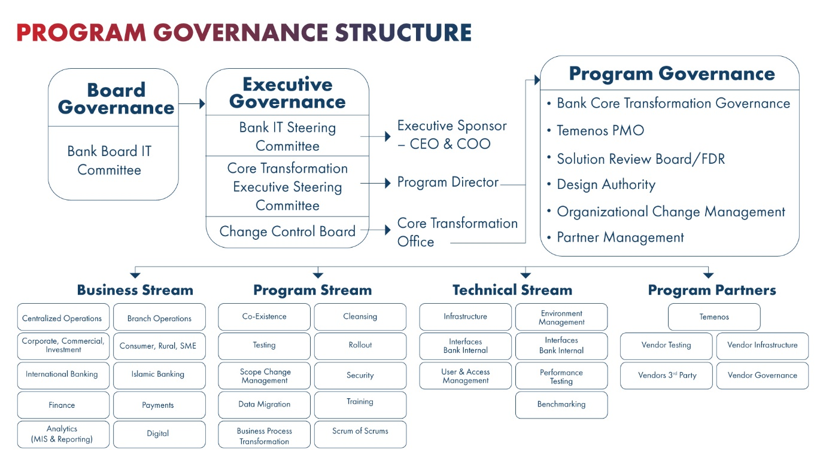

Assumptions

- All documentation will be provided in English.
- The Client will ensure that it provides sufficient staff dedicated to the performance of any Client responsibilities, Dependencies in this proposal and who have appropriate skills as business and IT specialists. The Client’s resources shall provide timely inputs and information as required in a timely manner.
- JBLoader changes due to upgrade will be manage by the bank
- Monitory and logging stack is owned by the bank and if there is any change it will be manage by the bank
- The Client shall ensure that all relevant members of its team attend training.
- The Client will participate in reviews and workshops, such as business process review workshops and analysis meetings as necessary.
- The Client will participate in meetings required to provide parameterization and defining attributes for bank products where required.
- The Client will provide any relevant input documents to facilitate in workshop preparation and to assess Bank’s requirements in detail.
- In providing any Client Inputs and Signoffs, the Client shall be responsible for consulting with all relevant stakeholders within the Client and promptly providing to SYS a single consolidated Client position on each such item.
- The total implementation timeline for the core upgrade project is 8 months, followed by 1 month of post-go-live support.
- The Client is responsible for the selection and procurement of all IT infrastructure necessary for the Project (including IT hardware, associated Software such as operating systems and support and maintenance arrangements for the infrastructure).
- The Client shall ensure there is a suitable VPN connection for access from Offsite to all the Client Software Environments.
- The Client must decide on the technical architecture of the Project, such decision to be consistent with any guidance given by Temenos in relation to suitable architectures.
- The Client will be responsible for licensing, implementing and making available any ancillary systems, infrastructure, network tools and other software (not mentioned in the proposal), required to operate the Temenos Products.
- In relation to any Interfaces, the Client shall be responsible for any configuration of the relevant third-party applications and for the co-ordination with any third parties (including relevant certifications).
- The Client acknowledges that Onsite SYS team members will sometimes need to have private meetings and to interact with the Offsite team. Accordingly, the Client shall provide occasional and reasonable access to the meeting room, teleconference, and video conference facilities.
- Bank will be responsible for performing UAT and SYS will provide support only during UAT Phase.
- Installation of any software other than the proposed solution components is the responsibility of Bank.
- Temenos licenses are not included.
- Any environment other than Dev, SIT, UAT, Production, and DR is out of scope.
- Integration with any device other than defined in the scope stands out of scope.
- Any kind of data entry/scanning activity will be considered out of scope.
- Anything else not included in this section and not listed in the above Project Scope is considered out of scope for this proposal.
- Any type of hardware arrangement either for device integration or servers related is not part this proposal.
- Test scripts will be provided by Bank.
- Any additional requirements beyond the given scope in the technical scope will be catered for through a change management process.

Case Studies

State Bank of Pakistan
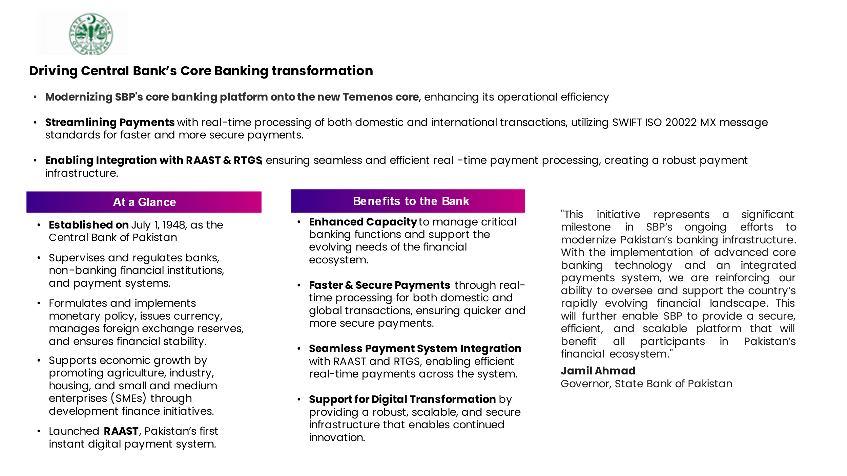

National Bank of Fujairah
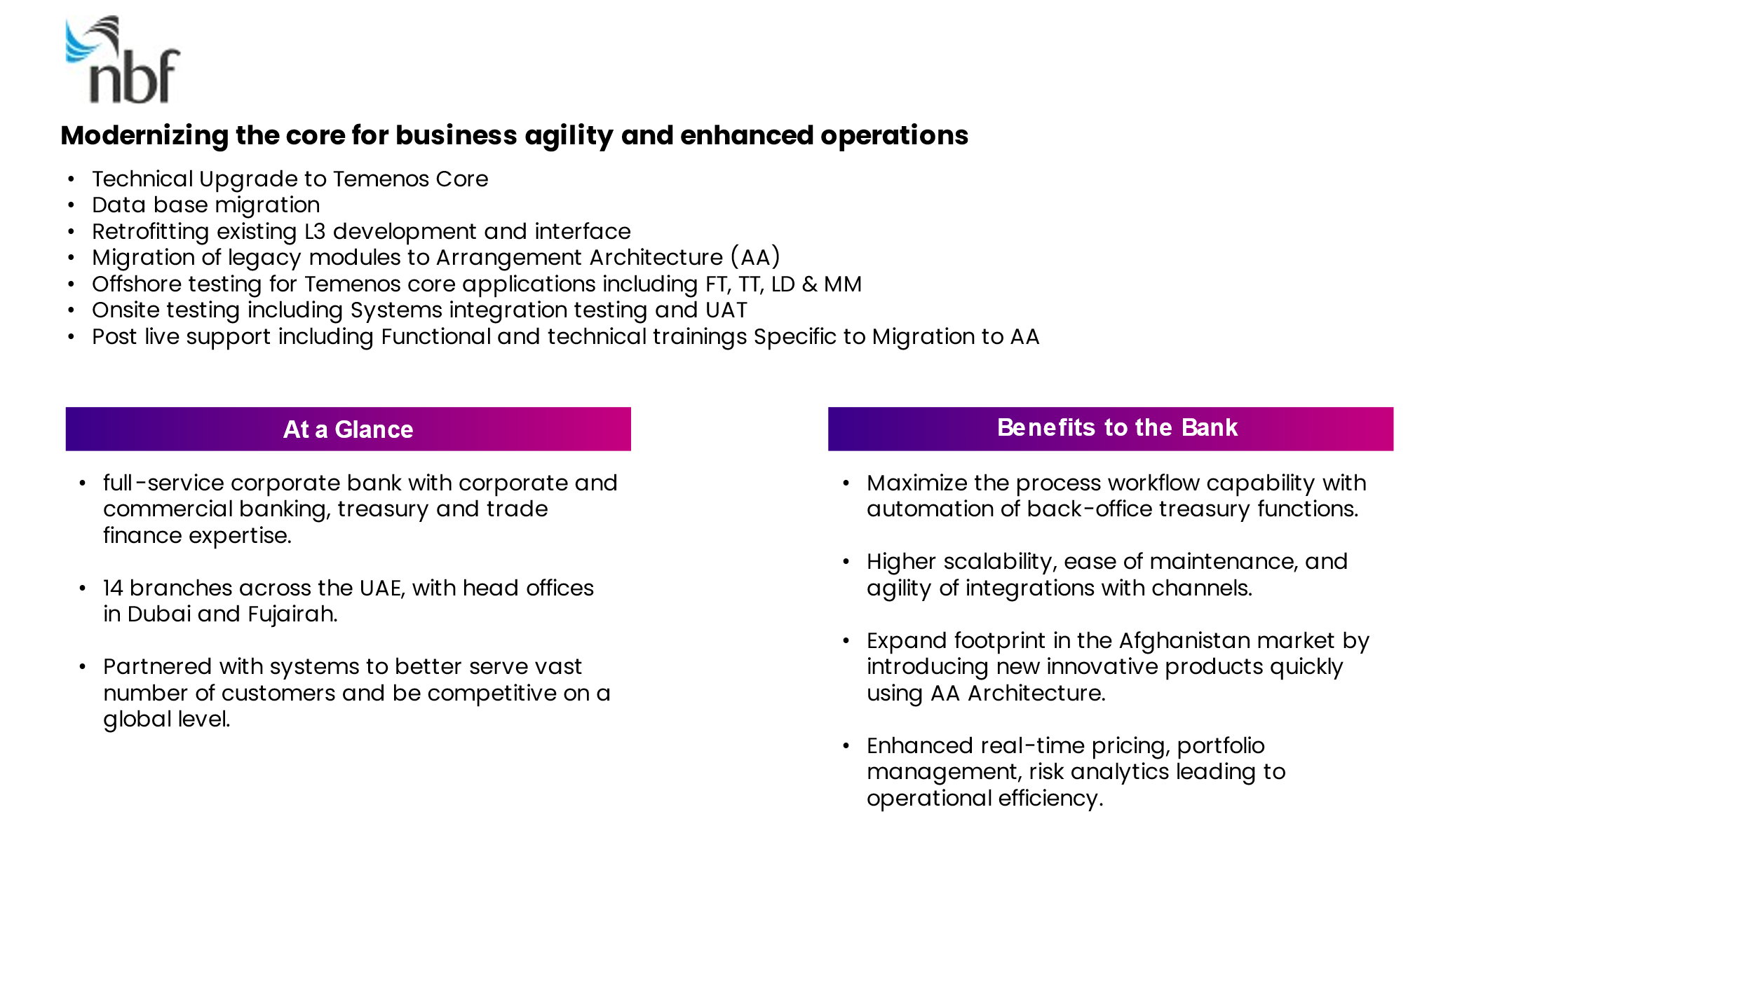

Ziraat Bankasi
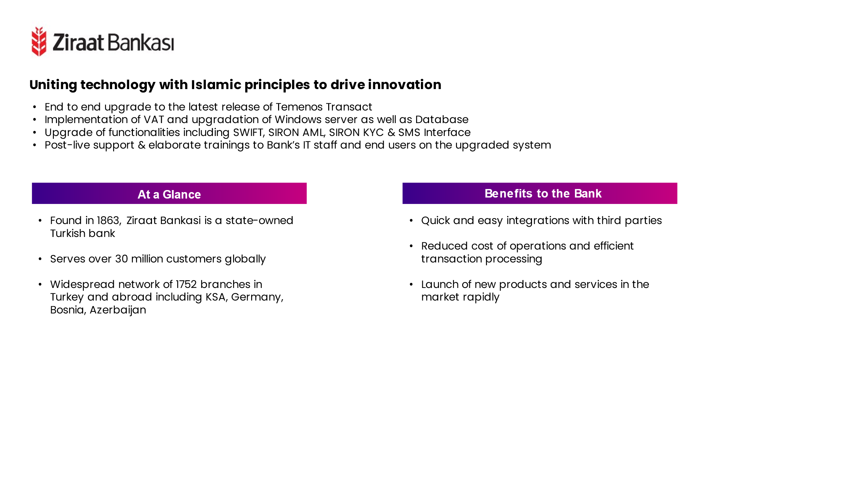

Meezan Bank
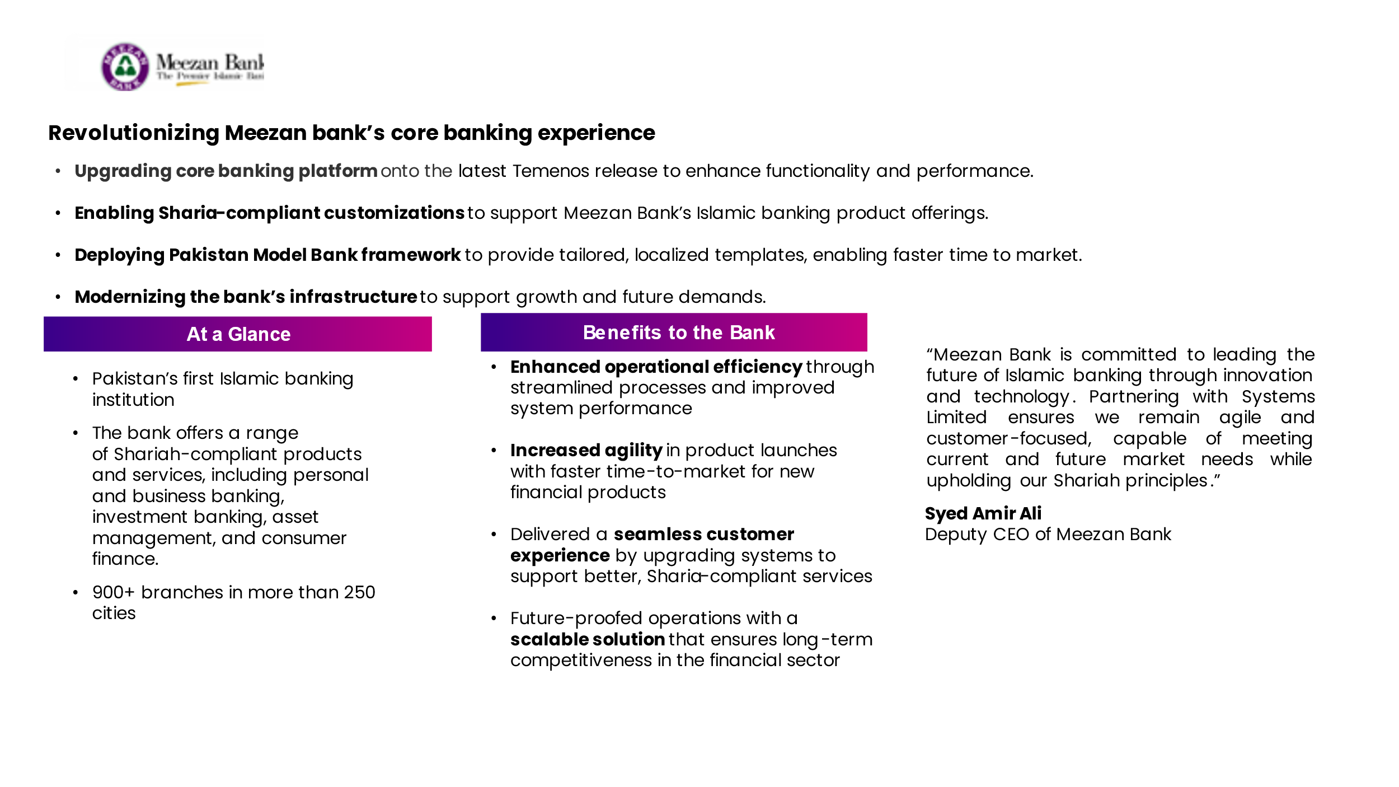

Sharjah Islamic Bank
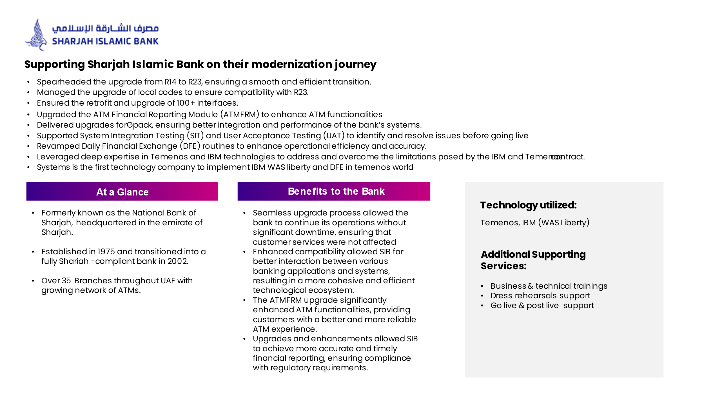

VPBank
