Alt-NFP Bayesian State Space Forecasting Model: Methodology and Results

1. Overview
This document describes the methodology and empirical results for the QCEW-anchored Bayesian state space model. This is the reference specification against which all subsequent model variants should be evaluated. The specification uses a fixed birth/death offset, Gaussian observation errors, the nutpie sampler (8k draws, 6k tune), and reports 0 divergences.
The model extracts a latent national employment growth signal from four data sources—monthly QCEW (truth anchor), CES (SA and NSA, noisy observations), and two payroll provider (PP) continuing-units series from independent providers—operating entirely in monthly log growth rates.
Core design principles:
- QCEW is truth. The near-census Quarterly Census of Employment and Wages defines the measurement scale ($α=0$, $λ=1$, fixed $σ$). This choice is motivated by planned extensions to more granular estimation (state x supersector), where CES precision degrades but QCEW coverage remains scale-invariant.
- CES is a noisy observer. CES measures total employment with estimated bias ($α_{\text{CES}}$), loading ($λ_{\text{CES}}$), and noise ($σ_{\text{CES}}$). The model learns how CES relates to truth rather than assuming it.
- PP providers are independent. PP1 and PP2 come from different payroll companies with independent measurement systems. No common factor is imposed across providers; cross-provider correlation is fully explained by the shared latent signal.
- PP1 has autocorrelated errors. PP1’s clients are small and medium-sized employers. Importantly, in this preliminary iteration, no efforts to harmonize the provider’s clients were undertaken. As opposed to PP2, PP1’s clients contain instances where the client is paying their employees in multiple establishments under a single account. This creates persistent measurement artifacts modeled as AR(1) errors.
The model is estimated on 119 months of data (February 2016 – December 2025). All indices are rebased to 100 at March 12, 2020.

2. Data Sources and Transformation

2.1 Data Sources
Source | Type | Coverage | Frequency | Concept
QCEW | Administrative (UI tax records) | Near-census (~10M establishments) | Monthly | Total private employment (NSA)
CES SA | Survey | ~145,000 establishments | Monthly | Total private employment (seasonally adjusted)
CES NSA | Survey | ~145,000 establishments | Monthly | Total private employment (not seasonally adjusted)
PP1 | Payroll provider 1 microdata | Small to medium single and multi-establishment firms | Monthly | Continuing-units employment (NSA)
PP2 | Payroll provider 2 microdata | Small single-establishment firms | Monthly | Continuing-units employment (NSA)
QCEW data quality. Employers file UI tax reports quarterly. BLS publishes monthly employment counts, but only the quarter-end month (March, June, September, December) is derived directly from current-period tax filings. Months 1 and 2 within each quarter come from UI tax records that are reported retrospectively —they are not reported in real time for the active reference period. The model reflects this quality gradient through month-dependent fixed sigmas (Section 4.4).
No common provider factor. Cross-provider correlation (empirically ~0.97) is fully explained by the shared latent employment signal through their respective loadings.

2.2 Growth-Rate Specification
All series enter the model as monthly log growth rates:
$$g_{t}^{x}=ln\left(x_{t}\right)-ln\left(x_{t-1}\right)$$
The first observation is dropped since differencing consumes one period, yielding $T=119$ monthly observations.

2.3 Sample Summary
Series | Observations | Start and end periods | Mean growth (%/mo)
Total | 119 | 2016-02-12 – 2025-12-12
QCEW | 113 | 2016-02-12 – 2025-06-12 | +0.116
— Month 3 | 38 |  | —
—Months 1 & 2 | 75 |  | —
CES SA | 119 | 2016-02-12 – 2025-12-12 | +0.098
CES NSA | 119 | 2016-02-12 – 2025-06-12 | +0.116
PP1 | 113 | 2016-01-12 – 2025-06-12 | +0.184
PP2 | 82 | 2019-02-12 – 2025-12-12 | +0.313
CES NSA and QCEW mean growth agree at +0.116%/mo, confirming they measure the same concept. PP1 and PP2 show higher mean growth due to survivorship bias in continuing-units panels.

3. Latent State: Continuing-Units Employment Growth

3.1 AR(1) Dynamics
The latent process is seasonally adjusted continuing-units employment growth:
$$g_{t}^{\text{cont}}=μ_{g}+ϕ\left(g_{t-1}^{\text{cont}}-μ_{g}\right)+σ_{g} ε_{t}, ε_{t}∼N\left(0,1\right)$$
Initialized at $g_{0}^{\text{cont}}=μ_{g}+σ_{g} ε_{0}$ and evolved via pytensor.scan. The non-centered parameterization (sampling $ε_{t}$ and scaling by $σ_{g}$) improves MCMC geometry.

3.2 Priors
Parameter | Prior | Rationale
$$μ_{g}$$ | $$N\left(0.001,{0.005}^{2}\right)$$ | ~0.1%/mo (~1.2% annualized); wide for recession/expansion
$$ϕ$$ | $$\text{Uniform}\left(0,0.99\right)$$ | Uninformative over the stationary region
$$σ_{g}$$ | $$\text{Half-}N\left(0,0.008\right)$$ | Scaled to observed monthly growth volatility

4. Measurement Equations

4.1 Seasonal Component
Deterministic monthly seasonal with 11 free parameters and a sum-to-zero constraint:
$$s_{m}\text{ for }m=1,…,11, s_{12}=-\sum_{m=1}^{11}{s_{m}}$$
Prior: $s_{m}∼N\left(0,{0.015}^{2}\right)$.

4.2 Birth/Death Offset
$$\text{bd}∼N\left(0.001,{0.002}^{2}\right)$$
Time-invariant, capturing the systematic difference between continuing-units growth and total employment growth.

4.3 Composite Growth Signals
Signal | Formula | Observed by
NSA continuing-units | $$g_{t}^{\text{cont,nsa}}=g_{t}^{\text{cont}}+s_{t}$$ | PP1, PP2
SA total employment | $$g_{t}^{\text{total,sa}}=g_{t}^{\text{cont}}+\text{bd}$$ | CES SA
NSA total employment | $$g_{t}^{\text{total,nsa}}=g_{t}^{\text{cont}}+s_{t}+\text{bd}$$ | CES NSA, QCEW

4.4 QCEW Likelihood — Truth Anchor
QCEW defines the measurement scale with $α=0$, $λ=1$, and fixed noise that varies by month-in-quarter:
$$y_{t}^{\text{QCEW}}=g_{t}^{\text{total,nsa}}+ε_{t}^{\text{QCEW}}, ε_{t}^{\text{QCEW}}∼N\left(0,σ_{\text{QCEW},t}^{2}\right)$$
$$σ_{\text{QCEW},t}=\left\{\begin{matrix}0.0005 & \text{quarter-end month (M3: Mar, Jun, Sep, Dec)} \\ 0.0015 & \text{mid-quarter month (M1–2)}\end{matrix}\right.$$
Why fixed sigma. Estimating $σ_{\text{QCEW}}$ would allow the model to discount QCEW, undermining its anchor role. The fixed values are calibrated: 0.05%/mo for M3 reflects near-census quality ($±$~6,500 jobs at current levels); 0.15%/mo for M1–2 reflects the additional uncertainty from retrospective UI reporting (i.e., these months are not from the current reference period’s filing). These values were tightened from an earlier calibration (0.1% / 0.3%) after diagnostics revealed the looser values gave QCEW only ~4% of the precision budget—insufficient for the anchor to constrain the latent trajectory, which drifted systematically below QCEW observations as CES (95% precision share) dominated month-to-month filtering.
Why QCEW over CES as anchor. At the national level, CES is highly precise, but the architecture must scale to state $×$ supersector where CES sample sizes shrink by 1–2 orders of magnitude. QCEW’s administrative coverage is scale-invariant.

4.5 CES Likelihood — Noisy Observation
$$y_{t}^{\text{CES,SA}}=α_{\text{CES}}+λ_{\text{CES}}⋅g_{t}^{\text{total,sa}}+ε_{t}^{\text{SA}}, ε_{t}^{\text{SA}}∼N\left(0,σ_{\text{CES,SA}}^{2}\right)$$
$$y_{t}^{\text{CES,NSA}}=α_{\text{CES}}+λ_{\text{CES}}⋅g_{t}^{\text{total,nsa}}+ε_{t}^{\text{NSA}}, ε_{t}^{\text{NSA}}∼N\left(0,σ_{\text{CES,NSA}}^{2}\right)$$
SA and NSA share $α_{\text{CES}}$ and $λ_{\text{CES}}$ but have separate noise parameters.
Parameter | Prior | Rationale
$$α_{\text{CES}}$$ | $$N\left(0,{0.005}^{2}\right)$$ | Small bias allowed
$$λ_{\text{CES}}$$ | $$N\left(1.0,{0.25}^{2}\right)$$ | Centered on unit loading
$$σ_{\text{CES,SA}}$$ | $$\text{InverseGamma}\left(3.0,0.004\right)$$ | Mode $≈0.001$; prevents zero-collapse
$$σ_{\text{CES,NSA}}$$ | $$\text{InverseGamma}\left(3.0,0.004\right)$$ | Mode $≈0.001$; prevents zero-collapse

4.6 PP Likelihood — Independent Providers
Each PP series observes NSA continuing-units growth with provider-specific parameters and independent measurement errors:

4.6.1 PP1: AR(1) Measurement Error
PP1 clients are a mixture of small and medium-sized single and multi-establishment firms. Within-client restructuring creates autocorrelated residuals:
$$u_{t}=ρ u_{t-1}+η_{t}, η_{t}∼N\left(0,σ_{1}^{2}\right)$$
Implemented as a conditional likelihood:
$$y_{1,t}^{\text{PP}}∣y_{1,t-1}^{\text{PP}}∼N​\left(μ_{1,t}+ρ\left(y_{1,t-1}^{\text{PP}}-μ_{1,t-1}\right), σ_{1}^{2}\right)$$
where $μ_{1,t}=α_{1}+λ_{1} g_{t}^{\text{cont,nsa}}$, with marginal variance $σ_{1}^{2}/\left(1-ρ^{2}\right)$ at $t=0$.

4.6.2 PP2: iid Measurement Error
PP2 clients are predominantly single-establishment firms with clean client-establishment alignment:
$$y_{2,t}^{\text{PP}}=α_{2}+λ_{2} g_{t}^{\text{cont,nsa}}+ε_{2,t}, ε_{2,t}∼N\left(0,σ_{2}^{2}\right)$$

4.6.3 PP Priors
Parameter | Prior | Rationale
$$α_{p}$$ | $$N\left(0,{0.005}^{2}\right)$$ | Small systematic bias allowed
$$λ_{p}$$ | $$N\left(1.0,{0.25}^{2}\right)$$ | Centered on unit loading
$$σ_{p}$$ | $$\text{InverseGamma}\left(3.0,0.004\right)$$ | Mode $≈0.001$; prevents funnel geometry
$ρ$ (PP1 only) | $$\text{Uniform}\left(0,0.99\right)$$ | Positive autocorrelation; bounded below 1

5. Identification
- Latent $g_{t}^{\text{total,nsa}}$: QCEW observations with $α=0$, $λ=1$ directly anchor NSA total employment growth.
- CES calibration: Given the QCEW-identified latent state, $α_{\text{CES}}$ is the mean CES residual and $λ_{\text{CES}}$ is the CES-vs-latent slope.
- Seasonal pattern: CES SA + CES NSA jointly identify $s_{t}≈g_{t}^{\text{CES,NSA}}-g_{t}^{\text{CES,SA}}$, crosschecked against the QCEW anchor which directly observes NSA total growth.
- Birth/death offset: The mean wedge between total growth (QCEW, CES) and continuing-units growth (PP).
- PP parameters: Given $g_{t}^{\text{cont,nsa}}$ (total minus BD), PP bias, loading, and noise are identified from PP residuals.

6. Computational Implementation
Setting | Value
Draws | 8,000 per chain
Tuning | 6,000 per chain
Chains | 4
Target accept | 0.97
Preferred sampler | nutpie (Rust-based NUTS)
Fallback | PyMC NUTS
Runtime | ~2 minutes (Apple M4 Max)
The higher draw count and target acceptance rate (vs. standard 4,000/0.95) are needed because the latent AR(1) dynamics create tight coupling between global parameters ($μ_{g}$, $ϕ$, $σ_{g}$) and the 119-element latent trajectory. These parameters require more exploration to achieve adequate effective sample sizes.

7. Empirical Results

7.1 Sampling Diagnostics
Diagnostic | Value
Divergences | 0
R-hat (all parameters) | $$≤1.01$$
Min ESS (bulk) | 315 ($μ_{g}$)
Median ESS (bulk) | ~9,000
Max ESS (bulk) | ~27,000
Zero divergences. All R-hat values at 1.01 or below. The lowest ESS occurs for $μ_{g}$ (315, just below the 400 threshold); all other parameters exceed 400. The tightened QCEW sigmas substantially improved convergence compared to the earlier calibration (where $μ_{g}$ ESS was 53 and R-hat was 1.07), because the stronger QCEW anchor better identifies the latent trajectory and reduces the coupling between global parameters and the 119-element latent state.

7.2 Latent Dynamics
Parameter | Posterior mean | 80% HDI | Interpretation
$$μ_{g}$$ | +0.001%/mo | [−0.2%, +0.3%] | Long-run continuing-units growth near zero
$$ϕ$$ | 0.070 | [0.00, 0.11] | Minimal persistence; shocks dissipate quickly
$$σ_{g}$$ | 1.6%/mo | [1.5%, 1.7%] | Monthly innovation volatility
The near-zero $μ_{g}$ implies all trend employment growth comes from the birth/death offset. In a steady state, the continuing-units population is approximately constant (entries $≈$ exits from the panel), and net growth is driven by business formation.
The low $ϕ$ (0.07) indicates employment growth shocks are nearly transitory—a departure from random walk specifications common in the literature.

7.3 Birth/Death Offset
Statistic | Value
Mean | +0.014%/mo
80% HDI | [−0.18%, +0.20%]
Annualized | +0.17%
The BD offset is statistically indistinguishable from zero with wide uncertainty. This reflects genuine identification difficulty: BD is the difference between QCEW (total) and PP (continuing units), both of which are noisy relative to this small quantity.

7.4 CES Observation Parameters
Parameter | Estimate | Interpretation
$$α_{\text{CES}}$$ | +0.034%/mo | CES overstates growth by ~0.4%/year vs QCEW
$$λ_{\text{CES}}$$ | 0.986 [0.98, 1.00] | Near-unit loading; slight attenuation
$$σ_{\text{CES,SA}}$$ | 0.085%/mo | CES SA measurement noise
$$σ_{\text{CES,NSA}}$$ | 0.093%/mo | CES NSA measurement noise
The CES bias finding. $α_{\text{CES}}=+0.034\% per$month implies CES systematically overstates private employment growth by approximately 0.4% per year relative to the QCEW census, compounding to ~4% over a decade. This is consistent with the well-documented pattern of negative CES-to-QCEW benchmark revisions and may reflect assumptions in the CES birth/death model or declining survey response rates. Under the earlier, looser QCEW calibration (0.1% / 0.3%), the model estimated $α_{\text{CES}}=+0.051\%$ per month; the tighter QCEW anchor reduces the estimated bias because the latent trajectory tracks QCEW more closely, leaving less gap for $α_{\text{CES}}$ to absorb.
CES noise is higher than under the loose calibration. $σ_{\text{CES,SA}}=0.085\%$ and $σ_{\text{CES,NSA}}=0.093\%$ are roughly double the earlier estimates (~0.05%). With a tighter QCEW anchor, the latent is more tightly pinned to QCEW observations, and CES residuals relative to that anchor are larger. This is a more realistic estimate of CES survey noise for a sample of ~145,000 establishments.
$λ_{\text{CES}}≈0.99$ indicates CES does not distort scale, and it faithfully maps the magnitude of growth fluctuations. The systematic error is primarily a level drift (bias), not a slope problem.

7.5 PP Parameters
Parameter | PP1 | PP2
$α_{p}$ (%/mo) | +0.087 | +0.224
$$λ_{p}$$ | 1.35 [1.31, 1.38] | 1.53 [1.45, 1.60]
$σ_{p}$ (%/mo) | 0.5 | 1.1
$$ρ$$ | 0.29 [0.17, 0.42] | —
$σ_{\text{marg}}$ (%/mo) | 0.54 | —
PP loadings above unity. Both PP series amplify the latent signal ($λ>1$). This reflects survivorship bias: when weak establishments exit the continuing units panel, the remaining sample’s growth rate exceeds the population average. PP2 shows higher amplification ($λ=1.53$) than PP1 ($λ=1.35$), consistent with PP2’s smaller client base experiencing more turnover.
PP1 autocorrelation. $ρ=0.29$ with HDI [0.16, 0.42] confirms autocorrelated measurement errors. The multi-establishment structure of PP1 clients creates persistent artifacts as firms restructure across months. The innovation sigma (0.5%) measures new information per observation; the marginal sigma (0.55%) is the total residual volatility.
PP2 noise. PP2’s higher noise ($σ=1.1\%$) reflects its smaller, more volatile client base.

7.6 Precision Budget
Source | Obs | Prec/obs | Total prec | Share
CES SA | 119 | 1,345k | 160M | 32.8%
CES NSA | 119 | 1,126k | 134M | 27.5%
PP1 | 113 | 62k | 7M | 1.4%
PP2 | 82 | 19k | 2M | 0.3%
QCEW (M3) | 38 | 4,000k | 152M | 31.1%
QCEW (M1–2) | 75 | 444k | 33M | 6.8%
Total |  |  | 488M | 100%
National-level interpretation. CES contributes 60.3% and QCEW contributes 37.9%. The tightened QCEW sigmas (0.05% M3, 0.15% M1–2) give QCEW enough weight to actually anchor the latent trajectory month-to-month. Under the earlier, looser calibration (0.1% / 0.3%), QCEW had only 4% share and the latent index drifted systematically below QCEW observations as CES (95%) dominated filtering. CES noise is now estimated at ~0.09%—more realistic for a survey of 145,000 establishments—rather than the artificially tight ~0.05% that arose when QCEW lacked sufficient precision to constrain the latent. PP contributes 1.7% combined.
This balance will invert at state $×$ supersector. CES noise scales as $∼1/\sqrt{n}$ where $n$ is the sample size. At a typical state-supersector cell, $σ_{\text{CES}}$ could be 0.5–2%, reducing CES per-observation precision by 30–500$×$ and making QCEW the dominant information source.

7.97 Seasonal Pattern
The estimated seasonal is consistent with the empirical CES SA–NSA differential:
- January: −2.0% (post-holiday layoffs)
- June: +0.8% (summer hiring)
- September–October: −0.8% (seasonal transitions)
The seasonal is well-identified from simultaneous CES SA and NSA data, crosschecked against monthly QCEW.

8. Forecasting
Reported forecast output is jobs added (month-over-month change in thousands, SA and NSA) first; index and level are derived for consistency and optional use.

8.1 Method
Forecasts are generated by simulating the AR(1) forward from the last posterior state:
$$g_{T+h}^{\text{cont}}=μ_{g}+ϕ\left(g_{T+h-1}^{\text{cont}}-μ_{g}\right)+σ_{g} ε_{T+h}$$
with $g_{T+h}^{\text{total,sa}}=g_{T+h}^{\text{cont}}+\text{bd}$ and $g_{T+h}^{\text{total,nsa}}=g_{T+h}^{\text{cont}}+s_{m\left(T+h\right)}+\text{bd}$.
Index levels are reconstructed by cumulating log growth rates; employment levels (thousands) by scaling against the base-period employment-to-index ratio. For NFP communication, change is primary: the model reports jobs added (month-over-month change in thousands, SA and NSA), e.g. “The economy added 138k jobs on a seasonally adjusted basis (−259k not seasonally adjusted).” The main forecast figure (saved as forecast_levels.png) plots jobs added (month-over-month change) for SA and NSA; console output leads with the same. Employment levels are available for reference.

8.2 January 2026 Forecast
Metric | SA | NSA
Jobs added (mean, thousands) | +122k | −2,572k
Jobs added (80% HDI) | [−2,641k, +2,905k] | [−5,291k, +162k]
Monthly growth (mean) | +0.079% | −1.990%
Index (mean) | 102.34 | 101.63
Employment level (mean) | 128,321k | 126,199k
The wide intervals reflect $σ_{g}=1.6\%$/mo innovation uncertainty. The strongly negative NSA forecast is driven by the January seasonal ($s_{\text{Jan}}≈-2.0\%$).

8.3 Uncertainty Decomposition
Forecast uncertainty propagates three sources: parameter uncertainty (different MCMC draws yield different structural parameters), state uncertainty (the terminal filtered state has posterior spread), and innovation uncertainty (the future shock $ε_{T+h}$). Innovation uncertainty dominates at short horizons.

9. The Nowcasting Window

9.1 Information Regime Shift
During the historical period, CES dominated (60% of precision) with QCEW providing 38%. In the nowcasting window—after PP data arrives but before CES is published—PP becomes the sole monthly signal. PP’s relative contribution jumps from ~1.7% (in-sample) to dominant (nowcast month).

9.2 NFP Nowcast Construction
PP observes NSA continuing-units growth. Converting to an NFP-comparable estimate requires seasonal adjustment (subtract $s_{m\left(T+1\right)}$) and birth/death offset (add $\text{bd}$). The CES calibration parameters ($α_{\text{CES}}$, $λ_{\text{CES}}$) indicate how the latent state maps to CES-reported growth. The headline nowcast is jobs added (month-over-month change in thousands, SA and NSA), e.g. “+138k SA, −259k NSA,” not the employment level.

9.3 Operational Workflow
- Append new PP index rows (CES/QCEW columns are missing for nowcast month)
- Re-run load_data() — calendar extends automatically
- Re-run build_and_sample() — observation masks handle missing data
- Nowcast month is reported as jobs added (and growth); forecast horizon shifts forward
No code changes required. The model is data-availability-agnostic. Console and figure outputs lead with change (jobs added); levels are available if needed.

10. Relationship to Planned Extensions
Feature | Reference | Planned (State $×$ Supersector)
Truth anchor | QCEW (monthly, fixed $σ$) | Same — scale-invariant
CES treatment | Noisy obs ($α$, $λ$, $σ$ estimated) | Same, but $σ$ much larger
PP series | 2 national (PP1 & PP2, independent) | Disaggregated to cells
Latent dynamics | Single AR(1) | One per cell, hierarchical priors
Seasonal | Single pattern | Cell-specific, shrunk toward national
Birth/death | Single constant | Cell-specific, potentially time-varying
Cross-cell consistency | N/A | Reconciliation (cells sum to national)
Computation | 91s, single model | ~500 cells; joint hierarchical estimation
What transfers directly. The model equation, QCEW anchoring with quality-dependent sigma, CES calibration parameters, PP measurement model (including AR(1) for PP1), and the observation-mask approach to mixed data availability.
What requires extension. Hierarchical priors across cells (partial pooling), PP disaggregation pipeline, computational infrastructure for ~500 cells, and potentially time-varying birth/death and seasonal components.

11. Limitations
- Nowcasting window missing: Neither PP1 nor PP2 have estimates at the forecast horizon.
- Time-invariant birth/death. Cannot capture cyclical variation in net business formation at turning points.
- Static seasonal. Does not evolve across years (e.g., pandemic shifts).
- No time-varying provider bias. PP bias ($α_{p}$) is constant despite potential compositional drift.
- Calibrated QCEW sigmas. The 0.1% (M3) / 0.3% (M1–2) values reflect judgment, not estimation. Sensitivity analysis is recommended.
- National level only. No geographic or industry decomposition.
- PP1 $ρ$–$σ$ ridge. The AR(1) parameters trade off in the posterior, producing the lowest ESS values. Not a substantive concern but a known sampling characteristic.
- PP precision is low at national level. PP contributes <1% of total precision. Its value is primarily in the nowcasting window when CES is unavailable, and will grow substantially at state $×$ supersector where CES precision degrades.

12.Experiments: Nowcast Backtest and QCEW Sigma Sensitivity

12.1 Operational value of payroll data (nowcast backtest)
The precision budget (Section 7.8) shows PP contributing <1% of total information at the national level when CES and QCEW are available. That understates PP’s operational value: in real time, CES is released with a lag, while PP can be available sooner. To quantify how much PP helps when CES is missing, a nowcast backtest was run.
Design. For each of the last 12 months, CES was censored from that month onward; the v2 model was run with lighter sampling (2000 draws, 2 chains) using only QCEW, PP1, and PP2 as available. The model’s posterior mean for SA jobs added (month-over-month change) and growth in that month was compared to the actual CES release. Months 2025-01–06 have QCEW, PP1, and PP2; months 2025-07–12 have only PP2 (QCEW and PP1 end in 2025-06 in the current data).
Results. Primary metric: error in jobs added (thousands). Growth (pp) is secondary.
Setting | n | MAE jobs added (k) | MAE growth (pp)
Overall | 12 | 255 | 0.198
Data-rich (QCEW+PP1+PP2) | 6 | 166 | 0.127
PP2-only | 6 | 344 | 0.268
When only PP2 is available, nowcast error in jobs added is about twice as large (344k vs 166k) and growth error roughly twice as large (0.27 pp vs 0.13 pp). That directly quantifies PP’s value in the nowcasting window and supports the claim that PP matters most when CES (and at the national level, QCEW) is absent.
Real-time nowcast. The same procedure can be used operationally when CES for the latest month is delayed: run the backtest script with censor_ces_from set to that month’s reference date (e.g. the 12th). The script’s single-run output for that month is the model’s nowcast of SA jobs added and growth; the full 12-month backtest is only needed for evaluation, not for producing a single nowcast.

NFP Jobs Added Forecast
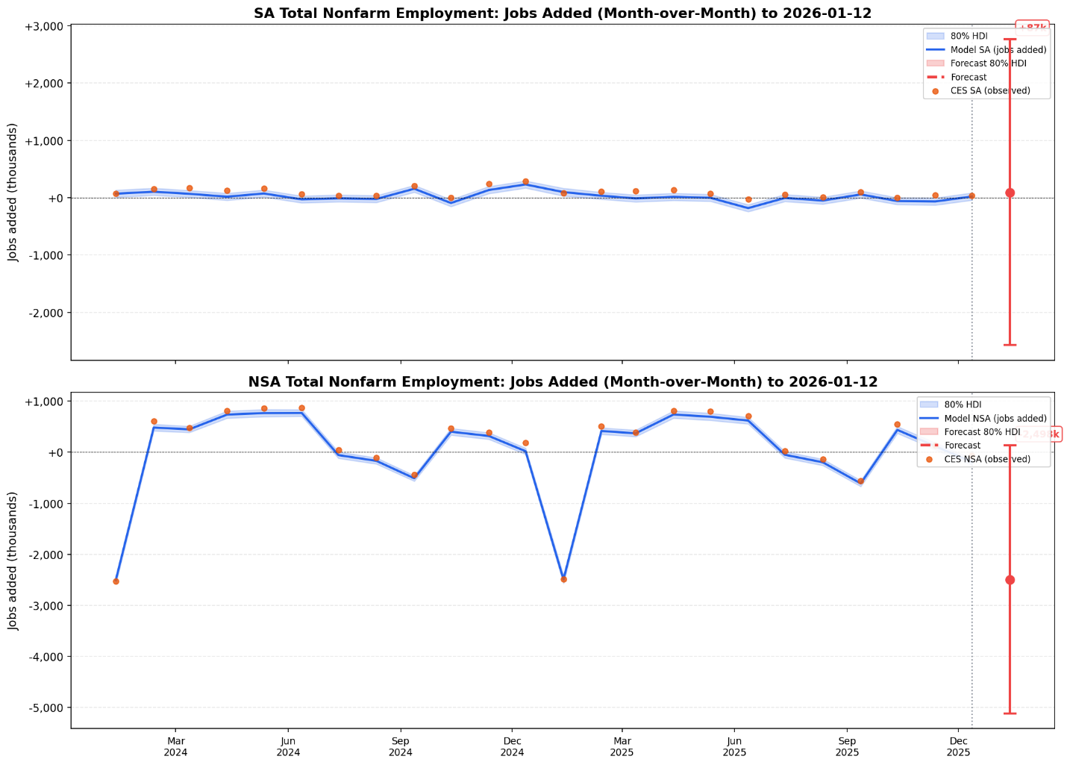

SA and NSA Total Employment Index Forecast
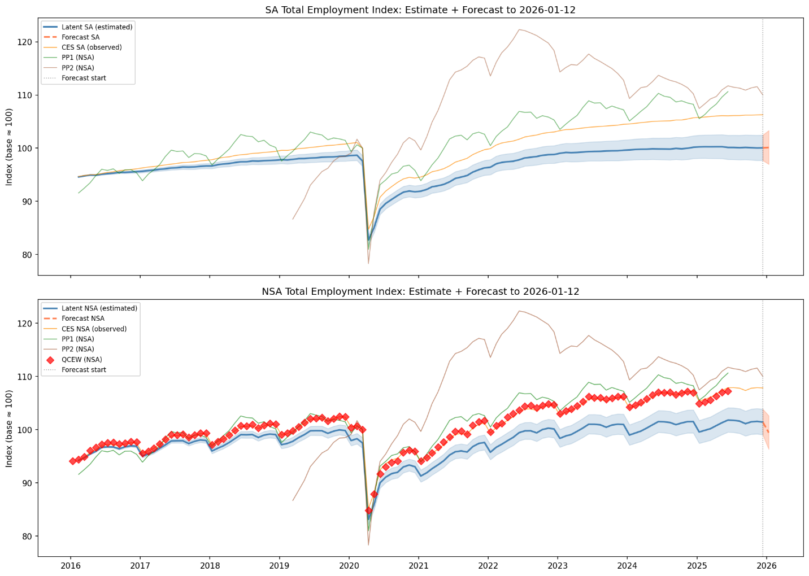

Seasonal Patterns
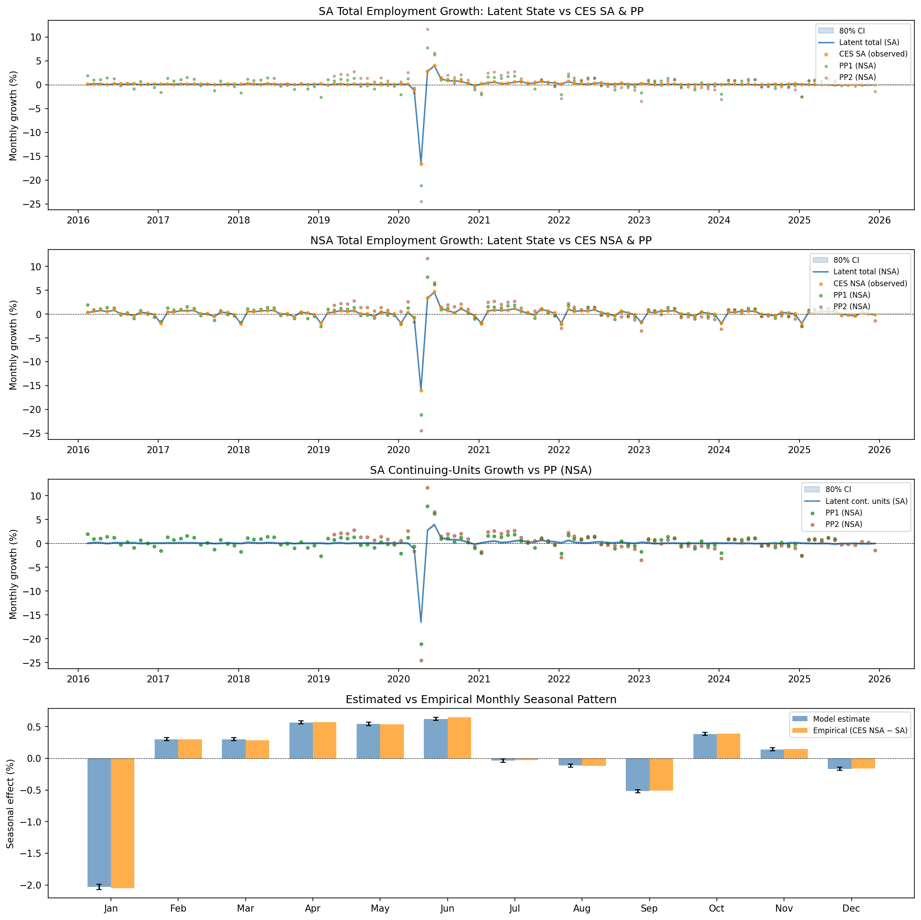

Reconstructed Index
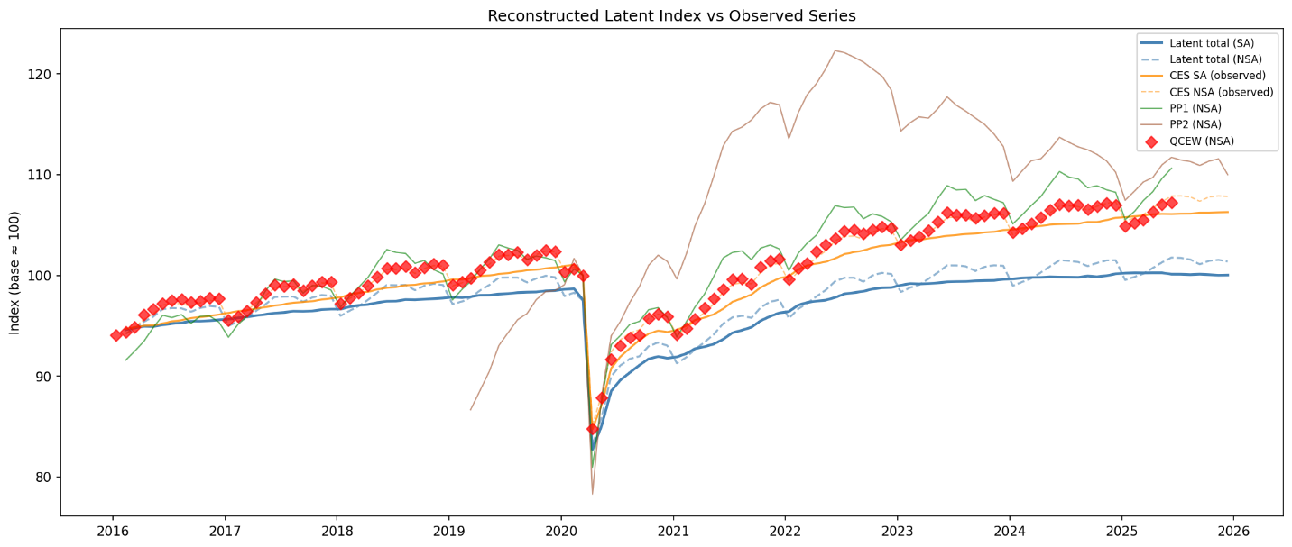

The PP1 series are provided under special circumstances and are not available for more current periods. The payroll provider microdata is expected to arrive shortly, however, in which case the series will be estimated for current periods.
In general, payroll provider series are timelier than official statistics and would have one additional period at the end of the series. This is the period for which SA and NSA NFP are to be forecast. For this exercise, that data is unavailable for PP2. Hence, this document will need to be updated when it arrives.

