Bayesian State Space Nowcasting of U.S. Employment Growth
A QCEW-Anchored Model with Payroll Provider Data

Executive Summary
We develop a Bayesian state space model that extracts a latent national employment growth signal from four data sources: the near-census QCEW (truth anchor), CES survey data (seasonally adjusted and not seasonally adjusted), and two independent payroll provider (PP) continuing-units series. The model operates entirely in monthly log growth rates over 119 months (February 2016 – December 2025).
Key findings: (1) CES systematically overstates private employment growth by ~0.4%/year relative to QCEW, consistent with well-documented negative benchmark revisions. (2) Employment growth shocks are nearly transitory (ρ = 0.07), not persistent as in random walk specifications. (3) Payroll provider data amplify the latent signal (loadings > 1) due to survivorship bias in continuing-units panels. (4) In a nowcast backtest, the model produces useful employment estimates when CES is unavailable, with mean absolute error of 166k jobs when QCEW and both PP sources are available, rising to 344k with PP2 alone.

1. Results

1.1 Sampling Diagnostics
The model was estimated with 8,000 draws per chain (6,000 tuning), 4 chains, target acceptance 0.97, using the nutpie sampler. It achieved zero divergences with all R-hat values ≤ 1.01. The lowest ESS (315, for ρ) is near the 400 threshold; median ESS is ~9,000. Runtime is ~2 minutes on Apple M4 Max.

1.2 Latent Employment Dynamics
Parameter | Posterior mean | 80% HDI | Interpretation
μ | +0.001%/mo | [−0.2%, +0.3%] | Long-run continuing-units growth near zero
ρ | 0.070 | [0.00, 0.11] | Minimal persistence; shocks dissipate quickly
ση | 1.6%/mo | [1.5%, 1.7%] | Monthly innovation volatility
The near-zero μ implies that all trend employment growth comes from the birth/death offset—the continuing-units population is approximately constant, with net growth driven by business formation. The low ρ (0.07) indicates employment growth shocks are nearly transitory, a departure from random walk specifications common in the literature. The birth/death offset itself is statistically indistinguishable from zero (mean +0.014%/mo, 80% HDI [−0.18%, +0.20%]), reflecting genuine identification difficulty between total and continuing-units growth concepts.

1.3 CES Calibration
Parameter | Estimate | Interpretation
α_CES | +0.034%/mo | CES overstates growth by ~0.4%/year vs QCEW
β_CES | 0.986 [0.98, 1.00] | Near-unit loading; slight attenuation
σ_CES_SA | 0.085%/mo | CES SA measurement noise
σ_CES_NSA | 0.093%/mo | CES NSA measurement noise
CES systematically overstates private employment growth by approximately 0.4% per year relative to the QCEW census, compounding to ~4% over a decade. This is consistent with the well-documented pattern of negative CES-to-QCEW benchmark revisions and may reflect assumptions in the CES birth/death model or declining survey response rates. The near-unit β indicates CES faithfully maps the magnitude of growth fluctuations—the systematic error is primarily a level drift (bias), not a slope problem.

1.4 Payroll Provider Parameters
Parameter | PP1 | PP2
α (%/mo) | +0.087 | +0.224
β | 1.35 [1.31, 1.38] | 1.53 [1.45, 1.60]
σ (%/mo) | 0.5 | 1.1
ρ_AR1 | 0.29 [0.17, 0.42] | —
σ_marginal (%/mo) | 0.54 | —
Both PP series amplify the latent signal (loadings > 1), reflecting survivorship bias: when weak establishments exit the continuing-units panel, the remaining sample’s growth rate exceeds the population average. PP2 shows higher amplification (1.53 vs 1.35), consistent with its smaller client base experiencing more turnover. PP1’s AR(1) autocorrelation (ρ = 0.29) confirms persistent measurement artifacts from multi-establishment client structures.

1.5 Precision Budget
Source | Obs | Prec/obs | Total prec | Share
CES SA | 119 | 1,345k | 160M | 32.8%
CES NSA | 119 | 1,126k | 134M | 27.5%
PP1 | 113 | 62k | 7M | 1.4%
PP2 | 82 | 19k | 2M | 0.3%
QCEW (M3) | 38 | 4,000k | 152M | 31.1%
QCEW (M1–2) | 75 | 444k | 33M | 6.8%
Total |  |  | 488M | 100%
CES contributes 60.3% and QCEW 37.9% of total precision at the national level. PP contributes just 1.7% combined. This balance will invert at state × supersector: CES noise scales as 1/√n, and at typical subnational cells CES measurement noise could be 0.5–2%, reducing per-observation precision by 30–500× and making QCEW the dominant information source.

1.6 Seasonal Pattern
The estimated seasonal is consistent with the empirical CES SA–NSA differential: January shows −2.0% (post-holiday layoffs), June +0.8% (summer hiring), and September–October −0.8% (seasonal transitions). The seasonal is well-identified from simultaneous CES SA and NSA data, crosschecked against monthly QCEW.
Figure 1. Estimated Seasonal Pattern

1.7 Reconstructed Employment Index
Figure 2. Reconstructed Employment Index vs. Observed Series

2. Forecasting and Nowcasting

2.1 Forecast Method and January 2026 Forecast
Forecasts are generated by simulating the AR(1) forward from the last posterior state. The primary output is jobs added (month-over-month change in thousands, SA and NSA). The wide intervals reflect 1.6%/mo innovation uncertainty; the strongly negative NSA forecast is driven by the January seasonal (−2%).
Metric | SA | NSA
Jobs added (mean) | +122k | −2,572k
Jobs added (80% HDI) | [−2,641k, +2,905k] | [−5,291k, +162k]
Monthly growth (mean) | +0.079% | −1.990%
Figure 3. NFP Jobs Added Forecast
Figure 4. SA and NSA Total Employment Index Forecast

2.2 Nowcasting Window
During the historical period, CES dominates (60% of precision) with QCEW providing 38%. In the nowcasting window—after PP data arrives but before CES is published—PP becomes the sole monthly signal. PP observes NSA continuing-units growth; converting to an NFP-comparable estimate requires seasonal adjustment and birth/death offset. The operational workflow requires no code changes: append new PP rows, re-run the model, and the observation masks handle missing CES/QCEW data automatically.

2.3 Nowcast Backtest
To quantify PP’s operational value, CES was censored from each of the last 12 months and the model was re-estimated using only available sources. Results:
Setting | n | MAE jobs added (k) | MAE growth (pp)
Overall | 12 | 255 | 0.198
Data-rich (QCEW+PP1+PP2) | 6 | 166 | 0.127
PP2-only | 6 | 344 | 0.268
When only PP2 is available, nowcast error roughly doubles (344k vs 166k jobs). This directly quantifies PP’s value in the nowcasting window and supports the claim that PP matters most when CES and QCEW are absent.

3. Model Summary

3.1 Data and Transformation
Source | Type | Coverage | Frequency | Concept
QCEW | Administrative (UI tax) | Near-census (~10M est.) | Monthly | Total private employment (NSA)
CES SA | Survey | ~145,000 est. | Monthly | Total private employment (SA)
CES NSA | Survey | ~145,000 est. | Monthly | Total private employment (NSA)
PP1 | Payroll provider | Small/medium firms | Monthly | Continuing-units employment (NSA)
PP2 | Payroll provider | Small single-est. firms | Monthly | Continuing-units employment (NSA)
All series enter the model as monthly log growth rates. The first observation is dropped by differencing, yielding 119 monthly observations (February 2016 – December 2025). All indices are rebased to 100 at March 12, 2020.

3.2 State Equation
The latent process is seasonally adjusted continuing-units employment growth, modeled as AR(1) with non-centered parameterization for MCMC efficiency. Priors: μ ~ N(0, 0.1%), ρ ~ Beta(2, 5), ση ~ HalfNormal(2%).

3.3 Measurement Equations
Three composite growth signals are constructed from the latent state: (a) NSA continuing-units growth = latent + seasonal (observed by PP1, PP2); (b) SA total employment = latent + birth/death offset (observed by CES SA); (c) NSA total employment = latent + seasonal + birth/death (observed by CES NSA, QCEW).
QCEW (truth anchor): Fixed bias = 0, loading = 1, with month-dependent noise: 0.05%/mo for quarter-end months (derived from current-period tax filings) and 0.15%/mo for months 1–2 (retrospective reporting). These are calibrated, not estimated, to prevent the model from discounting the anchor.
CES (noisy observer): Bias (α), loading (β), and noise (σ) are estimated. SA and NSA share α and β but have separate noise parameters. The model learns how CES relates to truth rather than assuming it.
Payroll providers (independent): Each PP series has provider-specific bias, loading, and noise. No common factor is imposed across providers; cross-provider correlation (~0.97) is fully explained by the shared latent signal. PP1 has AR(1) measurement errors due to multi-establishment client structures; PP2 has iid errors.

3.4 Identification
QCEW observations (α = 0, β = 1) directly anchor NSA total employment growth. Given the QCEW-identified latent state, CES calibration parameters (α, β) are the mean CES residual and CES-vs-latent slope. CES SA + NSA jointly identify the seasonal, crosschecked against QCEW. The birth/death offset is the mean wedge between total growth (QCEW, CES) and continuing-units growth (PP). PP parameters are then identified from PP residuals.

4. Limitations and Planned Extensions
Current limitations:
- Time-invariant birth/death offset cannot capture cyclical variation at turning points.
- Static seasonal does not evolve across years (e.g., pandemic shifts).
- No time-varying provider bias despite potential compositional drift.
- Calibrated QCEW sigmas reflect judgment, not estimation; sensitivity analysis is recommended.
- National level only; no geographic or industry decomposition.
- PP contributes <2% of total precision at the national level; its value is primarily in the nowcasting window and will grow at subnational granularity.
The architecture is designed to scale to state × supersector estimation (~500 cells). What transfers directly: the model equations, QCEW anchoring, CES calibration, PP measurement model, and the observation-mask approach. What requires extension: hierarchical priors (partial pooling), PP disaggregation, cross-cell reconciliation, and computational infrastructure for joint estimation.
Seasonal Patterns
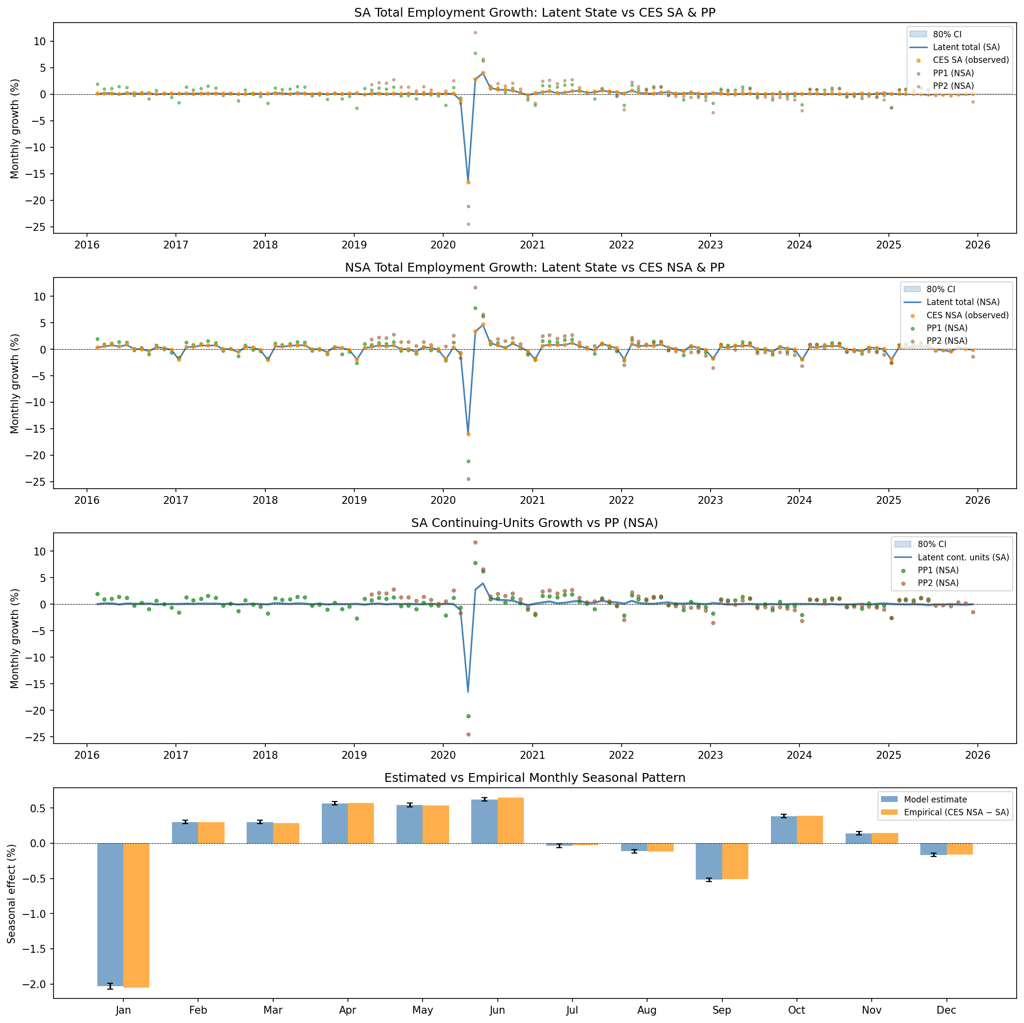
Reconstructed Index
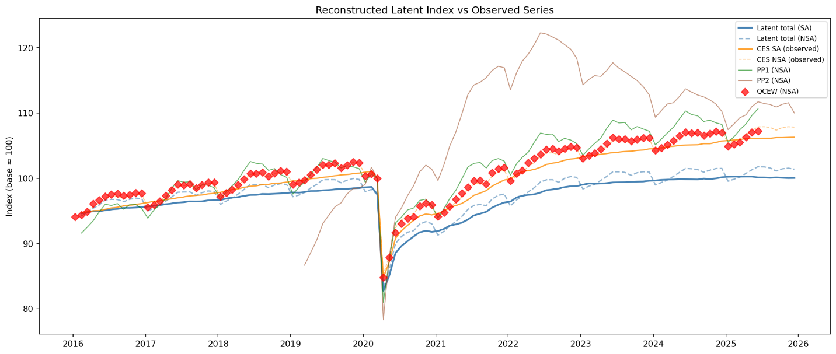
NFP Jobs Added Forecast
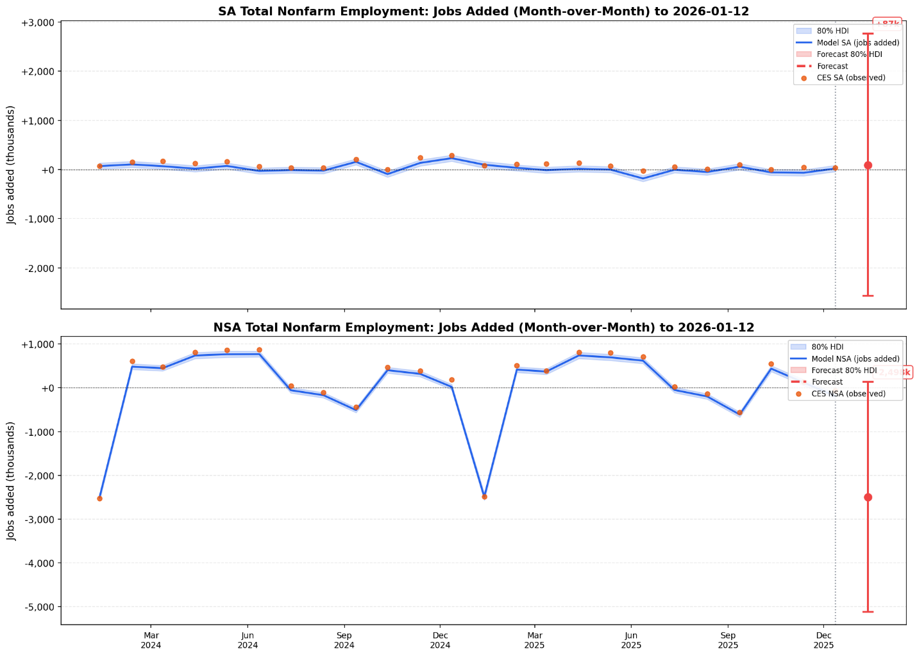
SA and NSA Total Employment Index Forecast
