AS
and A Level
Chemistry
Topic Guide: Instrumental analysis

Introduction
This guide is intended to help support teachers unfamiliar with this specification and to provide some background information on the parts of the topic that are new – both from a teacher’s perspective to ensure clarity of what is expected, and from a student’s perspective when discussing transition from GCSE and addressing misconceptions.

This guide can be used as a reference document for teachers, and parts of it (such as the worked examples) could work as revision material for students.
Included in this guide are:
- some ideas on how to address common misconceptions in both new and previously included content
- possible teaching sequences for key specification points where there is new or challenging content
- worked examples which teachers could use to support students in developing their problem solving skills
- links to external websites which can be used to further students’ understanding.
In each section the relevant specification content is referenced using the numbered points, e.g. §60 means point 60 in the specification.

Principles of spectroscopic analysis
Spectroscopy (§19)
Different forms of spectroscopy are employed as analytical techniques by chemists who wish to investigate the structures of substances on an atomic or molecular level. Spectroscopy involves irradiating a sample with electromagnetic radiation, some of which may be absorbed. A spectrometer is used to measure how much radiation is absorbed at different wavelengths. In some cases, the sample may emit radiation after previously absorbing some, and this may also be detected by a spectrometer. The data collected is plotted in a spectrum that can then be interpreted by the chemist to ascertain structural information about the sample being analysed.
The above paragraph represents a rather simplified view of the situation with regard to spectroscopy. There is a wealth of underpinning theory, much of it in the field of physics, which will be of interest to those with both a thirst for understanding and the skills to grasp the concepts. A very accessible source of information which may be of interest to curious students and teachers alike is this website: http://bit.ly/1CxewnV.
Electromagnetic radiation carries energy, and its absorption leads to a change in the energy state of the state of the sample. For example, absorption of ultraviolet (UV) or visible light (i.e. radiation) leads to electronic transitions, whereby electrons are promoted to higher energy levels. When promoted electrons return to their original energy levels (the ground state), radiation is emitted and therefore it is possible to collect absorption and emission spectra as a result of these effects. Figure 1 below illustrates some of the different types of the electromagnetic radiation in the spectrum, relating them to their properties (relative energies, wavelengths and frequencies) and their effect on a sample when absorbed.
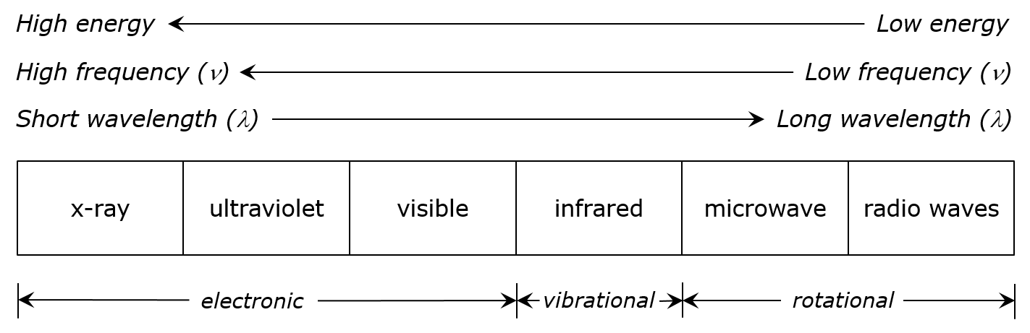
Figure 1: Types of electromagnetic radiation and their effects
Absorption of infrared radiation leads to changes in the vibrational state of a molecule, relating to the stretching and bending of bonds, and this forms the basis of (IR) spectroscopy. Absorption of radio waves, which are at the low energy end of the spectrum, can change the spin state of the nuclei of atoms in a sample; this is the principle which underpins nuclear magnetic resonance (NMR) spectroscopy. For the purposes of this specification, students are required to learn about IR spectroscopy and NMR spectroscopy (¹³C and ¹H). The focus at A level is on the interpretation of spectra, and not on the function and operation of instrumentation. However, teachers may wish to introduce the topic with some of the background theory. The basic principles of this theory are outlined in the appropriate sections.
Mass spectrometry is another analytical technique which is covered in this specification, and is very different from the aforementioned spectroscopic techniques in that electromagnetic radiation is not a feature of its implementation. There are numerous forms of mass spectrometry that work in different ways, but again the emphasis is on the interpretation of spectra rather than the operation of the technique. This topic guide covers the techniques of NMR spectroscopy (¹³C and ¹H), and includes brief descriptions of Time-of-Flight mass spectrometry and gas chromatography.
NMR Spectroscopy
Background
NMR spectroscopy is an analytical technique which has revolutionised the work of chemists since its discovery. NMR allows chemists to rapidly analyse a sample, collecting data that can be interpreted to deduce the structure of a molecule. The value of the technique to organic chemists was first revealed in 1951 when the ¹H NMR spectrum of ethanol was collected (see J. T. Arnold et al. (1951), Journal of Chemical Physics, 19, p.507). As technology has advanced, NMR spectrometers have become a ubiquitous feature of the chemistry research lab, with numerous applications beyond it. Modern NMR spectrometers, coupled with powerful computers and the brain power of a researcher, can be used to elucidate the structures of very large molecules, including proteins made up of >200 amino acid units (http://1.usa.gov/16Y5Mug). NMR spectra encountered at
A level tend to relate to smaller, simpler structures.
The two most commonly employed forms of NMR spectroscopy are ¹H NMR, often referred to as proton NMR, and ¹³C NMR, which is also known as carbon NMR. The pre-eminence of proton and carbon NMR reflects the fact that NMR spectroscopy is now a cornerstone of the analysis of organic compounds, and this is where the focus lies at A-level. A range of other nuclei are also NMR active, including ³¹P (phosphorus) and ¹⁹F (fluorine), and the technique has found use in inorganic and materials chemistry, forensics and also in medicine, where the same technology is at the heart of the MRI scanner. Such devices, which allow the non-invasive inspection of the inner workings of the human body, have helped doctors to locate tumours and other abnormalities since their first use at the University of Aberdeen in 1980 (http://bit.ly/1KwZ5xq).
The origin of NMR spectra
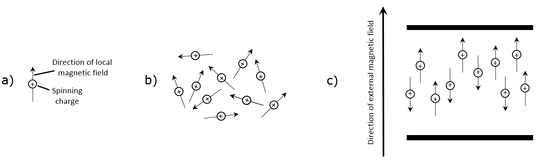
Atomic nuclei which have either an odd mass or odd atomic number (e.g. ¹H and ¹³C) can be considered to have a nuclear spin. A spinning charge has an associated magnetic field, so such nuclei can be thought of as mini bar magnets, as shown in Figure 2 a). In a given sample, the nuclear spins are oriented randomly, as are the local magnetic fields around the nuclei, as illustrated in Figure 2 b). When the sample is placed in a magnetic field, as in Figure 2 c), the nuclear spins can adopt one of two orientations, one where the local magnetic field is aligned with the external field, and one where the local magnetic field is aligned against the external field. These spin states are commonly referred to as +½ and –½ respectively.

Figure 2: Nuclear spin and magnetism
The +½ spin state is slightly lower in energy than the –½ spin state, and the difference in energy varies with the strength of the external magnetic field (B) as illustrated in Figure 3 a). In a sample which is under the influence of an external magnetic field, there will be slightly more nuclei in the +½ state than in the –½ state, as indicated in Figure 3 b). When the sample is irradiated with radio waves of the correct frequency, some of the nuclei in the lower energy +½ state absorb the radiation and flip their orientation such that they are now in the higher energy –½ state, as shown in Figure 3 c).
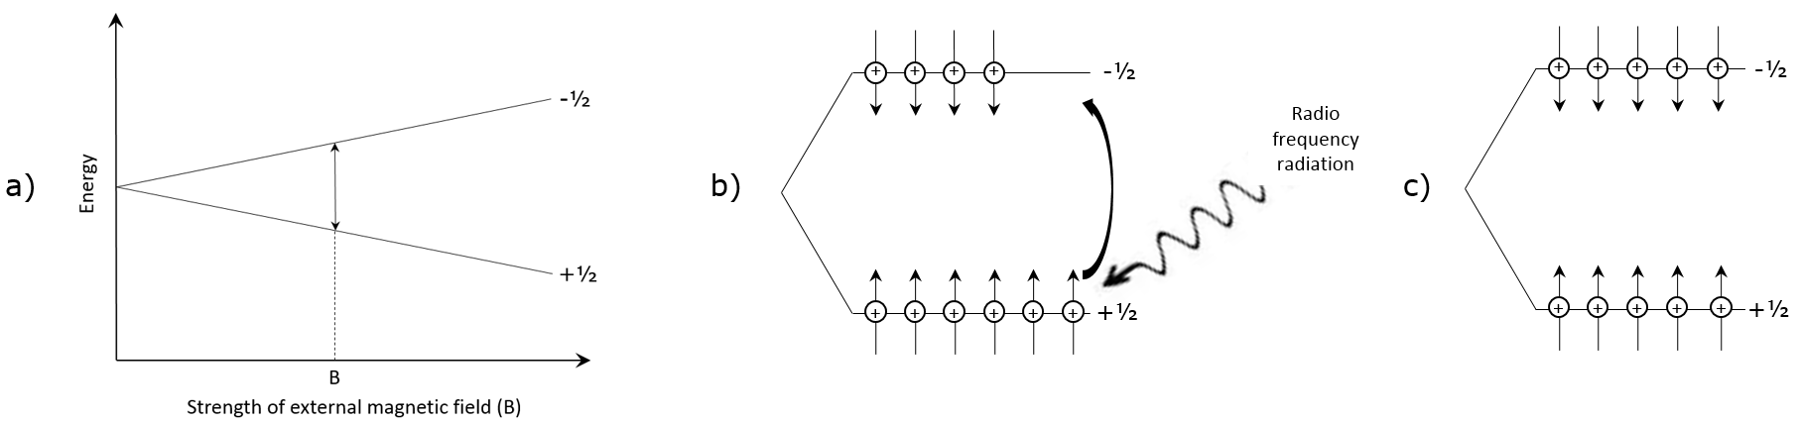

Figure 3: External magnetic field, spin states and absorption of RF radiation

In a given molecule, the nuclei of the atoms in different parts of the molecule experience local magnetic fields arising from the presence of electrons around them. The electrons, which themselves can be thought of as spinning charges, generate a magnetic field that effectively shields the nuclei from the external field. The presence of electron withdrawing groups e.g. electronegative halogen atoms leads to nearby nuclei becoming ‘deshielded’, meaning that they are more susceptible to the external field, and leads to an increase in the difference in energy between +½ and –½ spin states. The variation in the local magnetic field experienced by nuclei in different environments in a molecule results in them absorbing radiation of slightly different frequencies. This is the origin of NMR spectroscopy whereby nuclei in different environments in a molecule generate signals in slightly different positions in an NMR spectrum.
Teaching ¹³C NMR spectroscopy
¹³C NMR spectra are simpler than ¹H NMR spectra and perhaps easier to relate to a molecule’s structure, therefore it makes sense to teach the former first. A key skill that students need to grasp is the ability to identify the number of unique carbon environments there are in a given molecule. In particular, students need to recognise that molecules with symmetry have fewer unique carbon (and indeed proton) environments than comparable unsymmetrical molecules, meaning there are fewer signals in the NMR spectra of such compounds. Two possible teaching strategies for introducing the idea of carbon environments alongside ¹³C NMR are outlined below, with some suggested structures and associated spectra provided on subsequent pages.

Possible teaching strategies
Approach 1: Draw the four structures on the board and ask students to identify how many unique carbon environments are present in each one. Now issue the four ¹³C NMR spectra (spectra C1–C4) and ask students to discuss which spectrum matches which structure.
Approach 2: As per Approach 1, but instead only issue one of the ¹³C NMR spectra and talk through the assignment of the spectrum. Students then apply their learning to assign the remaining three spectra.
Approach 3: More adventurous students could simply be issued with all four ¹³C NMR spectra, with the possible structures drawn on the board in a random order. Ask students to discuss which spectrum matches which structure.
Molecular models or 3D images (e.g. Jmol) are very useful in helping students to identify carbon atoms in identical environments in molecules.

Chemical shift
Once students have become comfortable with the idea of identifying and assigning unique carbon environments within molecules, and the fact that each of these leads to a signal in a ¹³C NMR spectrum, the idea of chemical shift (δ) can be introduced. The Edexcel data book contains the chart shown in Figure 4 below, from which students are expected to work during exams.
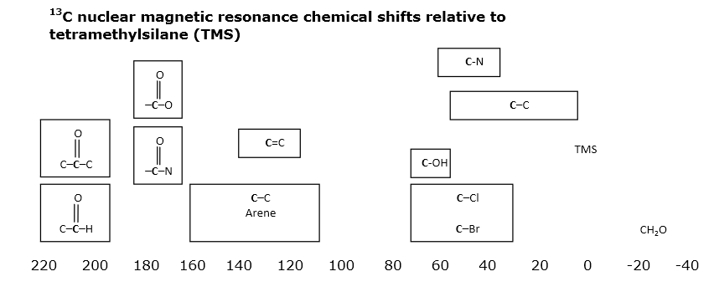
Figure 4: Chemical shift chart for ¹³C NMR spectra

The compound tetramethylsilane (TMS) is added as a reference (assigned chemical shift = 0 ppm) against which the chemical shift values of all other signals are measured. As discussed in the previous section, neighbouring atoms and groups affect the local magnetic field around the nucleus of a particular atom, which can have a significant effect on the chemical shift of the signal arising from that atom. Electronegative groups, which attract electrons away from a carbon centre and expose the nucleus more to the external magnetic, have the effect of deshielding the nucleus and lead to higher chemical shift values. The presence of pi-bonds also has a deshielding effect on the nuclei, resulting in very high chemical shift values. The NMR signals arising from different atoms in a molecule have chemical shift values that are diagnostic of the functional groups present.

Chemical shift values are measured in ‘parts per million’, or ppm, which is difficult to explain to students without invoking the background theory outlined previously. It is perfectly legitimate to proceed without explaining the origin of chemical shift, but teachers may prefer to share this with students even though it is not examinable at
A level. The ¹³C NMR spectrum of bromothane (Figure 5) can be used to illustrate the principle. The spectrum was taken on an instrument operating at a frequency of
25.16 MHz (for ¹³C NMR). Both peaks can be seen at chemical shift values greater than TMS. The instrument measures the difference between the peaks in Hz, and this is converted into ppm according to the equation:
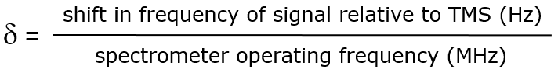

The ¹³C nuclei in the CH₃ and the CH₂Br groups in bromoethane absorb radiation with frequencies 485 Hz and 698 Hz higher than the ¹³C nuclei in TMS respectively when the spectrum is run at 25 MHz. The chemical shift values of the two peaks are calculated as shown below:

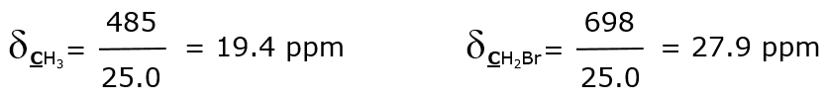

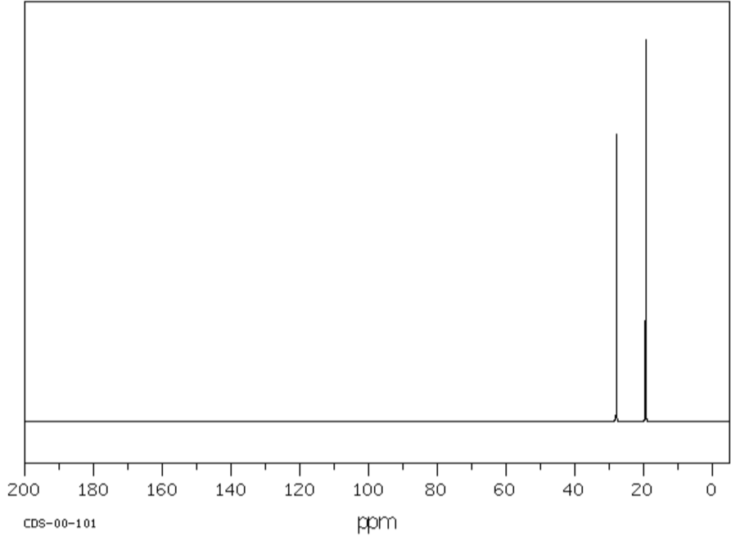
Figure 5: ¹³C NMR spectrum of bromoethane (CH₃CH₂Br)

NMR spectrometers may have magnets of different strengths, and operate at different frequencies. For example, many of the instruments commonly used today operate at 75 or 100 MHz for ¹³C NMR. At 100 MHz, the signal corresponding to the CH₃ group in bromoethane would be shifted 1940 Hz higher than those in TMS, but the signal would still be reported to have a chemical shift of 19.4 ppm. Hence chemical shift values are independent of the magnetic field strength and operating frequency of the spectrometer.

Possible teaching strategy
Draw the structure of 3-hydroxy-3-methylbutan-2-one on the board and ask students to predict a) the number of signals that will be present in its ¹³C NMR spectrum and b) the approximate chemical shift values of the signals. Students can then be issued with the spectrum (C5), which they can annotate to show their assignment of the different peaks. Spectrum C6 (2-methylphenol) can be used the same way.

Important points to note
Neither the heights of peaks nor the areas under them are significant in ¹¹³C NMR spectroscopy i.e. if there are two carbon atoms in a particular environment, they do not necessarily give rise to a peak which is twice the height (or area) of peak corresponding to a single carbon atom. This is a common misconception given the importance of integrals in ¹H NMR spectra.
¹³C NMR spectra are normally taken of compounds dissolved in a solvent, which in most cases contains carbon atoms itself. As such, many of the real spectra that can be found on the web contain solvent peaks that, at first glance, can cause students difficulties.
Teaching ¹H NMR spectroscopy
The theoretical basis of ¹H NMR is much the same as that which underpins ¹³C NMR. Students will need to be adept at identifying how many unique proton environments there are in a given molecule, and this is a good place to start when teaching the topic. In the case of ¹H NMR spectra, there is more information to he gleaned from NMR spectra, notably the relative areas under the peaks (integrals), which relate to the number of protons in each unique environment, and also the multiplicities (or splitting patterns) of the peaks, which are caused by the influence of the spin states of nearby protons on the local magnetic field.
As with ¹³C NMR, protons in different environments within a molecule experience different local magnetic fields as a result of shielding effects. The resulting chemical shifts provide information about the proximity of different functional groups relative to the nuclei associated with a particular peak. Figure 6 below is taken from the Edexcel data book, and illustrates the typical chemical shift ranges for different proton environments.
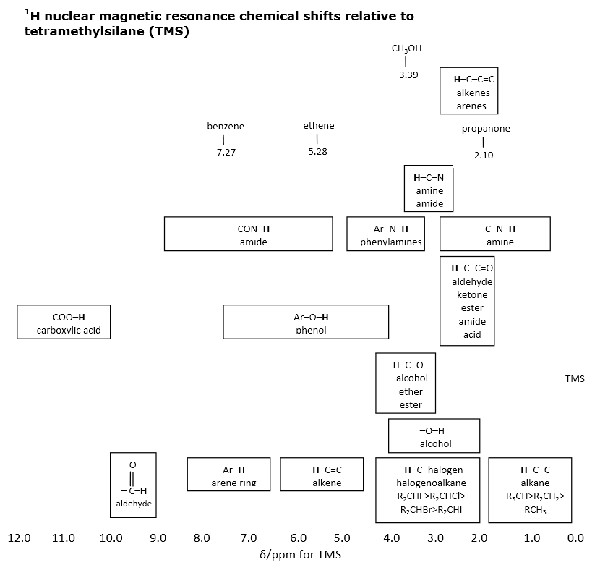
Figure 6: Chemical shifts in ¹H NMR spectra

Possible teaching strategy
Ask students to identify how many proton environments there are in
propan-1-ol, and hence the number of ¹H NMR signals. Then ask them to predict roughly the chemical shift of each signal, with reference to the data book. The spectrum (Figure 7) could then be issued to the students in order to introduce the ideas of relative peak areas (integrals) and splitting patterns (multiplicity).

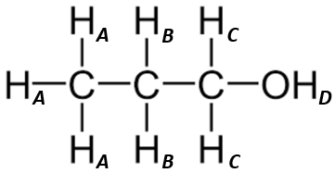
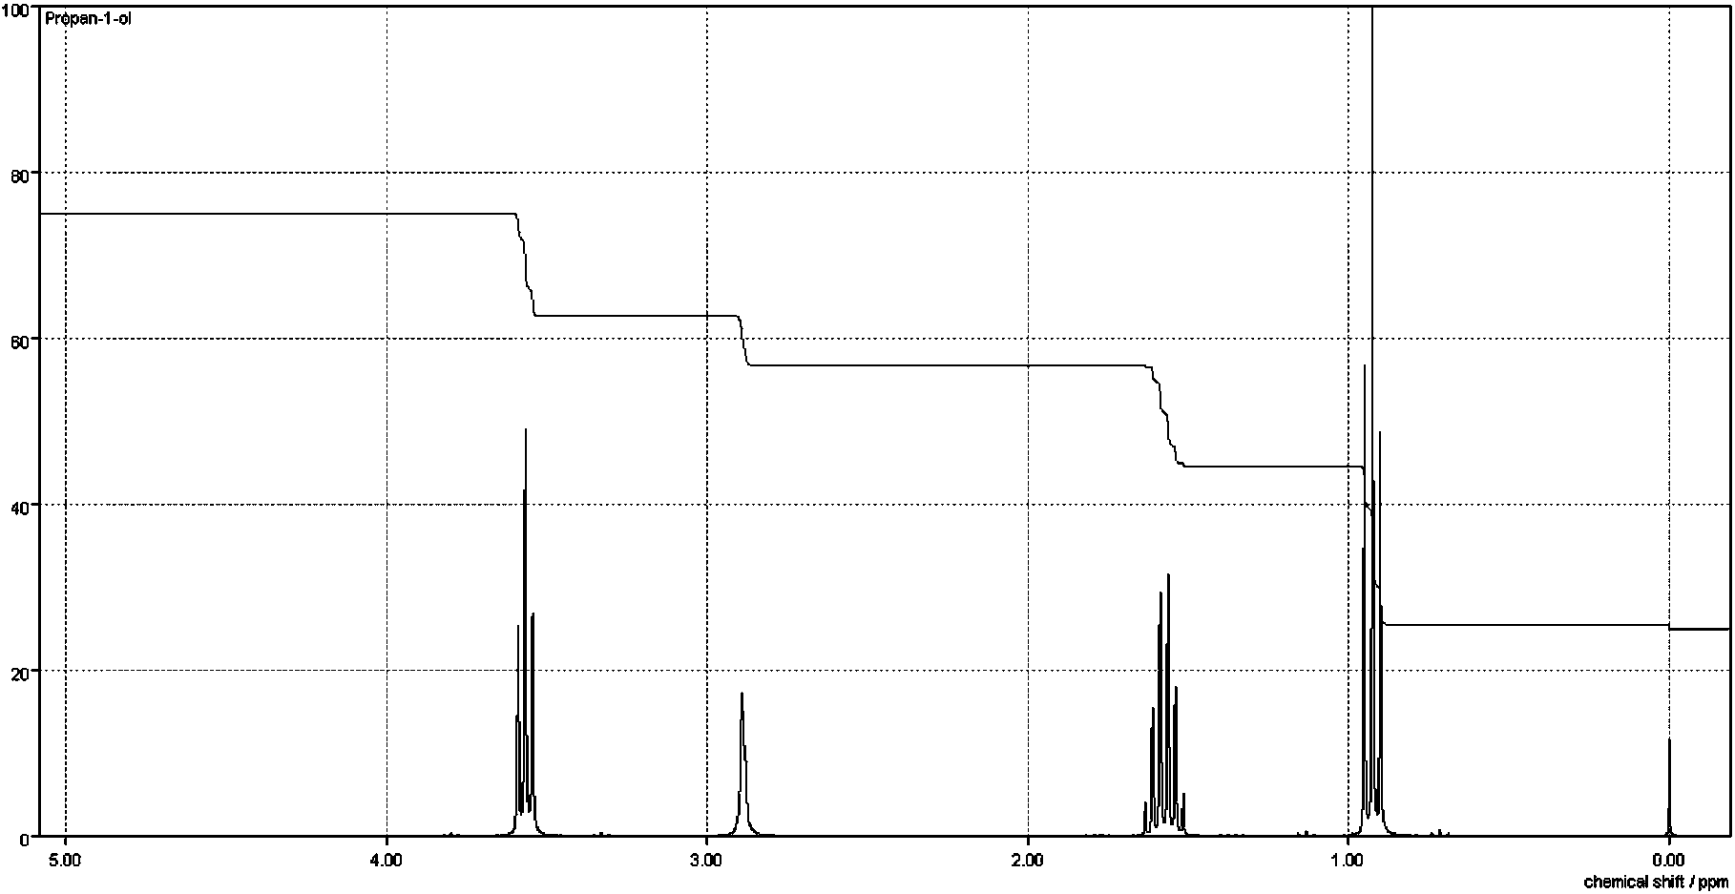
1H
2H
2H
3H
triplet
sextet
singlet
triplet
Figure 7: ¹H NMR spectrum of propan-1-ol

The ¹H NMR spectrum of propan-1-ol (Figure 7) has the relative integrals (peak areas) marked on it, clearly showing the 1:2:2:3 ratio that would be expected based on the numbers of protons in each environment in the molecule. The multiplicities (splitting patterns) of the peaks are also marked on the spectrum, and are discussed in more detail below. For reference purposes, the spectral data for propan-1-ol is presented in table form below (Table 1).

Chemical shift (δ) | Relative integral | Multiplicity | Proton/Group
0.94 | 3 | triplet (t) | H_{A}
1.57 | 2 | sextet (sex) | H_{B}
2.85 | 1 | singlet (s) | H_{D}
3.58 | 2 | triplet (t) | H_{C}
Table 1: ¹H NMR data for propan-1-ol

The multiplicities of the peaks are due to the magnetic effects of nearby proton nuclei within the molecule. At A-level, consideration of this effect is limited to the effect of protons on adjacent carbon atoms, although nuclei which are more distant within a molecule exert a magnetic effect which is detectable using modern high resolution NMR spectrometers. For the purposes of teaching, it is quite acceptable simply to invoke the ‘n+1’ rule, which states that the signal corresponding to protons in a given environment which have n protons on a neighbouring carbon atom will be split into n+1 peaks. This is illustrated clearly in the spectrum of propan-1-ol above.
The signal corresponding to the CH₃ protons (H_{A}) is split into three peaks (known as a triplet, or t) due to the effect of the two protons on the adjacent carbon atom (H_{B}). For example, n = 2, therefore the signal is split into 2 + 1 = 3 peaks. Similarly, the signal corresponding to the two protons on the carbon adjacent to the oxygen atom is a triplet because of the effect of the two protons on the adjacent carbon atom (H_{B} again). The signal corresponding to the two H_{B} protons is interesting in that it is split by all five protons on the two adjacent carbon atoms i.e. H_{A} and H_{C}. As predicted by the n+1 rule, this signal is split into 5 + 1 = 6 peaks i.e. a sextet.
Interestingly, the signal corresponding to H_{D} (OH) is not split into a triplet by the two protons on the adjacent carbon atom (H_{C}), nor are the H_{C} protons split by the OH proton (H_{D}). This is because protons on OH groups in alcohols, phenols and also carboxylic acids are ‘labile’, meaning they are readily exchanged between different molecules on the NMR timescale. This results in an averaging of the signal and the loss of any splitting effects. It is possible to observe such splitting if the NMR spectrum is run at lower temperatures, resulting in a slowing of the rate of proton exchange on the NMR timescale. However, in spectra that students will encounter at A level, signals corresponding to OH groups (and NH/NH₂ groups) will not be split by protons on adjacent carbon atoms and will always appear as singlets.
The theory which explains splitting patterns is not examinable at A level, but is quite straightforward and also helps to explain the intensities of each of the peaks in the splitting pattern. If students have been introduced to the other aspects of NMR theory, there is no reason why they should not be taught about the origins of peak splitting. The basic principle is that the protons on adjacent carbon atoms can either add to the strength of the external magnetic field or they can oppose it, depending on their spin state. Each adjacent proton has its own spin state (either +½ or –½), so increasing numbers of protons mean there are more possible permutations for the distribution of those states, which in turn leads to more complex splitting patterns as the protons in different molecules experience a range of different local magnetic fields. Figure 8 shows the effects of 1, 2 and 3 adjacent protons.
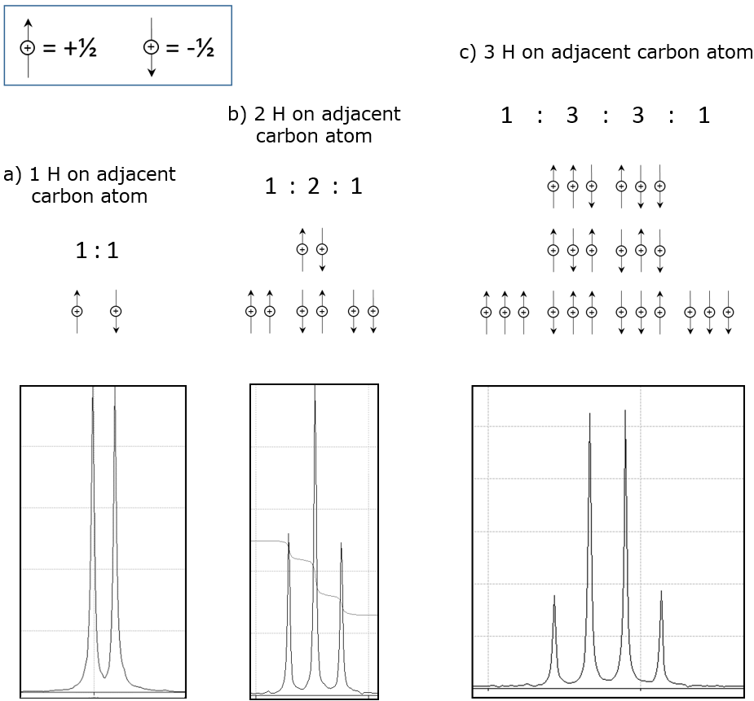
Figure 8: The origins of a) doublets, b) triplets and c) quartets

No. of protons on adjacent C atoms | Multiplicity (splitting pattern) | Relative intensities of peaks
0 | singlet (s) | 1
1 | doublet (d) | 1 : 1
2 | triplet (t) | 1 : 2 : 1
3 | quartet (q) | 1 : 3 : 3 : 1
4 | quintet (quin) | 1 : 4 : 6 : 4 : 1
5 | sextet (sex) | 1 : 5 :10:10: 5 : 1
6 | septet (sept) | 1 : 6 :15:20:15: 6 : 1
Table 2: Splitting patterns and peak intensities for different multiplicities (following the pattern of Pascal’s triangle)

As well as being able to interpret ¹H NMR spectra, students need to be able to predict the chemical shifts and splitting patterns of the signals corresponding to each of the different proton environments in a given molecule. Students may also be given data from a range of analytical techniques and also data relating to chemical tests, with a requirement to combine all of the evidence to solve a complex problem.

Possible teaching strategy
Ask students to draw the structures of the following compounds a) ethanol, b) propan-2-ol, c) pentan-2-one and d) ethyl propanoate. Then ask them to predict for each compound i) the number of signals in the ¹H NMR, ii) the chemical shift of each signal and iii) the multiplicity of each signal. Students could then be issued with spectra H1 – H4 and asked to match the spectra to the compounds.
Time-of-flight mass spectrometry (TOF-MS)
Traditionally, A-level chemistry students have learned about magnetic sector mass spectrometers, which operate via a sequence of steps; namely ionisation, acceleration, deflection and detection. Although such instruments are still in use today, there are many other types of mass spectrometer which are much more commonly deployed. One commonly used type of instrument is the Time-of-Flight (TOF) mass spectrometer, and this is the approach most likely to be encountered at A level. Knowledge of the operation of the mass spectrometer is not required by this specification, but the basic principles are well within the grasp of the A-level chemist. A brief outline is given below, which assumes that the reader is already familiar with the general principles of mass spectrometry.

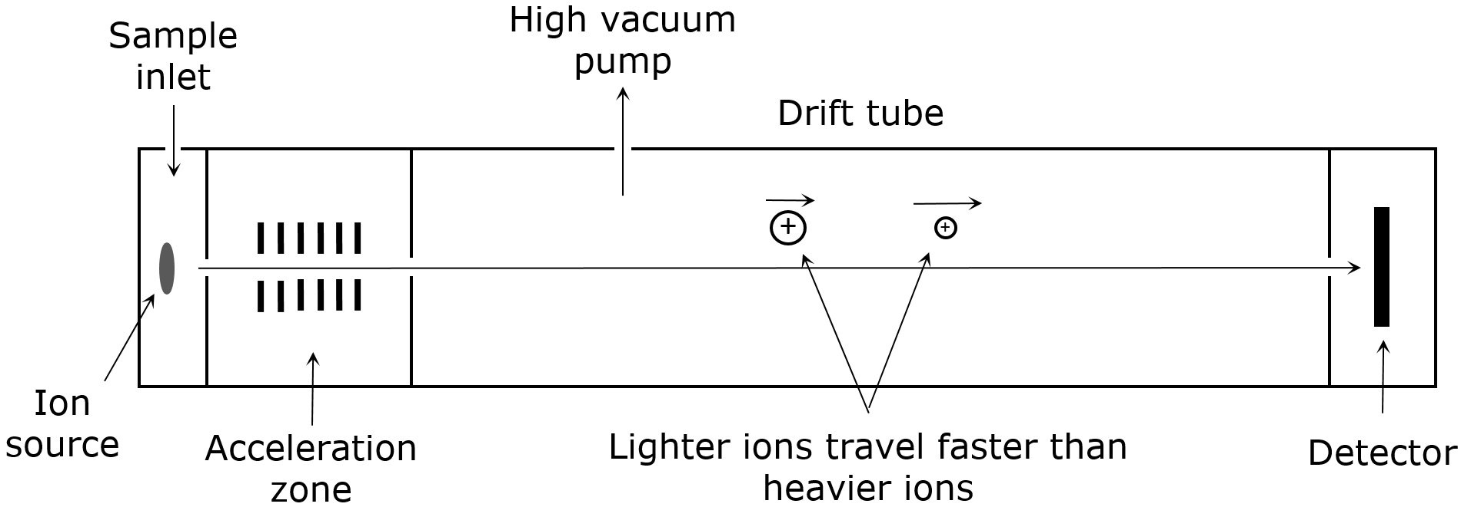

Figure 9: Schematic of a Time-of-Flight mass spectrometer

Ions are commonly generated using a pulsed laser in TOF mass spectrometry, although there are other approaches which can be used. A packet of ions is produced, which is then accelerated by an electric field. Ions of all masses enter the drift tube with the same kinetic energy (½mv²), which means that ions with smaller masses have a higher velocity than ions with larger masses, and therefore reach the detector first. The instrument is able to identify ions with different mass/charge (m/z) ratios by measuring the time taken for them to travel through the drift tube to the detector. The detector effectively ‘counts’ the ions, allowing the generation of the familiar mass spectrum showing ion abundance vs m/z ratio.

Gas chromatography-mass spectrometry (GC-MS)
Mass spectrometry is often used in tandem with gas chromatography (GC), which is a powerful separation technique (see Figure 10) that allows the analysis of complex mixtures. The sample to be analysed is injected into a stream of gas (a carrier gas such as helium), which then enters the GC column. The column has a very small diameter, typically around 0.25 mm, and is usually between 15 and 25 m long. The sample, as it is being carried in the stream of carrier gas, is known as the mobile phase, while the inside of the column is coated or packed with a stationary phase. The different components of the mixture in the sample interact differently with the stationary phase and have different retention times in the column. As such, different components of the mixture emerge from the end of the column at different times, where they can be detected before passing into a mass spectrometer for further analysis. In many cases, a separate detector is not employed, and the mass spectrometer is effectively the detector. GC-MS is commonly employed in the analysis of samples in the laboratory, and has widespread applications in forensics and environmental testing.
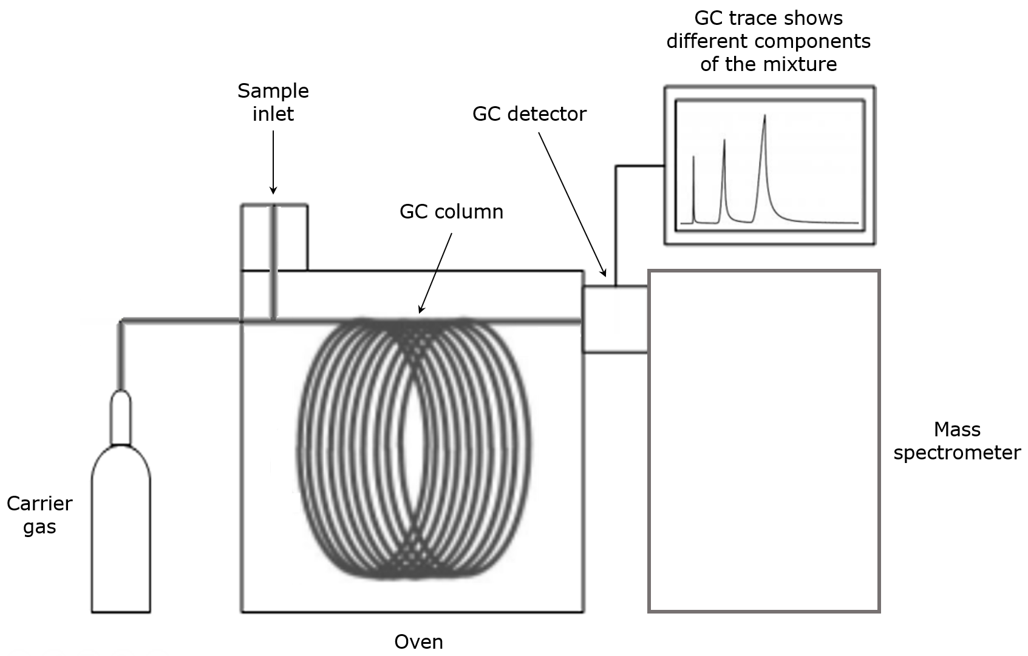

Figure 10: Schematic outlining the stages involved in gas chromatography-mass spectrometry (GC-MS)

¹³C NMR Spectrum of 2,4-dimethylpentane
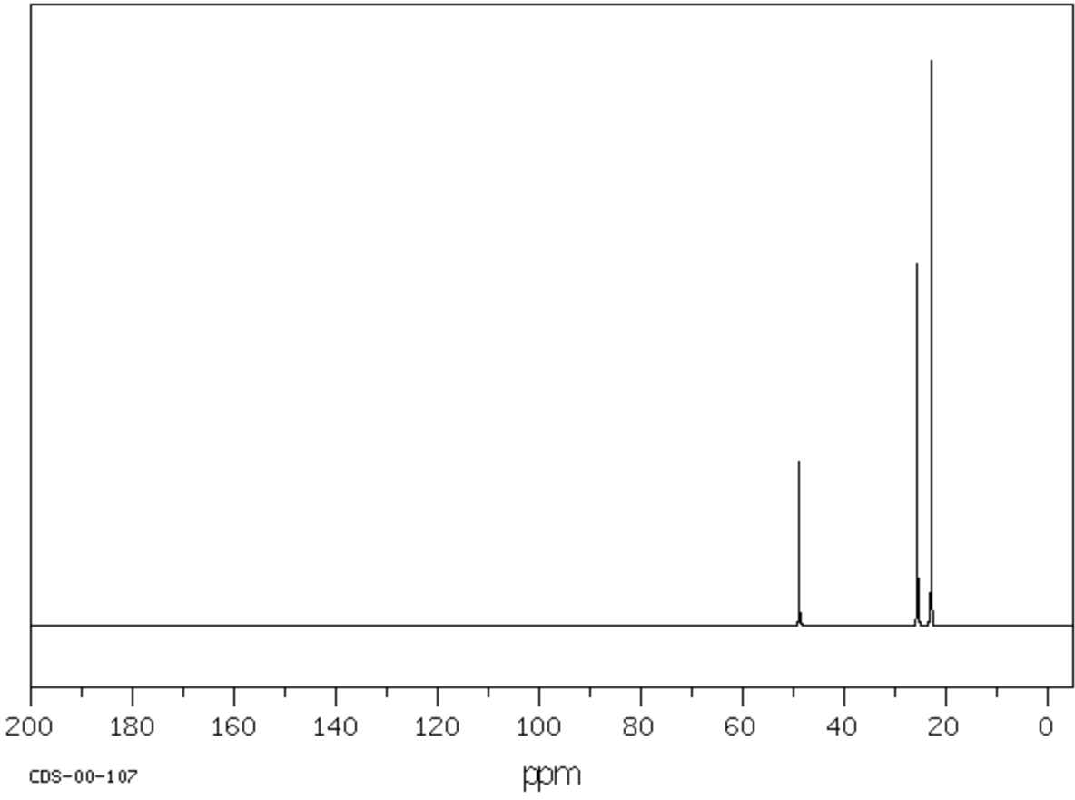
C1

¹³C NMR Spectrum of 2,2-dimethylbutane
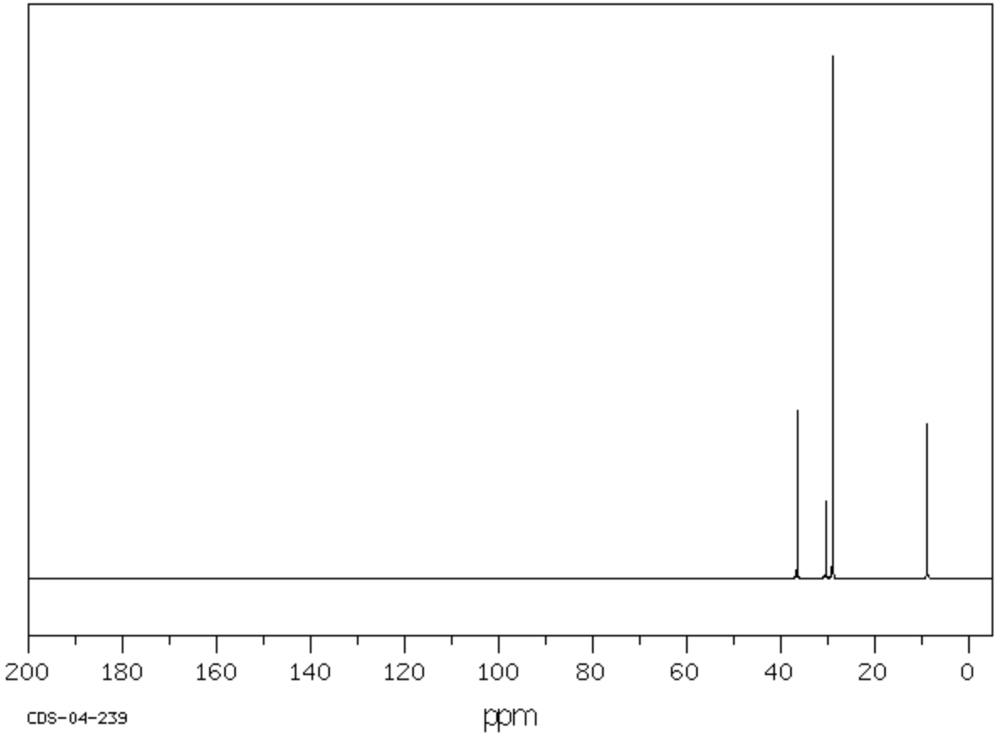
C2
¹³C NMR Spectrum of 2,3-dimethylbutane
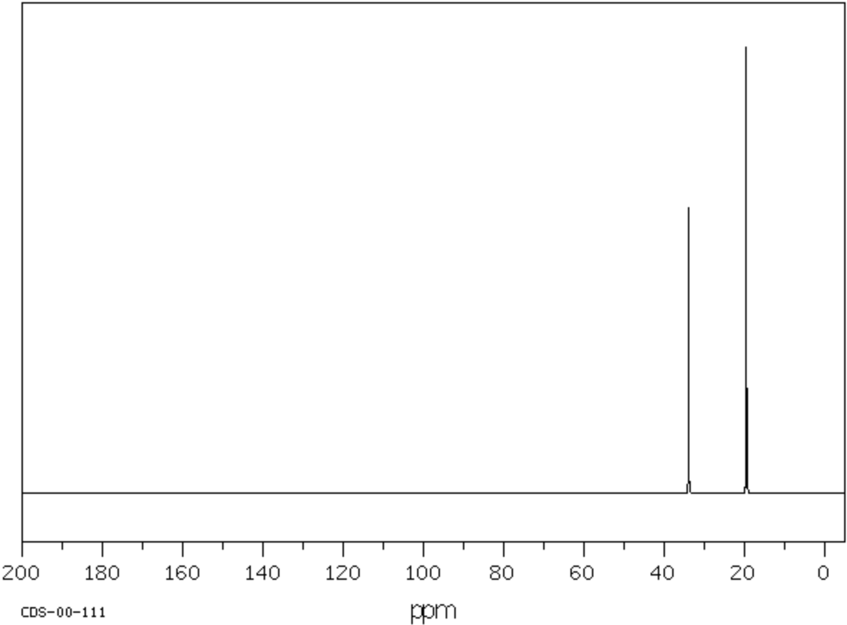
C3

¹³C NMR Spectrum of 5-methylhexan-2-ol
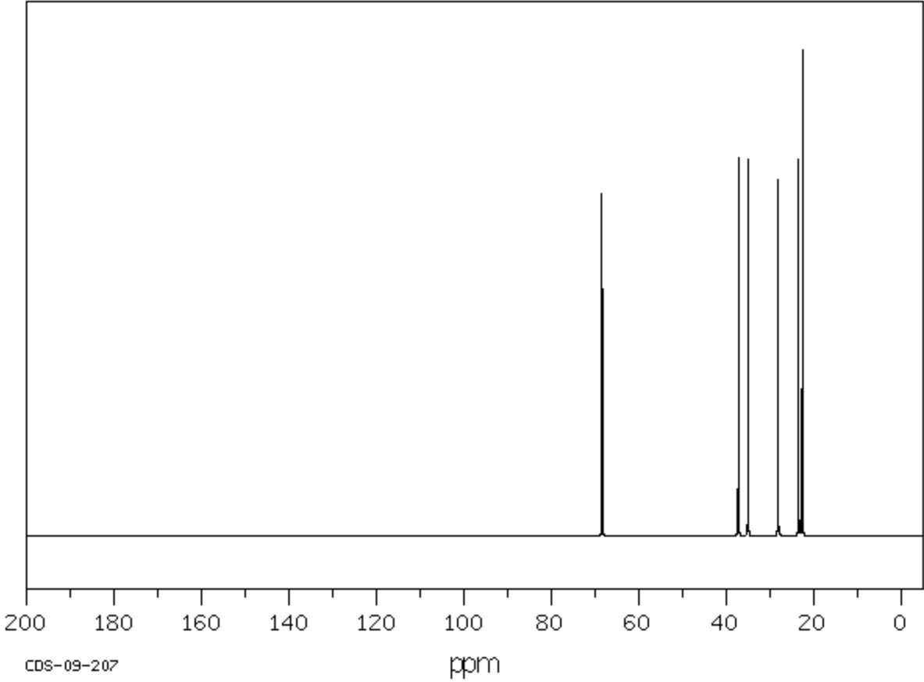
C4
¹³C NMR Spectrum of 3-hydroxy-3-methylbutan-2-one
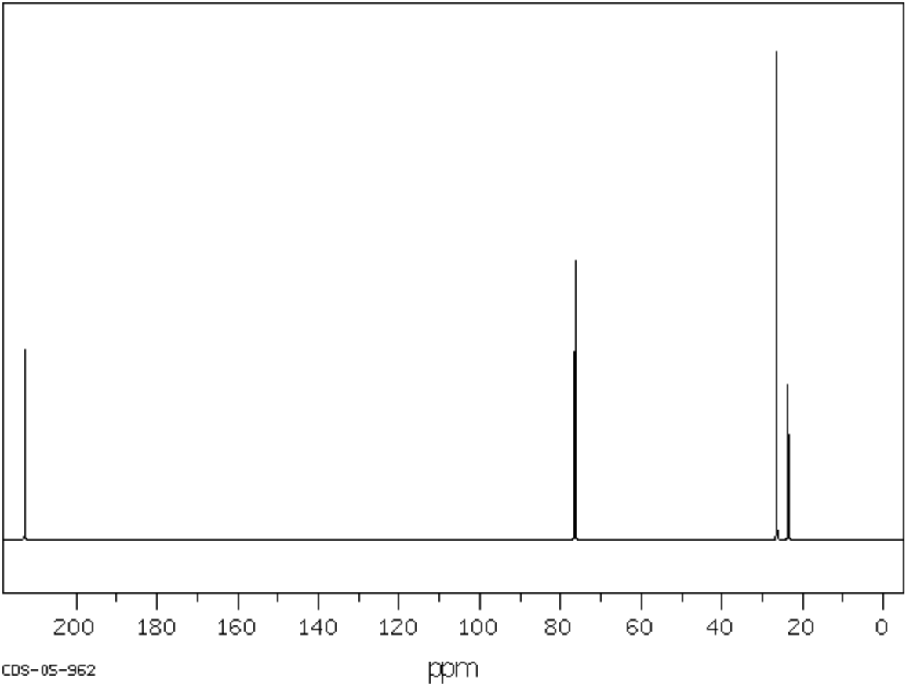
C5
¹³C NMR Spectrum of 2-methylphenol
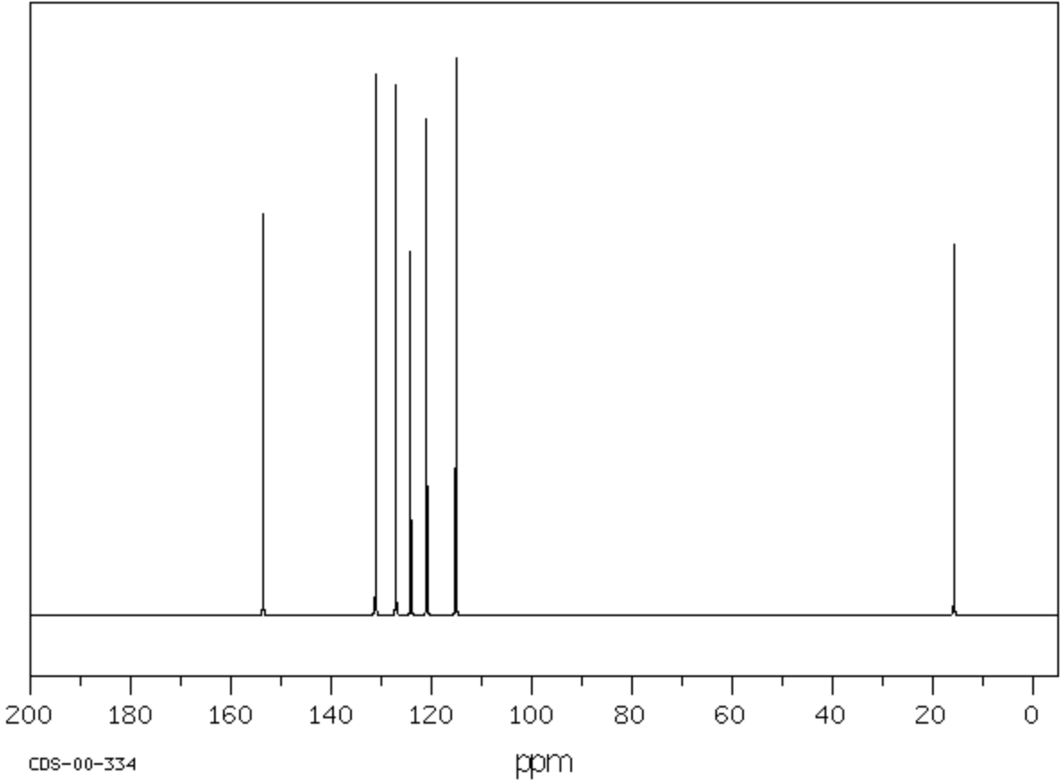
C6

¹³C NMR spectral data for 2,4-dimethylpentane
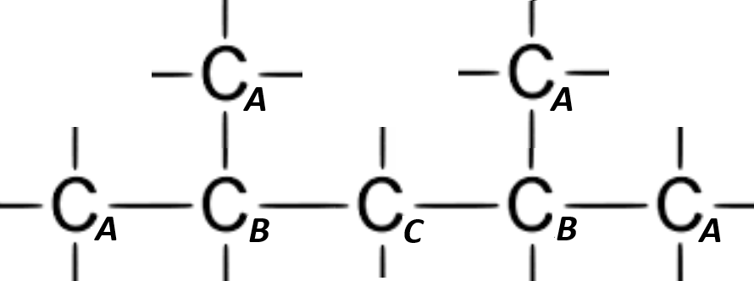
Chemical shift (δ) | Carbon
22.87 | C_{A}
25.60 | C_{B}
48.85 | C_{C}

¹³C NMR spectral data for 2,2-dimethylbutane
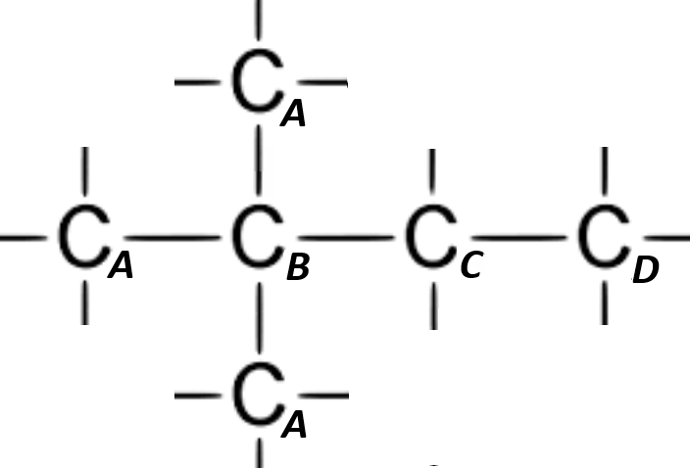
Chemical shift (δ) | Carbon
8.88 | C_{D}
28.96 | C_{A}
30.42 | C_{B}
36.49 | C_{C}

¹³C NMR spectral data for 2,3-dimethylbutane
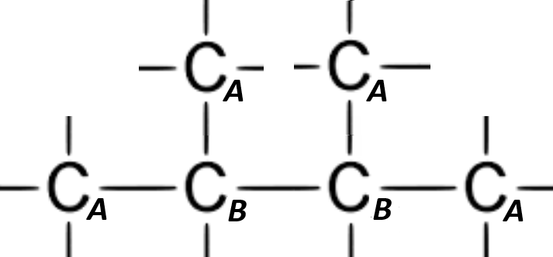
Chemical shift (δ) | Carbon
19.49 | C_{A}
33.89 | C_{B}

¹³C NMR spectral data for 5-methylhexan-2-ol
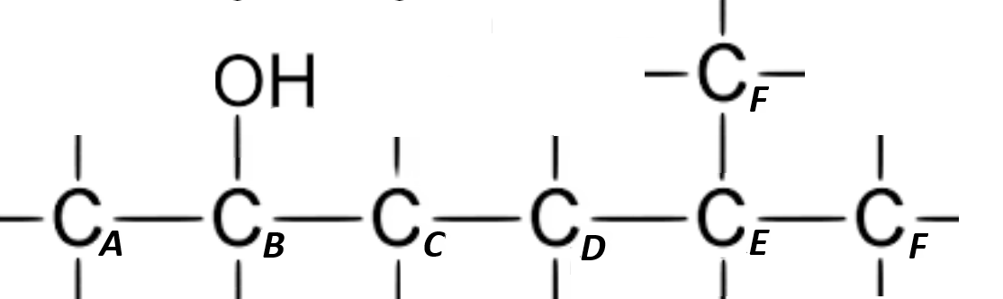

Chemical shift (δ) | Carbon | Chemical shift (δ) | Carbon
22.62 | C_{F} | 35.02 | C_{D}
23.47 | C_{A} | 37.25 | C_{C}
28.17 | C_{E} | 68.41 | C_{B}

¹³C NMR spectral data for 3-hydroxy-3-methylbutan-2-one
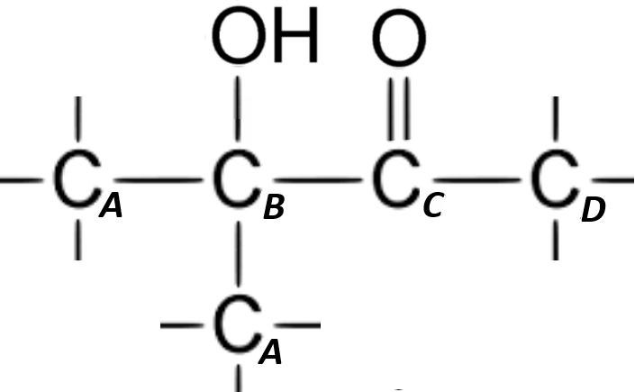
Chemical shift (δ) | Carbon
23.58 | C_{D}
26.42 | C_{A}
76.41 | C_{B}
212.71 | C_{C}

¹³C NMR spectral data for 2-methylphenol
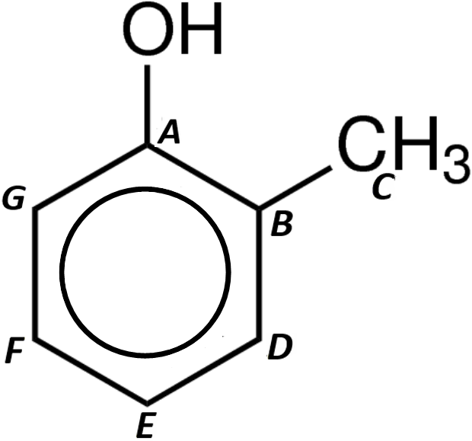

Chemical shift (δ) | Carbon | Chemical shift (δ) | Carbon
15.72 | C_{C} | 127.12 | C_{F}
115.12 | C_{G} | 131.14 | C_{D}
120.94 | C_{E} | 153.58 | C_{A}
124.15 | C_{B}

¹H NMR Spectrum of ethanol

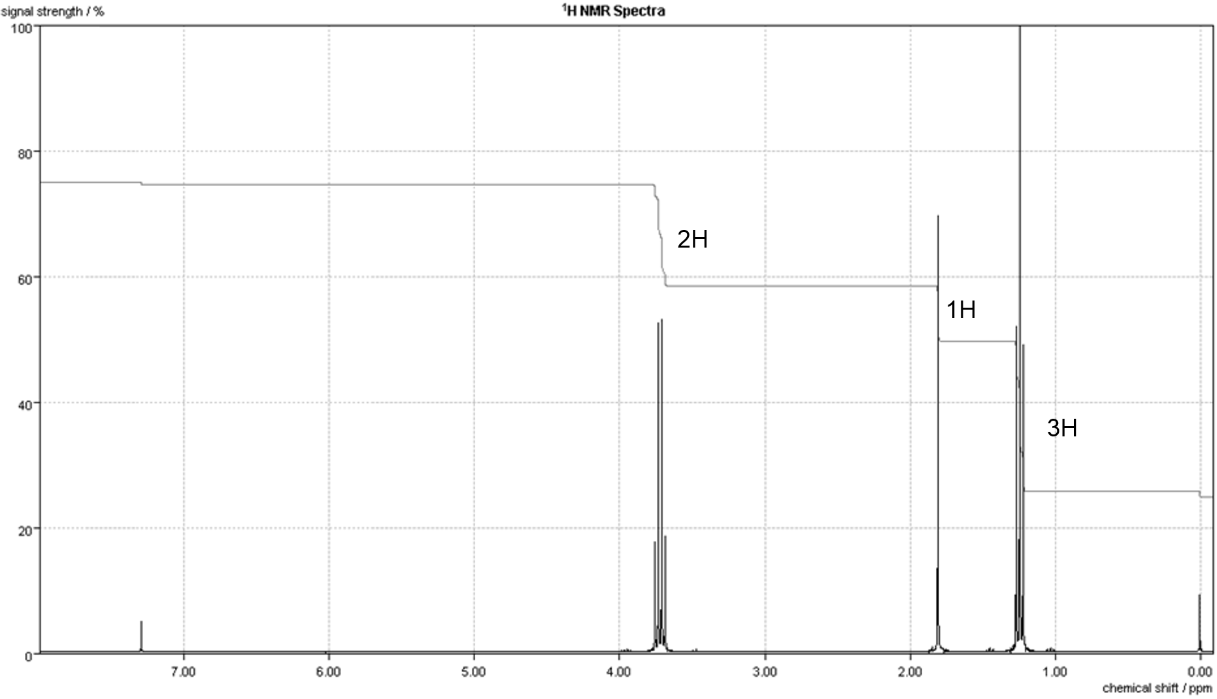
H1

¹H NMR Spectrum of propan-2-ol

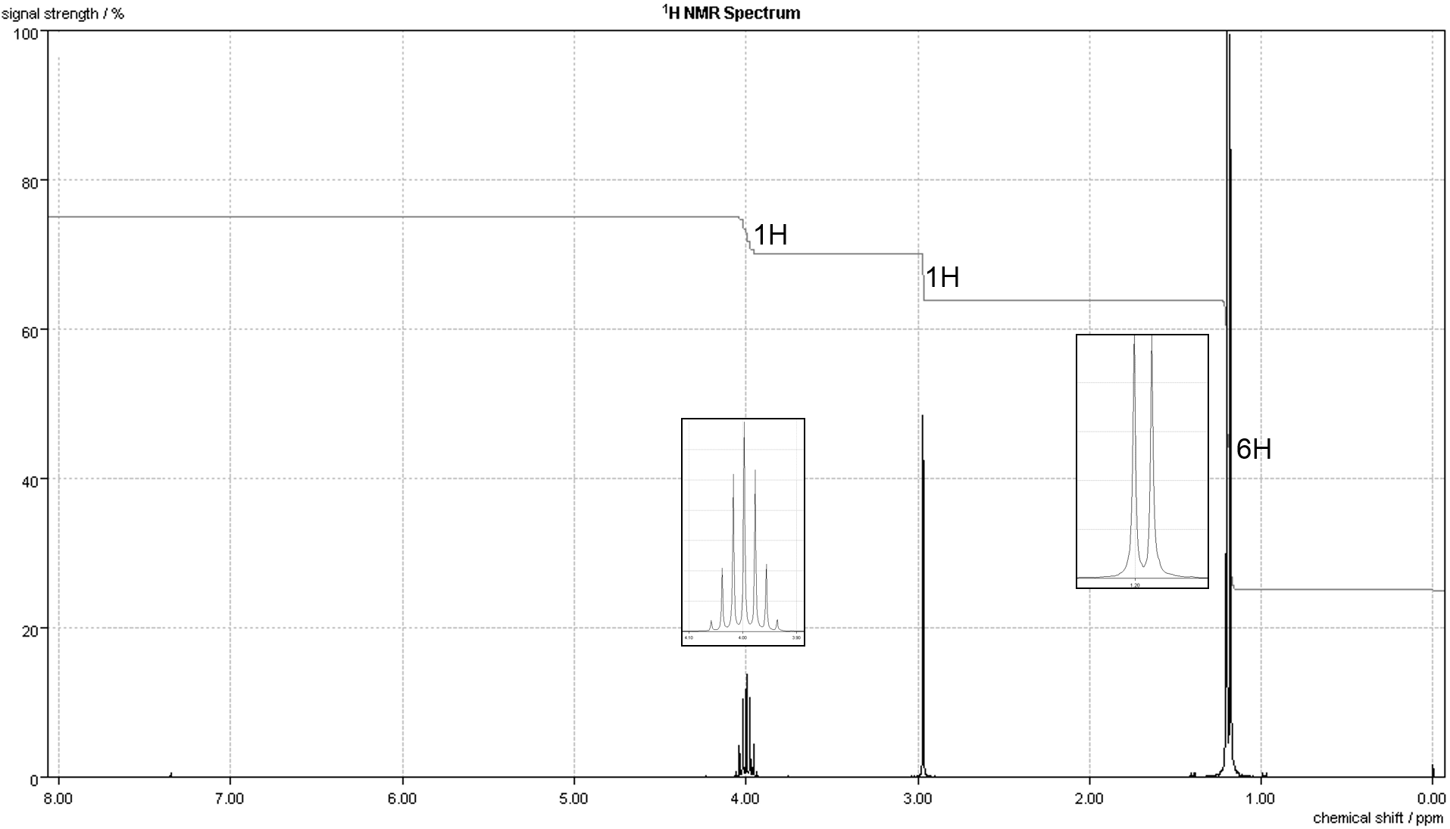
H2
¹H NMR Spectrum of pentan-3-one

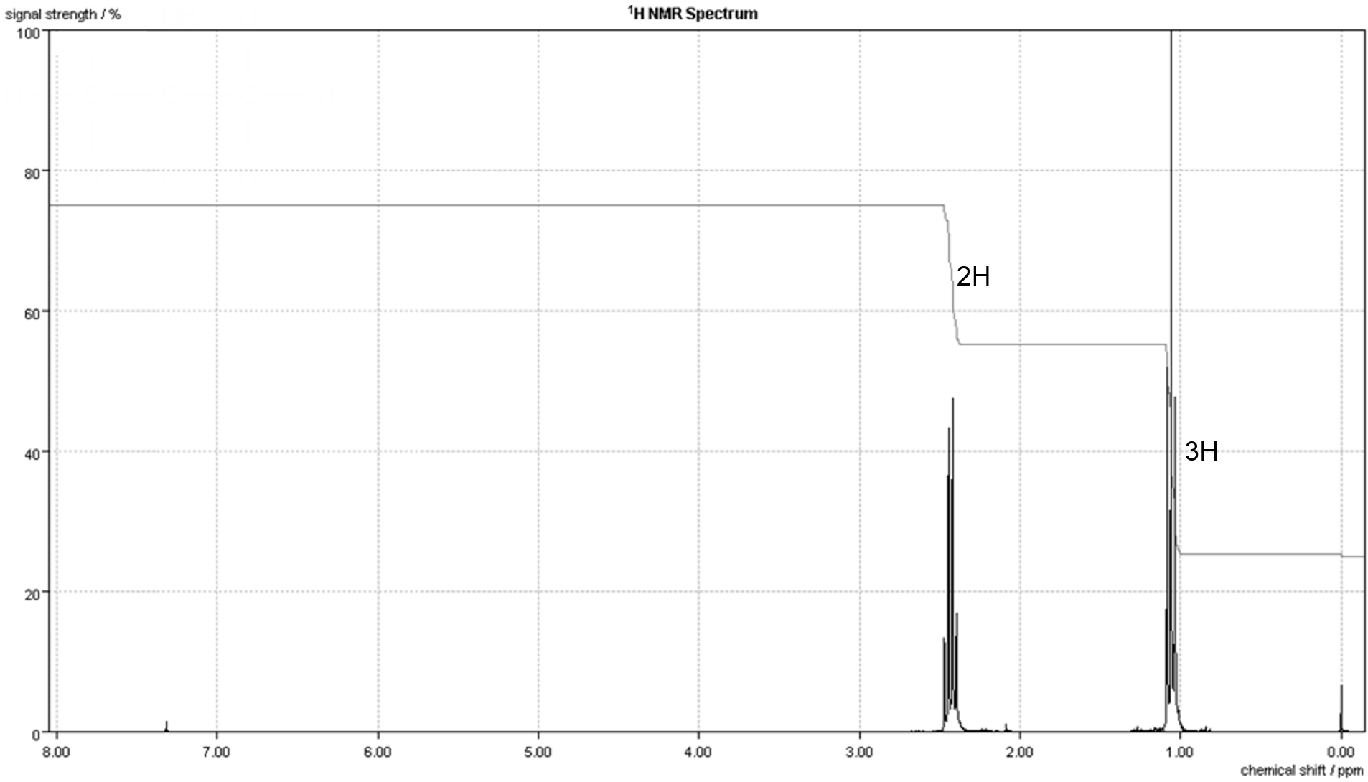
H3

¹H NMR Spectrum of ethyl propanoate

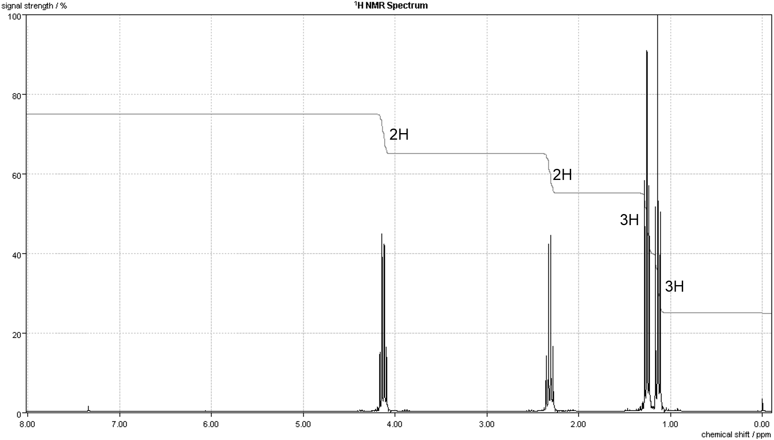
H4
¹H NMR spectral data for ethanol
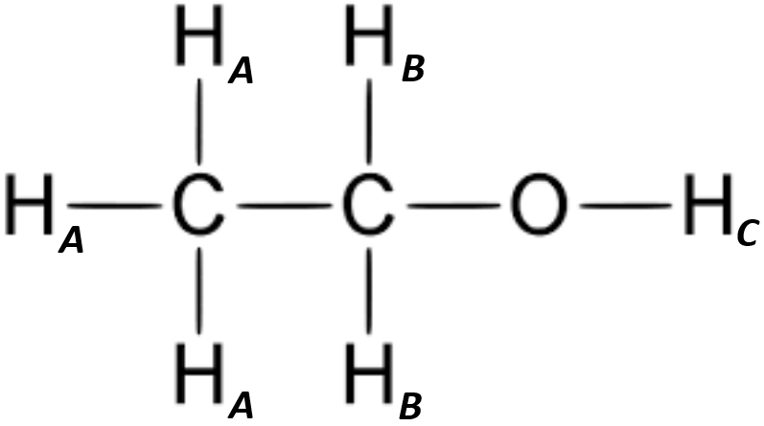

Chemical shift | Relative integral | Multiplicity | Proton/Group
1.23 | 3 | triplet (t) | H_{A}
1.86 | 1 | singlet (s) | H_{C}
3.69 | 2 | quartet (q) | H_{B}

¹H NMR spectral data for propan-2-ol
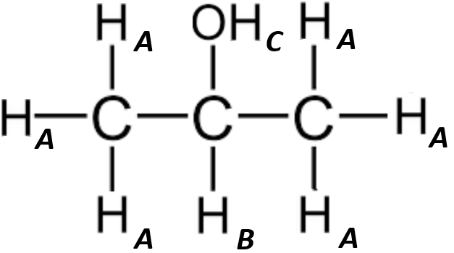

Chemical shift | Relative integral | Multiplicity | Proton/Group
1.20 | 6 | doublet (d) | H_{A}
2.96 | 1 | singlet (s) | H_{C}
4.01 | 1 | septet (s) | H_{B}

¹H NMR spectral data for pentan-3-one
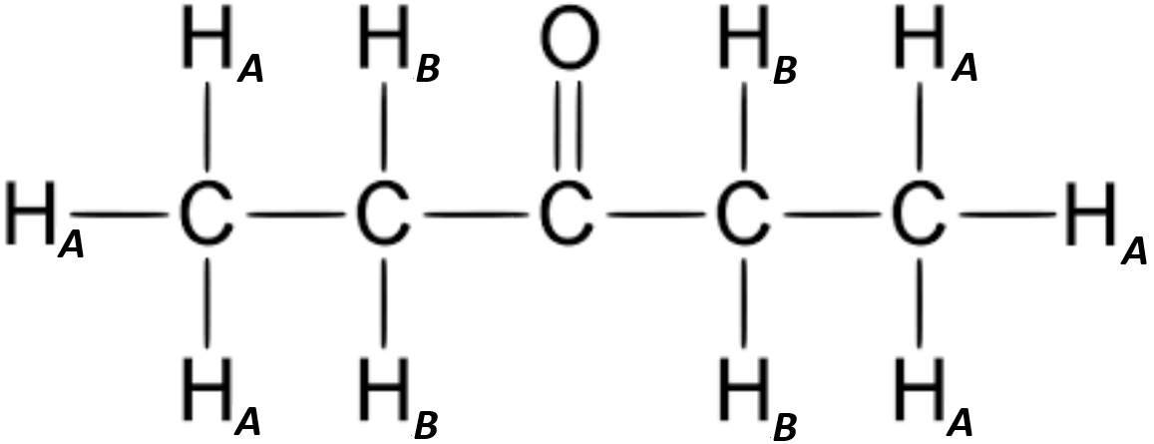

Chemical shift | Relative integral | Multiplicity | Proton/Group
1.06 | 3 | triplet (t) | H_{A}
2.44 | 2 | quartet (q) | H_{B}

¹H NMR spectral data for ethyl propanoate
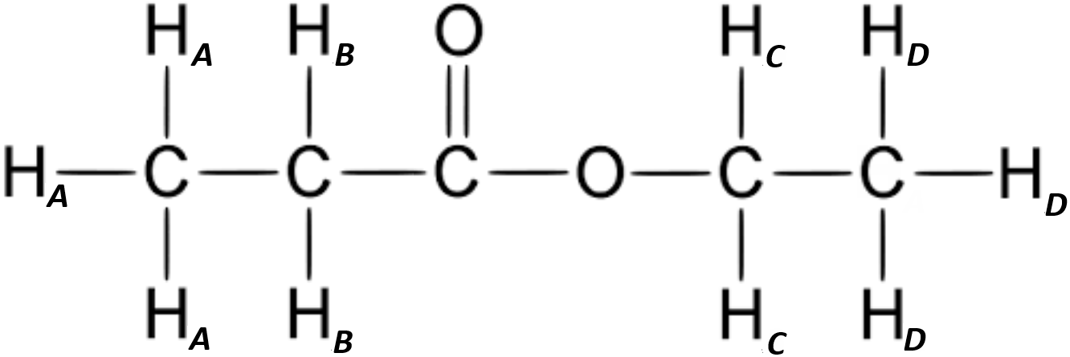

Chemical shift | Relative integral | Multiplicity | Proton/Group
1.14 | 3 | triplet (t) | H_{A}
1.26 | 3 | sextet (sex) | H_{D}
2.32 | 2 | quartet (q) | H_{B}
4.13 | 2 | quartet (q) | H_{C}

Questions
Mass Spectrometry
1 The mass spectrum of an unknown organic compound is shown below.

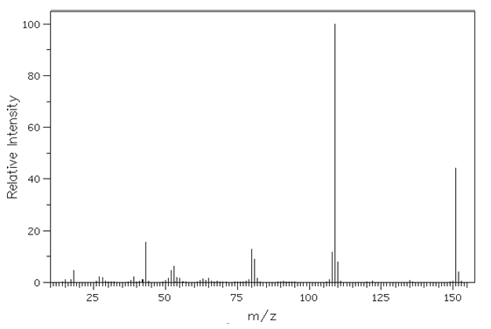

a Label the molecular ion peak, with an M on the mass spectrum.

b Calculate the empirical formula of the compound given the following percentage composition by mass:

C, 63.58 % H, 5.96 % N, 9.27 % O, 21.19 %

and using this deduce the molecular formula of the compound.

2 The diagram shows the mass spectrum of an organic compound.

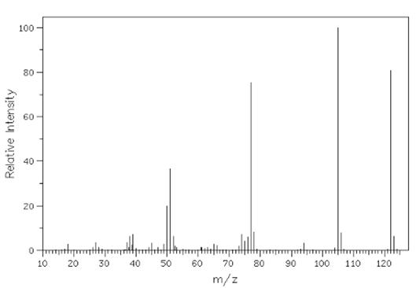

a Use the spectrum to confirm that the molecular formula of the compound could be C₇H₈O₂.

b Give the reason for existence of a peak at m/z = 125.

c The infrared spectrum of the compound has two strong absorptions at 1686 cm^{–1} and 2957 cm^{–1}. Identity the functional group responsible for each of these adsorptions.

d Suggest the formula of the ion responsible for the peak at m/z = 77.

e Use your answers to parts c and d to suggest a structural formula for the compound.

¹³C NMR
Identify each of the following organic compounds from their carbon-13 NMR spectrum and the molar mass.

Compound A – molar mass 48.0 g mol^{–1}
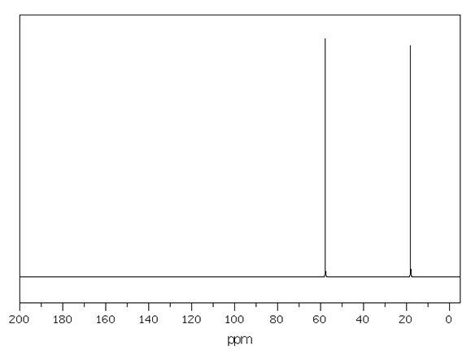

Compound B – molar mass 60.0 g mol^{–1}
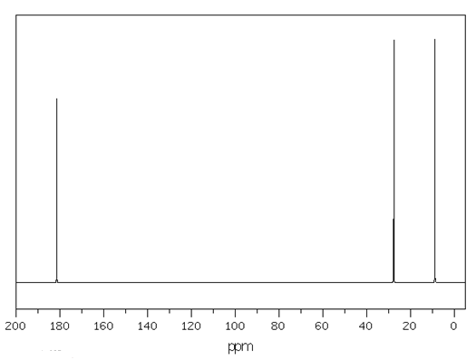
Compound C – molar mass 88.0 g mol^{–1}
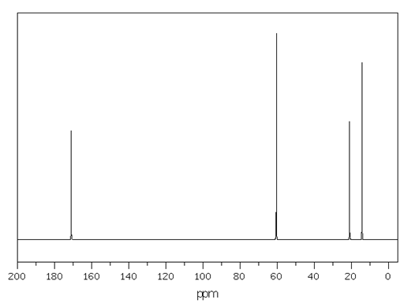

Compound D – molar mass 59.0 g mol^{–1}
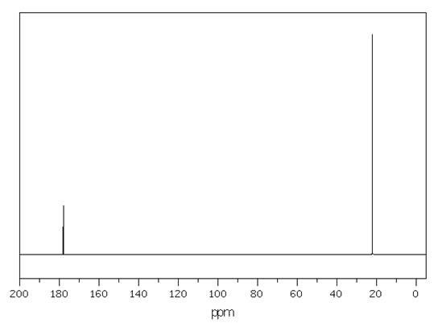

¹H NMR
Identify each of the following organic compounds from their proton NMR spectrum and the molar mass.

Compound A – molar mass 60.0 g mol^{–1}

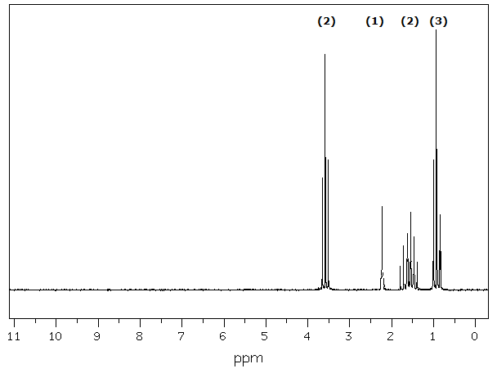
Compound B – molar mass 60.0 g mol^{–1}

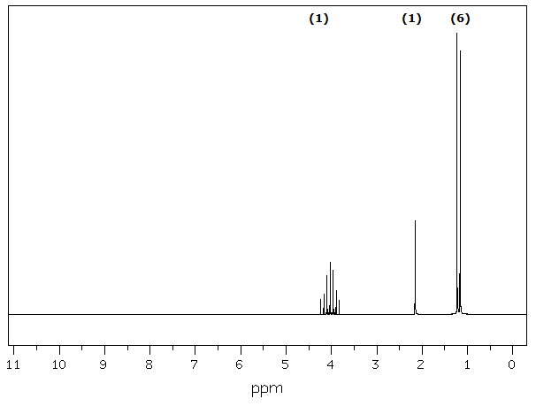
Compound C – molar mass 88.0 g mol^{–1}
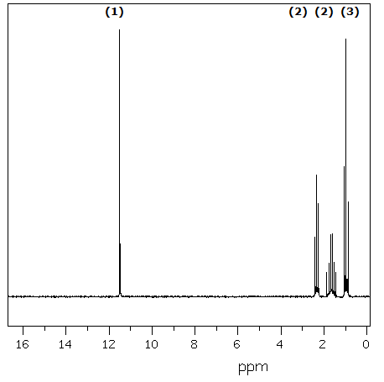
Compound D – molar mass 74.0 g mol^{–1}
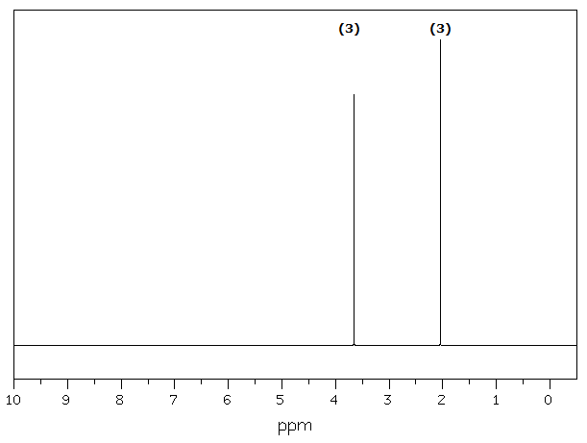
Answers
Mass spectrometry
1 a Peak at m/z = 151 labelled M
b Empirical formula = C₈H₉NO₂
Empirical formula mass = 151 = molecular mass
Molecular formula = C₈H₉NO₂
2 a Molecular ion peak is at m/z = 124
M_{r} of C₇H₈O₂ = 124
b The presence of a small amount of the isotope ¹³C in the compound.
c 1686 cm^{–1} − C=O
2957 cm^{–1} − OH in a carboxylic acid
d C₆H₅⁺
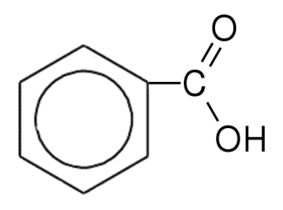
e

¹³C NMR
Compound A is ethanol (CH₃CH₂OH).
Compound B is ethanoic acid (CH₃COOH).
Compound C is ethyl ethanoate (CH₃COOCH₂CH₃).
Compound D is ethanamide (CH₃CONH₂).

¹H NMR
Compound A is propan-1-ol (CH₃CH₂CH₂OH).
Compound B is propan-2-ol (CH₃CHOHCH₃).
Compound C is Butanoic acid (CH₃CH₂CH₂COOH).
Compound D is methyl ethanoate (CH₃COOCH₃).

