R-Studio.R
Group Project – Low Yin Yu, and 9 other members
2026-04-30
rm(list=ls())
library(ggplot2)
library(haven)
data <- read.csv("~/Desktop/Group Project/Data/data_sleep (5).csv")
data <- data[,c("sleep","slpnaps","earns74","inlf","leis1","male","marr","yngkid","yrsmarr","hrwage","age")]
data <- data[data$marr == 1, ]
save(data, file = "~/Desktop/Group Project/Data/data_sleep (5).csv")
summary(data)
## sleep slpnaps earns74 inlf leis1
## Min. :1485 Min. :1485 Min. : 0 Min. :0.00 Min. :1745
## 1st Qu.:3046 1st Qu.:3133 1st Qu.: 2500 1st Qu.:0.75 1st Qu.:4103
## Median :3287 Median :3370 Median : 8250 Median :1.00 Median :4594
## Mean :3277 Mean :3385 Mean : 9900 Mean :0.75 Mean :4691
## 3rd Qu.:3536 3rd Qu.:3655 3rd Qu.:13750 3rd Qu.:1.00 3rd Qu.:5204
## Max. :4695 Max. :6110 Max. :42500 Max. :1.00 Max. :7417
##
## male marr yngkid yrsmarr hrwage
## Min. :0.0000 Min. :1 Min. :0.00 Min. : 0.00 Min. : 0.350
## 1st Qu.:0.0000 1st Qu.:1 1st Qu.:0.00 1st Qu.: 5.00 1st Qu.: 2.890
## Median :1.0000 Median :1 Median :0.00 Median :12.00 Median : 4.450
## Mean :0.6052 Mean :1 Mean :0.15 Mean :14.33 Mean : 5.139
## 3rd Qu.:1.0000 3rd Qu.:1 3rd Qu.:0.00 3rd Qu.:23.00 3rd Qu.: 6.350
## Max. :1.0000 Max. :1 Max. :1.00 Max. :43.00 Max. :32.480
## NA's :145
## age
## Min. :23.00
## 1st Qu.:29.00
## Median :37.00
## Mean :38.91
## 3rd Qu.:47.25
## Max. :65.00
##
plot(data$yrsmarr, data$slpnaps, main = "Total Sleep vs Years Married", xlab = "Years Married", ylab = "Total Sleep (Mins)", col ="steelblue", pch = 16)
abline(lm(slpnaps ~ yrsmarr, data = data),
col = "red", lwd = 2)
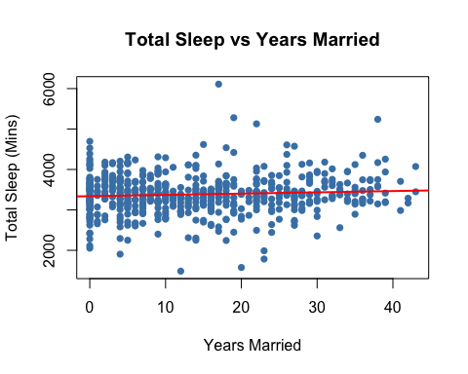
boxplot(sleep ~ male, data = data,
names = c("Female", "Male"),
main = "Sleep by Gender",
ylab = "Sleep (mins)", col = c("pink", "steelblue"))
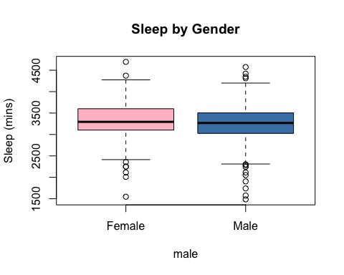
boxplot(sleep ~ yngkid, data = data,
names = c("No Young Child", "Young Child"),
main = "Sleep by Presence of Young Child",
col = c("lightgreen", "coral"))
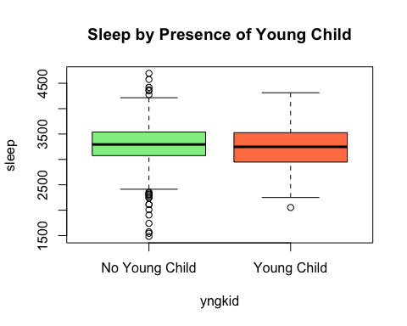
plot(data$hrwage, data$sleep,
main = "Sleep vs Hourly Wage by Gender",
xlab = "Hourly Wage (£)",
ylab = "Sleep (Minutes)",
col = ifelse(data$male == 1, "steelblue", "pink"),
pch = 16)
abline(lm(sleep ~ hrwage, data = data[data$male == 1, ]),
col = "steelblue", lwd = 2)
abline(lm(sleep ~ hrwage, data = data[data$male == 0, ]),
col = "hotpink", lwd = 2)
legend("topright",
legend = c("Male", "Female"),
col = c("steelblue", "hotpink"),
pch = 16, lty = 1)
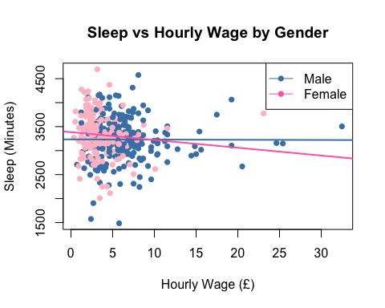
plot(data$age, data$sleep,
main = "Sleep vs Age by Gender",
xlab = "Age (Years)",
ylab = "Sleep (Minutes)",
col = ifelse(data$male == 1, "steelblue", "pink"),
pch = 16)
abline(lm(sleep ~ age, data = data[data$male == 1, ]),
col = "steelblue", lwd = 2)
abline(lm(sleep ~ age, data = data[data$male == 0, ]),
col = "hotpink", lwd = 2)
legend("topright",
legend = c("Male", "Female"),
col = c("steelblue", "hotpink"),
pch = 16, lty = 1)
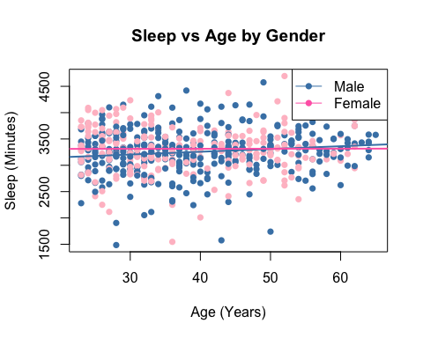
# Store the models
m1 <- lm(slpnaps ~ yrsmarr, data = data)
m2_male <- lm(sleep ~ hrwage, data = data[data$male == 1, ])
m2_female <- lm(sleep ~ hrwage, data = data[data$male == 0, ])
m3_male <- lm(sleep ~ age, data = data[data$male == 1, ])
m3_female <- lm(sleep ~ age, data = data[data$male == 0, ])
# Full regression output (coefficients, R², adjusted R², F-stat, p-values)
summary(m1)
##
## Call:
## lm(formula = slpnaps ~ yrsmarr, data = data)
##
## Residuals:
## Min 1Q Median 3Q Max
## -1892.4 -263.0 -25.7 267.1 2716.8
##
## Coefficients:
## Estimate Std. Error t value Pr(>|t|)
## (Intercept) 3339.401 32.808 101.785 <2e-16 ***
## yrsmarr 3.164 1.801 1.757 0.0794 .
## ---
## Signif. codes: 0 '***' 0.001 '**' 0.01 '*' 0.05 '.' 0.1 ' ' 1
##
## Residual standard error: 488.1 on 578 degrees of freedom
## Multiple R-squared: 0.005313, Adjusted R-squared: 0.003592
## F-statistic: 3.088 on 1 and 578 DF, p-value: 0.07942
summary(m2_male)
##
## Call:
## lm(formula = sleep ~ hrwage, data = data[data$male == 1, ])
##
## Residuals:
## Min 1Q Median 3Q Max
## -1747.59 -224.59 2.53 229.09 1343.44
##
## Coefficients:
## Estimate Std. Error t value Pr(>|t|)
## (Intercept) 3235.1540 50.8542 63.616 <2e-16 ***
## hrwage -0.4452 6.9119 -0.064 0.949
## ---
## Signif. codes: 0 '***' 0.001 '**' 0.01 '*' 0.05 '.' 0.1 ' ' 1
##
## Residual standard error: 429.2 on 254 degrees of freedom
## (95 observations deleted due to missingness)
## Multiple R-squared: 1.633e-05, Adjusted R-squared: -0.003921
## F-statistic: 0.004149 on 1 and 254 DF, p-value: 0.9487
summary(m2_female)
##
## Call:
## lm(formula = sleep ~ hrwage, data = data[data$male == 0, ])
##
## Residuals:
## Min 1Q Median 3Q Max
## -1319.6 -217.0 13.2 278.9 1360.5
##
## Coefficients:
## Estimate Std. Error t value Pr(>|t|)
## (Intercept) 3386.00 57.22 59.173 <2e-16 ***
## hrwage -16.29 13.41 -1.215 0.226
## ---
## Signif. codes: 0 '***' 0.001 '**' 0.01 '*' 0.05 '.' 0.1 ' ' 1
##
## Residual standard error: 425.3 on 177 degrees of freedom
## (50 observations deleted due to missingness)
## Multiple R-squared: 0.008275, Adjusted R-squared: 0.002672
## F-statistic: 1.477 on 1 and 177 DF, p-value: 0.2259
summary(m3_male)
##
## Call:
## lm(formula = sleep ~ age, data = data[data$male == 1, ])
##
## Residuals:
## Min 1Q Median 3Q Max
## -1708.96 -228.71 24.16 234.79 1270.01
##
## Coefficients:
## Estimate Std. Error t value Pr(>|t|)
## (Intercept) 3045.917 84.159 36.192 <2e-16 ***
## age 5.287 2.058 2.569 0.0106 *
## ---
## Signif. codes: 0 '***' 0.001 '**' 0.01 '*' 0.05 '.' 0.1 ' ' 1
##
## Residual standard error: 429.7 on 349 degrees of freedom
## Multiple R-squared: 0.01856, Adjusted R-squared: 0.01575
## F-statistic: 6.599 on 1 and 349 DF, p-value: 0.01062
summary(m3_female)
##
## Call:
## lm(formula = sleep ~ age, data = data[data$male == 0, ])
##
## Residuals:
## Min 1Q Median 3Q Max
## -1767.35 -211.98 -16.93 288.74 1379.91
##
## Coefficients:
## Estimate Std. Error t value Pr(>|t|)
## (Intercept) 3309.4269 102.6663 32.235 <2e-16 ***
## age 0.1088 2.5763 0.042 0.966
## ---
## Signif. codes: 0 '***' 0.001 '**' 0.01 '*' 0.05 '.' 0.1 ' ' 1
##
## Residual standard error: 436.6 on 227 degrees of freedom
## Multiple R-squared: 7.863e-06, Adjusted R-squared: -0.004397
## F-statistic: 0.001785 on 1 and 227 DF, p-value: 0.9663
# Just the R² on its own
summary(m1)$r.squared
## [1] 0.005313384
summary(m1)$adj.r.squared
## [1] 0.003592472
nrow(data) # total sample size
## [1] 580
table(data$male) # split by gender
##
## 0 1
## 229 351
ggplot(data=data[complete.cases(data$hrwage),],aes(x=hrwage))+geom_histogram()+geom_vline(xintercept=mean(data$hrwage,na.rm=TRUE),color="blue")+
geom_vline(xintercept=median(data$hrwage,na.rm=TRUE), color="red")+
xlab("Count")+
ylab("hrwage (£/hour)")
## `stat_bin()` using `bins = 30`. Pick better value `binwidth`.
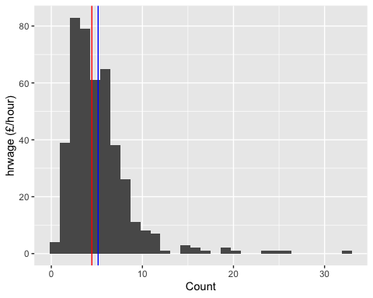
# Select numeric variables of interest
cor_vars <- data[, c("sleep", "slpnaps", "hrwage", "age", "yrsmarr", "yngkid")]
# Correlation matrix
cor_matrix <- cor(cor_vars, use = "complete.obs")
round(cor_matrix, 3)
## sleep slpnaps hrwage age yrsmarr yngkid
## sleep 1.000 0.893 -0.068 0.055 0.016 0.006
## slpnaps 0.893 1.000 -0.109 0.077 0.049 -0.031
## hrwage -0.068 -0.109 1.000 0.135 0.123 -0.006
## age 0.055 0.077 0.135 1.000 0.732 -0.345
## yrsmarr 0.016 0.049 0.123 0.732 1.000 -0.285
## yngkid 0.006 -0.031 -0.006 -0.345 -0.285 1.000

