COMP6441 Week 1 Portfolio

Name: Chuanze zhao
zID:5659271
Date Submitted:6/6/2026

Setup

Security Everywhere
I am currently living in the Meriton’s apartment. One thing I noticed is I must tap the card when I want to use the elevator to get to my floor. But when I want to go down to the ground floor, I don’t have to tap the key card. I can just press the button and go.

Another thing is I live in level 2, even if I tap the card, I cannot go to other level by using elevator because I only have level 2’s authorization. Also, there is a childcare center sharing same elevator, there is no need to tap the cards down to parking lot from Monday to Friday, 8 a.m. to 5 p.m.
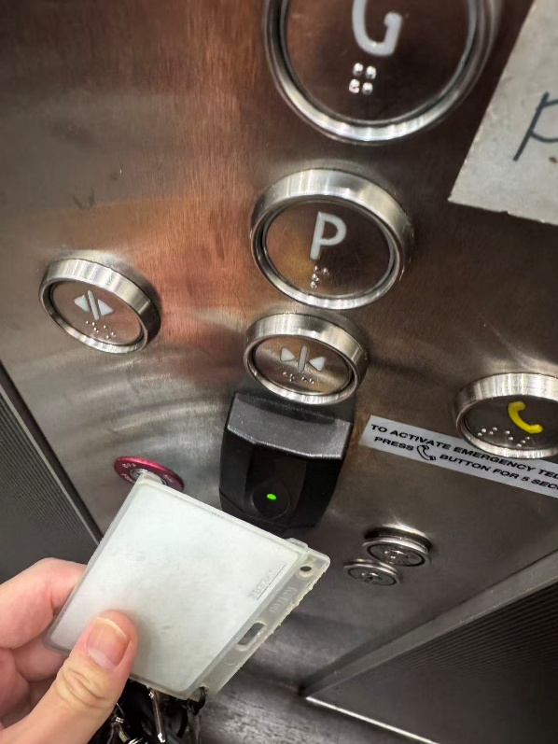
But after that time if I want to go down to the parking lot, I must tap my card. This is an example of access control and authorization refers to security everywhere.

The key card checks whether a person is allowed to enter restricted areas, while public areas such as the ground floor remain open to everyone.
But in other words, when the elevator does not need to swipe the card at 5-8 o'clock on weekdays, the security risk for the residents will increase, because if they forget to lock the car, everyone can go down the parking lot without permission.

Although it is convenient for the staff of the hosting office/or parents, there are certain risks for the residents, so I think of a problem in network security.

Both portability and ease of use are basically impossible to exist at the same time as a completely safe system. It can only be said to make corresponding choices.

Security Engineering

Bluetooth traces
To achieve this goal. I watched how other done this job and I found an app called BLE scanner in the apple store. I download it and try to find out what I can find in different spots.

The 1st spot is in my room. I opened the app, there were a lot of devices jumping out, and I was able to see the distance between my phone and those devices.

I could recognize some of the devices through the name, for example my iPad, it’s just literally “chuanze’s ipad”. Also, I was able to capture my roommate’s Tv in his room. Besides that, there were tons of N/A devices. Might be my PC or other electric device. Then I remember the course I finished comp 9336. This course talks about signals, especially Bluetooth and Wi-Fi. One thing I remember from the course is Bluetooth can go through the wall but can’t through the microwave. So, I put my phone in the microwave and refresh the app, it can’t deceive any devices.
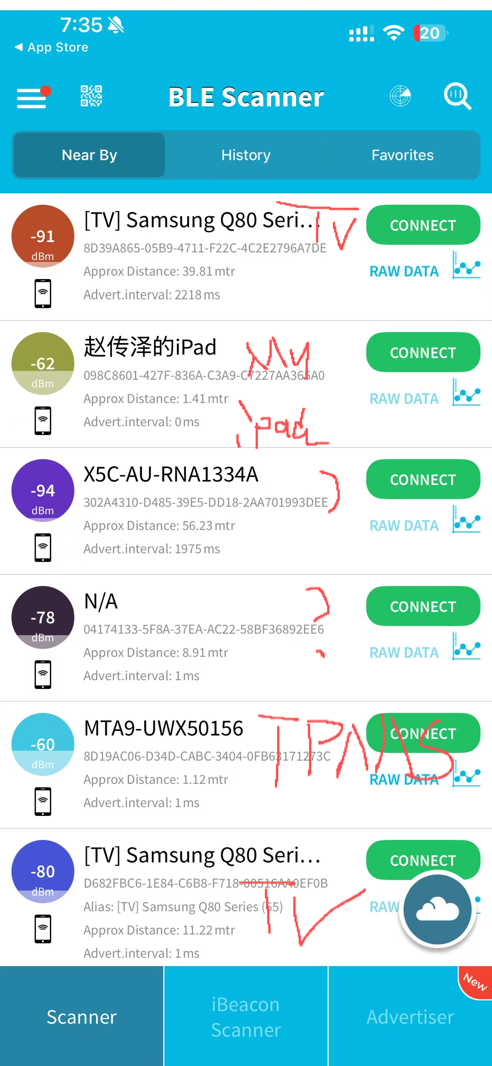
The distance between devices affects the dBm, when I put my phone and my ipad far away the dBm is getting less (as negative number getting greater). When I grab my phone and iPad closer the dBm gets less.

The second spot is my apr’s lobby, at this spot I was able to capture a lot of signals coming from the street. One most significant single that I have received on the app is Lime scooter. I could not get it when I was using the app in my room, but I can receive it at the lobby.
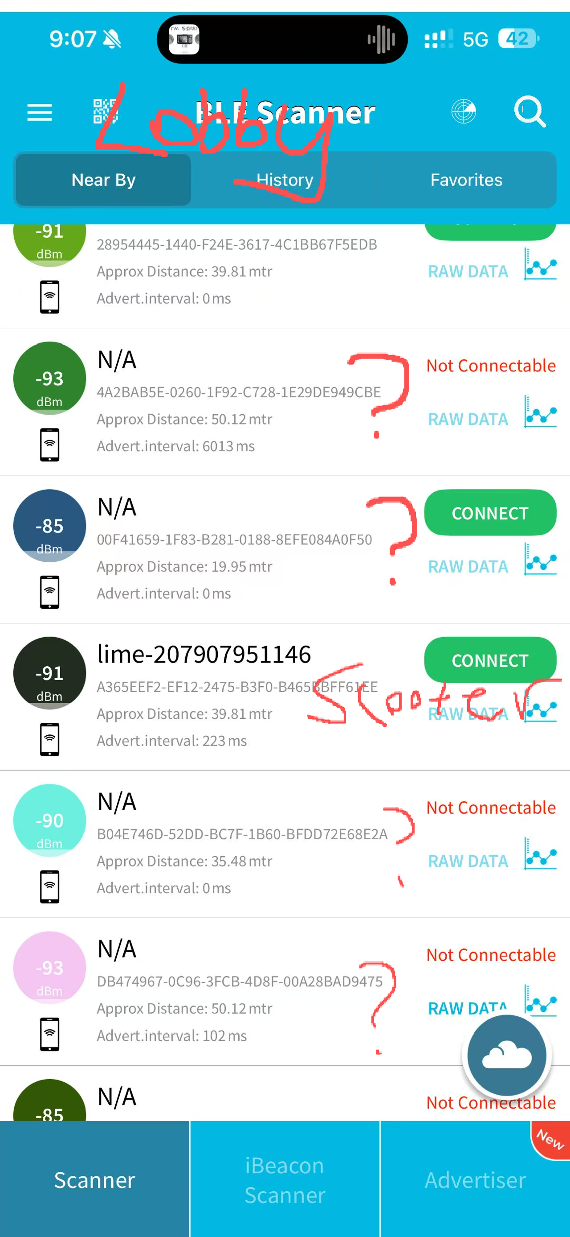
Then I found out the devices that can send signals around us are exposing our personal location and privacy anytime and anywhere. For criminals, they can easily guess the range of your device based on the distance. Our devices will inadvertently leak some privacy.

Overall, I learned that Bluetooth devices can reveal their presence nearby, and distance and barriers can strongly affect the signal. Also, our devices are leaking our privacy even if we are not using them.

Physical Security
For this physical security activity, I tried to open my roommate’s suitcase lock. Before I did this, I asked him first, and he said it was fine because he did not really use that suitcase anymore.

At first, I thought physical security meant I needed to open it in a physical way, like breaking the lock. So, I tried to use scissors and turn the lock part with force. My initial thought was maybe the lock is not strong enough so I can open easily if I push hard. But after trying for a while, the lock is good enough. I can’t open it by force. Then I realize if I keep doing it, I will break the lock, so I stop.

Then I started to think about the password instead. I remembered that my own suitcases were all using 000 when I first bought them. And to be honest, some of the password locks in my home are also still 000 because nobody really changes them. So I tried 000 on my roommate’s suitcase, and it actually opened. 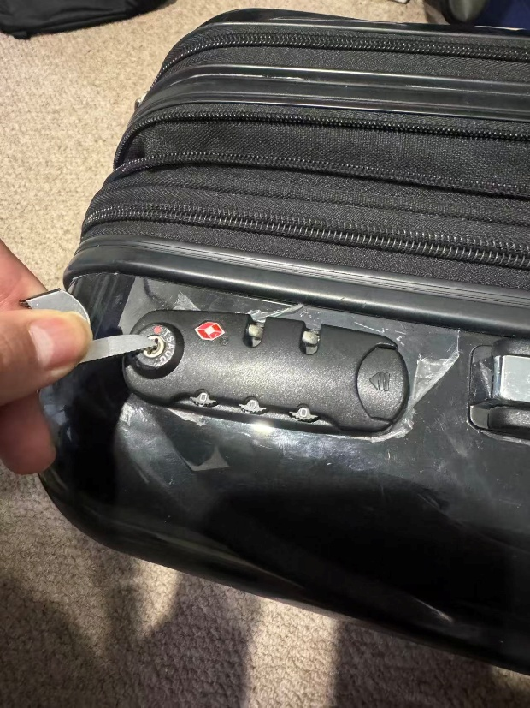

After this, the weak point was not really the lock itself. The lock looks like it gives enough protection (at least I could not open it with force). But if the code is still the default one, then the lock becomes much weaker. It is like a website using username admin and password 123 at the test phase but not changing the password when the website is published.

Even if the developer put many security features on it, if the admin password didn’t change, people can just log in and have all the authorization feels free to do anything on website (delete anything or add anything).

Back to this small case. If I used scissors and damaged it, maybe there would be scratches or marks, and my roommate 100% can tell I tried to open it with the force. But when I opened it with default code and closed it again, there was basically no evidence. So my roommate could not tell I successfully opened his suitcase.

What I learned is that real security is not only about adding more locks or making something look safe. A lot of problems come from small habits and people’s behavior, like not changing default passwords.

Sometimes the object itself is not the biggest problem. The behavior of the user is the real weak point.

Photo Detective
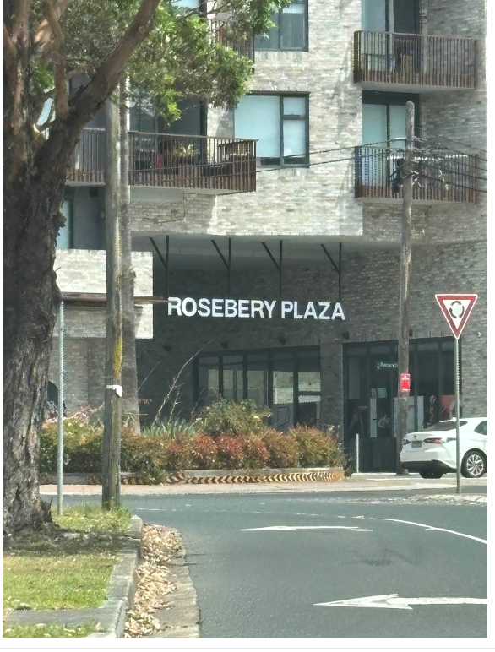

Photo from *Joshua
This is extremely easy to tell because it is just literally 500m from where I live.

The location where Joshua took the photo is the driveway that comes down from M1 highway, facing the Rosebery plaza.

The reason I knew where is because I drive through this roundabout at least 4 times a week (just for kidding but that is the main reason I could tell the spot so quickly).

Technically, lets me do a real analysis to the pic. First thing come from the image is word “Rosebery Plaza.” This is the most useful information. So, I google map the Rosebery plaza, here is the result: 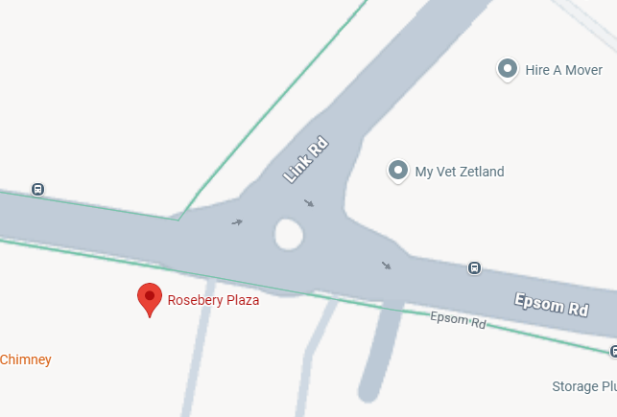

And because the shooting angle is facing to the plaza so it must be shot from link road, and there is a left turn mark on the ground so Joshua is on the left turn driveway.
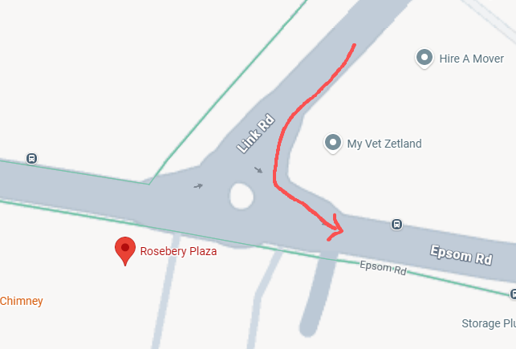
And based on the tree’s shadow, the time when I took this pic might be the sometime afternoon. The light comes from west to east.

Analysis and Reflection

Tutorial 1: Orientation
On the tutorial the topic we discuss is what if the building is shaking on campus and what if tsunami happened to campus what do we do.

It was a fun discussion tbh. About the shaking building in our group chat we all agree the same, firstly have to identify if there is an earthquake. Secondly, find yourself a cover to dodge falling ceiling. Lastly, follow the people to the ground.

But at how we deal with tsunami I initially have different ideas compared to others, my initial thought is stay in where you are and wait for help. But after the discussion I think when we actually facing the tsunami on campus we need to go to the high ground and find help from the security at first time.

The reason turns out my mind is one of our group members said if u stay in the room, when the water comes up u have nowhere to hide and it becomes harder to escape the room. That makes sense because what I thought is staying in the room at least we would not be pushed away. But when water fills the room people would be drowning to death. For most of the time proactive is more useful than Reactive.

Therefore, the devices that can send signals around us are exposing our personal location and privacy anytime and anywhere. For criminals, they can easily guess the range of your device based on the distance. Our devices will inadvertently leak some privacy.

Project

Select your Project
Game Hacking in RPG games.

I choose game hacking in RPG games as my project. The reason I chose this topic is because when I was playing Risk of Rain 2, I was stuck at one stage for a long time, and I was sad and annoyed. At that moment, my initial thought is I can change some character value, like HP or damage, so I can pass that stage easier. But after I searched for a while, I found it is not always easy to modify the game directly.

Then I started to think about other RPG games. For most of local single player RPG games, values like money, HP, level or inventory might be saved in local files or in the game memory. Some games maybe can be changed by editing the save file, and some other games may need a memory editor to find the value when the game is running. I think this is interesting because at first it looks like just cheating, but it is also about whether the game should trust the data from the client.

For this project, I want to evaluate this in an offline and safe environment. I may use a single player RPG game. I want to see if changing money or HP will work, and also check if the game will crash after I change the value.

I am still not 100% sure if this topic is deep enough, so I want to connect it with online RPG games. In single player games, changing money only affects me. But in online RPG, money, items, and inventory may affect trading, ranking and even real money value. So, I want to analyze why online games cannot trust client-side data too much.

Wrap up

Submission Instructions
To submit a valid portfolio entry, complete the activities, save your work as a PDF, and upload it to the relevant week submission page on Moodle.

