**DEFENITION  
  
 Flowchart**

* It is a type of diagram that shows the workflow, method and algorithm. It is commonly displayed using arrows, rectangles, ovals, diamonds, parallelogram and a cloud (also called the flowchart symbols) to show the process of the program. Arrows represents the relationship between the representative shapes. The ovals represent the beginning and the ending of the program. The rectangles show the process. Diamonds represents the decision. Parallelogram shows the I/O process and the internet is represented by a cloud. The main purpose of a flowchart is to provide the people a common language or reference point. It helps to create a draft of solution to a coding problem and a flowchart can help visualize the steps in a system including inputs, outputs, and loops.

**EXAMPLE OF A FLOWCHART:**

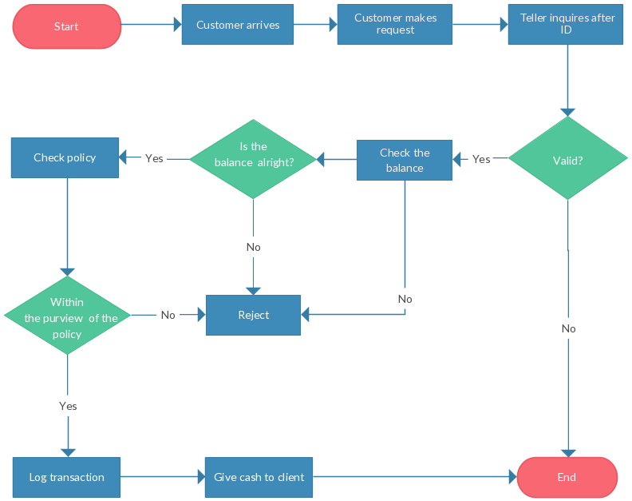

**Pseudocode**

* The word "pseudo" means "fake," so "pseudocode" means "fake code." The algorithm in the pseudocode helps programmers or nonprogrammers determine the step-by-step actions a program must take to complete a required or desired action. It is the detailed but readable description of what a computer program must do. Pseudocode is not actually a programming language, it only uses short phrases to write code for programs before you actually create it in a specific language. It is an informal program description that does not contain any code syntax, but instead serves as a general representation of a program's functions. It summarizes the flow of the program but it excludes the underlying details. Once the pseudocode is accepted, it is rewritten using the vocabulary and syntax of a programming language. Pseudocode cannot be compiled into an executable program. Therefore, pseudocode must be converted into a specific programming language if it is to become a usable application. The purpose of pseudocodes is to review the steps to confirm the proposed code matches the coding specifications but it does not provide as good a map for the programmer as a flowchart does. It does not include the full logic of the proposed code.

**EXAMPLE OF A PSEUDOCODE:**

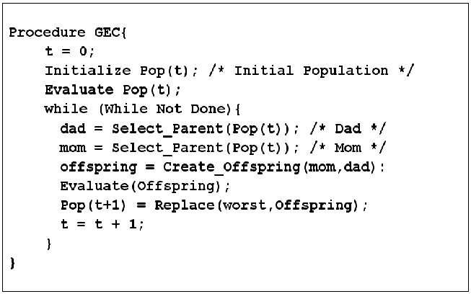

REFERENCES

FLOWCHART

*Rouse, M., Gallagher, P., Rouse, M., & Rouse, M. (n.d.). What is flowchart? - Definition from WhatIs.com. Retrieved from* [*https://whatis.techtarget.com/definition/flowchart*](https://whatis.techtarget.com/definition/flowchart)*.*

*(n.d.). Retrieved from* [*https://www.smartdraw.com/flowchart/flowchart-symbols.htm*](https://www.smartdraw.com/flowchart/flowchart-symbols.htm)*.*

PSEUDOCODE

*Beal, V. (n.d.). pseudocode. Retrieved from* [*https://www.webopedia.com/TERM/P/pseudocode.html*](https://www.webopedia.com/TERM/P/pseudocode.html)*.*

*(n.d.). Retrieved from* [*https://study.com/academy/lesson/pseudocode-definition-examples-quiz.html*](https://study.com/academy/lesson/pseudocode-definition-examples-quiz.html)*.*

*Rouse, M., Smith, S., Rouse, M., & Rouse, M. (n.d.). What is pseudocode? - Definition from WhatIs.com. Retrieved from https://whatis.techtarget.com/definition/pseudocode.*