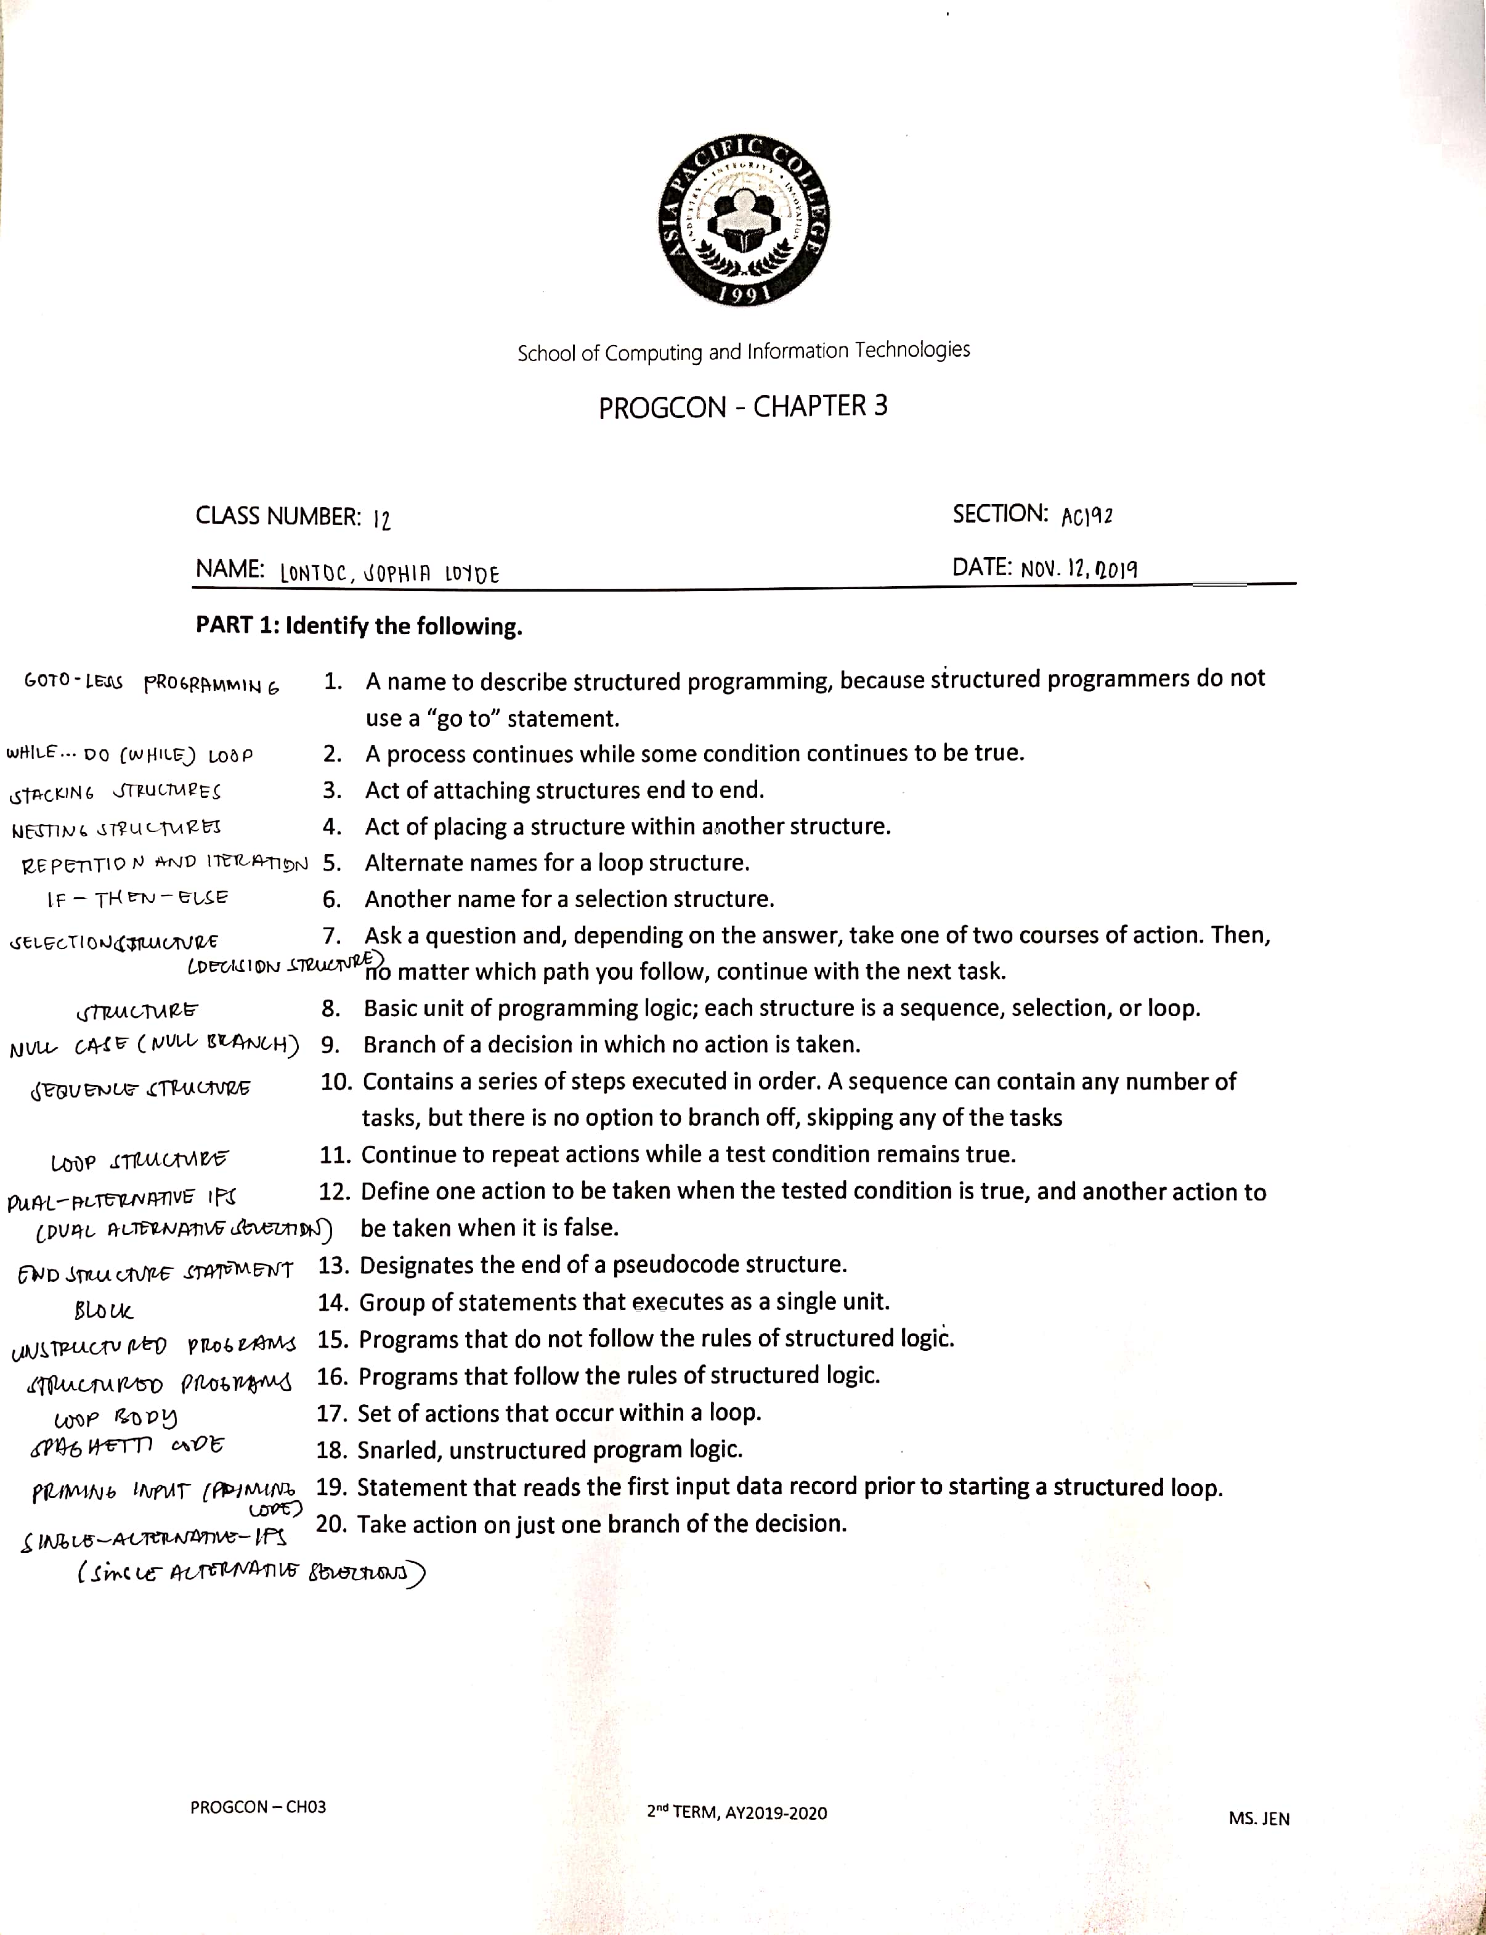LONTOC, SOPHIA LOYDE ACTIVITY 8

AC192