Lontoc, Sophia Loyde

AC192

SOM NIGHT

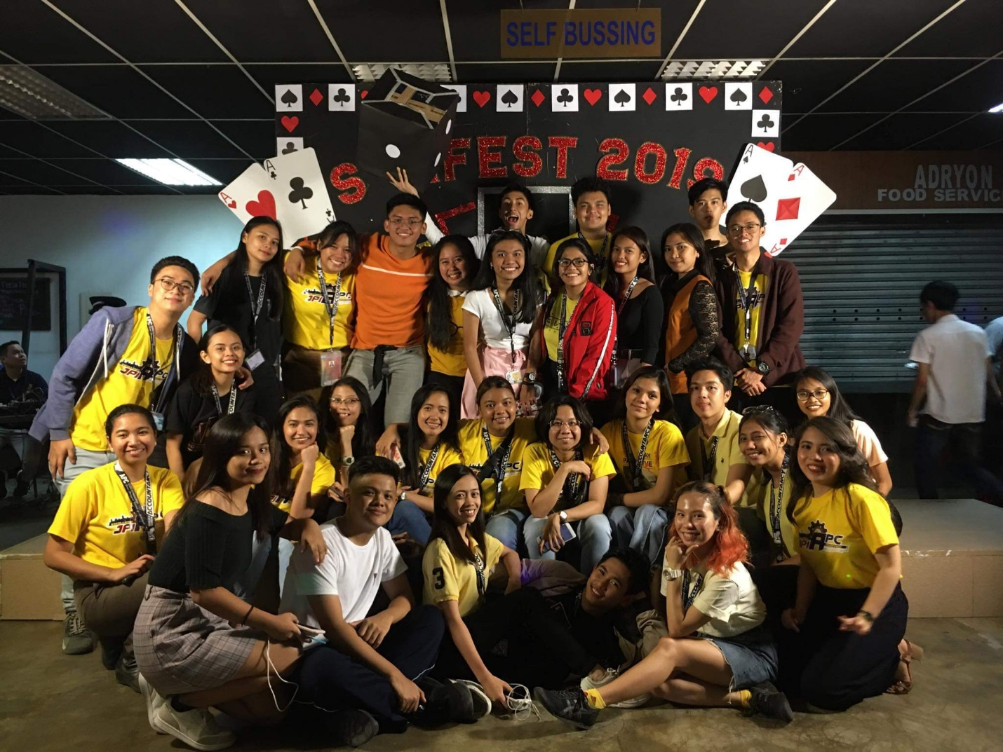 We did a lot of fun activities that night. First, we watched Mr. and Ms. SOM and luckily our Ms. SOM, Celine Ochea, won as the 3rd runner up while our Mr. SOM, Miggy Gonio won as the 1st runner up. We shouted as loud as we can just to support our Mr. and Ms. SOM. After the contest, we immediately went down to the after party, SOM Night. We did a lost of fun activities in the party, we danced, we sang, we played random games with the seniors. The SOM Night organizers also provided some snacks for us that makes it super fun! They have pizzas, juice and some pick-a-snack like chips and candies while we are dancing. I can say that School of Management is the best department, we share same vibes and we have similarities in each other that makes the whole party lit! The party finished around 9 in the evening and we went home with a smile in our face.

