Lontoc, Sophia Loyde

Reflection 4

My First Program using Flowgorithm

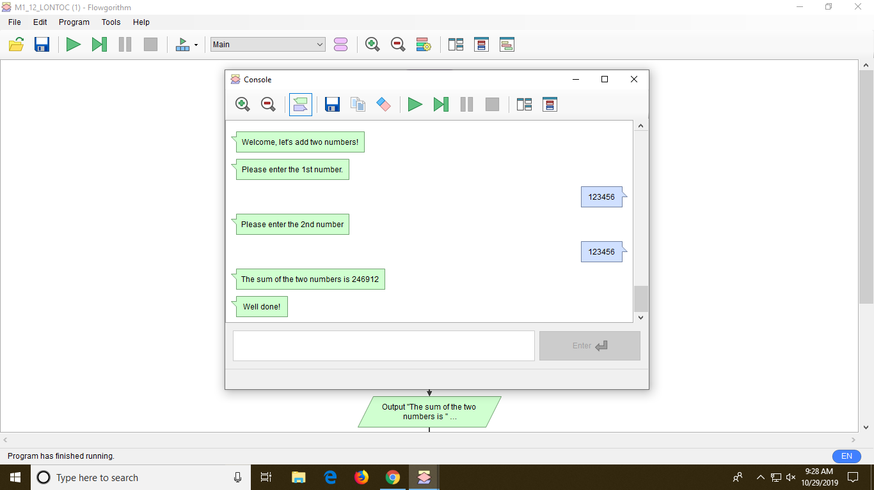 I’m new to this app and I find it very challenging since this is the first time I encountered this app and at first, I don’t know what to click and where to start. My first ever program made is a flowgorithm adding two numbers. (see photo below)

After I made this flowgorithm, I’m so happy and I want to make more of like this. I want to explore more about this app and create more programs that can definitely help somebody in need (if I already mastered the app, lol.) But the problem is that I can’t install the app in my laptop so I only have time to edit and improve my program in school during PROGCON subject.