Lontoc, Sophia Loyde

AC192

Reflection 5

Introduction to GitHub

This is also the first time I heard the website called GitHub. The website is very confusing because it is new to me, but eventually I learned how to upload and create repositories because our professor thought us how to create those things. This what my profile looks like in GitHub (see photo below)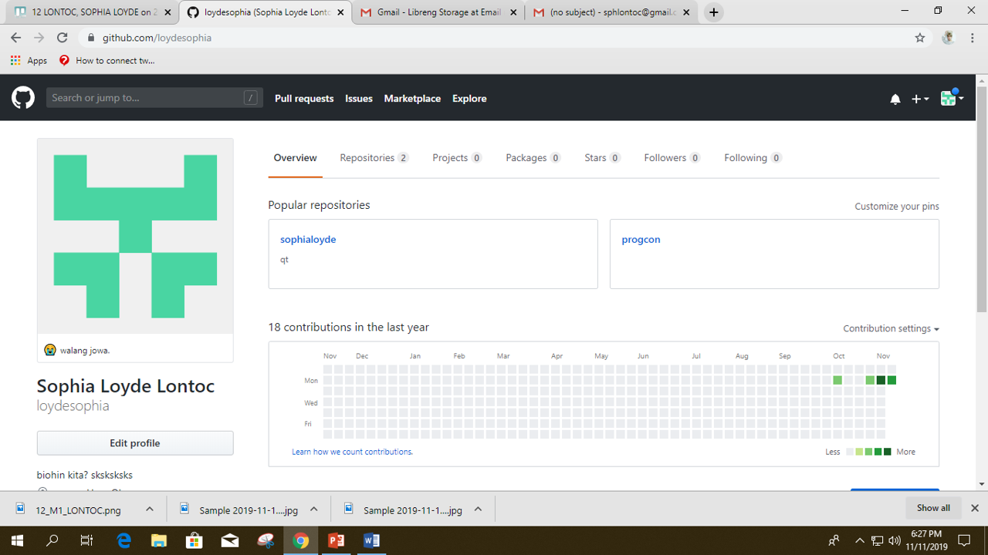

I find this website very helpful because it can help me to organize my files by creating repositories. I can recommend this site to my friends to also help them to organize their files according to their subjects.