C# .net decompile with .net Reflector 

Prerequisite

1. Install Reflexil <https://github.com/sailro/Reflexil/releases/tag/v2.7>
2. Choose for Reflector.bin.zip
3. 
4. <https://www.youtube.com/watch?v=dt5dr5dAuBQ&ab_channel=DavidTheTech>
5. In .Net reflector, Tools> Add-Ins
6. 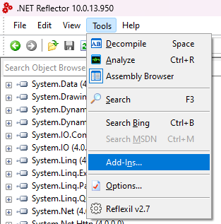
7. Click + , choose the Reflexil.Reflector.dll from there reflexilzip you just downloaded
8. 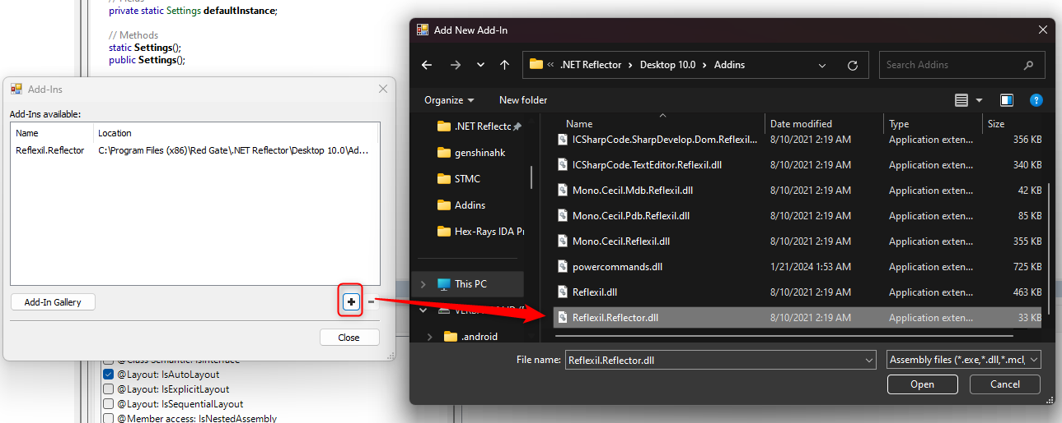

Start decompiling C#.Net .exe

1. https://www.youtube.com/watch?v=Q_-Gv-FQ-FA&ab_channel=BadLuckModders
2. Drag C#yourprogram .exe into .Net Reflector
3. Expand the form until found the function of the program which tells the condition of true of false ( password correct?)
4. 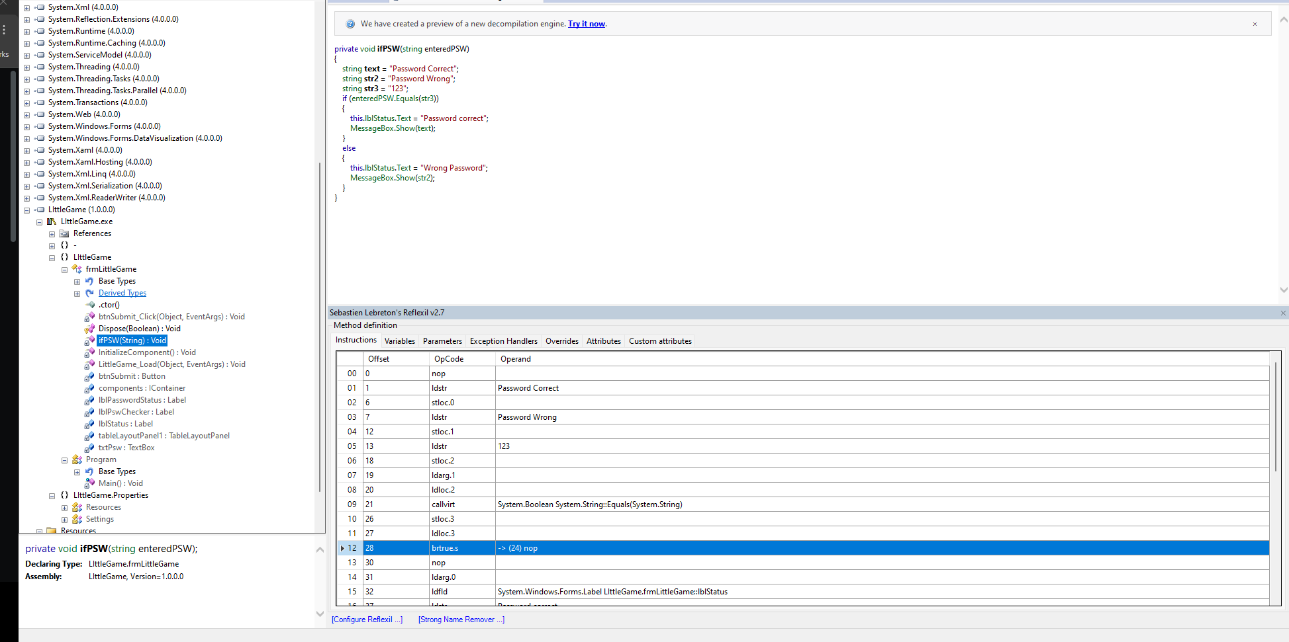
5. Tools > reflixer, the sebastien lebreton’s reflixer panel will show at the below
6. Navigate to the method definition> instructions
7. We can see the there is offset, opcode, and operand, in the operant there is already the statement tells password correct or wrong
8. 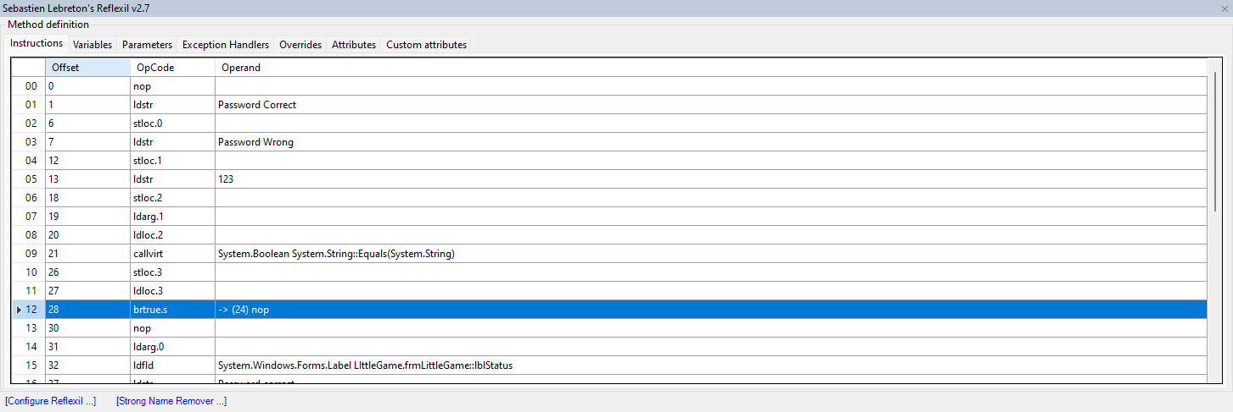
9. Same as the Youtube link for C#.net reverse engineering above, I don’t have a clue on the opcode,
10. Just right click >“Edit” all the OpCode which is something like brfalse.s, set it to brtrue.s
11. 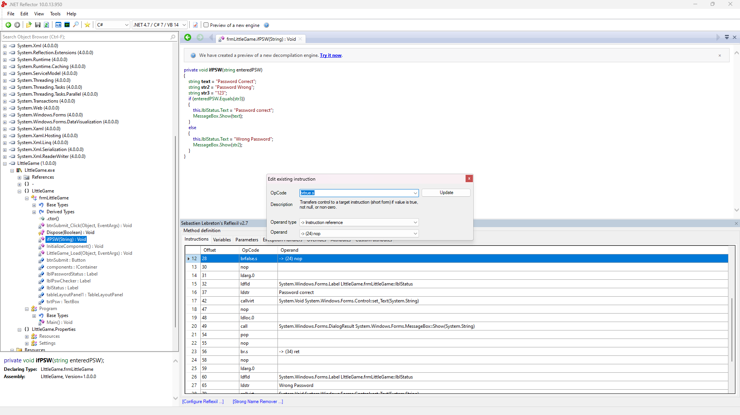
12. Right click on your program from the object browser, reflexir, save as patched.exe
13. 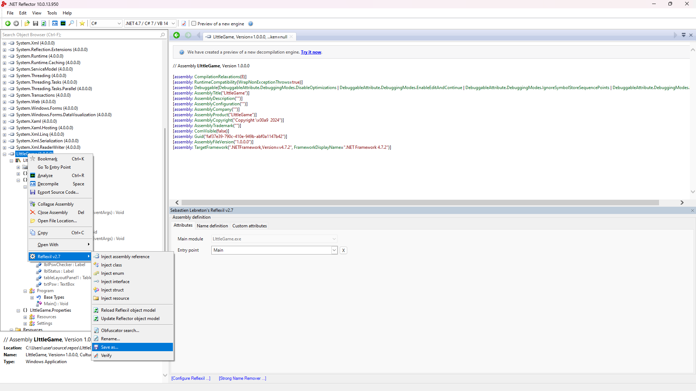
14. The updated patched program ss is shown as below
15. 