A PROJECT REPORT

on

“CLASSIFICATION OF SONG GENRES
FROM AUDIO DATA”

Submitted to

KIIT Deemed to be University

In Partial Fulfilment of the Requirement for the Award of

BACHELOR’S DEGREE IN

INFORMATION TECHNOLOGY

BY

ALINA TONGBRAM
LOYNA DUTTA

21051114
21051313

UNDER THE GUIDANCE OF

GUIDE NAME



SCHOOL OF COMPUTER ENGINEERING

KALINGA INSTITUTE OF INDUSTRIAL TECHNOLOGY

BHUBANESWAR, ODISHA - 751024

March 2024

KIIT Deemed to be University

School of Computer Engineering
Bhubaneswar, ODISHA 751024

CERTIFICATE

This is certify that the project entitled

“CLASSIFICATION OF SONG GENRES
FROM AUDIO DATA”

submitted by

ALINA TONGBRAM
LOYNA DUTTA

21051114

21051313

is a record of bonafide work carried out by them, in the partial fulfilment of the requirement for the award of Degree of Bachelor of Engineering (Computer Sci-ence & Engineering OR Information Technology) at KIIT Deemed to be university, Bhubaneswar. This work is done during year 2023-2024, under our guidance.

Date: 21/03/2024

Abinas Panda
Project Guide

Acknowledgements

We are profoundly grateful to ABINAS PANDA of KIIT University for his expert guidance and continuous encouragement throughout to see that this project rights its target since its commencement to its completion. .....................

ALINA TONGBRAM
LOYNA DUTTA

ABSTRACT

This project focuses on using machine learning to classify audio tracks into hip-hop and rock genres. By employing Principal Component Analysis (PCA) on scaled audio data, we identified the most significant features for classification. We then trained a decision tree and compared its performance to logistic regression, noting differences in effectiveness. To enhance model accuracy, we balanced the dataset and employed cross-validation for a comprehensive evaluation. Our findings demonstrate the potential and challenges of automated music genre classification, offering insights for applications in music streaming and digital libraries.

Additionally, the project underscored the importance of data preprocessing and feature selection in achieving high classification accuracy. Through balancing the data and utilizing PCA, we significantly reduced model bias and improved the interpretability of the results. The comparative analysis between decision trees and logistic regression provided a nuanced understanding of model strengths in context-specific applications. Ultimately, this research not only contributes to the technical field of music genre classification but also suggests practical pathways for enhancing user experience in music discovery platforms and digital archives, highlighting the critical role of machine learning in the evolving landscape of digital musicology.

Chapter 1

Introduction

In the realm of digital musicology and music information retrieval, the classification of music genres stands as a pivotal challenge, bridging the gap between computational methods and the intrinsic complexity of musical expression. With the exponential growth of digital music collections and streaming platforms, the need for accurate and efficient music genre classification has become increasingly pronounced. This project embarks on an exploratory journey to harness machine learning algorithms for the classification of audio tracks into two fundamentally distinct music genres: hip-hop and rock. Leveraging a comprehensive dataset and employing advanced data preprocessing techniques, including Principal Component Analysis (PCA) for feature reduction, this study aims to identify the most salient audio features that distinguish these genres. Through the application of decision trees and logistic regression models, complemented by strategic data balancing and rigorous cross-validation, the research seeks to navigate the challenges of genre classification. The initiative not only aims to enhance the precision of music categorization but also to contribute to the broader discourse on computational approaches in musicology, offering insights that could refine music recommendation systems and enrich the metadata of digital music libraries.

Chapter 2

Implementation

2.1 Methodology

Data Acquisition and Preprocessing
The methodology begins with the acquisition of two datasets: track metadata with genre labels and track metrics with features from the Echo Nest API. These datasets are imported using pandas, and a merge operation is performed on the `track_id` column to consolidate genre labels with their corresponding audio features.

The preprocessing phase includes:
- Merging datasets based on `track_id` to align track metadata with Echo Nest metrics.
- Visualizing correlations among audio features using a heatmap, which aids in understanding feature relationships and potential multicollinearity.
- Standardizing the feature set to ensure that the PCA (Principal Component Analysis) can accurately identify variance across features.

Feature Reduction with PCA
PCA is employed to reduce the dimensionality of the feature set, aiming to retain the most significant components that explain a substantial portion of the variance in the data. A cumulative explained variance plot helps determine the optimal number of components required for effective classification without significant loss of information.

Balancing the Dataset
Given the initial imbalance between the genres (hip-hop and rock), the dataset is balanced by downsampling the overrepresented genre. This step is crucial to prevent model bias toward the more prevalent class.

Model Training and Evaluation
Model Selection: Decision Tree and Logistic Regression models are trained using the features transformed by PCA. These models are chosen for their interpretability and suitability for binary classification tasks.

Training and Testing Split: The PCA-transformed and balanced dataset is split into training and testing sets, ensuring stratified sampling to maintain genre proportionality.

Model Evaluation: The models are evaluated using accuracy scores, confusion matrices, and classification reports. These metrics provide insights into the models' performance, including precision, recall, and F1 scores for each genre classification.

2.2 Testing Plan

Cross-Validation
K-Fold Cross-Validation: To assess the models' generalizability, a K-fold cross-validation approach is adopted, with the dataset divided into ten folds. This method ensures that every observation from the original dataset has the chance of appearing in the training and test set, providing a more reliable estimation of the models' performance.

Model Comparison: The mean accuracy scores from the cross-validation of both the Decision Tree and Logistic Regression models are compared to determine the more effective classifier for this specific task.

Comparative Analysis
- The performance metrics obtained from the initial model evaluations and the cross-validation process are analyzed to compare the effectiveness of the Decision Tree and Logistic Regression models in classifying songs into hip-hop and rock genres.
- This analysis will focus on identifying which model provides a better balance between precision and recall, considering the potential trade-offs between these metrics in the context of music genre classification.

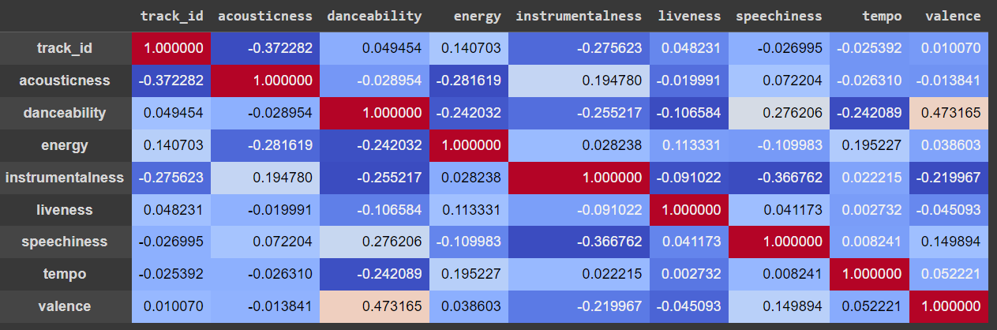

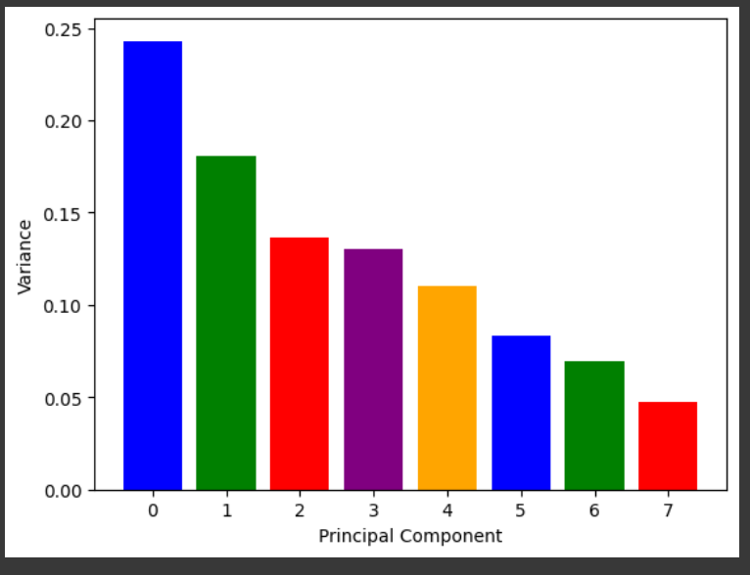

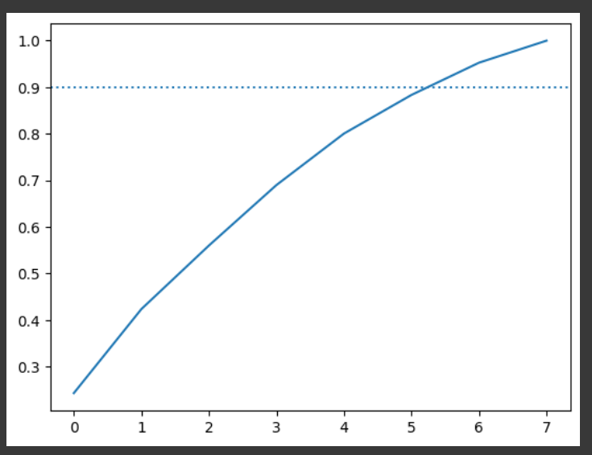

Chapter 3

Conclusion and Future Scope

3.1 Conclusion

This project embarked on a journey to classify audio tracks into two distinct genres, hip-hop and rock, utilizing machine learning techniques. Through the application of Principal Component Analysis (PCA) for feature reduction, followed by the employment of Decision Tree and Logistic Regression models, we navigated the complexities of genre classification. The methodology highlighted the importance of preprocessing steps, such as feature scaling and balancing the dataset, to ensure that our models had a solid foundation for training.

Our findings revealed that both models performed competently, yet they showcased distinct strengths and weaknesses. The Decision Tree model provided an interpretable framework for understanding feature importance, whereas the Logistic Regression model offered a more generalized approach, potentially more adaptable to unseen data. Cross-validation techniques reinforced the reliability of our evaluation, presenting a comprehensive view of the models' capabilities across different subsets of the data.

3.2 Future Scope

Exploring Advanced Models
Future research could explore more sophisticated machine learning algorithms, such as ensemble methods (Random Forests, Gradient Boosting Machines) or deep learning architectures (Convolutional Neural Networks, Recurrent Neural Networks), which might capture the complexities of audio data more effectively.

Real-world Application and Testing
Future projects could focus on the real-world application of these models, such as integrating them into music recommendation systems or digital music libraries. Testing the models in live environments would provide valuable feedback on their performance and user satisfaction.

Multi-label Classification
Expanding the scope to multi-label classification could address the complexity of music genres more realistically, where tracks may belong to multiple genres simultaneously. This approach would align more closely with the nuanced nature of music, offering a more detailed and user-friendly classification system.

