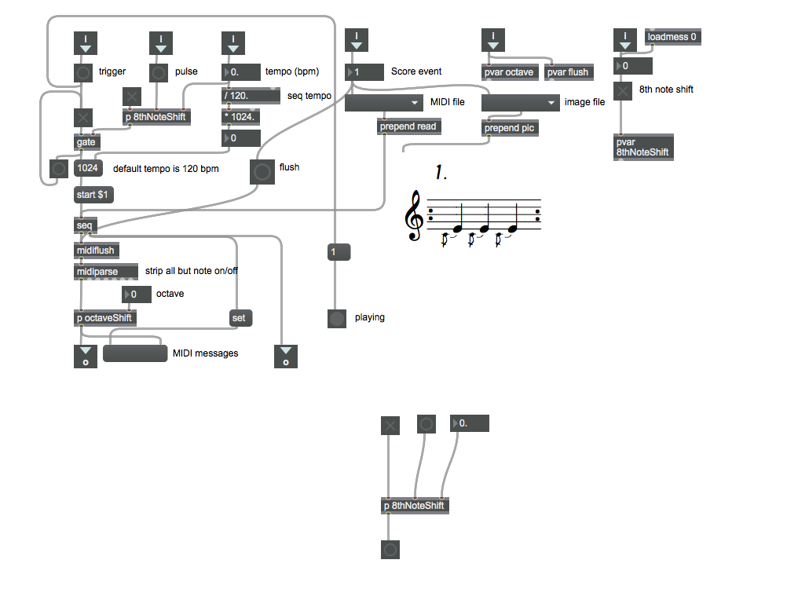**MUSC/COMP 122 - Digital Music**

**Laptop Orchestra**

**presents an electronic realization of**

**In C**

**(1964)**

**by Terry Riley**

**Arranged for laptops, game controllers, and other devices by David B Wetzel, Griffin Moe,**

**and the students of COMP/MUSC 122**

**(LUTE – Loyola University Technology Ensemble)**

**Friday December 16 @ approx. 10 am**

**Black Box Theater**

**Mundelein Basement**

Come see what we’ve been up to in the Digital Music Lab!

This is an informal presentation of Riley’s classic minimalist work, performed by students using software created this semester for sound synthesis and control.

**Come and go as you like.**

This is not a normal concert experience.