Change host name for RHEL8

1. Verify hostname

#hostnamectl

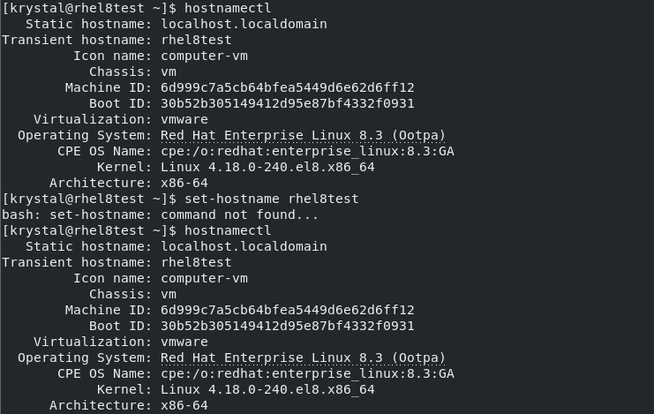

1. Change hostname

#hostnamectl set-hostname ‘(to the name you want)’



1. Verify hostname

#hostnamectl

