Overview of tasks

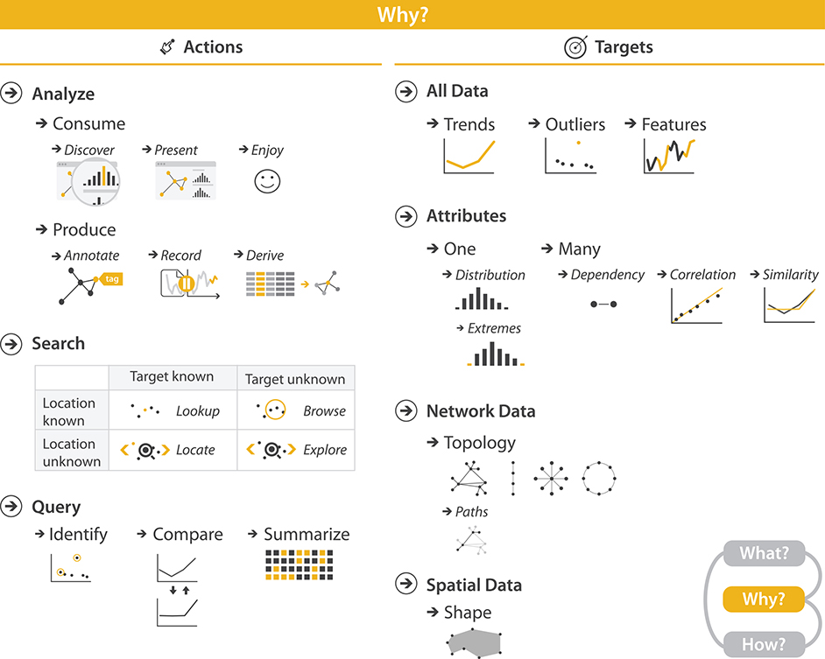

Slide 6

[www.babywizard.com](http://www.babywizard.com) is a vis tool originally intended for parents focused deciding on what to name their expected baby, ended up being used by many nonparents to analyze historical trends for their own enjoyment. It is based on US databases (I believe).



Baby names starting with ‘O’ had a significant dip in popularity in the middle years of the 20th century.