Slide 5

The constituency view shows all constituencies of equal size in a hexagonal shape in approximately the right location geographically. It is a much better representation of the number of seats held by each party (and their approximate location).

For example, the Labour party (red colour) won many seats in London – they cover a small area of the geographic map, but a much larger area of the constituency view. Also note the single green hexagon on the south coast – this represents the seat of Brighton, which is the only one held by the Green party, but completely invisible in the geographic view at this size.

Slide 7

You can read more about John Snow’s work (also in anaesthesia) here <https://www.ph.ucla.edu/epi/snow/broadstreetpump.html>

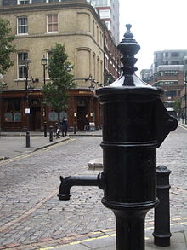 

This is a memorial to his work – a pump without a handle and, in the background, a pub named after him.

Slide 10

Full-size image

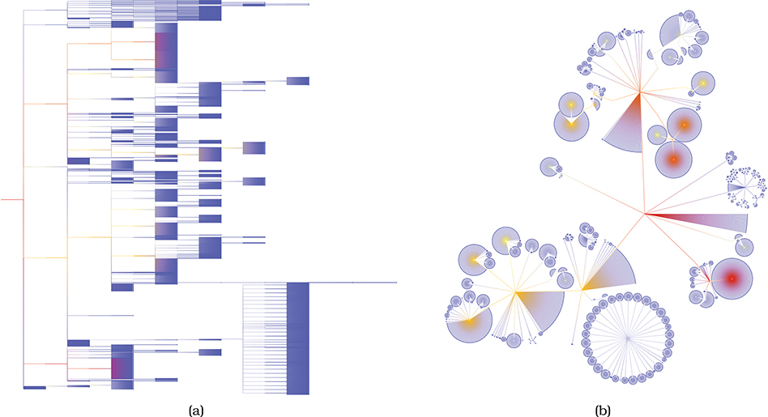

Slide 13

Network of 26,028 nodes and 100,290 edges, where the sfdp layout does not show much visible structure. The enormous number of overlapping lines leads to overwhelming visual clutter caused by occlusion.

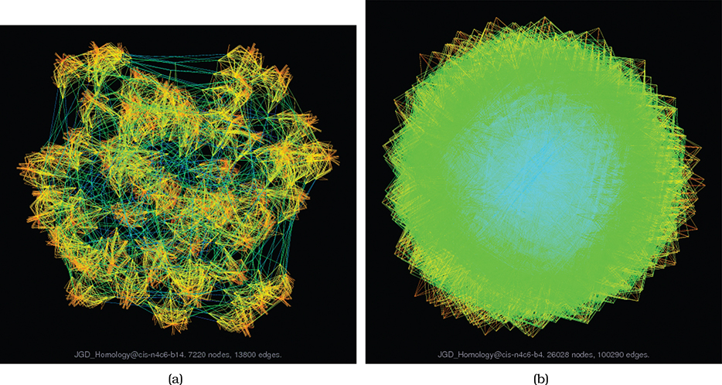

Slide 16

Examples of topology tasks include finding all possible paths from one node to another, finding the shortest path between two nodes, finding all the adjacent nodes one hop away from a target node, and finding nodes that act as a bridge between two components of the network that would otherwise be disconnected.