**Visual Analytics**

**Week 3 Lectorial Exercise**

For each of the following charts, identify data **items** and the **marks** used to encode them, and data **attributes** and the **channels** used to encode them. Also identify which type of **arrangement** is used for the data.

Note that underneath each chart there is a link to a web page providing details about the project, including information about the data and in many cases supporting interactivity. For now just encode what you see in the static image in this document, just notice that interactivity is being used a lot for emphasis (hover highlight, animated transitions, reordering, details popups, small multiples zooming).

**Marks: basic geometric elements. Channels: control appearance of marks**

**Marks for items**

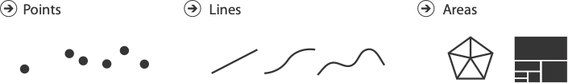

**Marks for links**

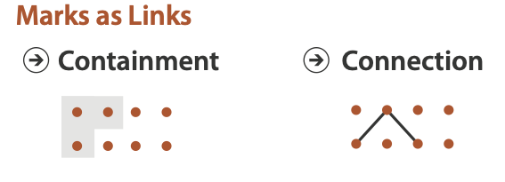

**Channels**

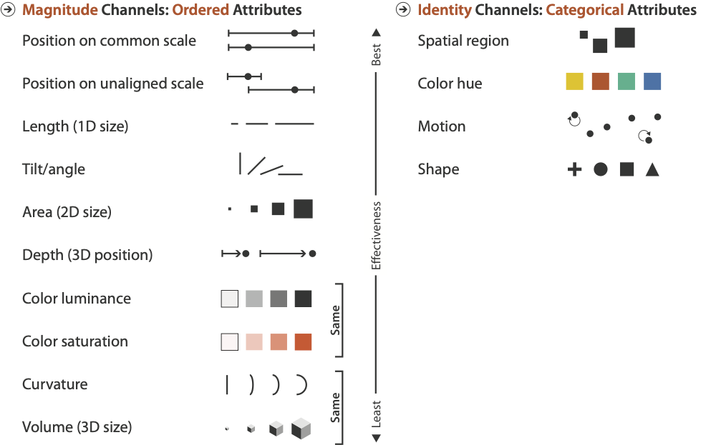

**Chart 1**

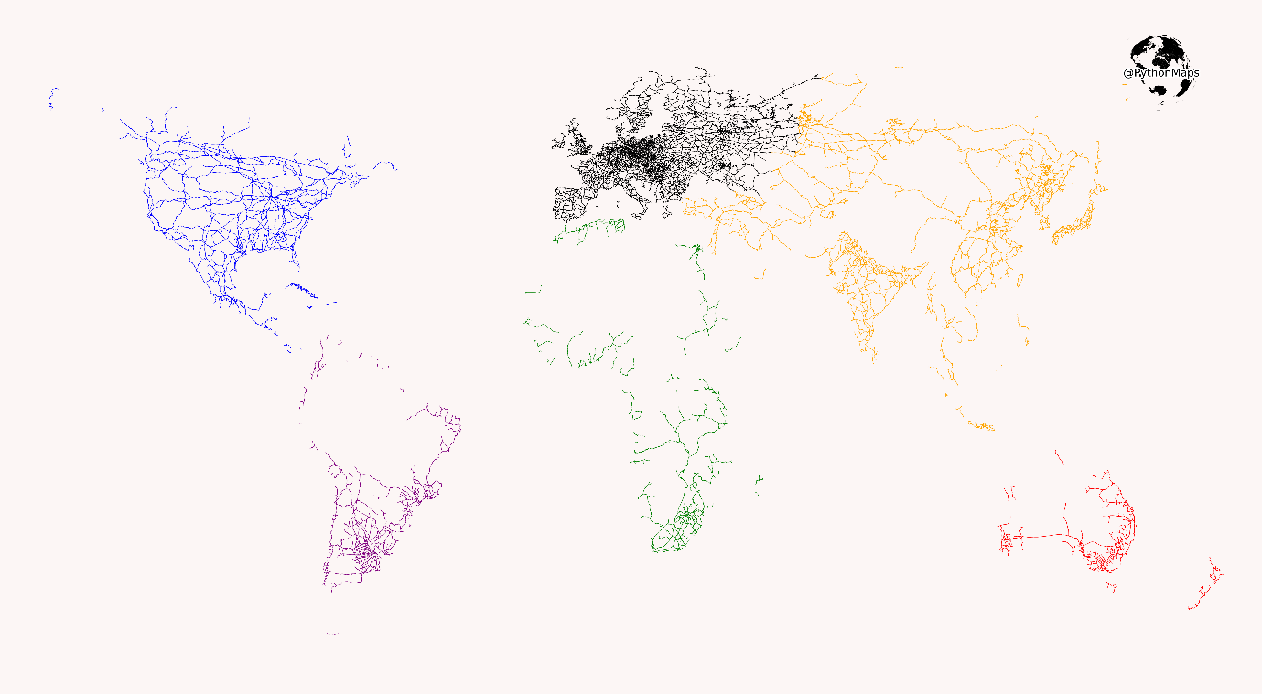

Railways of the world

<https://www.reddit.com/r/dataisbeautiful/comments/lj4wqt/the_railroads_of_the_world_oc/>

**Chart 2**

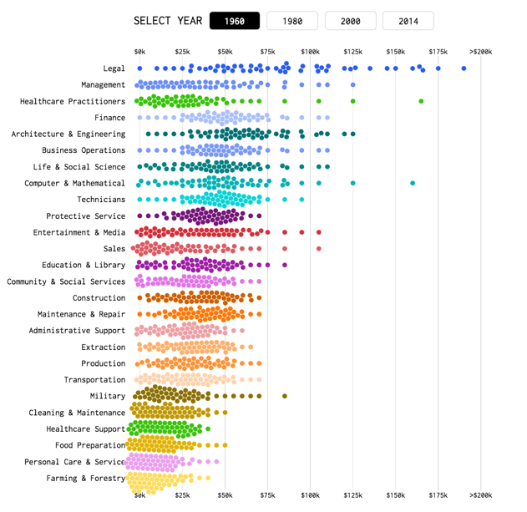

[https://flowingdata.com/2016/06/28/distributions-of-annual-income](https://flowingdata.com/2016/06/28/distributions-of-annual-income/)

**Chart 3**

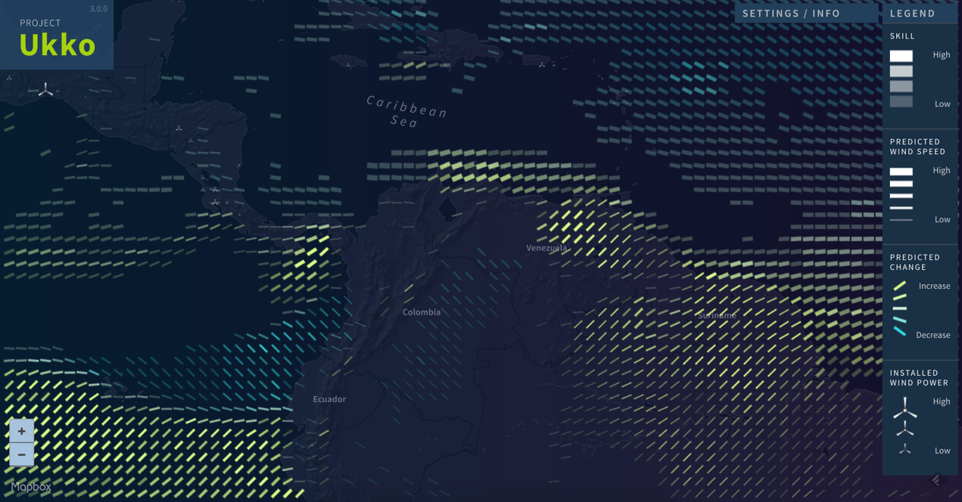

Seasonal wind predictions for the energy sector <http://project-ukko.net/>

**Answers**

**Chart 1**

The marks are links to show connections between stations and (probably) very small dots to show the stations (though the scale makes this supposition).

The channel used is colour to represent the continent.

The data is arranged spatially using a geographic representation.

**Chart 2**

The marks are points.

The channels are position on a common scale to represent income and colour to represent nothing at all (it is a redundant channel).

The data is arranged as multiple 1-d scatterplots with a small amount of vertical jitter so that points don’t overlap.

**Chart 3**

The marks are lines (representing wind) and symbols (representing installed wind power.

There are many channels for the lines used simultaneously:

* Angle represents wind direction
* Width represents wind speed
* Intensity represent prediction skill (roughly speaking, how accurate the prediction is)
* Colour represents predicted change in wind speed.

The channel for installed wind power uses the icon size to represent the quantity of installations.

The data is arranged spatially using a geographic representation.