Enterprise RAG: Agentic Routing and Semantic
This chapter covers:

- Understanding the limitations of naive RAG architectures and the full landscape of Enterprise RAG capabilities
- Building enterprise-grade RAG systems with agentic routing capabilities
- Implementing intelligent query rewriting and classification with LLM-based intent detection and multi-path routing
- Deploying semantic caching for performance optimization, cost reduction, and latency compliance
- Understanding how guardrails, memory, and other enterprise components fit into the broader architecture

The RAG systems we've explored in previous chapters represent a significant advancement over traditional language models, successfully grounding responses in factual information and eliminating many hallucination issues. However, as we transition from proof-of-concept implementations to enterprise-grade deployments, the limitations of these "naive" RAG approaches become increasingly apparent. While our Travelle hotel search and research paper agent demonstrate RAG's potential, they operate within relatively constrained environments, single-domain knowledge bases, straightforward query patterns, and predictable user interactions.
Enterprise environments present far more complex challenges that expose the shortcomings of basic RAG architectures. Consider a multinational corporation where employees need to access information spanning financial reports, technical documentation, HR policies, legal compliance documents, and real-time market data. A naive RAG system would attempt to search across all these diverse knowledge bases simultaneously, leading to information overload, irrelevant results, and degraded performance. More critically, different types of queries require fundamentally different approaches, a question about quarterly earnings needs to access structured financial data, while a request for technical troubleshooting requires searching through documentation and support tickets. And beyond retrieval accuracy, enterprises must contend with strict latency SLAs, API rate limits, regulatory compliance requirements, and the need for auditable, transparent decision-making at every step of the pipeline.
The reality is that enterprises don't need a single, monolithic RAG system, they need adaptive architectures that can understand query intent, route requests to appropriate knowledge sources, and dynamically adjust their behavior based on context and user requirements. This is where the concept of Enterprise RAG emerges, representing a paradigm shift from simple retrieval-and-generate workflows to multi-component systems capable of reasoning about queries and orchestrating complex information retrieval strategies.
While the full Enterprise RAG landscape encompasses all of these capabilities, this chapter focuses deeply on two foundational pillars: agentic routing, query rewriting, and semantic caching. We choose these because they represent the most impactful architectural upgrades you can make to a naive RAG system. Routing determines the quality and relevance of every response your system produces, while caching determines whether your system can operate at enterprise scale within real-world cost and latency constraints.
We'll build these capabilities from the ground up, starting with a comprehensive understanding of why naive RAG fails in complex environments, then progressing through the implementation of agentic routing mechanisms that can classify and direct queries with transparency and adaptability. Our semantic caching implementation will demonstrate how to capture and reuse semantic meaning across similar queries, delivering measurable improvements in response time and cost efficiency while maintaining accuracy and freshness.
The guardrails, memory, and other enterprise capabilities we've introduced here will be explored in the subsequent chapter, as we progressively build toward full agentic RAG systems. In Chapter 8, the routing and caching foundations we establish here will enable autonomous agents to conduct complex, multi-step reasoning tasks across vast enterprise knowledge landscapes, with guardrails ensuring safety and memory providing continuity.

  - The Enterprise RAG Landscape

Enterprise RAG is not a single technique; it is an architectural philosophy comprising multiple interconnected capabilities that collectively transform a basic retrieval pipeline into a production-ready intelligence system. Figure 7.1 illustrates the comprehensive landscape of these components and their interactions within a typical enterprise deployment.

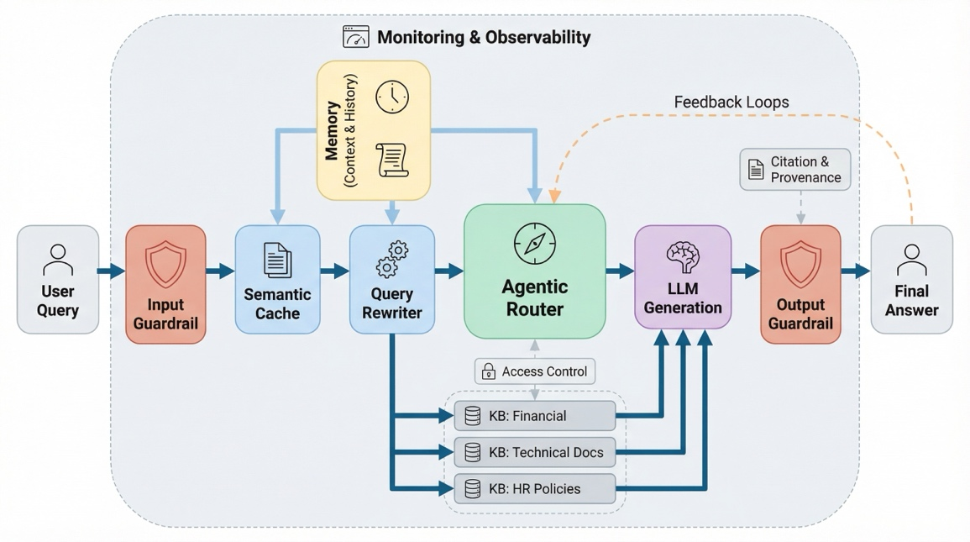

Figure 7.1 Enterprise RAG: A modular framework that uses a central decision-making hub to route requests through specialized knowledge repositories and safety guardrails for high-precision results.
Agentic Routing sits at the core of this architecture, acting as the system's decision-making brain. Rather than treating all queries identically, agentic routers analyze incoming requests, classify their intent, and dynamically direct them to the most appropriate retrieval mechanisms and language models. A factual lookup, an analytical request, a creative task, and an operational command each require fundamentally different approaches, and potentially different underlying models. This routing not only improves response quality but also optimizes resource utilization and reduces computational costs.

Guardrails provide the safety and compliance layer that enterprise deployments demand. Input guardrails validate and sanitize incoming queries, detecting prompt injection attempts, filtering harmful or out-of-scope requests, and enforcing organizational policies before a query ever reaches the retrieval pipeline. Output guardrails perform similar validation on generated responses, ensuring they don't leak sensitive information, violate compliance requirements, or produce harmful content. In regulated industries like finance, healthcare, and legal services, guardrails are not optional enhancements, they are foundational requirements without which no RAG system can be deployed to production.

Memory enables RAG systems to maintain context across interactions, transforming stateless question-answering into coherent, multi-turn conversations. Short-term memory tracks the current conversation thread, allowing follow-up questions like "What about last quarter?" to resolve correctly without restating the full context. Long-term memory captures user preferences, past interactions, and learned patterns over time, enabling the system to personalize responses and anticipate information needs. Without memory, every query exists in isolation, forcing users to repeatedly provide context and leading to frustrating, inefficient interactions.

Query Rewriting addresses a fundamental challenge in enterprise search: users rarely formulate perfect queries on their first attempt. A query rewriter takes the user's raw input and transforms it into one or more optimized queries that are better suited for retrieval. This might involve expanding abbreviations ("Q3 rev" becomes "third quarter revenue 2024"), decomposing complex multi-part questions into simpler sub-queries, resolving ambiguous references using conversation history, or reformulating vague requests into precise search terms. Effective query rewriting can dramatically improve retrieval precision without requiring any changes to the underlying knowledge base or embedding models.

Semantic Caching complements these capabilities by storing and retrieving previously computed results based on semantic similarity rather than exact query matching. While traditional caching systems only help with identical repeat queries, semantic caching recognizes that questions like "What are the Q3 revenue figures?" and "Show me third quarter earnings" are semantically equivalent and can share cached results. In enterprise environments where similar questions are asked repeatedly across teams and departments, semantic caching dramatically reduces response times, lowers API costs, helps meet strict latency SLAs, and avoids hitting rate limits, all without compromising response quality or freshness.

Beyond these core components, Enterprise RAG architectures may also incorporate feedback loops for continuous improvement, access control layers that enforce document-level permissions, citation and provenance tracking for auditability, and monitoring and observability systems that provide real-time visibility into system performance and decision-making. Each of these components addresses a specific enterprise requirement that naive RAG architectures simply cannot fulfill.
####

  - Agentic Routing

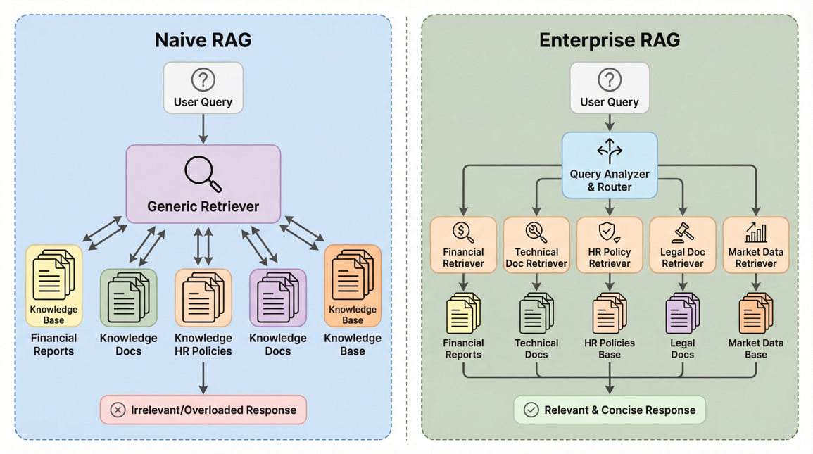

The reality is that enterprises don't need a single, monolithic RAG system, they need intelligent, adaptive architectures that can understand query intent, route requests to appropriate knowledge sources, and dynamically adjust their behavior based on context and user requirements. This is where the concept of Enterprise RAG emerges, representing a paradigm shift from simple retrieval-and-generate workflows to sophisticated, multi-agent systems capable of reasoning about queries and orchestrating complex information retrieval strategies.
At the heart of Enterprise RAG lies the concept of agentic routing, intelligent systems that can analyze incoming queries, classify their intent, and dynamically route them to the most appropriate retrieval mechanisms and language models. Rather than treating all queries identically, agentic routers can distinguish between factual lookups, analytical requests, creative tasks, and operational commands, each requiring different approaches and potentially different underlying models. This intelligent routing not only improves response quality but also optimizes resource utilization and reduces computational costs.
Complementing this intelligent routing capability is semantic caching, a sophisticated approach to storing and retrieving previously computed results based on semantic similarity rather than exact query matching. While traditional caching systems only help with identical repeat queries, semantic caching recognizes that questions like "What are the Q3 revenue figures?" and "Show me third quarter earnings" are semantically equivalent and can share cached results. This dramatically reduces response times, lowers API costs, and improves system scalability without compromising response quality.
Throughout this chapter, we'll build these enterprise capabilities from the ground up, starting with a comprehensive understanding of why naive RAG fails in complex environments, then progressing through the implementation of sophisticated agentic routing mechanisms that can intelligently classify and direct queries. We'll explore how to build routing systems that learn from user interactions, adapt to changing requirements, and provide transparency in their decision-making processes.
Our semantic caching implementation will demonstrate how to capture and reuse semantic meaning across similar queries, dramatically improving system performance while maintaining the accuracy and freshness of responses. By combining these capabilities, we'll create RAG systems that don't just retrieve and generate, they think, learn, and adapt to provide enterprise-grade intelligence that scales with organizational complexity.
The techniques we explore in this chapter lay the groundwork for the full agentic RAG systems we'll develop in Chapter 8, where these routing and caching capabilities will enable autonomous agents to conduct complex, multi-step reasoning tasks across vast enterprise knowledge landscapes.

##################

In the previous chapters, we've explored two powerful paradigms in modern AI: semantic search using encoder models and text generation using decoder models (LLMs). While each of these technologies is impressive, their true potential emerges when we combine them. This combination, known as Retrieval Augmented Generation (RAG), represents a significant advancement in building intelligent systems that are both knowledgeable and articulate.
As we discussed in Chapter 5, the fundamental challenge with large language models is their tendency to hallucinate or generate plausible sounding but potentially incorrect information. While they excel at understanding and generating human-like text, they lack access to current, verified information about specific domains. This limitation becomes particularly apparent in applications like our Travelle hotel search system, where accuracy and up-to-date information are crucial for providing valuable recommendations to users.
RAG addresses this limitation by grounding LLM responses in factual, retrieved information. By utilizing our semantic search capabilities to retrieve relevant information from our databases and then informing and guiding the LLMs' responses, we can ensure that our systems provide accurate, current, and contextually relevant information. This approach combines the precision of search with the natural language capabilities of LLMs, creating systems that can both understand user queries and respond with accurate, well-articulated information.

Retrieval Augmented Generation (RAG) eliminates or reduces hallucinations by grounding LLM responses in factual, retrieved information.

This chapter will explore how to implement RAG through two compelling applications. First, we'll expand our Travelle application to demonstrate how RAG can transform hotel search from simple listings into personalized, conversational recommendations. Second, we'll build a research agent that can find and synthesize relevant academic papers based on natural language queries, showcasing RAG's versatility across different domains and use cases.
In our Travelle example, we'll see how to effectively combine our semantic search system with LLM-powered text generation to create responses that are not only accurate but also personalized and engaging. Instead of presenting users with raw hotel data, our RAG-enhanced system will provide thoughtful analyses, comparative insights, and contextual recommendations that feel like getting advice from a knowledgeable travel expert.
Our research agent will demonstrate RAG's power in academic contexts, where precision and source attribution are paramount. Users will be able to ask questions like "What are the latest developments in neural network architectures for natural language processing?" and receive comprehensive answers that synthesize information from multiple research papers, complete with proper citations and source references.
RAG combines the strengths of retrieval systems, like the ones we built in previous chapters, with the generative power of decoder models. By leveraging retrieved information to guide the generation process, RAG enables our systems to provide more human-like responses and more natural, contextually relevant information to users. This represents a fundamental shift from traditional search interfaces toward conversational AI that can reason about and synthesize information.
We will explore the need for chunking larger documents to optimize search performance and improve the relevance of retrieved information. By breaking down abstracts of research papers into smaller, more focused chunks, we can enhance the precision of our search results and provide users with the most pertinent information. This chunking strategy becomes particularly crucial when dealing with lengthy documents like academic papers, where relevant information might be scattered across different sections.
Furthermore, we will explore Vector Databases as an alternative to FAISS. Vector Databases offer specialized storage and retrieval capabilities for high-dimensional vectors, making them well-suited for production semantic search tasks. We will investigate the advantages of using Vector Databases and how they can seamlessly integrate with our existing search architecture. We also welcome our contributor, Andre Zayarni (https://www.linkedin.com/in/zayarni/), Co-founder and CEO of Qdrant, one of the most popular Vector Database companies, who will share insights on building scalable vector search systems.
As we progress through the chapter, we will explore the trade-offs between using industrial-grade Language Models (LLMs) and open-source alternatives. While industrial LLMs like GPT-4, Claude, and others available through OpenRouter offer state-of-the-art performance and reliability, open-source alternatives provide flexibility, customization options, and cost-effectiveness. We'll demonstrate how to leverage OpenRouter as a unified gateway to multiple LLMs, allowing us to experiment with different models and find the optimal balance between performance, cost, and specific use case requirements.
By the end of this chapter, you will have gained a comprehensive understanding of Retrieval Augmented Generation, the benefits of chunking larger documents, the role of Vector Databases in production systems, and the considerations for choosing between different LLM providers. You'll have built two complete RAG applications that demonstrate the versatility and power of combining retrieval and generation, providing a solid foundation for implementing RAG in your own projects.

  - Retrieval Augmented Generation (R.A.G)

RAG is a powerful approach that combines the strengths of retrieval systems and generative models to enhance the performance and capabilities of natural language processing tasks. In Chapter 1, we introduced the concept of RAG and its potential to revolutionize the way we interact with and generate text. In Chapter 3, we further explored the architecture and components of RAG systems, setting the stage for their application in semantic search.
At its core, RAG aims to leverage the vast information available in external knowledge sources to guide and improve text generation. Decoder models, such as ChatGPT, rely solely on the patterns and relationships learned from the training data to generate text. While these models have achieved remarkable success in various tasks, they often struggle with generating factually accurate and contextually relevant information, especially when dealing with domain-specific or rare knowledge.
This is where RAG comes into play. By integrating a retrieval component into the generation process, RAG enables the model to access and utilize relevant information from external sources dynamically. As illustrated in the figure 5.1, the RAG architecture consists of several key components: Query Processing, Knowledge Base, Document Embeddings, Retrieval System, Document Retriever, Context, Prompt, Decoder Model, and Generated Response.

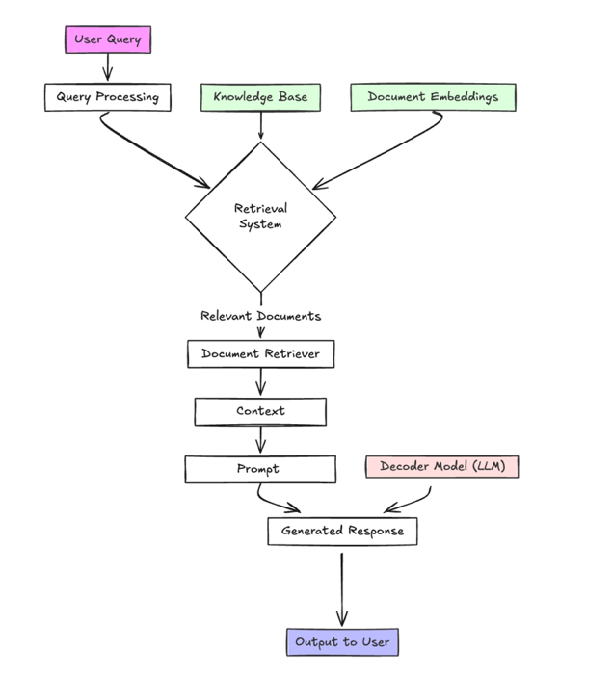

Figure 6.1 Architecture of a Retrieval Augmented Generation (RAG) system showcasing the integration of retrieval and generative components for enhanced natural language processing tasks.
The retrieval component (our search engine), acts as a knowledge retriever, searching through a large corpus of text to find the most relevant passages or documents based on the input query or context. The retrieved information is then fed into the generative model, which uses it to guide and inform the text-generation process. The generative model can attend to the retrieved information, extracting key facts, entities, and relationships that are relevant to the current context. This allows the model to generate text that is not only fluent and coherent but also factually accurate and contextually appropriate.
One of the key advantages of RAG is its ability to handle a wide range of knowledge domains and adapt to different contexts. By leveraging external knowledge sources, RAG can generate text that is informed by up-to-date and domain-specific information, even if such information was not present in the training data. This is particularly valuable in scenarios where the training data may be limited or rapidly evolving, such as in news summarization, question-answering, or dialogue systems.
We usually start with a search engine for RAG. To generate the embeddings, we can simply use the Sentence Transformers (as seen in the last two chapters). Once the relevant information is retrieved, the generative model takes over. As depicted in the figure, the retrieved documents are processed and fed into the Context component, which is then used as input to the Prompt. The Prompt serves as the input to the Decoder Model, which generates the final response. The retrieved passages or documents are typically concatenated with the input query or context, forming a unified input sequence for the generative model. The model then attends to this input sequence, using attention mechanisms to focus on the most relevant parts of the retrieved information.
The attention mechanism allows the model to dynamically weigh the importance of different parts of the retrieved information based on their relevance to the current generation context (Covered in Chapter 3). This enables the model to selectively incorporate the most salient facts, entities, and relationships from the retrieved passages into the generated text. Let’s explore how generation would work using OpenAI’s GPT 4o model.
In the last chapter, we used Open AI’s gpt-4o model to build our basic RAG, now we will use a OpenRouter, a unified platform which allows us to use, potentially any LLM (Open Source or Industrial) as our endpoint. To get started, just like Open AI, we would need to sign up on OpenRouter website and create an API Key. So why OpenRouter: it provides a unified API to access and manage multiple LLMs through a single interface, offering benefits like cost optimization, standardized API access, and access to a wider range of models. This means developers can easily switch between different models and providers without rewriting code, and they can also let users choose their preferred models.
They also offer free usage for certain LLMs (usually the newer ones) to allow users to access them free of cost.
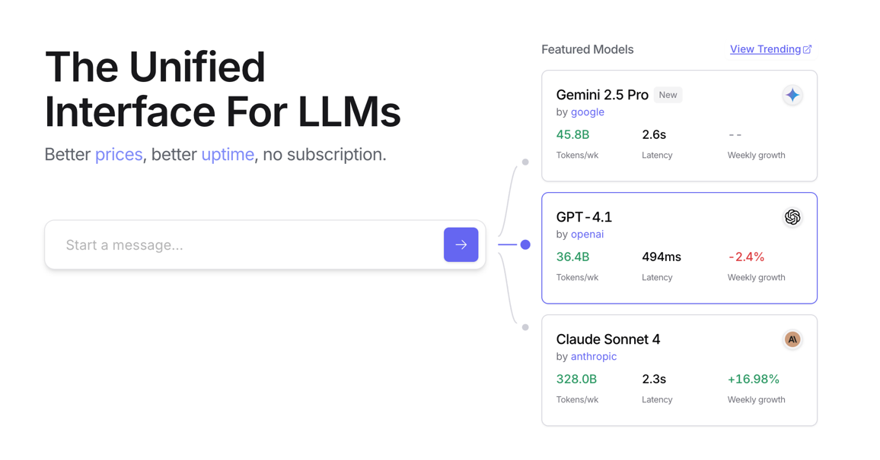

Figure 6.2 OpenRouter.ai landing page, allowing access to potentially any LLM Endpoint
Let’s get started with building a full-fledged RAG tool for our travelle hotel search. We are essentially going to combine code from Chapter 4 and 5.
Listing 6.1 Complete code for RAG with Search with LLM endpoint (colab link)

Step 1: Install and load the required python packages

!pip install huggingface
!pip install -U datasets
!pip install sentence-transformers
!pip install faiss-cpu
!pip install einops

import pandas as pd
from datasets import load_dataset
from sentence_transformers import SentenceTransformer
import torch
import scipy.spatial
from datasets import load_dataset
import faiss

Step 2: Load the Hotel Dataset

dataset = load_dataset("traversaal-ai-hackathon/hotel_datasets") #A
df=pd.DataFrame(dataset['train'])

df_paris = df.loc[df.locality=='Paris']#B
df_paris.drop_duplicates()
reviews = df_paris['review_text'].tolist()
#A we are loading the same dataset we used in Chapter 4
#B selecting our dataset to Paris Locality only

Step 3: Defining Functions for Search

def get_embeddings(data, model): #A
embeddings = model.encode(data, show_progress_bar=False).astype('float32')
return embeddings

def search_faiss_index(query_embedding, faiss_index, k=5): #B
query_embedding_normalized = query_embedding / np.linalg.norm(query_embedding)
distances, indices = faiss_index.search(query_embedding_normalized, k)
return distances, indices

def create_faiss_index(embeddings): #C
embeddings_normalized = embeddings / np.linalg.norm(embeddings, axis=1, keepdims=True)
index = faiss.IndexFlatIP(embeddings_normalized.shape[1]) #D
index.add(embeddings_normalized)
return index

#A Generates embeddings for a list of text data.
#B Performs a semantic search on a FAISS index using a query embedding.
#C Creates a FAISS index from a set of embeddings.
#D Initialize the FAISS index with cosine similarity (Inner Product)

Step 4: Setting up Embeddings and FAISS

reviews = df_paris['review_text'].tolist()
model = SentenceTransformer("nomic-ai/nomic-embed-text-v1.5", trust_remote_code=True)
if torch.cuda.is_available():
model = model.to('cuda')

review_embeddings = get_embeddings(reviews, model)
faiss_index = create_faiss_index(review_embeddings)

Step 5: Query and Search Results

import json

def search_hotels_by_query(query, model, faiss_index, df, k=25): #A
query_embedding = get_embeddings([query], model)
distances, indices = search_faiss_index(query_embedding, faiss_index, k=k)

results = []
for i, (idx, distance) in enumerate(zip(indices[0], distances[0]), 1):
results.append({
"rank": i,
"hotel_name": df.iloc[idx]['hotel_name'],
"review_text": df.iloc[idx]['review_text'],
"cosine_similarity": float(distance) # Convert float32 to standard float
})

return results

query = "Hotel with a view of the Eiffel tower." #B
json_output = search_hotels_by_query(query, model, faiss_index, df_paris, k=25)
json_output

#A Performs a semantic search for hotels based on a query using a FAISS index.
#B Example usage

##output:
[{'rank': 1,
'hotel_name': 'Pullman Paris Eiffel Tower Hotel',
'review_text': 'Excellent service. Stunning view of the Eiffel towere from our balcony, The room is gorgeous, comfortable and spacious. Definitely will be recommending this hotel to family and friends. If you’re looking for a hotel that has everything you need in Paris, luxury and view, this is the one.',
'cosine_similarity': 0.8226630687713623},
{'rank': 2,
'hotel_name': 'Pullman Paris Eiffel Tower Hotel',
'review_text': 'If you stay at this hotel it is for the amazing views of the Eiffel Tower and for the pictures. The photos and memories of being on the balcony looking at the Eiffel Tower in all its splendor cannot be denied. When we arrived we were impressed with proximity of hotel to the Eiffel Tower. Definitely within walking distance, 7 minutes, we could even see our hotel when we climbed up the tower later that day . The view itself is spectacular!! We were upgraded to a suite top floor (9th floor) with a balcony. My kids had a seperate room , the view with no balcony, twin beds. They loved the view. That was an experience of a lifetime. Breakfast was good. I did feel it was overpriced for what you get, cereal, fruit, eggs, different teas, water. But the selection was enormous and',
'cosine_similarity': 0.8078267574310303},
{'rank': 3,
'hotel_name': 'Citadines Tour Eiffel Paris',
'review_text': 'Had a Eiffel tower balcony view room and the view did not disappoint was absolutely amazing and so nice to see everyone from the room or balcony. Staff at reception were nice and was no problem in checking out 1 hour later for free. Very clean hotel. ',
'cosine_similarity': 0.7935440540313721},
{'rank': 4,
'hotel_name': 'Hotel Marignan Champs-Elysees',
'review_text': 'Very good hotel near the Champs-Elysees. The superior rooms are very nice and a good size. The Eiffel Tower suite has an excellent view of the Eiffel Tower. Within walking distance of many things but far enough away from the Champs to feel like you are not right in the middle of a tourist spot. The thing that makes this hotel is the staff. They are helpful and willing to do anything they can to make your stay perfect. ',
'cosine_similarity': 0.7929470539093018},
{'rank': 5,
'hotel_name': 'Hotel Tourisme Avenue',
'review_text': 'Nice Hotel only a few minutes away from Eiffel tower. 3 Metro lines in Front of the hotel, supermarket and restaurants very close. Small but nice and clean rooms, good bed, very friendly and helpful personal, very good breakfast buffet. ',
'cosine_similarity': 0.7913917899131775},
{'rank': 6,
'hotel_name': 'Passy Eiffel Hotel',
'review_text': 'Had a great stay at this hotel for a few nights. Comfortable, clean room with a balcony overlooking the street. Not touristy even though it is really close to the Eiffel Tower. Walk the back streets and you find a variety of great places to eat. Hotel staff was helpful and friendly. Would definitely stay there again.',
'cosine_similarity': 0.7903724908828735},
So far, we have the results from our original query, we can now produce a personalized results which can serve as a summary of all our findings and list the most relevant information needed.

Step 6: Combining query results with an LLM using Open Router’s API

OPEN_ROUTER_API_KEY = userdata.get('OPEN_ROUTER_API_KEY')#A

from openai import OpenAI
open_router_client = OpenAI( #B
base_url="https://openrouter.ai/api/v1", #C
api_key=OPEN_ROUTER_API_KEY,
)

#A Retrieve API key securely from Colab user data
#B Initialize the OpenAI-compatible client, but point it to OpenRouter's API instead of OpenAI's
#C OpenRouter is a gateway to multiple LLMs like GPT, Claude, Mistral, and others, through one unified API

Step 7: Define a function that uses a language model to generate an answer based on a user's query

def generate_answer(query):
json_output = search_hotels_by_query(query, model, faiss_index, df_paris, k=25)
prompt = f""" #A
Based on the following query from a user, please generate a small answer
focusing on the original query and the response given. The answer should be paragraphs.
Remove the special characters and (/n), make the output clean and long.
Please cite source for each part as [1][2].
Just start with the answer, no need to give any salutations. #B

###########
query:
"{query}" #C

########

context:
"{json_output}" #D
#####

Return in Markdown format.
""" #C
stream = open_router_client.chat.completions.create(
model="qwen/qwen3-8b", # Model to use (can be any OpenAI-compatible model, change the model here as needed)
messages=[
{
"role": "user",
"content": prompt,
},
],
stream=True, #E
)

# Initialize a variable to hold the full response
output_text = ""

# Iterate through the streaming response chunks
for chunk in stream:
if chunk.choices[0].delta.content is not None:
content = chunk.choices[0].delta.content
output_text += content # Append new content to the full output
print(content, end="") # Print each chunk live as it's received

return output_text,json_output #F

#A Build the prompt that will be sent to the LLM
#B Instructions to clean and format the answer
#C The user's original query
#D The context retrieved from Search Function (via semantic search)
#E Enable streaming, so we get partial output as it generates
#F Return both the final answer and the context used (for reference or display)

Step 8: Final Answer and Usage Example
query = "Hotels with a view of the Eiffel Tower"
response,sources = generate_answer(query)

Pullman Paris Eiffel Tower Hotel is highly recommended for its exceptional view of the Eiffel Tower, with multiple reviews highlighting the stunning balcony vistas and the ability to capture memorable photos of the landmark [1]. The hotel’s proximity to the Eiffel Tower allows guests to enjoy walking distances and even spot the tower from their room or balcony [2]. Its superior rooms and suites, particularly those on the top floor, offer panoramic views, making it a top choice for travelers seeking both luxury and a direct sightline to the iconic structure [1].

Hotel Marignan Champs-Elysees is another notable option, praised for its Eiffel Tower suite with an excellent view. While not as close as some other hotels, it provides a balanced location near the Champs-Elysees, offering convenience without the overwhelming tourist atmosphere [3]. The staff’s helpfulness and the cozy, clean accommodations further enhance its appeal, especially for those prioritizing comfort and service [11].

Hotel Tourisme Avenue is conveniently located just minutes from the Eiffel Tower, with reviews emphasizing its accessibility via three metro lines and nearby amenities like supermarkets and restaurants [4]. The small but well-maintained rooms and friendly staff contribute to a pleasant stay, while the breakfast buffet is described as a highlight [8]. Some guests also noted the view from their rooms, though it may not be as direct as other options [23].

Citadines Tour Eiffel Paris offers affordable apartments with Eiffel Tower views, particularly from the kitchen area where guests can see the top of the tower [5]. The property is praised for its modern decor, clean environment, and helpful front desk staff, though the rooms are not considered luxurious [10]. Despite its budget-friendly pricing, it remains a popular choice for families due to its spacious layout and kitchen facilities [6].

Passy Eiffel Hotel is frequently mentioned for its balcony views of the Eiffel Tower, with guests appreciating the serene setting despite its proximity to the landmark [7]. The hotel’s staff is noted for being friendly and accommodating, and the breakfast is described as outstanding [13]. Its location allows easy access to major attractions like the Louvre and Notre Dame, with a 15-minute walk to the Eiffel Tower [19].

Hotel La Comtesse stands out for its prime location near the Eiffel Tower and its ability to upgrade guests to a better view room [12]. Reviews highlight the modern amenities, comfortable beds, and excellent breakfast options, along with the hotel’s charm and safety features [17]. The staff’s attentiveness and the convenience of nearby metro access make it a favorable choice for visitors [22].

Cler Hotel is praised for its Eiffel Tower view rooms and proximity to the landmark, with guests noting the cleanliness and helpful staff [9]. While the rooms are smaller than expected, the view and location are significant draws, especially for those seeking a more intimate experience [21]. The hotel’s ability to accommodate last-minute stays and its friendly atmosphere add to its appeal [21].

This example perfectly demonstrates the transformative power of RAG over traditional search results. Instead of presenting users with raw hotel data, JSON outputs, or simple ranked lists, our RAG system synthesizes information from multiple sources into a comprehensive, readable response that directly addresses the user's specific query about "Hotels with a view of the Eiffel Tower."
The generated response showcases several key advantages over plain search results. First, it provides contextual analysis by comparing different hotels and their specific view offerings, from the Pullman's "exceptional view" with "stunning balcony vistas" to Citadines' more modest kitchen-area views. Second, it synthesizes information from multiple data points, room types, guest reviews, location details, and amenities, into coherent paragraphs that tell a complete story about each property. Third, it maintains source attribution through numbered citations, allowing users to trace specific claims back to their origins while presenting information in a natural, conversational format that's far more digestible than raw search results.
Looking at the code structure, we can see how each component contributes to this enhanced experience.

The prompt construction:
- (#A) carefully instructs the LLM to generate clean, paragraph-formatted responses with proper citations. The formatting instructions
- (#B) ensure the output is polished and professional, removing technical artifacts that might confuse users. The user's original query
- (#C) is preserved to maintain focus and relevance, while the retrieved context
- (#D) provides the factual foundation that prevents hallucination. The streaming functionality
- (#E) enables real-time response generation, creating a more interactive experience, and the dual return values
- (#F) provide both the polished response and the raw sources for transparency or further reference.
While our RAG was successful, it only covered one city Paris, to make it scalable across multiple cities, we will use Vector Database, Qdrant, in our next section, to help us with not only retrieve the relevant reviews but use the filters within the meta data to select the appropriate city.
In section 6.3, we'll explore the concept of chunking, a critical technique for breaking down extensive documents into manageable pieces that can be effectively searched and retrieved. Imagine trying to find relevant information in a 50-page hotel brochure or a 30-page research paper; without proper chunking, our system might miss crucial details buried in the middle of these documents or struggle with context window limitations that prevent the LLM from processing such large inputs effectively.

  - Using Vector Databases: For scalability and enhancing search capabilities

In this section, we will explore how vector databases can enhance our search capabilities for scalability. As discussed in previous chapters, Vector Databases serve as a good and practical replacement for FAISS. Not only we will now use Vector Database for embedding retrieval, but we will also focus on utilizing their meta data filtering capabilities find the most relevant embeddings for our query. With a vast collection of reviews spanning multiple cities and languages, finding appropriate responses becomes more challenging as the dataset expands. However, vector databases allow us to efficiently retrieve the most relevant results based on similarity scores and meta data, enabling us to provide users with a personalized experience.

Until now we had only limited ourselves to one city, i.e. Paris for all searches, consider the following code:

distances, indices = search_faiss_index(query_embedding, faiss_index, k=k)

If we haven't already filtered our city, the code above will search through each embedding, and for a query like, "Hotel which is centrally located, close to all attractions and has great food nearby," it will end up getting results for all hotels that match this query across all cities. This can result in irrelevant or unnecessary information being retrieved, leading to less personalized recommendations.
We often want to work with a system that considers diversity when generating responses, ensuring a range of options are presented to users. By introducing filtering based on specific criteria like city, location, and preferences, the search process can be parameterized to provide more relevant results. This not only enhances the user experience but also saves time by avoiding the need for manual sifting through irrelevant content.
Let’s expand our search and RAG capabilities, across multiple cities, we will be utilizing pretty much all the code from our previous listing, just replacing FAISS with Qdrant and adding meta data filters.

Listing 6.2 Expanding search and RAG across multiple cities (colab link)

Step 1: Install and load the required python packages
!pip install qdrant_client #A
from qdrant_client import QdrantClient, models #B

client = QdrantClient(":memory:")#C #D
text_embeddings_size = 768 #E
#A: Import necessary modules from the Qdrant client library
#B: Qdrant allows you to store and search high-dimensional vector embeddings efficiently
#C: Create a new Qdrant client instance using in-memory storage
#D:":memory:" means the data will be stored temporarily in RAM (not saved to disk)
#E: Display the size (number of dimensions) of the text embeddings we generated earlier

Step 2: Pulling data for all cities and Embedding them
dataset = load_dataset("traversaal-ai-hackathon/hotel_datasets")
df_all=pd.DataFrame(dataset['train'])
df_all.drop_duplicates()
reviews_df = df_all.dropna(subset=['review_text'])
reviews = reviews_df['review_text'].tolist()

review_embeddings = get_embeddings(reviews, model)#A

#A: Generate Embeddings for all reviews

Step 3: Creating Qdrant Collection
Define the name of the collection we want to manage in Qdrant. A collection in Qdrant is like a table in traditional databases , it stores a group of vectors and their associated metadata.

try:

if client.collection_exists(collection_name):#A

client.delete_collection(collection_name=collection_name)
print(f"Collection '{collection_name}' deleted successfully.")
client.create_collection(
collection_name=collection_name, #B

vectors_config=models.VectorParams(
size=text_embeddings_size,
distance=models.Distance.COSINE
),
)

print(f"Collection '{collection_name}' created successfully.") #C

except Exception as e:
print(f"An error occurred while setting up the collection: {e}")

#A: If the collection already exists, delete it to ensure we're starting fresh.
#B: The name of the new collection being created
#C: Print a confirmation that the collection was created successfully.

Step 4: Implement Qdrant Search

Prepare the data for uploading to Qdrant, we need to create "points", where each point contains:
- An `id` (unique identifier for the point/review)
- A `vector` (the embedding of the review text)
- `payload` (metadata associated with the vector, like hotel name, city, etc.)

points_to_upload = [
models.PointStruct(
id=i, # Use the index as the unique ID
vector=review_embeddings[i].tolist(),
payload={
"hotel_name": reviews_df.iloc[i]['hotel_name'],
"review_text": reviews_df.iloc[i]['review_text'],
"locality": reviews_df.iloc[i]['locality'], # Include locality for filtering
},
)
for i in range(len(review_embeddings))
]

client.upsert(
collection_name="hotel_reviews", #A
wait=True,
points=points_to_upload,
)

#A: Upload the created points to the Qdrant collection in batches

Step 4: Function to search Qdrant with an optional city filter

def search_qdrant_with_filter(query, model, client, city=None, k=10): #A

query_filter = None
if city:
query_filter = models.Filter( #B
must=[
models.FieldCondition(
key="locality",
match=models.MatchValue(value=city)
)
]
)

text_hits = client.query_points(
collection_name="hotel_reviews",
query=query_embedding,
query_filter=query_filter,
limit=k,
with_payload=True,
).points

return text_hits

#A: Performs a semantic search on the Qdrant collection with an optional city filter.
#B: Perform the search

Step 5: Modify the generate_answer function to use Qdrant search

def generate_answer_qdrant(query, city=None):

qdrant_results = search_qdrant_with_filter(query, model, client, city=city, k=25)
context_string = ""
for i, result in enumerate(qdrant_results):
context_string += f"Source {i+1}:\n"
context_string += f"Hotel: {result.payload.get('hotel_name', 'N/A')}\n"
context_string += f"Review: {result.payload.get('review_text', 'N/A')}\n"
context_string += f"Locality: {result.payload.get('locality', 'N/A')}\n"
context_string += f"Similarity Score: {result.score:.4f}\n\n"

prompt = f"""
Based on the following query from a user and the provided context from hotel reviews,
please generate a concise answer summarizing the relevant information.
Focus on addressing the user's query using details found in the reviews.
Cite the sources using numerical references like [1], [2], etc., corresponding to the "Source #" in the context.
Format the output as a few paragraphs.
Remove any special characters like (/n) and ensure the output is clean.
Begin directly with the answer.

###########
query:
"{query}"

########

context:
"{context_string}"
#####

Return in Markdown format.
"""

stream = open_router_client.chat.completions.create(
model="qwen/qwen3-8b",
messages=[
{
"role": "user",
"content": prompt,
},
],
stream=True,
)

output_text = ""

for chunk in stream:
if chunk.choices[0].delta.content is not None:
content = chunk.choices[0].delta.content
output_text += content
print(content, end="")
return output_text, qdrant_results #A

#A Return the generated text and the Qdrant search results

Step 6: Query for hotels with generic example

query= "Amazing hotel close to everything"
city_filter = "Istanbul"
response_paris, sources_paris = generate_answer_qdrant(query, city=city_filter)

print("\n--- Generated Answer (City Filter) ---")#A

print("\n--- Sources Used (City Filter) ---")
for i, result in enumerate(sources_paris):
print(f"Source {i+1}: Hotel: {result.payload.get('hotel_name', 'N/A')}, Locality: {result.payload.get('locality', 'N/A')}, Score: {result.score:.4f}")

print("\n" + "="*50 + "\n") # Separator

#A: Print personalized answer from the LLM
#B: Print details about the sources (Qdrant results) that were used

Several hotels in Istanbul are highlighted for their exceptional location and proximity to major attractions and amenities. The White House Hotel Istanbul is praised for its beautiful, unique design and convenient location, with a walking distance to main attractions and numerous restaurants nearby [1]. Skalion Hotel & Spa is noted for being within walking distance of iconic sites like the Blue Mosque and Hagia Sophia, and it offers attached markets, pharmacies, and restaurants, eliminating the need for taxis [2]. Hotel Amira Istanbul is frequently mentioned as a top choice, with its perfect location near attractions and helpful staff who even organized transport and provided itinerary guidance [4]. Tomtom Suites also stands out for its fantastic location and friendly staff, who offered excellent recommendations for dining and made breakfast available in the hotel’s restaurant [5].

Other notable options include the Mula Hotel, which is just a 10-minute walk from landmarks such as Ayasofya and Sultan Ahmed mosques [13], and the Demiray Hotel&Spa, celebrated for its easy access to everything and a stunning Bosphorus view [14]. The InterContinental Istanbul is highlighted for its fantastic location and luxurious rooms with Bosphorus views, along with an amazing breakfast spread [25]. Additionally, the AJWA Sultanahmet and Romance Istanbul Hotel are recommended for their central locations and proximity to tourist spots [11][16]. These hotels consistently emphasize their strategic positions, making them ideal for travelers seeking convenience and ease of access to Istanbul’s cultural and historical sites.
--- Generated Answer (City Filter) ---

--- Sources Used (City Filter) ---
Source 1: Hotel: White House Hotel Istanbul, Locality: Istanbul, Score: 0.7178
Source 2: Hotel: Skalion Hotel & Spa, Locality: Istanbul, Score: 0.7026
Source 3: Hotel: Pera Palace Hotel, Locality: Istanbul, Score: 0.6989
Source 4: Hotel: Hotel Amira Istanbul, Locality: Istanbul, Score: 0.6807
Source 5: Hotel: Tomtom Suites, Locality: Istanbul, Score: 0.6802
Source 6: Hotel: Hotel Amira Istanbul, Locality: Istanbul, Score: 0.6790
Source 7: Hotel: Elite World Grand İstanbul Basın Ekspres, Locality: Istanbul, Score: 0.6787
Source 8: Hotel: Pell Palace Hotel Spa, Locality: Istanbul, Score: 0.6785
Source 9: Hotel: Tomtom Suites, Locality: Istanbul, Score: 0.6776
Source 10: Hotel: Skalion Hotel & Spa, Locality: Istanbul, Score: 0.6770
Source 11: Hotel: AJWA Sultanahmet, Locality: Istanbul, Score: 0.6750
Source 12: Hotel: Ramada by Wyndham Istanbul Old City, Locality: Istanbul, Score: 0.6738
Source 13: Hotel: Mula Hotel, Locality: Istanbul, Score: 0.6737
Source 14: Hotel: Demiray Hotel&Spa, Locality: Istanbul, Score: 0.6726
Source 15: Hotel: Swissotel The Bosphorus, Istanbul, Locality: Istanbul, Score: 0.6725
Source 16: Hotel: Romance Istanbul Hotel, Locality: Istanbul, Score: 0.6714
Source 17: Hotel: Conrad Istanbul Bosphorus, Locality: Istanbul, Score: 0.6710
Source 18: Hotel: Demiray Hotel&Spa, Locality: Istanbul, Score: 0.6696
Source 19: Hotel: Hotel Yasmak Sultan, Locality: Istanbul, Score: 0.6686
Source 20: Hotel: Wyndham Istanbul Oldcity, Locality: Istanbul, Score: 0.6679
Source 21: Hotel: Romance Istanbul Hotel, Locality: Istanbul, Score: 0.6677
Source 22: Hotel: Sura Hagia Sophia Hotel, Locality: Istanbul, Score: 0.6674
Source 23: Hotel: Hotel Amira Istanbul, Locality: Istanbul, Score: 0.6674
Source 24: Hotel: Pera Palace Hotel, Locality: Istanbul, Score: 0.6672
Source 25: Hotel: InterContinental Istanbul, Locality: Istanbul, Score: 0.6667

The implementation of city-based filtering represents a crucial optimization in our RAG system that dramatically improves both relevance and efficiency. When a user searches for "Amazing hotel close to everything" with the city filter set to "Istanbul," our system first applies a metadata filter at the vector database level before performing semantic similarity search. This means that instead of searching through our entire global hotel database, which might contain hundreds of thousands of properties across dozens of cities, we're only querying the subset of embeddings associated with Istanbul hotels. This filtering approach ensures that every single result returned is geographically relevant, eliminating the possibility of retrieving highly rated hotels from Paris or London that might have similar semantic characteristics but are completely irrelevant to someone planning a trip to Istanbul.
The efficiency gains from this filtering approach are substantial, as evidenced by our results showing 25 Istanbul-specific hotels all with strong similarity scores ranging from 0.7178 to 0.6667. Without city filtering, our semantic search might have been diluted with hotels from other cities that happen to match the phrase "close to everything," potentially pushing down more relevant Istanbul options in the ranking. The filtered results demonstrate remarkable precision: hotels like the White House Hotel Istanbul and Skalion Hotel & Spa emerge at the top with the highest similarity scores, while the system successfully identifies properties with strategic locations near major attractions like the Blue Mosque, Hagia Sophia, and the Bosphorus. This targeted approach not only reduces computational overhead by limiting the search space but also ensures that our LLM receives highly relevant context about Istanbul-specific amenities, local attractions, and neighborhood characteristics, enabling it to generate more accurate and locally informed recommendations.
Now that we've demonstrated the power of vector databases with metadata filtering in our hotel search system, we're ready to explore a more complex and intellectually demanding application: building a Research RAG system for academic paper discovery and analysis. This next example will showcase how the chunking approaches we discussed earlier come into play when dealing with dense academic content, where precision and scholarly accuracy are paramount. Unlike hotel descriptions that focus on amenities and location, research papers contain complex methodologies, technical terminology, and interconnected concepts that require sophisticated chunking strategies to extract meaningful insights. We'll implement a system that can answer queries like "What are the latest developments in neural network architectures for natural language processing?" by intelligently retrieving and synthesizing information from multiple research paper abstracts, demonstrating how RAG can transform academic research workflows.
Before that, I had the opportunity to connect with Andre, Co-Founder & CEO of Qdrant, who was nice enough to give a great overview on what his journey has been in building the company from ground up.
SPOT-LIGHT: Qdrant, an Introduction (Contribution by Andre Zayarni, Co-Founder & CEO, Qdrant)

The original idea of ​​developing Qdrant as a dedicated vector search engine arose from the need to combine pure similarity search with additional business logic in the form of filters for metadata fields. In vector search applications, it's common to associate vectors with additional metadata, attributes that provide contextual information about the data points. Efficiently filtering vectors based on this metadata during search operations is crucial for almost all real-world applications, such as recommendation systems, anomaly detection, and semantic search solutions.
The standard HNSW algorithm excels at approximate nearest neighbor searches in high-dimensional spaces but falls short when it comes to filtering based on metadata. This limitation arises because the HNSW structures are not inherently designed to handle complex filtering criteria during the search process. As a result, implementing metadata filtering typically involves pre- or post-processing steps that significantly degrade performance and accuracy.
Qdrant addresses this challenge by introducing a custom filterable HNSW implementation. This innovative approach integrates metadata filtering directly into the search algorithm, eliminating the need for inefficient post-processing. The HNSW graph is modified to include metadata-aware connections. Each node in the graph retains information about the metadata associated with its vector, allowing the search algorithm to consider filtering criteria during traversal. During the search, Qdrant's algorithm selectively explores neighboring nodes that satisfy the specified metadata filters. This selective exploration reduces unnecessary computations and focuses the search on relevant portions of the graph.
Qdrant supports complex filtering conditions and multiple index datatypes, including numerical ranges, keywords, full-text, geo coordinates, and more. It optimizes data structures to handle metadata efficiently, minimizing overhead and ensuring that the inclusion of metadata does not adversely affect search speeds.
Besides the extended metadata filtering support, Qdrant provides several additional features for advanced vector search:
- Payload-based vector index partitioning and custom sharding for scalable multitenant applications.
- Hybrid search with Sparse Vectors, to combine the power of pure vector-based lexical search with semantic vector search.
- Native multi-vector search support for applications where data points are represented by more than one vector, capturing different aspects or modalities of the data. Multi-vector search is also compatible with late-interaction models like ColBERT, which is highly recommended as a reranking step when working with high-dimensional similarity searches.
- For flexible resource management, Qdrant allows dynamic offloading of vectors and payload data to cold storage layers. Moreover, the inherent support for various types of quantization for real-time vector data compression allows for effective memory resource reduction and notable performance enhancement.

For developers and organizations dealing with complex vector data and requiring sophisticated filtering mechanisms and advanced vector search capabilities, Qdrant offers a powerful solution. The engine core is implemented with Rust which ensures that the database is both fast and reliable, capable of handling large-scale, high-throughput applications with low latency. Its open-source nature encourages community collaboration and continuous improvement, positioning it as a leading choice in the vector database landscape.

  - Document Chunking: Overcoming Context Length Limitations, the need for chunking

Now that we have implemented our Vector Databases, we must address a fundamental technical constraint that affects all embedding models: context length limitations. Unlike the scaling approaches we see in large language models, embedding models face unique challenges when processing lengthy documents that cannot be solved simply by increasing computational resources. What does that mean? It means, we cannot embed an entire document, unless it’s limited to a certain token length, if the threshold is crossed our embedding models will ignore all the text outside the token length or the context window.

    - The Technical Reality of Context Windows in Embedding Models
Embedding models, including the sentence transformers we've been using, operate with fixed context windows that define the maximum number of tokens they can process in a single forward pass. Our Nomic Embed Text model, for instance, has a context window of 8,192 tokens, meaning it can process text inputs with up to 8,192 tokens when generating embeddings. To put this in perspective, this translates to approximately 6,000-7,000 words of English text, depending on the complexity of the vocabulary and tokenization patterns.
This limitation stems from the fundamental architecture of transformer-based embedding models. The self-attention mechanism that enables these models to understand contextual relationships operates with quadratic complexity, meaning that processing time increases exponentially with sequence length. When we feed a document with 8,192 tokens into our embedding model, the attention mechanism must compute relationships between every token and every other token, resulting in roughly 67 million attention computations. Doubling the context length would quadruple the computational requirements, making it prohibitively expensive for most applications.

    - The Computational Impossibility of Extending Context
The mathematical reality of extending context windows quickly becomes staggering. Consider what happens when we attempt to double our context length from 8,192 to 16,384 tokens. The attention mechanism must now compute approximately 268 million attention operations, a four-fold increase. But the computational nightmare doesn't stop there. If we were ambitious enough to attempt a 32,768-token context window, we'd be looking at over 1 billion attention computations per document.
To put this in perspective, processing a single 32,768-token document would require the equivalent computational power of several high-end NVIDIA A100 GPUs running continuously for minutes, just to generate one embedding. Imagine trying to process a dataset of 100,000 research papers or hotel descriptions, you'd need a data center's worth of GPU resources, with costs running into hundreds of thousands of dollars per processing run. Even tech giants with virtually unlimited resources find such computational demands impractical for routine embedding tasks.

Processing a single 32,768-token document would require the equivalent computational power of one high-end NVIDIA A100 GPUs running continuously for 4 minutes, just to generate one embedding.

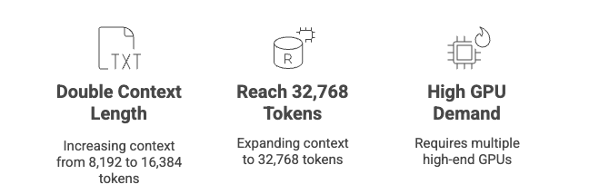

Figure 6.3 Computational Cost of Context Window Expansion
The situation becomes even more dire when we consider that most real-world applications require embedding thousands or millions of documents. A modest hotel database with 10,000 properties, each requiring extended context processing, would demand GPU clusters worth more than most companies' entire IT budgets. The economics simply don't work, we'd be spending astronomical amounts on computational resources for marginal improvements in embedding quality.
More importantly, simply increasing computational power doesn't solve the context length problem in embedding models. Unlike generative models where longer contexts can theoretically improve performance, embedding models face a different challenge: they need to compress all the information from the input text into a fixed-size vector representation. As the input text grows longer, the model must somehow encode an increasing amount of diverse information into the same dimensional space. This leads to what researchers call "information dilution", where important details get lost in the averaging process required to create a single embedding vector.

Taking a Deep Dive in our Claim
The claim states that "Processing a single 32,768-token document would require the equivalent computational power of one high-end NVIDIA A100 GPUs running continuously for 4 minutes, just to generate one embedding."
Let's break this down and fact-check it.
- Generating an embedding for a single 32,768-token document is a computationally intensive task. Embeddings are numerical representations of text, created by complex neural networks like transformer models.
- The computational cost for this process increases significantly with the number of tokens (due to the quadratic scaling of attention mechanisms), the size of the model, and the dimensionality of the resulting embedding.
- The NVIDIA A100 GPU, a high-end accelerator designed for AI, can process approximately 130 tokens per second for large language model inference. Based on this, a rough calculation shows that a single A100 would take around 4.2 minutes to generate an embedding for a 32,768-token document. Therefore, the claim that it would require "minutes" to generate one embedding is quite plausible for an A100.

    - Why More Compute Power Doesn't Help
This is a question frequently asked by developers new to embedding systems: "Why can't we just increase the context length like we do with LLMs?" The answer lies in the fundamental difference between how these models process information. Large language models generate text sequentially, focusing on local context and building meaning incrementally. Embedding models, however, must create a holistic representation of the entire input that captures its semantic essence in a single vector.
Consider the mathematical reality: when we generate embeddings, we're essentially taking the mean of token representations across the entire sequence. If we have a 4,000-token document about hotel amenities and extend it to 8,000 tokens by adding information about local attractions, the resulting embedding must somehow represent both topics equally. This leads to a less specific, more generic representation that may not perform well in similarity searches for either topic.

    - A Practical Example: The Long Document Problem
Let's examine this with a concrete example from our hotel domain. Imagine we have a comprehensive hotel description that includes:

The Grand Hotel Paris offers luxurious accommodations in the heart of the city.
Our 200 rooms feature marble bathrooms, Egyptian cotton linens, and stunning
city views. The hotel boasts five restaurants, including a Michelin-starred
establishment on the 20th floor... [continues for 2,000 words covering rooms,
dining, spa services, business facilities, local attractions, historical
significance, architectural details, sustainability initiatives, etc.]

If we embed this entire document as a single unit, several problems emerge:

- Semantic Dilution: A user searching for "spa services" might not find this document because the spa information represents only a small fraction of the total content, getting lost in the averaging process.
- Context Window Overflow: If the document exceeds 8,192 tokens, the embedding model simply truncates the input, potentially losing crucial information that appears later in the text.
- Retrieval Precision: Even if the document is found, the system would retrieve the entire lengthy description when the user only needed specific information about spa facilities.

    - The Chunking Solution
This is where document chunking becomes essential. Instead of embedding the entire hotel description as one unit, we can break it into focused segments:
Chunk 1: "The Grand Hotel Paris offers luxurious accommodations...
Our 200 rooms feature marble bathrooms, Egyptian cotton linens..."

Chunk 2: "Dining options include five restaurants, with our Michelin-starred
establishment offering panoramic city views..."

Chunk 3: "The hotel's spa facilities span two floors, featuring a heated
indoor pool, sauna, and full-service wellness center..."

Each chunk now contains focused, semantically coherent information that can be embedded effectively within the model's context window. When a user searches for "spa services," the system can retrieve Chunk 3 specifically, providing precise, relevant information without the noise of unrelated content.
This chunking approach transforms our RAG system from a blunt instrument that processes entire documents into a precise tool that can locate and retrieve exactly the information users need. In the following sections, we'll explore different chunking strategies and implement them in both our hotel search system and our research paper agent, demonstrating how proper document segmentation dramatically improves retrieval accuracy and system performance.
The chunking approach becomes even more critical when we venture into academic research domains, where precision and comprehensiveness are paramount. Consider the challenge of building a research agent that can analyze academic papers to answer complex queries like "What are the recent advances in attention mechanisms for computer vision?" Unlike our hotel descriptions, research papers present a unique set of challenges: abstracts that compress months of research into 200-300 words, dense technical content with specialized terminology, and interconnected concepts that span multiple sections.
In our upcoming research paper RAG system, we'll demonstrate how chunking transforms abstract analysis from a crude keyword-matching exercise into a sophisticated understanding tool. A typical research paper abstract might contain information about the problem statement, methodology, experimental setup, results, and conclusions, all compressed into a single paragraph. Without proper chunking, our embedding model would create a generic representation that might miss nuanced queries about specific aspects like "methodology for training transformer models" or "evaluation metrics for attention mechanisms."
By implementing intelligent chunking strategies for research abstracts, we can create focused embeddings that capture distinct semantic concepts. For instance, we might chunk an abstract about neural network architectures into methodology-focused segments, results-oriented segments, and application-specific segments. This allows our RAG system to provide precise answers with proper academic citations, synthesizing information from multiple papers while maintaining the scholarly rigor expected in research contexts. As we'll see in our implementation, this nuanced approach enables researchers to quickly identify relevant work, understand key contributions, and explore connections between different research efforts, transforming how we interact with academic literature in the age of AI.

  - Building Research Paper RAG Tool with Qdrant

Now that we understand the theoretical foundations of chunking and its necessity for handling long documents, let's implement a practical chunking system for our research paper RAG application. This implementation will demonstrate how to break down research abstracts and papers into semantically coherent chunks that can be effectively embedded and retrieved. You will need to setup a Kaggle Account and API key using the Settings Page. We will be using the recursive split chunking approach here.
The Recursive Split in Chunking
When building Retrieval-Augmented Generation (RAG) systems for research papers or long-form documents, it’s not enough to simply split text into equal parts. You need to preserve meaning. That’s where recursive chunking comes in. Recursive chunking is a hierarchical, fallback-based splitting technique. Instead of breaking text blindly by character count, it tries to find natural semantic boundaries, like paragraphs, newlines, sentences, or even words, before giving up and doing a brute-force cut. Let’s break that down:
Why not just split by fixed size?
Imagine you chop a sentence right after 1024 characters. You might end up with:
“In this paper, we show that convolutional architectures are supe”
Not ideal. Embedding this would hurt retrieval because you're embedding broken meaning.
What does "recursive" mean here?
It means the splitter tries to split on the largest meaningful separator first (like \n\n or paragraph breaks). If that doesn't work (e.g., in dense text), it goes to smaller separators, like sentence endings or even spaces. As a last resort, it does a raw character split.
Example heuristic order:
Paragraphs (\n\n)
Sentences (\n)
Phrases (. or ,)
Words ( )
Characters (fallback)
Each recursion step ensures we’re being as graceful as possible before doing violence to the text structure.
Overlap matters too
Even after splitting well, LLMs don’t have persistent memory across chunks. So, if a sentence spans two chunks, and you didn’t preserve that context via overlap, you lose critical continuity. This is why in the simple_recursive_split function, each chunk is preceded by a small slice from the end of the previous one (e.g., last 50 characters). This helps preserve context across embeddings.

Step 1: Data Preparation and Loading (Colab Link)
import pandas as pd
import kagglehub

import kagglehub

kagglehub.login()#A

path = kagglehub.dataset_download("nechbamohammed/research-papers-dataset") #A
df = pd.read_csv("dblp-v10.csv")

df = df[:500] #C
df.dropna(subset=['abstract'], inplace=True)

data = [] #D
for row_num, row in df.iterrows():
if row['abstract'] != 'NaN':
data.append({
"page_content": row['abstract'],
"metadata": {
"source": row["title"],
"authors": row["authors"],
"year": row["year"],
"venue": row["venue"],
"paper_id": row["id"]
}
})

#A: You will have to setup a Kaggle Account and API key in settings page
#B: Download and load research papers dataset
#C: Subset data
#D: Prepare data with metadata for traceability

Step 2: Implement Recursive Split

def simple_recursive_split(docs, chunk_size=1024, chunk_overlap=50, separators=None):
text = docs["page_content"]
metadata = docs["metadata"]

if separators is None:
separators = ["\n\n", "\n", " ", ".", ","]

def split_with_separators(t):
if len(t) <= chunk_size:
return [t]

for sep in separators:
if sep and sep in t:
parts = t.split(sep)
chunks = []
current = ""

for part in parts:
part += sep
if len(current + part) <= chunk_size:
current += part
else:
if current:
chunks.append(current.strip())
current = part

if current:
chunks.append(current.strip())

result = []
for chunk in chunks:
if len(chunk) > chunk_size:
result.extend(split_with_separators(chunk))
else:
result.append(chunk)
return result

return [t[i:i + chunk_size] for i in range(0, len(t), chunk_size)]

splits = split_with_separators(text)

overlapped = []
for i, chunk in enumerate(splits):
if i == 0:
overlapped.append({
"page_content": chunk,
"metadata": metadata
})
else:
overlap = splits[i - 1][-chunk_overlap:]
overlapped.append({
"page_content": f"{overlap} {chunk}",
"metadata": metadata
})

return overlapped

texts = [chunk for doc in data for chunk in simple_recursive_split(doc, 1024, 50)] #A
#A: Apply chunking to all documents

Step 3: Generate Embeddings for Each Chunk
from transformers import AutoTokenizer, AutoModel
import torch

text_tokenizer = AutoTokenizer.from_pretrained("nomic-ai/nomic-embed-text-v1.5", trust_remote_code=True)
text_model = AutoModel.from_pretrained("nomic-ai/nomic-embed-text-v1.5", trust_remote_code=True)

def get_text_embeddings(text):
inputs = text_tokenizer(text, return_tensors="pt", padding=True, truncation=True)
with torch.no_grad():
outputs = text_model(**inputs)
embeddings = outputs.last_hidden_state.mean(dim=1)
return embeddings[0].detach().numpy()

text_embedded = [get_text_embeddings(document["page_content"]) for document in texts] #A

#A: Generate embeddings for all chunks

Step 4: Store Chunks in Vector Database
from qdrant_client import QdrantClient, models
from uuid import uuid4
import numpy as np

client = QdrantClient(":memory:")#A

collection_name = "research_collection" #B
text_embeddings_size = len(text_embedded[0])

client.create_collection(
collection_name=collection_name,
vectors_config=models.VectorParams(
size=text_embeddings_size,
distance=models.Distance.COSINE
),
)

client.upload_points(
collection_name="research_collection",
points=[
models.PointStruct(
id=str(uuid4()),
vector=np.array(text_embedded[idx]),
payload={
"metadata": doc["metadata"],
"content": doc["page_content"]
}
)
for idx, doc in enumerate(texts)
]
)
#A: Initialize Qdrant client
#B: Create collection

Step 5: Implement Research Query Function

def query_qdrant(query, qdrant_client, limit=5):
query_em = get_text_embeddings(query)

text_hits = qdrant_client.query_points(
collection_name="research_collection",
query=query_em,
limit=limit
).points

results = []
for i, point in enumerate(text_hits):
results.append({
'source_id': i + 1,
'content': point.payload['content'],
'metadata': point.payload['metadata']
})

return results

Step 6: Create RAG Generation Function

from openai import OpenAI

open_router_client = OpenAI(
base_url="https://openrouter.ai/api/v1",
api_key=OPEN_ROUTER_API_KEY
)

def generate_answer(query):
prompt = f"""
Based on the following query, generate a comprehensive answer.
Include citations [1][2] and mention authors, paper titles, and venues.
Explain concepts clearly.

Query: "{query}"
Context: "{query_qdrant(query, client)}"

Return in Markdown format.
"""

stream = open_router_client.chat.completions.create(
model="qwen/qwen3-8b:free",
messages=[{"role": "user", "content": prompt}],
stream=True,
)

output_text = ""
for chunk in stream:
if chunk.choices[0].delta.content is not None:
content = chunk.choices[0].delta.content
output_text += content
print(content, end="")

return output_text, query_qdrant(query, client)
This implementation demonstrates how chunking transforms our ability to work with research papers. Instead of treating entire abstracts as monolithic units, we create focused, searchable segments that can be precisely retrieved and synthesized by our RAG system. The chunking approach ensures that specific methodologies, results, or conclusions can be found even within longer documents, making our research agent far more effective at answering targeted academic queries.
  - Summary
- The first step towards building Semantic Search is to identify the data needed to build the engine. For Travelle (hotel search engine for finding relevant hotels in Paris based on free form search), we began by exploring the hotel dataset, which provided us with a rich collection of hotel information and reviews, serving as the foundation for our search engine.
- To capture the semantic meaning of the hotel reviews, we utilized state-of-the-art models like Sentence Transformers to convert the text into dense vector representations, also known as embeddings. Specifically, we employed the Nomic Embedding Model, which has shown impressive performance in capturing semantic similarity.
- It's worth noting that there is a vast array of encoder models available for generating embeddings. The choice of the most suitable model depends on various factors, such as the specific use case, the size of the dataset, and whether an open-source or closed-source model is preferred. Careful consideration should be given to select the model that aligns best with the requirements of the search engine.
- Distance metrics play a pivotal role in measuring the similarity between embeddings and the user's query. Two commonly used metrics are cosine similarity and Euclidean distance. These metrics allow us to quantify the proximity or similarity between the query and the hotel reviews in the vector space, enabling us to retrieve the most relevant results.
- When it comes to semantic similarity, two popular architectures are the Bi-Encoder and Cross-Encoder models. The Bi-Encoder model offers advantages in terms of efficiency and computational resources, making it a preferred choice for many applications. It allows for the pre-computation and storage of embeddings, enabling fast retrieval during the search process.
- To efficiently store and search through the embeddings at scale, FAISS (Facebook AI Similarity Search) is a powerful library designed for similarity search and clustering of dense vectors. FAISS provides a range of indexing techniques and algorithms that optimize the search process, ensuring fast and accurate retrieval of the most relevant hotel reviews based on the user's query.

