WDAC

A commonly recommended way to use Windows Defender Application Control (WDAC) in an enterprise environment is to adopt a default-deny, explicit allow-list model, where only known and trusted code is permitted to run, and everything else is blocked by default. In practice, this starts with a well-scoped base policy (for example, “Default Windows” or “Allow Microsoft”) that defines the core trust boundary, and then uses supplemental policies to add explicit allow rules for individual line-of-business applications as they are validated, rather than expanding the base policy over time. This keeps the core policy stable and easier to audit while allowing controlled growth of the application set. Alongside this, Microsoft recommends using explicit deny policies, particularly for high-risk areas such as kernel drivers and user-mode tooling, to block known vulnerable, abused, or unwanted components even if they are otherwise signed or would be implicitly allowed by another policy. Separating allow and deny intent in this way, allow lists for business functionality, supplemental policies for app onboarding, and focused deny policies for drivers and risky utilities, helps reduce attack surface, limits the impact of compromised signed code, and makes WDAC policy management more predictable and maintainable over time

How to use WDAC AppControl Manager

Change Policy Settings; e.g. from Enforced to Audit Only
Pre-Requisites:
- Download the enforce WDAC Policies in XML format.
- I would download all base policies including the deny policies so you have a full set of Audit Only policies.
Note: the same method can be used to change any policy settings, in this example we will change a policy from Enforced Mode to Audit Mode.

1 | Open the AppControl Manager, and scroll down the left menu to Policy Management --> Configure Policy Rule Options  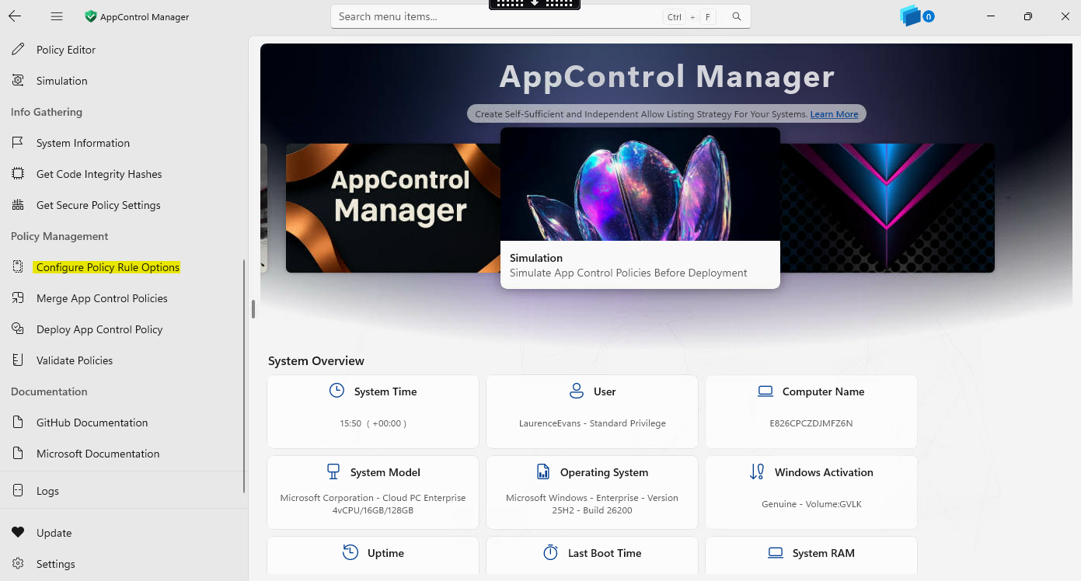
2 | Click on Select Policy File and select the WDAC policy you want to edit (ensure to download the xml files prior)  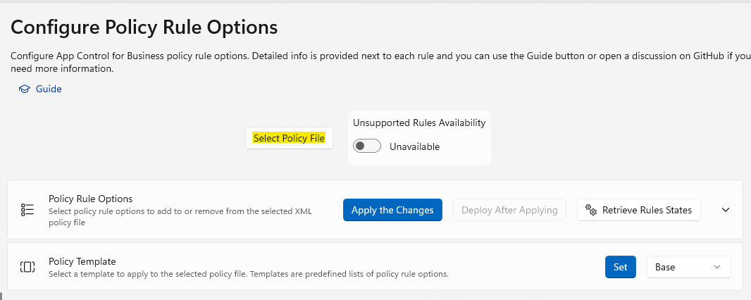
3 | This will load the policy with the currently configured options:  Select the Unsupported Rules Availability if you need to turn something off that’s not supported.  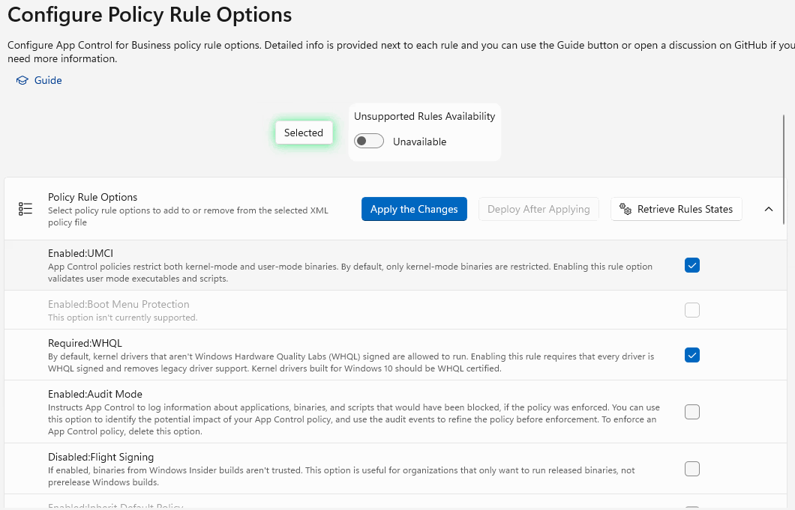
4 | Check the check box in the row for the Enabled:Audit Mode  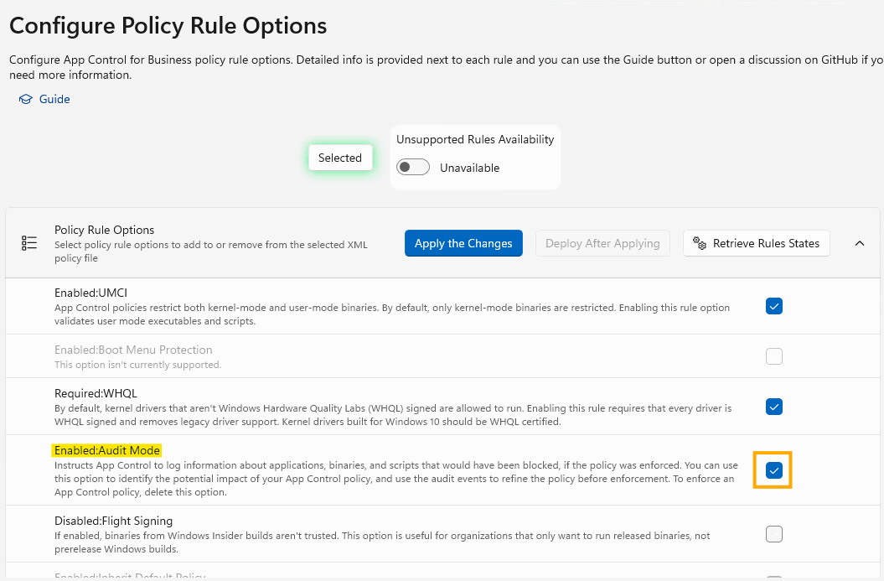
5 | Select Apply the Changes. This will save the changes to the policy.  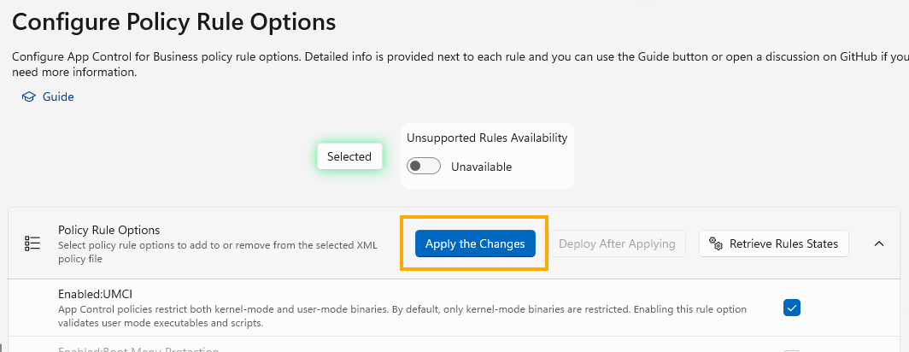
6 | From the left menu, select Policy Editor  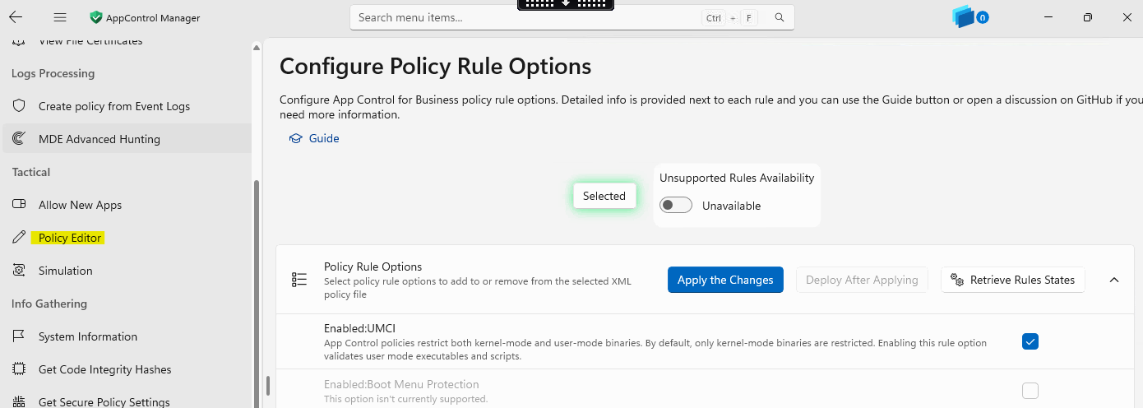
7 | Click on Select Policy File, and select the updated policy.  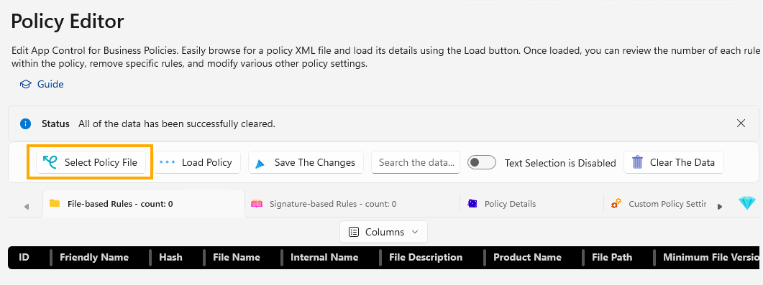
8 | Select Load Policy, which will load the policy into the table  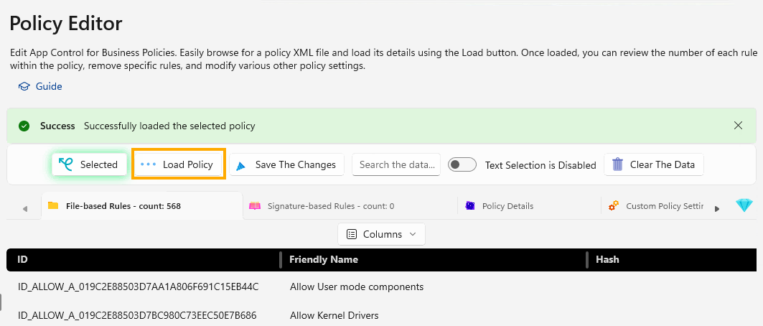
9 | Click on Policy Details  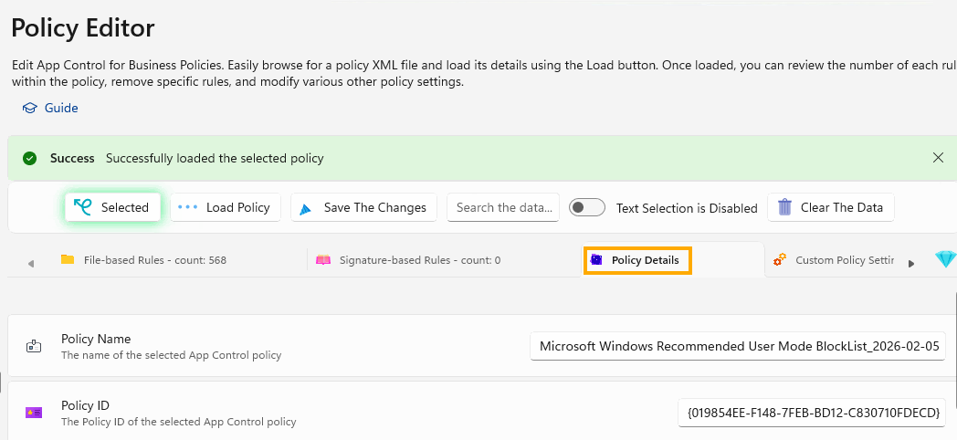
10 | Update the Policy Name, update the description (as required) and date at the end to reflect the date of change  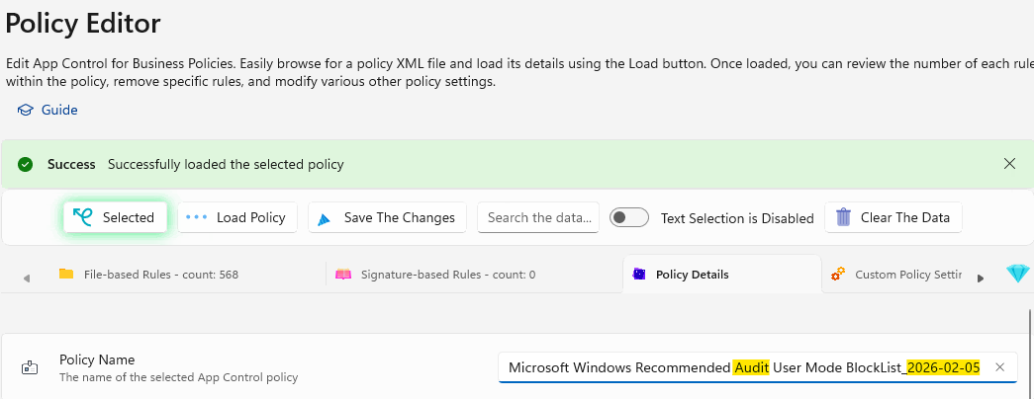  Note: check the version too, ensure its higher than the one already applied otherwise the policy will not apply via intune and error
11 | Select Save the Changes.
12 | Within the Intune Portal create the corresponding WDAC Audit Policy and upload the XML files to it, assign to devices for testing.
13 | To check the policies have updated on the client, open an elevated PowerShell window and type in  - citool.exe --list-policies  Check the Friendly Name of the policies and confirm they match the newly created/updated policies. You can also use the Policy ID to confirm.  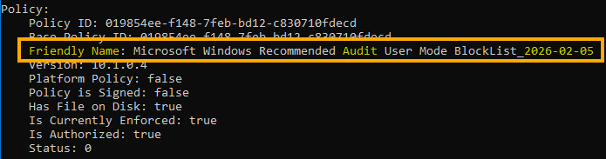

How to Generate a new Supplemental policy

Before starting ensure you have:
- The base policy downloaded
- The WDAC policies are in Audit Mode

1 | Login to the device and Synchronise to Intune  Settings --> Accounts --> Access Work or School  Select the drop down arrow next to your account  And select Info  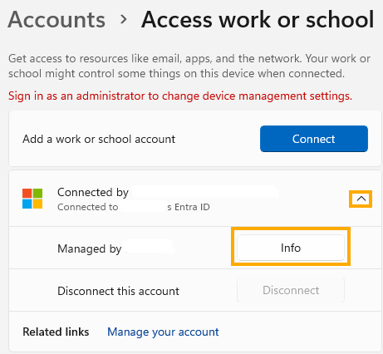
2 | Scroll to the bottom of the page and select Sync
3 | 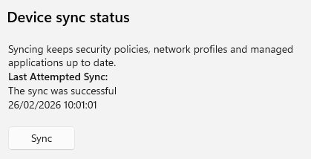
4 | Open an elevated PowerShell session and run the CITool to list the WDAC Policies assigned to the device  - citool.exe --list-policies
5 | Check that all base policies are in Audit Mode:  There should be three policies, the Base Allow, Deny Driver and Deny User Mode Blocklist policies  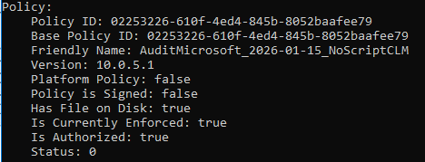  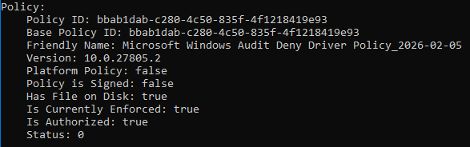  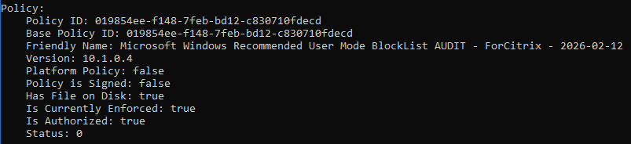
6 | Open Event Viewer and cleat the Code Integrity Logs  - Application and Services Logs --> Microsoft --> Windows --> Code Integrity --> Operational  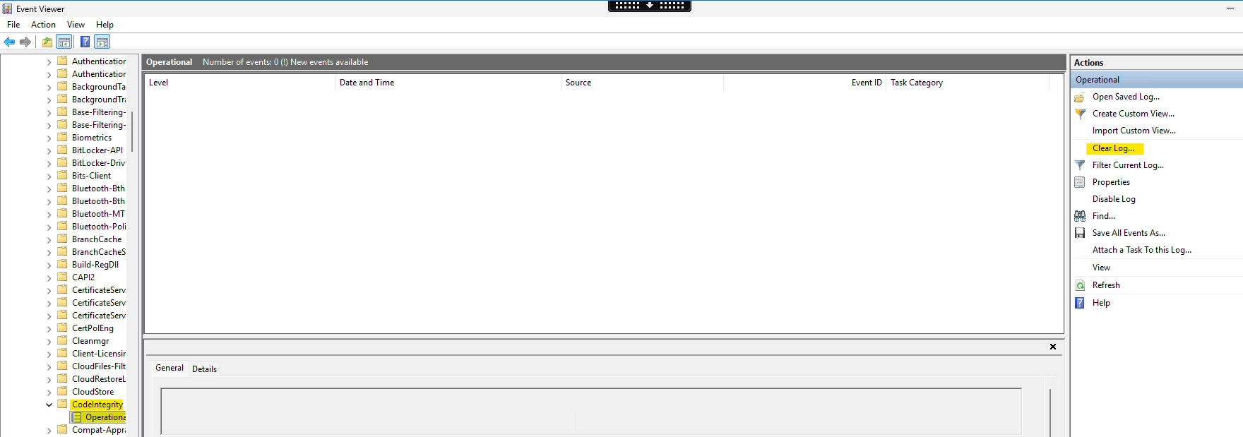
7 | Install the App for which you want to create a Supplementary policy for. In this example I'm using Chrome  Open Company Portal if the app is published and select install or install the app form the desktop if you have admin rights.  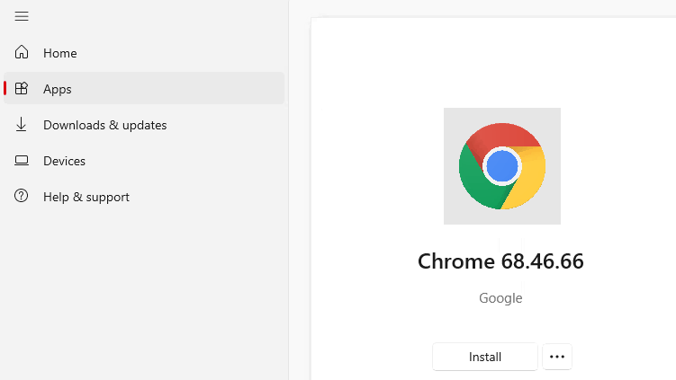
8 | Once the app is installed, check for updates to capture the update process
9 | Go back to Event Viewer once the install and update is complete and filter on event ID 3076 and then do a search for the app name, in this instance its Chrome  This will show if there are any events which need to be captured.  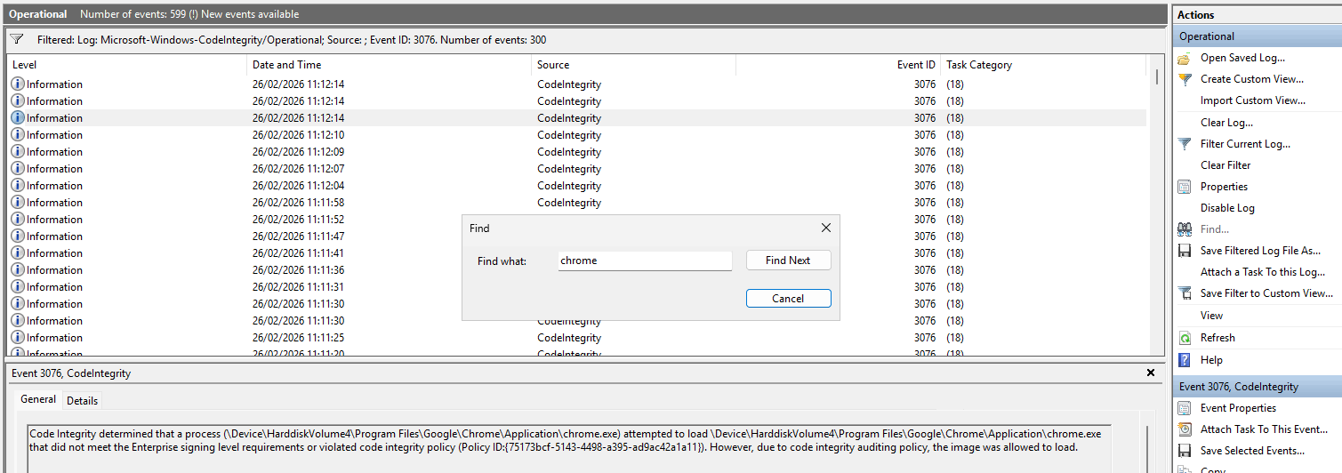
10 | Export the Event Logs and save them locally.
11 | Open AppControl Manager and select Create Supplemental Policy  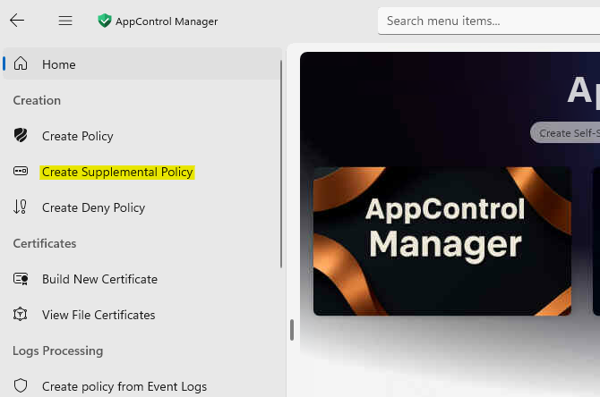
12 | Set Mode to Create New Policy  Browse for Folders: select the folders where chrome is installed C:\Program Files\Google\Chrome  Note: Multiple folders can be selected  Policy Name: EUD-CPC-EPS-Windows-WDAC-Supplemental-Allow-Chrome-2026-02-26  Base Policy File: Select the Base Allow policy
13 | Select Create Supplemental Policy  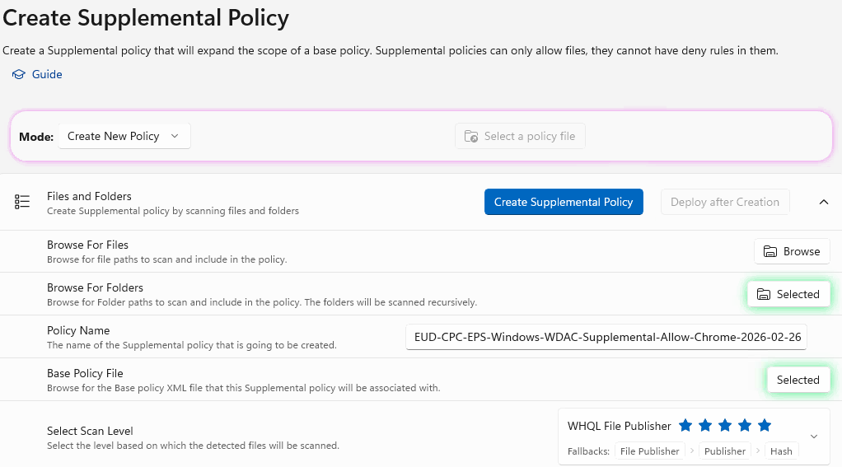
14 | The Success banner will appear when completed:  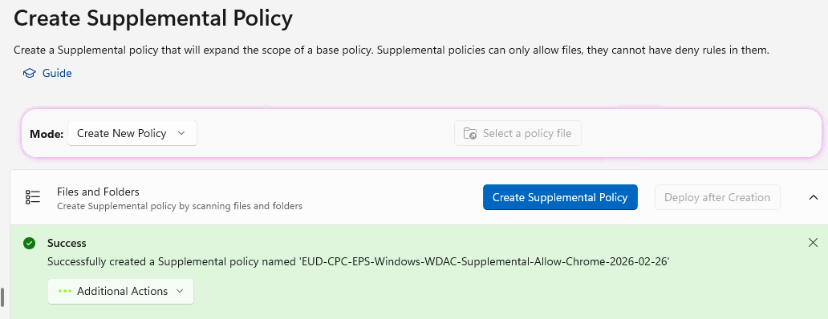
15 | Select View detected file details to see what it has captured.  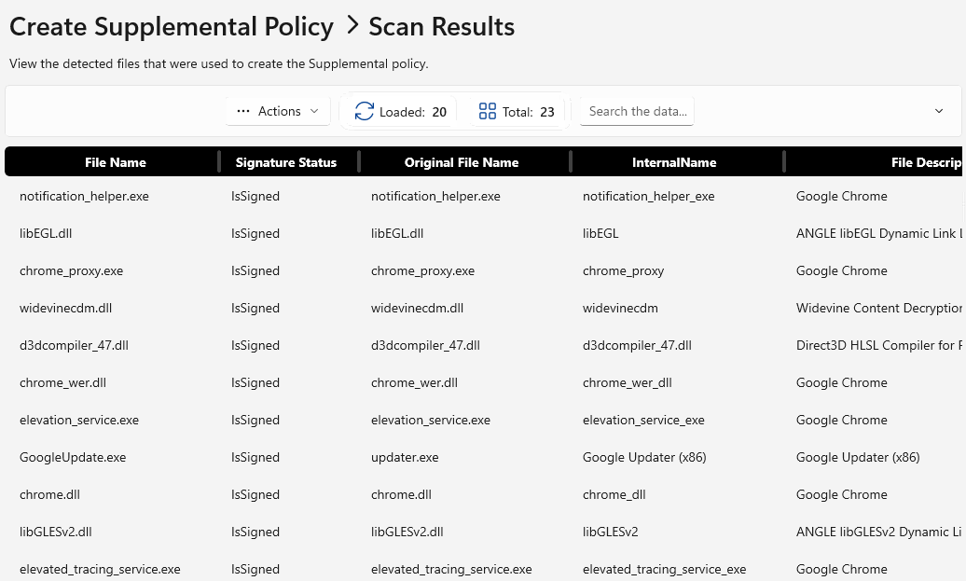
16 | To view the policy, on the Additional Actions select the dropdown and select Open In The Policy Editor  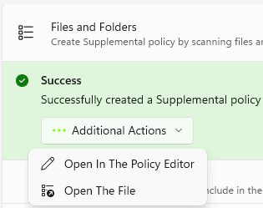
17 | If you don’t save the file to a specific location, the XML file will be saved the following location:  C:\Users\[User]\AppData\Local\Packages\VioletHansen.AppControlManager…\LocalCache\PoliciesLibraryCache  Copy the policy to a known folder, such as Documents and rename it.
18 | Go Back to AppControl Manager
19 | From the Left Menu, select Create policy from Event Logs  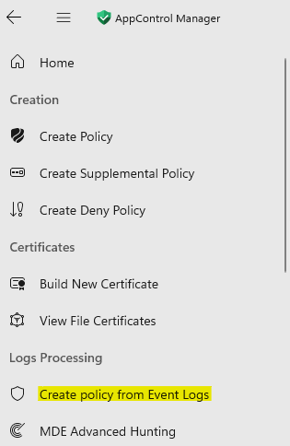
20 | Click on the button Select Code Integrity EVTX Files, and select the Event Log file you exported earlier  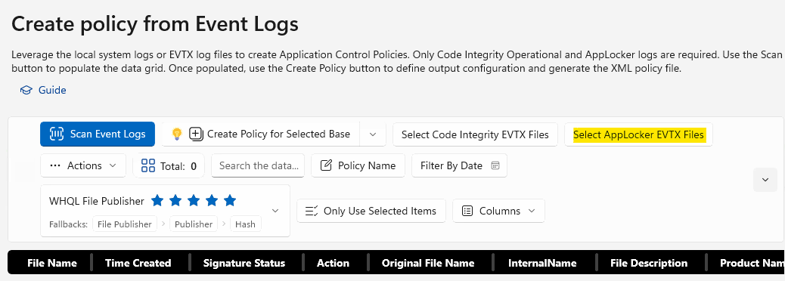
21 | Select the dropdown next to Create Policy for Selected Base  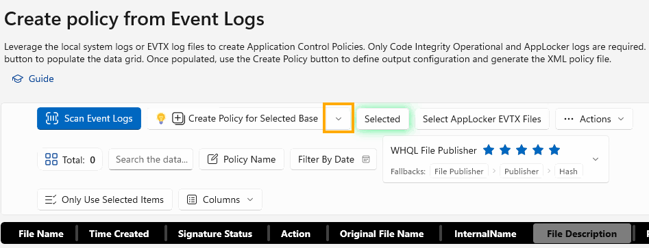
22 | Select Browse and select the newly created supplemental policy  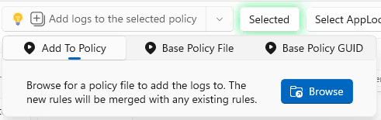
23 | Either click on the Base Policy File and attach the Base Policy or Add the Base Policy GUID.  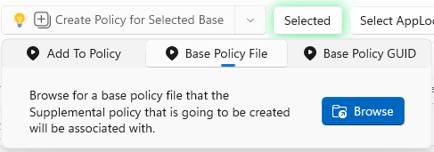  Now the Supplemental and base policies are associated.
24 | Select Scan Event Logs  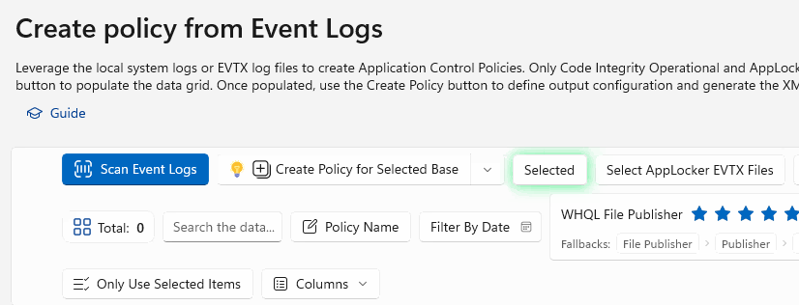
25 | Any identified files will be listed, go through them and only select the files related to the application you are working on. In this instance its Chrome.  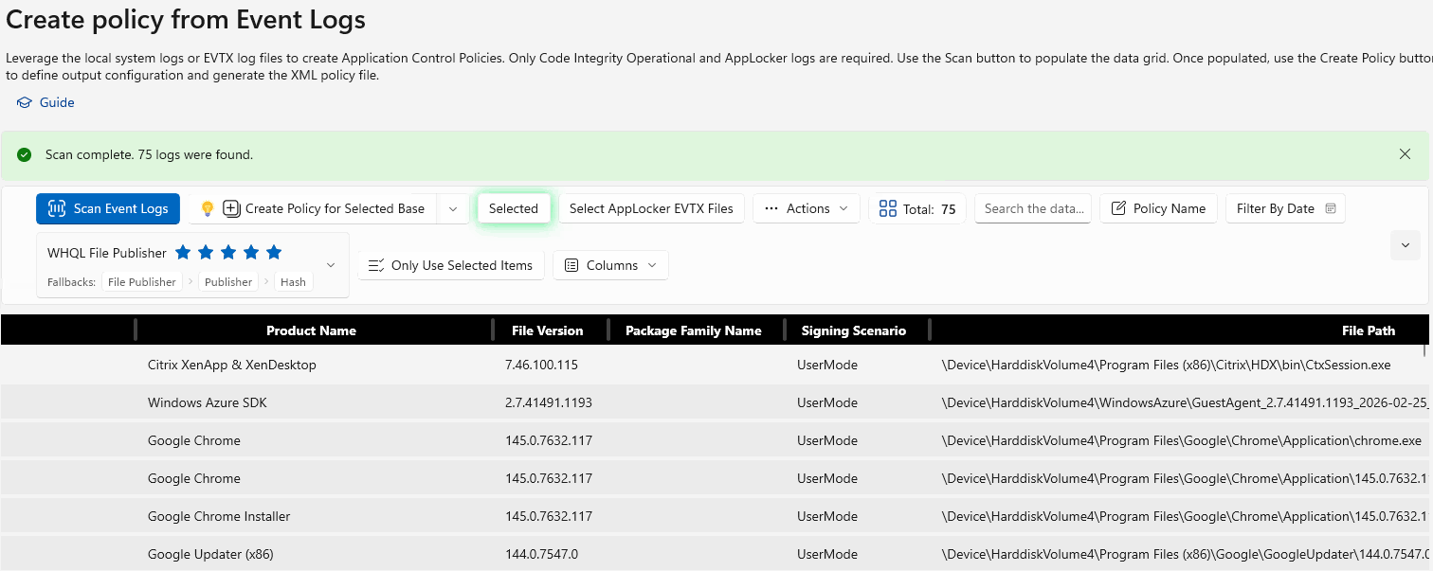
26 | Click on Add logs to the selected policy  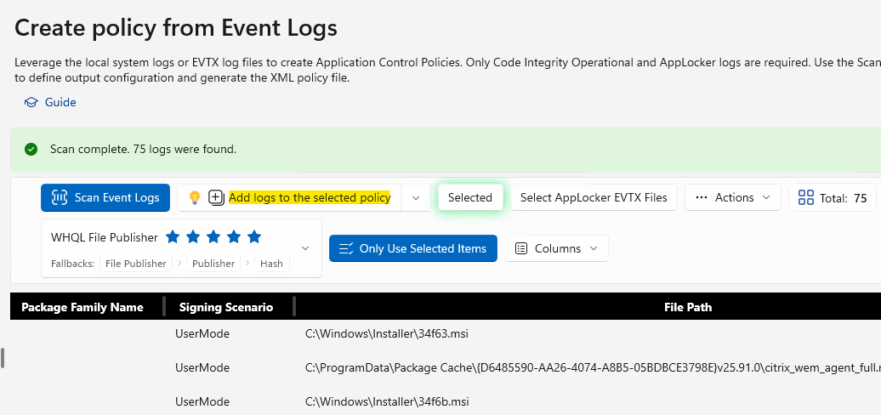
27 | Confirm they have been added successfully  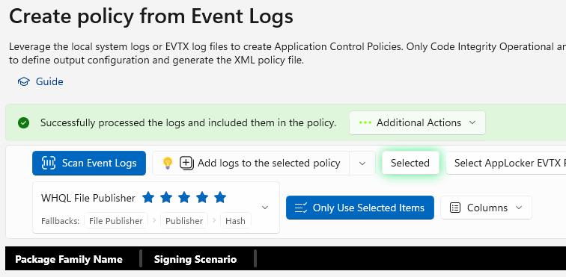
28 | From the Intune Portal create a new AppControl Policy and attach the new XML file just created.
29 | Sync your device and run the CITool to see that the policy has applied
30 | Check the Event Logs to see if there are any further blocks. If there are repeat the process.

Use Event Logs to update a Supplemental Policy

Pre-Requisites
- Export the Code integrity Operational logs from Event Viewer on a machine that is in Audit Mode to capture the required entries.
  - Application and Services Logs --> Microsoft --> Windows --> Code Integrity --> Operational
- Download the Supplemental policy which is to be updated in XML format. This should be the original XML file
- Have the Base policy ID or download the Base policy which the Supplemental policy is associated with.

In this example I am going to use exported event logs from a failed Citrix component and use the AppControl manager to update the Supplemental policy with items found from the event logs.

Best Practice, is prior to capturing any event logs, is to clear the event logs, install the app, export the event logs. This will help ensure you are only capturing what you need.

1 | Open AppControl Manager, this will require elevation
2 | From the left menu, select Create Policy from Event Logs  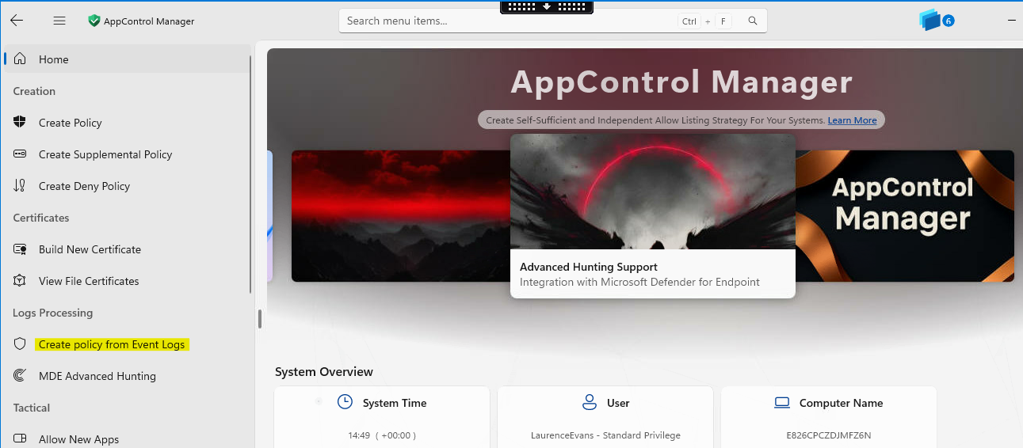
3 | Click on Select Code Integrity EVTX Files, and select the event viewer log file
4 | Click on the drop down arrow on the Add logs to the selected policy  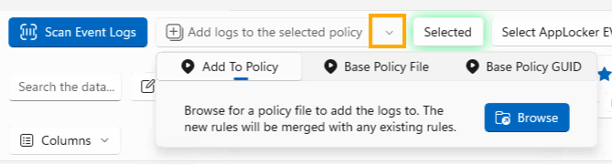
5 | Select Browse, and select the Policy which you want to update
6 | Click on the dropdown arrow again, and either select Base Policy File or Base Policy GUID depending on what you have to hand.
7 | Click on Scan Event Logs  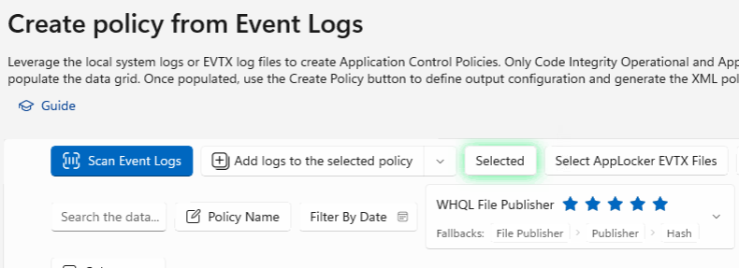
8 | Comb through each entry and select the ones to be imported, then click on Only Use Selected Items  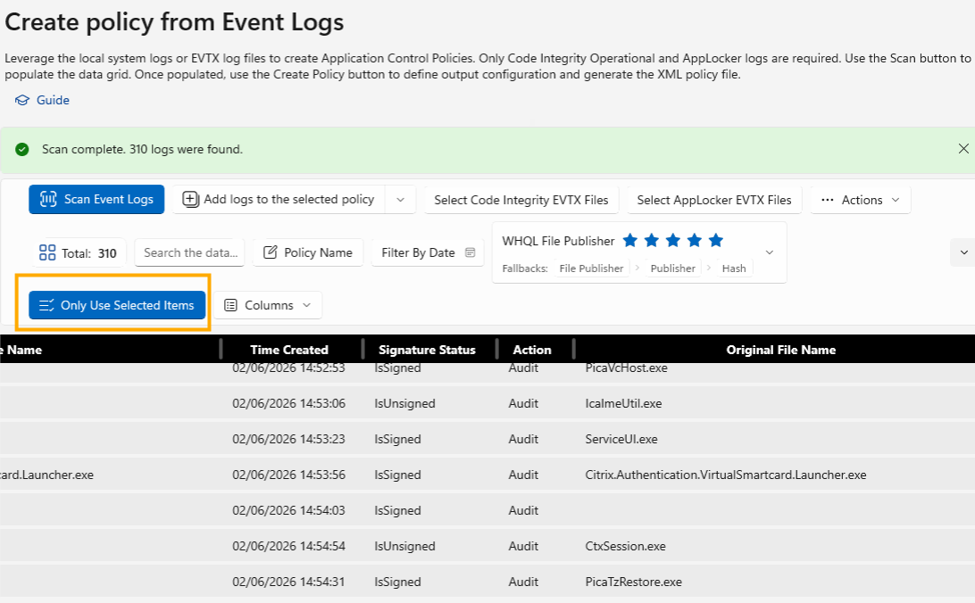
9 | Select Add logs to the selected policy  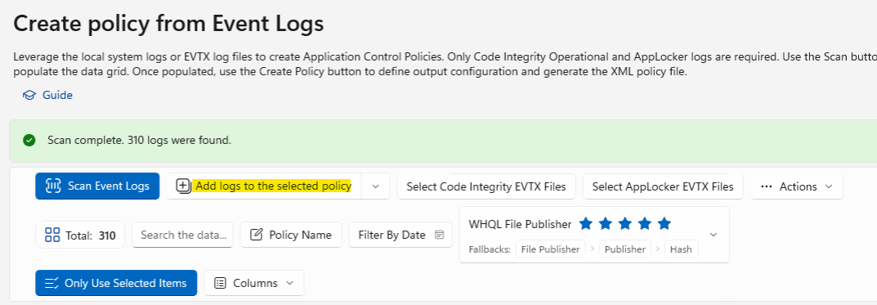
10 | When the policy has been updated the Green banner will appear, and state Successfully processed the logs and included them in the policy  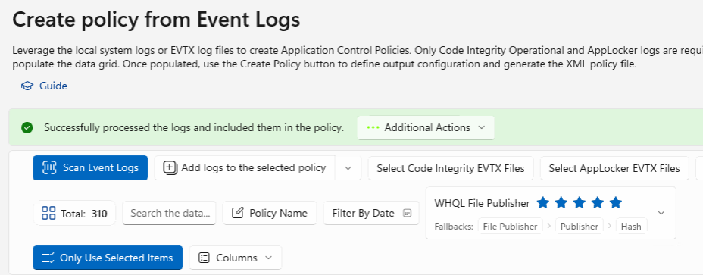
11 | Click on Additional Actions and select Open In the Policy Editor.  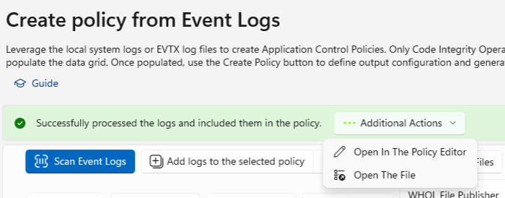
12 | Proceed to the next step

Update the Policy Friendly name and save changes.

1 | Open AppControl Manager, this will require elevation
2 | From the left menu, select Policy Editor  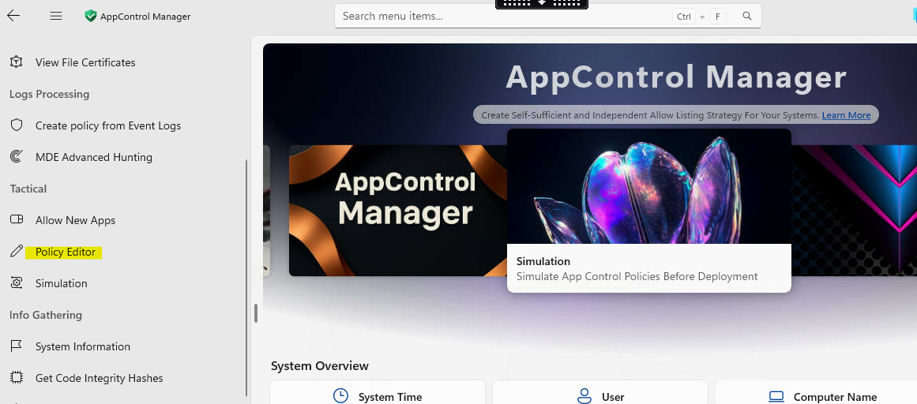
3 | Click on Select Policy File, this will open a dialog box, select the supplemental file you want to update:  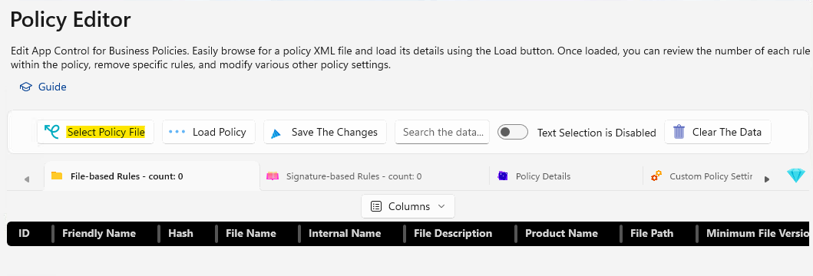
4 | A message will appear to show you have selected the file. Click somewhere outside of this dialog box and do not select clear, as this will clear the selection.  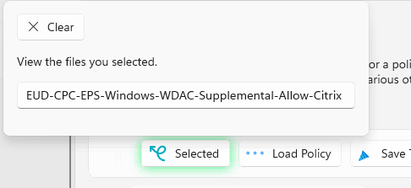
5 | Click on Load Policy  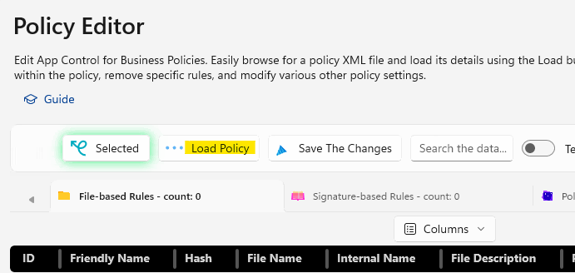
6 | This will load the policy into the policy editor  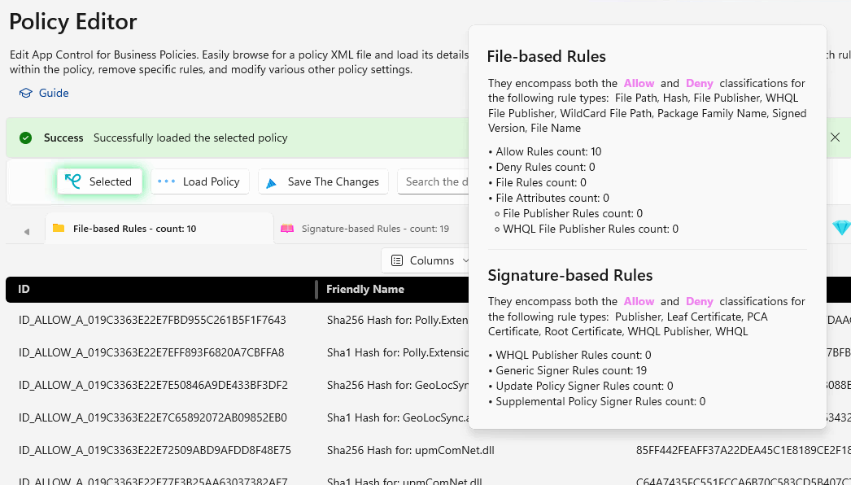
7 | Click on Policy Details, update the Policy Name to include the date the policy was updated. The Friendly name will appear in the CITool.exe when run.  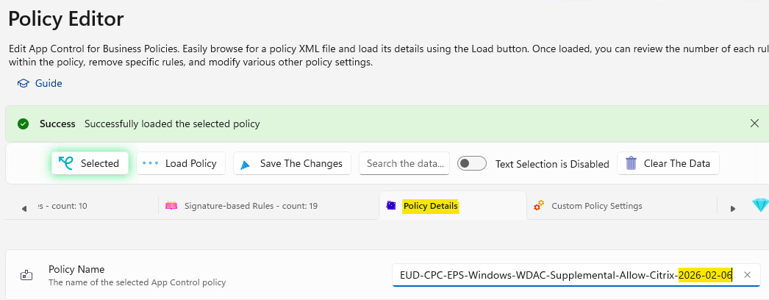
8 | Click on Save The Changes  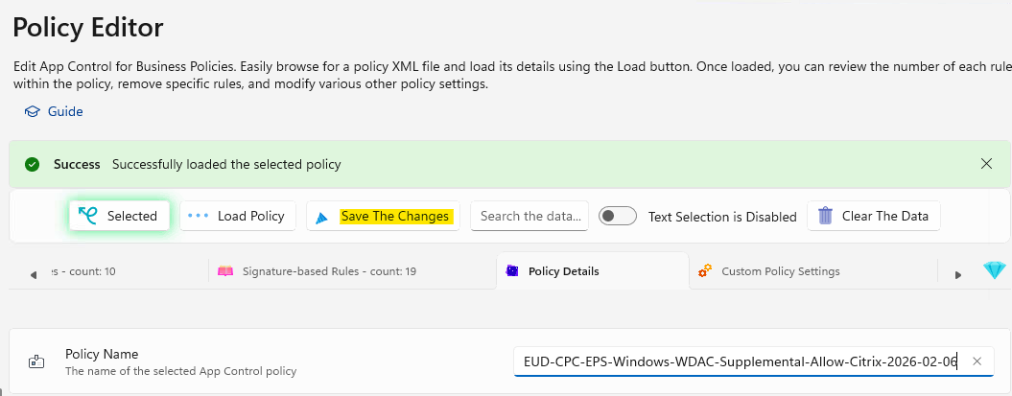
9 | Upload the updated policy to Intune, and SharePoint for any future required changes.

Validate the policy has updated on the machine before any testing continues and how to remediate any stuck policies

To confirm any updated policies have applied to a device use the CITool in an elevated PowerShell prompt

1 | Open PowerShell in an elevated window
2 | Type: citool.exe --list-policies  This will list all policies and whether they are enforced or not. This is where the friendly name is important.
3 | Scroll down the list to find the newly updated policy and confirm the friendly name matches what you expect and the policy is enforced.  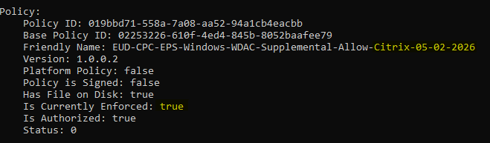  Note: you may need to sync the machine and reboot before you see them, if after a sync and reboot you still see the old policy see the procedure to Troubleshoot stale policies.

Troubleshoot stuck policies

1 | If the new WDAC policy is not applying, and within the Intune Portal is showing an error, as per below, it is likely the old policy is not being removed and blocking the application of the new policy.
2 | To resolve this issue, login to the effected machine and open an elevated PowerShell session and use the CITool to list the policies.  Type: citool.exe --list-policies  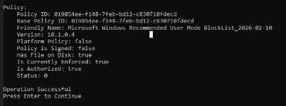  Find the Policy ID for the policy that is not updating and copy it.
3 | Run the following command to remove the policy:  Citool.exe --remove-policy <Policy ID>  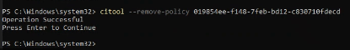  Confirm this is successful by listing the policies again.
4 | Sync the device using Company Portal or Account Settings, with Intune and reboot.
5 | From an elevated PowerShell prompt run the CITool to list the policies and confirm the new policy has been applied  Citool.exe --remove-policy <Policy ID>  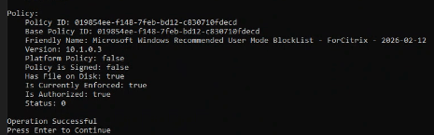
6 | From the Intune Portal, the policy status will update and show Succeeded.

How to read the event logs and troubleshoot the deny policies
If you have created the Base Policies, the Base Deny Policies for Device and User Block, associated Supplementary policies and you are still having issues with an app not working the way it should, using the Code Integrity Logs can help identify the offending policy.

1 | Before you start ensure the device has the Audit Policies applied, including the Deny User and Device Block policies.
2 | Confirm the Audit Policies are applied using the CITool and check the enforced policies are not listed  - CITool.exe --list-policies  For example:  
3 | Clear the Code Integrity Event Logs  - Application and Services Logs --> Microsoft --> Windows --> Code Integrity --> Operational
4 | Run / Install the app that is being blocked by WDAC enforcement
5 | Export the Code Integrity Logs so they do not become bloated by continued logging.
6 | Open the exported event logs
7 | Search for Events with Event ID 3076  These will show as an Information event as opposed to an error as WDAC is in audit mode. If looking through event logs whereby the policies are enforced look for event 3077 and filter on errors.  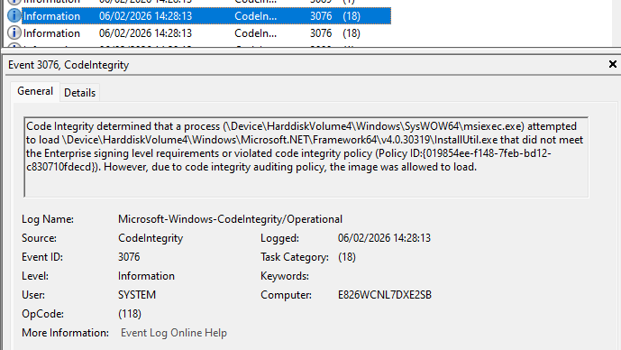  Here is an example of the same error when the policy is enforced:  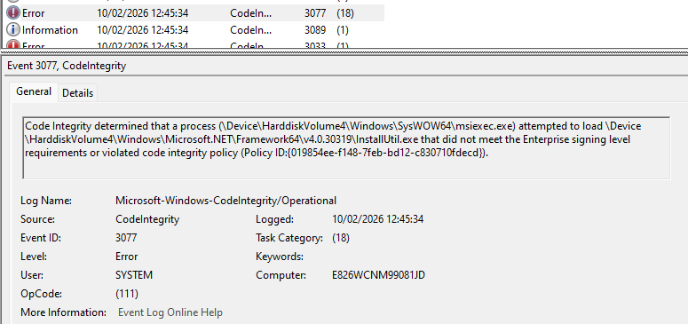
8 | The important information in this log event is the Policy ID. This will tell you which policy is blocking.  In this example the policy ID ends 0fdecd
9 | Open an elevated PowerShell prompt and type in:  - CITool.exe --list-policies
10 | Search through the list of policies to find the policy which matches this policy ID:  
11 | We now know this is the offending policy.  As this is the User Mode Block List policy, then we know adding a Hash Rule or Certificate Rule into the allow list will not make a difference all the Block List will override any allow.
12 | Open this policy in VSCode (xml format).  The User Mode Block list contains many items, DLL and EXE's as well as powershell which is not allowed to run when this policy is enforced.
13 | The first thing to do is search for the item which is detailed as being blocked in the event log. In this example its InstallUtil.exe
14 | Copy the ID as highlighted in Orange:  The delete this entire line
15 | Search the XML file for the ID, as there will be a FileRuleRef within the <SigningScenario> element  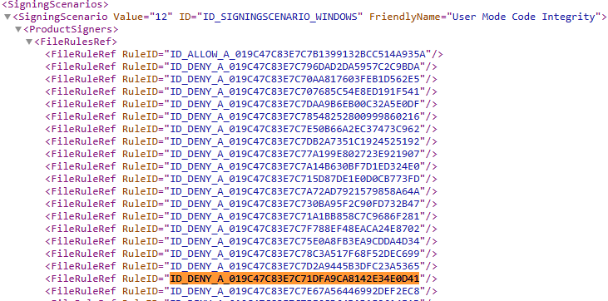
16 | Delete this row from the XML and save the file.
17 | Search the Code Integrity Event Logs for any other items which are also blocked by the same policy and repeat this process.  Be very careful not to break the xml.
18 | Using the AppControl Manager we will check the integrity of the file before uploading back to Intune
19 | Open AppControl Manager and scroll down to Policy Management > Validate Policy
20 | Select Validate Policy  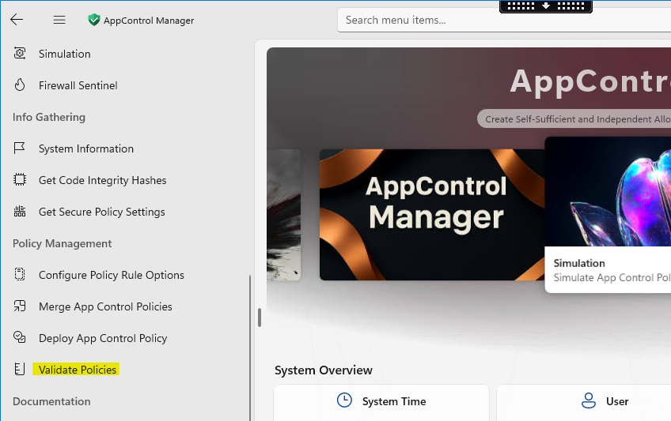
21 | Select Browse and search for the saved policy
22 | Once selected the validation test will run automatically and provide you the result  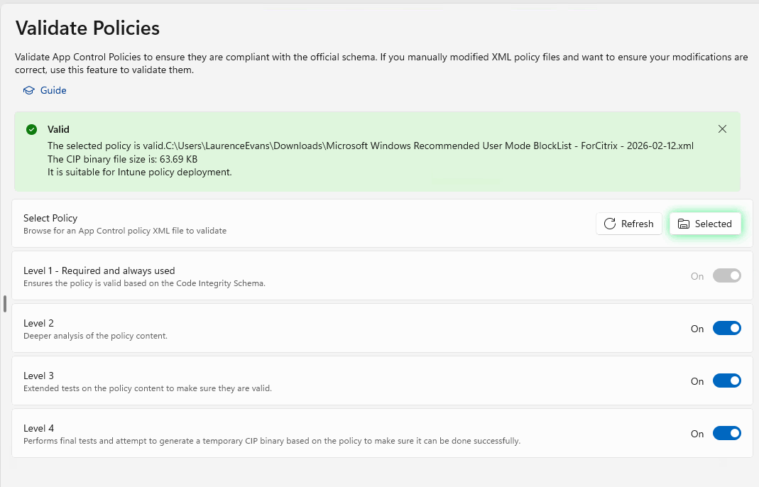
23 | If the policy is Valid then run through the process to update the Friendly Name and then upload to Intune and re-test
24 | If the test is successful in Audit Mode then run through the process to put the policy back into Enforced Mode, update the friendly name and upload to Intune
25 | Apply the enforced mode policies and re-test.

Notes: If after collecting event logs and updating supplemental policies and you still see items being blocked, check the exe being blocked and check in the user deny policy to see if it is being blocked in there. The exe maybe allowed by the supplemental policy but if it is listed in the user deny, the deny will win. To overcome this you will need to relax the user deny policy, this will require approval.

