Lecture Lec03.ppt in class worksheet
Question 1. How many bits wide is Port B? How many bits wide is Port F?
A:
PORTB:8
PORTF:5
Question 2. Why are there two shift right instructions (LSR and ASR)?
ASR is a signed shift right, maintaining the sign bit as it shifts
A:
ASR means algrithom shift right, all bits move right,and most left bit maintains its sign.
LSR means logically shift right,all bits move right,and most left bit replaced by 0
Question 3. Why are there five versions of the LDR instruction?
LDR, LDRB, LDRSB, LDRH, LDRSH
A:
LDR: load 32bits data to register from memory
LDRB:load 8 bits data using zero extend to 32 bits from memory
LDRSB: load 8 bits data using sign extend to 32 bits from memory
LDRH: load 16 bits data using zero extend to 32 bits from memory
LDRSH: load 16 bits data using sign extend to 32 bits from memory
Question 4. What address allows us to access just pin PA7?
A:
0x40004200
Question 5. Interface a switch to Port A bit 5 using positive logic.
A:
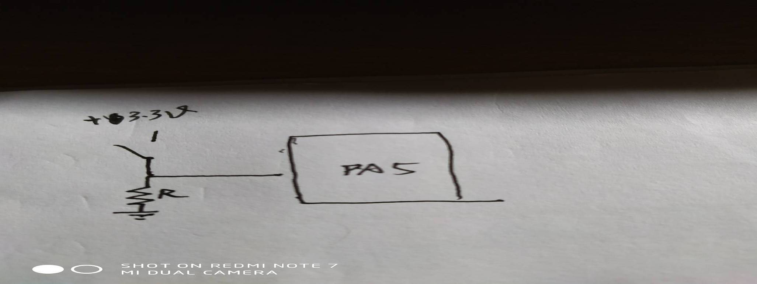

Question 6. Interface an LED to Port A bit 7 using positive logic. The LED parameters are 1.5V 20mA. Assume the output low voltage of a 7406 V_{OL} is 0.5V. Calculate the limiting resistor and give the connection Diagram.
A:
R = (5-0.5-1.5)/0.02=150Ohm
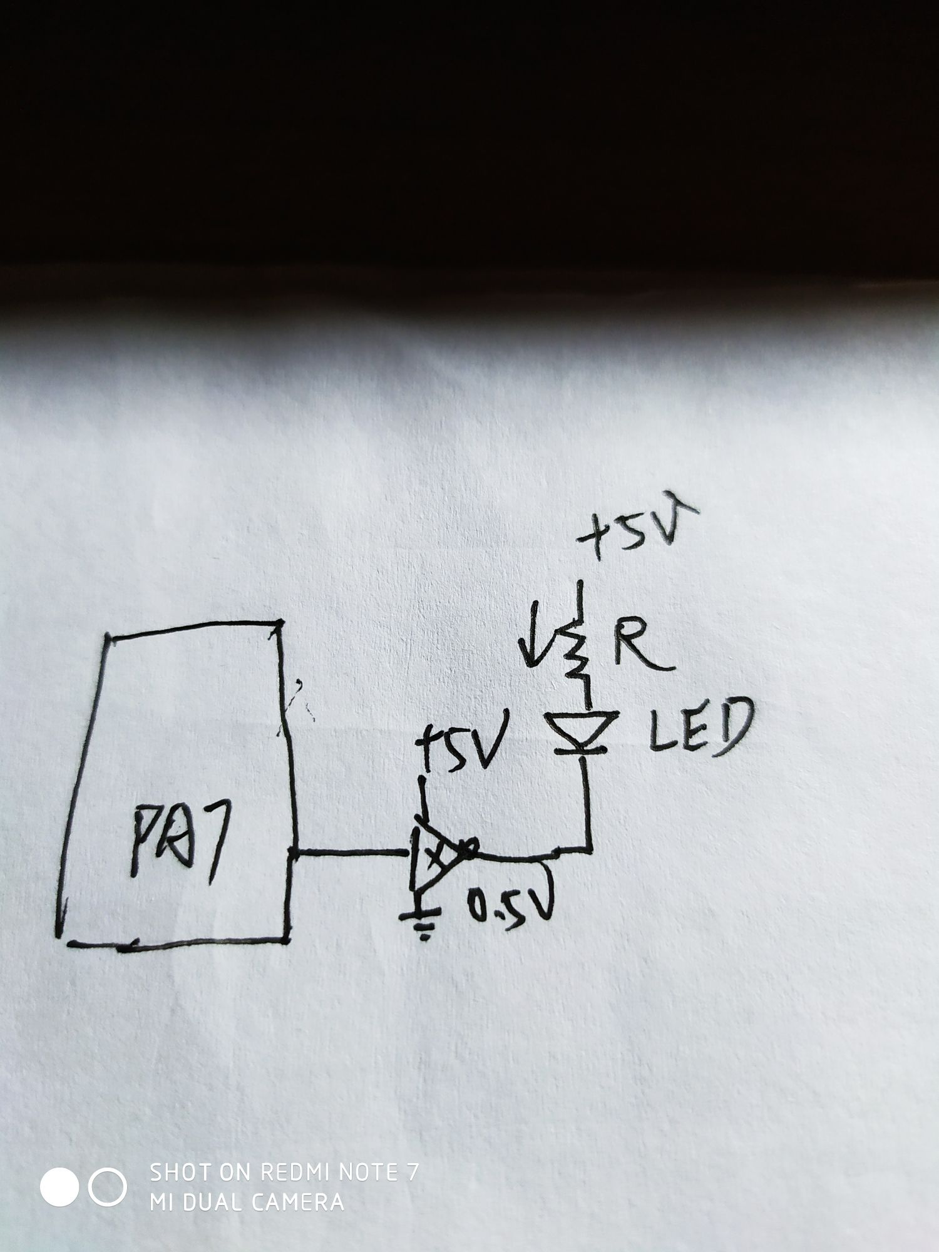
Question 7. Interface an LED to Port A bit 4 using positive logic. The LED parameters are 1.4V 2mA. Assume the microcontroller output voltage V_{OH} is 3.2V. Calculate the limiting resistor and give the connection Diagram.

A:
R=(3.2-1.4)/0.002=900Ohm
