Lecture Lec5.ppt in class worksheet
Question 1. You wish to pass three numbers into a function, according to AAPCS how would you pass the numbers?
依次传入R0-R2
Question 2. You wish to pass five numbers into a function, according to AAPCS how would you pass the numbers?
依次传入R0-3,最后一个压入堆栈
Question 3. What do each of the following assembly directives do? Answer each line separately, not as one complete program.
AA SPACE 10
BB RN 2
CC DCB 1,2,3
DD DCB "Jon\n\r",0
EE DCW 1,2,3
FF DCD 1,2,3
GG EQU 10
Uint8_t AA [10]
将寄存器R2重命名为 BB
Char CC[3]={1,2,3}
Char* DD = “Jon\n\r\0”;
Short EE[3]={1,2,3}
int FF[3]={1,2,3}
#define GG 20

Question 4. Create an array in RAM that can hold ten 32-bit unsigned numbers called Buf. Write an assembly and a C function that sets the value of each element to its index. This function has no formal input or output parameters, but does modify the Buf array.
C: unsigned int arr[10];
void Func(void){
for (int i = 0; i < 10; i++)
{
arr[i]=i;
}
}
Assemble:
ARR SPACE 40
FUNC
MOVE R0,#0
B LOOP
LOOP
MOV R2,R0,LSL#2; R2=R0*4
LDR R1,=ARR; load arr address
ADD R1,R1,R2;
STR R0,[R1] ; save index to specified position
ADD R0,R0,#1
CMP R0,#10
BHS EXIT
EXIT
Question 5. How many bits wide is the SysTick timer?
24 bits
Question 6. Does SysTick count up or down?
Count down
Question 7. Write a C function that uses SysTick to wait 100 μs. Assume the bus clock is running at 16 MHz.

void sysTick_Wait100us(){
volatile uint32_t elapsedTime;
uint32_t startTime = NVIC_ST_CURRENT_R;
Do{
elapsedTime = (startTime-NVIC_ST_CURRENT_R)&0X00FFFFFF;
}while(elapsedTime <= 1600);
}
Question 8 在实验课上的工程文件基础上，分别实现PF2脉冲宽度5ms,200ms，截取逻辑分析仪波形图
200ms
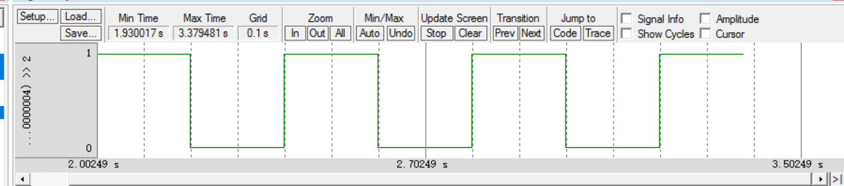
5ms:
