1. 计算下列代码片段的 Halstead 复杂度的11项内容：
if (month < 3) {
month += 12;
–year;
}
return dayray((int)(day + (month + 1) * 26/10 + year +
year/4 + 6 * (year/100) + year/400)% 7);

operator | occrrences
if | 1
< | 1
+= | 1
- | 1
dayray | 1
int | 1
+ | 6
* | 2
/ | 4
% | 1
Sum = 10 | Sum = 19

operand | occurrences
month | 3
year | 5
day | 1
3 | 1
12 | 1
1 | 1
26 | 1
10 | 1
4 | 1
6 | 1
100 | 1
400 | 1
7 | 1
Total operand kinds = 13 | Sum = 19

n1 = 10, n2 = 13, N1 = 19,N2 = 19

- n = n1+ n2 = 10 + 13 = 23
- N= N1 + N2 = 19 + 19 = 38
- N^=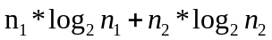 = 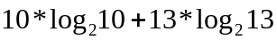
- V=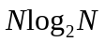=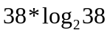
- L^ = 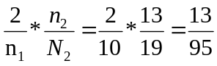
- 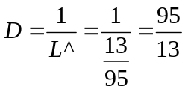
- 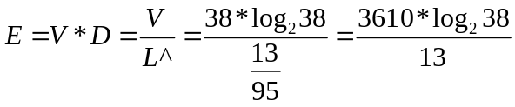
- L’ = L^*L^*V=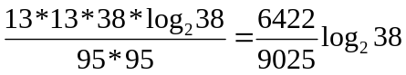
- T^=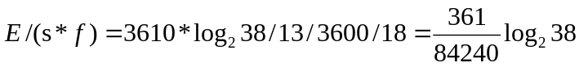
- 平均语句大小：N/语句数=38/4=9.5
- B = V/3000=