Question 1. What is the range of voltages that represent logic low?
0-1.3v

Question 2. What is the range of voltages that represent logic high?
2.0v-5.0v

Question 3. What is the difference between positive and negative logic?
当开关按下时，正逻辑输出为1，负逻辑输出为0,
当开关松开时，正逻辑输出为0，负逻辑输出为1
Question 4. What is the difference between volatile and nonvolatile memory?
当断电时，易失性存储器会丢失所有存储信息，非易失性存储器不会，
易失性存储器读写速度更快
Question 5. What is flash?
一种非易失性存储器
Question 6. How much RAM and ROM does our microcontroller have?
32kB RAM and 2 kB EEPROM
Question 7. How many bits wide is Port B? How many bits wide is Port F?
8 bits for B
5 bits for F
Question 8. What are the steps required to initialize a parallel port? Which steps are optional?
- Activate the clock for the port
- Unlock the port(only neccessary for port C3-0,D7,F0)
- Disable analog function of the pin(if we take digital as input)
- Clear pctl to set port as regular digital function)
- Set GPIO_PORTX_DIR_R to ensure its direction
- Set GPIO_PORTX_AFSEL_R to 0
- Set GPIO_PORTX_DEN_R to 1 to enable data io

Question 9. What are the steps required to input one bit from an input pin?
- Active the clock for the port
- Unlcok the port if needed
- Clear amsel to disable analog
- Cleara pctl to select gpio
- Set DIR to 0 as input
- Clear afsel bits to 0 to select regular io
- Set PUEbits to 1 to enable internal pull-up
- Set DEN bits to 1 to enabel data pins
- Read from specified input pin.
Question 10. Why are there two shift right instructions (LSR and ASR)?
LSR ： logic shift right , ignore the sign
ASR: algorithm shif right, take the sign into consideration
Question 11. Interface an LED to Port A bit 7 using positive logic. The LED parameters are 1.5V 20mA. Assume the output low voltage of a 7406 V_{OL} is 0.5V. Calculate the limiting resistor and give the connection Diagram.
R = (5-0.5-1.5)/0.02 = 3/0.02=150Ohm
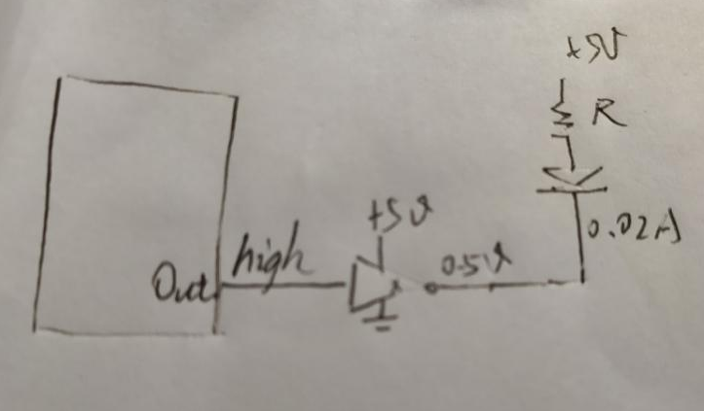

Question 12. Interface an LED to Port A bit 4 using positive logic. The LED parameters are 1.4V 2mA. Assume the microcontroller output voltage V_{OH} is 3.2V. Calculate the limiting resistor and give the connection Diagram.
R = (3.3-1.6)/0.002=1.7/0.002=850Ohm

0