（1）cfg

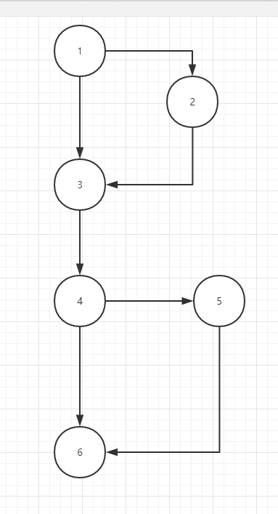

(2)邻接矩阵

|  |  |  |  |  |  |  |
| --- | --- | --- | --- | --- | --- | --- |
| From\to | 1 | 2 | 3 | 4 | 5 | 6 |
| 1 | 0 | 1 | 1 | 0 | 0 | 0 |
| 2 | 0 | 0 | 1 | 0 | 0 | 0 |
| 3 | 0 | 0 | 0 | 1 | 0 | 0 |
| 4 | 0 | 0 | 0 | 0 | 1 | 1 |
| 5 | 0 | 0 | 0 | 0 | 0 | 1 |
| 6 | 0 | 0 | 0 | 0 | 0 | 0 |

1. 边：7

顶点：6

复杂度：7-6+2=3

（4）独立路径集合

{1->3->4->6,

1. >2->3->4->6,

1->3->4->5->6,

1->2->3->4->5->6}